UNITED STATES

SECURITIES AND EXCHANGE COMMISSION

Washington, D.C. 20549

FORM 10-K

(Mark One)

- ANNUAL REPORT PURSUANT TO SECTION 13 OR 15(d) OF THE SECURITIES EXCHANGE ACT OF 1934

For the fiscal year ended December 31, 2022

OR
- TRANSITION REPORT PURSUANT TO SECTION 13 OR 15(d) OF THE SECURITIES EXCHANGE ACT OF 1934

FOR THE TRANSITION PERIOD FROM TO

Commission File Number : 001-14895

Sarepta Therapeutics, Inc.

(Exact name of registrant as specified in its charter)

Delaware | 93-0797222
(State or other jurisdiction of | (I.R.S. Employer
incorporation or organization) | Identification Number)
215 First Street
Suite 415
Cambridge, MA | 02142
(Address of principal executive offices) | (Zip Code)
Registrant’s telephone number, including area code: (617) 274-4000

Securities registered pursuant to Section 12(b) of the Act:

 |  | Trading
Title of each class |  | Symbol(s) |  | Name of each exchange on which registered
Common Stock, $0.0001 par value |  | SRPT |  | The NASDAQ Stock Market LLC
 |  |  |  | (The NASDAQ Global Select Market)
Securities registered pursuant to Section 12(g) of the Act: None
Indicate by check mark if the Registrant is a well-known seasoned issuer, as defined in Rule 405 of the Securities Act. YES ց NO տ Indicate by check mark if the Registrant is not required to file reports pursuant to Section 13 or 15(d) of the Act. YES տ NO ց

Indicate by check mark whether the Registrant: (1) has filed all reports required to be filed by Section 13 or 15(d) of the Securities Exchange Act of 1934 during the preceding 12 months (or for such shorter period that the Registrant was required to file such reports), and (2) has been subject to such filing requirements for the past 90

days. YES ց NO տ

Indicate by check mark whether the Registrant has submitted electronically every Interactive Data File required to be submitted pursuant to Rule 405 of Regulation S-T (§232.405 of this chapter) during the preceding 12 months (or for such shorter period that the Registrant was required to submit such files). YES ց NO տ
Indicate by check mark whether the registrant is a large accelerated filer, an accelerated filer, a non-accelerated filer, smaller reporting company, or an emerging growth company. See the definitions of “large accelerated filer,” “accelerated filer,” “smaller reporting company,” and “emerging growth company” in Rule 12b-2 of the Exchange Act.

Large accelerated filer

ց

Accelerated filer

տ

Non-accelerated filer

տ

Smaller reporting company

տ

Emerging growth company տ

If an emerging growth company, indicate by check mark if the registrant has elected not to use the extended transition period for complying with any new or revised financial accounting standards provided pursuant to Section 13(a) of the Exchange Act. տ
Indicate by check mark whether the registrant has filed a report on and attestation to its management’s assessment of the effectiveness of its internal control over financial reporting under Section 404(b) of the Sarbanes-Oxley Act (15 U.S.C. 7262(b)) by the registered public accounting firm that prepared or issued its audit report.

ց

If securities are registered pursuant to Section 12(b) of the Act, indicate by check mark whether the financial statements of the registrant included in the filing reflect the correction of an error to previously issued financial statements. տ
Indicate by check mark whether any of those error corrections are restatements that required a recovery analysis of incentive-based compensation received by any of the registrant’s executiYHR FHUVGXULQJWKHUHOHYDQWUHFRYHU\SHULRGSXUVXDQWWR'-1(b). տ

Indicate by check mark whether the Registrant is a shell company (as defined in Rule 12b-2 of the Exchange Act). YES տ NO ց

The aggregate market value of the voting and non-voting common equity held by non-affiliates of the Registrant, based on the closing price of the shares of common stock on The Nasdaq Global Select Market on June 30, 2022, was approximately $6,561,646,013.

The number of shares of Registrant’s Common Stock outstanding as of February 23, 2023 was 87,981,885.

DOCUMENTS INCORPORATED BY REFERENCE

The registrant has incorporated by reference into Part II and Part III of this Annual Report on Form 10-K portions of its definitive Proxy Statement for the 2023 Annual Meeting of Stockholders to be filed no later than 120 days after the end of the fiscal year covered by this Annual Report on Form 10-K.

Sarepta Therapeutics, Inc.

FORM 10-K INDEX

Page

PART I 6

Item 1. Business 6

Item 1A. Risk Factors 32

Item 1B. Unresolved Staff Comments 68

Item 2. Properties 69

Item 3. Legal Proceedings 69

Item 4. Mine Safety Disclosures 69

PART II 70

Item 5. Market for Registrant’s Common Equity, Related Stockholder Matters and Issuer Purchases of Equity

Securities 70

Item 6. Reserved 70

Item 7. Management’s Discussion and Analysis of Financial Condition and Results of Operations 71

Item 7A. Quantitative and Qualitative Disclosures About Market Risk 82

Item 8. Financial Statements and Supplementary Data 82

Item 9. Changes in and Disagreements with Accountants on Accounting and Financial Disclosure 83

Item 9A. Controls and Procedures 83

Item 9B. Other Information 84

Item 9C. Disclosure Regarding Foreign Jurisdictions that Prevent Inspections 84

PART III 85

Item 10. Directors, Executive Officers and Corporate Governance 85

Item 11. Executive Compensation 85

Item 12. Security Ownership of Certain Beneficial Owners and Management and Related Stockholder Matters 85

Item 13. Certain Relationships and Related Transactions, and Director Independence 85

Item 14. Principal Accounting Fees and Services 85

PART IV 86

Item 15. Exhibits, Financial Statement Schedules 86

Item 16. Form 10-K Summary 92

-i-

Forward-Looking Information

This Annual Report on Form 10-K, including the “Management’s Discussion and Analysis of Financial Condition and Results of Operations” section in Item 7, and other materials accompanying this Annual Report on Form 10-K contain forward-looking statements or incorporate by reference forward-looking statements. Statements that are not purely historical are forward-looking statements. Forward-looking statements are often identified by words such as “believe,” “anticipate,” “expect,” “intend,” “plan,” “will,” “may,” “estimate,” “could,” “continue,” “ongoing,” “predict,” “potential,” “likely,” “seek” and other similar expressions, as well as variations or negatives of these words. These statements address expectations, projections of future results of operations or financial condition, or other “forward-looking” information. These statements relate to our future plans, objectives, expectations, intentions and financial performance and the assumptions that underlie these statements. These forward-looking statements include, but are not limited to:

- our belief that our proprietary technology platforms and collaborations can be used to develop potential therapeutic candidates to treat a broad range of diseases;

- our expectation that our partnerships with manufacturers will support our clinical and commercial manufacturing capacity for our Duchenne muscular dystrophy gene therapy programs and Limb-girdle muscular dystrophy programs, while also acting as a manufacturing platform for potential future gene therapy programs, and our belief that our current network of manufacturing partners is able to fulfill the requirements of our commercial plan;

- our plan to continue building out our network for commercial distribution in jurisdictions in which our products are approved;

- estimated timelines and milestones for 2023 and beyond, including announcing additional data for SRP-9001 in 2023, and meeting with the U.S. Food and Drug Administration (the “FDA”) in 2023 to discuss a potentially pivotal trial for SRP-9003;

- our plan to expand our pipeline through internal research and development and through strategic transactions;

- the timely completion and satisfactory outcome of our post-marketing requirements and commitments, including verification of a clinical benefit for our products;

- our engagement with regulatory authorities outside of the U.S.;

- the possible impact of regulations and regulatory decisions by the FDA and other regulatory agencies on our business, as well as the development of our product candidates and our financial and contractual obligations;

- the possible impact of any competing products on the commercial success of our products and our product candidates and our ability to compete against such products;

- our ability to enter into research, development or commercialization alliances with universities, hospitals, independent research centers, non-profit organizations, pharmaceutical and biotechnology companies and other entities for specific molecular targets or selected disease indications and our ability to selectively pursue opportunities to access certain intellectual property rights that complement our internal portfolio through license agreements or other arrangements;

- our expectations regarding the potential benefits of the partnership, licensing and/or collaboration arrangements and other strategic arrangements and transactions we have entered into or may enter into in the future;

- the potential benefits of our technologies and programs, including those with strategic partners;

- our plans and ability to file and progress to issue additional patent applications to enhance and protect our new and existing technologies and programs;

- our estimates regarding how long our currently available cash and cash equivalents will be sufficient to finance our operations and business plans and statements about our future capital needs;

- our estimates regarding future revenues, research and development expenses, other expenses, capital requirements and payments to third parties;

- the potential impact of the ongoing COVID-19 pandemic on our business, including our commercial sales, ongoing and planned clinical trials, manufacturing and operations;

- our expectation regarding the impact of environmental laws and regulations on our business; and

- our beliefs and expectations regarding milestone, royalty or other payments that could be due to third parties under existing agreements.

-2-

We undertake no obligation to update any of the forward-looking statements contained in this Annual Report on Form 10-K after the date of this report, except as required by law or the rules and regulations of the U.S. Securities and Exchange Commission (the “SEC”). We caution readers not to place undue reliance on forward-looking statements. Our actual results could differ materially from those discussed in this Annual Report on Form 10-K. The forward-looking statements contained in this Annual Report on Form 10-K, and other written and oral forward-looking statements made by us from time to time, are subject to certain risks and uncertainties that could cause actual results to differ materially from those anticipated in the forward-looking statements, including the risks, uncertainties and assumptions identified under the heading “Risk Factors” in this Annual Report on Form 10-K.

-3-

Risk Factors Summary

Our business is subject to numerous risks and uncertainties, including those described in Item 1A “Risk Factors”. These risks include, but are not limited to the following:

- We are highly dependent on the commercial success of our products in the U.S. We may not be able to meet expectations with respect to sales of our products or attain profitability and positive cash-flow from operations.

- Even though EXONDYS 51, VYONDYS 53 and AMONDYS 45 have received accelerated approval from the FDA, they face future post-approval development and regulatory requirements, which present additional challenges for us to successfully navigate.

- Failure to obtain or maintain regulatory exclusivity for our products could result in our inability to protect our products from competition and our business may be adversely impacted.

- We are subject to uncertainty relating to reimbursement policies which, if not favorable, could hinder or prevent the commercial success of our products and/or product candidates.

- Our products may not be widely adopted by patients, payors or healthcare providers, which would adversely impact our potential profitability and future business prospects.

- We cannot predict whether historical revenues from eteplirsen, golodirsen and casimersen through our early access program ("EAP") outside the U.S. will continue or whether we will be able to continue to distribute our products through our EAP.

- We face intense competition and rapid technological change, which may result in other companies discovering, developing or commercializing competitive products.

- We have entered into multiple collaborations and strategic transactions, including our collaboration with Roche, and may seek or engage in future collaborations, strategic alliances, acquisitions or licensing agreements that complement or expand our business. We may not be able to complete such transactions, and such transactions, if executed, may increase our capital requirements, dilute our stockholders, cause us to incur debt or assume contingent liabilities and subject us to other risks.

- We may find it difficult to enroll patients in our clinical trials, which could delay or prevent clinical trials of our product candidates.

- Failures or delays in the commencement or completion of ongoing and planned clinical trials of our product candidates could negatively impact commercialization efforts; result in increased costs; and delay, prevent or limit our ability to gain regulatory approval of product candidates and to generate revenues and continue our business.

- Clinical development is lengthy and uncertain. Clinical trials of our novel gene therapy candidates may be delayed, including as a result of the COVID-19 pandemic, and certain programs may never advance in the clinic or may be more costly to conduct than we anticipate, any of which could have a material adverse impact on our business.

- Results from pre-clinical and early-stage clinical trials may not be indicative of efficacy in late-stage clinical trials, and pre-clinical and clinical trials may fail to demonstrate acceptable levels of safety, efficacy, and quality of our product candidates, which could prevent or significantly delay their regulatory approval.

- Our product candidates may cause undesirable side effects or have other properties that could delay or prevent regulatory approval of product candidates, limit the commercial potential or result in significant negative consequences following any potential marketing approval.

- If there are significant delays in obtaining or we are unable to obtain or maintain required regulatory approvals, we will not be able to commercialize our product candidates in a timely manner or at all, which could impair our ability to generate sufficient revenue and have a successful business.

-4-

- We are investing significant resources in the development of novel gene therapy product candidates. Only a few gene therapy products have been approved in the U.S. and the European Union (“EU”). If we are unable to show the safety and efficacy of these product candidates, experience delays in doing so or are unable to successfully commercialize at least one of these drugs, our business would be materially harmed;

- Because we are developing product candidates for the treatment of certain diseases in which there is little clinical experience and we are using new endpoints or methodologies, there is increased risk that the FDA, the European Medicines Agency (the "EMA") or other regulatory authorities may not consider the endpoints of our clinical trials to provide clinically meaningful results and that these results may be difficult to analyze;

- We may not be able to advance all of our programs, and we may use our financial and human resources to pursue particular programs and fail to capitalize on programs that may be more profitable or for which there is a greater likelihood of success.

- If we are unable to maintain our agreements with third parties to distribute our products to patients, our results of operations and business could be adversely affected.

- We rely on third parties to conduct some aspects of our early stage research and pre-clinical and clinical development. The inadequate performance by or loss of any of these third parties could affect the development and commercialization of our product candidate development. The third parties we use in the manufacturing process for our products and product candidates may fail to comply with cGMP regulations.

- We currently rely on third parties to manufacture our products and to produce our product candidates. Our dependence on these parties, including failure on our part to accurately anticipate product demand and timely secure manufacturing capacity to meet commercial, EAP, clinical and pre-clinical product demand may impair the availability of product to successfully support various programs, including research and development and the potential commercialization of additional product candidates in our pipeline.

- Products intended for use in gene therapies are novel, complex and difficult to manufacture. We could experience production problems that result in delays in our development or commercialization of gene therapy programs, limit the supply of our product candidates or future approved products or otherwise harm our business.

- Our success, competitive position and future revenue depend in part on our ability and the abilities of our licensors and other collaborators to obtain, maintain and defend the patent protection for our products, product candidates, and platform technologies, to preserve our trade secrets, and to prevent third parties from infringing on our proprietary rights.

- The COVID-19 pandemic has resulted and may continue to result in disruptions to our commercialization, clinical trials, manufacturing and other business operations, which could have a material adverse effect on our business, financial condition, operating results, cash flows and prospects.

- We have incurred operating losses since our inception and we may not achieve or sustain profitability.

- Our stock price is volatile and may fluctuate due to factors beyond our control.

- Our revenues and operating results could fluctuate significantly, which may adversely affect our stock price.

-5-

PART I

Item 1. Business.

Overview

We are a commercial-stage biopharmaceutical company focused on helping patients through the discovery and development of unique RNA-targeted therapeutics, gene therapy and other genetic therapeutic modalities for the treatment of rare diseases. Applying our proprietary, highly-differentiated and innovative technologies, and through collaborations with our strategic partners, we have developed multiple approved products for the treatment of Duchenne muscular dystrophy (“Duchenne”) and are developing potential therapeutic candidates for a broad range of diseases and disorders, including Duchenne, Limb-girdle muscular dystrophies (“LGMDs”) and other neuromuscular and central nervous system (“CNS”) related disorders.

Commercial Products

To date, we have developed and commercialized the following approved products for the treatment of Duchenne:

- EXONDYS 51 (eteplirsen) Injection (“EXONDYS 51”) is indicated for the treatment of Duchenne in patients who have a confirmed mutation of the dystrophin gene that is amenable to exon 51 skipping. EXONDYS 51 uses our phosphorodiamidate morpholino oligomer (“PMO”) chemistry and exon-skipping technology to skip exon 51 of the dystrophin gene.

- VYONDYS 53 (golodirsen) Injection (“VYONDYS 53”) is indicated for the treatment of Duchenne in patients who have a confirmed mutation of the dystrophin gene that is amenable to exon 53 skipping. VYONDYS 53 uses our PMO chemistry and exon-skipping technology to skip exon 53 of the dystrophin gene.

- AMONDYS 45 (casimersen) Injection (“AMONDYS 45”) is indicated for the treatment of Duchenne in patients who have a confirmed mutation of the dystrophin gene that is amenable to exon 45 skipping. AMONDYS 45 uses our PMO chemistry and exon-skipping technology to skip exon 45 of the dystrophin gene.

Technology and Platforms

Exon skipping is intended to promote the production of an internally truncated but functional dystrophin protein. The original PMO structure and variations of this structure that are so-called PMO-based (collectively “PMO-based”) are central to our proprietary chemistry platform. PMO technologies can be used to selectively up-regulate or down -regulate the production of a target protein through pre-mRNA splice alteration. PMO-based compounds have the potential to be designed to create more, less, or none of certain proteins, or produce analogues of endogenous proteins. This technology can be used to correct disease-causing genetic errors by inducing the targeted expression of novel proteins.

The PMO chemistry platform is highly adaptable, and we have developed next-generation PMO-based chemistries for advancing RNA-targeted therapeutics. These next-generation chemistries are specifically designed to enhance tissue targeting, intracellular delivery, target selectivity and drug potency. One of these novel technologies is based on cell-penetrating peptide-conjugated PMO (“PPMO”). The PPMO features covalent attachment of a cell- penetrating peptide to a PMO with the goal of enhanced delivery into the cell. Our most advanced PPMO product candidate is SRP-5051, which is designed to treat Duchenne in patients with genetic mutations amenable to exon 51 skipping.

As part of our multifaceted approach to Duchenne, we are also developing gene therapy technologies to treat Duchenne. We are clinically developing a product candidate, SRP-9001, that aims to express a smaller but still functional version of dystrophin. We use a unique adeno-associated virus (“AAV”) vector called AAVrh.74 to transport the transgene – the genetic material that will make the protein of interest – to the target cells. A unique, engineered dystrophin is used because naturally-occurring dystrophin is too large to fit in an AAV.

We are also developing gene therapy programs for various forms of LGMDs. Our most advanced LGMD product candidate, SRP-9003, is designed to transfer a gene that codes for and restores beta-sarcoglycan protein with the goal of restoring the dystrophin associated protein complex. SRP-9003 utilizes the AAVrh.74 vector, the same vector used in SRP-9001.

Our pipeline includes more than 40 programs at various stages of discovery, pre-clinical and clinical development, reflecting our aspiration to apply our multifaceted approach and expertise in precision genetic medicine to make a profound difference in the lives of patients suffering from rare diseases.

-6-

Objectives and Business Strategy

We believe that our proprietary technology platforms and collaborations can be used to develop novel pharmaceutical products to treat a broad range of diseases and address key currently-unmet medical needs. We intend to leverage our technology platforms, organizational capabilities, collaborations and resources to lead the field of precision genetic medicines, including the treatment of rare, neuromuscular and other diseases, with a diversified portfolio of product candidates. In pursuit of this objective, we intend to focus on the following activities:

- continuing to build our gene therapy engine, including developing gene therapy product candidates, operationalizing our manufacturing strategy and furthering our commercial capabilities in preparation for potential regulatory approvals;

- advancing our RNA technologies (e.g., PMO and PPMO), launching potential approved products and supporting commercialization of approved products;

- investing in next-generation precision medicine through internal research, strategic partnerships, collaborations and other potential opportunities; and

- continuing to nurture our culture, which is based on strong patient focus, bias to action, a self-starter mentality, smart and appropriate risk-taking and high ethics.

Core Therapeutic Areas

Duchenne: Duchenne is a rare X-linked recessive genetic disorder affecting children (primarily males) that is characterized by progressive muscle deterioration and weakness. It is the most common type of muscular dystrophy. Duchenne is caused by an absence of dystrophin, a protein that protects muscle cells. The absence of dystrophin in muscle cells leads to significant cell damage and ultimately causes muscle cell death and fibrotic replacement. In the absence of dystrophin protein, affected individuals generally experience the following symptoms, although disease severity and life expectancy vary:

- muscle damage characterized by inflammation, fibrosis and loss of myofibers beginning at an early age;

- muscle weakness and progressive loss of muscle function beginning in the first few years of life;

- decline of ambulation and respiratory function after the age of seven;

- total loss of ambulation in the pre-teenage or early teenage years;

- progressive loss of upper extremity function during mid- to late-teens; and

- respiratory and/or cardiac failure, resulting in death before the age of 30.

LGMDs are autosomal recessive, monogenic, rare neuromuscular diseases caused by missense and deletion mutations. These diseases affect males and females equally. Some types of LGMDs affect skeletal muscle and cardiac muscle. More severe forms of LGMDs mimic Duchenne. LGMDs as a class affect an estimated range of approximately 1 in every 14,500 to 1 in every 123,000 individuals. Currently, there are no approved treatment options for LGMDs.

Charcot-Marie-Tooth (“CMT”) Disease is a group of hereditary, degenerative nerve diseases that are caused by mutations in genes that produce proteins involved in the structure and function of either the peripheral nerve axon or the myelin sheath. CMT can cause degeneration of motor skills, resulting in muscle weakness, and limiting patients’ ability to walk or use their hands, and in some cases, can cause degeneration of sensory nerves, resulting in a reduced ability to feel heat, cold, and pain. CMT affects approximately 1 in every 2,500 individuals, while CMT type 1A, which is most often caused by an extra copy of the PMP22 gene, affects approximately 50,000 patients in the U.S. Most patients are diagnosed at infancy, while other patients develop symptoms at adolescence. Currently, there are no available treatment options.

-7-

Our Commercial Products

EXONDYS 51. We launched our first commercial product, EXONDYS 51, in 2016. EXONDYS 51 is indicated for the treatment of Duchenne in patients who have a confirmed mutation of the dystrophin gene that is amenable to exon 51 skipping. EXONDYS 51 uses our PMO chemistry and exon-skipping technology to skip exon 51 of the dystrophin gene. PMO-based compounds are synthetic compounds that bind to complementary sequences of RNA by standard Watson- Crick nucleobase pairing. The two key structural differences between PMO-based compounds and naturally occurring RNA are that the PMO nucleobases are bound to synthetic morpholino rings instead of ribose rings, and the morpholino rings are linked by phosphorodiamidate groups instead of phosphodiester groups. Replacement of the negatively charged phosphodiester in RNA with the uncharged phosphorodiamidate group in PMO eliminates linkage ionization at physiological pH. Due to these modifications, PMO-based compounds are resistant to degradation by plasma and intracellular enzymes. Unlike the RNA-targeted technologies such as siRNAs and DNA gapmers, PMO-based compounds operate by steric blockade rather than by cellular enzymatic degradation to achieve their biological effects. Thus, PMOs use a fundamentally different mechanism from other RNA-targeted technologies.

EXONDYS 51 targets the most frequent series of mutations that cause Duchenne. Approximately 13% of Duchenne patients are amenable to exon 51 skipping.

VYONDYS 53. We launched VYONDYS 53 in 2019. VYONDYS 53 is indicated for the treatment of Duchenne in patients who have a confirmed mutation of the dystrophin gene that is amenable to exon 53 skipping. VYONDYS 53 uses our PMO chemistry and exon-skipping technology to skip exon 53 of the dystrophin gene. VYONDYS 53 has the potential to treat up to 8% of Duchenne patients who are amenable to exon 53 skipping.

AMONDYS 45. We launched AMONDYS 45 in the first quarter of 2021. AMONDYS 45 is indicated for the treatment of Duchenne in patients who have a confirmed mutation of the dystrophin gene that is amenable to exon 45 skipping. AMONDYS 45 uses our PMO chemistry and exon-skipping technology to skip exon 45 of the dystrophin gene. AMONDYS 45 has the potential to treat up to 8% of Duchenne patients who are amenable to exon 45 skipping.

We are conducting various clinical trials for EXONDYS 51, VYONDYS 53 AND AMONDYS 45, including studies that are required to comply with our post-marketing FDA requirements and commitments to verify and describe the clinical benefit of the three products.

For the years ended December 31, 2022, 2021 and 2020, the Company recorded net revenues of $843.8 million, $612.4 million and $455.9 million, respectively, related to the sale of our products.

Our Pipeline – Key Programs

SRP-5051 (Duchenne PPMO program) uses our next- generation chemistry platform, PPMO, and our exon-skipping technology to skip exon 51 of the dystrophin gene. The PPMO technology features covalent attachment of a cell-penetrating peptide to a PMO with the goal of enhanced delivery into the cell. In pre- clinical research, our proprietary class of PPMO compounds demonstrated an increase in dystrophin production and a more durable response compared to PMO. In addition, PPMO treatment in non-human primates resulted in high levels of exon-skipping in skeletal, cardiac and smooth muscle tissues. Pre-clinical trials also indicated that PPMOs may require less frequent dosing than PMOs, and that PPMOs could potentially be tailored to reach other organs beyond muscle.

In 2019, we commenced a multiple ascending dose study for the treatment of Duchenne with SRP-5051 in patients who are amenable to exon 51 skipping (“Study 5051-201”). In December 2020 and May 2021, we announced results from Part A of Study 5051-201. We initiated Part B of Study 5051-201 in the fourth quarter of 2021 and are currently enrolling. In August 2022, the FDA lifted the clinical hold placed on Study 5051-201 following a serious adverse event of hypomagnesemia. We anticipate Part B of Study 5051-201 to be our potentially pivotal trial.

SRP-9001 (Duchenne gene therapy program) aims to express a smaller but still functional version of dystrophin. A unique, engineered dystrophin is used because naturally-occurring dystrophin is too large to fit in an AAV vector. SRP-9001 employs the AAVrh.74 vector, which is designed to be systemically and robustly delivered to skeletal, diaphragm and cardiac muscle without promiscuously crossing the blood brain barrier, which we believe makes it a strong candidate to treat peripheral neuromuscular diseases. An MHCK7 promoter was chosen for its ability to robustly express in the heart, which is critically important for patients with Duchenne, who typically die from pulmonary or cardiac complications. Lastly, the transgene was designed to maintain spectrin-like repeats 2 and 3, which has been reported to be critical to maintaining muscle force.

In the fourth quarter of 2017, an investigational new drug (“IND”) application for SRP-9001 was cleared by the FDA, and a Phase 1/2a clinical trial in individuals with Duchenne was initiated (Study 101). In October 2018, Nationwide Children’s Hospital (“Nationwide”) presented results from Study 101 in four individuals with Duchenne enrolled in the trial. In March 2019, we presented

-8-

nine-month functional and creatine kinase ("CK") data from baseline from these four individuals, and twelve-month CK data from baseline from one of these individuals. In the fourth quarter of 2018, we commenced a randomized, double-blind, placebo-controlled trial of SRP-9001 with the goal to establish the functional benefits of SRP-9001 protein expression (Study 102). In January 2021, we released top-line results for Part 1 of Study 102 (the 48-week assessment of the 41 participants) and interim expression results from Part 2 of Study 102 (the crossover phase). We announced topline results for Part 2 of Study 102 in January 2022. In May 2021, we announced 12 -week expression and safety results from the first 11 participants enrolled in Study 103, an open-label study evaluating the safety and expression of commercially representative material for SRP-9001 (Study 103). In October 2021, we announced functional data from the first 11 patients and tolerability data for all 32 patients enrolled in Study 103. We also initiated our pivotal trial of SRP-9001 for the treatment of Duchenne (Study 301) in October 2021 and expect the data read out in the fourth quarter of 2023. In July 2022, we announced additional data from Study 102 and Study 103.

In September 2022, we announced that we submitted a biologics license application (“BLA”) seeking accelerated approval of SRP-9001 for the treatment of ambulant individuals with Duchenne. In November 2022, the FDA accepted for filing and granted priority review for the BLA for SRP-9001 with an anticipated regulatory action date of May 29, 2023.

SRP-9003 (LGMD, gene therapy program). We are developing gene therapy programs for various types of LGMDs. Our LGMD programs use the AAVrh.74 vector, the same vector used in our SRP-9001 gene therapy program, to transfect a restorative gene. The most advanced of our LGMD product candidates, SRP-9003, aims to treat LGMD2E, also known as beta-sarcoglycanopathy, a severe and debilitating form of LGMD characterized by progressive muscle fiber loss, inflammation and muscle fiber replacement with fat and fibrotic tissue. SRP-9003 is designed to transfect a gene that codes for and restores beta-sarcoglycan protein with the goal of restoring the dystrophin associated protein complex. SRP-9003 has generated positive pre-clinical safety and efficacy data utilizing the AAVrh.74 vector.

A Phase 1/2a trial of SRP-9003 commenced in the fourth quarter of 2018. In February 2019, we announced two-month biopsy data from the first three-patient cohort dosed in the SRP-9003 trial, and in October 2019, we announced nine-month functional data from these three patients. In June 2020, we announced safety and expression results from three clinical trial participants in the high-dose cohort measured at 60 days, and one-year functional data from three clinical trial participants in the low-dose cohort. In September 2020, we announced six-month functional data from three clinical trial participants in the in the high-dose cohort, and eighteen-month functional data from three clinical trial participants in the low-dose cohort. We also announced one-year functional data in the high-dose cohort and two-year functional data in the low-dose cohort in March 2021. In March 2022, we announced 36-month functional data from three clinical trial participants in the low-dose cohort and 24-month functional data from two clinical trial participants in the high-dose cohort. We plan to meet with the FDA in 2023 to discuss our potentially pivotal trial.

-9-

The chart below summarizes the status of our programs, including those with our strategic partners:
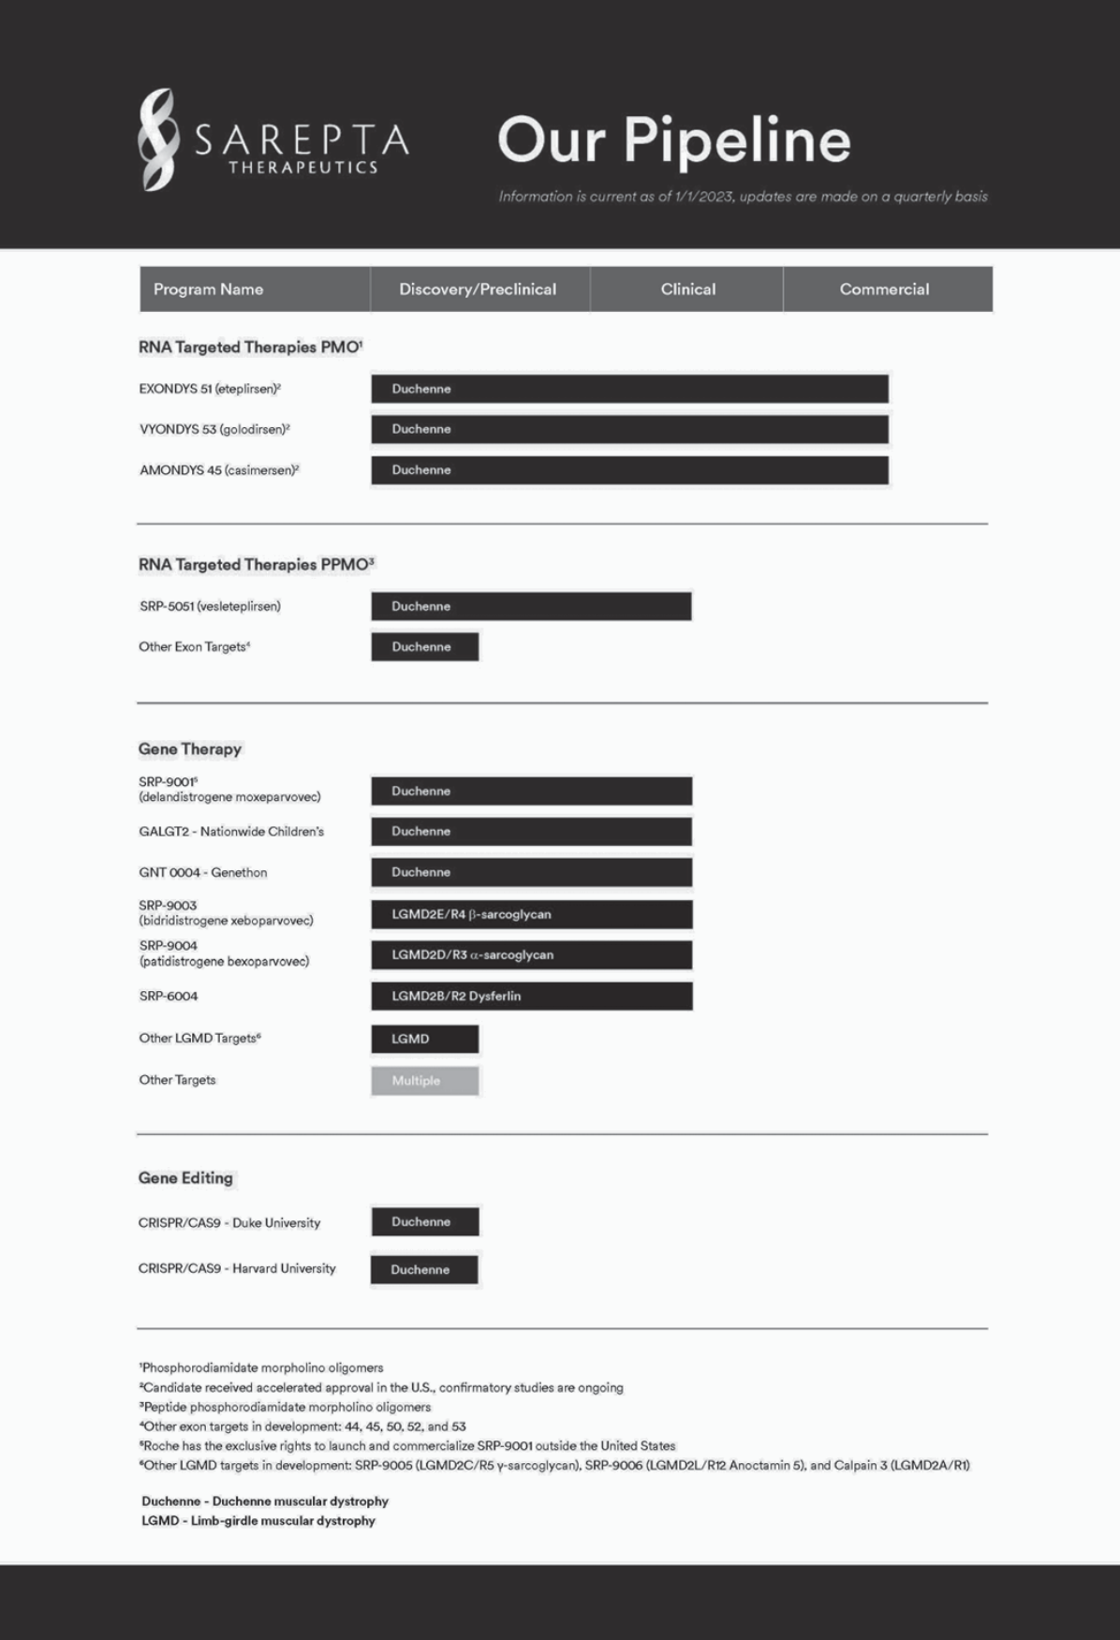

-10-

Manufacturing, Supply and Distribution

We have developed proprietary state-of-the-art Chemistry, Manufacturing and Controls (“CMC”) and manufacturing capabilities that allow manufacturing and testing of our products and product candidates to support both clinical development as well as commercialization. We continue to refine and optimize our manufacturing processes. We have entered into certain manufacturing and supply arrangements with third-party suppliers which will in part utilize these capabilities to support production of certain of our product candidates and their components. In 2017, we opened a facility in Andover, Massachusetts, which significantly enhanced our research and development manufacturing capabilities. However, we currently do not have internal large-scale Good Manufacturing Practices (“GMP”) manufacturing capabilities to produce our products and product candidates for commercial and/or clinical use. For our current and future manufacturing needs, we have entered into supply agreements with specialized contract manufacturing organizations (each a “CMO”) to produce custom raw materials, the active pharmaceutical ingredients (“APIs”), drug product and finished goods for our products and product candidates for both commercial and clinical use. All of our CMO partners have extensive technical expertise, GMP experience and experience manufacturing our specific technology.

For our commercial products, we have worked with our existing CMOs to increase product capacity from mid-scale to large-scale. While there is a limited number of companies that can produce raw materials and APIs in the quantities and with the quality and purity that we require for our commercial products, based on our diligence to date, we believe our current network of CMOs is able to fulfill these requirements, and is capable of expanding capacity as needed. Additionally, we have, and will continue to evaluate further relationships with additional suppliers to increase overall capacity as well as further reduce risks associated with reliance on a limited number of suppliers for manufacturing.

Our commercial products are distributed in the U.S. through a limited network of home infusion specialty pharmacy providers that deliver the medication to patients and a specialty distributor that distributes our products to hospitals and hospital outpatient clinics. With respect to the pre-commercial distribution of our products to patients outside of the U.S., we have contracted with third party distributors and service providers to distribute our products in certain countries through our EAPs. We plan to continue building out our network for commercial distribution in jurisdictions in which our products are approved.

Our gene therapy manufacturing capabilities have been greatly enhanced through partnerships with Thermo Fisher Scientific Inc. (“Thermo”), Catalent, Inc. (“Catalent”) and Aldevron LLC (“Aldevron”). We have adopted a hybrid development and manufacturing strategy in which we are building internal manufacturing expertise relative to all aspects of AAV-based manufacturing, including gene therapy and gene editing supply, while closely partnering with manufacturing partners to expedite development and commercialization of our gene therapy programs. We expect that our partnerships with Thermo and Catalent will support our clinical and commercial manufacturing capacity for our SRP-9001 Duchenne program and LGMD programs, while also acting as a manufacturing platform for potential future gene therapy programs. The collaboration integrates process development, clinical production and testing, and commercial manufacturing. Aldevron is providing GMP-grade plasmid for our SRP-9001 Duchenne program and LGMD programs, as well as plasmid source material for future gene therapy programs, such as CMT and other neuromuscular and CNS related disorders.

Manufacturers and suppliers of our commercial products and product candidates are subject to the FDA’s current GMP (“cGMP”) requirements and other rules and regulations prescribed by foreign regulatory authorities. We depend on our third-party partners for continued compliance with cGMP requirements and applicable foreign standards.

Material Agreements

We believe that our RNA-targeted and gene therapy technologies could be broadly applicable for the potential development of pharmaceutical products in many therapeutic areas. To enhance and further exploit our core technologies, we have and may continue to enter into research, development or commercialization alliances with universities, hospitals, independent research centers, non-profit organizations, pharmaceutical and biotechnology companies and other entities for new technologies, including for specific molecular targets or selected disease indications. We may also selectively pursue opportunities to access certain intellectual property rights that complement our internal portfolio through license agreements or other arrangements.

F. Hoffman-La Roche Ltd

License, Collaboration, and Option Agreement

On December 21, 2019, we entered into a license, collaboration, and option agreement (the “Collaboration Agreement”) with F. Hoffman-La Roche Ltd (“Roche”) pursuant to which we granted Roche an exclusive license under certain of our intellectual property rights to develop, manufacture, and commercialize SRP-9001 in all countries outside of the U.S. We retained all rights to SRP-9001 in the U.S. The transaction closed on February 4, 2020. We have entered into Amendments 1 through 10 to the Collaboration Agreement on: October 23, 2020, October 28, 2020, February 4, 2021, June 23, 2021, August 31, 2021, November 30, 2021, January 5, 2022, January 28, 2022, April 4, 2022, and July 26, 2022, respectively.

-11-

Also, under the terms of the Collaboration Agreement, Roche granted us a license to use certain of its intellectual property rights to perform development activities worldwide under a joint global development plan, commercialize SRP-9001 in the U.S., and perform certain manufacturing and medical affairs activities worldwide. Such license is non-exclusive under Roche’s background intellectual property rights, exclusive in the U.S. under intellectual property rights developed by Roche under the Collaboration Agreement, and non-exclusive outside the U.S. under intellectual property rights developed by Roche under the Collaboration Agreement.

We intend to manufacture and supply all clinical and, upon approval in the relevant market, commercial supply of SRP-9001.

Roche Options and Negotiation Rights

Pursuant to the Collaboration Agreement, we granted Roche an exclusive option to obtain an exclusive license to develop, manufacture and commercialize the following products outside of the U.S.: (i) certain exon-skipping products that target the dystrophin gene to induce exon skipping, including eteplirsen, golodirsen, casimersen and SRP-5051; (ii) certain gene therapy products other than SRP-9001 that encode and directly express dystrophin or a derivative thereof; and (iii) certain gene-editing products that modify, repair, or activate an endogenous dysfunctional dystrophin gene. The products subject to Roche’s options are collectively referred to as the “Option Products.” Upon option exercise, the Option Product that is the subject of the option exercise will be included under the Collaboration Agreement as a product licensed to Roche subject to similar obligations, including with respect to development, manufacturing, commercialization, and cost-sharing as those that apply to SRP-9001.

Pursuant to the Collaboration Agreement, Roche has a right of first negotiation if we seek to grant a third-party license to commercialize SRP-9001 in the U.S. Roche had a similar right of first negotiation with respect to our LGMDs products, but such right has expired.

Exclusivity

Other than under the Collaboration Agreement, Roche may not perform any clinical trials for, or commercialize, any gene therapy product, gene-editing product, or antisense oligonucleotide for Duchenne for a period of five years following the execution of the Collaboration Agreement. The exclusivity period for one or more types of products may be extended if Roche exercises its option with respect to one or more exon-skipping products, gene therapy products, or gene-editing products, in each case, for a period of five years from the time of option exercise.

Development

The parties will use commercially reasonable efforts to conduct development activities with respect to SRP-9001 under the Collaboration Agreement pursuant to agreed-upon development plans. Subject to certain exceptions, we will perform all development activities directed to obtaining and maintaining regulatory approvals for SRP-9001 in the U.S. and the EU, as set forth in a joint global development plan. Subject to certain exceptions, the parties will share the costs of the development activities under such joint global development plan. Roche will have sole responsibility to perform all development activities set forth in a territory-specific development plan for SRP-9001, including additional activities not set forth in the joint global development plan that are specifically directed to obtaining and maintaining regulatory approvals for SRP-9001 outside of the U.S. Roche will be solely responsible for costs arising from the territory-specific development plan for SRP-9001.

Governance

Governing committees will facilitate collaboration between the parties with respect to development, manufacturing, medical affairs, intellectual property protection, and commercialization of SRP-9001 and any other licensed products.

Financial Terms

In consideration for the rights that we granted and for prepaid funding for development activities, in February 2020, Roche and Roche Finance Ltd, an affiliate of Roche (“Roche Finance”), together paid us an up-front payment of approximately $1.2 billion. Of the $1.2 billion cash received from Roche, (i) $312.1 million, net of issuance costs, was allocated to the approximately 2.5 million shares of our common stock issued to Roche based on the closing price when the shares were issued, (ii) $ 485.0 million was allocated to the option to purchase the Option Products, and (iii) $348.7 million was allocated to a single, combined performance obligation comprised of: (i) the license of IP relating to SRP-9001 transferred to Roche, (ii) the related research and development services provided under the joint global development plan, (iii) the services provided to manufacture clinical supplies of SRP-9001, and (iv) our participation in a joint steering committee with Roche, because we determined that the license of IP and related activities were not capable of being distinct from one another. Additionally, we are eligible to receive up to $1.7 billion in development, regulatory and sales milestone payments with respect to SRP-9001.

-12-

In addition, the Collaboration Agreement provides that Roche will pay us royalties on net sales of SRP-9001, at a tiered royalty rate based on the average cost to manufacture SRP-9001.

In the event that Roche chooses to exercise its option with respect to one or more Option Products, we will be paid an option exercise fee upon each such exercise and the Option Products that are the subject of the option exercise will be subject to separate milestone payments and royalties on sales of such Option Product.

Term; Termination

Unless earlier terminated as described below, the Collaboration Agreement will continue with respect to SRP -9001 or any Option Product for which Roche has exercised its option, on a product-by-product and country-by-country basis, until the end of the royalty term for such product in such country. The royalty term expires on the later of (a) twelve years after first commercial sale in such country, (b) loss of regulatory exclusivity in such country and (c) expiration of all valid claims of specific licensed patents in such country.

Either party may terminate the Collaboration Agreement for the other party’s material breach if such breach is not cured within a specified cure period.

If Roche breaches its development or commercialization diligence obligations with respect to a licensed product or fails to develop or commercialize a particular licensed product in a particular region for a specified period of time, then we may terminate the Collaboration Agreement with respect to such licensed products in such regions.

Roche may terminate the Collaboration Agreement if we fail to supply SRP-9001 to Roche in accordance with the terms of the Collaboration Agreement and the supply agreements to be entered into between the parties. Roche may also terminate the Collaboration Agreement for convenience with extended advance notice, in its entirety or on a licensed product-by-licensed product and region-by-region basis.

The foregoing description of the terms of the Collaboration Agreement is not complete and is qualified in its entirety by reference to the text of the Collaboration Agreement, a copy of which is filed as an exhibit to this Annual Report.

Myonexus Therapeutics Inc.

On May 3, 2018, we purchased from Myonexus Therapeutics Inc. (“Myonexus”), a privately-held Delaware corporation, a warrant to purchase common stock of Myonexus (the “Warrant”), which, in combination with amendments to the Myonexus certificate of incorporation, provided us with an exclusive option (the “Option”) to acquire Myonexus. In consideration for the Warrant, we made an up-front payment of $60.0 million to Myonexus. On February 27, 2019, we announced that we exercised the exclusive option to acquire Myonexus and, on April 4, 2019, we paid the Myonexus shareholders approximately $173.8 million and completed the acquisition of Myonexus. As part of the consideration for the transaction, we are required to make contingent payments to the former shareholders of Myonexus upon achievement of a threshold amount of net sales of Myonexus products and the receipt and subsequent sale of a Priority Review Voucher (“PRV”) with respect to a Myonexus product.

BioMarin Pharmaceutical Inc.

License Agreement

On July 17, 2017, we executed a license agreement (as amended on April 14, 2019 and November 17, 2021, the “License Agreement”) with BioMarin Leiden Holding BV, BioMarin Nederlands BV and BioMarin Technologies BV (collectively, “BioMarin”), pursuant to which BioMarin granted us a royalty-bearing, worldwide license under patent rights (“Licensed Patents”) and know-how (“Licensed Know-How”) controlled by BioMarin with respect to BioMarin’s Duchenne program, which are potentially necessary or useful for the treatment of Duchenne, to practice and exploit the Licensed Patents and Licensed Know-How in all fields of use and for all purposes, including to develop and commercialize antisense oligonucleotide products that target one or more exons of the dystrophin gene to induce exon skipping, including eteplirsen, golodirsen and casimersen (collectively, the “Products”).

The license granted to us by BioMarin is co-exclusive with BioMarin, with respect to the Licensed Patents, and is non-exclusive with respect to Licensed Know-How. Pursuant to the amendment to the License Agreement dated November 17, 2021 (the “2021 Amendment”), BioMarin exercised its right to convert the exclusive license under the Licensed Patents to the current co-exclusive license.

-13-

Under the terms of the License Agreement, we were required to pay BioMarin an up-front payment of $15.0 million. Pursuant to the 2021 Amendment, BioMarin is eligible to receive up to $20.0 million from us per dystrophin gene exon (other than exon 51) targeted by one or more Products in specified regulatory milestones, as well as an additional $10.0 million milestone, payable following the regulatory approval of eteplirsen by the EMA. BioMarin is also eligible to receive through June 30, 2022 royalties segmented by specified geographic markets, in some jurisdictions dependent on the existence of a patent, ranging from 4% to 8% of net sales on a product-by-product and country-by-country basis. Beginning July 1, 2022, pursuant to the 2021 Amendment, BioMarin was eligible to receive royalties of 4% in the U.S. and 5% outside the U.S. of net sales of Products covered by a Licensed Patent on a product-by-product and country-by-country basis.

Milestones and royalties are payable with respect to the Products through June 30, 2022. Beginning July 1, 2022, pursuant to the 2021 Amendment, milestones and royalties are payable only with respect to the Products covered by a Licensed Patent. Beginning July 1, 2022, pursuant to the 2021 Amendment, the royalty term applicable to the Products covered by a Licensed Patent will expire upon March 31, 2024 in the U.S. and December 31, 2024 outside the U.S. The royalties for all Products covered by a Licensed Patent are subject to reductions, including for generic competition and, under specified conditions, for a specified portion of payments that we may become required to pay under third-party license agreements, subject to a maximum royalty reduction.

Unless earlier terminated, the License Agreement will expire upon the expiration of the last-to-expire royalty term. Either party may terminate the License Agreement in the event of the other party’s uncured material breach. BioMarin may also terminate the License Agreement on a Licensed Patent-by-Licensed Patent basis under specified circumstances relating to patent challenges by us.

Settlement Agreement

On July 17, 2017, Sarepta and The University of Western Australia (“UWA”) on the one hand, and the BioMarin Parties and Academisch Ziekenhuis Leiden (“AZL”) on the other hand (collectively, the “Settlement Parties”), executed a Settlement Agreement pursuant to which all legal actions in the U.S. and certain legal actions in Europe (the “Actions”) would be stopped or withdrawn as between the Settlement Parties. Specifically, the terms of the Settlement Agreement required that existing efforts pursuing ongoing litigation and opposition proceedings would be stopped as between the Settlement Parties, and the Settlement Parties would cooperate to withdraw the Actions before the European Patent Office (except for actions involving third parties), the U.S. Patent and Trademark Office (“USPTO”), the U.S. Court of Appeals for the Federal Circuit and the High Court of Justice of England and Wales, except for the cross-appeal of the Interlocutory Decision of the Opposition Division dated April 15, 2013 of the European Patent Office of EP 1619249B1 (“EP ‘249 Appeal”) in which Sarepta agreed to withdraw its appeal and BioMarin/AZL agreed to continue with its appeal with Sarepta having oversight of the continued appeal by BioMarin/AZL.

Additionally, under the terms of the Settlement Agreement, the Settlement Parties agreed to release each other and the customers, end-users, agents, suppliers, distributors, resellers, contractors, consultants, services and partners of Sarepta or BioMarin (as applicable) from claims and damages related to (i) the patent rights controlled by the releasing party that are involved in the Actions, (ii) with respect to Sarepta and UWA, its patent rights related to the patent rights involved in the Actions, and (iii) with respect to BioMarin and AZL, all of the Licensed Patents and Licensed Know-How.

Under the terms of the Settlement Agreement, we made an up-front payment of $20.0 million to BioMarin.

University of Western Australia

In April 2013, we entered into an agreement with UWA under which an existing exclusive license agreement between the two parties was amended and restated and, in June 2016, we entered into the first amendment to the license agreement (the “UWA License Agreement”). The UWA License Agreement grants us specific rights to compounds for the treatment of Duchenne by inducing exon skipping. EXONDYS 51, VYONDYS 53 and AMONDYS 45 fall under the scope of the license agreement. Under the UWA License Agreement, we are required to make payments of up to $6.0 million in the aggregate to UWA based on the successful achievement of certain development and regulatory milestones relating to EXONDYS 51, VYONDYS 53, AMONDYS 45 and up to three additional product candidates. As of December 31, 2022, $4.2 million of the $6.0 million development and regulatory milestone payments had been made. We are also obligated to make payments to UWA of up to $20.0 million upon the achievement of certain sales milestones. Additionally, we are required to pay a low-single-digit percentage royalty on net sales of products covered by issued patents licensed from UWA during the term of the UWA License Agreement.

Currently, the latest date on which an issued patent covered by the UWA License Agreement expires is November 2030 (excluding any patent term extension, supplemental protection certificate or pediatric extensions that may be available); however, patents granted from pending patent applications could result in a later expiration date.

-14-

Patents and Proprietary Rights

Our success depends in part upon our ability to obtain and maintain exclusivity for our products, product candidates and platform technologies. We typically rely on a combination of patent protection and regulatory exclusivity to maintain exclusivity for our products and product candidates, whereas exclusivity for our platform technologies is generally based on patent protection and trade secret protection. In addition to patent protection, regulatory exclusivity, and trade secret protection, we also protect our products, product candidates and platform technologies with copyrights, trademarks, and contractual protections.

We actively seek patent protection for our product candidates and certain of our proprietary technologies by filing patent applications in the U.S. and other countries as appropriate. These patent applications are directed to various inventions, including, but not limited to, active ingredients, pharmaceutical formulations, methods of use, and manufacturing methods. In addition, we actively acquire exclusive rights to third party patents and patent applications to protect our in-licensed product candidates and corresponding platform technologies.

We do not have patents or patent applications in every jurisdiction where there is a potential commercial market for our product candidates. For each of our programs, our decision to seek patent protection in specific foreign markets, in addition to the U.S., is based on many factors, including:

- our available resources;

- the number and types of patents already filed or pending;

- the likelihood of success of the product candidate;

- the size of the commercial market;

- the presence of a potential competitor in the market; and

- whether the legal authorities in the market effectively enforce patent rights.

We continually evaluate our patent portfolio and patent strategy and believe our owned and licensed patents and patent applications provide us with a competitive advantage; however, if markets where we do not have patents or patent applications become commercially important, our business may be adversely affected. A discussion of certain risks and uncertainties that may affect our freedom to operate, patent position, regulatory exclusivities and other proprietary rights is set forth in Item 1A. Risk Factors included in this report, and a discussion of legal proceedings related to the key patents protecting our products and product candidates are set forth below in the footnotes to the tables in this section.

Certain of our product candidates are in therapeutic areas that have been the subject of many years of extensive research and development by academic organizations and third parties who may control patents or other intellectual property that they might assert against us, should one or more of our product candidates in these therapeutic areas succeed in obtaining regulatory approval and thereafter be commercialized. We continually evaluate the intellectual property rights of others in these areas in order to determine whether a claim of infringement may be made by others against us. Should we determine that a third party has intellectual property rights that could impact our ability to freely market a compound, we consider a number of factors in determining how best to prepare for the commercialization of any such product candidate. In making this determination we consider, among other things, the stage of development of our product candidate, the anticipated date of first regulatory approval, whether we believe the intellectual property rights of others are valid, whether we believe we infringe the intellectual property rights of others, whether a license is available upon commercially reasonable terms, whether we will seek to challenge the intellectual property rights of others, the term of the rights, and the likelihood of and liability resulting from an adverse outcome should we be found to infringe the intellectual property rights of others.

Currently, U.S. patents, as well as most foreign patents, are generally effective for 20 years from the date the earliest regular application was filed. In some countries, the patent term may be extended to recapture a portion of the term lost during regulatory review of the claimed therapeutic. For example, in the U.S., under the Drug Price Competition and Patent Term Restoration Act of 1984, commonly known as the Hatch-Waxman Act, a patent that covers an FDA-approved drug may be eligible for patent term extension (for up to 5 years, but not beyond a total of 14 years from the date of product approval) as compensation for patent term lost during the FDA regulatory review process. In the U.S., only one patent may be extended for any product based on FDA delay. In addition to patent term extension, patents in the U.S. may be granted additional term due to delays at the USPTO during prosecution of a patent application. We actively strive to maximize the potential for patent protection for our products and product candidates in accordance with the law.

-15-

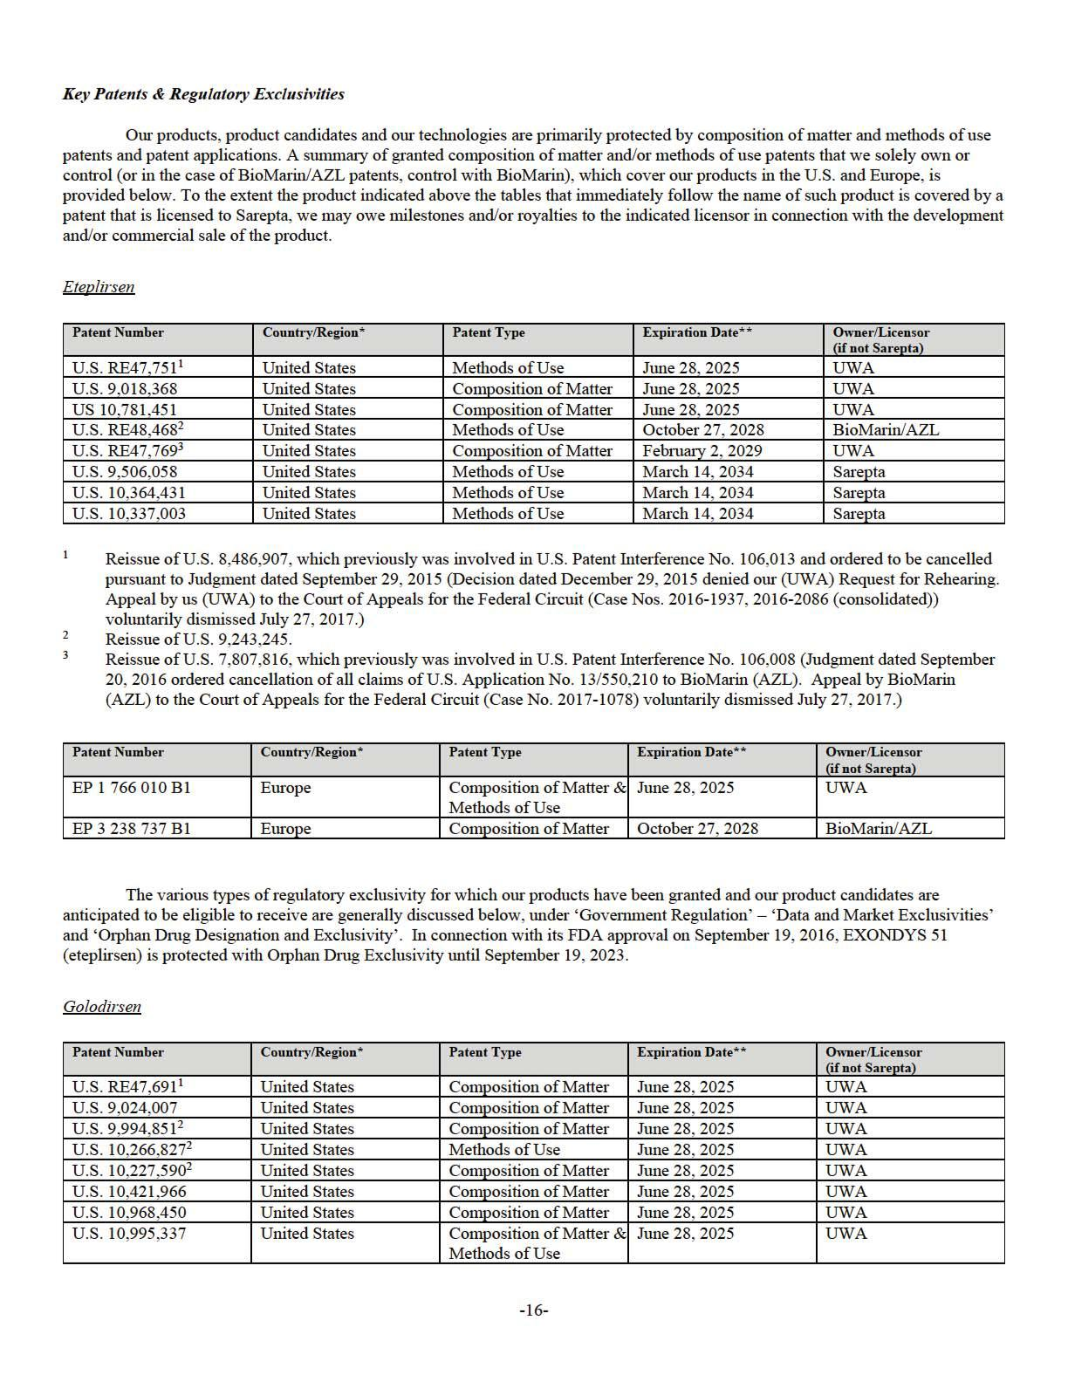

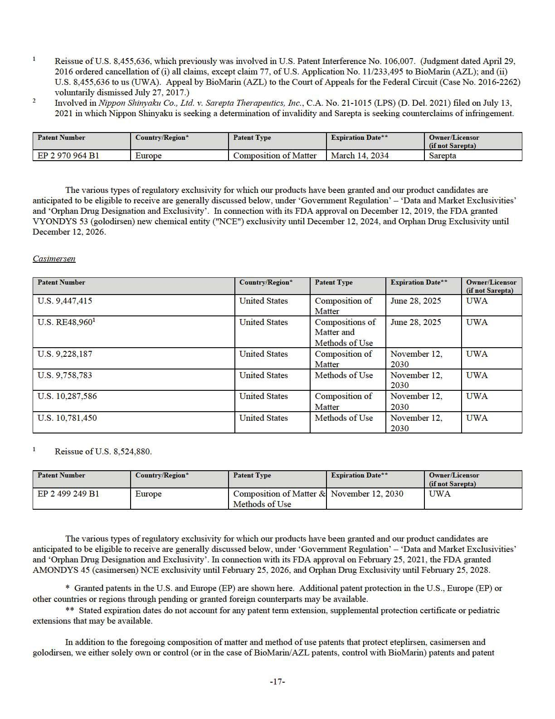

applications in the U.S. and in major foreign markets that, if granted, provide additional protection for eteplirsen, casimersen, and golodirsen, which cover the composition of matter, preparation and/or uses of the products. These patents, and patent applications, if granted, would expire through at least 2038, such expiration dates not accounting for any patent term extension, patent term adjustment, supplemental protection certificate or pediatric extensions that may be available.

Platform Technologies

We separately own patents and patent applications in the U.S. and in major foreign markets that cover our proprietary PMO-based platform technologies (e.g., PPMO) relevant to our products. These patents, and patent applications, if granted, expire through at least 2038, such expiration dates not accounting for any patent term extension, supplemental protection certificate or pediatric extensions that may be available.

Trademarks

Our trademarks are important to us and are generally filed to protect our corporate brand, our products and platform technologies. We typically file trademark applications and pursue their registration in the U.S., Europe and other markets in which we anticipate using such trademarks. We are the owner of multiple federal trademark registrations in the U.S. including, but not limited to, Sarepta, Sarepta Therapeutics, the double-helix logo, EXONDYS, EXONDYS 51, the EXONDYS 51 Logo, VYONDYS, VYONDYS 53, the VYONDYS 53 Logo, AMONDYS, AMONDYS 45, and the AMONDYS 45 Logo. In addition, we have multiple pending trademark applications and registrations in the U.S. and in major foreign markets. Trademark protection varies in accordance with local law, and continues in some countries as long as the trademark is used and in other countries as long as the trademark is registered. Trademark registrations generally are for fixed but renewable terms.

Government Regulation

The testing, manufacturing, labeling, advertising, promotion, distribution, exportation and marketing of our products are subject to extensive regulation by governmental authorities in the U.S. and in other countries. In the U.S., the FDA, under the Federal Food, Drug and Cosmetic Act and its implementing regulations, regulates pharmaceutical products. Failure to comply with applicable U.S. requirements may subject us to administrative or judicial sanctions, such as FDA refusal to approve pending marketing applications, withdrawal of approval of approved products, warning letters, untitled letters, product recalls, product seizures, total or partial suspension of production or distribution, injunctions, civil penalties and/or criminal prosecution.

U.S. Drug Approval Process

To obtain FDA approval of a product candidate, we must, among other things, submit clinical data providing substantial evidence of safety and efficacy of the product for its intended use, as well as detailed information on product composition, its manufacture and controls and proposed labeling. The testing and collection of data and the preparation of necessary applications are expensive and time-consuming. The FDA may not act quickly or favorably in reviewing these applications, and we may encounter significant difficulties or costs in our efforts to obtain FDA approvals that could delay or preclude us from marketing our products.

The steps required before a drug may be approved for marketing in the U.S. generally include the following:

- pre-clinical laboratory tests and animal toxicity testing;

- submission of an IND for conducting human clinical testing to the FDA, which must become effective before human clinical trials commence;

- approval by an Institutional Review Board (“IRB”) or independent ethics committee at each clinical trial site before each trial may be initiated;

- adequate and well-controlled human clinical trials to establish the safety and efficacy of the drug product for each indication, including controlled studies or comparison of treated group from clinical trials to data from natural history data or studies;

- submission of a complete and compliant marketing application containing chemistry, manufacturing and control information for the drug substance and drug product, reports of nonclinical and clinical trials, product labeling and administrative information;

- satisfactory completion of an FDA inspection of the commercial manufacturing facilities at which the drug substance and drug product are made to assess compliance with cGMP;

-18-

- satisfactory FDA audit of the clinical trial site(s) that generated the pivotal safety and efficacy data included in the marketing application and also potentially the nonclinical trial site(s) in the form of pre-approval inspections; and

- FDA review and approval of the marketing application.

Pre-clinical trials may include laboratory evaluations of the product chemistry, pharmacology, toxicity and formulation, as well as animal studies to assess the pharmacokinetics, metabolism, bio- distribution, elimination and toxicity of the product candidate. The conduct of the pre-clinical tests and formulation of the compounds for testing must comply with federal regulations and requirements. The results of the pre-clinical trials, manufacturing information, analytical data and a proposed first in human clinical trial protocol are submitted to the FDA as part of the IND, which must become effective before clinical trials may be initiated. The IND will become effective 30 days after receipt by the FDA, unless the FDA raises concerns or questions about the supportive data, or the study design, particularly regarding potential safety issues with conducting the clinical trial as described in the protocol. In this situation, the trials are placed on clinical hold and the IND sponsor must resolve any outstanding FDA concerns before clinical trials can proceed.

Clinical trials involve the administration of the product candidate to healthy volunteers or patient participants under the supervision of a qualified principal investigator. Clinical trials are conducted under protocols detailing the objectives of the study, the administration of the investigational product, subject selection and exclusion criteria, study procedures, parameters to be used in monitoring safety and the effectiveness criteria to be evaluated. Each protocol must be submitted to the FDA as a submission to the IND. Clinical trials must be conducted and monitored in accordance with the FDA’s Good Clinical Practice (“GCP”) requirements and federal and state laws and regulations protecting study subjects. Further, each clinical trial must be reviewed and approved by the IRB at or servicing each institution in which the clinical trial will be conducted. The IRB will consider, among other things, rationale for conducting the trial, clinical trial design, participant informed consent, ethical factors, the safety and rights of human subjects and the possible liability of the institution. The FDA can temporarily or permanently halt a clinical trial at any time, or impose other sanctions, if it believes that the clinical trial is not being conducted in accordance with FDA requirements or presents an unacceptable risk to the clinical trial subjects. The IRB may also require the clinical trial at a particular site be halted, either temporarily or permanently, for failure to comply with GCP or the IRB’s requirements, or may impose other conditions.

Clinical trials typically are conducted in three sequential drug development phases (Phases 1, 2 and 3) prior to approval, and a portion of these phases may overlap. A fourth post-approval phase (Phase 4) may include additional clinical trials. A general description of clinical trials conducted in each phase of development is provided below. However, the number of study subjects involved in each phase of drug development for rare diseases can be significantly less than typically expected for more common diseases with larger patient populations:

- Phase 1. Phase 1 clinical trials involve the initial introduction of the drug into human subjects. These studies are usually designed to determine the safety of single and multiple doses of the compound and determine any dose limiting toxicities or intolerance, as well as the metabolism and pharmacokinetics of the drug in humans. Phase 1 studies usually involve fewer than 100 subjects and are conducted in healthy adult volunteers, unless it is unethical to administer the study drug to healthy volunteers, in which case they are tested in patients.

- Phase 2. Phase 2 clinical trials are usually conducted in a limited patient population to evaluate the safety and efficacy of the drug for a specific indication to determine optimal dosage and to identify possible adverse effects and safety risks. Phase 2 studies usually involve patients with the disease under investigation and may vary in size from several dozen to several hundred.

- Phase 3. If an investigational drug is found to be potentially effective and to have an acceptable safety profile in early phase studies, larger Phase 3 clinical trials are conducted to confirm clinical efficacy, dosage and safety in the intended patient population, which may involve geographically dispersed clinical trial sites. Generally, two adequate and well-controlled Phase 3 clinical trials which establish the safety and efficacy of the drug for a specific indication are required for approval of a marketing application. Phase 3 studies usually include several hundred to several thousand patients for larger, non-orphan drug indications/diseases. However, clinical trials for rare or orphan diseases generally have fewer patients due to their lower prevalence. For these orphan diseases, a company may also try to demonstrate efficacy and safety by comparing treated patients in clinical trials to untreated patients participating in placebo-controlled clinical trials or to observational natural history studies.

- Phase 4. Phase 4 trials are clinical trials conducted after the FDA has approved a product for marketing. Typically, there are two forms of Phase 4 trials: those that are conducted to fulfill mandatory conditions of product approval and those that are voluntarily conducted to gain additional experience from the treatment of patients in the intended therapeutic indication. The mandatory studies are used to confirm clinical benefit in the case of drugs approved under the accelerated approval regulations or to provide additional clinical safety or efficacy data for “full” approvals. Failure to promptly conduct and complete mandatory Phase 4 clinical trials could result in withdrawal of approval for products approved under accelerated approval regulations.

-19-

A company seeking marketing approval for a new drug in the U.S. must submit the results of the pre-clinical and clinical trials to the FDA in the form of a marketing application, together with, among other things, detailed information on the manufacture and composition of the product candidate and proposed labeling, including payment of a user fee for FDA review of the application. The user fee is waived for an application for a product intended to treat an Orphan Indication. The FDA assesses all submitted marketing applications for completeness before it accepts them for filing. In some cases, the FDA may request additional information before accepting a marketing application for filing. Once the submission is accepted for filing, the FDA begins an in -depth review of the marketing application. Applications receive either standard or priority review. Under the current goals mandated under the Prescription Drug User Fee Act (the “PDUFA”), the FDA has ten months in which to complete its initial review of a standard marketing application and respond to the applicant, and six months for a priority marketing application. The FDA does not always meet its PDUFA goal dates for standard or priority marketing applications. The review process and the PDUFA goal date may be extended by three months if the FDA requests or the marketing application sponsor otherwise provides additional information or clarification regarding information already provided in the submission within the last three months before the PDUFA goal date. The FDA may refer an application to an advisory committee for review, evaluation and recommendation as to whether the application should be approved. Though the FDA is not bound by such recommendations, it considers them carefully when making decisions. If the FDA’s evaluations of the marketing application and the clinical and manufacturing procedures and facilities are favorable, the FDA may issue an approval letter. If the FDA finds deficiencies in the marketing application, it may issue a complete response letter, which defines the conditions that must be met in order to secure final approval of the marketing application. If and when those conditions have been met to the FDA’s satisfaction, the FDA will issue an approval letter, authorizing commercial marketing of the drug. Sponsors that receive a complete response letter may submit to the FDA information that represents a complete response to the issues identified by the FDA. Resubmissions by the marketing application sponsor in response to a complete response letter trigger new review periods of varying length (typically two to six months) based on the content of the resubmission. If the FDA’s evaluation of the marketing application and the commercial manufacturing procedures and facilities is not favorable, the FDA may not approve the marketing application.

A sponsor may also seek designation of its drug candidates under programs designed to accelerate the FDA’s review and potential approval of marketing applications. For instance, a sponsor may seek FDA designation of a drug candidate as a “fast track product.” Fast track products are those products intended for the treatment of a serious or life-threatening disease or condition and which demonstrate the potential to address unmet medical needs for such disease or condition. If fast track designation is obtained, the FDA may initiate early and frequent communication and begin reviewing sections of a marketing application before the application is complete. This “rolling review” is available if the applicant provides, and the FDA approves, a schedule for the remaining information. Eteplirsen was granted fast track status in 2007.

The Food and Drug Administration Safety and Innovation Act (“FDASIA”) enacted and signed into law in 2012 amended the criteria for the fast track and accelerated approval pathways and, as a result, the pathways now share many common eligibility criteria. FDASIA provides both the sponsor companies and the FDA with greater flexibility and expedited regulatory mechanisms. The statute clarifies that a fast track product may be approved pursuant to an accelerated approval (Subpart – H) or under the traditional approval process. In addition, FDASIA codified the accelerated approval pathway as separate and apart from the fast track pathway, meaning that for drugs to be eligible for accelerated approval, they do not need to be designated under the fast track pathway. FDASIA reinforces the FDA’s authority to grant accelerated approval of a drug that treats a serious condition and generally provides a meaningful advantage over available therapies and demonstrates an effect on a surrogate endpoint that is reasonably likely to predict clinical benefit or on a clinical endpoint that can be measured earlier than irreversible morbidity or mortality (“IMM”) that is reasonably likely to predict an effect on IMM or other clinical benefit (i.e., an intermediate clinical endpoint). Approvals of this kind typically include requirements for appropriate post-approval Phase 4 clinical trials to confirm clinical benefit. FDASIA retains this requirement and further requires those studies to verify and describe the predicted effect on irreversible morbidity or mortality or other clinical benefit. The Food and Drug Omnibus Reform Act of 2022 (“FDORA”) signed by President Biden on December 29, 2022 as part of the Consolidated Appropriations Act, 2023 (H.R. 2617) includes numerous reforms to the accelerated approval process for drugs and biologics and enables FDA to require, as appropriate, that a post-approval study be underway prior to granting accelerated approval. FDORA also expands the expedited withdrawal procedures already available to FDA to allow the agency to use expedited procedures if a sponsor fails to conduct any required post-approval study of the product with due diligence including with respect to “conditions specified by the Secretary of HHS.” FDORA also adds the failure of a sponsor of a product approved under accelerated approval to conduct with due diligence any required post-approval study with respect to such product or to submit timely reports with respect to such product to the list of prohibited acts in the Food, Drug, and Cosmetic Act.

Additionally, FDASIA established a new, expedited regulatory mechanism referred to as breakthrough therapy designation. Breakthrough therapy designation, fast track, and accelerated approval are not mutually exclusive and are meant to serve different purposes. The breakthrough therapy designation is focused on expediting the development and review process and by itself does not create an alternate ground for product approval. A sponsor may seek FDA designation of a drug candidate as a breakthrough therapy if the drug is intended, alone or in combination with one or more other drugs, to treat a serious or life- threatening disease or condition and preliminary clinical evidence indicates that the drug may demonstrate substantial improvement over existing therapies on one or

-20-

more clinically significant endpoints, such as substantial treatment effects observed early in clinical development. The FDA issued guidance entitled “Expedited Programs for Serious Conditions––Drugs and Biologics” in May 2014.

Finally, if a drug candidate demonstrates a significant benefit over existing therapy, it may be eligible for priority review, which means it will be reviewed within a six-month timeframe from the date a complete marketing application is accepted for filing. A Regenerative Medicine Advanced Therapy (“RMAT”) designation is also designed to accelerate approval for regenerative advanced therapies such as our gene therapy product candidates, but the exact mechanisms have not yet been announced by FDA.

We cannot be sure that any of our drug candidates will qualify for any of these expedited development, review and approval programs, or that, if a drug does qualify, that the product candidates will be approved, will be accepted as part of any such program or that the review time will be shorter than a standard review.

Holders of an approved marketing application are required to:

- report serious adverse drug reactions to the FDA;

- submit annual and periodic reports summarizing product information and safety data;

- comply with requirements concerning advertising and promotional labeling;

- continue to have quality control and manufacturing procedures conform to cGMP after approval; and

- conduct any post-marketing study designated as a required condition of the marketing application approval.

The FDA periodically inspects the sponsor’s records related to safety reporting and/or manufacturing; this latter effort includes assessment of compliance with cGMP. Accordingly, manufacturers must continue to expend time, money and effort in the area of production and quality control to maintain cGMP compliance. Discovery of problems with a product after approval may result in restrictions on a product, manufacturer, or holder of an approved marketing application, including withdrawal of the product from the market.

Foreign Regulatory Requirements

In 2018, the Committee for Medicinal Products for Human Use (“CHMP”) within the EMA confirmed its negative opinion for eteplirsen, and the European Commission adopted the CHMP opinion.

As of the date of this Annual Report, EXONDYS 51, VYONDYS 53 and AMONDYS 45 have only been approved for sale and marketing in the U.S. by the FDA, and EXONDYS 51 has been approved in addition for sale and marketing in Israel by the Israeli Ministry of Health.

Thus, in addition to regulations in the U.S., our business is subject to a variety of foreign regulations governing clinical trials and commercial sales and distribution of our products. Irrespective of whether it concerns an FDA approved or investigational drug, the commencement of clinical trials and the subsequent marketing of a drug product in foreign countries are subject to preliminary approvals from the corresponding regulatory authorities of such countries. For example, the conduct of clinical trials in the EU is governed by the Clinical Trials Regulation (EU) No 536/2014 and the principles and guidelines on GCP.

In April 2014, the EU adopted a new Clinical Trials Regulation (EU) (the "Regulation") No 536/2014 to replace the current Clinical Trials Directive 2001/20/EC. Although the new Regulation has been adopted and has entered into force in 2014, it only came into application in the EU Member States six months after the EC confirmed the functionality of the new Clinical Trials Information System (“CTIS”), which includes the centralized EU portal and database for clinical trials introduced by the Regulation. On July 31, 2021, the EC published a notice in the Official Journal of the European Union, confirming full functionality of the EU portal and database. The Regulation has, consequently, entered into application on January 31, 2022 and has repealed the Clinical Trials Directive 2001/20/EC and its national implementation legislations. However, it does foresee in a three-year transition period. During the first year, until January 31, 2023, sponsors of clinical trials were able to choose whether to file a clinical trial application (“CTA”) under the regime of the Directive, using the EudraCT, or under the Regulation, using the CTIS. As of the second year, all new CTAs must be submitted under the Regulation, via the CTIS. Clinical trials that were submitted under the Directive prior to January 31, 2023, will be allowed to continue under the old regime until the end of the transition period, but sponsors may also opt to transition ongoing trials on a voluntary basis. By January 31, 2025, all clinical trials that had been authorized under the Directive, must either have ended in the EU and European Economic Area (the “EEA”), or have been transitioned to the new regime. No legislation needs to be adopted to implement the new Regulation into national EU Member State law as it is directly applicable. The new Regulation provides an overhaul of the system, in order to harmonize the assessment of the submission and assessment of clinical trials conducted in EU Member States and to ensure greater consistency with the highest standards of patient safety in the EU. Under the Clinical Trial Directive 2001/20/EC and the Commission Directive 2005/28/EC laying down the requirements for the conduct of clinical trials in the

-21-

EU, a sponsor had to obtain approval from the competent national authority of the member state of the EU (“EU Member State”) in which the clinical trial would be conducted, or in multiple EU Member States if the clinical trial would be conducted in a number of countries. Furthermore, the sponsor could only start a clinical trial at a specific study site after the competent ethics committee issued a favorable opinion. The CTA had to include the supporting information prescribed by Directive 2001/20/EC and Directive 2005/28/EC, corresponding national laws of the EU Member States, and as further detailed in the applicable guidance documents. In contrast, the new legislation seeks to simplify and streamline approval of the clinical trials. Under the new coordinated procedure, the sponsor of a clinical trial is required to submit a single application to a reporting EU Member State via the centralized EU portal in the CTIS. The reporting EU Member State will consult and coordinate with all other EU Member States in which the clinical trial is planned to be conducted. If the application is rejected, it can be amended and resubmitted through the central EU portal in the CTIS. If an approval is issued, the sponsor can start the clinical trial in all EU Member States concerned. However, an EU Member State can in certain cases declare an “opt-out” from the approval. In such a case, the clinical trial cannot be conducted in such EU Member State(s). The Regulation also aims to streamline and simplify the rules on safety reporting for clinical trials.

In order to obtain marketing authorization for a medicinal product in the EU, applicants are required to submit a marketing authorization application ("MAA") to either (a) the national competent authorities (through the decentralized, mutual recognition, or national procedures) or (b) the EMA (through the centralized authorization procedure). Applicants are required to demonstrate the quality, safety and efficacy of the medicinal product in the application for marketing authorization, which implies the requirement to conduct human clinical trials to generate the necessary clinical data. Furthermore, all applications for marketing authorization for new medicines have to include the results of studies as described in an agreed pediatric investigation plan (“PIP”) aimed at ensuring that the necessary data are obtained through studies in children, unless the medicine is exempt because of a deferral or waiver. Deferrals allow an applicant to delay development of the medicine in children until, for instance, there is enough information to demonstrate its effectiveness and safety in adults. Waivers, on the other hand, may be granted when the development of a medicine in children is not needed or is not appropriate, such as for diseases that only affect the adult population. Regulation (EC) No 726/2004 of the European Parliament and of the Council lays down the rules applicable to the centralized procedure for the authorization of medicinal products. The centralized procedure allows pharmaceutical companies to submit a single application to the EMA, which is followed by a single evaluation and which results in a single approval to market the medicinal product throughout the EEA, on the basis of a single market authorization. Approval via the centralized procedure is a two-step process whereby the CHMP first evaluates the MAA and issues an opinion on whether the medicinal product may be authorized or not (step 1). The CHMP opinion is subsequently sent to the EC, which takes a legally binding decision to grant a marketing authorization (step 2). The marketing authorization is valid throughout the EU and is automatically recognized in three of the four European Free Trade Association states (Iceland, Liechtenstein and Norway). This allows the marketing authorization holder to market the medicine and make it available throughout the EEA. The timeframe for the first step of the centralized procedure (evaluation by the CHMP) opinion is 210 days from receipt of a valid application. However, the actual time needed to complete this first step is generally longer than the 210 days, since procedural clock stops are required in order for the applicant to respond to additional requests for information by the CHMP. Following a positive CHMP opinion, the EC has 67 days to issue its decision to grant the marketing authorization or not.

Accelerated evaluation of the MAA under the centralized procedure is possible in exceptional cases, following a justified request from the applicant, when a medicinal product is of a major public health interest, particularly from the point of view of therapeutic innovation. The CHMP determines what constitutes a major public interest on a case-by-case basis. Justifications must include the major benefits expected and present the arguments to support the claim that the medicinal product introduces new methods of therapy or improves on existing methods, thereby addressing, to a significant extent, the greater unmet needs for maintaining and improving public health. If the applicant provides sufficient justification for an accelerated assessment, the CHMP can reduce the timeframe for review of a MAA to 150 days. The timeframe for the EC to issue its decision remains unaltered.

Article 3 of Regulation (EC) No 726/2004 defines in which cases the centralized application procedure must (mandatory scope) or may (optional scope) be followed. The centralized procedure is mandatory for medicinal products derived from biotechnological and other high-tech processes, orphan medicinal products, advanced therapy medicinal products and products indicated for the treatment of HIV/AIDS, cancer, diabetes, auto-immune and other immune dysfunctions, viral diseases and neurodegenerative diseases. For medicinal products that do not fall under any of the aforementioned categories, a submission via the centralized procedure is possible, provided that it concerns (i) a new active substance or (ii) product that can demonstrate a significant therapeutic, scientific or technical innovation and for which approval would be in the interest of public health. Given the foregoing, our portfolio of innovative orphan products for neurodegenerative diseases is subject to the mandatory centralized procedure.

Innovative medicinal products which have been authorized in accordance with the centralized procedure, benefit from an eight-year period of data protection/exclusivity and a ten-year period of marketing protection/exclusivity. During the data exclusivity period, applicants for approval of generics of these innovative products cannot reference or rely upon data contained in the marketing authorization dossier submitted for the innovative medicinal product. Furthermore, the marketing protection entails that even if the generic product is approved, it cannot be placed on the market until the full ten-year period of market protection has elapsed from the initial authorization of the reference medicinal product. The marketing protection period can be extended to a maximum of eleven years if, during the first eight years of those ten years, the marketing authorization holder for the innovative product obtains an

-22-

authorization for one or more new therapeutic indications which, during the scientific evaluation prior to their authorization, are held to bring a significant clinical benefit in comparison with existing therapies.

Similar to the U.S., marketing authorization holders and manufacturers of medicinal products are subject to comprehensive regulatory oversight by the EMA and/or the national competent authorities of the EU Member States. This oversight applies both before and after the granting of manufacturing and marketing authorizations. It includes compliance with EU GMP and GDP rules in relation to such activities as distribution, importing and exporting of medicinal products, rules governing conduct of pharmacovigilance (including good pharmacovigilance practices (“GVP”)) and requirements governing advertising, promotion and sale of medicinal products.

Failure to comply with the EU Member State laws implementing the EU Community Code on medicinal products, and EU rules governing the promotion of medicinal products, interactions with physicians, misleading and comparative advertising and unfair commercial practices, with the EU Member State laws that apply to the promotion of medicinal products, statutory health insurance, bribery and anti-corruption or with other applicable regulatory requirements can result in enforcement action by the relevant EU Member State authorities. This may include any of the following sanctions: fines, imprisonment, orders forfeiting products or prohibiting or suspending their supply to the market, orders to suspend, vary, or withdraw the marketing authorization or requiring the manufacturer to issue public warnings, or to conduct a product recall.

The approval process in other countries outside the U.S. and the EU varies from country to country, and the time may be longer or shorter than that required for the FDA approval. In addition, the requirements governing the conduct of clinical trials, product licensing, pricing and reimbursement for market access vary greatly from country to country. In all cases, clinical trials are conducted in accordance with GCP and the applicable regulatory requirements and the ethical principles that have their origin in the Declaration of Helsinki.

Data and Market Exclusivities

In addition to patent exclusivities, the FDA and certain other foreign health authorities may grant data or market exclusivity for a newly approved chemical entity or biologic, which runs in parallel to any patent protection. Regulatory data protection or exclusivity prevents a potential generic competitor from relying on clinical trial data generated by the sponsor when establishing the safety and efficacy of its competing product. Market exclusivity prohibits any marketing of the same drug for the same indication.

In the U.S., the FDA will generally grant an NCE that is the subject of an NDA with five years of regulatory data exclusivity, during which time a competitor generally may not submit an application to the FDA based on a sponsor’s clinical data. A competitor, however, may file an Abbreviated New Drug Application (“ANDA”) seeking approval of a generic drug four years from the date of approval of the innovative product if it is accompanied by a so-called Paragraph IV certification. For a newly approved biologic that is the subject of a BLA, the FDA will generally grant 12 years of market exclusivity, during which time a competitor may not market the same drug for the same indication.

In addition, the FDA may provide six months of pediatric exclusivity to a sponsor of a marketing application if the sponsor conducted a pediatric study or studies of a product. This process is applied to products developed for adult use and is initiated by the FDA as a written request for pediatric studies that applies to a sponsor’s product. If the sponsor conducts qualifying studies and the studies are accepted by the FDA, then an additional six months of pediatric exclusivity will be added to previously granted exclusivity, such as orphan drug exclusivity and NCE exclusivity, as well as certain patent-based exclusivities.

Orphan Drug Designation and Exclusivity

In the U.S., the FDA may grant orphan drug designation to drugs intended to treat a rare disease or condition that affects fewer than 200,000 individuals in the U.S., or more than 200,000 individuals in the U.S. for which there is no reasonable expectation that the cost of developing and making available in the U.S. a drug for this type of disease or condition will be recovered from sales in the U.S. for that drug. An orphan drug designation must be requested before submitting an application for marketing approval. An orphan drug designation does not shorten the duration of the regulatory review and approval process. The approval of an orphan designation request does not alter the regulatory requirements and process for obtaining marketing approval. Safety and efficacy of a compound must be established through adequate and well-controlled studies. If a chemical or biological product which has an orphan drug designation subsequently receives FDA approval for the indication for which it has such designation, the product is generally entitled to an orphan drug exclusivity period of seven years, which means the FDA may not grant approval to any other application to market the same chemical or biological product for the same indication for a period of seven years, except in limited circumstances, such as where an alternative product demonstrates clinical superiority to the product with orphan exclusivity. The FDA has historically taken the position that the scope of orphan exclusivity aligns with the approved indication or use of a product, rather than the disease or condition for which the product received orphan designation. However, on September 30, 2021, the U.S. Court of Appeals for the 11th Circuit issued a decision in Catalyst Pharms., Inc. v. Becerra holding that the scope of orphan drug exclusivity

-23-

must align with the disease or condition for which the product received orphan designation, even if the product’s approval was for a narrower use or indication. It remains to be seen how this decision affects orphan drug exclusivity going forward. In addition, holders of exclusivity for orphan drugs are expected to assure the availability of sufficient quantities of their orphan drugs to meet the needs of patients. Failure to do so could result in the withdrawal of orphan exclusivity for the drug. Competitors may receive approval of different drugs or biologics for the indications for which a prior approved orphan drug has exclusivity.

Pharmaceutical companies can apply for the designation as an orphan medicine. In the EU, applications for orphan designation are evaluated by the EMA in accordance with Regulation (EC) No 141/2000. In order to qualify as an orphan medicine, the medicinal product must be intended to diagnose, prevent or treat a condition that is life-threatening or chronically debilitating, with a prevalence of no more than 5 in 10,000 people in the EU or for which it is unlikely that its sale would generate sufficient returns to justify the investment needed for its development. In addition, the sponsor is required to demonstrate that no satisfactory method of diagnosis, prevention or treatment of the condition has been authorized in the EU or, if such method exists, the medicinal product is of significant benefit to those affected by the condition as compared to approved methods. The benefits of being granted orphan designation are significant, including up to ten years of market exclusivity. During this ten-year period, the EMA may not accept a new marketing application for a similar medicinal product for the same therapeutic indication as the approved orphan medicinal product. Pursuant to Regulation (EC) 1901/2006 on medicinal products for pediatric use, the ten-year orphan market exclusivity can be extended to a maximum period of twelve years upon the satisfactory completion of all the key elements of the agreed PIP. We have been granted orphan drug designation for eteplirsen in the EU.

Expanded / Early Access

In certain countries, drug products approved in the U.S. or the EU can be accessed by patients before the drug has obtained marketing approval in such country. There are various forms of this access including, but not limited to, the actual purchase of product by the purchaser, which is often times the government for patients, on a named patient basis, and providing the product free of charge on a named patient basis for compassionate use. Each country has its own laws and regulations that apply to these forms of access and the extent and nature of such laws and regulations vary by country. For example, in 2018, the so-called Right to Try Act became law in the U.S. The law, among other things, allows eligible patients to access certain investigational new drug products that have completed a Phase I clinical trial and that are undergoing investigation for FDA approval without enrolling in clinical trials and without obtaining FDA permission under the FDA expanded access program. There is no obligation for a pharmaceutical manufacturer to make its drug products available to such eligible patients as a result of the Right to Try Act.

We established a global EAP for eteplirsen, golodirsen and casimersen in some countries where eteplirsen, golodirsen and casimersen currently have not been approved. The EAP provides a mechanism through which physicians can prescribe our products, within their professional responsibility, to patients who meet pre-specified medical and other criteria and can secure funding.

-24-

Other Regulatory Requirements

In addition to regulations enforced by the FDA and foreign authorities relating to the clinical development and marketing of products, we are or may become subject to regulation under the Occupational Safety and Health Act, the Toxic Substances Control Act, the Resource Conservation and Recovery Act and other present and potential future foreign, federal, state and local laws and regulations. Our research and development processes involve the controlled use of hazardous materials and chemicals and produce waste products. We are subject to federal, state and local environmental laws and regulations governing the use, manufacture, storage, handling and disposal of hazardous materials and waste products. Although we believe that we are in material compliance with applicable environmental laws that apply to us, we cannot predict whether new regulatory restrictions will be imposed by state or federal regulators and agencies or whether existing laws and regulations will adversely affect us in the future. While it is impossible to accurately predict the future costs associated with environmental compliance and potential remediation activities, we understand the importance of complying with all current and future applicable environmental laws and regulations. Compliance with environmental laws is not expected to require significant capital expenditures and has not had, and is not expected to have, a material adverse effect on our operations.

Healthcare Fraud and Abuse Laws

We are subject to various federal, state and local laws targeting fraud and abuse in the healthcare industry, including anti-kickback and false claims laws. Violations of fraud and abuse laws may be punishable by crime or civil sanctions, including fines and civil monetary penalties, and/or exclusion from federal health care programs (including Medicare and Medicaid). Federal and state authorities are paying increased attention to enforcement of these laws within the pharmaceutical industry, and private individuals have been active in alleging violations of the laws and bringing suits on behalf of the government under the federal False Claims Act (“FCA”). Violations of international fraud and abuse laws could result in similar penalties, including exclusion from participation in health programs outside the U.S. Given the broad scope of these laws, our activities could be subject to scrutiny under the laws. If we were subject to allegations concerning, or were convicted of violating, these laws, our business could be harmed.

The federal Anti-Kickback Statute generally prohibits, among other things, a pharmaceutical manufacturer from directly or indirectly soliciting, offering, receiving, or paying any remuneration in cash or in kind where one purpose is either to induce the referral of an individual for, or the purchase or prescription of, a particular drug that is payable by a federal health care program, including Medicare or Medicaid. A person or entity does not need to have actual knowledge of the statute or a specific intent to violate the statute. Violations of the federal Anti-Kickback Statute can result in exclusion from Medicare, Medicaid or other governmental programs as well as civil and criminal fines and penalties of up to $112,131 per violation and three times the amount of the unlawful remuneration. A claim arising from a violation of the federal Anti-Kickback Statute also constitutes a false or fraudulent claim for purposes of the FCA. A new federal anti-kickback statute enacted in 2018 prohibits certain payments related to referrals of patients to certain providers (such as clinical laboratories) and applies to services reimbursed by private health plans as well as government health care programs.

Federal and state false claims laws generally prohibit anyone from knowingly and willfully, among other activities, presenting, or causing to be presented for payment to third party payors (including Medicare and Medicaid) claims for drugs or services that are false or fraudulent (which may include claims for services not provided as claimed or claims for medically unnecessary services). False or fraudulent claims for purposes of the FCA carry fines and civil penalties for violations ranging from $12,537 to $25,076 for each false claim, plus up to three times the amount of damages sustained by the federal government and may provide the basis for exclusion from federally funded healthcare programs. There is also a criminal FCA statute by which individuals or entities that submit false claims can face criminal penalties. In addition, under the federal Civil Monetary Penalty Law, the Department of Health and Human Services (“HHS”) Office of Inspector General has the authority to exclude from participation in federal health care programs or to impose civil penalties against any person who, among other things, knowingly presents, or causes to be presented, certain false or otherwise improper claims. A federal healthcare fraud statute prohibits the knowing and willful execution, or attempt to execute, a scheme to defraud a health care benefit program, including private health plans, or obtain, through false or fraudulent pretenses, money or property owned by, or under the custody or control of, such a health care benefit program.

The majority of states also have anti-kickback, false claims, and similar fraud and abuse laws and although the specific provisions of these laws vary, their scope is generally broad, and there may not be regulations, guidance or court decisions that apply the laws to particular industry practices.

Laws and regulations have also been enacted by the federal government and various states to regulate the sales and marketing practices of pharmaceutical manufacturers. The laws and regulations generally limit financial interactions between manufacturers and health care providers; require pharmaceutical companies to comply with the pharmaceutical industry’s voluntary compliance guidelines and the relevant compliance guidance promulgated by the U.S. federal government; and/or require disclosure to the government and/or public of financial interactions (so-called “sunshine laws”). State laws may also require disclosure of pharmaceutical pricing information and marketing expenditures. Manufacturers must also submit information to the FDA on the identity and quantity of drug samples requested and distributed by a manufacturer during each year. Many of these laws and

-25-

regulations contain ambiguous requirements or require administrative guidance for implementation. Given the lack of clarity in laws and their implementation, our activities could be subject to the penalty provisions of the pertinent federal and state laws and regulations.

Data Privacy and Security

We may be subject to privacy and security laws in the various jurisdictions in which we operate, obtain or store personally identifiable information. The legislative and regulatory landscape for privacy and data protection continues to evolve, and there has been an increasing focus on privacy and data protection issues with the potential to affect our business. Our ongoing efforts to comply with evolving laws and regulations may be costly and require ongoing modifications to our policies, procedures and systems. Failure to comply with laws regarding data protection would expose us to risk of enforcement actions and penalties under such laws. Even if we are not determined to have violated these laws, government investigations into these issues typically require the expenditure of significant resources and generate negative publicity, which could harm our business, financial condition, results of operations or prospects.

Within the U.S., there are numerous federal and state laws and regulations related to the privacy and security of personal information. For example, at the federal level, the Health Insurance Portability and Accountability Act of 1996 (“HIPAA”), as amended, and its implementing regulations establish privacy and security standards that limit the use and disclosure of individually identifiable health information, or protected health information, and require the implementation of administrative, physical and technological safeguards to protect the privacy of protected health information. While we have determined that we are neither a “covered entity” nor a “business associate” directly subject to HIPAA, many of the U.S. health care providers with which we interact are subject to HIPAA, and we may have assumed obligations related to protecting the privacy of personal information. States are increasingly regulating the privacy and security of personal information. For example, the California Consumer Privacy Act (“CCPA”), which as of January 1, 2023 and was amended and expanded by the California Privacy Rights Act (“CPRA”), gives California consumers (defined to include all California residents) certain rights, including the right to ask covered companies to disclose copies of personal information collected and delete a consumer’s personal information and requires covered companies to provide notice to California consumers regarding their data processing activities. Together the CCPA and CPRA place limitations on a covered company’s ability to sell personal information and share it for purposes of cross-context behavioral advertising. The Virginia Consumer Data Protection Act (“VCDPA”) has also gone into effect and other states either have comprehensive laws similar to the VCDPA, CCPA and CDPRA going into operation this year, in the case of Colorado, Connecticut and Utah, or are considering such laws.

In addition, we may be subject to privacy and security laws in the various jurisdictions in which we operate, obtain or store personally identifiable information. The legislative and regulatory landscape for privacy and data protection continues to evolve, and there has been an increasing focus on privacy and data protection issues with the potential to affect our business. For example, the processing of personal data relating to EEA citizens or in the context of the activities of an establishment in the EEA is subject to the General Data Protection Regulation (the “GDPR”), which took effect in May 2018. The GDPR increases obligations with respect to clinical trials conducted in the EEA, such as in relation to the provision of fair processing notices, responding to data subjects who exercise their rights and reporting certain data breaches to regulators and affected individuals. The GDPR also requires us to enter certain contractual arrangements with third parties that process GDPR-covered personal data on our behalf. The GDPR also increases the scrutiny applied to transfers of personal data from the EEA (including from clinical trial sites in the EEA) to countries that are considered by the EC to lack an adequate level of data protection, such as the U.S. The July 2020 invalidation by the Court of Justice of the EU of the EU- U.S. Privacy Shield framework, one of the mechanisms used to legitimize the transfer of personal data from the EEA to the U.S., has led to increased scrutiny on data transfers from the EEA to the U.S. generally and may increase our costs of compliance with data privacy legislation. If our or our partners’ or service providers’ privacy or data security measures fail to comply with the GDPR requirements, we may be subject to litigation, regulatory investigations, enforcement notices requiring us to change the way we use personal data and/or fines of up to EURO 20 million or up to 4% of the total worldwide annual turnover of the preceding financial year, whichever is higher, as well as claims by affected individuals, negative publicity, reputational harm and a potential loss of business and goodwill.

Pharmaceutical Pricing and Reimbursement

We have an ongoing dialogue with payors globally with the goal of obtaining broad coverage for our products. To date, payors’ policies on coverage for our products have varied widely, including policies that allow broad coverage per the respective product’s prescribing information, policies that provide limited coverage and policies that have denied coverage. The majority of payors have policies that provide for case-by-case coverage or restricted coverage. Our revenue depends, in part, upon the extent to which payors provide coverage for our products and the amount that payors, including government authorities or programs, private health insurers and other organizations, reimburse patients and healthcare providers for the cost of our products. Reimbursement coverage policies and inadequate reimbursement may reduce the demand for, or the price purchasers are willing to pay for, our or our partners’ products. Patients who are prescribed medications for the treatment of their conditions, and their prescribing physicians, generally rely on third-party payors to reimburse all or part of the costs associated with their prescription drugs. Patients are unlikely

-26-

to use our products unless coverage is provided, and reimbursement is adequate to cover a significant portion of the cost of such products.

Third Party Reimbursement and Pricing in the U.S.

Commercial Insurance. Coverage and reimbursement of our products vary from commercial payor to commercial payor. Many commercial payors, such as managed care plans, manage access to FDA approved products, and may use drug formularies and medical policies (which may include specific coverage requirements such as prior authorization, re-authorization and achieving performance metrics under value-based contracts) to control utilization. Exclusion from or restriction in coverage can reduce product usage.

Medicaid. Our products are eligible to be reimbursed by Medicaid. Medicaid is a joint federal and state program that is administered by the states for low income and disabled beneficiaries. Under the Medicaid Drug Rebate Program, participating manufacturers are required to pay a rebate for each unit of product reimbursed under the state Medicaid programs. The amount of the rebate for each product is set by law and depends in part on the prices at which our products are sold to certain other purchasers and may be subject to an additional discount if certain pricing increases more than inflation. State Medicaid programs and Medicaid managed care plans can seek additional “supplemental” rebates from manufacturers in connection with favorable positioning on formularies.

Medicare. Medicare is a federal program that is administered by the federal government that covers individuals age 65 and over, disabled individuals and individuals with certain conditions. Our products are eligible for reimbursement under Medicare Part B. Medicare Part B generally covers drugs that are usually administered by physicians or other clinicians. Medicare Part B pays for such drugs under a payment methodology based on the average sales price (“ASP”) of the drugs. Reimbursement levels and reimbursement methodologies have come under scrutiny and may be subject to change. See “Government Regulation – Healthcare and Other Reform.” The Centers for Medicare & Medicaid Services (“CMS”) are also increasingly bundling drug reimbursement into procedure costs, which can severely decrease the reimbursement rates for some manufacturers’ drugs.

Federal Purchasers. Drug products are subject to discounted pricing when purchased by federal agencies via the Federal Supply Schedule (“FSS”). FSS participation is required for a drug product to be covered and reimbursed by certain federal agencies and for coverage under Medicaid, Medicare Part B and the Public Health Service (“PHS”) 340B drug pricing program. FSS pricing is negotiated periodically with the Department of Veterans Affairs. FSS pricing is intended not to exceed the price that a manufacturer charges its most-favored non-federal customer for its product. In addition, prices for drugs purchased by the Veterans Administration, Department of Defense (including drugs purchased by military personnel and dependents through the TRICARE retail pharmacy program), Coast Guard, and PHS are subject to a cap on pricing (known as the “federal ceiling price”) and may be subject to an additional discount if pricing increases more than the rate of inflation.

PHS 340B Drug Pricing Program. To maintain coverage of drugs under the Medicaid Drug Rebate Program and Medicare Part B, manufacturers are required to extend discounts to certain purchasers under the PHS 340B drug pricing program. Purchasers eligible for discounts include hospitals that serve a disproportionate share of financially needy patients, community health clinics and other entities that receive health services grants from the PHS.

Healthcare and Other Reform. In the U.S., federal and state governments continue to propose and pass legislation designed to reform delivery of, or payment for, health care, which include initiatives to reduce the cost of healthcare. For example, in March 2010, the U.S. Congress enacted the Patient Protection and Affordable Care Act and the Health Care and Education Reconciliation Act (the “Healthcare Reform Act”), which expanded health care coverage through Medicaid expansion, implemented the “individual mandate” for health insurance coverage (by imposing a tax penalty on individuals who did not obtain insurance) and changed the coverage and reimbursement of drug products under government healthcare programs. There have been ongoing efforts to modify or repeal all or certain provisions of the Healthcare Reform Act. For example, tax reform legislation was enacted at the end of 2017 that eliminated the tax penalty established under the Healthcare Reform Act for individuals who do not maintain mandated health insurance coverage beginning in 2019. The Healthcare Reform Act has also been subject to judicial challenge. On June 17, 2021, the U.S. Supreme Court dismissed the latest judicial challenge to the Healthcare Reform Act brought by several states without specifically ruling on the constitutionality of the Healthcare Reform Act.

Beyond the Healthcare Reform Act, there have been ongoing healthcare reform efforts. Some recent healthcare reform efforts have sought to address certain issues related to the COVID-19 pandemic, including an expansion of telehealth coverage under Medicare and accelerated or advanced Medicare payments to healthcare providers. Other reform efforts affect pricing or payment for drug products. Drug pricing and payment reform was a focus of the Trump Administration and has been a focus of the Biden Administration. For example, federal legislation enacted in 2021 eliminates a statutory cap on Medicaid drug rebate program rebates effective January 1, 2024. As another example, in 2022, the Inflation Reduction Act ("IRA") of 2022 contains numerous drug pricing and payment reforms. Among other provisions, the IRA imposes a yearly cap ($2,000 in 2025) on out-of-pocket prescription drug costs in Medicare Part D, implements a new Medicare Part D manufacturer discount drug program in 2025; requires manufacturers to

-27-

pay a rebate to the federal government if prices for single-source drugs and biologicals covered under Medicare Part B and nearly all covered drugs under Medicare Part D increase faster than the rate of inflation and, starting in 2026, creates a drug price negotiation program under which the prices for certain high Medicare spend drugs and biologicals without generic or biosimilar competition will be limited by a cap that is defined by reference to, among other things, a specified non-federal average manufacturer price.

Healthcare reform efforts have been and may continue to be subject to scrutiny and legal challenge. For example, revisions to regulations under the federal anti -kickback statute would remove protection for traditional Medicare Part D discounts offered by pharmaceutical manufacturers to pharmacy benefit managers and health plans. Pursuant to court order, the removal was delayed and recent legislation imposed a moratorium on implementation of the rule until January 1, 2032.

Adoption of new healthcare reform legislation at the federal or state level could affect demand for, or pricing of, our products or product candidates if approved for sale. We cannot predict, however, the ultimate content, timing or effect of any healthcare reform legislation or action, or its impact on us, and healthcare reform could increase compliance costs and may adversely affect our future business and financial results.

There have also been efforts by government officials or legislators to implement measures to regulate prices or payment for pharmaceutical products, including legislation on drug importation. Recently, there has been considerable public and government scrutiny of pharmaceutical pricing and proposals to address the perceived high cost of pharmaceuticals. There have also been recent state legislative efforts to address drug costs, which generally have focused on increasing transparency around drug costs or limiting drug prices. Certain state legislation has been subject to legal challenges. Adoption of new legislation regulating drug pricing at the federal or state level could further affect demand for, or pricing of, our products.

General legislative cost control measures may also affect reimbursement for our products. The Budget Control Act of 2011, as amended, resulted in the imposition of reductions in Medicare (but not Medicaid) payments to providers in 2013 and remains in effect through 2031 (except May 1, 2020 to March 31, 2022) unless additional Congressional action is taken. Any significant spending reductions affecting Medicare, Medicaid or other publicly funded or subsidized health programs that may be implemented and/or any significant taxes or fees that may be imposed on us could have an adverse impact on our results of operations.

Third Party Reimbursement and Pricing outside the U.S.

We currently have no products approved for marketing outside the U.S., other than a marketing authorization for EXONDYS 51 in Israel. We may need to conduct long-term pharmacoeconomic studies in order to demonstrate the cost-effectiveness of our products. In the EU and certain other territories, price controls and Health Technology Assessments for new, highly priced medicines are expected. Uncertainty exists about the pricing and reimbursement status of newly approved products in the EU. Criteria such as cost-effectiveness, cost per quality- adjusted life year, budget impact, or others, in addition to the clinical benefit, are often required to demonstrate added value or benefit of a drug and vary by country. Third party reimbursement limits may reduce the demand for our products. The pace of the application process in some countries could also delay commercial product launches. Gaining acceptance of our product pipeline and an economically viable reimbursement terms in the EU and other markets will require strong education and awareness efforts around Duchenne as well as strong data supporting its effectiveness and cost-effectiveness.

-28-

Competition

The pharmaceutical and biotechnology industries are intensely competitive, and any product or product candidate developed by us competes or would likely compete with existing drugs and therapies. There are many pharmaceutical companies, biotechnology companies, public and private universities, government agencies and research organizations that compete with us in developing various approaches to the treatment of rare, neuromuscular and other diseases. Many of these organizations have substantially greater financial, technical, manufacturing and sales and marketing resources than we have. Several of them have developed or are developing therapies that could be used for treatment of the same diseases that we are targeting. In addition, some of these competitors have significantly greater commercial infrastructures than we have. Our ability to compete successfully depends largely on:

- the efficacy, safety and reliability of our products and product candidates;

- the dosing, strength, convenience and other product profile attributes of our products and product candidates;

- product acceptance by physicians and other health-care providers;

- protection of our proprietary rights and the level of generic or innovative competition;

- the ability to have freedom to operate to commercialize our products and product candidates;

- our ability to supply commercial quantities of a product meeting FDA specifications to the market and the cost of supplying our products and product candidates;

- our ability to complete clinical development and obtain regulatory approvals for our product candidates;

- obtaining reimbursement for product use in approved indications and the price of our products;

- our ability to recruit and retain skilled employees; and

- the availability of substantial capital resources to fund development and commercialization activities.

EXONDYS 51, VYONDYS 53 and AMONDYS 45 were the first three disease modifying therapeutics approved by the FDA for the treatment of Duchenne for patients with a confirmed mutation that is amenable to exon 51 skipping, exon 53 skipping or exon 45 skipping, respectively. However, in the field of Duchenne alone, these products and those in our pipeline face a variety of competitors who either have FDA approval or are being clinically developed for the treatment of Duchenne. For example, Nippon Shinyaku Co. Ltd. (“Nippon”) announced on August 13, 2020 that the FDA approved VILTEPSO (viltolarsen) injection for patients with Duchenne who are amenable to exon 53 skipping therapy. On March 25, 2020, Nippon announced that the Japanese Ministry of Health, Labor, and Welfare (“MHLW”) approved Viltepso Intravenous Infusion 250 mg (viltolarsen) for the treatment of patients with Duchenne who are amendable to exon 53 skipping therapy making it the first non-steroidal treatment for Duchenne approved in Japan. Nippon has announced plans to pursue global registration for viltolarsen.

In addition, there are many companies who have announced plans to transition pre-clinical candidates to clinical development for the treatment of Duchenne, including the following:

- Wave Life Sciences (“Wave”) announced in September 2021 that it initiated dosing in a Phase 1b/2a clinical trial evaluating WVE-N531, its exon 53 skipping product candidate.

- Daiichi Sankyo (“Daiichi”) announced a Phase 1/2 clinical trial conducted in Japan for its exon 45 skipping oligonucleotide candidate, DS-5141b. In April 2018, Daiichi announced top-line results of the Phase 1/2 clinical trial of DS-5141 and that Daiichi will continue to develop DS-5141b. Daiichi is sponsoring a Phase 2 clinical trial of DS-5141b.

- Pfizer Inc. (“Pfizer”), presented initial Phase 1b clinical data for its AAV-9 / mini-dystrophin gene transfer product candidate for Duchenne, PF-06939926/BMB-D0016, in June 2019. In January 2021, Pfizer announced the first dose of its Phase 3 CIFFREO study that will evaluate the efficacy and safety of PF-06939926 in boys with Duchenne.

There are several companies in addition to those mentioned above that are pursuing disease modifying programs for Duchenne that are at the pre-clinical stage or clinical stage. These companies are pursuing oligonucleotides, gene transfer therapy or gene editing. Other companies continue to pursue development and approval of products for the treatment of Duchenne and their products may or may not prove to be safer and/or more efficacious than the products and product candidates in our Duchenne pipeline. Regarding any of these competitors, it is unknown if clinical development of these or other compounds is planned or would be continued.

Additionally, companies have product candidates with mechanisms of action distinct from ours in different stages of development or approval in Duchenne which we believe could be seen as complementary to exon skipping and not a direct replacement of our products or product candidates at this time.

-29-

Several companies and institutions have also entered into collaborations or other agreements for the development of product candidates, including mRNA, gene (CRISPR, AAV, etc.) or small molecule therapies that are potential competitors to therapies being developed by us in the muscular dystrophy, neuromuscular, CNS and rare disease space.

We also believe that other biotechnology and pharmaceutical companies share a focus on RNA-targeted drug discovery and development.

For additional information on the various risks posed by competition, refer to Part I, Item 1A. Risk Factors of this Annual Report on Form 10-K.

Human Capital Resources

Our urgent mission – to engineer precision genetic medicine for rare diseases that devastate lives and cut futures short – is dependent on our ability to attract, develop and retain the industry’s best and brightest talent across all dimensions of diversity. This understanding informs our approach to managing our human capital resources.

General Information. As of December 31, 2022, we had 1,162 employees globally, 562 of whom hold advanced degrees. Of these employees, 779 are engaged directly in research and development activities and 383 are in selling and general and administration. None of our employees in the U.S. are covered by collective bargaining agreements and we consider relations with our employees to be good.

Equity, diversity, and inclusion. We promote diversity, inclusion and equity across the organization. In the area of gender diversity, representation of women has increased over the past several years: in 2019 and 2020 women made up 54% and 55% of our workforce, respectively, and in 2021, this percentage increased to 56%. As of December 31, 2022, women made up 57% of our workforce. The number of women in leadership positions has also consistently increased. In 2017, women represented 35% of the leadership positions at the Director level and above. This percentage increased to 36% in 2018, 44% in 2019, 47% in 2020, 48% in 2021 and 52% as of December 31, 2022. In addition, as of December 31, 2022, women held 25% of the seats of our Board of Directors, including the Chair of the Board.

Racial and ethnic diversity has also increased in the past few years, from 23% of our workforce being racially/ethnically diverse in 2017 and 2018, increasing to 26% in 2019 and to 30% in 2020 and 2021. As of December 31, 2022, this number increased to 34%.

As of December 31, 2022, 63% of our Executive Committee, which represents the most senior leadership positions in the Company, is diverse based on gender and ethnicity.

Compensation, Benefits and Ongoing Professional Development. We face intense competition for qualified and specialized employees from other pharmaceutical and biotechnology companies, universities and government entities, and we are committed to rewarding, supporting, and developing our employees who make it possible to deliver on our strategy. To that end, we offer a comprehensive total rewards package that includes market-competitive pay, broad-based equity grants and bonuses, healthcare benefits, retirement savings plans, paid time off and family leave, caregiving support, fitness subsidies, and an Employee Assistance Program. We also offer robust learning opportunities for employees at every stage in their career and provide annual training to employees on various topics.

In recognition of the ongoing challenges brought on by the COVID-19 pandemic, we have taken various steps to support our employees, including transitioning to remote/hybrid work and offering flexible schedules, childcare assistance and sessions focused on resilience and happiness in uncertain times. At the same time, we continue to take steps to protect our facility-dependent employees to ensure they remain healthy and feel supported and safe in our facilities.

General Corporate Information

We were originally incorporated in the State of Oregon on July 22, 1980, and on June 6, 2013, we reincorporated in the State of Delaware. Our principal executive offices are located at 215 First Street, Suite 415, Cambridge, MA 02142 and our telephone number is (617) 274-4000. Our common stock is quoted on the Nasdaq Global Select Market under the symbol “SRPT”.

While we achieve revenue from our products in the U.S. and through distribution of eteplirsen, golodirsen and casimersen through our EAP outside the U.S., we are likely to continue to incur operating losses in the near term associated with our ongoing operations, research and development activities and potential business development activities. For more information about our revenues and operating losses, see Item 7, Management’s Discussion and Analysis of Financial Condition and Results of Operations.

-30-

As of December 31, 2022, we had approximately $2,008.4 million of cash, cash equivalents and investments, consisting of $966.8 million of cash and cash equivalents, $1,022.6 million of short-term investments and $19.0 million of long-term restricted cash. We believe that our balance of cash, cash equivalents and investments is sufficient to fund our current operational plan for at least the next twelve months. In addition to pursuing additional cash resources through public or private financings, we may also seek to enter into contracts, including collaborations or licensing agreements with respect to our technologies, with third parties, including government entities.

Where You Can Find Additional Information

We make available free of charge through our corporate website, www.sarepta.com, our annual reports, quarterly reports, current reports, proxy statements and all amendments to those reports as soon as reasonably practicable after such material is electronically filed or furnished with the SEC. These reports may also be obtained without charge by submitting a written request via mail to Investor Relations, Sarepta Therapeutics, Inc., 215 First Street, Suite 415, Cambridge, MA 02142 or by e-mail to investorrelations@sarepta.com. Our internet website and the information contained therein or incorporated therein are not intended to be incorporated into this Annual Report on Form 10-K. In addition, the Securities and Exchange Commission (the “SEC”) maintains an Internet site that contains reports, proxy and information statements, and other information regarding reports that we file or furnish electronically with the SEC at www.sec.gov.

We have adopted a Code of Business Conduct and Ethics and written charters for our Audit Committee, Compensation Committee and Nominating and Corporate Governance Committee. Each of the foregoing is available on our website at www.sarepta.com under “For Investors—Corporate Governance.” In accordance with SEC rules, we intend to disclose any amendment (other than any technical, administrative, or other non -substantive amendment) to the above code, or any waiver of any provision thereof with respect to any of our executive officers, on our website within four business days following such amendment or waiver. In addition, we may use our website as a means of disclosing material non-public information and for complying with our disclosure obligations under Regulation Fair Disclosure promulgated by the SEC. These disclosures will be included on our website under the “For Investors” section.

-31-

Item 1A. Risk Factors.

Set forth below and elsewhere in this report and in other documents we file with the SEC are descriptions of risks and uncertainties that could cause actual results to differ materially from the results contemplated by the forward-looking statements contained in this report. Because of the following factors, as well as other variables affecting our operating results, past financial performance should not be considered a reliable indicator of future performance and investors should not use historical trends to anticipate results or trends in future periods. The risks and uncertainties described below are not the only ones facing us. Other events that we do not currently anticipate or that we currently deem immaterial also affect our results of operations and financial condition.

Risks Related to Our Business

We are highly dependent on the commercial success of our products in the U.S. We may not be able to meet expectations with respect to sales of our products or attain profitability and positive cash-flow from operations.

The FDA granted accelerated approval for EXONDYS 51, VYONDYS 53 and AMONDYS 45, respectively, as therapeutic treatments for Duchenne in patients who have a confirmed mutation in the dystrophin gene that is amenable to exon 51, exon 53 and exon 45 skipping, respectively. EXONDYS 51 is currently commercially available in the U.S. and Israel only, and VYONDYS 53 and AMONDYS 45 are currently commercially available in the U.S. only, although they are available in additional countries through our EAP. The commercial success of our products continues to depend on a number of factors attributable to one of our products or the products of our competitors, including, but not limited to:

- the effectiveness of our sales, managed markets, marketing efforts and support for our products;

- the generation and dissemination of new data analyses and the consistency of any new data with prior results, whether they support a favorable safety, efficacy and effectiveness profile of our products and any potential impact on our FDA accelerated approval status and/or FDA package insert for our products;

- the effectiveness of our ongoing commercialization activities, including negotiating and entering into any additional commercial, supply and distribution contracts, ongoing manufacturing efforts and hiring any additional personnel as needed to support commercial efforts;

- our ability to timely comply with FDA post-marketing requirements and commitments, including through successfully conducting additional studies that confirm clinical efficacy, effectiveness and safety of our products and acceptance of the same by the FDA and medical community since continued approval may be contingent upon verification of a clinical benefit in confirmatory trials, particularly in light of FDA's expanded expedited withdrawal procedures as set forth in FDORA;

- the occurrence of any side effects, adverse reactions or misuse, or any unfavorable publicity in these areas;

- the generation of evidence describing payers, patients and/or societal value of our products;

- whether we can consistently manufacture our products and product candidates at acceptable costs;

- the rate and consistency with which our products are prescribed by physicians, which depends on physicians’ views on the safety, effectiveness and efficacy of our products;

- our ability to secure and maintain adequate reimbursement for our products, including the duration of the prior-authorization as well as the number and duration of re-authorization processes required for patients who initially obtained coverage by third parties, including by government payors, managed care organizations and private health insurers;

- our ability to obtain and maintain patent protection for our products, to preserve our trade secrets, to prevent third parties from infringing on our proprietary rights and to operate without infringing on the proprietary rights of third parties;

- the development, commercialization or pricing of competing products or therapies for the treatment of Duchenne, or its symptoms, and the existence of competing clinical trials;

- our ability to increase awareness of the importance of genetic testing and knowing/understanding Duchenne mutations, and identifying and addressing procedural barriers to obtaining therapy;

- our ability to remain compliant with laws and regulations that apply to us and our commercial activities;

- the actual market-size, ability to identify patients and the demographics of patients eligible for our products, which may be different than expected;

- the sufficiency of our drug supply to meet commercial and clinical demands and standards, which are negatively impacted by various factors, including when our projections on the potential number of amenable patients and their average weight are

-32-

inaccurate; the potential impacts of the COVID-19 pandemic; if regulatory requirements increase our drug supply needs; if our current drug supply is destroyed or negatively impacted at our manufacturing sites, storage sites or in transit; failure to meet cGMP requirements; or if we encounter delays expanding the number of patients on our products and portions of our products’ supply expire before sale;

- our ability to obtain regulatory approvals to commercialize our product candidates, and to commercialize our products in markets outside of the U.S.;

- the process leading to a patient’s first infusion of our products may be slower for certain patients. For example, the time to first infusion may take longer if a patient chooses to put in an intravenous port, which eases access to the vein. Delays in the process prior to first infusion could negatively impact the sales of our products; and

- the exercise by Roche of its option to obtain an exclusive license to commercialize one or more of our Duchenne products beyond SRP-9001 outside of the U.S. and Roche’s subsequent commercialization efforts.

In addition, the response to COVID-19 by healthcare providers has made it difficult for some patients to receive infusions or initiate treatment with our commercial products. The need to prioritize rated orders issued by the Federal Emergency Management Agency pursuant to the U.S. Defense Production Act could also impact the manufacturing, supply chain and distribution of our products and product candidates. For this and other reasons, such as delays in processing reauthorizations and modifications to program benefits by insurers, we expect that COVID-19 will reduce our revenue from commercial product sales. We experience significant fluctuations in sales of our products from period to period and, ultimately, we may never generate sufficient revenues from our products to reach or maintain profitability or sustain our anticipated levels of operations.

Even though EXONDYS 51, VYONDYS 53 and AMONDYS 45 have received accelerated approval from the FDA, they face future post-approval development and regulatory requirements, which present additional challenges for us to successfully navigate.

The accelerated approvals for EXONDYS 51, VYONDYS 53 and AMONDYS 45 granted by the FDA were based on an increase in the surrogate biomarker of dystrophin in skeletal muscles observed in some patients treated with these products. These products are subject to ongoing FDA requirements governing labeling, packaging, storage, advertising, promotion and recordkeeping, and we are required to submit additional safety, efficacy and other post-marketing information to the FDA.

Under the accelerated approval pathway, continued approval may be contingent upon verification of a clinical benefit in confirmatory trials. These post-approval requirements and commitments may not be feasible and/or could impose significant burdens and costs on us; could negatively impact our development, manufacturing and supply of our products; and could negatively impact our financial results. Failure to meet post-approval commitments and requirements, including completion of enrollment and in particular, any failure to obtain positive safety and efficacy data from our ongoing and planned studies of our products, would lead to negative regulatory action from the FDA and/or withdrawal of regulatory approval of EXONDYS 51, VYONDYS 53 or AMONDYS 45. The recently enacted FDORA has expanded FDA's expedited withdrawal procedures for drugs approved via the accelerated approval pathway if a sponsor fails to conduct any required post-approval study with due diligence.

Manufacturers of drug products and their facilities are subject to continual review and periodic inspections by the FDA and other regulatory authorities for compliance with cGMP regulations. Drug product manufacturers are required to continuously monitor and report adverse events from clinical trials and commercial use of the product. If we or a regulatory agency discover previously unknown adverse events or events of unanticipated severity or frequency, a regulatory agency may require labeling changes, implementation of risk evaluation and mitigation strategy program, or additional post-marketing studies or clinical trials. If we or a regulatory agency discover previously unknown problems with a product, such as problems with a facility where the API or drug product is manufactured or tested, a regulatory agency may impose restrictions on that product and/or the manufacturer, including removal of specific product lots from the market, withdrawal of the product from the market, suspension of manufacturing or suspension of clinical trials using the same manufacturing materials. Sponsors of drugs approved under FDA accelerated approval provisions also are required to submit to the FDA, at least 30 days before initial use, all promotional materials intended for use after the first 120 days following marketing approval. If we or the manufacturing facilities for our products fail to comply with applicable regulatory requirements, a regulatory agency may:

- issue warning letters or untitled letters;

- seek an injunction or impose civil or criminal penalties or monetary fines;

- suspend or withdraw or alter the conditions of our marketing approval;

- mandate modifications to promotional materials or require us to provide corrective information to healthcare practitioners;

- suspend any ongoing clinical trials;

- require us to enter into a consent decree, which can include imposition of various fines, reimbursements for inspection costs, required due dates for specific actions and penalties for noncompliance;

-33-

- refuse to approve pending applications or supplements to applications submitted by us;

- suspend or impose restrictions on operations, including costly new manufacturing requirements;

- seize or detain products, refuse to permit the import or export of products or require us to initiate a product recall; or

- refuse to allow us to enter into supply contracts, including government contracts.

We are subject to uncertainty relating to reimbursement policies which, if not favorable, could hinder or prevent the commercial success of our products and/or product candidates.

Our ability to successfully maintain and/or increase sales of our products in the U.S. depends in part on the coverage and reimbursement levels set by governmental authorities, private health insurers and other third-party payors. Third party payors are increasingly challenging the effectiveness of and prices charged for medical products and services. We may not be able to obtain or maintain adequate third- party coverage or reimbursement for our products, and/or we may be required to provide discounts or rebates on our products in order to obtain or maintain adequate coverage.

We expect that private insurers will continue to consider the efficacy, effectiveness, cost -effectiveness and safety of our products, including any new data and analyses that we are able to collect and make available in a compliant manner, in determining whether to approve reimbursement for our products and at what levels. If there are considerable delays in the generation of new evidence or if any new data and information we collect is not favorable, third party insurers may make coverage decisions that negatively impact sales of our products. We continue to have discussions with payors, some of which may eventually deny coverage. We may not receive approval for reimbursement of our products from additional insurers on a satisfactory rate or basis, in which case our business would be materially adversely affected. In addition, obtaining these approvals can be a time consuming and expensive process. Our business would be materially adversely affected if we are not able to maintain favorable coverage decisions and/or fail to receive additional favorable coverage decisions from third party insurers, in particular during re-authorization processes for patients that have already initiated therapy. Our business could also be adversely affected if government health programs, private health insurers, including managed care organizations, or other reimbursement bodies or payors limit the indications for which our products will be reimbursed or fail to recognize accelerated approval and surrogate endpoints as clinically meaningful.

In addition, the impact of the ongoing COVID-19 pandemic has resulted in delays in processing reauthorizations and modifications to program benefits by insurers, making it difficult for patients to obtain or maintain favorable coverage decisions for our products. Furthermore, we cannot predict to what extent the COVID-19 pandemic, depending on its duration, an economic recession, changes in fiscal policy or general increase in unemployment rates may disrupt global healthcare systems and access to our products or result in a widespread loss of individual health insurance coverage due to unemployment or trends in employee attrition, a shift from commercial payor coverage to government payor coverage, or an increase in demand for patient assistance and/or free drug programs, any of which would adversely affect access to our products and our net sales.

In some foreign countries, particularly Canada and the countries of Europe, Latin America and Asia Pacific, the pricing of prescription pharmaceuticals is subject to strict governmental control. In these countries, pricing negotiations with governmental authorities can take 12 to 24 months or longer after the receipt of regulatory approval and product launch. In order to obtain favorable reimbursement for the indications sought or pricing approval in some countries, we may be required to collect additional data, including conducting additional studies. Furthermore, several countries around the world have implemented government measures to either freeze or reduce pricing of pharmaceutical products. If reimbursement for our products is unavailable in any country in which reimbursement is sought, limited in scope or amount, or if pricing is set at unsatisfactory levels, our business could be materially harmed. In addition, many foreign countries reference to other countries’ official public list price, hence an unsatisfactory price level in one country could consequently impinge negatively upon overall revenue.

We expect to experience pricing pressures in connection with the sale of our current and future products due to a number of factors, including current and future healthcare reforms and initiatives by government health programs and private insurers (including managed care plans) to reduce healthcare costs, the scrutiny of pharmaceutical pricing, the ongoing debates on reducing government spending and additional legislative proposals. These healthcare reform efforts or any future legislation or regulatory actions aimed at controlling and reducing healthcare costs, including through measures designed to limit reimbursement, restrict access or impose unfavorable pricing modifications on pharmaceutical products, could impact our and our partners’ ability to obtain or maintain reimbursement for our products at satisfactory levels, or at all, which could materially harm our business and financial results.

Additionally, our gene therapy product candidates represent novel approaches to treatment that will call for new levels of innovation in both pricing, reimbursement, payment and drug access strategies. Current reimbursement models may not accommodate the unique factors of our gene therapy product candidates, including high up-front costs, lack of long-term efficacy and safety data and

-34-

fees associated with complex administration, dosing and patient monitoring requirements. Hence, it may be necessary to restructure approaches to payment, pricing strategies and traditional payment models to support these therapies.

The downward pressure on healthcare costs in general has become intense. As a result, increasingly high barriers are being erected to the entry of new products. If we are unable to obtain adequate levels of reimbursement, our ability to successfully market and sell our products and product candidates will be harmed. The manner and level at which reimbursement is provided for services related to our products and product candidates (e.g., for administration of our products to patients) is also important. Inadequate reimbursement for such services may lead to physician resistance and limit our ability to market or sell our products.

Healthcare policy reform and other governmental and private payor initiatives may have an adverse effect upon, and could prevent commercial success of our products and product candidates.

The U.S. government and individual states continue to aggressively pursue healthcare reform, which includes ongoing attempts to manage utilization as well as control and/or lower the cost of prescription drugs and biologics. See “Item 1. Business— Government Regulation—Third Party Reimbursement and Pricing in the U.S.” There is no assurance that federal or state health care reform will not adversely affect our future business and financial results, and we cannot predict how future federal or state legislative, judicial or administrative changes relating to healthcare policy will affect our business.

The U.S. government, state legislatures and foreign governments have shown significant interest in implementing cost-containment programs to limit the growth of government-paid healthcare costs, including proposed or implemented reforms involving price controls, waivers from Medicaid drug rebate law requirements, restrictions on reimbursement and requirements for substitution of generic products for branded prescription drugs and the introduction of international reference pricing in the U.S. We anticipate that the U.S. Congress, state legislatures and the private sector will continue to consider and may adopt healthcare policies intended to curb rising healthcare costs. These cost containment measures may include, among other possible actions, implementation or modification of:

- controls on government funded reimbursement for drugs;

- caps or mandatory discounts under certain government sponsored programs;

- challenges to the pricing of drugs or limits or prohibitions on reimbursement for specific products through other means;

- reform of drug importation laws;

- delegation of decision making to state Medicaid agencies and waiver of reimbursement requirements;

- expansion of use of managed care systems in which healthcare providers contract to provide comprehensive healthcare for a fixed cost per person; and

- prohibition on direct-to-consumer advertising or drug marketing practices.

In recent years, there has been heightened governmental scrutiny over the manner in which manufacturers set prices for their commercial products, which has resulted in several Congressional inquiries and proposed and enacted state and federal legislation designed to, among other things, bring more transparency to product pricing, review the relationship between pricing and manufacturer patient programs, and reform government program reimbursement methodologies for pharmaceutical products.

We are unable to predict what additional legislation, regulations or policies, if any, relating to the healthcare industry or third party coverage and reimbursement may be enacted in the future or what effect such legislation, regulations or policies would have on our business. Any cost containment measures, including those listed above, or other healthcare system reforms that are adopted, could significantly decrease the available coverage and the price we might establish for our products and product candidates, which would have an adverse effect on our net revenues and operating results.

-35-

Our products may not be widely adopted by patients, payors or healthcare providers, which would adversely impact our potential profitability and future business prospects.

The commercial success of our products, particularly in the U.S., depends upon the level of market adoption by patients, payors and healthcare providers. If our products do not achieve an adequate level of market adoption for any reason, or if market adoption does not persist, our potential profitability and our future business prospects will be severely adversely impacted. The degree of market acceptance of our products depends on a number of factors, including:

- our ability to demonstrate to the medical and payor community, including specialists who may purchase or prescribe our products, the clinical efficacy, effectiveness and safety of our products as the prescription products of choice for their respective indications;

- the effectiveness of our sales and marketing organizations and distribution networks;

- the ability of patients or providers to be adequately reimbursed for our products in a timely manner from government and private payors;

- the ability to timely demonstrate to the satisfaction of payors real world effectiveness and the economic, humanistic and societal benefits of our products;

- the actual and perceived efficacy and safety profile of our products, particularly if unanticipated adverse events related to our products’ treatment arise and create safety concerns among potential patients or prescribers or if new data and analyses we obtain for our products do not support, or are interpreted by some parties to not support, the efficacy of our products; and

- the efficacy and safety of our other exon-skipping and gene therapy product candidates and third parties’ competitive therapies.

Further, the potential commercial success of our product candidates, including SRP-9001, will depend on additional factors, including the capacity of any infusion centers responsible for the administration of our product candidates.

We may not be able to expand the global footprint of our products outside of the U.S.

Even though EXONDYS 51 was approved for marketing in the U.S. and in Israel, and VYONDYS 53 and AMONDYS 45 were approved for marketing in the U.S., we may not receive approval to commercialize these products in additional countries. In November 2016, we submitted a MAA for eteplirsen to the EMA and the application was validated in December 2016. As we announced on June 1, 2018, the CHMP of the EMA adopted a negative opinion for eteplirsen. In September 2018, the CHMP of the EMA confirmed its negative opinion for eteplirsen, and the European Commission adopted the CHMP opinion in December 2018. During 2019, we sought follow-up EMA scientific advice for eteplirsen. Once data from our ongoing studies are available, we plan to evaluate future engagement with the EMA on potential next steps.

In order to market any product in a country outside of the U.S., we must comply with numerous and varying regulatory requirements for approval in those countries regarding demonstration of evidence of the product’s safety and efficacy and governing, among other things, labeling, distribution, advertising, and promotion, as well as pricing and reimbursement of the product. Obtaining marketing approval in a country outside of the U.S. is an extensive, lengthy, expensive and uncertain process, and the regulatory authority may reject an application or delay, limit or deny approval of any of our products for many reasons, including:

- we may not be able to demonstrate to the satisfaction of regulatory authorities outside the U.S. the risk benefit of our products;

- the results of clinical trials may not meet the level of statistical or clinical significance required for approval by regulatory authorities outside the U.S.;

- regulatory authorities outside the U.S. may disagree with the adequacy (number, design, size, controls, conduct or implementation) of our clinical trials prior to granting approval, and we may not be able to generate the required data on a timely basis, or at all;

- regulatory authorities outside the U.S. may conclude that data we submit to them fail to demonstrate an appropriate level of safety or efficacy of our products, or that our products’ respective clinical benefits outweigh their safety risks;

- regulatory authorities outside the U.S. may not accept data generated at our clinical trial sites or require us to generate additional data or information;

- regulatory authorities outside the U.S. may impose limitations or restrictions on the approved labeling of our products, thus limiting intended users or providing an additional hurdle for market acceptance of the product;

-36-

- regulatory authorities outside the U.S. may identify deficiencies in the manufacturing processes, or may require us to change our manufacturing process or specifications; and

- regulatory authorities outside the U.S. may adopt new or revised approval policies and regulations.

Approval procedures vary among countries and can involve additional product testing and additional administrative review periods. The time required to obtain approval in other countries might differ significantly from that required to obtain approval in the U.S. In particular, in many foreign countries, it is required that a product receives pricing and reimbursement approval before the product can be distributed commercially. Many foreign countries undertake cost-containment measures that could affect pricing or reimbursement of our products. This can result in substantial delays, and the price that is ultimately approved in some countries may be lower than the price for which we expect to offer our products.

Marketing approval in one country does not ensure marketing approval in another, but a failure or delay in obtaining marketing approval in one country may have a negative effect on the approval process in others. Failure to obtain marketing approval in other countries or any delay or setback in obtaining such approval would impair our ability to develop foreign markets for our products and could adversely affect our business and financial condition. In addition, failure to obtain approval in one country or area may affect sales under the EAP in other countries or areas. Even if we are successful in obtaining regulatory approval of our products in additional countries, our revenue earning capacity will depend on commercial and medical infrastructure, pricing and reimbursement negotiations and decisions with third party payors, including government payors.

In addition, we have granted Roche an exclusive option to obtain an exclusive license to commercialize certain products, including eteplirsen, golodirsen and casimersen, outside of the U.S. If this option is exercised, Roche will have sole control over and decision-making authority with respect to the commercialization of such products outside the U.S.

Historical revenues from eteplirsen, golodirsen and casimersen through our EAP outside the U.S. may not continue and we may not be able to continue to distribute eteplirsen, golodirsen and casimersen through our EAP.

We established a global EAP for eteplirsen, golodirsen and casimersen in some countries where these products currently have not been approved. While we generate revenue from the distribution of these products through our EAP, we cannot predict whether historical revenues from this program will continue, whether we will be able to continue to distribute our products through our EAP, or whether revenues will exceed revenues historically generated from sales through our EAP. Reimbursement through national EAPs may cease to be available if authorization for an EAP expires or is terminated. For example, healthcare providers in EAP jurisdictions may not be convinced that their patients benefit sufficiently from our products or alternatively, may prefer to wait until such time as our products are approved by a regulatory authority in their country before prescribing any of our products. Even if a healthcare provider is interested in obtaining access to our products for its patient through the EAP, the patient may not be able to obtain access to our products if funding for the drug is not secured.

Our business and financial results have not yet been adversely affected by the ongoing conflict between Russia and Ukraine. As our revenue from countries outside of the United States increases, our access to patients in that region through our EAP and our ability to generate revenue from commercial sales of our products in Russia or Ukraine may be adversely affected. The United States and other nations have raised the possibility of sanctions on companies that do business with Russia or its allies, including Belarus. We also may be adversely impacted by sanctions imposed on third parties with which we do business, such as third-party distributors and service providers of our EAP.

Any failure to maintain revenues from sales of eteplirsen, golodirsen or casimersen through our EAP and/or to generate revenues from commercial sales of these products exceeding historical sales due to issues under our EAP or due to global instability, like that resulting from the ongoing conflict between Russia and Ukraine, could have a material adverse effect on our business, financial condition, results of operations and growth prospects.

-37-

Failure to obtain or maintain regulatory exclusivity for our products could result in our inability to protect our products from competition and our business may be adversely impacted. If a competitor obtains an authorization to market the same or substantially same product before a product of ours is authorized in a given country and is granted regulatory exclusivity, then our product may not be authorized for sale as a result of the competitor’s regulatory exclusivity and as a result, our investment in the development of that product may not be returned.

In addition to any patent protection, we rely on various forms of regulatory exclusivity to protect our products. During the development of our products, we anticipate any one form of regulatory exclusivities becoming available upon approval of our products. Implementation and enforcement of regulatory exclusivity, which may consist of regulatory data protection and market protection, varies widely from country to country. Failure to qualify for regulatory exclusivity, or failure to obtain or maintain the extent or duration of such protections that we expect in each of the markets for our products due to challenges, changes or interpretations in the law or otherwise, could affect our revenues for our products or our decision on whether to market our products in a particular country or countries or could otherwise have an adverse impact on our results of operations. We are not guaranteed to receive or maintain regulatory exclusivity for our current or future products, and if our products that are granted orphan status were to lose their status as orphan drugs or the data or marketing exclusivity provided for orphan drugs, our business and operations could be adversely affected.

Due to the nature of our products and product candidate pipeline, in addition to NCE exclusivity and new biologic exclusivity, orphan drug exclusivity is especially important for our products that are eligible for orphan drug designation. For eligible products, we plan to rely on orphan drug exclusivity to maintain a competitive position. If we do not have adequate patent protection for our products, then the relative importance of obtaining regulatory exclusivity is even greater. While orphan status for any of our products, if granted or maintained, would provide market exclusivity for the time periods specified above upon approval, we would not be able to exclude other companies from obtaining regulatory approval of products using the same or similar active ingredient for the same indication during or beyond the exclusivity period applicable to our product on the basis of orphan drug status (e.g., seven years in the U.S.). For example, the exclusivity period for EXONDYS 51 will end in September 2023. Orphan drug designation neither shortens the development time or regulatory review time of a drug, nor gives the drug any advantage in the regulatory review or approval process. A recent decision in 2021 by the U.S. Court of Appeals for the Eleventh Circuit in Catalyst Pharmaceuticals, Inc. vs. Becerra regarding interpretation of the Orphan Drug Act’s exclusivity provisions as applied to drugs and biologics approved for orphan indications narrower than the product’s orphan designation has the potential to significantly broaden the scope of orphan exclusivity for such products. Depending on how FDA applies the Catalyst decision, it could impact our ability to obtain or seek to work around orphan exclusivity and might affect our ability to retain orphan exclusivity that the FDA previously has recognized for our products. Legislation has been introduced to amend the Orphan Drug Act in a way that may prevent these effects of the Catalyst decision, but it is unclear if or when such legislation could be enacted.

In addition, we may face risks with maintaining regulatory exclusivities for our products, and our protection may be circumvented, even if maintained. For instance, orphan drug exclusivity in the U.S. may be rescinded if (i) an alternative, competing product demonstrates clinical superiority to our product with orphan exclusivity; or (ii) we are unable to assure the availability of sufficient quantities of our orphan products to meet the needs of patients. Moreover, competitors may receive approval of different drugs or biologics for indications for which our prior approved orphan products have exclusivity. Orphan drug exclusivity in Europe may be modified for several reasons, including a significant change to the orphan medicinal product designations or status criteria after -market authorization of the orphan product ( e.g., product profitability exceeds the criteria for orphan drug designation), problems with the production or supply of the orphan drug, or a competitor drug, although similar, is safer, more effective or otherwise clinically superior than the initial orphan drug. Thus, other companies may have received, or could receive, approval to market a product candidate that is granted orphan drug exclusivity for the same drug or similar drug and same orphan indication as any of our product candidates for which we plan to file an NDA, BLA or MAA. If that were to happen, our prior approved orphan products may face competition and any pending NDA, BLA or MAA for our product candidate for that indication may not be approved until the competing company’s period of exclusivity has expired in the U.S. or the EU, as applicable. For example, in September 2021, the FDA issued guidance concerning its position on interpreting when gene therapy products would be considered the “same” or “different” for purposes of orphan drug exclusivity. The guidance states that if two gene therapy products have or use different vectors, the FDA generally intends to consider them to be “different” drugs. Further, according to the guidance, the FDA generally intends to consider vectors from the same viral group (e.g., adeno-associated virus 2 (AAV2) vs. adeno-associated virus 5 (AAV5)) to be different, when the differences between the vectors impact factors such as tropism, immune response avoidance, or potential insertional mutagenesis. However, there is considerable uncertainty as to the interpretation of these guidelines. As illustrated by this guidance, orphan drug exclusivity as applied to gene therapy products is an evolving area subject to change and interpretation by the FDA and therefore, we cannot be certain as to how the FDA will apply those rules to our products.

-38-

If we are unable to successfully maintain and further develop internal commercialization capabilities, sales of our products may be negatively impacted.

We have hired and trained a commercial team and put in the organizational infrastructure we believe we need to support the commercial success of our products in the U.S. Factors that may inhibit our efforts to maintain and further develop commercial capabilities include:

- an inability to retain an adequate number of effective commercial personnel;

- an inability to train sales personnel, who may have limited experience with our company or our products, to deliver a consistent message regarding our products and be effective in educating physicians on how to prescribe our products;

- an inability to equip sales personnel with compliant and effective materials, including medical and sales literature to help them educate physicians and our healthcare providers regarding our products and their proper administration and educate payors on the safety, efficacy and effectiveness profile of our products to support favorable coverage decisions;

- unforeseen costs and expenses associated with maintaining and further developing an independent sales and marketing organization; and

- restrictions on the ability of our employees to perform their jobs due to the COVID-19 pandemic, such as quarantines and self-isolations.

If we are not successful in maintaining an effective commercial, sales and marketing infrastructure, we will encounter difficulty in achieving, maintaining or increasing projected sales of our products in the U.S., which would adversely affect our business and financial condition.

The patient population suffering from Duchenne, LGMDs, and CMT 1A is small and has not been established with precision. If the actual number of patients is smaller than we estimate, our revenue and ability to achieve profitability may be adversely affected.

Duchenne, LGMD, and CMT 1A are rare, fatal genetic disorders. Duchenne affects an estimated one in approximately every 3,500 to 5,000 males born worldwide, of which up to 13% are estimated to be amenable to exon 51 skipping, up to 8% are estimated to be amenable to exon 53 skipping and up to 8% are estimated to be amenable to exon 45 skipping. LGMDs as a class affect an estimated range of approximately one in every 14,500 to one in every 123,000 individuals. CMT is a group of peripheral nerve disorders affecting approximately one in every 2,500 individuals. CMT type 1A affects approximately 50,000 patients in the U.S. Our estimates of the size of these patient populations are based on limited number of published studies as well as internal analyses. Various factors may decrease the market size of our products and product candidates, including the severity of the disease, patient demographics and the response of patients’ immune systems to our products and product candidates. If the results of these studies or our analysis of them do not accurately reflect the relevant patient population, our assessment of the market may be inaccurate, making it difficult or impossible for us to meet our revenue goals, or to obtain and maintain profitability.

We face intense competition and rapid technological change, which may result in other companies discovering, developing or commercializing competitive products.

The biotechnology and pharmaceutical industries are highly competitive and subject to significant and rapid technological change. We are aware of many pharmaceutical and biotechnology companies that are actively engaged in research and development in areas in which our products and product candidates are aimed. Some of these competitors are developing or testing product candidates that now, or may in the future, compete directly with our products or product candidates. For example, we face competition in the field of Duchenne by third parties who are developing or who had once developed: (i) exon skipping product candidates, such as Wave (notably for exons 51 and 53), Nippon Shinyaku (notably for exon 44 and exon 53, for which it has received FDA approval for its product Viltepso (viltolarsen)), Daiichi (notably for exon 45), Dyne Therapeutics pursuing antibody-oligonucleotide conjugates for exons 44, 45, 51, and 53, Avidity Biosciences pursuing antibody-oligonucleotide conjugates for exons 44, 45 and 51, PepGen (notably for exon 51) and BioMarin (BMN-351 for exon 51); (ii) gene therapies, such as Pfizer and Solid (in partnership with Ultragenyx), and Regenxbio; (iii) gene editing, including CRISPR/Cas 9 approaches, such as Exonics Therapeutics (acquired by Vertex Pharmaceuticals), CRISPR Therapeutics, Editas Medicine, Beam Therapeutics Inc. (in partnership with Pfizer) and Precision Biosciences (in partnership with Eli Lilly); (iv) other disease modifying approaches, such as PTC Therapeutics, which has a small molecule candidate, ataluren, that targets nonsense mutations; and (v) other approaches that may be palliative in nature or potentially complementary with our products and product candidates and that are or were once being developed by Santhera, Catabasis, Fibrogen, ReveraGen, Capricor Therapeutics (in partnership with Nippon Shinyaku), BioPhytis, Mallinckrodt, Antisense Therapeutics, Italfarmco, Dystrogen and Edgewise Therapeutics. Although BioMarin announced on May 31, 2016 its intent to discontinue clinical and regulatory development of drisapersen as well as its other clinical stage candidates, BMN 044, BMN 045 and BMN 053, then - currently in Phase 2 studies for distinct forms of Duchenne, it further announced its intent to continue to explore the development of next generation oligonucleotides for the treatment of Duchenne. Indeed, BioMarin has announced it is pursuing IND enabling studies for BMN-351, an oligonucleotide therapy. In addition, while Wave announced its intention to discontinue development of suvodirsen

-39-

and suspend development of WVE-N531, it has announced that it commenced clinical development for its exon 53 oligonucleotide, WVE-N531.

In addition, we are aware of many pharmaceutical and biotechnology companies that are actively engaged in research and development using platform technologies that may be viewed as competing with ours beyond and including those companies mentioned immediately above, such as Alnylam Pharmaceuticals, Inc., Arbutus (formerly Tekmira Pharmaceuticals Corp.), Deciphera Pharmaceuticals, Ionis Pharmaceuticals, Inc., Roche Innovation Center Copenhagen (formerly Santaris Pharma A/S), Shire plc (now Takeda), Biogen, Moderna Therapeutics, Avidity, Dyne Therapeutics, Stoke Therapeutics, Fulcrum Therapeutics, Ultragenyx, Sanofi and PepGen. Additionally, several companies and institutions have entered into collaborations or other agreements for the development of product candidates, including mRNA, gene therapy and gene editing (CRIPSR and AAV, among others) and small molecule therapies that are potential competitors for therapies being developed in the muscular dystrophy, neuromuscular and rare disease space, including, but not limited to, Astellas Pharma, Biogen Inc., Arrowhead Pharmaceuticals, Ionis, Alexion Pharmaceuticals, Inc., Sanofi, Shire (now Takeda), Eli Lilly, Alnylam Pharmaceuticals, Inc., Moderna Therapeutics, Inc., Akashi, Capricor Therapeutics (in partnership with Nippon Shinyaku), Oxford University, Exonics Therapeutics (acquired by Vertex Pharmaceuticals), and Editas Medicine.

If any of our competitors are successful in obtaining regulatory approval for any of their product candidates, it may limit our ability to enter into the market, gain market share or maintain market share in the Duchenne space or other diseases targeted by our platform technologies, products and product candidate pipeline.

It is possible that our competitors will succeed in developing technologies that, in addition to limiting the market size for our products or product candidates, impact the regulatory approval and post-marketing process for our products and product candidates, are more effective than our products or product candidates or would render our technologies obsolete or noncompetitive. Our competitors may, among other things, relative to our products or product candidates:

- develop safer or more effective products;

- implement more effective approaches to sales and marketing;

- develop less costly products;

- have lower cost of goods;

- receive more favorable reimbursement coverage;

- obtain preferred formulary status;

- obtain regulatory approval more quickly;

- have access to more manufacturing capacity;

- develop products that are more convenient and easier to administer;

- form more advantageous strategic alliances; or

- establish superior intellectual property positions.

Further, development and commercialization of our gene therapy product candidates, such as SRP-9001, may compete with or supersede our current approved products, which may impact future revenues from sales of our current approved products. Our gene therapy product candidates are being developed for potential treatment of overlapping patient populations with our current approved products, and we have not determined if our gene therapy product candidates will be used in patients in combination with our existing approved products or in separate treatment regiments.

Our revenue could face competitive pressures for any of the above reasons. Moreover, if competing products are marketed in a territory in which we also have the authority to market our products, our sales may diminish, or our business could be otherwise materially adversely affected.

We have entered into multiple collaborations and strategic transactions, including our collaboration with Roche, and may seek or engage in future strategic collaborations, alliances, acquisitions or licensing agreements or other relationships that complement or expand our business. We may not be able to complete such transactions, and such transactions, if executed, may increase our capital requirements, dilute our stockholders, cause us to incur debt or assume contingent liabilities and subject us to other risks.

In order to achieve our long-term business objectives, we actively evaluate various strategic opportunities on an ongoing basis, including licensing or acquiring products, technologies or businesses. We may face competition from other companies in

-40-

pursuing such opportunities. This competition is most intense for approved drugs and late-stage drug candidates, which have the lowest risk in terms of probability of success but would have a higher risk and more immediate effect on our financial performance. Our ability to complete transactions may also be limited by applicable antitrust and trade regulation laws and regulations in the relevant U.S. and foreign jurisdictions in which we or the operations or assets we seek to acquire carry on business.

We have entered into multiple collaborations, including with Roche, Nationwide, Duke University, Genethon, University of Florida, Genevant Sciences, Dyno Therapeutics, Selecta Biosciences, and Hansa Biopharma. We may not realize the anticipated benefits of such collaborations, and the anticipated benefits of any future collaborations or strategic relationships, each of which involves numerous risks, including:

- collaborators have significant discretion in determining the efforts and resources that they will apply to a collaboration;

- collaborators may not pursue development and commercialization of our products or product candidates based on clinical trial results, changes in their strategic focus due to the acquisition of competitive products, availability of funding, or other external factors, such as a business combination that diverts resources or creates competing priorities;

- collaborators may delay clinical trials, provide insufficient funding for a clinical trial, stop a clinical trial, abandon a product candidate, repeat or conduct new clinical trials, or require a new formulation of a product candidate for clinical testing;

- collaborators could independently develop, or develop with third parties, products that compete directly or indirectly with our products or product candidates, or otherwise undermine or devalue the efforts of our collaboration;

- collaborators may not properly maintain or defend our intellectual property rights or may use our intellectual property or proprietary information in a way that gives rise to actual or threatened litigation that could jeopardize or invalidate our intellectual property or proprietary information or expose us to potential liability;

- disputes may arise between us and a collaborator that cause the delay or termination of the research, development or commercialization of our products or product candidates, or that result in costly litigation or arbitration that diverts management attention and resources;

- collaborations may be terminated and, if terminated, may eliminate our rights to commercialize certain product candidates or may result in a need for additional capital;

- failure to successfully develop the acquired or licensed drugs or technology or to achieve strategic objectives, including successfully developing and commercializing the drugs, drug candidates or technologies that we acquire or license;

- entry into markets in which we have no or limited direct prior experience or where competitors in such markets have stronger market positions;

- disruption of our ongoing business, distraction of our management and employees from other opportunities and challenges and retention of key employees;

- potential failure of the due diligence processes to identify significant problems, liabilities or other shortcomings or challenges of an acquired company, or acquired or licensed product or technology, including but not limited to, problems, liabilities or other shortcomings or challenges with respect to intellectual property, product quality, safety, accounting practices, employee, customer or third-party relations and other known and unknown liabilities;

- liability for activities of the acquired company or licensor before the acquisition or license, including intellectual property infringement claims, violations of laws, commercial disputes, tax liabilities, and other known and unknown liabilities;

- exposure to litigation or other claims in connection with, or inheritance of claims or litigation risk as a result of an acquisition or license, including but not limited to, claims from terminated employees, customers, former equity holders or other third-parties;

- difficulty in integrating the products, product candidates, technologies, business operations and personnel of an acquired asset or company; and

- difficulties in the integration of the acquired company’s departments, systems, including accounting, human resource and other administrative systems, technologies, books and records, and procedures, as well as in maintaining uniform standards, controls, including internal control over financial reporting required by the Sarbanes-Oxley Act of 2002 and related procedures and policies.

For example, we will have limited influence and control over the development and commercialization activities of Roche in the territories in which it leads development and commercialization of SRP-9001, and if the exclusive option is exercised, in the territories in which it may lead commercialization of certain other products or product candidates. Roche’s development and commercialization activities in the territories where it is the lead party may adversely impact our own efforts in the U.S. Failure by

-41-

Roche to meet its obligations under the collaboration agreement, to apply sufficient efforts at developing and commercializing collaboration products, or to comply with applicable legal or regulatory requirements, may materially adversely affect our business and our results of operations. In addition, to the extent we rely on Roche to commercialize any products for which we obtain regulatory approval, we will receive less revenues than if we commercialized these products ourselves.

Even if we achieve the long-term benefits associated with strategic transactions, our expenses and short-term costs may increase materially and adversely affect our liquidity and short-term net income (loss). Future licenses or acquisitions could result in potentially dilutive issuances of our equity securities, the incurrence of debt, the creation of contingent liabilities, impairment or expenses related to goodwill, and impairment or amortization expenses related to other intangible assets, which could harm our financial condition. For example, in February 2020, we issued and sold 2,522,227 shares of common stock to Roche Finance in connection with the entry into the collaboration agreement with Roche.

Risks Related to the Development of our Product Candidates

We may find it difficult to enroll patients in our clinical trials, which could delay or prevent clinical trials of our product candidates.

Identifying and qualifying patients to participate in clinical trials of our product candidates is critical to our success. The timing of our clinical trials depends on the speed at which we can recruit eligible patients to participate in testing our product candidates. We have experienced delays in some of our clinical trials, and we may experience similar delays in the future. These delays could result in increased costs, delays in advancing our product development, delays in testing the effectiveness of our technology or termination of the clinical trials altogether.

We may not be able to identify, recruit and enroll a sufficient number of patients, or those with required or desired characteristics to achieve diversity in a study, to complete our clinical trials within the expected timeframe. Patient enrollment can be impacted by factors including, but not limited to:

- design and complexity and/or commitment of participation required in the study protocol;

- size of the patient population;

- diagnostic capabilities within patient population;

- eligibility criteria for the study in question;

- clinical supply availability;

- delays in participating site identification, qualification and subsequent activation to enroll;

- perceived risks and benefits of the product candidate under study, including as a result of adverse effects observed in similar or competing therapies;

- proximity and availability of clinical trial sites for prospective patients;

- availability of competing therapies and clinical trials;

- competition of site efforts to facilitate timely enrollment in clinical trials;

- participating site motivation;

- patient referral practices of physicians;

- activities of patient advocacy groups;

- ability to monitor patients adequately during and after treatment; and

- severity of the disease under investigation.

In particular, each of the conditions for which we plan to evaluate our product candidates are rare genetic diseases with limited patient pools from which to draw for clinical trials. Further, because newborn screening for these diseases is not widely adopted, and it can be difficult to diagnose these diseases in the absence of a genetic screen, we may have difficulty finding patients who are eligible to participate in our studies. The eligibility criteria of our clinical trials will further limit the pool of available study participants. Additionally, the process of finding and diagnosing patients may prove costly. The treating physicians in our clinical trials may also use their medical discretion in advising patients enrolled in our clinical trials to withdraw from our studies to try alternative therapies. In addition, the COVID-19 pandemic may impact patient ability and willingness to travel to clinical trial sites as a result of quarantines and other restrictions, which may negatively impact enrollment in our clinical trials.

-42-

We may not be able to initiate or continue clinical trials if we cannot enroll the required eligible patients per protocol to participate in the clinical trials required by the FDA or the EMA or other regulatory agencies. Our ability to successfully initiate, enroll and complete a clinical trial in any foreign country is subject to numerous risks unique to conducting business in foreign countries, including:

- difficulty in establishing or managing relationships with contract research organizations (“CROs”) and physicians;

- different standards for the conduct of clinical trials;

- our inability to locate qualified local consultants, physicians and partners;

- the potential burden of complying with a variety of foreign laws, medical standards and regulatory requirements, including the regulation of pharmaceutical and biotechnology products and treatment;

- ability to procure and deliver necessary clinical trial materials needed to perform the study; and

- inability to implement adequate training at participating sites remotely when in person training cannot be completed.

If we have difficulty enrolling a sufficient number of patients to conduct our clinical trials as planned, we may need to delay, limit or terminate ongoing or planned clinical trials, any of which would have an adverse effect on our business.

Failures or delays in the commencement or completion of ongoing and planned clinical trials of our product candidates negatively impact commercialization efforts; result in increased costs; and delay, prevent or limit our ability to gain regulatory approval of product candidates and to generate revenues and continue our business.

Successful completion of clinical trials at each applicable stage of development is a prerequisite to submitting a marketing application to the regulatory agencies and, consequently, the ultimate approval and commercial marketing of any of our product candidates for the indications in which we develop them. We do not know whether any of our clinical trials will begin or be completed, and results announced, as planned or expected, if at all, as the commencement and completion of clinical trials and announcement of results is often delayed or prevented for a number of reasons, including, among others:

- denial by the regulatory agencies of permission to proceed with our planned clinical trials or any other clinical trials we may initiate, or placement of a clinical trial on hold;

- delays in filing or receiving approvals of additional INDs that may be required;

- negative and/or unanticipated results from our ongoing non-clinical trials or clinical trials;

- challenges in identifying, recruiting, enrolling and retaining patients to participate in clinical trials;

- challenges with subject compliance within clinical trials;

- timely and effectively contract with (under reasonable terms), manage and work with investigators, institutions, hospitals and the CROs/ vendors involved in the clinical trial;

- negotiate contracts and other related documents with clinical trial parties and institutional review boards, such as informed consents, CRO agreements and site agreements, which can be subject to extensive negotiations that could cause significant delays in the clinical trial process, with terms possibly varying significantly among different trial sites and CROs and possibly subjecting the Company to various risks;

- inadequate quantity or quality of supplies of a product candidate or other materials necessary to conduct clinical trials, for example as a result of delays in defining and implementing the manufacturing process for materials used in pivotal trials or for the manufacture of larger quantities or other delays or issues arising in the manufacturing of sufficient supply of finished drug product;

- difficulties obtaining institutional review board (“IRB”) approval, and equivalent (Ethics Committees or ECs) approval for sites outside the U.S., to conduct a clinical trial at a prospective site or sites;

- ensure adherence to trial designs and protocols agreed upon and approved by regulatory authorities and applicable legal and regulatory guidelines;

- delays or problems in analyzing data, or the need for additional analysis or data or the need to enroll additional patients;

- the occurrence of serious adverse events or unexpected drug-related side effects experienced by patients in a clinical trial or unexpected results in ongoing non-clinical trials;

-43-

- delays in validating endpoints utilized in a clinical trial;

- delays in validating outcome assessments needed in a clinical trial;

- our inability to have formal meetings with the regulatory agencies or to interact with them on a regular basis;

- our inability to satisfy the requirements of the regulatory agencies to commence clinical trials, such as developing potency assays and lot release specifications that correlate with the activity or response of the product candidate or other CMC requirements;

- the regulatory agencies disagreeing with our clinical trial design and our interpretation of data from clinical trials, or changing the requirements for approval even after the regulatory authority has reviewed and commented on the design for our clinical trials;

- reports from non-clinical or clinical testing of competing therapies that raise safety or efficacy concerns; and

- the recruitment and retention of employees, consultants or contractors with the required level of expertise.

Any inability to complete successfully pre-clinical and clinical development could result in additional costs to us or impair our ability to generate revenues from product sales, regulatory and commercialization milestones and royalties. In addition, manufacturing or formulation changes to our product candidates often require additional studies to demonstrate comparability of the modified product candidates to earlier versions. Clinical study delays also shorten any periods during which we may have the exclusive right to commercialize our product candidates or allow our competitors to bring products to market before we do, which impairs our ability to successfully commercialize our product candidates and harms our business and results of operations.

Clinical development is lengthy and uncertain. Clinical trials of our novel gene therapy candidates may be delayed, including as a result of the COVID-19 pandemic, and certain programs may never advance in the clinic or may be more costly to conduct than we anticipate, any of which could have a material adverse impact on our business.

Clinical testing is expensive and complex and can take many years to complete, and its outcome is inherently uncertain. We may not be able to initiate, may experience delays in, or may have to discontinue clinical trials for our product candidates as a result of numerous unforeseen events, including:

- the FDA, other regulators, IRBs, or ethics committees may not authorize us or our investigators to commence a clinical trial or conduct a clinical trial at a prospective trial site for any number of reasons, including concerns regarding safety and aspects of the clinical trial design;

- we may experience delays in reaching, or fail to reach, agreement on favorable terms with prospective trial sites and prospective CROs, the terms of which can be subject to extensive negotiation and may vary significantly among different CROs and trial sites;

- the outcome of our pre-clinical studies and our early clinical trials may not be predictive of the success of later clinical trials, and interim results of a clinical trial do not necessarily predict final results;

- we may be unable to establish clinical endpoints that applicable regulatory authorities would consider clinically meaningful;

- clinical trials of any product candidates may fail to show safety or efficacy, or produce negative or inconclusive results, and we may decide, or regulators may require us, to conduct additional nonclinical studies or clinical trials, or we may decide to abandon product development programs;

- differences in trial design between early-stage clinical trials and later-stage clinical trials make it difficult to extrapolate the results of earlier clinical trials to later clinical trials;

- pre-clinical and clinical data are often susceptible to varying interpretations and analyses, and many product candidates believed to have performed satisfactorily in pre-clinical studies and clinical trials have nonetheless failed to obtain marketing approval; and

- regulators may elect to impose a clinical hold, or we or our investigators, IRBs, or ethics committees may elect to suspend or terminate clinical research or trials for various reasons, including noncompliance with regulatory requirements or a finding that the participants are being exposed to unacceptable benefit risk ratio. For example, in the past we have received clinical holds from the FDA. Although these holds have generally not materially affected our development timelines, there is no assurance that any future hold would not have a material adverse effect. A clinical hold, or any of the above factors, may be out of our control and could materially impair our development timelines, expenses and results of operations.

In addition, the impact of COVID-19 has caused disruptions and may cause future delays in some of our clinical trials. Responses to COVID-19 by healthcare providers and regulatory agencies could delay the commencement of clinical trials, site

-44-

initiation, protocol compliance, or the completion of clinical trials, including the completion of post-marketing requirements and commitments, slow down enrollment, and make the ongoing collection of data for patients enrolled in studies more difficult or intermittent.

Results from pre-clinical and early-stage clinical trials may not be indicative of safety or efficacy in late-stage clinical trials, and pre-clinical and clinical trials may fail to demonstrate acceptable levels of safety, efficacy, and quality of our product candidates, which could prevent or significantly delay their regulatory approval.

To obtain the requisite regulatory approvals to market and sell any of our product candidates, we must demonstrate, through extensive pre-clinical and clinical trials, that the product candidate is safe and effective in humans. Ongoing and future pre-clinical and clinical trials of our product candidates may not show sufficient safety, efficacy or adequate quality to obtain or maintain regulatory approvals. For example, although we believe the data for SRP-9001, SRP-9003 and SRP-5051 collected to date are positive, the additional data we collect may not be consistent with the pre- clinical and/or early clinical data or show a safe benefit that warrants further development or pursuit of a regulatory approval for these product candidates.

Furthermore, success in pre-clinical and early clinical trials does not ensure that the subsequent trials will be successful, nor does it predict final results of a confirmatory trial. Some of our clinical trials were conducted with small patient populations and were not blinded or placebo-controlled, making it difficult to predict whether the favorable results that we observed in such trials will be repeated in larger and more advanced clinical trials. For example, our most recent announcements for SRP-9001, SRP-9003 and SRP-5051 include: in July 2022, we announced additional data and analyses from Study 102 and Study 103 for SRP-9001; in May 2021, we announced results from the 30 mg/kg cohort of Part A of Study 5051-201 for SRP-5051; and in March 2022, we announced 24 - month functional data from two clinical trial participants in the high-dose cohort, and 36-month functional data from three clinical trial participants in the low-dose cohort for SRP-9003. These data are based on small patient samples, and, given the heterogeneity of Duchenne and LGMD patients and potential lot-to-lot variability, the data may not be predictive of future results. In addition, we cannot assure that the results of additional data or data from any future trial will yield results that are consistent with the data presented, that we will be able to demonstrate the safety and efficacy of these product candidates, that later trial results will support further development, or even if such later results are favorable, that we will be able to successfully complete the development of, obtain accelerated, conditional or standard regulatory approval for, or successfully commercialize any of such product candidates. Similarly, we cannot provide assurances that data from our ongoing and planned studies with respect to our commercially approved products and product candidates will be positive and consistent or that the interpretation by regulators, such as the FDA or EMA, of the data we collect for our products or product candidates will be consistent with our interpretations.

Our product candidates may cause undesirable side effects or have other properties that could delay or prevent regulatory approval of product candidates, limit the commercial potential or result in significant negative consequences following any potential marketing approval.

Our product candidates may cause undesirable side effects. In addition to side effects caused by our product candidates, the administration process or related procedures also can cause adverse side effects. If any such adverse events occur in our trials, we may decide, or the FDA, the EMA or other regulatory authorities could order us, to halt, delay or amend pre-clinical development or clinical development of our product candidates or we may be unable to receive regulatory approval of our product candidates for any or all targeted indications. For example, FDA placed Study 5051-201 on clinical hold in June 2022 following a serious adverse event of hypomagnesemia, which was lifted in August 2022. Even if we are able to demonstrate that all future serious adverse events are not product-related, such occurrences could affect patient recruitment or the ability of enrolled patients to complete the trial. Moreover, if we elect, or are required, to delay, suspend or terminate any clinical trial of any of our product candidates, the commercial prospects of such product candidates may be harmed and our ability to generate product revenues from any of these product candidates may be delayed or eliminated. Any of these occurrences may harm our ability to develop other product candidates and may harm our business, financial condition and prospects significantly.

Our gene therapy product candidates may be perceived as unsafe or may result in unforeseen adverse events. Failure of other gene therapy programs, negative public opinion and increased regulatory scrutiny of gene therapy may damage public perception of the safety of our gene therapy product candidates and harm our ability to conduct our business or obtain regulatory approvals for our gene therapy product candidates.

Gene therapy remains a newly applied technology, with only a few gene therapy products approved to date in the U.S., the EU or elsewhere. Public perception may be influenced by claims that gene therapy is unsafe, and gene therapy may not gain the acceptance of the public or the medical community. In particular, our success will depend upon physicians who specialize in the

-45-

treatment of genetic diseases targeted by our product candidates, prescribing treatments that involve the use of our product candidates in lieu of, or in addition to, existing treatments with which they are familiar and for which greater clinical data may be available.

In addition, ethical, social and legal concerns about gene therapy, genetic testing and genetic research could result in additional regulations or prohibiting the processes we may use. Federal and state agencies, congressional committees and foreign governments have expressed their intentions to further regulate biotechnology. More restrictive regulations or claims that our product candidates are unsafe or pose a hazard could prevent us from commercializing any products. New government requirements may be established that could delay or prevent regulatory approval of our product candidates under development. It is impossible to predict whether legislative changes will be enacted, regulations, policies or guidance changed, or interpretations by agencies or courts changed, or what the impact of such changes, if any, may be.

More restrictive government regulations or negative public opinion would harm our business, financial condition, results of operations and prospects and may delay or impair the development and commercialization of our gene therapy product candidates or demand for any products we may develop. For example, earlier gene therapy trials led to several well-publicized adverse events, including death. Lack of efficacy and/or serious adverse events related to clinical trials we, our strategic partners or other companies conduct, even if such adverse events are not ultimately attributable to the relevant product candidates or products, and/or failed commercialization of gene therapy products may result in increased government regulation, unfavorable public perception, potential regulatory delays in the testing or approval of our product candidates, stricter labeling requirements for those product candidates that are approved and a decrease in demand for any such product candidates.

If there are significant delays in obtaining or we are unable to obtain or maintain required regulatory approvals, we will not be able to commercialize our product candidates in a timely manner or at all, which could impair our ability to generate sufficient revenue and have a successful business.

The research, testing, manufacturing, labeling, approval, commercialization, marketing, selling and distribution of drug products are subject to extensive regulation by applicable local, regional and national regulatory authorities and regulations may differ from jurisdiction to jurisdiction. In the U.S., approvals and oversight from federal (e.g., FDA), state and other regulatory authorities are required for these activities. Sale and marketing of our product candidates in the U.S. or other countries is not permitted until we obtain the required approvals from the applicable regulatory authorities. Of the large number of drugs in development in the biopharmaceutical industry, only a small percentage result in the submission of a marketing application to the FDA or an MAA to the EMA and even fewer are approved for commercialization.

Our ability to obtain the government or regulatory approvals required to commercialize any of our product candidates in any jurisdiction, including in the U.S. or the EU, cannot be assured, may be significantly delayed or may never be achieved for various reasons including the following:

- Our non-clinical, clinical, chemistry, manufacturing and controls and other data and analyses from past, current and future studies for any of our product candidates may not be sufficient to meet regulatory requirements for marketing application approvals. The regulatory authorities could disagree with our interpretations and conclusions regarding data we provide in connection with NDA, BLA or MAA submissions for one or more of our product candidates, and may delay, reject or refuse to accept for review, or approve any submission we make or identify additional requirements for product approval to be submitted upon completion, if ever. In addition, in the U.S., an FDA advisory committee could determine that our data are insufficient to provide a positive recommendation for approval of any NDA or BLA we submit to the FDA. Even if we meet FDA requirements and an advisory committee votes to recommend approval of an NDA or BLA submission, the FDA could still disagree with the advisory committee’s recommendation and deny approval of a product candidate based on their review.

- The regulatory approval process for product candidates targeting orphan diseases, such as Duchenne, that use new technologies and processes, such as antisense oligonucleotide therapies, gene therapy and other alternative approaches or endpoints for the determination of efficacy is uncertain due to, among other factors, evolving interpretations of a new therapeutic class, the broad discretion of regulatory authorities, lack of precedent, small safety databases, varying levels of applicable expertise of regulators or their advisory committees, scientific developments, changes in the competitor landscape, shifting political priorities and changes in applicable laws, rules or regulations and interpretations of the same. As a result of uncertainty in the approval process for products intended to treat serious rare diseases, we may not be able to anticipate, prepare for or satisfy requests or requirements from regulatory authorities, including completing and submitting planned NDAs, BLAs and MAAs for our product candidates, in a timely manner, or at all. Examples of such requests or requirements could include, but are not limited to, conducting additional or redesigned trials and procedures (e.g., additional safety data, patient muscle biopsies, dystrophin analyses and the use of assays), repeating or completing additional analysis of our data, or providing additional supportive data. In addition,

-46-

in the U.S., an FDA advisory committee or regulators may disagree with our data analysis, interpretations and conclusions at any point in the approval process, which could negatively impact the approval of our NDA or BLA or result in a decision by the Company not to proceed with an NDA or BLA submission for a product candidate based on feedback from regulators.

- We may not have the resources required to meet regulatory requirements and successfully navigate what is generally a lengthy, expensive and extensive approval process for commercialization of drug product candidates.

Any failure on our part to respond to these requirements in a timely and satisfactory manner could significantly delay or negatively impact confirmatory study timelines and/or the development plans we have for PMO, PPMO, gene therapy-based product candidates or other product candidates. Responding to requests from regulators and meeting requirements for clinical trials, submissions and approvals may require substantial personnel, financial or other resources, which, as a small biopharmaceutical company, we may not be able to obtain in a timely manner or at all. In addition, our ability to respond to requests from regulatory authorities that involve our agents, third party vendors and associates may be complicated by our own limitations and those of the parties we work with. It may be difficult or impossible for us to conform to regulatory guidance or successfully execute our product development plans in response to regulatory guidance, including guidance related to clinical trial design with respect to any NDA, BLA or MAA submissions.

Even if our product candidates demonstrate safety and efficacy in clinical studies, the regulatory agencies may not complete their review processes in a timely manner, or we may not be able to obtain regulatory approval. Additional delays may result if an FDA Advisory Committee or other regulatory advisory group or authority recommends non-approval or restrictions on approval. In addition, we may experience delays or rejections based upon additional government regulation from future legislation or administrative action, or changes in regulatory agency policy during the period of product development, clinical studies and the review process. Regulatory agencies also may approve a treatment candidate for fewer or more limited indications than requested or may grant approval subject to the performance of post-marketing studies. Furthermore, regulatory agencies may not approve the labeling claims that are necessary or desirable for the successful commercialization of our treatment candidates. Finally, some of our product candidates may require diagnostic tests to ensure we appropriately select patients suitable for treatment. If we are unable to successfully develop diagnostic tests for these product candidates, experience significant delays in doing so, or are unable to obtain required regulatory clearances or approvals for any diagnostic tests, the commercialization of our product candidates may be delayed or prevented. Even if we receive the required regulatory clearance or approvals for certain diagnostic tests, the commercial success of any of our product candidates that require such tests will be dependent upon the continued availability of such tests.

We are investing significant resources in the development of novel gene therapy product candidates. Only a few gene therapy products have been approved in the U.S. and EU. If we are unable to show the safety and efficacy of these product candidates, experience delays in doing so or are unable to successfully commercialize at least one of these drugs, our business would be materially harmed.

We are investing significant resources in the development of our gene therapy product candidates. We believe that a

significant portion of the long-term value attributed to our company by investors is based on the commercial potential of these product candidates. There can be no assurance that any development problems we experience in the future related to our gene therapy programs will not cause significant delays or unanticipated costs, or that such development problems can be solved. Development problems and delays in one program may delay the development of other programs. Early results from ongoing clinical trials may differ materially from final results from such clinical trials. The results from pre-clinical and early clinical studies do not always accurately predict results in later, large-scale clinical trials. We may also experience delays in developing a sustainable, reproducible and commercial-scale manufacturing process or transferring that process to commercial partners, which may prevent us from completing our clinical trials or commercializing our products on a timely or profitable basis, if at all.

In addition, the clinical trial requirements of the FDA, the EMA, and other regulatory agencies and the criteria these regulators use to determine the safety and efficacy of a product candidate vary substantially according to the type, complexity, novelty and intended use and market of the potential products. The regulatory approval process for novel product candidates such as ours can be more expensive and take longer than for other, better known or more extensively studied pharmaceutical or other product candidates. Currently, only a few gene therapy products have been approved in the Western world. Given the few precedents of approved gene therapy products, it is difficult to determine how long it will take or how much it will cost to obtain regulatory approvals for our gene therapy product candidates in the U.S., the EU or other jurisdictions. Approvals by the EMA and the EC may not be indicative of what the FDA may require for approval.

Regulatory requirements governing gene therapy products have evolved and may continue to change in the future. Within the FDA, the Center for Biologics Evaluation and Research (“CBER”) regulates gene therapy products. Within the CBER, the review of gene therapy and related products is consolidated in the Office of Cellular, Tissue and Gene Therapies, and the FDA has established

-47-

the Cellular, Tissue and Gene Therapies Advisory Committee to advise CBER on its reviews. The CBER works closely with the National Institutes of Health (the “NIH”). The FDA and the NIH have published guidance documents with respect to the development and submission of gene therapy protocols. For example, on January 28, 2020, the FDA issued final guidance documents that updated draft guidance documents that were originally released in July 2018 to reflect recent advances in the field, and to set forth the framework for the development, review and approval of gene therapies. These final guidance documents pertain to the development of gene therapies for the treatment of specific disease categories, including rare diseases, and to manufacturing and long-term follow up issues relevant to gene therapy, among other topics. The FDA also issued a new guidance document in September 2021 describing the FDA’s approach for determining whether two gene therapy products were the same or different for the purpose of assessing orphan drug exclusivity, as well as a draft guidance document in March 2022 on human gene therapy product incorporating human genome editing. In addition, the FDA can put an IND on hold if the information in an IND is not sufficient to assess the risks in pediatric patients.

These regulatory review agencies, committees and advisory groups and the new requirements and guidelines they promulgate may lengthen the regulatory review process, require us to perform additional or larger studies, increase our development costs, lead to changes in regulatory positions and interpretations, delay or prevent approval and commercialization of these treatment candidates or lead to significant post-approval studies, limitations or restrictions. As we advance our product candidates, we will be required to consult with these regulatory and advisory groups and comply with applicable requirements and guidelines, failure of which may lead to delayed or discontinued development of our product candidates.

If the anticipated or actual timing of marketing approvals for our gene therapy product candidates, or the market acceptance of these product candidates, if approved, including treatment reimbursement levels agreed to by third-party payors, do not meet the expectations of investors or public market analysts, the market price of our common stock would likely decline.

Because we are developing product candidates for the treatment of certain diseases in which there is little clinical experience and we are using new endpoints or methodologies, there is increased risk that the FDA, the EMA or other regulatory authorities may not consider the endpoints of our clinical trials to provide clinically meaningful results and that these results may be difficult to analyze.

During the FDA review process, we will need to identify success criteria and endpoints such that the FDA will be able to determine the clinical efficacy and safety profile of our product candidates. As we are developing novel treatments for diseases in which there is little clinical experience with new endpoints and methodologies, such as gene therapy, there is heightened risk that the FDA, the EMA or other regulatory bodies may not consider the clinical trial endpoints to provide clinically meaningful results (reflecting a tangible benefit to patients) . In addition, the resulting clinical data and results may be difficult to analyze. Even if the FDA does find our success criteria to be sufficiently validated and clinically meaningful, we may not achieve the pre- specified endpoints to a degree of statistical significance. Achieving appropriate statistical power may be challenging for some of the ultra-rare genetically defined diseases we are targeting in our programs, especially if the acceptance of descriptive data is not yet established. In addition, different methodologies, assumptions and applications we utilize to assess particular safety or efficacy parameters may yield different statistical results. Even if we believe the data collected from clinical trials of our product candidates are promising, these data may not be sufficient to support approval by the FDA or foreign regulatory authorities. Pre-clinical and clinical data can be interpreted in different ways. Accordingly, the FDA or foreign regulatory authorities could interpret these data in different ways from us or our partners, which could delay, limit or prevent full or accelerated regulatory approval.

If our study data do not consistently or sufficiently demonstrate the safety or efficacy of any of our product candidates, the regulatory approvals for such product candidates could be significantly delayed as we work to meet approval requirements, or, if we are not able to meet these requirements, such approvals could be withheld or withdrawn.

Fast track product, breakthrough therapy, priority review, or Regenerative Medicine Advanced Therapy (“RMAT”) designation by the FDA, or access to the Priority Medicine scheme (“PRIME”) by the EMA, for our product candidates, if granted, may not lead to faster development or regulatory review or approval process, and it does not increase the likelihood that our product candidates will receive marketing approval.

We may seek fast track, breakthrough therapy designation, RMAT designation, PRIME scheme access or priority review designation for our product candidates if supported by the results of clinical trials. A fast track product designation is designed to facilitate the clinical development and expedite the review of drugs intended to treat a serious or life -threatening condition which demonstrate the potential to address an unmet medical need. A breakthrough therapy is defined as a drug that is intended, alone or in combination with one or more other drugs, to treat a serious or life-threatening disease or condition, where preliminary clinical evidence indicates that the drug may demonstrate substantial improvement over existing therapies on one or more clinically significant endpoints, such as substantial treatment effects observed early in clinical development. A RMAT designation is designed to accelerate approval for regenerative advanced therapies such as our gene therapy product candidates. Priority review designation is intended to

-48-

speed the FDA marketing application review timeframe for drugs that treat a serious condition and, if approved, would provide a significant improvement in safety or effectiveness. PRIME is a scheme provided by the EMA to enhance support for the development of medicines that target an unmet medical need.

For drugs and biologics that have been designated as fast track products or breakthrough therapies, or granted access to the PRIME scheme, interaction and communication between the regulatory agency and the sponsor of the trial can help to identify the most efficient path for clinical development. Sponsors of drugs with fast track products or breakthrough therapies may also be able to submit marketing applications on a rolling basis, meaning that the FDA may review portions of a marketing application before the sponsor submits the complete application to the FDA, if the sponsor pays the user fee upon submission of the first portion of the marketing application. For products that receive a priority review designation, the FDA's marketing application review goal is shortened to six months, as opposed to ten months under standard review. This review goal is based on the date the FDA accepts the marketing application for review, this application validation period typically adds approximately two months to the timeline for review and decision from the date of submission. RMAT designations will accelerate approval and will include all the benefits of fast track and breakthrough therapy designations, including early interactions with the FDA, but the exact mechanisms have not yet been announced by FDA.

Designation as a fast track product, breakthrough therapy, RMAT, PRIME, or priority review product is within the discretion of the regulatory agency. Accordingly, even if we believe one of our product candidates meets the criteria for designation as a fast track product, breakthrough therapy, RMAT, PRIME, or priority review product, the agency may disagree and instead determine not to make such designation. In any event, the receipt of such a designation for a product candidate may not result in a faster development process, review or approval compared to drugs considered for approval under conventional regulatory procedures and does not assure ultimate marketing approval by the agency. In addition, regarding fast track products and breakthrough therapies, the FDA may later decide that the products no longer meet the conditions for qualification as either a fast track product, RMAT, or a breakthrough therapy or, for priority review products, decide that period for FDA review or approval will not be shortened.

We may not be able to advance all of our programs, and we may use our financial and human resources to pursue particular programs and fail to capitalize on programs that may be more profitable or for which there is a greater likelihood of success.

Our pipeline includes more than 40 programs in various stages of development for a broad range of diseases and disorders. We plan to expand our pipeline through internal research and development and through strategic transactions. Because we have limited resources, we may not be able to advance all of our programs. We may also forego or delay pursuit of opportunities with certain programs or for indications that later prove to have greater commercial potential. Our resource allocation decisions may cause us to fail to capitalize on viable commercial products or profitable market opportunities. Our spending on current and future research and development programs for product candidates may not yield any commercially viable products. If we do not accurately evaluate the commercial potential or target market for a particular product candidate, we may relinquish valuable rights to that product candidate through strategic collaboration, licensing or other royalty arrangements in cases in which it would have been more advantageous for us to retain sole development and commercialization rights to such product candidate, or we may allocate internal resources to a product candidate in a therapeutic area in which it would have been more advantageous to enter into a partnering arrangement.

Risks Related to Third Parties

If we are unable to maintain our agreements with third parties to distribute our products to patients, our results of operations and business could be adversely affected.

We rely on third parties to commercially distribute our products to patients in the U.S. We have contracted with a third-party logistics company to warehouse our products and with distributors and specialty pharmacies to sell and distribute our products to patients. A specialty pharmacy is a pharmacy that specializes in the dispensing of medications for complex or chronic conditions that require a high level of patient education and ongoing management.

This distribution network requires significant coordination with our sales and marketing and finance organizations. In addition, failure to coordinate financial systems could negatively impact our ability to accurately report product revenue from our products. If we are unable to effectively manage the distribution process, the sales of our products, as well as any future products we may commercialize, could be delayed or severely compromised and our results of operations may be harmed.

-49-

In addition, the use of third parties involves certain risks, including, but not limited to, risks that these organizations will:

- not provide us with accurate or timely information regarding their inventories, the number of patients who are using our products or serious adverse events and/or product complaints regarding our products;

- not effectively sell or support our products;

- reduce or discontinue their efforts to sell or support our products;

- not devote the resources necessary to sell our products in the volumes and within the time frame we expect;

- be unable to satisfy financial obligations to us or others; or

- cease operations.

Any such events may result in decreased product sales, lower product revenue, loss of revenue, and/or reputational damage, which would harm our results of operations and business.

With respect to the pre-commercial distribution of our products to patients outside of the U.S., we have contracted with third party distributors and service providers to distribute our products in certain countries through our EAP. We will need to continue building out our network for commercial distribution in jurisdictions in which our products are approved, which will also require third party contracts. The use of distributors and service providers involves certain risks, including, but not limited to, risks that these organizations will not comply with applicable laws and regulations, or not provide us with accurate or timely information regarding serious adverse events and/or product complaints regarding our products. Any such events may result in regulatory actions that may include suspension or termination of the distribution and sale of our products in a certain country, loss of revenue, and/or reputational damage, which could harm our results of operations and business.

Furthermore, a significant outbreak of COVID-19 at one of our third-party logistics, distribution, or specialty pharmacy sites could lead to a delay in the commercial or pre-commercial shipments of our products to patients and hospitals.

We rely on third parties to conduct some aspects of our early stage research and pre-clinical and clinical development. The inadequate performance by or loss of any of these third parties could affect the development and commercialization of our product candidate development.

We have relied upon, and plan to continue to rely upon, third parties to conduct some aspects of our early stage research and pre-clinical and clinical development with respect to certain of our product candidates, including our follow- on exon-skipping product candidates, PPMO, gene therapy and gene editing product candidates. Our third-party collaborators may not commit sufficient resources or adequately develop our programs for these candidates. If our third-party collaborators fail to commit sufficient resources to any of our product candidates or to carry out their contractual duties or obligations, our programs related to any particular product candidate could be delayed, terminated, or unsuccessful. Furthermore, if we fail to make required payments to these third-party collaborators, including up-front, milestone, reimbursement or royalty payments, or to observe other obligations in our agreements with them, these third parties may not be required to perform their obligations under our respective agreements with them and may have the right to terminate such agreements. In addition, if our strategic partners experience regulatory delays for the development of their clinical product candidates, including clinical holds, our opportunities to commercialize products may be delayed.

We also have relied upon and plan to continue to rely upon third-party CROs to monitor and manage data completeness for our ongoing pre-clinical and clinical programs. We rely on these parties for execution of our pre -clinical and clinical trials, and we control only certain aspects of their activities. Nevertheless, we are responsible for ensuring that each of our studies is conducted in accordance with the applicable protocol and legal, regulatory and scientific standards, and our reliance on collaborators and CROs does not relieve us of our regulatory responsibilities.

The individuals at our third-party collaborators and CROs who conduct work on our behalf, including their sub-contractors, are not always our employees, and although we participate in the planning of our early stage research and pre -clinical and clinical programs, we cannot control whether or not they devote sufficient time and resources or exercise appropriate oversight of these programs, except for remedies available to us under our agreements with such third parties. If our collaborators and CROs do not successfully carry out their contractual duties or obligations or if the quality or accuracy of the data they obtain is compromised due to the failure to adhere to our pre-clinical and clinical protocols, regulatory requirements or for other reasons, our clinical trials may be extended, delayed or terminated, and we may not be able to obtain regulatory approval for or successfully commercialize our product candidates. As a result, our results of operations and the commercial prospects for our product candidates would be harmed, our costs could increase and our ability to generate revenues could be delayed.

-50-

Our reliance on third parties requires us to share our proprietary information, which increases the possibility that a competitor will discover them or that our proprietary information will be misappropriated or inadvertently disclosed.

Our reliance on third-party collaborators requires us to disclose our proprietary information to these parties, which could increase the risk that a competitor will discover this information or that this information will be misappropriated or disclosed without our intent to do so. If any of these events were to occur, then our ability to obtain patent protection or other intellectual property rights could be irrevocably jeopardized, and costly, distracting litigation could ensue. Furthermore, if these third parties cease to continue operations and we are not able to quickly find a replacement provider or we lose information or items associated with our products or product candidates, our development programs may be delayed. Although we carefully manage our relationships with our third-party collaborators and CROs, there can be no assurance that we will not encounter challenges or delays in the future or that these delays or challenges will not have a material adverse impact on our business, financial condition and prospects.

Risks Related to Manufacturing

We currently rely on third parties to manufacture our products and to produce our product candidates; our dependence on these parties, including failure on our part to accurately anticipate product demand and timely secure manufacturing capacity to meet commercial, EAP, clinical and pre-clinical product demand may impair the availability of product for commercial supply or to successfully support various programs, including research and development and the potential commercialization of additional product candidates in our pipeline.

We rely on, and expect to continue relying on for the foreseeable future, a limited number of third parties to manufacture and supply materials (including raw materials and subunits), API and drug product and to provide labeling and packaging of vials and storage of our products and product candidates. The limited number of third parties with facilities and capabilities suited for the manufacturing process of our products and product candidates creates a risk that we may not be able to obtain materials and APIs in the quantity and purity that we require. As of the date of this Annual Report, we have dual sourcing for the APIs and drug product for all three of our commercial products.

In addition, the process for adding new manufacturing capacity is lengthy and often causes delays in development efforts. Any interruption of the development or operation of those facilities due to, among other reasons, events such as the ongoing COVID-19 pandemic, order delays for equipment or materials, equipment malfunctions, quality control and quality assurance issues, regulatory delays and possible negative effects of such delays on supply chains and expected timelines for product availability, production yield issues, shortages of qualified personnel, discontinuation of a facility or business or failure or damage to a facility by natural disasters, such as earthquakes or fires, could result in the cancellation of shipments, loss of product in the manufacturing process or a shortfall in supply of our products, product candidates or materials.

If these third parties cease providing quality manufacturing and related services to us, and we are not able to engage appropriate replacements in a timely manner, our ability to manufacture our products or product candidates in sufficient quality and quantity required for our planned commercial, pre-clinical and clinical or EAPs, our various product research, development and commercialization efforts would be adversely affected.

Furthermore, any problems in our manufacturing process or the facilities with which we contract make us a less attractive collaborator for potential partners, including larger pharmaceutical companies and academic research institutions, which could limit our access to additional attractive development programs.

We, through our third-party manufacturers, seek to produce or produce supply of our products and product candidates. In light of the limited number of third parties with the expertise to produce our products and product candidates, the lead time needed to manufacture them, and the availability of underlying materials, we may not be able to, in a timely manner or at all, establish or maintain sufficient commercial and other manufacturing arrangements on the commercially reasonable terms necessary to provide adequate supply of our products and product candidates. Furthermore, we may not be able to obtain the significant financial capital that may be required in connection with such arrangements. Even after successfully engaging third parties to execute the manufacturing process for our products and product candidates, such parties may not comply with the terms and timelines they have agreed to for various reasons, some of which may be out of their or our control, which impacts our ability to execute our business plans on expected or required timelines in connection with the commercialization of our products and the continued development of our product candidates. When we enter into long-term manufacturing agreements that contain exclusivity provisions and /or substantial termination penalties, we constrain our operational flexibility.

The operations at one of our partner sites could also be disturbed by man-made or natural disasters, public health pandemics or epidemics or other business interrupts such as potential supply chain disruptions caused by the ongoing conflict between Russia and

-51-

Ukraine. In addition, the need to prioritize rated orders issued by the Federal Emergency Management Agency pursuant to the U.S.

Defense Production Act could impact the manufacturing, supply chain and distribution of our products and product candidates.

The third parties we use in the manufacturing process for our products and product candidates may fail to comply with cGMP regulations.

Our contract manufacturers are required to produce our materials, APIs and drug products under cGMP. We and our contract manufacturers are subject to periodic inspections by the FDA, EMA and corresponding state and foreign authorities to ensure strict compliance with cGMP and other applicable government regulations. In addition, before we can begin to commercially manufacture our product candidates in third-party or our own facilities, we must obtain regulatory approval from the FDA, which includes a review of the manufacturing process and facility. A manufacturing authorization also must be obtained from the appropriate EU regulatory authorities and may be required by other foreign regulatory authorities. The timeframe required to obtain such approval or authorization is uncertain. In order to obtain approval, we need to demonstrate that all of our processes, methods and equipment are compliant with cGMP, and perform extensive audits of vendors, contract laboratories and suppliers. In complying with cGMP, we are obligated to expend time, money and effort in production, record keeping and quality control to seek to assure that the product meets applicable specifications and other requirements.

We do not have direct operational control over a third-party manufacturer’s compliance with regulations and requirements. In addition, changes in cGMP could negatively impact the ability of our contract manufacturers to complete the manufacturing process of our products and product candidates in a compliant manner on the schedule we require for commercial and clinical trial use, respectively. Failure to achieve and maintain compliance with cGMP and other applicable government regulations, including failure to detect or control anticipated or unanticipated manufacturing errors, results in product recalls, clinical holds, delayed or withheld approvals, patient injury or death.

Failure by our contract manufacturers to adhere to applicable cGMP and other applicable government regulations, or our contract manufacturers experiencing manufacturing problems, may result in significant negative consequences, including product seizures or recalls, postponement or cancellation of clinical trials, loss or delay of product approval, fines and sanctions, loss of revenue, termination of the development of a product candidate, reputational damage, shipment delays, inventory shortages, inventory write-offs and other product-related charges and increased manufacturing costs. If we experience any of these consequences, the success of our commercialization of our products and/or our development efforts for our product candidates could be significantly delayed, fail or otherwise be negatively impacted.

We may not be able to successfully optimize manufacturing of our product candidates in sufficient quality and quantity or within targeted timelines, or be able to secure ownership of intellectual property rights developed in this process, which could negatively impact the commercial success of our products and/or the development of our product candidates.

Our focus remains on optimizing manufacturing for our follow-on exon skipping product candidates and other programs, including PPMO and gene therapy. We may not be able to successfully increase manufacturing capacity for the production of materials, APIs and drug products, whether in collaboration with third party manufacturers or on our own, in a manner that is safe, compliant with cGMP conditions or other applicable legal or regulatory requirements, in a cost-effective manner, in a time frame required to meet our timeline for commercialization, clinical trials and other business plans, or at all.

Challenges complying with cGMP requirements and other quality issues arise during efforts to increase manufacturing capacity and scale up production. We experience such issues in connection with manufacturing, packaging and storage of our products and product candidates, and during shipping and storage of the APIs or finished drug product. In addition, in order to release our products for commercial use and demonstrate stability of product candidates for use in clinical trials (and any subsequent drug products for commercial use), our manufacturing processes and analytical methods must be validated in accordance with regulatory guidelines. Failure to successfully validate, or maintain validation of, our manufacturing processes and analytical methods or demonstrate adequate purity, stability or comparability of our products or product candidates in a timely or cost-effective manner, or at all, may undermine our commercial efforts. Failure to successfully validate our manufacturing processes and analytical methods or to demonstrate adequate purity, stability or comparability, will negatively impact the commercial availability of our products and the continued development and/or regulatory approval of our product candidates, which could significantly harm our business.

During our work with our third-party manufacturers to increase and optimize manufacturing capacity, they may make proprietary improvements in the manufacturing processes for our products or product candidates. We may not own or be able to secure ownership of such improvements or may have to share the intellectual property rights to those improvements. Additionally, we may need additional processes, technologies and validation studies, which could be costly and which we may not be able to develop or acquire from third parties. Failure to secure the intellectual property rights required for the manufacturing process needed for large-scale clinical trials or the continued development of our product candidates could cause significant delays in our business plans or otherwise negatively impact the continued development of our product candidates.

-52-

Products intended for use in gene therapies are novel, complex and difficult to manufacture. We could experience production problems that result in delays in our development or commercialization of gene therapy programs, limit the supply of our product candidates or future approved products or otherwise harm our business.

We currently have development, manufacturing and testing agreements with third parties to manufacture supplies of our gene therapy product candidates. Several factors could cause production interruptions, including equipment malfunctions, facility contamination, raw material shortages or contamination, natural disasters, disruption in utility services, human error or disruptions in the operations of suppliers.

The physical and chemical properties of biologics such as ours generally cannot be fully characterized. As a result, assays of the finished product may not be sufficient to ensure that the product will perform in the intended manner. Accordingly, we employ multiple steps to control our manufacturing process to assure that the process works and the product candidate is made strictly and consistently in compliance with the process. Problems with the manufacturing process, even minor deviations from the normal process, could result in product defects or manufacturing failures that result in lot failures, product recalls, product liability claims or insufficient inventory. We may encounter problems achieving adequate quantities and quality of clinical and/or commercial-grade materials that meet FDA, EMA or other applicable foreign standards or specifications with consistent and acceptable production yields and costs.

In addition, the FDA, the EMA and other foreign regulatory authorities may require us to submit samples of any lot of any approved product together with the protocols showing the results of applicable tests at any time. Under some circumstances, the FDA, the EMA or other foreign regulatory authorities may require that we not distribute a lot until the competent authority authorizes its release. Slight deviations in the manufacturing process, including those affecting quality attributes and stability and deviations among different sites, may result in unacceptable changes in the product that could result in lot failures or product recalls. Lot failures or product recalls could cause us to delay clinical trials or product launches which could be costly to us and otherwise harm our business, financial condition, results of operations and prospects.

As our product candidates advance to later stage clinical trials, it is customary that various aspects of the development program, such as manufacturing, formulation and other processes, and methods of administration, may be altered to optimize the candidates and processes for scale-up necessary for later stage clinical trials and potential approval and commercialization. These changes may not produce the intended optimization, including production of drug substance and drug product of a quality and in a quantity sufficient for Phase 3 clinical stage development or for commercialization, which may cause delays in the initiation or completion of clinical trials and greater costs. We may also need to conduct additional studies to demonstrate comparability between newly manufactured drug substance and/or drug product for commercialization relative to previously manufactured drug substance and/or drug product for clinical trials. Demonstrating comparability may require us to incur additional costs or delay initiation or completion of clinical trials and, if unsuccessful, could require us to complete additional pre-clinical studies or clinical trials.

We also may encounter problems hiring and retaining the experienced scientific, quality control and manufacturing personnel needed to operate our manufacturing process which could result in delays in our production or difficulties in maintaining compliance with applicable regulatory requirements.

Currently the capacity to produce our viral vectors or gene therapy product candidates at commercial levels is limited and the availability of sufficient GMP compliance capacity may result in delays in our development plans or increased capital expenditures, and the development and sales of any gene therapy products, if approved, may be materially harmed.

Risks Related to our Intellectual Property

Our success, competitive position and future revenue depend in part on our ability and the abilities of our licensors and other collaborators to obtain, maintain and defend the patent protection for our products, product candidates, and platform technologies, to preserve our trade secrets, and to prevent third parties from infringing on our proprietary rights.

We currently directly hold various issued patents and patent applications, or have exclusive license or option rights to issued patents and patent applications, in each case in the U.S. as well as other countries that protect our products, product candidates and platform technologies. We anticipate filing additional patent applications both in the U.S. and in other countries. Our success will depend, in significant part, on our ability to obtain, maintain and defend our U.S. and foreign patents covering our products, product candidates and platform technologies as well as preserving our trade secrets for these assets. The patent process is subject to numerous risks and uncertainties, and we can provide no assurance that we will be successful in obtaining, maintaining, or defending our patents.

-53-

Even when our patent claims are allowed, the claims may not issue, or in the event of issuance, may not be sufficient to protect our products, product candidates or platform technologies or may be challenged in post-grant proceedings by third parties.

The patent positions of pharmaceutical, biotechnology and other life sciences companies can be highly uncertain and involve complex legal and factual questions for which important legal principles remain unresolved. This uncertainty is heightened for our PMO-based products and product candidates and gene therapy-based product candidates for which there has not been a significant number of patent litigations involving such technologies. No consistent policy regarding the breadth of claims allowed in biotechnology patents has emerged to date in the U.S. and tests used for determining the patentability of patent claims in all technologies are in flux. The USPTO and patent offices in other jurisdictions have often required that patent applications directed to pharmaceutical and/or biotechnology-related inventions be limited or narrowed substantially to cover only the specific innovations exemplified in the patent application, thereby limiting the scope of protection against competitive challenges. Accordingly, even if we or our licensors are able to obtain patents, the patents might be substantially narrower than anticipated. Thus, there is no assurance as to the degree and range of protections any of our patents, if issued, may afford us or whether patents will be issued. Patents which may be issued to us may be subjected to further governmental review that may ultimately result in the reduction of their scope of protection, and pending patent applications may have their requested breadth of protection significantly limited before being issued, if issued at all. The pharmaceutical, biotechnology and other life sciences patent situation outside the U.S. can be even more uncertain.

As a matter of public policy, there might be significant pressure on governmental bodies to limit the scope of patent protection or impose compulsory licenses for disease treatments that prove successful, particularly as a tactic to impose a price control. Additionally, competitors may leverage such pressure to enhance their ability to exploit these laws to create, develop and market competing products.

We may be able to assert that certain activities engaged in by our competitors infringe on our current or future patent rights. To the extent that we enforce our patents, an alleged infringer may deny infringement and/or counter- claim that our patents are not valid or enforceable, and if successful, could negatively impact our patent estate. We may not be able to successfully defend patents necessary to prevent competitors from developing, manufacturing, or commercializing competing product candidates or products. To the extent we assert infringement of a patent that covers a competing product candidate or product as well as our own product candidate(s) or product(s), or such a patent is otherwise challenged without our initiation, the patent protection for our own product candidate(s) or product(s) could be materially adversely affected should an infringing competitor be successful in challenging the validity, enforceability, or scope of our patent(s). Our patent rights might be challenged, invalidated, circumvented or otherwise not provide any competitive advantage. Defending our patent positions may require significant financial resources and could negatively impact other Company objectives. Even if we successfully enforce our patent rights against a competitor, we may not be able to recover adequate damages or obtain other desired relief.

Under the Hatch-Waxman Act, one or more motivated third parties may file an ANDA, seeking approval of a generic copy of an innovator product approved under the NDA pathway such as our PMO products, or an NDA under Section 505(b)(2), for a new or improved version of the original innovator products. In certain circumstances, motivated third parties may file such an ANDA or NDA under Section 505(b)(2) as early as the so-called “NCE-1” date that is one year before the expiry of the five-year period of NCE exclusivity or more generally four years after NDA approval. The third parties are allowed to rely on the safety and efficacy data of the innovator’s product, may not need to conduct clinical trials and can market a competing version of a product after the expiration or loss of patent exclusivity or the expiration or loss of regulatory exclusivity and often charge significantly lower prices. Upon the expiration or loss of patent protection or the expiration or loss of regulatory exclusivity for a product, the major portion of revenues for that product may be dramatically reduced in a very short period of time. If we are not successful in defending our patents and regulatory exclusivities, we will not derive the expected benefit from them. As such, a third party could be positioned to market an ANDA or Section 505(b)(2) product that competes with one of our products prior to the expiry of our patents if the third party successfully challenges the validity, enforceability, or scope of our patents protecting the product.

The patent landscape is continually evolving, and we may be able to assert that certain activities engaged in by third parties infringe our current or future patent rights. There has been, and we believe that there will continue to be, significant litigation in the biopharmaceutical and pharmaceutical industries regarding patent and other intellectual property rights. As such, the patents and patent applications that we own, license, have optioned, and rely on for exclusivity for our product candidates may be challenged.

Uncertainty over intellectual property in the pharmaceutical and biotechnology industry has been the source of litigation and other disputes, which is inherently costly and unpredictable.

Litigation, interferences, oppositions, inter partes reviews, administrative challenges or other similar types of proceedings are, have been and may in the future be necessary in some instances to determine the validity and scope of certain of our proprietary rights, and in other instances to determine the validity, enforceability, scope or non-infringement of certain patent rights claimed by third parties to be pertinent to the manufacture, use or sale of our product candidates or products. We may also face challenges to our patent and regulatory exclusivities covering our products by third parties, including manufacturers of generics and/or biosimilars who

-54-

may choose to launch or attempt to launch their products before the expiration of our patents or regulatory exclusivity. Litigation, interferences, oppositions, inter partes reviews, administrative challenges or other similar types of proceedings are unpredictable and may be protracted, expensive and distracting to management. The outcomes of such proceedings could adversely affect the validity, enforceability, and scope of our patents or other proprietary rights, hinder our ability to manufacture and market our products, require us to seek a license for the infringed products or technology or result in the assessment of significant monetary damages against us that may exceed amounts, if any, accrued in our financial statements. An adverse determination in a judicial or administrative proceeding or a failure to obtain necessary licenses could prevent us from developing, manufacturing or selling our products. Furthermore, payments under any licenses that we are able to obtain would reduce our profits derived from our products. Any of these circumstances could result in financial, business or reputational harm to us or could cause a decline or volatility in our stock price.

On September 16, 2011, the Leahy-Smith America Invents Act (the “Leahy-Smith Act”), was signed into law. The Leahy-Smith Act includes a number of significant changes to U.S. patent law, including provisions that affect the way patent applications will be prosecuted, and that may also affect patent litigation. The USPTO has issued regulations and procedures to govern administration of the Leahy-Smith Act. In view of the long timelines for interpreting legal provisions in the court system and the evolving nature of our laws, it is not clear what, if any, impact the Leahy-Smith Act will have on the operation of our business. However, the Leahy-Smith Act and its implementation could increase the uncertainties and costs surrounding the prosecution of our patent applications and the enforcement or defense of our issued patents, all of which could have a material adverse effect on our business and financial condition. For instance, a third party may petition the Patent Trial and Appeal Board (“PTAB”) seeking to challenge some or all of the claims in any of our patents through an inter partes review or other post-grant proceedings. Should the PTAB or the USPTO Director institute an inter partes review or other proceedings and the PTAB decide that some or all of the claims in the challenged patent are unpatentable, unenforceable, or invalid, such a decision, if upheld on appeal, could have a material adverse effect on our business and financial condition.

Our business prospects will be impaired if third parties successfully assert that our products, product candidates, or platform technologies infringe proprietary rights of such third parties.

Similar to us, competitors continually seek intellectual property protection for their technology. Several of our development programs, particularly gene therapy programs, focus on therapeutic areas that have been the subject of extensive research and development by third parties for many years and have been protected with third party patent rights. Due to the amount of intellectual property in our various fields of technology, we cannot be certain that we do not infringe intellectual property rights of competitors or other third parties or that we will not infringe intellectual property rights of competitors or other third parties granted or created in the future. Moreover, activities we conduct or those conducted on our behalf in connection with the development of our product candidates may not be protected from infringement under the so-called Safe Harbor provision of 35 U.S.C. § 271(e)(1) and thus may be found to infringe the patent rights of third parties. Our competitors or other third parties might have obtained, or could obtain in the future, patents that threaten, limit, interfere with or eliminate our ability to make, use and sell our products, product candidates or platform technologies in important commercial markets.

Due to the nature of our various partnerships, collaborators, licensors, CROs, CMOs and the like, we may be subjected to claims of infringement arising from activities conducted by these third parties in connection with our product candidates, whether or not such activities are authorized by us. In addition, we may have contractual obligations to indemnify these partners from claims of infringement or declaratory relief. As a result, we may be subject to substantial unforeseen costs, distraction, and financial liability if a third party making such a claim was successful in obtaining a final judgment of infringement and validity.

In order to maintain or obtain freedom to operate for our products and product candidates, we may incur significant expenses, including those associated with entering into agreements with third parties that require milestone and royalty payments. Additionally, if we were to challenge the patent rights of our competitors or otherwise defend against allegations of infringement, misappropriation, breach of contract or related claims, we could incur substantial costs and ultimately might not be successful.

If our products, product candidates, or platform technologies are alleged to infringe or are determined to infringe enforceable proprietary rights of others, we could incur substantial costs and may have to:

- obtain rights or licenses from others, which might not be available on commercially reasonable terms or at all;

- abandon development of an infringing product candidate, or cease commercialization of an infringing product;

- redesign our products, product candidates or processes to avoid infringement;

- pay damages; and/or

- defend litigation or administrative proceedings which might be costly whether we win or lose, and which could result in a substantial diversion of financial and management resources.

-55-

Any of these events could result in product and product candidate development delays or cessation, and as such substantially harm our potential earnings, financial condition and operations. The patent landscape of our product candidates and products is continually evolving and multiple parties, including both commercial entities and academic institutions, may have rights to claims or may be pursuing additional claims that could provide these parties a basis to assert that our products, product candidates or platform technologies infringe on the intellectual property rights of such parties. There has been, and we believe that there will continue to be, significant litigation in the biopharmaceutical and pharmaceutical industries regarding patent and other intellectual property rights.

Risks Related to our Business Operations

Failure to comply with healthcare and other regulations is subject to substantial penalties and our business, operations and financial condition could be adversely affected.

As a manufacturer of pharmaceuticals, within the U.S., certain federal and state healthcare laws and regulations apply to or affect our business. These laws may constrain the business or financial arrangements and relationships through which we conduct business, including how we conduct research regarding, market, sell, and distribute our products. The laws and regulations include:

- federal healthcare anti-kickback law, which prohibit, among other things, persons from soliciting, receiving or providing remuneration, directly or indirectly, to induce either the referral of an individual, for an item or service or the purchasing or ordering of a good or service, for which payment may be made under federal healthcare programs such as Medicare and Medicaid;

- federal false claims laws which prohibit, among other things, individuals or entities from knowingly presenting, or causing to be presented, information or claims for payment from Medicare, Medicaid or other third-party payors that are false or fraudulent;

- the Federal Food, Drug and Cosmetic Act, which among other things, strictly regulates drug product and medical device marketing, prohibits manufacturers from marketing such products for off-label use and regulates the distribution of samples;

- federal consumer protection and unfair competition laws, which broadly regulate marketplace activities and activities that potentially harm consumers;

- federal laws that require pharmaceutical manufacturers to report certain calculated product prices to the government or provide certain discounts or rebates to government authorities or private entities, often as a condition of reimbursement under government healthcare programs;

- the so-called “federal sunshine” law, which requires pharmaceutical and medical device companies to monitor and report certain financial interactions with teaching hospitals, physicians and certain non-physician practitioners to the federal government for re-disclosure to the public; and

- state law equivalents of the above federal laws, such as anti-kickback and false claims laws which may apply to items or services reimbursed by any third party payor, including commercial insurers, state laws regulating interactions between pharmaceutical manufactures and healthcare providers, and state laws governing the privacy and security of health information in certain circumstances, many of which differ from each other in significant ways and often are not preempted by federal laws, thus complicating compliance efforts.

The number and complexity of both federal and state laws continues to increase, and additional governmental resources are being used to enforce these laws and to prosecute companies and individuals who are believed to be violating them. We anticipate that government scrutiny of pharmaceutical sales and marketing practices will continue for the foreseeable future and subject us to the risk of government investigations and enforcement actions.

We have implemented a compliance program, which is based on industry best practices and is designed to ensure that our activities comply with all applicable laws, regulations and industry standards. While our compliance program is intended to detect and prevent potential non-compliance, we cannot be certain that compliance will be assured. If our operations are found to be in violation of any of the laws described above or any other laws, rules or regulations that apply to us, we will be subject to penalties, including civil and criminal penalties, damages, fines and the curtailment or restructuring of our operations. Any penalties, damages, fines, curtailment or restructuring of our operations could adversely affect our ability to operate our business and our financial results. Responding to government investigations, defending any claims raised, and any resulting fines, restitution, damages and penalties, settlement payments or administrative actions, as well as any related actions brought by stockholders or other third parties, could have a material impact on our reputation, business and financial condition and divert the attention of our management from operating our business. Even if we successfully defend against an action against us for violation of a law, the action and our defense could nonetheless cause us to incur significant legal expenses and divert our management’s attention from the operation of our business. Moreover, achieving and sustaining compliance with applicable federal and state privacy, security, fraud and reporting laws may prove costly.

-56-

If we, our collaborators, or any third-party manufacturers engaged by us or our collaborators fail to comply with environmental, health and safety laws and regulations, we could become subject to fines or penalties or incur costs that could harm our business.

We, our collaborators, and any third-party manufacturers we engage are subject to numerous environmental, health and safety laws and regulations, including those governing laboratory procedures and the generation, handling, use, storage, treatment, manufacture, transportation and disposal of, and exposure to, hazardous materials and wastes, as well as laws and regulations relating to occupational health and safety, including those governing laboratory procedures, exposure to blood-borne pathogens and the handling of bio-hazardous materials. Our operations involve the use of hazardous materials, including organic and inorganic solvents and reagents. Although we believe that our activities conform in all material respects with such environmental laws, there can be no assurance that violations of these laws will not occur in the future as a result of human error, accident, equipment failure or other causes. Liability under environmental, health and safety laws can be joint and several and without regard to fault or negligence. The failure to comply with past, present or future laws could result in the imposition of substantial fines and penalties, remediation costs, property damage and personal injury claims, loss of permits or a cessation of operations, and any of these events could harm our business and financial condition. We expect that our operations will be affected by other new environmental, health and workplace safety laws on an ongoing basis, and although we cannot predict the ultimate impact of any such new laws, they may impose greater compliance costs or result in increased risks or penalties, which could harm our business.

Further, with respect to the operations of any current or future collaborators or third party contract manufacturers, it is possible that if they fail to operate in compliance with applicable environmental, health and safety laws and regulations or properly dispose of wastes associated with our product or product candidates, we could be held liable for any resulting damages, suffer reputational harm or experience a disruption in the manufacture and supply of our product or product candidates.

Comprehensive tax reform in the U.S. and future guidance could adversely affect our business and financial condition.

The Tax Cuts and Jobs Act (the “TCJA”) was enacted on December 22, 2017 in the U.S. The TCJA contains significant changes to corporate taxation, including reduction of the U.S. corporate tax rate from 35% to 21%, elimination of U.S. tax on foreign earnings (subject to certain important exceptions), one-time taxation of offshore earnings at reduced rates regardless of whether they are repatriated, limitation of the tax deduction for interest expense, immediate deductions for certain new investments instead of deductions for depreciation expense over time, and modifying or repealing many business deductions and credits. On March 27, 2020, President Trump signed into law the “Coronavirus Aid, Relief, and Economic Security Act” or the CARES Act, which included certain changes in tax law intended to stimulate the U.S. economy in light of the COVID-19 outbreak, including temporary beneficial changes to the treatment of net operating losses, interest deductibility limitations and payroll tax matters.

We continue to monitor changes in tax laws in the U.S. and the impact of proposed and enacted legislation in the international jurisdictions in which the company operates, which could materially impact our tax provision, cash tax liability and effective tax rate.

The COVID-19 pandemic has resulted, and may continue to result in disruptions to our commercialization, clinical trials, manufacturing and other business operations, which could have a material adverse effect on our business, financial condition, operating results, cash flows and prospects.

The COVID -19 pandemic has presented a substantial public health and economic challenge around the world. The rapid spread of COVID-19 has led to the implementation of various responses, including government-imposed quarantines, shelter-in-place mandates, sweeping restrictions on travel, mandatory shutdowns for non-essential businesses, requirements regarding social distancing, and other public health safety measures, as well as reported adverse impacts on healthcare resources, facilities and providers across the United States and in other countries. In response to the pandemic, healthcare providers have, and may need to further, reallocate resources, such as physicians, staff, hospital beds, and intensive care unit facilities, as they prioritize limited resources and personnel capacity to focus on the treatment of patients with COVID-19 and implement limitations on access to hospitals and other medical institutions due to concerns about the spread of COVID-19 in such settings. These responses may be extended by the duration of the outbreak, periodic spikes in infection rates due to new strains of the virus, new information that will emerge concerning the severity of the coronavirus and the actions to contain the coronavirus or treat its impact. These actions have and may continue to negatively impact commercialization, clinical trials, manufacturing and other business operations, including:

- Commercial: The response to COVID-19 by healthcare providers has made it difficult for some patients, especially those dependent on a hospital setting, to receive infusions or initiate treatment with our commercial products. In addition, as a result of the pandemic, some patients may choose to delay or stop treatment to avoid a visit to a hospital or a visit of a third party in their homes to minimize the risk of infection. In some cases, at home infusions have been delayed due to outbreaks of COVID-19 among trained personnel and staffing shortages at times during periodic spikes in infection rates. The impact of COVID-19 may also result in delays in processing reauthorizations and modifications to program benefits by insurers, making it difficult for patients to obtain or maintain favorable coverage decisions for our products. In addition, the increase in unemployment due to the pandemic has resulted in decreased insurance

-57-

coverage for many individuals. These challenges may continue for the duration of the COVID-19 pandemic, which is uncertain, and are expected to reduce our revenue and cash flows.

- Clinical trials: The impact of COVID-19 has caused disruptions and may cause delays in some of our clinical trials. Missing data could undermine data integrity and probability of success. The response to COVID-19 by healthcare providers and regulatory agencies could delay the commencement of trials, site initiation, compliance in the trials, the completion of trials, including the completion of post-marketing requirements and commitments, slow down enrollment, and make the ongoing collection of data for patients enrolled in studies more difficult or intermittent. In addition, as COVID-19 continues to spread, some participants and clinical investigators may be unable or unwilling to comply with clinical trial protocols. For example, quarantines or other travel limitations (whether voluntary or required) were implemented in many countries during the pandemic, and may impede participant movement, affect sponsor access to study sites, or interrupt healthcare services, which may negatively impact the execution of clinical trials. Significant delays or disruptions to our clinical trials could adversely affect our ability to timely initiate studies, conduct successful studies, obtain or maintain regulatory approvals, or commercialize our product candidates.

- Manufacturing: A significant outbreak at one of our partner sites could lead to delays in the manufacturing of our products and product candidates. In addition, the need to prioritize rated orders issued by the Federal Emergency Management Agency pursuant to the U.S. Defense Production Act could impact the manufacturing, supply chain and distribution of our products and product candidates.

- Operations: Remote working increases our vulnerability to cyber security breaches. Further, if the spread of the COVID-19 pandemic continues and our operations are adversely impacted, including due to an outbreak in a facility, we risk a delay, default and/or nonperformance under existing agreements.

Any of the foregoing factors could have a material adverse impact on our business, financial condition, operating results, cash flows and prospects. The extent to which COVID-19 impacts our operations and those of our third-party partners will depend on future developments, which are highly uncertain and cannot be predicted with confidence, including the duration of the pandemic, additional or modified government actions, new information which emerges concerning the severity of COVID-19 and the actions taken to contain the virus or treat its impact, among others. In particular, the speed of the continued spread of COVID- 19 globally, and the magnitude of interventions to contain the spread of the virus, will determine the impact of the pandemic on our operations.

Our ability to use net operating loss carryforwards and other tax attributes to offset future taxable income may be limited by provisions of the Internal Revenue Code, and it is possible that certain transactions or a combination of certain transactions may result in material additional limitations on our ability to use our net operating losses.

We have incurred substantial losses during our history and expect to incur more as we pursue our business strategy. To the extent that we continue to generate taxable losses, unused losses will carry forward to offset a portion of future taxable income, if any, subject to expiration of such carryforwards in the case of carryforwards generated prior to January 1, 2018. In general, under Section 382 of the Internal Revenue Code, a corporation that undergoes an “ownership change” is subject to limitations on its ability to utilize its pre-change net operating losses and certain other tax assets (including R&D tax credits) to offset future taxable income. In general, an ownership change occurs if the aggregate stock ownership of certain stockholders increases by more than 50 percentage points over such stockholders’ lowest percentage ownership during the testing period, which is generally three years. An ownership change could limit our ability to utilize our net operating loss and tax credit carryforwards for taxable years including or following such “ownership change.” Such limitations may result in expiration of a portion of the net operating loss carryforwards incurred prior to 2018 before utilization and may be substantial. If such change has occurred or does occur, the tax benefits related to the net operating loss carryforwards and certain other tax assets may be limited or lost. Moreover, proposed U.S. Treasury Regulations promulgated under Section 382 of the Code could, if finalized, significantly impact a corporation’s ability to use its pre- change net operating loss carryforwards or other attributes following an ownership change. Limitations imposed on the ability to use net operating losses and tax credits to offset future taxable income could require us to pay U.S. federal income taxes earlier than we estimated or than would have otherwise been required if such limitations were not in effect and could cause such net operating losses and tax credits to expire unused, in each case reducing or eliminating the benefit of such net operating losses and tax credits and potentially adversely affecting our financial position. Similar rules and limitations may apply for state income tax purposes. At the state level, there may also be periods during which the use of net operating loss carryforwards or other attributes is suspended or otherwise limited, which could accelerate or permanently increase state taxes owed. These net operating losses have been fully offset by a valuation allowance due to uncertainties surrounding our ability to realize these tax benefits.

On August 16, 2022, the Inflation Reduction Act of 2022, which includes changes to the U.S. federal taxation of corporations, was enacted into law. The Inflation Reduction Act among other things implements a corporate book minimum tax (“BMT”) 15% rate that could apply to consolidated groups of companies with adjusted financial statement income in excess of $1.0 billion over a three- year period. The BMT has various limitations, including a more restrictive limit on availability of net operating loss carryforwards, which if applied to us, could impact its cash tax liability and ability to utilize tax attributes.

-58-

In addition, many of the jurisdictions in which we operate have or are expected to adopt changes to tax laws as a result of the Base Erosion and Profit Shifting final proposals from the Organization for Economic Co-operation and Development and specific country anti-avoidance initiatives. In addition, the current proposal of the BMT may result in increases in tax imposed by non-U.S. jurisdictions. Such tax law changes and anti-avoidance initiatives increase uncertainty and may adversely affect our tax provision, cash tax liability and effective tax rate.

We are winding down our expired U.S. government contracts, and the U.S. government may deny payment of some or all of the currently outstanding amounts owed to us. In addition, further development of our infectious disease programs may be limited by the intellectual property and other rights retained by the U.S. government.

We have historically relied on U.S. government contracts and awards to fund and support certain infectious disease development programs. These contracts expired and we are currently involved in contract close-out activities. The U.S. government has the right to perform additional audits prior to making final payment of costs and fees. If we are not able to adequately support costs incurred or other government requirements, the government may deny payment of some or all of the currently outstanding amounts owed to us. In addition, the U.S. government may have the right to develop all or some parts of product candidates that we have developed under a U.S. government contract after such contract has terminated or expired.

Our employees, principal investigators, consultants and strategic partners may engage in misconduct or other improper activities, including non-compliance with regulatory standards and requirements and insider trading.

We are exposed to the risk of fraud or other misconduct by our employees, principal investigators, consultants and strategic partners. Misconduct by these parties could include intentional failures to comply with the regulations of the FDA and non- U.S. regulators, provide accurate information to the FDA and non-U.S. regulators, comply with healthcare fraud and abuse laws and regulations in the U.S. and abroad, report financial information or data accurately or disclose unauthorized activities to us. We adopted a code of conduct applicable to all of our employees, but it is not always possible to identify and deter employee misconduct, and the precautions we take to detect and prevent this activity may not be effective in controlling unknown or unmanaged risks or losses or in protecting us from governmental investigations or other actions or lawsuits stemming from a failure to comply with these laws or regulations. If any such actions are instituted against us, and we are not successful in defending ourselves or asserting our rights, those actions could have a significant impact on our business, including the imposition of significant fines or other sanctions.

Failure to retain our key personnel or an inability to attract and retain additional qualified personnel would cause our future growth and our ability to compete to suffer.

We are highly dependent on the efforts and abilities of the principal members of our senior management. Additionally, we have scientific personnel with significant and unique expertise in RNA-targeted therapeutics and gene therapy technologies. The loss of the services of any one of the principal members of our managerial team or staff may prevent us from achieving our business objectives.

The competition for qualified personnel in the biotechnology field is intense, and our future success depends upon our ability to attract, retain, motivate and support such personnel. The COVID-19 pandemic has exacerbated workforce competition and workforce shortages. In order to develop and commercialize our products successfully, we will be required to retain key management and scientific employees. In certain instances, we may also need to expand or replace our workforce and our management ranks. In addition, we rely on certain consultants and advisors, including scientific and clinical advisors, to assist us in the formulation and advancement of our research and development programs. Our consultants and advisors may be employed by other entities or have commitments under consulting or advisory contracts with third parties that limit their availability to us, or both. If we are unable to attract, assimilate or retain such key personnel, our ability to advance our programs would be adversely affected.

Turnover rates of key employees has varied substantially in recent years. Over the last few years, we have had several executive management changes. Leadership transitions can be inherently difficult to manage and may cause uncertainty or a disruption to our business or may increase the likelihood of turnover in other key officers and employees. If we lose the services of one or more of our senior management or key employees, or if one or more of them decides to join a competitor or otherwise to compete with us, our business could be harmed.

-59-

Risks Related to our Financial Condition and Capital Requirements

We have incurred operating losses since our inception and we may not achieve or sustain profitability.

We incurred an operating loss of $536.2 million for the year ended December 31, 2022. Our accumulated deficit was $3.9 billion as of December 31, 2022. Although we currently have three commercially approved products in the U.S., we believe that it will take us some time to attain profitability and positive cash flow from operations. Since our products and product candidates target small patient populations, the per-patient drug pricing must be high in order to recover our development and manufacturing costs, fund adequate patient support programs, fund additional research and achieve profitability. We may be unable to maintain or obtain sufficient sales volumes at a price high enough to justify our product development efforts and our sales, marketing and manufacturing expenses.

We have generally incurred expenses related to research and development of our technologies and product candidates and from general and administrative expenses that we have incurred while building our business infrastructure. We anticipate that our expenses will increase substantially if and/or as we:

- continue the commercialization of our products in the U.S.;

- expand the global footprint of our products outside of the U.S.;

- establish our sales, marketing and distribution capabilities;

- continue our research, pre-clinical and clinical development of our product candidates;

- respond to and satisfy requests and requirements from regulatory authorities in connection with development and potential approval of our product candidates;

- initiate additional clinical trials for our product candidates;

- seek marketing approvals for our product candidates that successfully complete clinical trials;

- acquire or in-license other product candidates;

- maintain, expand and protect our intellectual property portfolio;

- increase manufacturing capabilities, including capital expenditures related to our real estate facilities and entering into manufacturing agreements;

- hire additional clinical, quality control and scientific personnel; and

- add operational, financial and management information systems and personnel, including personnel to support our product development and planned future commercialization efforts.

As a result, we expect to continue to incur significant operating losses at least through 2023. Because of the numerous risks and uncertainties associated with developing biopharmaceutical products, we are unable to predict the extent of any future losses or when, or if, we will become profitable.

We may need to raise additional funding, which may not be available on acceptable terms, or at all. Failure to obtain this necessary capital when needed may force us to delay, limit or terminate our product development efforts or other operations.

We may require additional capital from time to time in the future in order to meet FDA post-marketing approval requirements and market and sell our products as well as to continue the development of product candidates in our pipeline, to prepare for potential commercialization of additional product candidates in our pipeline, to expand our product portfolio and to continue or enhance our business development efforts. The actual amount of funds that we may need and the sufficiency of the capital we have or are able to raise will be determined by many factors, some of which are in our control and others that are beyond our control.

While we are currently well capitalized, we may use available capital resources sooner than we expect under our current operating plan. In addition, our operating plan may change. We may need or choose to seek additional funds sooner than planned, through equity or debt financings, government or other third-party funding, marketing and distribution arrangements and other collaborations, strategic alliances, funded research and development arrangements and licensing arrangements or a combination of these approaches. In any event, we expect to require additional capital to expand future development efforts, obtain regulatory approval for, and to commercialize, our product candidates. Raising funds in the current economic environment may present additional challenges. Even if we believe we have sufficient funds for our current or future operating plans, we may seek additional capital if market conditions are favorable or in light of specific strategic considerations.

-60-

Any additional fundraising efforts may divert our management from their day-to-day activities, which may adversely affect our ability to develop and commercialize our product candidates. In addition, we cannot guarantee that future financing will be available in sufficient amounts or on terms acceptable to us, if at all. In the event we receive negative data from our key clinical programs or encounter other major setbacks in our development, manufacturing or regulatory activities or in our commercialization efforts, our stock price is likely to decline, which would make a future financing more difficult. Moreover, the terms of any financing may adversely affect the holdings or the rights of our stockholders. The issuance of additional securities, whether equity or debt, by us, or the possibility of such issuance, may cause the market price of our shares to decline. The sale of additional equity or convertible securities may dilute all of our stockholders. The incurrence of indebtedness may result in increased fixed payment obligations and we may be required to agree to certain restrictive covenants, such as limitations on our ability to incur additional debt, limitations on our ability to acquire, sell or license intellectual property rights and other operating restrictions that could adversely impact our ability to conduct our business. We could also be required to seek funds through arrangements with collaborative partners or otherwise at an earlier stage than otherwise would be desirable and we may be required to relinquish rights to some of our technologies or product candidates or otherwise agree to terms unfavorable to us, any of which may have a material adverse effect on our business, operating results and prospects.

If we are unable to obtain funding on a timely basis, we may be required to significantly curtail, delay or discontinue one or more of our research or development programs or the commercialization of any product, if approved, or be unable to expand our operations or otherwise capitalize on our business opportunities, as desired, which could materially affect our business, financial condition and results of operations.

Raising additional capital may cause dilution to our existing stockholders, restrict our operations or require us to relinquish rights.

We may seek additional capital through a combination of private and public equity offerings, debt financings, collaborations and strategic and licensing arrangements. To the extent that we raise additional capital through the sale of common stock or securities convertible or exchangeable into common stock, the ownership interest of our stockholders in our company may be diluted. In addition, the terms of any such securities may include liquidation or other preferences that materially adversely affect the rights of our stockholders. Debt financing, if available, may increase our fixed payment obligations and may involve agreements that include covenants limiting or restricting our ability to take specific actions, such as incurring additional debt, making capital expenditures or declaring dividends. If we raise additional funds through collaboration, strategic partnerships and licensing arrangements with third parties, we may have to relinquish valuable rights to our product candidates, our intellectual property, future revenue streams or grant licenses on terms that are not favorable to us.

The estimates and judgments we make, or the assumptions on which we rely, in preparing our consolidated financial statements could prove inaccurate.

Our consolidated financial statements have been prepared in accordance with accounting principles generally accepted in the U.S. The preparation of these consolidated financial statements requires us to make estimates and judgments that affect the reported amounts of our assets, liabilities, revenues and expenses, the amounts of charges accrued by us and related disclosure of contingent assets and liabilities. Such estimates and judgments include revenue recognition, inventory, valuation of stock-based awards, research and development expenses and income tax. We base our estimates on historical experience, facts and circumstances known to us and on various other assumptions that we believe to be reasonable under the circumstances. We cannot provide assurances, however, that our estimates, or the assumptions underlying them, will not change over time or otherwise prove inaccurate. If this is the case, we may be required to restate our consolidated financial statements, which could, in turn, subject us to securities class action litigation. Defending against such potential litigation relating to a restatement of our consolidated financial statements would be expensive and would require significant attention and resources of our management. Moreover, our insurance to cover our obligations with respect to the ultimate resolution of any such litigation may be inadequate. As a result of these factors, any such potential litigation could have a material adverse effect on our financial results and cause our stock price to decline, which could in turn subject us to securities class action litigation.

Risks Related to Our Common Stock

Our stock price is volatile and may fluctuate due to factors beyond our control.

The market prices for and trading volumes of securities of biotechnology companies, including our securities, has historically been volatile. Our stock has had significant swings in trading prices, in particular in connection with our public communications regarding feedback received from regulatory authorities. For example, over the last twelve months, as of the date of this report, our stock has increased as much as 16% in a single day or decreased as much as 13% in a single day. The market has from time to time

-61-

experienced significant price and volume fluctuations unrelated to the operating performance of particular companies. The market price of our common stock may fluctuate significantly due to a variety of factors, including but not limited to:

- the commercial performance of our products in the U.S.;

- the timing of our submissions to regulatory authorities and regulatory decisions and developments;

- positive or negative clinical trial results or regulatory interpretations of data collected in clinical trials conducted by us, our strategic partners, our competitors or other companies with investigational drugs targeting the same, similar or related diseases to those targeted by us;

- delays in beginning and completing pre-clinical and clinical trials for potential product candidates;

- delays in entering or failing to enter into strategic relationships with respect to development and/or commercialization of our products or product candidates or entry into strategic relationships on terms that are not deemed to be favorable to us;

- technological innovations, product development or additional commercial product introductions by ourselves or competitors;

- changes in applicable government regulations or regulatory requirements in the approval process;

- developments concerning proprietary rights, including patents and patent litigation matters, such as developments in the interferences declared by the USPTO, including in the near term any outcomes of ongoing interference proceedings and over the longer term the outcomes from any related appeals;

- public concern relating to the commercial value, efficacy or safety of any of our products;

- our ability to obtain funds, through the issuance of equity or equity linked securities or incurrence of debt, or other corporate transactions;

- comments by securities analysts;

- developments in litigation against us;

- changes in senior management; or

- general market conditions in our industry or in the economy as a whole.

Broad market and industry factors may seriously affect the market price of a company’s stock, including ours, regardless of actual operating performance. For example, the trading prices of biopharmaceutical companies have been highly volatile as a result of the COVID-19 pandemic, inflation and increased interest rates and overall market volatility. In addition, our operations and performance may be affected by political or civil unrest or military action, including the ongoing conflict between Russia and Ukraine. Additionally, in the past, following periods of volatility in the overall market and the market price of a particular company’s securities, securities class action litigation has often been instituted against these companies. Such litigation could result in substantial costs and a diversion of our management’s attention and resources.

Our revenues and operating results could fluctuate significantly, which may adversely affect our stock price.

Our revenues and operating results may vary significantly from year -to-year and quarter- to-quarter as well as in comparison to the corresponding quarter of the preceding year. Variations my result from one or more factors, including, without limitation:

- timing of purchase orders;

- changes in coverage and reimbursement policies of health plans and other health insurers, especially in relation to those products that are currently manufactured, under development or identified for future development by us;

- re-authorizations processes that may be required for patients who initially obtained coverage by third parties, including government payors, managed care organizations and private health insurers;

- transition from temporary billing codes established by the CMS to permanent medical codes;

- timing of approval of applications filed with the FDA;

-62-

- timing of product launches and market acceptance of products launched;

- changes in the amounts spent to research, develop, acquire, license or promote new and existing products;

- results of clinical trial programs;

- serious or unexpected health or safety concerns with our product or product candidates and any resulting clinical holds;

- introduction of new products by others that render one or more of our products obsolete or noncompetitive;

- the ability to maintain selling prices and gross margins on our products;

- increases in the cost of raw materials contained within our products and product candidates;

- manufacturing and supply interruptions, including product rejections or recalls due to failure to comply with manufacturing specifications;

- timing of revenue recognition relating to our distribution agreements;

- the ability to protect our intellectual property from being acquired by other entities;

- the ability to avoid infringing the intellectual property of others;

- the continued impact of the ongoing COVID-19 pandemic; and

- the addition or loss of customers.

In addition, in one or more future periods, our results of operations may fall below the expectations of securities analysts and investors. In that event, the market price of our common stock could decline.

Provisions of our certificate of incorporation, bylaws and Delaware law might deter acquisition bids for us that might be considered favorable and prevent or frustrate any attempt to replace or remove the then-current management and board of directors.

Certain provisions of our certificate of incorporation and bylaws may make it more difficult for a third party to acquire control of us or effect a change in our board of directors and management. These provisions include:

- when the board is comprised of six or more directors, classification of our board of directors into two classes, with one class elected each year;

- directors may only be removed for cause by the affirmative vote of a majority of the voting power of all the then-outstanding shares of voting stock;

- prohibition of cumulative voting of shares in the election of directors;

- right of the board of directors to elect directors to fill a vacancy created by the expansion of the board of directors or the resignation, death, disqualification or removal of a director;

- express authorization of the board of directors to make, alter or repeal our bylaws;

- prohibition on stockholder action by written consent;

- advance notice requirements for nominations for election to our board or for proposing matters that can be acted upon by stockholders at stockholder meetings;

- the ability of our board of directors to authorize the issuance of undesignated preferred stock, the terms and rights of which may be established and shares of which may be issued without stockholder approval, including rights superior to the rights of the holders of common stock; and

- a super-majority (66 2/3%) of the voting power of all of the then-outstanding shares of capital stock are required to amend, rescind, alter or repeal our bylaws and certain provisions of our certificate of incorporation.

In addition, we are governed by the provisions of Section 203 of the Delaware General Corporation Law, which may prohibit certain business combinations with stockholders owning 15% or more of our outstanding voting stock. These and other provisions in our certificate of incorporation and our bylaws and in the Delaware General Corporation Law could make it more difficult for stockholders or potential acquirers to obtain control of our board of directors or initiate actions that are opposed by the then-current board of directors.

-63-

A significant number of shares of our common stock are issuable pursuant to outstanding stock awards, and we expect to issue additional stock awards and shares of common stock to attract and retain employees, directors and consultants. We may also issue shares of common stock to finance our operations and in connection with our strategic goals. Exercise of these awards and sales of shares will dilute the interests of existing security holders and may depress the price of our common stock.

Currently, our Amended and Restated Certificate of Incorporation authorizes the issuance of up to 198.0 million shares of common stock. As of December 31, 2022, there were approximately 88.0 million shares of common stock outstanding and outstanding awards to purchase 11.0 million shares of common stock under various incentive stock plans. Additionally, as of December 31, 2022, there were approximately 4.9 million shares of common stock available for future issuance under our 2018 Equity Incentive Plan, approximately 0.2 million shares of common stock available for issuance under our Amended and Restated 2013 Employee Stock Purchase Plan, and approximately 0.8 million shares of common stock available for issuance under our 2014 Employment Commencement Incentive Plan.

We may issue additional shares to grant equity awards to our employees, officers, directors and consultants under our 2018 Equity Incentive Plan, our 2013 Employee Stock Purchase Plan or our 2014 Employment Commencement Incentive Plan. We may also issue additional common stock and warrants from time to time to finance our operations and in connection with strategic transactions, such as acquisitions and licensing. For example, in February 2020, we issued and sold 2,522,227 shares of common stock to Roche Finance in connection with the entry into the collaboration agreement with Roche.

The issuance of additional shares of common stock or warrants to purchase common stock and the perception that such issuances may occur or exercise of outstanding warrants or stock options may have a dilutive impact on other stockholders and could have a material negative effect on the market price of our common stock.

Future sales of our common stock in the public market could cause our share price to fall.

Sales of a substantial number of our common stock in the public market, including sales by members of our management or board of directors, or the perception that these sales might occur, could depress the market price of our common stock and could impair our ability to raise capital through the sale of additional equity or equity-related securities.

Risks Related to Our Convertible Senior Notes

Servicing our 1.50% notes due 2024 (the “2024 Notes”) and 1.25% notes due 2027 (the “2027 Notes”, and together with the 2024 Notes, the “Notes”) requires a significant amount of cash, and we may not have sufficient cash flow to pay our debt.

In 2017, we issued $570.0 million aggregate principal amount of Notes, pursuant to that certain indenture, dated as of November 14, 2019, between us, as issuer, and U.S. Bank National Association, as trustee. In September 2022, we issued $1,150.0 million aggregate principal amount of 2027 Notes, pursuant to that certain indenture dated as of September 16, 2022, between us, as issuer, and U.S. Bank National Association, as trustee, including $20.0 million of 2027 Notes issued to the Michael A. Chambers Living Trust in a private placement. Our ability to make scheduled payments of the principal of, to pay interest on, or to refinance our indebtedness, including the Notes, depends on our future performance, which is subject to many factors, including, economic, financial, competitive and other, beyond our control. We do not expect our business to be able to generate cash flow from operations in the foreseeable future, sufficient to service our debt and make necessary capital expenditures and we may therefore be required to adopt one or more alternatives, such as selling assets, restructuring debt or obtaining additional equity capital on terms that may be onerous or highly dilutive. Our ability to refinance the 2024 Notes, which are non-callable and mature in 2024, and the 2027 Notes, which mature in 2027, will depend on the capital markets and our financial condition at such times. We may not be able to engage in any of these activities or engage in these activities on desirable terms, which could result in a default on our debt obligations, and limit our flexibility in planning for and reacting to changes in our business.

-64-

We may not have the ability to raise the funds necessary to repurchase the Notes as required upon a fundamental change, and our future debt may contain limitations on our ability to repurchase the Notes.

Holders of the Notes will have the right to require us to repurchase their Notes for cash upon the occurrence of a fundamental change at a fundamental change repurchase price equal to 100% of the principal amount of the Notes to be repurchased, plus accrued and unpaid interest, if any. A fundamental change may also constitute an event of default or prepayment under, and result in the acceleration of the maturity of, our then-existing indebtedness. We cannot assure you that we will have sufficient financial resources, or will be able to arrange financing, to pay the fundamental change repurchase price in cash with respect to any Notes surrendered by holders for repurchase upon a fundamental change. In addition, restrictions under our then existing credit facilities or other indebtedness, if any, may not allow us to repurchase the Notes upon a fundamental change. Our failure to repurchase the Notes upon a fundamental change when required would result in an event of default with respect to the Notes which could, in turn, constitute a default under the terms of our other indebtedness, if any. If the repayment of the related indebtedness were to be accelerated after any applicable notice or grace periods, we may not have sufficient funds to repay the indebtedness and repurchase the Notes.

Capped call transactions entered into in connection with the Notes may impact the value of our common stock.

In connection with the Notes, we entered into capped call transactions (the “Capped Call Transactions”) with certain financial institutions. The Capped Call Transactions are expected to generally reduce the potential dilution upon conversion of the Notes into shares of our common stock.

In connection with establishing their initial hedges of the Capped Call Transactions, these financial institutions or their respective affiliates may have entered into various derivative transactions with respect to our common stock and/or purchased our common stock. The financial institutions, or their respective affiliates, may modify their hedge positions by entering into or unwinding various derivatives with respect to our common stock and/or purchasing or selling our common stock or other securities of ours in secondary market transactions prior to the maturity of the Notes. This activity may have an impact on the value of our common stock.

General Risks

Unfavorable global economic conditions could harm our business, financial condition or results of operations.

Our results of operations could be harmed by general conditions in the global economy and in the global financial markets. A severe or prolonged economic downturn, including the impact of increased interest rates and inflation (such as the recent rise in inflation in the United States), could result in a variety of risks to our business, including weakened demand for our product candidates and our ability to raise additional capital when needed on acceptable terms, if at all. A weak or declining economy could strain our manufacturers, possibly resulting in manufacturing disruption, or cause delays in payments for our services by third-party payors or our future collaborators. Any of the foregoing could harm our business and we cannot anticipate all of the ways in which the current economic climate and financial market conditions could harm our business.

We may be subject to product liability claims and our insurance may not be adequate to cover damages.

The current and future use of our product candidates by us and our collaborators in clinical trials, expanded access programs, the sale of our products, or the use of our products under emergency use vehicles may expose us to liability claims inherent to the manufacture, clinical testing, marketing and sale of medical products. These claims might be made directly by consumers or healthcare providers or indirectly by pharmaceutical companies, our collaborators or others selling such products. Regardless of merit or eventual outcome, we may experience financial losses in the future due to such product liability claims. We have obtained commercial general liability insurance coverage for our clinical trials and the sale of commercial products. However, we may not be able to maintain insurance coverage at a reasonable cost or in sufficient amounts to protect us against all losses. If a successful product liability claim or series of claims is brought against us for uninsured liabilities or in excess of insured liabilities, our assets may not be sufficient to cover such claims and our business operations could be impaired.

If we succeed in obtaining regulatory approval for SRP-9001, sale of this gene therapy product candidate may decrease sales growth, or reduce sales, of our currently approved products, which could negatively impact our operating results, including through potential inventory write-offs.

Substantial overlap may exist between the addressable patient population for SRP-9001, if approved, and the patient populations eligible for treatment with our existing commercialized products. SRP-9001, if approved, may be used in combination with our existing approved products or may be adopted as a separate treatment regimen. Accordingly, SRP-9001 and our other gene therapy product candidates, if approved, may compete with our current approved products. As a result, successful commercialization of our gene therapy product candidates, such as SRP-9001, may reduce sales of our currently approved products, potentially resulting in significant accounting charges relating to write-off of inventory if such inventory becomes obsolete or unusable.

-65-

Violation of the General Data Protection Regulation could subject us to significant fines.

The GDPR increases our obligations with respect to clinical trials conducted in the member states of the EEA by expanding the definition of personal data to include coded data and requiring changes to informed consent practices and more detailed notices for clinical trial subjects and investigators. In addition, the GDPR increases the scrutiny that clinical trial sites located in the EEA should apply to transfers of personal data from such sites to countries that are considered to lack an adequate level of data protection, such as the U.S. The GDPR imposes substantial fines for breaches of data protection requirements, which can be up to four percent of global revenue or 20 million Euros, whichever is greater, and it also confers a private right of action on data subjects for breaches of data protection requirements. Compliance with these directives will be a rigorous and time-intensive process that may increase our cost of doing business, and despite those efforts, there is a risk that we may be subject to fines and penalties, litigation and reputational harm in connection with our European activities.

We have expanded, and may continue to expand, our organization and may experience difficulties in managing this growth, which could disrupt our operations.

To support the expansion of our business activities, we have expanded, and may continue to expand, our full-time employee base, as well as our consultant and contractor base. Our management may need to divert a disproportionate amount of its attention away from our day- to-day activities and devote a substantial amount of time to managing these growth activities. Our ability to manage our growth properly and maintain compliance with all applicable rules and regulations will require us to continue to improve our operational, legal, financial and management controls, as well as our reporting systems and procedures. We may not be able to effectively manage the expansion of our operations, which may result in weaknesses in our infrastructure, operational mistakes, loss of business opportunities, loss of employees and reduced productivity among remaining employees. Our growth could require significant capital expenditures and may divert financial resources from other projects, such as the development of additional product candidates. If our management is unable to effectively manage our growth, our expenses may increase more than expected, our ability to generate and/or grow revenues could be reduced, and we may not be able to implement our business strategy.

Our sales and operations are subject to the risks of doing business internationally.

We are increasing our presence in international markets, including emerging markets, subjecting us to many risks that could adversely affect our business and revenues, such as:

- the inability to obtain necessary foreign regulatory or pricing approvals of products in a timely manner;

- uncertainties regarding the collectability of accounts receivable;

- fluctuations in foreign currency exchange rates that may adversely impact our revenues, net income and value of certain of our investments;

- difficulties in staffing and managing international operations;

- the imposition of governmental controls;

- less favorable intellectual property or other applicable laws;

- increasingly complex standards for complying with foreign laws and regulations that may differ substantially from country to country and may conflict with corresponding U.S. laws and regulations;

- the far-reaching anti-bribery and anti-corruption legislation in the U.K., including the U.K. Bribery Act 2010, and elsewhere and escalation of investigations and prosecutions pursuant to such laws;

- compliance with complex import and export control laws;

- restrictions on direct investments by foreign entities and trade restrictions; and

- changes in tax laws and tariffs.

In addition, our international operations are subject to regulation under U.S. law. For example, the Foreign Corrupt Practices Act (“FCPA”) prohibits U.S. companies and their representatives from paying, offering to pay, promising to pay or authorizing the payment of anything of value to any foreign government official, government staff member, political party or political candidate for the purpose of obtaining or retaining business or to otherwise obtain favorable treatment or influence a person working in an official capacity. In many countries, the healthcare professionals we regularly interact with may meet the FCPA's definition of a foreign government official. Failure to comply with domestic or foreign laws could result in various adverse consequences, including: possible delay in approval or refusal to approve a product, recalls, seizures or withdrawal of an approved product from the market, disruption in the supply or availability of our products or suspension of export or import privileges, the imposition of civil or criminal

-66-

sanctions, the prosecution of executives overseeing our international operations and damage to our reputation. Any significant impairment of our ability to sell products outside of the U.S. could adversely impact our business and financial results.

We rely significantly on information technology and any failure, inadequacy, interruption or security lapse of that technology, including any cyber security incidents, could harm our ability to operate our business effectively.

In the ordinary course of our business, we collect and store sensitive data, including intellectual property, our proprietary business information and that of our suppliers, as well as personally identifiable information of the patients using our commercially approved products, clinical trial participants and employees. Similarly, our third-party providers possess certain of our sensitive data. The secure maintenance of this information is critical to our operations and business strategy. Our ongoing operating activities also depend on functioning computer systems. Despite our security measures, our information technology and infrastructure are subject to attacks or breaches. Any such breach could result in a material compromise of our networks, and the information stored there could be accessed, publicly disclosed, lost, stolen, or rendered, permanently or temporarily, inaccessible. Furthermore, we may not promptly discover a system intrusion. Attacks could have a material impact on our business, operations or financial results. Any such access, disclosure or other loss of information, including our data being breached at third party providers, could result in legal claims or proceedings, liability under laws that protect the privacy of personal information, disrupt our operations and damage our reputation, which could adversely affect our business. We also may need to pay “ransomware” to re-access our systems.

In addition, privacy and data protection laws may be interpreted and applied differently from country to country and may create inconsistent or conflicting requirements, which increase the costs incurred by us in complying with such laws. The European Union’s GDPR, which greatly increases the jurisdictional reach of European Union law and became effective in May 2018, adds a broad array of requirements for handling personal data including the public disclosure of significant data breaches, and imposes substantial penalties for non-compliance of up to the greater of €20 million or 4% of global annual revenue for the preceding financial year. Our efforts to comply with GDPR and other privacy and data protection laws imposes significant costs and challenges that are likely to increase over time, and we are exposed to substantial penalties or litigation related to violations of existing or future data privacy laws and regulations.

Additionally, the CCPA, which became effective January 1, 2020, substantially expands privacy obligations of many businesses. The CCPA requires new disclosures to California consumers, imposes new rules for collecting or using information about minors, and affords consumers new abilities, such as the right to know whether the data is sold or disclosed and to whom, the right to request that a company delete personal information collected, the right to opt-out of the sale of personal information and the right to non-discrimination in terms of price or service when a consumer exercises a privacy right. Failure to comply with these regulations is subject to civil sanctions, including fines and penalties. The CCPA provides for civil penalties for violations, as well as a private right of action for data breaches that is expected to increase data breach litigation. Moreover, a newly passed ballot initiative, the California Privacy Rights Act (“CPRA”), which took effect on January 1, 2023, expands on the CCPA, creating new consumer rights and protections, including the right to correct personal information, the right to opt out of the use of personal information in automated decision making, the right to opt out of “sharing” consumer’s personal information for cross-context behavioral advertising, and the right to restrict use of and disclosure of sensitive personal information, including geolocation data to third parties. We will need to evaluate and potentially update our privacy program to seek to comply with the CPRA and will incur additional costs and expenses in our effort to comply.

We may incur substantial costs in connection with litigation and other disputes.

In the ordinary course of business we may, and in some cases have, become involved in lawsuits and other disputes such as securities claims, intellectual property challenges, including interferences declared by the USPTO, and employee matters. It is possible that we may not prevail in claims made against us in such disputes even after expending significant amounts of money and company resources in defending our positions in such lawsuits and disputes. The outcome of such lawsuits and disputes is inherently uncertain and may have a negative impact on our business, financial condition and results of operations.

The increasing use of social media platforms presents new risks and challenges.

Social media is increasingly being used to communicate about our products, technologies and programs, and the diseases our product and product candidates are designed to treat. Social media practices in the biopharmaceutical industry continue to evolve and regulations relating to such use are not always clear. This evolution creates uncertainty and risk of noncompliance with regulations applicable to our business. For example, patients may use social media channels to comment on the effectiveness of a product or to report an alleged adverse event. When such disclosures occur, there is a risk that we fail to monitor and comply with applicable adverse event reporting obligations or we may not be able to defend ourselves or the public's legitimate interests in the face of the political and market pressures generated by social media due to restrictions on what we may say about our product and/or product

-67-

candidates. There is also a risk of inappropriate disclosure of sensitive information or negative or inaccurate posts or comments about us on any social networking website. If any of these events were to occur or we otherwise fail to comply with applicable regulations, we could incur liability, face overly restrictive regulatory actions or incur other harm to our business.

We or the third parties upon whom we depend may be adversely affected by natural disasters and/or terrorism attacks, and our business continuity and disaster recovery plans may not adequately protect us from a serious disaster.

Natural disasters could severely disrupt our operations, and have a material adverse effect on our business, results of operations, financial condition and prospects. If a natural disaster, power outage, terrorism attack or other event occurred that prevented us from using all or a significant portion of our office, manufacturing and/or lab spaces, that damaged critical infrastructure, such as the manufacturing facilities of our third-party contract manufacturers, or that otherwise disrupted operations, it may be difficult or, in certain cases, impossible for us to continue our business for a substantial period of time.

The disaster recovery and business continuity plans we have in place may prove inadequate in the event of a serious disaster or similar event. We may incur substantial expenses as a result of the limited nature of our disaster recovery and business continuity plans, which could have a material adverse effect on our business.

Item 1B. Unresolved Staff Comments.

None.

-68-

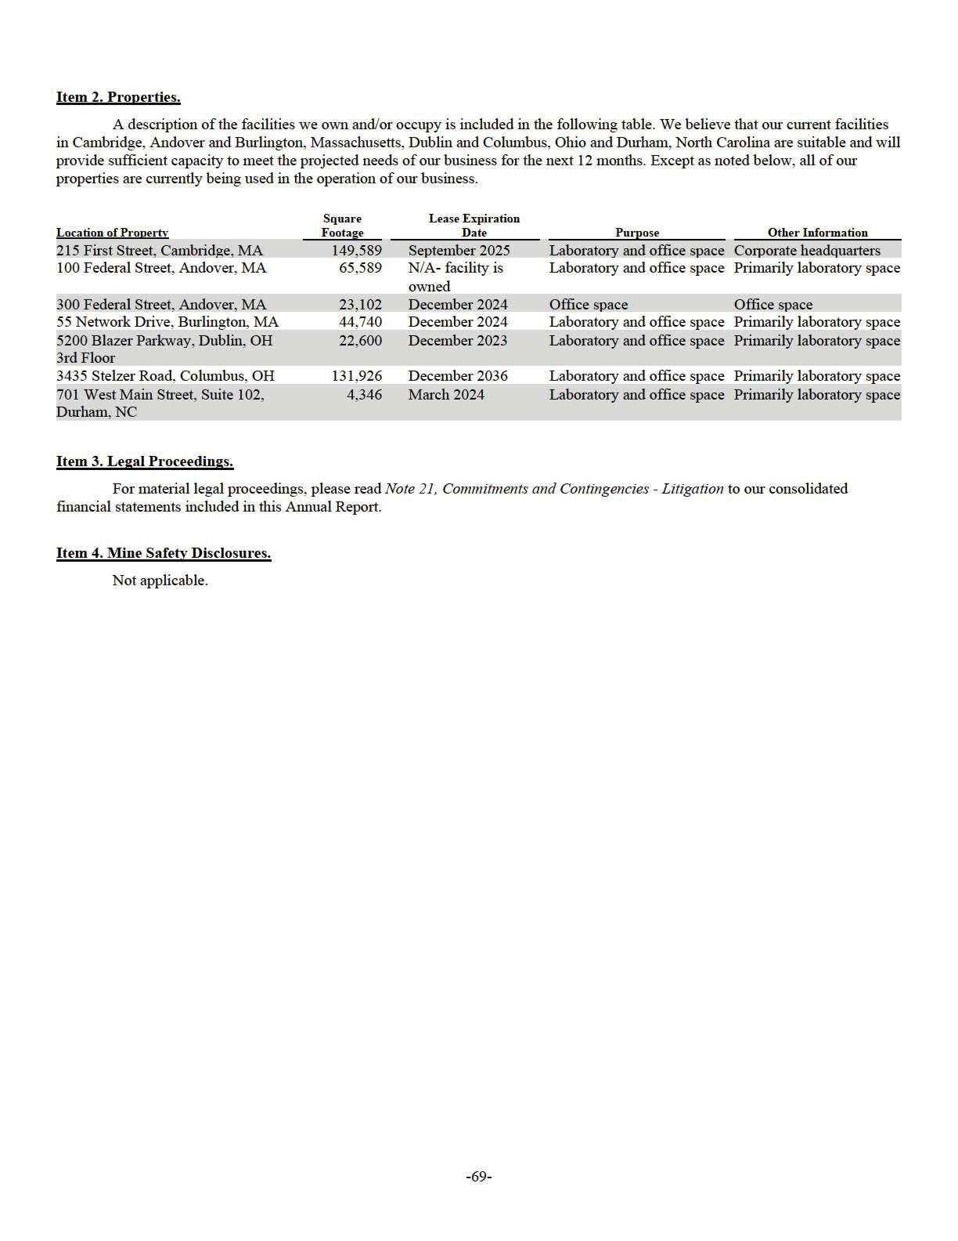

PART II

Item 5. Market for Registrant’s Common Equity, Related Stockholder Matters and Issuer Purchases of Equity Securities. Market Information
Our common stock is quoted on the Nasdaq Global Select Market under the same symbol “SRPT”.

Holders

As of February 23, 2023, we had 161 stockholders of record of our common stock.

Dividends

We did not declare or pay cash dividends on our common stock in 2022, 2021 or 2020. We currently expect to retain future earnings, if any, to finance the operation and expansion of our business, and we do not anticipate paying any cash dividends in the foreseeable future. Any future determination related to our dividend policy will be made at the discretion of our board of directors.

Performance Graph

The following graph compares the performance of our Common Stock for the periods indicated with the performance of the NASDAQ Composite Index, NASDAQ Biotechnology Index and the NYSE ARCA Biotechnology Index. This graph assumes an investment of $100 after the market closed December 29, 2017 in each of our common stock, the NASDAQ Composite Index, NASDAQ Biotechnology Index and the NYSE ARCA Biotechnology Index, and assumes reinvestment of dividends, if any. The stock price performance shown on the graph below is not necessarily indicative of future stock price performance. This graph is not “soliciting material,” is not deemed “filed” with the SEC and is not to be incorporated by reference into any of our filings under the Securities Act of 1933, as amended, or the Securities Exchange Act of 1934, as amended, whether made before or after the date hereof and irrespective of any general incorporation language in any such filing.
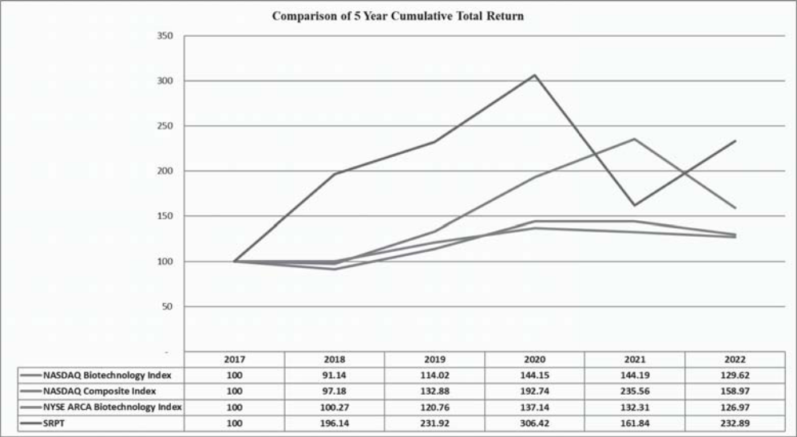

Recent Sales of Unregistered Securities.

None.

Purchases of Equity Securities by the Issuer and Affiliated Purchasers.

None.

Item 6. Reserved

-70-

Item 7. Management’s Discussion and Analysis of Financial Condition and Results of Operations.

The purpose of Management's Discussion and Analysis of Financial Condition and Results of Operations is to provide an understanding of the financial condition, changes in financial condition and results of operations of Sarepta Therapeutics, Inc. The following discussion and analysis of our financial condition and results of operations should be read in conjunction with our consolidated financial statements and related notes included elsewhere in this Annual Report on Form 10-K. This discussion contains forward-looking statements that involve risks and uncertainties. Please review our legend titled “Forward-Looking Information” at the beginning of this Annual Report on Form 10-K which is incorporated herein by reference. Our actual results could differ materially from those discussed below. Factors that could cause or contribute to such differences include, but are not limited to, those identified below, and those discussed in the section titled “Risk Factors” included elsewhere in this Annual Report on Form 10- K. Throughout this discussion, unless the context specifies or implies otherwise, the terms “Sarepta”, “we”, “us” and “our” refer to Sarepta Therapeutics, Inc. and its subsidiaries.

This section discusses 2022 and 2021 items and year-to-year comparisons between 2022 and 2021. Discussions of 2020 items and year-to-year comparisons between 2021 and 2020 have been excluded from this Form 10-K and can be found in “Management’s Discussion and Analysis of Financial Condition and Results of Operations” in Part II, Item 7 of our Annual Report on Form 10-K for the fiscal year ended December 31, 2021.

Overview

We are a commercial-stage biopharmaceutical company focused on helping patients through the discovery and development of unique RNA-targeted therapeutics, gene therapy and other genetic therapeutic modalities for the treatment of rare diseases. Applying our proprietary, highly-differentiated and innovative technologies, and through collaborations with our strategic partners, we have developed multiple approved products for the treatment of Duchenne and are developing potential therapeutic candidates for a broad range of diseases and disorders, including Duchenne, LGMDs, and other CNS related disorders.

We commercialized three products, all of which were granted accelerated approval by the FDA:

- EXONDYS 51 (eteplirsen) Injection (“EXONDYS 51”) is indicated for the treatment of Duchenne in patients who have a confirmed mutation of the dystrophin gene that is amenable to exon 51 skipping. EXONDYS 51 uses our PMO chemistry and exon-skipping technology to skip exon 51 of the dystrophin gene.

- VYONDYS 53 (golodirsen) Injection (“VYONDYS 53”) is indicated for the treatment of Duchenne in patients who have a confirmed mutation of the dystrophin gene that is amenable to exon 53 skipping. VYONDYS 53 uses our PMO chemistry and exon-skipping technology to skip exon 53 of the dystrophin gene.

- AMONDYS 45 (casimersen) Injection (“AMONDYS 45”) is indicated for the treatment of Duchenne in patients who have a confirmed mutation of the dystrophin gene that is amenable to exon 45 skipping. AMONDYS 45 uses our PMO chemistry and exon-skipping technology to skip exon 45 of the dystrophin gene.

We are in the process of conducting various EXONDYS 51, VYONDYS 53 and AMONDYS 45 clinical trials, including studies that are required to comply with our post-marketing FDA requirements/commitments to verify and describe the clinical benefit of these products.

A summary description of our key product candidates, including those in collaboration with our strategic partners, is as

follows:

- SRP-5051 uses our next-generation chemistry platform, cell-penetrating peptide-conjugated PPMO, and our exon-skipping technology to skip exon 51 of the dystrophin gene. SRP-5051, a peptide conjugated PMO, is designed to bind to exon 51 of dystrophin pre-mRNA, resulting in exclusion of this exon during mRNA processing in patients with genetic mutations that are amenable to exon 51 skipping. Exon skipping is intended to promote the production of an internally truncated but functional dystrophin protein. In the fourth quarter of 2017, we commenced a first-in-human, single ascending dose, study for the treatment of Duchenne in patients who are amenable to exon 51 skipping. In 2019, we commenced Study 5051-201. In December 2020, we announced an interim analysis on clinical results from the 10 mg/kg and 20 mg/kg dose cohorts of Part A of Study 5051-201. In May 2021, we announced results from the 30 mg/kg cohort of Part A of Study 5051-201. We initiated Part B of Study 5051-201 in the fourth quarter of 2021. In July 2022, the FDA placed Study 5051-201 on clinical hold following a serious adverse event of hypomagnesemia. The clinical hold was lifted in August 2022. We are currently enrolling Part B of Study 5051-201.

- SRP-9001 (Duchenne gene therapy program) aims to express a smaller but still functional version of dystrophin. A unique, engineered dystrophin is used because naturally-occurring dystrophin is too large to fit in an adeno-associated virus (“AAV”) vector. In the fourth quarter of 2017, an investigational new drug (“IND”) application for SRP-9001 was cleared by the FDA, and a Phase 1/2a clinical trial in individuals with Duchenne was initiated (Study 101). In October 2018, Nationwide Children’s Hospital (“Nationwide”) presented results from the Phase 1/2a clinical trial in

-71-

four individuals with Duchenne enrolled in the trial. In March 2019, we presented nine-month functional and creatine kinase (“CK”) data from baseline from these four individuals, and twelve -month CK data from baseline from one of these individuals. In June 2020, we announced that functional, safety and tolerability data at twelve-months from baseline from these four individuals had been published in JAMA Neurology. In September 2020, we presented functional, safety and tolerability data at 24 months from these four individuals. In the fourth quarter of 2018, we commenced a randomized, double-blind, placebo-controlled trial of SRP-9001 with the goal to establish the functional benefits of SRP-9001 protein expression (Study 102) . In January 2021, we released top-line results for Part 1 of Study 102 (the 48 -week assessment of 41 participants) and interim expression results from Part 2 of Study 102 (the crossover phase) . We announced topline results for Part 2 of Study 102 in January 2022. We have completed dosing in the first cohort in Study 103, an open-label study evaluating the safety and expression of commercially representative material for SRP-9001. In May 2021, we announced 12-week expression and safety results from the first 11 participants enrolled in Study 103. In October 2021, we announced functional data from the first 11 patients and tolerability data for all 32 patients enrolled in Study 103. We also initiated our pivotal trial (Study 301) in October 2021 and expect a data read out in the fourth quarter of 2023. In July 2022, we announced additional data from our Studies 102 and 103. In September 2022, we announced that we submitted a biologics license application (“BLA”) seeking accelerated approval of SRP-9001 for the treatment of ambulant individuals with Duchenne. In November 2022, the FDA accepted for filing and granted priority review for the BLA for SRP-9001 with an anticipated regulatory action date of May 29, 2023.

- SRP-9003 (LGMD, gene therapy program). We are developing gene therapy programs for various forms of LGMDs. The most advanced of our LGMD product candidates, SRP-9003, is designed to transfer a gene that codes for and restores beta-sarcoglycan protein with the goal of restoring the dystrophin associated protein complex. It utilizes the AAVrh.74 vector system, the same vector used in our SRP-9001 gene therapy program. A Phase 1/2a trial of SRP-9003 was commenced in the fourth quarter of 2018. In February 2019, we announced positive two-month biopsy data from the first three-patient low-dose cohort dosed in the SRP-9003 trial, and in October 2019, we announced positive nine-month functional data from these three patients. We have dosed one additional cohort of three patients at a higher dose per the study protocol. In June 2020, we announced safety and expression results from three clinical trial participants in the high-dose cohort measured at 60 days, and one-year functional data from three clinical trial participants in the low-dose cohort. In September 2020, we announced six-month functional data from three clinical trial participants in the high-dose cohort, and eighteen-month functional data from three clinical trial participants in the low-dose cohort. In March 2021, we announced 24-month functional and expression data from the three clinical trial participants in the low-dose cohort and twelve-month functional data from the three clinical trial participants in the high-dose cohort. In March 2022, we announced 36-month functional data from three clinical trial participants in the low-dose cohort and 24-month functional data from two clinical trial participants in the high-dose cohort. We expect to engage with the FDA to discuss our next steps for our potentially pivotal trial in 2023.

Our pipeline includes more than 40 programs in various stages of pre-clinical and clinical development, reflecting our multifaceted approach and expertise in precision genetic medicine to make a profound difference in the lives of patients suffering from rare diseases.

We have developed proprietary state-of-the-art CMC and manufacturing capabilities that allow synthesis and purification of our products and product candidates to support both clinical development as well as commercialization. Our current main focus in manufacturing is to sustain large-scale production of our PMO-based therapies and optimizing manufacturing for PPMO and gene therapy-based product candidates. We have entered into certain manufacturing and supply arrangements with third-party suppliers and will utilize these capabilities to support production of certain of our products and product candidates and their components. In 2017, we opened a facility in Andover, Massachusetts, which significantly enhanced our research and development manufacturing capabilities. However, we currently do not have internal large scale GMP manufacturing capabilities to produce our products and product candidates for commercial and/or clinical use.

The likelihood of our long-term success must be considered in light of the expenses, difficulties and delays frequently encountered in the development and commercialization of new pharmaceutical products, competitive factors in the marketplace and the complex regulatory environment in which we operate. We may never achieve significant revenue or profitable operations.

COVID-19 Pandemic

Despite careful tracking and planning, we are unable to accurately predict the extent of the impact of the COVID-19 pandemic on our business, results of operations and financial condition due to the uncertainty of future developments. The full extent to which the COVID-19 pandemic will directly or indirectly impact our business, results of operations and financial condition will depend on future developments that are highly uncertain and cannot be accurately predicted, including new information that may emerge concerning COVID-19, the actions taken to contain it or treat its impact and the economic impact on local, regional, national and international markets. For additional information on the various risks posed by the COVID-19 pandemic, refer to Part I, Item 1A. Risk Factors of this Annual Report on Form 10-K.

-72-

Critical Accounting Policies and Estimates

The discussion and analysis of our financial condition and results of operations is based upon our consolidated financial statements included elsewhere in this Annual Report on Form 10-K. The preparation of our consolidated financial statements in accordance with accounting principles generally accepted in the U.S. requires us to make estimates and judgments that affect the reported amounts of assets, liabilities, revenues and expenses and related disclosure of contingent assets and liabilities for the periods presented. Some of these judgments can be subjective and complex, and, consequently, actual results may differ from these estimates. We believe that the estimates and judgments upon which we rely are reasonable based upon historical experience and information available to us at the time that we make these estimates and judgments. To the extent there are material differences between these estimates and actual results, our consolidated financial statements will be affected. Although we believe that our judgments and estimates are appropriate, actual results may differ from these estimates. We believe the following accounting policies to be most critical to the judgments and estimates used in the preparation of our consolidated financial statements:

- inventory;

- income tax; and

- stock-based compensation.

Inventory Valuation

Inventories are stated at the lower of cost and net realizable value with cost determined on a first-in, first-out basis. We capitalize inventory costs associated with products following regulatory approval when future commercialization is considered probable and the future economic benefit is expected to be realized. EXONDYS 51, VYONDYS 53 and AMONDYS 45 inventory that may be used in clinical development programs is charged to research and development expense when the product enters the research and development process and no longer can be used for commercial purposes.

We periodically analyze our inventories for excess amounts or obsolescence and write down obsolete or otherwise unmarketable inventory to its estimated net realizable value based on assumptions about expected future demand and market conditions. Additionally, though our products are subject to strict quality control and monitoring, which we perform throughout the manufacturing processes, certain batches or units of product may not meet quality specifications. Expense incurred related to excess inventory, obsolete inventory, or inventories that do not meet our quality specifications are recorded as a component of cost of sales in the consolidated statements of operations.

Income Tax

We recognize the effect of income tax positions only if those positions are more likely than not of being sustained upon an examination. The calculation of our tax liabilities (or amount of reduction in our deferred tax assets from net operating loss carryover and research credit carryover) resulting from uncertain tax positions can involve significant judgment. Further, the calculation may involve the application of complex tax regulations in a foreign jurisdiction. Any significant impact as a result of changes in underlying facts, law, tax rates, tax audit, or review could lead to adjustments to our deferred tax asset, income tax expense, our effective tax rate, and/or our cash flow. Although we believe that we have adequately provided for tax liabilities resulting from uncertain tax positions, the actual amounts paid, if any, could have a material impact on our results of operations. Interest and penalties associated with uncertain tax positions are classified as a component of income tax expense.

Stock-Based Compensation for Awards with Market Conditions

We use the fair value method to determine stock-based compensation expense. The fair value for stock-based awards with market conditions is based on a lattice model with Monte Carlo simulations. The lattice model requires the use of subjective assumptions which include the award’s expected term and the price volatility of the underlying stock. The assumptions used in calculating the fair value of stock-based compensation expense for awards with market conditions represent management’s best estimates, but these estimates involve inherent uncertainties and the application of management judgment. As a result, the use of different assumptions could result in materially different stock-based compensation expense.

Please read Note 2, Summary of Significant Accounting Policies to the consolidated financial statements included elsewhere in this Annual Report on Form 10-K for a further discussion of our critical accounting policies and estimates.

-73-

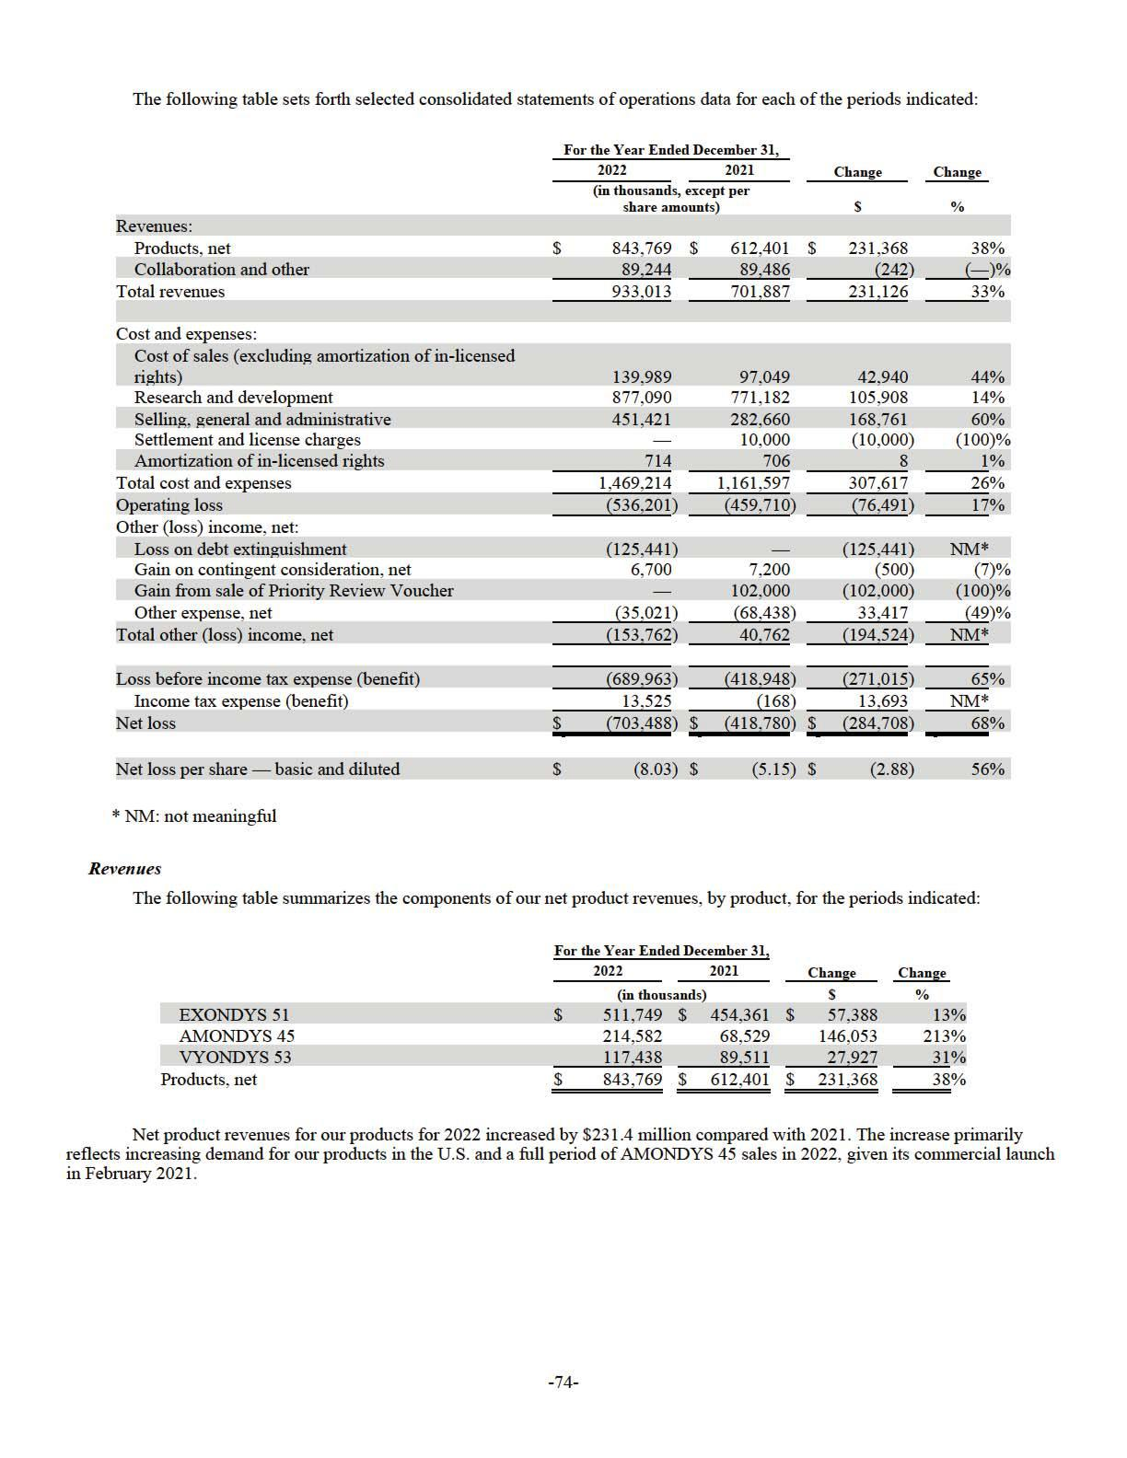

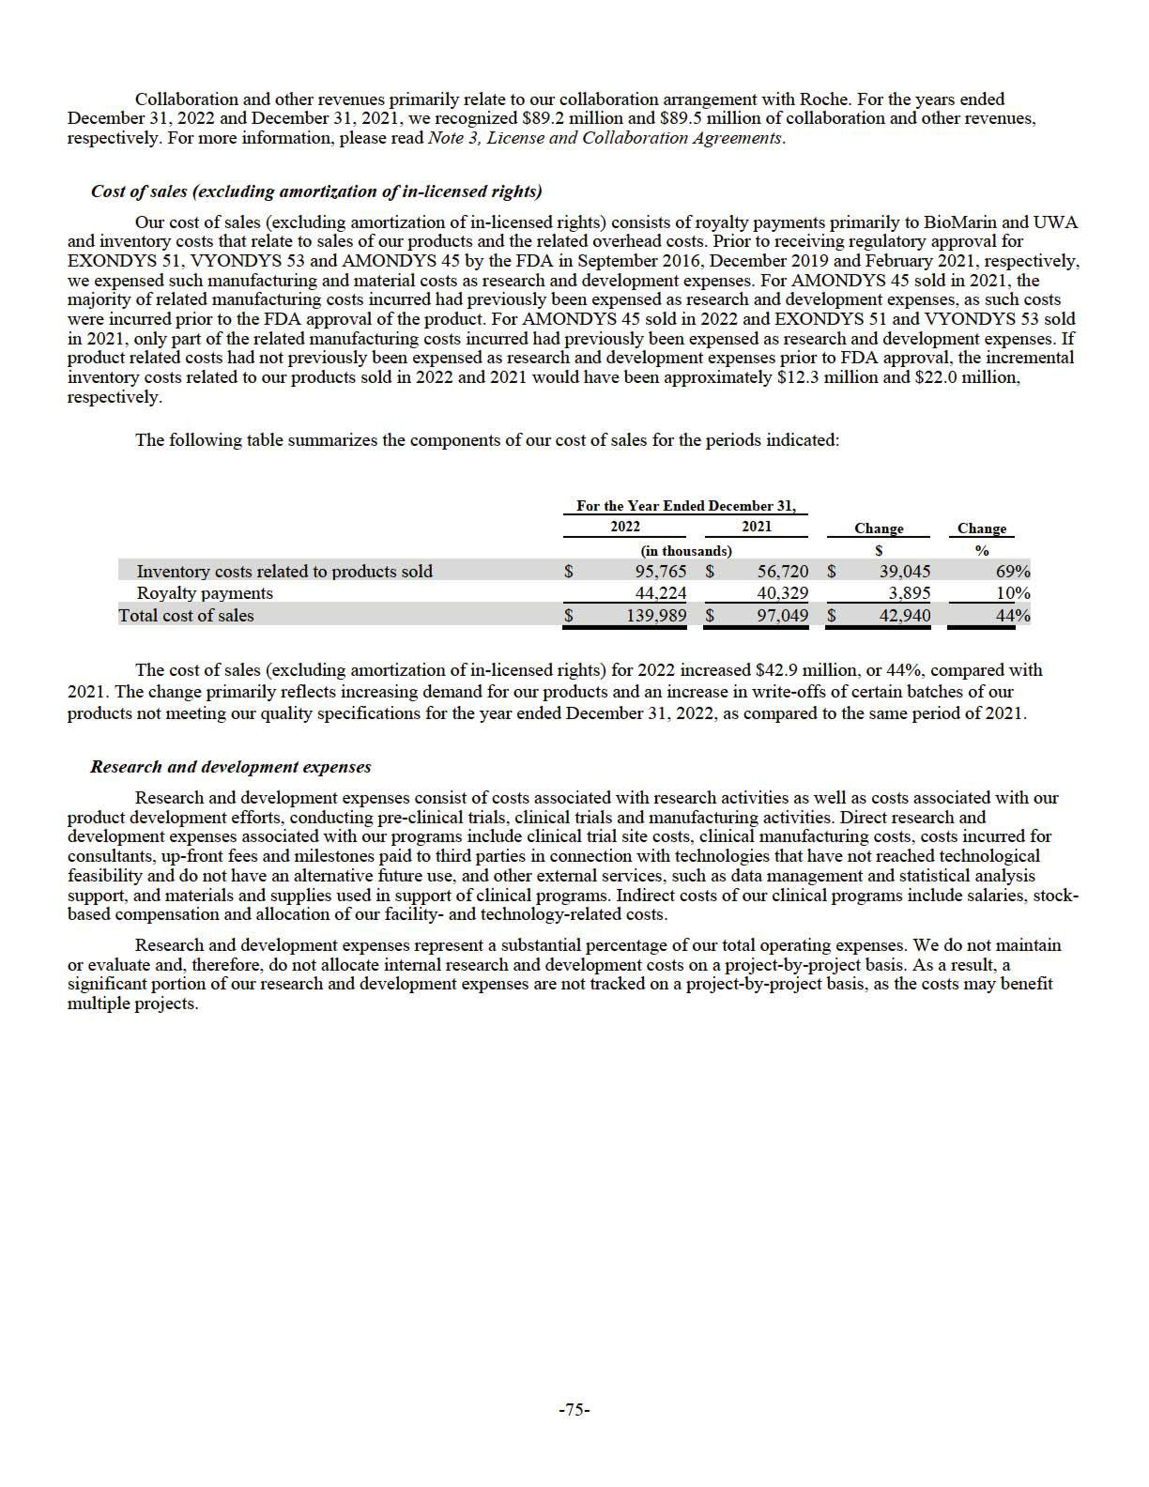

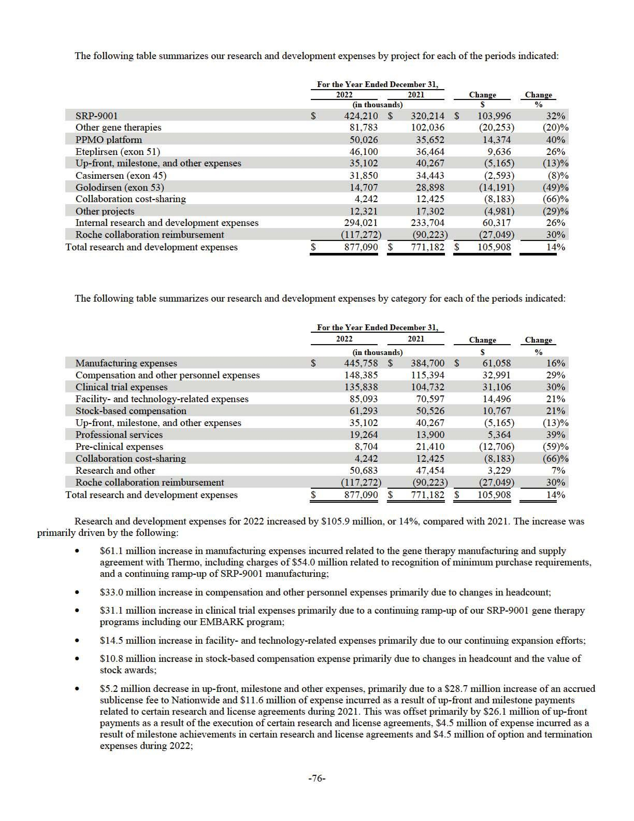

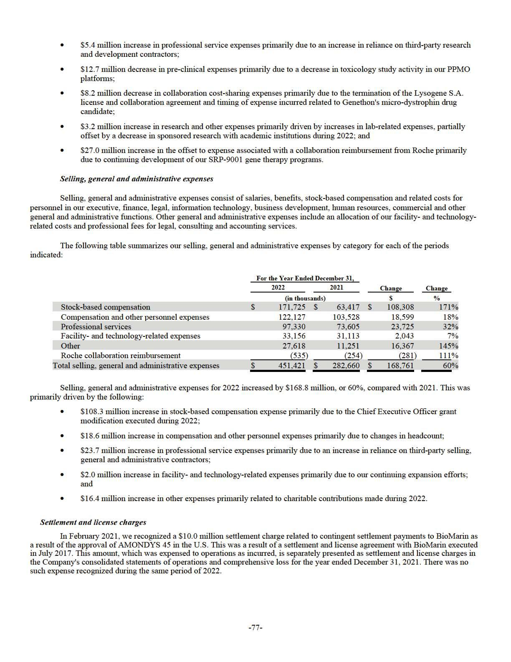

Amortization of in-licensed rights

Amortization of in-licensed rights relates to the agreements we entered into with BioMarin and UWA in July 2017 and April 2013, respectively. Each in-licensed right is being amortized on a straight -line basis over the remaining life of the patent from the first commercial sale of each product. For both the years ended December 31, 2022 and 2021, we recorded amortization of in -licensed rights of approximately $0.7 million.

Loss on debt extinguishment

On September 14, 2022, the Company entered into separate, privately negotiated transactions to repurchase a portion of the outstanding senior convertible notes due on November 15, 2024 (the “2024 Notes”) (see Note 13, Indebtedness) . The holders exchanged $150.6 million in aggregate principal value of 2024 Notes held by them plus accrued interest of $0.8 million for an aggregate payment of $248.6 million. The Company accounted for the repurchase of the 2024 Notes as a debt extinguishment by recognizing the difference between the repurchase price of the debt and the net carrying amount of the extinguished debt as loss on debt extinguishment. The loss incurred on the extinguishment was $98.5 million.

On September 16, 2022, the Company repaid in full all of its amounts outstanding with respect to the December 13, 2019, term loan with Biopharma Credit PLC and Biopharma Credit Investments V (Master) LP (the "December 2019 Term Loan") and repaid in full all obligations to the lenders (see Note 13, Indebtedness). The aggregate payoff amount was approximately $585.5 million, which included $550.0 million of principal amounts, additional loan consideration and premiums of $25.4 million, and accrued interest of $10.1 million through the repayment date. The loss incurred on the extinguishment was $26.9 million and represents the difference between the aggregate payoff amount and the net carrying amount of the December 2019 Term Loan.

Gain on contingent consideration, net

The gain on contingent consideration, net, relates to the fair value adjustment of the Company’s contingent consideration derivative liability related to regulatory-related contingent payments to Myonexus selling shareholders as well as to two academic institutions under separate license agreements that meet the definition of a derivative. For the years ended December 31, 2022 and 2021, we recognized net gains of $6.7 million and $7.2 million, respectively, to adjust the fair value of the contingent consideration liabilities. For further information on our contingent considerations, please read Note 5, Fair Value Measurements.

Gain from sale of Priority Review Voucher

In February 2021, we entered into an agreement to sell the PRV we received from the FDA in connection with the approval of AMONDYS 45 (the "AMONDYS 45 PRV"). Following the termination of the applicable waiting period under the Hart-Scott-Rodino Antitrust Improvements Act of 1976, as amended, in April 2021, we completed our sale of the AMONDYS 45 PRV and received proceeds of $102.0 million, with no commission costs, which was recorded as a gain from sale of the PRV as it did not have a carrying value at the time of the sale.

Other expense, net

Other expense, net primarily consists of interest expense on our debt facilities, interest income on our cash, cash equivalents and investments, amortization of investment premium or accretion of investment discount, and unrealized gain or loss from our investment in our strategic investments. Interest expense includes interest accrued on our convertible notes and term loan. Our cash equivalents and investments consist of money market funds, corporate bonds, commercial paper, government and government agency debt securities and certificates of deposit.

Other expense, net for 2022 decreased by approximately $33.4 million compared with 2021. The decreases are primarily due to a $16.1 million increase in interest income and $11.1 million increase in accretion of investment discount due to the investment mix of our investment portfolio, as well as a $10.3 million reduction of interest expense incurred as a result of the repayment of our December 2019 Term Loan, partially offset by an increase of $4.9 million in losses on disposal of assets.

Income tax expense (benefit)

Income tax expense for 2022 was approximately $13.5 million and income tax benefit for 2021 was $0.2 million. Income tax expense (benefit) for all periods presented relates to state and foreign income taxes.

Liquidity and Capital Resources

On September 16, 2022, we issued $ 1,150.0 million aggregate principal amount of convertible senior notes due on September 15, 2027 (the “2027 Notes”). The 2027 Notes are senior unsecured obligations of the Company and bear interest at a rate of 1.25% per annum, payable semi- annually in cash on each March 15 and September 15, commencing on March 15, 2023. The net proceeds were $1,126.7 million after deducting the discounts and offering expenses of $23.3 million. The debt discount is amortized under the effective interest method and recorded as interest expense over the life of the 2027 Notes.

-78-

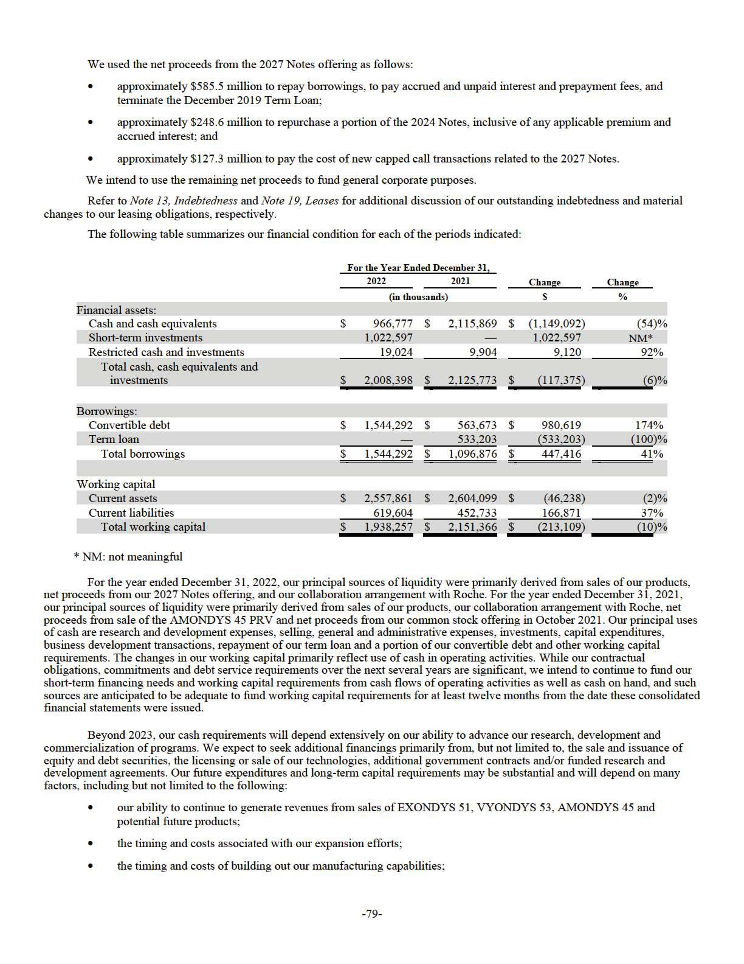

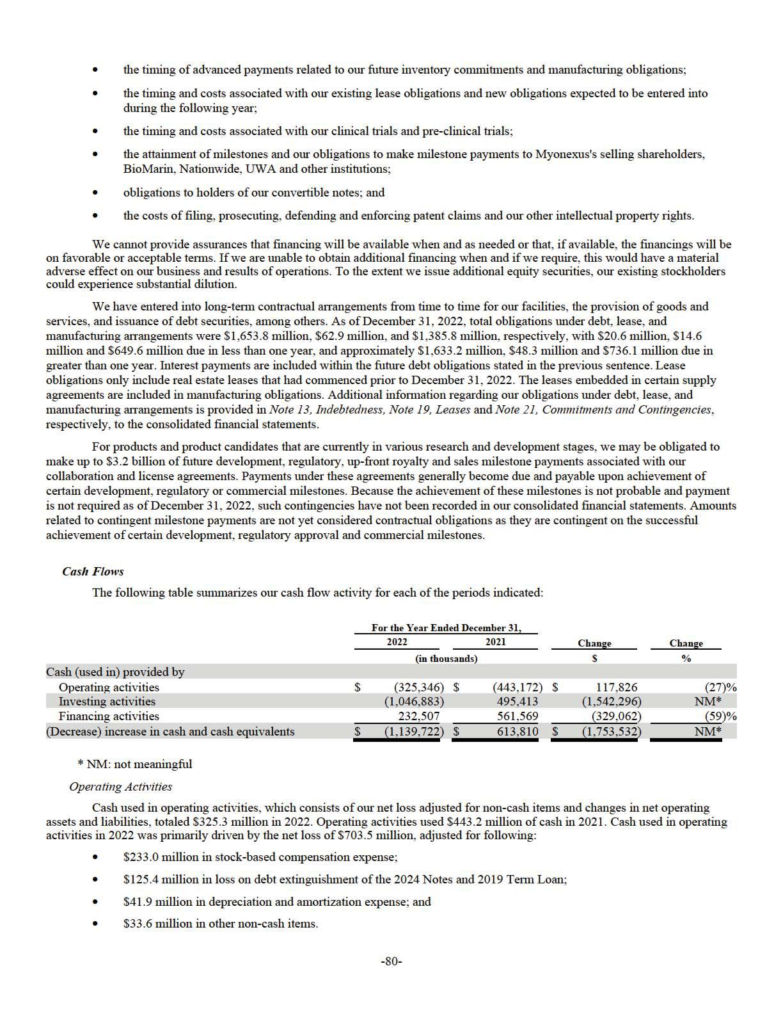

These amounts were partially offset by the gain on contingent consideration of $6.7 million and $9.6 million in other non-cash items.

The net cash outflow from changes in our operating assets and liabilities was primarily driven by the following:

- $89.2 million decrease in deferred revenue related to the collaboration with Roche;

- $61.6 million increase in accounts receivable due to an increase in demand for our products; and

- $50.8 million increase in inventory due to our continuing build-up of inventory purchased in 2022 as the demand for our products increased.

- $147.6 million increase in accounts payable, accrued expenses, lease liabilities and other liabilities due to the timing and invoicing of payments; and

- $14.6 million decrease in other assets primarily due to the release of manufacturing deposits and amortization of prepaids primarily related to SRP-9001 batch production.

Cash used in operating activities in 2021 was primarily driven by the net loss of $418.8 million, adjusted for:

- $113.9 million in stock-based compensation expense;

- $38.0 million in depreciation and amortization expense; and

- $31.0 million in other non-cash items.

These amounts were partially offset by the gain of $102.0 million recorded from the sale of the AMONDYS 45 PRV and the gain on contingent consideration of $7.2 million.

The net cash outflow from changes in our operating assets and liabilities was primarily driven by the following:

- $89.2 million decrease in deferred revenue related to the collaboration with Roche;

- $83.8 million increase in inventory due to our continuing build-up of inventory purchased in 2021 as the demand for our products increased; and

- $51.7 million increase in accounts receivable due to the launch of AMONDYS 45 in 2021 and an increase in demand for our products.

- $103.2 million decrease in other assets primarily due to lower manufacturing-related deposits as a result of the accelerated amortization of nonrefundable advance payments due to capacity changes associated with the execution of the Third Amendment to our manufacturing and supply agreement with Thermo; and

- $23.3 million increase in accounts payable, accrued expenses, lease liabilities and other liabilities due to the timing and invoicing of payments.

Investing Activities

Cash used in investing activities was $1,046.9 million in 2022 compared to $495.4 million of cash provided by investing activities in 2021. Cash used in investing activities in 2022 primarily consisted of the following:

- $1,936.9 million of purchases of available-for-sale securities; and

- $30.8 million of purchases of property and equipment due to the continued build-out of our facilities. These amounts were partially offset by $923.2 million of maturity and sales of available-for-sale securities. Cash provided by investing activities in 2021 primarily consisted of the following:
- $466.0 million of maturity and sales of available-for-sale securities; and

- $102.0 million of net proceeds related to the sale of the AMONDYS 45 PRV.

- $38.5 million of purchases of property and equipment due to the continued build-out of our facilities; and

- $30.0 million of purchases of available-for-sale securities.

Financing Activities

-81-

Cash provided by financing activities was $232.5 million in 2022 compared to $561.6 million in 2021. Cash provided by financing activities in 2022 consisted primarily of the following:

- $1,127.4 million in proceeds from the 2027 Notes offering, net of commissions;

- $30.0 million in proceeds from exercise of options and purchase of stock under our Employee Stock Purchase Program; and

- $26.3 million in partial settlement of capped call share options for the 2024 Notes.

These amounts were partially offset by the following items:

- $550.0 million for the repayment of the 2019 Term Loan;

- $247.9 million in the repurchase of a portion of the 2024 Notes;

- $127.3 million purchase of capped call share options for the 2027 Notes; and

- $25.4 million for payment on the debt extinguishment of the 2019 Term Loan. Cash provided by financing activities in 2021 primarily consisted of the following:

- $548.5 million in proceeds from the issuance of common stock; and

- $20.8 million in proceeds from exercise of options and purchase of stock under our Employee Stock Purchase Program. These amounts were partially offset by $7.8 million of taxes paid related to net share settlement of equity awards.

Other Funding Commitments

We have several on-going clinical trials in various stages. Our most significant clinical trial expenditures are to CROs. The CRO contracts are generally cancellable at our option. As of December 31, 2022, we had approximately $480.8 million in cancellable future commitments based on existing CRO contracts.

Recent Accounting Pronouncements

Please read Note 2, Summary of Significant Accounting Policies and Recent Accounting Pronouncements to the consolidated

financial statements included elsewhere in this Annual Report on Form 10-K.

Item 7A. Quantitative and Qualitative Disclosures About Market Risk.

Our current investment policy is to maintain a diversified investment portfolio consisting of money market investments, commercial paper, government and government agency bonds and high-grade corporate bonds with maturities of 36 months or less. Our cash is primarily deposited in and invested through highly rated financial institutions in the U.S. As of December 31, 2022, we had $2,008.4 million of cash, cash equivalents and investments, comprised of $1,022.6 million of short- term investments, $966.8 million of cash and cash equivalents and $19.0 million of long-term restricted cash. The Company only holds debt securities classified as available-for -sale. The fair value of cash equivalents and short-term investments is subject to change as a result of potential changes in market interest rates. The potential change in fair value for interest rate sensitive instruments has been assessed on a hypothetical 10 basis point adverse movement across all maturities. For the year ended December 31, 2022, we estimate that such hypothetical adverse 10 basis point movement would result in a hypothetical loss in fair value of approximately $0.4 million to our interest rate sensitive instruments. The Company did not hold any investments in interest rate sensitive instruments as of December 31, 2021.

Our $ 1,150.0 million aggregate principal amount of our 2027 Notes has a fixed interest rate of 1.25% per annum, payable semi-annually in cash on each March 15 and September 15 and our $419.4 million aggregate principal amount of our 2024 Notes has a fixed interest rate of 1.5% per annum, payable semi-annually in cash on each May 15 and November 15, and therefore are not subject to fluctuations in market interest rates.

Item 8. Financial Statements and Supplementary Data.

The information required by this Item 8 begins on page F-1 in Item 15 of Part IV of this Annual Report on Form 10-K and is incorporated into this item by reference.

-82-

Item 9. Changes in and Disagreements with Accountants on Accounting and Financial Disclosure.

None.

Item 9A. Controls and Procedures.

Disclosure Controls and Procedures

We carried out an evaluation as of the end of the period covered by this Annual Report on Form 10-K, under the supervision and with the participation of our management, including our principal executive officer and principal financial officer, of the effectiveness of our disclosure controls and procedures pursuant to paragraph (b) of Rule 13a-15 and 15d-15 under the Exchange Act. Based on that review, the principal executive officer and principal financial officer have concluded that our disclosure controls and procedures are effective to ensure that information required to be disclosed by us in the reports we file or submit under the Exchange Act (1) is recorded, processed, summarized, and reported within the time periods specified in the SEC rules and forms, and (2) is accumulated and communicated to our management, including our principal executive officer and principal financial officer, as appropriate to allow timely decisions regarding required disclosure.

We do not expect that our disclosure controls and procedures will prevent all errors and all fraud. A control procedure, no matter how well conceived and operated, can provide only reasonable, not absolute, assurance that the objectives of the control procedure are met. Because of the inherent limitations in all control procedures, no evaluation of controls can provide absolute assurance that all control issues and instances of fraud, if any, within our Company have been detected. These inherent limitations include the realities that judgments in decision making can be faulty, and that breakdowns can occur because of simple error or mistake. Additionally, controls can be circumvented by the individual acts of some persons, by collusion of two or more people, or by management override of the control. We considered these limitations during the development of our disclosure controls and procedures, and will continually reevaluate them to ensure they provide reasonable assurance that such controls and procedures are effective.

Internal Control over Financial Reporting

Management’s Annual Report on Internal Control over Financial Reporting

Management is responsible for establishing and maintaining adequate internal control over financial reporting for our Company, as such term is defined in Rules 13a-15(f) and 15d-15(f) under the Exchange Act.

Our internal control over financial reporting is a process designed to provide reasonable assurance regarding the reliability of financial reporting and the preparation of financial statements for external purposes in accordance with generally accepted accounting principles, and includes those policies and procedures that:

- pertain to the maintenance of records that, in reasonable detail, accurately and fairly reflect the transactions and dispositions of our assets;

- provide reasonable assurance that transactions are recorded as necessary to permit preparation of financial statements in accordance with generally accepted accounting principles, and that our receipts and expenditures are being made only in accordance with authorizations of our management and directors; and

- provide reasonable assurance regarding prevention or timely detection of unauthorized acquisition, use or disposition of our assets that could have a material effect on our financial statements.

Because of its inherent limitations, internal control over financial reporting may not prevent or detect misstatements. Also, projections of any evaluation of effectiveness to future periods are subject to the risk that controls may become inadequate because of changes in conditions, or that the degree of compliance with the policies or procedures may deteriorate. Management assessed the effectiveness of our internal control over financial reporting as of December 31, 2022. In making this assessment, management used the criteria set forth by the Committee of Sponsoring Organizations of the Treadway Commission (“COSO”) in its 2013 Internal Control Integrated Framework.

Based on this assessment, management has concluded that, as of December 31, 2022, our internal control over financial reporting was effective based on those criteria.

The effectiveness of our internal control over financial reporting as of December 31, 2022, has been audited by KPMG LLP, an independent registered public accounting firm, as stated in their report which appears in this Annual Report on Form 10-K.

Changes in Internal Control over Financial Reporting

There have not been material changes in our internal control over financial reporting as defined in Rules 13a–15(f) and 15d– 15(f) under the Exchange Act for the quarter ended December 31, 2022 that our certifying officers concluded materially affected, or are reasonably likely to materially affect, our internal control over financial reporting.

-83-

Item 9B. Other Information.

None.

Item 9C. Disclosure Regarding Foreign Jurisdictions that Prevent Inspections.

Not applicable.

-84-

PART III

Item 10. Directors, Executive Officers and Corporate Governance.

The information regarding our directors and executive officers required by this item will be included in either an amendment to this Annual Report on Form 10-K or in our definitive proxy statement for our 2023 annual meeting of stockholders to be filed with the Commission not later than 120 days after the end of the fiscal year covered by this Annual Report on Form 10-K and is incorporated herein by reference.

Item 11. Executive Compensation.

The information required by this item will be included in either an amendment to this Annual Report on Form 10-K or in our definitive proxy statement for our 2023 annual meeting of stockholders to be filed with the Commission not later than 120 days after the end of the fiscal year covered by this Annual Report on Form 10-K and is incorporated herein by reference.

Item 12. Security Ownership of Certain Beneficial Owners and Management and Related Stockholder Matters.

The information required by this item will be included in either an amendment to this Annual Report on Form 10-K or in our definitive proxy statement for our 2023 annual meeting of stockholders to be filed with the Commission not later than 120 days after the end of the fiscal year covered by this Annual Report on Form 10-K and is incorporated herein by reference.

Item 13. Certain Relationships and Related Transactions, and Director Independence.

The information required by this item will be included in either an amendment to this Annual Report on Form 10-K or in our definitive proxy statement for our 2023 annual meeting of stockholders to be filed with the Commission not later than 120 days after the end of the fiscal year covered by this Annual Report on Form 10-K and is incorporated herein by reference.

Item 14. Principal Accounting Fees and Services.

The information required by this item will be included in either an amendment to this Annual Report on Form 10-K or in our definitive proxy statement for our 2023 annual meeting of stockholders to be filed with the Commission not later than 120 days after the end of the fiscal year covered by this Annual Report on Form 10-K and is incorporated herein by reference.

-85-

PART IV

Item 15. Exhibits, Financial Statement Schedules.

(a) The following documents are filed as part of this Annual Report on Form 10-K:

(1) Financial Statements

The following consolidated financial statements of the Company and the Report of KPMG LLP, Independent Registered Public Accounting Firm, are included in Part IV of this Annual Report on Form 10-K on the pages indicated:

Report of Independent Registered Public Accounting Firm (KPMG LLP, Boston, MA, Auditor Firm ID: 185) | F-2
Consolidated Balance Sheets | F-4
Consolidated Statements of Operations and Comprehensive Loss | F-5
Consolidated Statements of Stockholders’ Equity | F-6
Consolidated Statements of Cash Flows | F-7
Notes to Consolidated Financial Statements | F-8

(2) Financial Statement Schedules

All schedules are omitted because they are not applicable or the required information is shown in the consolidated financial statements or the notes thereto.

(3) Exhibits

The exhibits required by Item 601 of Regulation S-K are listed in paragraph (b) below.

(b) Exhibits.

The following exhibits are filed herewith or are incorporated by reference to exhibits filed with the SEC:

Exhibit |  |  |  |  |  |  |  |  |  |  |  |  |  |  |  |  |  |  |  |  |  |  | Incorporated by Reference to Filings Indicated
Exhibit |  |  |  |  | Description |  |  |  |  |  |  |  |  |  |  |  |  |  |  |  |  | Form |  | File No. |  | Exhibit |  | Filing |  | Provided
Number |  |  |  |  |  |  |  |  |  |  |  |  |  |  |  |  |  |  |  |  |  | Form |  | File No. |  | Exhibit |  | Date |  | Herewith
2.1 |  | Agreement and Plan of Merger dated June 6, 2013 |  |  |  |  |  |  |  |  |  |  |  |  |  |  |  |  |  |  |  | 8-K12B | 001-14895 |  | 2.1 |  | 6/6/13
 |  | between Sarepta Therapeutics, Inc., a Delaware
 |  | corporation, and Sarepta Therapeutics, Inc., an
 |  | Oregon corporation.
 |  |  |  |  |  |  |  |  |  |  |  |  |  |  |  |  |  |  |  |  |  | 10-Q | 001-14895 |  | 2.1 |  | 8/8/18
2.2* | Warrant to Purchase Common Stock of Myonexus
 |  | Therapeutics, Inc., issued by Myonexus
 |  | Therapeutics, Inc. to Sarepta Therapeutics, |  |  |  |  |  | Inc.,
 |  | dated as of May 3, 2018.
3.1 | Amended and Restated Certificate of Incorporation. |  |  |  |  |  |  |  |  |  |  |  |  |  |  |  |  |  |  |  |  | 8-K12B | 001-14895 |  | 3.1 |  | 6/6/13
 |  |  |  |  |  |  |  |  |  |  |  |  |  |  |  |  |  |  |  |  |  | 8-K | 001-14895 |  | 3.1 |  | 6/30/15
3.2 |  | Amendment to the Amended and Restated Certificate
3.2 |  | of Incorporation.
3.3 | Second Amended and Restated ByLaws of Sarepta |  |  |  |  |  |  |  |  |  |  |  |  |  |  |  |  |  |  |  |  | 8-K | 001-14895 |  | 3.1 |  | 12/13/22
 |  | Therapeutics, Inc.
4.1 |  | Form of Specimen Certificate for Common Stock. |  |  |  |  |  |  |  |  |  |  |  |  |  |  |  |  |  |  |  | 10-Q | 001-14895 |  | 4.1 |  | 8/8/13
4.2 | Indenture, dated as of November 14, 2017, by and |  |  |  |  |  |  |  |  |  |  |  |  |  |  |  |  |  |  |  |  | 8-K | 001-14895 |  | 4.1 |  | 11/14/17
 |  | between Sarepta Therapeutics, Inc. and U. S. Bank
 |  | National Association (including the form of the
 |  | 1.50% Convertible Senior Note due 2024).
4.3 |  |  |  |  |  |  |  |  |  |  |  |  |  |  |  |  |  |  |  |  |  | 8-K | 001-14895 |  | 4.2 |  | 11/14/17
4.3 |  | Form of 2024 Note (included in Exhibit 4.2)
4.4 |  | Indenture, dated as of September 16, 2022, by and |  |  |  |  |  |  |  |  |  |  |  |  |  |  |  |  |  |  |  | 8-K | 001-14895 |  | 4.1 |  | 9/19/22
 |  | between Sarepta Therapeutics, Inc. and U. S. Bank
 |  |  |  |  |  |  |  |  |  |  |  |  |  |  |  |  |  |  |  |  | -86-

Trust Company, National Association (including the form of the 1.250% Convertible Senior Note due 2027).

4.5 Form of 2027 Note (included in Exhibit 4.4)

4.6 Description of Registered Securities

10.1† Sarepta Therapeutics, Inc. Amended and Restated

2011 Equity Incentive Plan.

10.2† Form of Stock Option Award Agreement under the Amended and Restated 2011 Equity Incentive Plan.

10.3† Form of Restricted Stock Agreement under the Amended and Restated 2011 Equity Incentive Plan.

10.4† Form of Restricted Stock Unit Award Agreement under 2011 Equity Incentive Plan.

10.5† Form of Stock Appreciation Right Award Agreement under the 2011 Equity Incentive Plan.

10.6† Sarepta Therapeutics, Inc. Amended and Restated
2013 Employee Stock Purchase Plan.
10.7† Sarepta Therapeutics, Inc. 2014 Employment Commencement Incentive Plan, as amended.

10.8† Form of Stock Option Award Agreement under 2014 Employment Commencement Incentive Plan

10.9* Amended and Restated Exclusive License Agreement by and among The University of Western Australia, Sarepta Therapeutics, Inc., and Sarepta International CV dated April 10, 2013.

10.10* First Amendment to License Agreement by and among The University of Western Australia, Sarepta Therapeutics, Inc., and Sarepta International CV dated June 19, 2016.

10.11 Lease Agreement dated June 25, 2013 by and between Sarepta Therapeutics, Inc. and ARE-MA Region No. 38, LLC.

10.12† Amendment No. 1 to the Sarepta Therapeutics, Inc. Amended and Restated 2011 Equity Incentive Plan

10.13 Asset Purchase Agreement dated February 20, 2017 by and between Sarepta Therapeutics Inc. and Gilead Sciences, Inc.

10.14† Employment Agreement, dated as of June 26, 2017, between Sarepta Therapeutics, Inc. and Douglas S. Ingram

10.15† Change in Control and Severance Agreement by and between Douglas S. Ingram and Sarepta Therapeutics, Inc., effective June 26, 2017

10.16† Amendment No. 1 to the Sarepta Therapeutics, Inc.

2014 Employment Commencement Incentive Plan

10.17† Restricted Stock Agreement under the 2014 Employment Commencement Incentive Plan

10.18† Performance Stock Option Award Agreement under the 2014 Employment Commencement Incentive Plan

8-K | 001-14895 | 4.2 | 9/19/22
10-K | 001-14895 | 4.4 | 2/26/20
8-K | 001-14895 | 10.1 | 7/1/16
10-K | 001-14895 | 10.13 | 2/28/17
10-K | 001-14895 | 10.14 | 2/28/17
10-K | 001-14895 | 10.17 | 2/28/17
10-K | 001-14895 | 10.18 | 2/28/17
8-K | 001-14895 | 10.2 | 7/1/16
S-8 | 001-14895 | 4.4 | 2/25/16
10-K | 001-14895 | 10.28 | 3/3/14
10-Q | 001-14895 | 10.1 | 5/9/13
10-Q | 001-14895 | 10.1 | 8/9/16
8-K | 001-14895 | 10.1 | 7/1/13
8-K | 001-14895 | 10.1 | 6/30/15
10-Q | 001-14895 | 10.1 | 5/4/17
8-K | 001-14895 | 10.1 | 6/28/17
8-K | 001-14895 | 10.2 | 6/28/17
8-K | 001-14895 | 10.3 | 6/28/17
8-K | 001-14895 | 10.4 | 6/28/17
8-K | 001-14895 | 10.5 | 6/28/17

-87-

10.19* Settlement Agreement between Sarepta Therapeutics, Inc., Sarepta International C.V. and The University of Western Australia on the one hand, and BioMarin Leiden Holding BV, BioMarin Nederlands BV and BioMarin Technologies BV on the other hand dated July 17, 2017

10.20* License Agreement between Sarepta Therapeutics, Inc. and Sarepta International C.V. on the one hand and BioMarin Leiden Holding BV, BioMarin Nederlands BV and BioMarin Technologies BV on the other hand dated July 17, 2017

10.21 Base Call Option Transaction Confirmation, dated as of November 8, 2017, between Sarepta Therapeutics, Inc. and JPMorgan Chase Bank, National Association, London Branch.

10.22 Base Call Option Transaction Confirmation, dated as of November 8, 2017, between Sarepta Therapeutics, Inc. and Goldman Sachs & Co. LLC.

10.23 Additional Call Option Transaction Confirmation, dated as of November 9, 2017, between Sarepta Therapeutics, Inc. and JPMorgan Chase Bank, National Association, London Branch

10.24 Additional Call Option Transaction Confirmation, dated as of November 9, 2017, between Sarepta Therapeutics, Inc. and Goldman Sachs & Co. LLC

10.25 Base Call Option Transaction Confirmation, dated as of September 13, 2022, between Sarepta Therapeutics, Inc. and Barclays Bank PLC.

10.26 Base Call Option Transaction Confirmation, dated as of September 13, 2022, between Sarepta Therapeutics, Inc. and Goldman Sachs & Co. LLC.

10.27 Base Call Option Transaction Confirmation, dated as of September 13, 2022, between Sarepta Therapeutics, Inc. and Mizuho Markets Americas LLC.

10.28 Base Call Option Transaction Confirmation, dated as of September 13, 2022, between Sarepta Therapeutics, Inc. and Morgan Stanley & Co. LLC.

10.29 Base Call Option Transaction Confirmation, dated as of September 13, 2022, between Sarepta Therapeutics, Inc. and RBC Capital Markets, LLC.

10.30 Additional Call Option Transaction Confirmation, dated as of September 14, 2022 between Sarepta Therapeutics, Inc. and Barclays Bank PLC.

10.31 Additional Call Option Transaction Confirmation, dated as of September 14, 2022 between Sarepta Therapeutics, Inc. and Goldman Sachs & Co. LLC.

10.32 Additional Call Option Transaction Confirmation, dated as of September 14, 2022 between Sarepta Therapeutics, Inc. and Mizuho Markets Americas LLC.

10-Q | 001-14895 | 10.7 | 8/3/17
10-Q | 001-14895 | 10.8 | 8/3/17
8-K | 001-14895 | 10.1 | 11/14/17
8-K | 001-14895 | 10.2 | 11/14/17
8-K | 001-14895 | 10.3 | 11/14/17
8-K | 001-14895 | 10.4 | 11/14/17
8-K | 001-14895 | 10.3 | 9/19/22
8-K | 001-14895 | 10.4 | 9/19/22
8-K | 001-14895 | 10.5 | 9/19/22
8-K | 001-14895 | 10.6 | 9/19/22
8-K | 001-14895 | 10.7 | 9/19/22
8-K | 001-14895 | 10.8 | 9/19/22
8-K | 001-14895 | 10.9 | 9/19/22
8-K | 001-14895 | 10.10 | 9/19/22

-88-

10.33 Additional Call Option Transaction Confirmation, dated as of September 14, 2022 between Sarepta Therapeutics, Inc. and Morgan Stanley & Co. LLC.

10.34 Additional Call Option Transaction Confirmation, dated as of September 14, 2022 between Sarepta Therapeutics, Inc. and RBC Capital markets, LLC.

10.35 Seventh Amendment to a Lease Agreement between the Company and ARE-MA Region No. 38, LLC dated April 27, 2018

8-K | 001-14895 | 10.11 | 9/19/22
8-K | 001-14895 | 10.12 | 9/19/22
10-Q | 001-14895 | 10.4 | 5/3/18

10.36† Sarepta Therapeutics, Inc. 2018 Equity Incentive |  |  |  |  |  |  |  |  |  |  |  |  |  |  |  |  |  |  |  |  |  |  |  |  |  |  |  |  |  |  |  |  |  |  |  | 10-Q | 001-14895 | 10.1 | 8/8/18
 |  | Plan
10.37† Letter Agreement between Douglas S. Ingram and |  |  |  |  |  |  |  |  |  |  |  |  |  |  |  |  |  |  |  |  |  |  |  |  |  |  |  |  |  |  |  |  |  |  |  | 10-Q | 001-14895 | 10.4 | 8/8/18
 |  | Sarepta Therapeutics, Inc. dated June 26, 2018
10.38† | Form of Restricted Stock Unit Award Agreement |  |  |  |  |  |  |  |  |  |  |  |  |  |  |  |  |  |  |  |  |  |  |  |  |  |  |  |  |  |  |  |  |  |  | 10-Q | 001-14895 | 10.5 | 8/8/18
 |  | under Sarepta Therapeutics, Inc. 2014 Employment
 |  | Commencement Incentive Plan
10.39† | Amendment No. 2 to the Sarepta Therapeutics, Inc. |  |  |  |  |  |  |  |  |  |  |  |  |  |  |  |  |  |  |  |  |  |  |  |  |  |  |  |  |  |  |  |  |  |  | 10-Q | 001-14895 | 10.6 | 8/8/18
 |  | 2014 Employment Commencement Incentive Plan
10.40† | Form of Stock Option Award Agreement under |  |  |  |  |  |  |  |  |  |  |  |  |  |  |  |  |  |  |  |  |  |  |  |  |  |  |  |  |  |  |  |  |  |  | 10-Q | 001-14895 | 10.1 | 10/31/18
 |  | Sarepta Therapeutics, Inc. 2018 Equity Incentive
 |  | Plan
10.41† |  | Form of Restricted Stock Award Agreement under |  |  |  |  |  |  |  |  |  |  |  |  |  |  |  |  |  |  |  |  |  |  |  |  |  |  |  |  |  |  |  |  |  | 10-Q | 001-14895 | 10.2 | 10/31/18
 |  | Sarepta Therapeutics, Inc. 2018 Equity Incentive
 |  | Plan
10.42† | Form of Restricted Stock Unit Award Agreement |  |  |  |  |  |  |  |  |  |  |  |  |  |  |  |  |  |  |  |  |  |  |  |  |  |  |  |  |  |  |  |  |  |  | 10-Q | 001-14895 | 10.3 | 10/31/18
 |  | under Sarepta Therapeutics, Inc. 2018 Equity
 |  | Incentive Plan
 |  |  |  |  |  |  |  |  |  |  |  |  |  |  |  |  |  |  |  |  |  |  |  |  |  |  |  |  |  |  |  |  |  |  |  | 10-Q | 001-14895 | 10.4 | 10/31/18
10.43† | Form of Stock Appreciation Right Award Agreement
 |  | under Sarepta Therapeutics, Inc. 2018 Equity
 |  | Incentive Plan
10.44† | Form of Performance-Based Restricted Stock Unit |  |  |  |  |  |  |  |  |  |  |  |  |  |  |  |  |  |  |  |  |  |  |  |  |  |  |  |  |  |  |  |  |  |  | 10-Q | 001-14895 | 10.1 | 05/4/22
 |  | Award Agreement under Sarepta Therapeutics, Inc.
 |  | 2018 Equity Incentive Plan
10.45† | Amendment to Restricted Stock Award Agreement |  |  |  |  |  |  |  |  |  |  |  |  |  |  |  |  |  |  |  |  |  |  |  |  |  |  |  |  |  |  |  |  |  |  | 10-K | 001-14895 | 10.75 | 2/28/19
 |  | between Douglas S. Ingram and Sarepta
 |  | Therapeutics, Inc. dated December 17, |  |  |  |  |  |  |  |  | 2018
 |  |  |  |  |  |  |  |  |  |  |  |  |  |  |  |  |  |  |  |  |  |  |  |  |  |  |  |  |  |  |  |  |  |  |  | 10-Q | 001-14895 | 10.1 | 8/7/19
10.46^ | Amendment No. 1 to License Agreement between
 |  | Sarepta Therapeutics, Inc. and ST International
 |  | Holdings Two, Inc. on the one hand and BioMarin
 |  | Leiden Holding BV, BioMarin Nederlands BV and
 |  | BioMarin Technologies BV on the other hand
10.47† | Amendment No. 1 to the Sarepta Therapeutics, Inc. |  |  |  |  |  |  |  |  |  |  |  |  |  |  |  |  |  |  |  |  |  |  |  |  |  |  |  |  |  |  |  |  |  |  | 10-Q | 001-14895 | 10.4 | 8/7/19
 |  | Amended and Restated 2013 Employment Stock
 |  | Purchase Plan (as Amended and Restated on June |  |  |  |  |  |  |  |  |  |  |  |  |  |  |  | 27,
 |  | 2016)
10.48 |  | Letter Agreement between Sarepta Therapeutics, Inc. |  |  |  |  |  |  |  |  |  |  |  |  |  |  |  |  |  |  |  |  |  |  |  |  |  |  |  |  |  |  |  |  |  | 10-Q | 001-14895 | 10.1 | 5/8/19
 |  | and Myonexus Therapeutics, Inc. dated February 26,
 |  | 2019
10.49† | Form of Executive Vice President Severance Letter |  |  |  |  |  |  |  |  |  |  |  |  |  |  |  |  |  |  |  |  |  |  |  |  |  |  |  |  |  |  |  |  |  |  | 10-Q | 001-14895 | 10.2 | 5/8/19
 |  | Agreement
10.50† | Form of Executive Vice President Change in Control |  |  |  |  |  |  |  |  |  |  |  |  |  |  |  |  |  |  |  |  |  |  |  |  |  |  |  |  |  |  |  |  |  |  | 10-Q | 001-14895 | 10.3 | 5/8/19
 |  | and Severance Agreement
 |  |  |  |  |  |  |  |  |  |  |  |  |  |  |  |  |  |  |  |  |  |  |  |  |  |  |  |  |  |  |  |  |  |  |  | -89-

10.51^ License, Collaboration, and Option Agreement between Sarepta Therapeutics Three, LLC and F. Hoffman-La Roche Ltd dated December 21, 2019

10.52 Stock Purchase Agreement between Sarepta Therapeutics, Inc. and Roche Finance Ltd dated December 21, 2019

10.53† Director Compensation Policy

10.54† Amendment No. 2 to the Sarepta Therapeutics, Inc.

2014 Employment Commencement Incentive Plan

10.55† Amendment No. 1 to the Sarepta Therapeutics, Inc.

2018 Equity Incentive Plan

10.56† Amendment No. 2 to the Sarepta Therapeutics, Inc.

2018 Equity Incentive Plan

10.57† Promotion Letter dated December 14, 2020 by and between Sarepta Therapeutics, Inc. and Louise Rodino-Klapac

10.58† Offer Letter dated April 19, 2018 by and between Sarepta Therapeutics, Inc. and Louise Rodino-Klapac

10.59† Promotion Letter dated December 14, 2020 by and between Sarepta Therapeutics, Inc. and Ian M. Estepan

10.60† Offer Letter dated by December 18, 2014 and between Sarepta Therapeutics, Inc. and Ian M. Estepan

10.61 Amendment no. 1 dated October 23, 2020 to the License, Collaboration, and Option Agreement between Sarepta Therapeutics Three, LLC and F. Hoffman-La Roche Ltd dated December 21, 2019

10.62 Amendment no. 2 dated October 28, 2020 to the License, Collaboration, and Option Agreement between Sarepta Therapeutics Three, LLC and F. Hoffman-La Roche Ltd, dated December 21, 2019

10.63 Amendment no. 3 dated February 4, 2021 to the License, Collaboration, and Option Agreement between Sarepta Therapeutics Three, LLC and F. Hoffman-La Roche Ltd, dated December 21, 2019

10.64 Amendment no. 4 dated June 23, 2021 to the License, Collaboration, and Option Agreement between Sarepta Therapeutics Three, LLC and F. Hoffman-La Roche Ltd, dated December 21, 2019

10.65 Amendment no. 5 dated August 31, 2021 to the License, Collaboration, and Option Agreement between Sarepta Therapeutics Three, LLC and F. Hoffman-La Roche Ltd, dated December 21, 2019.

10.66 Amendment no. 6 dated November 30, 2021 to the License, Collaboration, and Option Agreement

10-K | 001-14895 | 10.51 | 2/26/20
10-K | 001-14895 | 10.52 | 2/26/20
10-K | 001-14895 | 10.55 | 2/26/20
8-K | 001-14895 | 10.1 | 2/21/20
8-K | 001-14895 | 10.1 | 6/8/2020
10-Q | 001-14895 | 10.1 | 8/2/2022
10-K | 001-14895 | 10.59 | 3/1/21
10-K | 001-14895 | 10.60 | 3/1/21
10-K | 001-14895 | 10.61 | 3/1/21
10-K | 001-14895 | 10.62 | 3/1/21
10-Q | 001-14895 | 10.1 | 8/4/21
10-Q | 001-14895 | 10.2 | 8/4/21
10-Q | 001-14895 | 10.3 | 8/4/21
10-Q | 001-14895 | 10.4 | 8/4/21
10-Q | 001-14895 | 10.1 | 11/3/21
10-K | 001-14895 | 10.62 | 3/1/22

-90-

between Sarepta Therapeutics Three, LLC and F.

Hoffman-La Roche Ltd, dated December 21, 2019

10.67 | Amendment no. 7 dated January 5, 2022 to the |  |  |  |  |  |  |  |  |  |  |  |  |  |  |  |  |  |  |  |  |  |  |  |  |  |  |  |  | 10-K | 001-14895 | 10.63 | 3/1/22
 |  |  | License, Collaboration, and Option Agreement |  |  |  |  |  |  |  |  |  |  |  |  |  |  | F.
 |  |  | between Sarepta Therapeutics Three, LLC and
 |  |  | Hoffman-La Roche Ltd, dated December 21, 2019
10.68 | Amendment no. 8 dated January 28, 2022 to the |  |  |  |  |  |  |  |  |  |  |  |  |  |  |  |  |  |  |  |  |  |  |  |  |  |  |  |  | 10-K | 001-14895 | 10.64 | 3/1/22
 |  |  | License, Collaboration, and Option Agreement
 |  |  | between Sarepta Therapeutics Three, LLC and |  |  |  |  |  |  |  |  |  |  |  |  |  |  | F.
 |  |  | Hoffman-La Roche Ltd, dated December 21, 2019
10.69 | Amendment no. 9 dated March 23, 2022 to the |  |  |  |  |  |  |  |  |  |  |  |  |  |  |  |  |  |  |  |  |  |  |  |  |  |  |  |  | 10-Q | 001-14895 | 10.2 | 8/2/2022
 |  |  | License, Collaboration, and Option Agreement |  |  |  |  |  |  |  |  |  |  |  |  |  |  | F.
 |  |  | between Sarepta Therapeutics Three, LLC and
 |  |  | Hoffman-La Roche Ltd, dated December 21, 2019
10.70 | Amendment no. 10 dated May 31, 2022 to the |  |  |  |  |  |  |  |  |  |  |  |  |  |  |  |  |  |  |  |  |  |  |  |  |  |  |  |  |  |  |  | X
 |  |  | License, Collaboration, and Option Agreement |  |  |  |  |  |  |  |  |  |  |  |  |  |  | F.
 |  |  | between Sarepta Therapeutics Three, LLC and
 |  |  | Hoffman-La Roche Ltd, dated December 21, 2019
10.71^ |  |  | Amendment No. 2, dated November 17, 2021 to |  |  |  |  |  |  |  |  |  |  |  |  |  |  |  |  |  |  |  |  |  |  |  |  |  |  | 10-K | 001-14895 | 10.66 | 3/1/22
 |  |  | License Agreement between Sarepta Therapeutics,
 |  |  | Inc. and ST International Holdings Two, Inc. on the
 |  |  | one hand and BioMarin Leiden Holding BV,
 |  |  | BioMarin Nederlands BV and BioMarin
 |  |  | Technologies BV on the other hand
10.72† |  | Letter Agreement, dated November 18, 2022, |  |  |  |  |  |  |  |  |  |  |  |  |  |  |  |  |  |  |  |  |  |  |  |  |  |  |  |  |  |  | X
 |  |  | between Sarepta Therapeutics, Inc. and Douglas S.
 |  |  | Ingram
10.73† | Separation and Consulting Agreement and General |  |  |  |  |  |  |  |  |  |  |  |  |  |  |  |  |  |  |  |  |  |  |  |  |  |  |  |  |  |  |  | X
 |  |  | Release, signed November 2, 2022, between Sarepta
 |  |  | Therapeutics, Inc. and William C. Ciambrone
21.1 | Subsidiaries of the Registrant. |  |  |  |  |  |  |  |  |  |  |  |  |  |  |  |  |  |  |  |  |  |  |  |  |  |  |  |  |  |  |  | X
23.1 |  |  | Consent of Independent Registered Public |  |  |  |  |  |  |  |  |  |  |  |  |  |  |  |  |  |  |  |  |  |  |  |  |  |  |  |  |  | X
 |  |  | Accounting Firm.
24.1 | Power of Attorney (contained on signature page). |  |  |  |  |  |  |  |  |  |  |  |  |  |  |  |  |  |  |  |  |  |  |  |  |  |  |  |  |  |  |  | X
31.1 |  | Certification of the Company’s President and Chief |  |  |  |  |  |  |  |  |  |  |  |  |  |  |  |  |  |  |  |  |  |  |  |  |  |  |  |  |  |  | X
 |  |  | Executive Officer, Douglas S. Ingram, pursuant to
 |  |  | Section 302 of the Sarbanes-Oxley Act of 2002.
 |  |  |  |  |  |  |  |  |  |  |  |  |  |  |  |  |  |  |  |  |  |  |  |  |  |  |  |  |  |  |  |  | X
31.2 |  | Certification of the Company’s Executive Vice |  |  |  |  |  |  |  |  |  |  |  |  |  |  |  |  |  |  |  |  |  |  |  |  |  |  |  |  |  |  | X
 |  |  | President, Chief Financial Officer, Ian Estepan, |  |  |  |  |  |  |  |  |  |  |  |  |  |  |  | Act of
 |  |  | pursuant to Section 302 of the Sarbanes-Oxley
 |  |  | 2002.
32.1** |  | Certification of the Company’s President and Chief |  |  |  |  |  |  |  |  |  |  |  |  |  |  |  |  |  |  |  |  |  |  |  |  |  |  |  |  |  |  | X
 |  |  | Executive Officer, Douglas S. Ingram, pursuant to
 |  |  | Section 906 of the Sarbanes-Oxley Act of 2002.
32.2** |  | Certification of the Company’s Executive Vice |  |  |  |  |  |  |  |  |  |  |  |  |  |  |  |  |  |  |  |  |  |  |  |  |  |  |  |  |  |  | X
 |  |  | President, Chief Financial Officer, Ian Estepan,
pursuant to Section 906 of the Sarbanes-Oxley Act of
2002.

-91-

101 | The following financial statements from the Annual | X
 | Report on Form 10-K of Sarepta Therapeutics, Inc.
 | for the year ended December 31, 2022, formatted in
 | Inline XBRL: (i) Consolidated Balance Sheets; (ii)
 | Consolidated Statements of Operations and
 | Comprehensive Loss; (iii) Consolidated Statements
 | of Stockholders’ Equity; (iv) Consolidated
 | Statements of Cash Flows; and (v) Notes to
 | Consolidated Financial Statements, tagged as blocks
 | of text and including detailed tags.
104 | The Cover page from the Annual Report on Form 10- | X
 | K of Sarepta Therapeutics, Inc for the year ended
 | December 31, 2022, formatted in Inline XBRL.

† Indicates management contract or compensatory plan, contract or arrangement.

- Certain identified information has been excluded from the exhibit because it is both (i) not material and (ii) would be competitively harmful if publicly disclosed.

* Confidential treatment has been granted for portions of this exhibit.
** Furnished herewith. This exhibit shall not be deemed “filed” for purposes of Section 18 of the Securities Exchange Act of 1934, or otherwise subject to the liability of that Section. Such exhibit shall not be deemed incorporated into any filing under the Securities Act of 1933 or the Securities Exchange Act of 1934.

Item 16. Form 10-K Summary.

Not applicable.

-92-

SIGNATURES

Pursuant to the requirements of Section 13 or 15(d) of the Securities Exchange Act of 1934, the registrant has duly caused this report to be signed on its behalf by the undersigned, thereunto duly authorized.

Dated: February 28, 2023 SAREPTA THERAPEUTICS, INC.

By: /s/ Douglas S. Ingram

Douglas S. Ingram

President and Chief Executive Officer

POWER OF ATTORNEY

KNOW ALL PERSONS BY THESE PRESENTS, that each person whose signature appears below constitutes and appoints Douglas S. Ingram and Ian M. Estepan, and each of them, with full power of substitution and resubstitution and full power to act without the other, as his or her true and lawful attorney-in-fact and agent to act in his or her name, place and stead and to execute in the name and on behalf of each person, individually and in each capacity stated below, and to file, any and all documents in connection therewith, with the Securities and Exchange Commission, granting unto said attorneys-in-fact and agents, and each of them, full power and authority to do and perform each and every act and thing, ratifying and confirming all that said attorneys-in-fact and agents or any of them or their and his or her substitute or substitutes, may lawfully do or cause to be done by virtue thereof.

Pursuant to the requirements of the Securities Exchange Act of 1934, this report has been signed below by the following persons on behalf of the registrant and in the capacities indicated on February 28, 2023:

Signature |  | Title
/s/ Douglas S. Ingram |  | President, Chief Executive Officer and Director (Principal Executive Officer)
Douglas S. Ingram
/s/ Ian M. Estepan |  | Executive Vice President, Chief Financial Officer (Principal Financial and
Ian M. Estepan |  | Accounting Officer)
/s/ M. Kathleen Behrens |  | Chairwoman of the Board
M. Kathleen Behrens, Ph.D.
/s/ Richard Barry |  | Director
Richard Barry
/s/ Kathryn Boor |  | Director
Kathryn J. Boor, Ph.D.
/s/ Michael A. Chambers |  | Director
Michael A. Chambers
/s/ Stephen L. Mayo |  | Director
Stephen L. Mayo, Ph.D.
/s/ Claude Nicaise |  | Director
Claude Nicaise, MD
/s/ Hans Wigzell |  | Director
Hans Wigzell, M.D., Ph.D.

-93-

[This page intentionally left blank.]

SAREPTA THERAPEUTICS, INC.

CONSOLIDATED FINANCIAL STATEMENTS

 | Page
Report of Independent Registered Public Accounting Firm (KPMG LLP, Boston, MA, Auditor Firm ID: 185) | Number
 | F-2
Consolidated Balance Sheets ...................................................................................................................................................... | F-4
Consolidated Statements of Operations and Comprehensive Loss ............................................................................................. | F-5
Consolidated Statements of Stockholders’ Equity ...................................................................................................................... | F-6
Consolidated Statements of Cash Flows ..................................................................................................................................... | F-7
Notes to Consolidated Financial Statements............................................................................................................................... | F-8

F-1

Report of Independent Registered Public Accounting Firm

To the Stockholders and Board of Directors

Sarepta Therapeutics, Inc.:

Opinions on the Consolidated Financial Statements and Internal Control Over Financial Reporting

We have audited the accompanying consolidated balance sheets of Sarepta Therapeutics, Inc. and subsidiaries (the Company) as of December 31, 2022 and 2021, the related consolidated statements of operations and comprehensive loss, stockholders’ equity, and cash flows for each of the years in the three-year period ended December 31, 2022, and the related notes (collectively, the consolidated financial statements). We also have audited the Company’s internal control over financial reporting as of December 31, 2022, based on criteria established in Internal Control – Integrated Framework (2013) issued by the Committee of Sponsoring Organizations of the Treadway Commission.

In our opinion, the consolidated financial statements referred to above present fairly, in all material respects, the financial position of the Company as of December 31, 2022 and 2021, and the results of its operations and its cash flows for each of the years in the three-year period ended December 31, 2022, in conformity with U.S. generally accepted accounting principles. Also in our opinion, the Company maintained, in all material respects, effective internal control over financial reporting as of December 31, 2022 based on criteria established in Internal Control – Integrated Framework (2013) issued by the Committee of Sponsoring Organizations of the Treadway Commission.

Change in Accounting Principle

As discussed in Note 2 to the consolidated financial statements, the Company has changed its method of accounting for convertible debt as of January 1, 2021 due to the adoption of Accounting Standards Update (ASU) No. 2020-06, Debt – Debt with Conversion and Other Options (Subtopic 470 -20) and Derivatives and Hedging – Contracts in Entity’s Own Equity (Subtopic 815-40): Accounting for Convertible Instruments and Contracts in an Entity’s Own Equity.

Basis for Opinions

The Company’s management is responsible for these consolidated financial statements, for maintaining effective internal control over financial reporting, and for its assessment of the effectiveness of internal control over financial reporting, included in the accompanying Management’s Annual Report on Internal Control over Financial Reporting. Our responsibility is to express an opinion on the Company’s consolidated financial statements and an opinion on the Company’s internal control over financial reporting based on our audits. We are a public accounting firm registered with the Public Company Accounting Oversight Board (United States) (PCAOB) and are required to be independent with respect to the Company in accordance with the U.S. federal securities laws and the applicable rules and regulations of the Securities and Exchange Commission and the PCAOB.

We conducted our audits in accordance with the standards of the PCAOB. Those standards require that we plan and perform the audits to obtain reasonable assurance about whether the consolidated financial statements are free of material misstatement, whether due to error or fraud, and whether effective internal control over financial reporting was maintained in all material respects.

Our audits of the consolidated financial statements included performing procedures to assess the risks of material misstatement of the consolidated financial statements, whether due to error or fraud, and performing procedures that respond to those risks. Such procedures included examining, on a test basis, evidence regarding the amounts and disclosures in the consolidated financial statements. Our audits also included evaluating the accounting principles used and significant estimates made by management, as well as evaluating the overall presentation of the consolidated financial statements. Our audit of internal control over financial reporting included obtaining an understanding of internal control over financial reporting, assessing the risk that a material weakness exists, and testing and evaluating the design and operating effectiveness of internal control based on the assessed risk. Our audits also included performing such other procedures as we considered necessary in the circumstances. We believe that our audits provide a reasonable basis for our opinions.

Definition and Limitations of Internal Control Over Financial Reporting

A company’s internal control over financial reporting is a process designed to provide reasonable assurance regarding the reliability of financial reporting and the preparation of financial statements for external purposes in accordance with generally accepted accounting principles. A company’s internal control over financial reporting includes those policies and procedures that (1) pertain to the maintenance of records that, in reasonable detail, accurately and fairly reflect the transactions and dispositions of the assets of the company; (2) provide reasonable assurance that transactions are recorded as necessary to permit preparation of financial statements in accordance with generally accepted accounting principles, and that receipts and expenditures of the company are being made only in

F-2

accordance with authorizations of management and directors of the company; and (3) provide reasonable assurance regarding prevention or timely detection of unauthorized acquisition, use, or disposition of the company’s assets that could have a material effect on the financial statements.

Because of its inherent limitations, internal control over financial reporting may not prevent or detect misstatements. Also, projections of any evaluation of effectiveness to future periods are subject to the risk that controls may become inadequate because of changes in conditions, or that the degree of compliance with the policies or procedures may deteriorate.

Critical Audit Matter

The critical audit matter communicated below is a matter arising from the current period audit of the consolidated financial statements that was communicated or required to be communicated to the audit committee and that: (1) relates to accounts or disclosures that are material to the consolidated financial statements and (2) involved our especially challenging, subjective, or complex judgments. The communication of a critical audit matter does not alter in any way our opinion on the consolidated financial statements, taken as a whole, and we are not, by communicating the critical audit matter below, providing a separate opinion on the critical audit matter or on the accounts or disclosures to which it relates.

Evaluation of lower of cost or net realizable value of raw materials inventory

As described in Note 2 and Note 8 to the consolidated financial statements, approximately 16%, or $59.2 million, of the Company’s total inventory balance is comprised of raw materials. As discussed in Note 2, the Company periodically analyzes its raw materials inventories, and writes down obsolete or otherwise unmarketable inventory to its estimated net realizable value.

We identified the evaluation of lower of cost or net realizable value of raw materials inventory as a critical audit matter. The estimate of expected future demand for raw materials inventory is difficult to assess and results in the application of greater auditor judgment. Specifically, challenging auditor judgment was required to assess the potential impact the Company’s gene therapy technologies and competitor RNA-targeted therapeutic or gene therapy products could have on existing raw materials inventory.

The following are the primary procedures we performed to address this critical audit matter. We evaluated the design and tested the operating effectiveness of certain internal controls over the Company’s inventory valuation process, including controls related to the estimate of expected future demand for raw materials. We compared the Company’s prior period forecasted demand for raw materials to actual results to assess their ability to accurately estimate expected future demand. We evaluated clinical progress associated with the Company’s gene therapy technologies by inspecting internal meeting minutes and interviewing research and development personnel of the Company and assessed the potential impact of those technologies on expected future demand for raw materials inventory. We also read publicly available information to identify information regarding other competitor entities with RNA-targeted therapeutic or gene therapy products that could impact the Company’s estimates of expected future demand.

/s/ KPMG LLP

We have served as the Company’s auditor since 2002.

Boston, Massachusetts

February 28, 2023

F-3

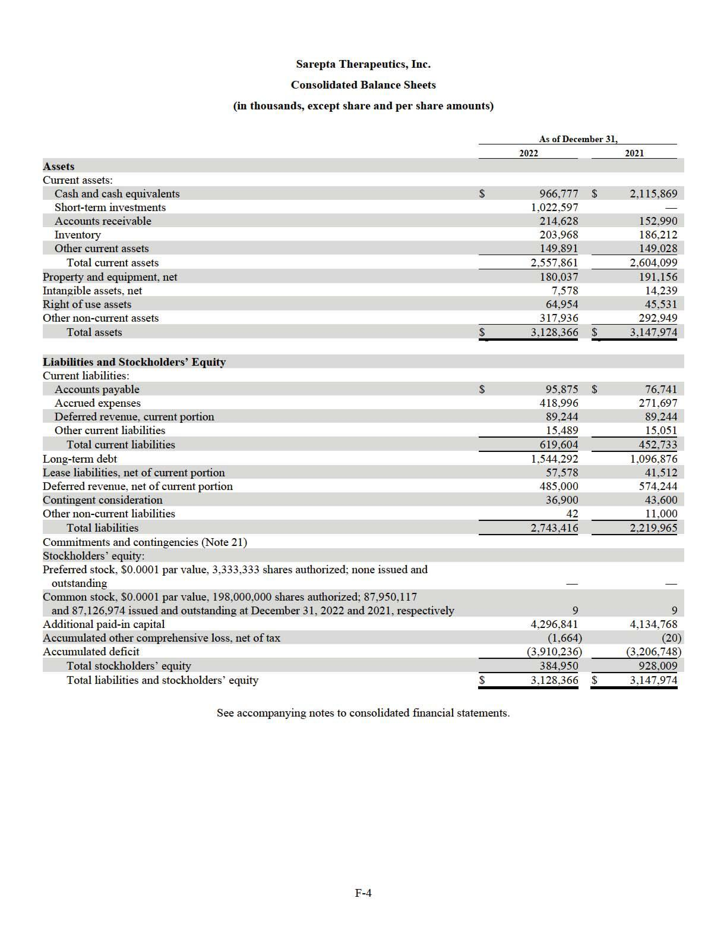

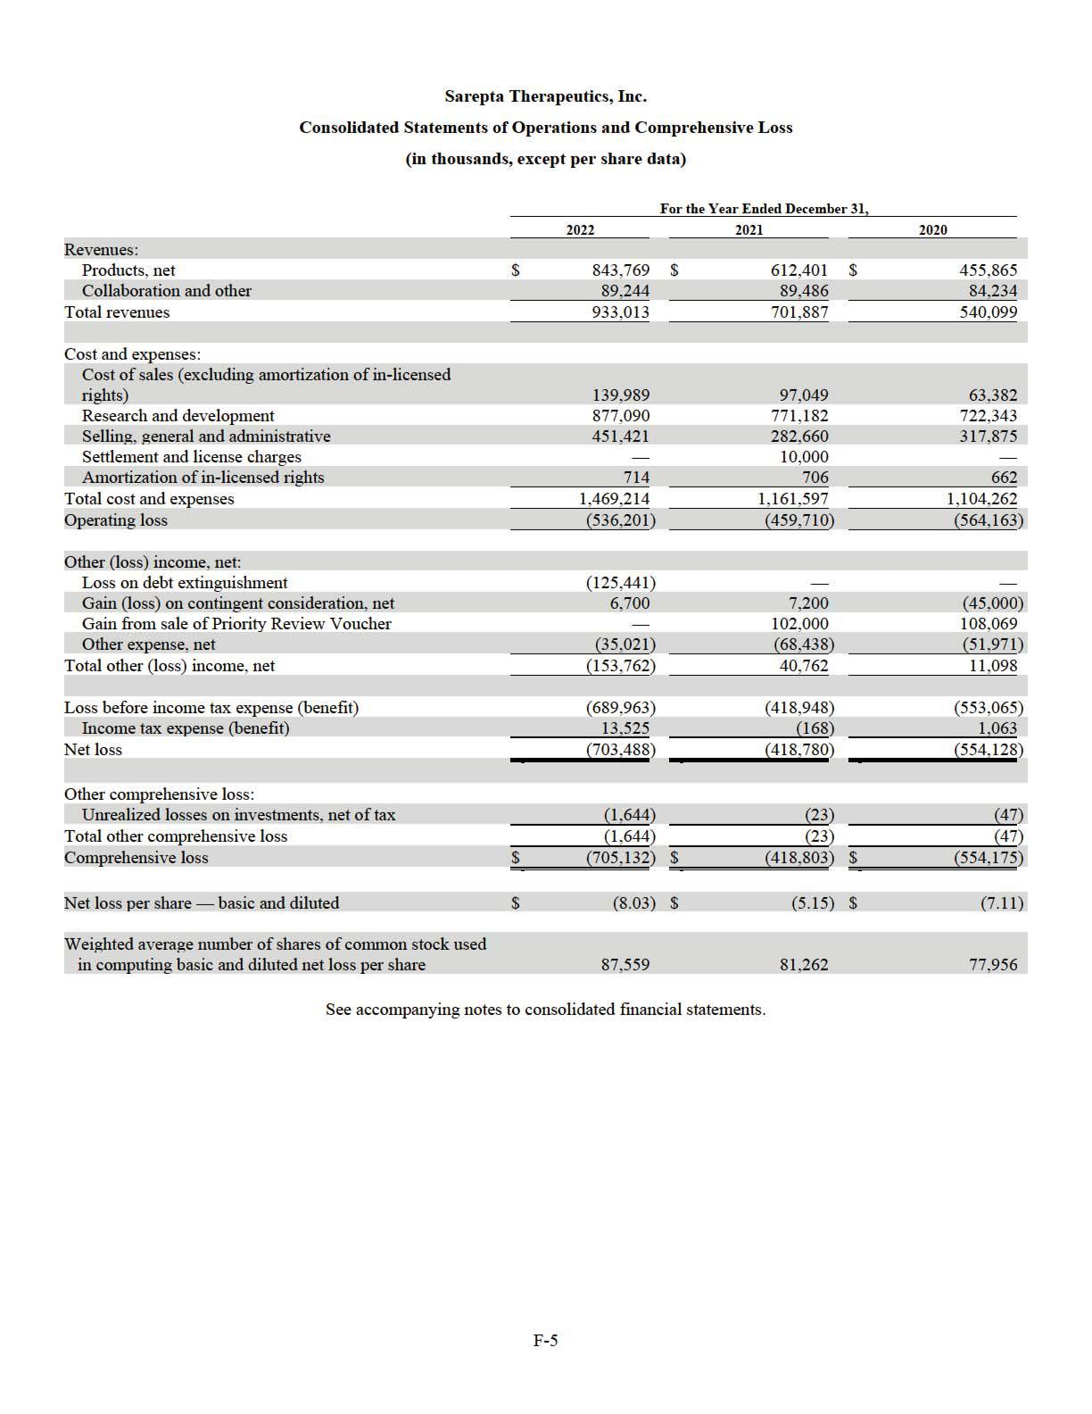

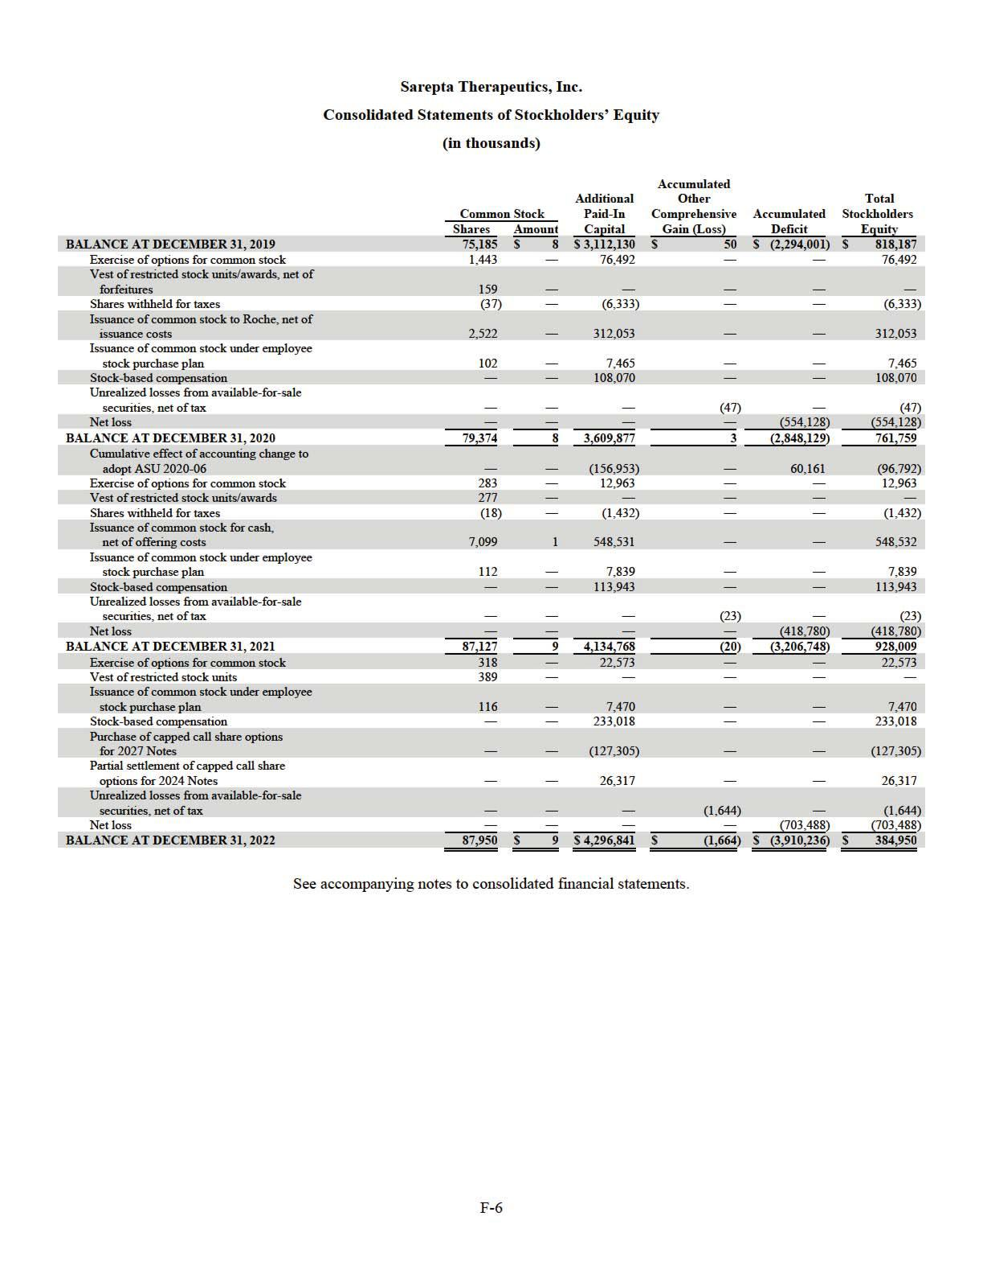

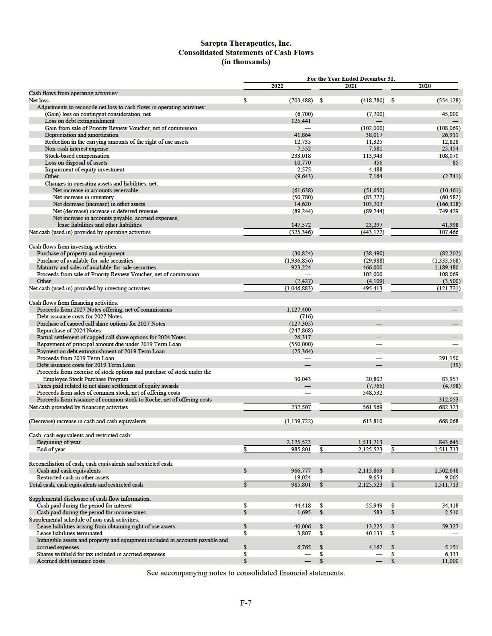

Sarepta Therapeutics, Inc.

NOTES TO CONSOLIDATED FINANCIAL STATEMENTS

1. ORGANIZATION AND NATURE OF BUSINESS

Sarepta Therapeutics, Inc. (together with its wholly-owned subsidiaries, “Sarepta” or the “Company”) is a commercial-stage biopharmaceutical company focused on helping patients through the discovery and development of unique RNA- targeted therapeutics, gene therapy and other genetic therapeutic modalities for the treatment of rare diseases. Applying its proprietary, highly-differentiated and innovative technologies, and through collaborations with its strategic partners, the Company has developed multiple approved products for the treatment of Duchenne muscular dystrophy (“Duchenne”) and is developing potential therapeutic candidates for a broad range of diseases and disorders, including Duchenne, Limb-girdle muscular dystrophies (“LGMDs”) and other neuromuscular and central nervous system (“CNS”) disorders.

The Company's products in the U.S., EXONDYS 51 (eteplirsen) Injection (“EXONDYS 51”), VYONDYS 53 (golodirsen) Injection (“VYONDYS 53”) and AMONDYS 45 (casimersen) Injection (“AMONDYS 45”), were granted accelerated approval by the U.S. Food and Drug Administration (the “FDA”) on September 19, 2016, December 12, 2019 and February 25, 2021, respectively. Indicated for the treatment of Duchenne in patients who have a confirmed mutation of the dystrophin gene that is amenable to exon 51, exon 53 and exon 45 skipping, respectively, EXONDYS 51, VYONDYS 53 and AMONDYS 45 use the Company’s phosphorodiamidate morpholino oligomer (“PMO”) chemistry and exon-skipping technology to skip exon 51, exon 53 and exon 45 of the dystrophin gene. Exon skipping is intended to promote the production of an internally truncated but functional dystrophin protein.

As of December 31, 2022, the Company had approximately $2,008.4 million of cash, cash equivalents and investments, consisting of $1,022.6 million of short- term investments, $966.8 million of cash and cash equivalents and $19.0 million of long-term restricted cash. The Company believes that its balance of cash, cash equivalents and investments as of December 31, 2022 is sufficient to fund its current operational plan for at least the next twelve months, though it may pursue additional cash resources through public or private debt and equity financings, seek funded research and development arrangements and additional government contracts and establish collaborations with or license its technology to other companies.

- SUMMARY OF SIGNIFICANT ACCOUNTING POLICIES AND RECENT ACCOUNTING PRONOUNCEMENTS

Basis of Presentation

The accompanying consolidated financial statements, which have been prepared in accordance with accounting principles generally accepted in the U.S. (“U.S. GAAP”), reflect the accounts of Sarepta Therapeutics, Inc. and its wholly-owned subsidiaries. All intercompany transactions between and among its consolidated subsidiaries have been eliminated. Management has determined that the Company operates in one segment: discovering, developing, manufacturing and delivering therapies to patients with rare diseases. The Company’s Chief Executive Officer, as the chief operating decision-maker, manages and allocates resources to the operations of the Company on a total company basis. The Company’s research and development organization is responsible for the research and discovery of new product candidates and supports development and registration efforts for potential future products. The Company’s supply chain organization manages the development of the manufacturing processes, clinical trial supply and commercial product supply. The Company’s commercial organization is responsible for commercialization of EXONDYS 51, VYONDYS 53 and AMONDYS 45 in the U.S. and internationally. The Company is supported by other back-office general and administration functions. Consistent with this decision-making process, the Company’s Chief Executive Officer uses consolidated, single-segment financial information for purposes of evaluating performance, forecasting future period financial results, allocating resources and setting incentive targets. In the opinion of the Company’s management, all adjustments of a normal recurring nature necessary for a fair presentation have been reflected.

Estimates and Uncertainties

The preparation of the consolidated financial statements in conformity with U.S. GAAP requires management to make estimates and assumptions that affect the reported amounts of assets, liabilities, equity, revenue, expenses and the disclosure of contingent assets and liabilities. Actual results could differ from those estimates.

F-8

Fair Value Measurements

The Company has certain financial assets and liabilities that are recorded at fair value which have been classified as Level 1,

2 or 3 within the fair value hierarchy as described in the accounting standards for fair value measurements:

- Level 1—quoted prices for identical instruments in active markets;

- Level 2—quoted prices for similar instruments in active markets, quoted prices for identical or similar instruments in markets that are not active, and model-derived valuations in which all significant inputs and significant value drivers are observable in active markets; and

- Level 3—valuations derived from valuation techniques in which one or more significant value drivers are unobservable.

The fair value of the majority of the Company’s financial assets are categorized as Level 2 within the fair value hierarchy. These assets include commercial paper, government and government agency bonds, corporate bonds and certificates of deposit. For additional information related to fair value measurements, please read Note 5, Fair Value Measurements to the consolidated financial statements.

Cash Equivalents

Only investments that are highly liquid and readily convertible to cash and have original maturities of three months or less are considered cash equivalents.

Investments

Available-For-Sale Debt Securities

Available-for- sale debt securities are recorded at fair value and unrealized gains and losses are included in accumulated other comprehensive income in stockholder’s equity. Interest income and realized gains and losses are reported in other expense, net, on a specific identification basis.

Equity Investments

The Company’s equity investments include its investments in a publicly traded biotechnology company and several privately held biotechnology companies and are included in other non-current assets in the Company’s consolidated balance sheets. The equity investment in the publicly traded biotechnology company has a readily determinable fair value and is carried at fair value. The equity investments in the privately held biotechnology companies do not have readily determinable fair values and are measured at cost less any impairment, plus or minus changes resulting from observable price changes for the identical or a similar investment of the same issuer. Any change in the valuation of equity investments is recorded as a gain or loss on the Company’s consolidated statements of operations and comprehensive loss.

Accounts Receivable

The Company’s accounts receivable primarily arise from product sales. They are generally stated at the invoiced amount and do not bear interest. Revenues from product sales are recorded at the net sales price (transaction price), which includes estimates of variable consideration for which reserves are established and which result from Medicaid rebates, governmental chargebacks including Public Health Services (“PHS”) chargebacks, prompt pay discounts, co-pay assistance and distribution fees. These reserves are based on the amounts earned or to be claimed on the related sales and are classified as reductions of accounts receivable (if no payments are required of the Company) for PHS chargebacks, prompt pay discounts and certain distribution fees, or a current liability (if a payment is required of the Company) for Medicaid rebates, co-pay assistance and certain distribution fees.

The accounts receivable from product sales represents receivables due from the Company’s specialty distributor and specialty pharmacies in the U.S. as well as certain distributors in the European Union (“EU”), Brazil, Israel and the Middle East. The Company has had no historical write-offs of its accounts receivable and its payment terms range from 60 to 91 days for sales within the U.S. and 45 and 150 days for the majority of product sales outside the U.S. The Company monitors the financial performance and creditworthiness of its customers so that it can properly assess and respond to changes in the customers’ credit profiles or any specific issues. The Company provides reserves against trade receivables for expected credit losses that may result from a customer’s inability to pay. Amounts determined to be uncollectible are written-off against the established reserve. As of December 31, 2022, the credit profiles for the Company’s customers are deemed to be in good standing and an allowance for credit losses is not considered necessary.

F-9

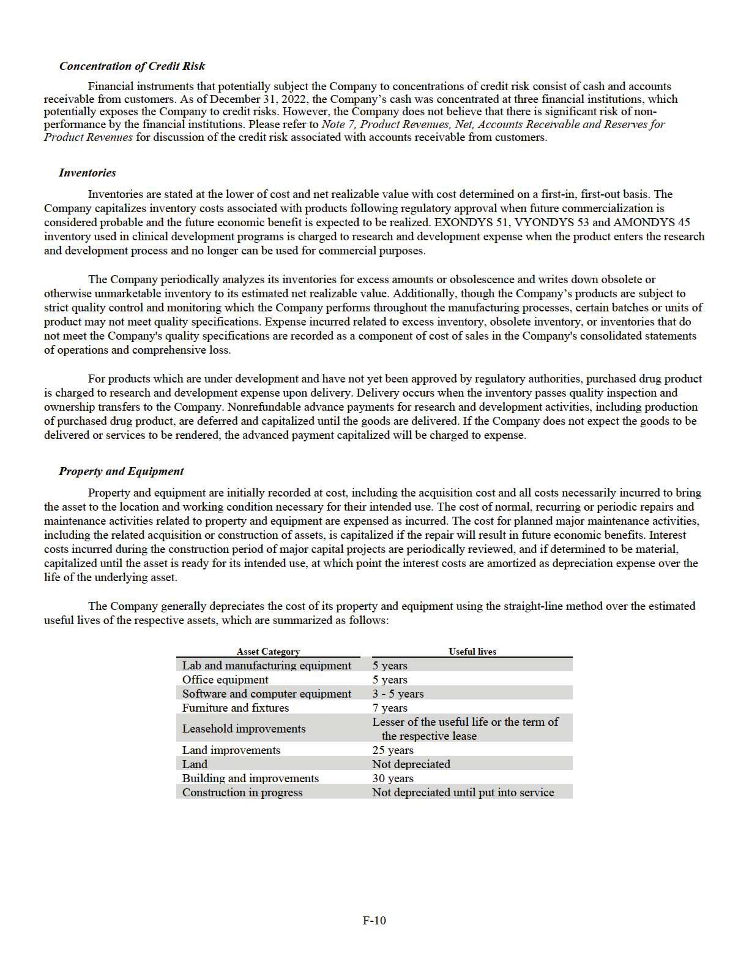

Intangible assets

The Company’s intangible assets consist of in-licensed rights, patent costs and software licenses, which are stated in the Company’s consolidated balance sheets, net of accumulated amortization and impairments, if applicable.

The in-licensed rights primarily relate to agreements with BioMarin Pharmaceutical, Inc. (“BioMarin”) and the University of Western Australia (“UWA”). The in- licensed rights are being amortized on a straight-line basis over the remaining life of the related patents because the life of the related patents reflects the expected time period that the Company will benefit from the in-licensed rights.

Patent costs consist primarily of external legal costs, filing fees incurred to file patent applications and renewal fees on proprietary technology developed or licensed by the Company. Patent costs associated with applying for a patent, being issued a patent and annual renewal fees are capitalized. Costs to defend a patent and costs to invalidate a competitor’s patent or patent application are expensed as incurred. Patent costs are amortized on a straight-line basis over the shorter of the estimated economic lives or the initial term of the patents, which is generally 20 years.

Impairment of Long-Lived Assets

Long-lived assets held and used by the Company, intangible assets with definite lives and right of use (“ROU”) assets are reviewed for impairment whenever events or circumstances indicate that the carrying amount of assets may not be recoverable. The Company evaluates recoverability of assets to be held and used by comparing the carrying amount of an asset to future net undiscounted cash flows to be generated by the asset. If the asset is considered to be impaired, the impairment to be recognized is measured as the amount by which the carrying amount of the assets exceeds the fair value of the assets. Such reviews assess the fair value of the assets based upon estimates of future cash flows that the assets are expected to generate.

Convertible Debt

As a result of adopting ASU 2020-06, “Debt – Debt with Conversion and Other Options (Subtopic 470-20) and Derivatives and Hedging – Contracts in Entity’s Own Equity (Subtopic 815-40): Accounting for Convertible Instruments and Contracts in an Entity’s Own Equity”, the Company accounts for the liability and equity components of convertible debt instruments that can be settled in cash as a single liability measured at its amortized cost, as long as no other features require bifurcation and recognition as derivatives under ASC Topic 815, Derivatives and Hedging (“ASC 815”). Simultaneously with the issuance of the Company's convertible senior notes due on November 15, 2024 (the "2024 Notes") and convertible senior notes due on September 15, 2027 (the "2027 Notes") in November 2017 and September 2022, respectively, the Company bought capped call options from certain counterparties to minimize the impact of potential dilution upon conversion. The premium for the capped call options was recorded as additional paid-in capital. For additional information related to the convertible debt transactions, please read Note 13, Indebtedness to the consolidated financial statements.

Revenue Recognition

The Company recognizes revenue when a customer obtains control of promised goods or services, in an amount that reflects the consideration which the Company expects to receive in exchange for the goods or services provided. To determine revenue recognition for arrangements within the scope of ASC Topic 606, Revenue from Contracts with Customers (“ASC 606”), the Company performs the following five steps: (1) identify the contract with the customer; (2) identify the performance obligations in the contract; (3) determine the transaction price; (4) allocate the transaction price to the performance obligations in the contract; and (5) recognize revenue when or as the Company satisfies a performance obligation. The Company only applies the five-step model to contracts when it is probable that the entity will collect the consideration it is entitled to in exchange for the goods or services it transfers or provides to the customer. At contract inception, the Company assesses the goods or services promised within each contract and determines those that are performance obligations, and assesses whether each promised good or service is distinct. The Company then recognizes as revenue the amount of the transaction price that is allocated to the respective performance obligation when or as the performance obligation is satisfied. The only performance obligation in the Company’s contracts with customers is to timely deliver drug products to the customer’s designated location.

Product revenues

The Company distributes its products principally through its customers. The customers subsequently resell the products to patients and health care providers. The Company provides no right of return to the customers except in cases of shipping error or product defect. Product revenues are recognized when the customers take control of the products, which typically occurs upon

F-11

delivery to the customers. For the years ended December 31, 2022, 2021 and 2020, the majority of the product revenues recognized were generated by the specialty distributor and specialty pharmacies in the U.S.

Variable Consideration

Product revenues are recorded at the net sales price (transaction price) which includes estimated reserves for variable consideration, such as Medicaid rebates, governmental chargebacks, including PHS chargebacks, prompt payment discounts, co-pay assistance and distribution fees. These reserves reflect the Company’s best estimates of the amount of consideration to which it is entitled based on the terms of the contracts. Additional details relating to variable consideration follows:

- Medicaid rebates relate to the Company’s estimated obligations to states under established reimbursement arrangements. Medicaid rebate reserves are recorded in the same period the related revenue is recognized, resulting in a reduction of product revenue and the establishment of a liability which is included in accrued expenses.

- Governmental chargebacks, including PHS chargebacks, relate to the Company’s estimated obligations resulting from contractual commitments to sell products to qualified healthcare providers at prices lower than the list prices that the Company charges to wholesalers. The wholesaler charges the Company for the difference between what the wholesaler pays for the products and the ultimate selling price to the qualified healthcare providers. Chargeback reserves are recorded in the same period the related revenue is recognized, resulting in a reduction of product revenue and accounts receivable. Chargeback amounts are generally determined at the time of resale to the qualified healthcare provider from the wholesaler, and the Company generally issues credits for such amounts within a few weeks of receiving notification of resale from the wholesaler.

- Prompt payment discounts relate to the Company’s estimated obligations for credits to be granted to specialty pharmacies for remitting payment on their purchases within established incentive periods. Reserves for prompt payment discounts are recorded in the same period the related revenue is recognized, resulting in a reduction of product revenue and accounts receivable.

- Co-pay assistance relates to financial assistance provided to qualified patients, whereby the Company may assist them with prescription drug co-payments required by the patient’s insurance provider. Reserves for co-pay assistance are recorded in the same period the related revenue is recognized, resulting in a reduction of product revenue and the establishment of a liability which is included in accrued expenses.

- Distribution fees relate to fees paid to customers in the distribution channel that provide the Company with inventory management, data and distribution services and are generally accounted for as a reduction of revenue. To the extent that the services received are distinct from the Company’s sale of products to the customers, these payments are accounted for as selling, general and administrative expenses. Reserves for distribution fees result in an increase in a liability if payments are required of the Company or a reduction of accounts receivable if no payments are required of the Company.

Collaboration revenue

The Company’s collaboration revenue is primarily generated from its collaboration arrangement with F. Hoffman-La Roche Ltd. (“Roche”). For more information, please read Note 3, License and Collaboration Agreements. At the inception of a collaboration arrangement, the Company first assesses whether the contractual arrangement is within the scope of ASC Topic 808, Collaborative Arrangements (“ASC 808”) to determine whether the arrangement involves a joint operating activity and involves two (or more) parties that are both active participants in the activity and exposed to significant risks and rewards dependent on the commercial success of such activity. Then the Company determines whether the collaboration arrangement in its entirety represents a contract with a customer as defined by ASC 606. If only a portion of the collaboration arrangement is potentially with a customer, the Company applies the distinct good or service unit-of-account guidance in ASC 606 to determine whether there is a unit of account that should be accounted for under ASC 606. For the units of account in the collaboration arrangement that do not represent a vendor-customer relationship, the Company will (i) consider applying other GAAP, including by analogy, or (ii) if there is no appropriate analogy, consistently apply a reasonable and rational accounting policy election.

In general, by analogy to ASC 606, the Company identifies the performance obligations within the collaboration arrangement and identifies and allocates the transaction price the Company expects to receive on a relative standalone selling price basis to each performance obligation. Variable consideration, consisting of development and regulatory milestones, will be included in the transaction price only if the Company expects to receive such consideration and if it is probable that the inclusion of the variable consideration will not result in a significant reversal in the cumulative amount of revenue recognized under the arrangement. Sales-based royalty and milestone payments are excluded from the transaction price the Company expects to receive until the underlying sales occur because the license to the Company’s intellectual property is deemed to be the predominant item to which the royalties or milestones relate as it is the primary driver of value in its collaboration arrangement.

F-12

For the recognition of revenue associated with each performance obligation, if the Company determines ASC 606 is not appropriate to apply by analogy, the Company will apply a reasonable, rational and consistently applied accounting policy election to faithfully depict the transfer of services to the collaboration partner over the estimated performance period. Up-front payments from a collaboration partner are recognized as deferred revenue when received and recognized as revenue over the estimated performance period. Reimbursement payments from a collaboration partner associated with cost-sharing provisions in a collaboration arrangement are recognized as the related expense is incurred and classified as an offset to operating expenses.

Valuation of Product Options

The Company's collaboration arrangements may contain options which provide the collaboration partner with the right to obtain additional licenses. If an arrangement contains product options, by analogy to ASC 606, the Company evaluates the product options to determine whether they represent material rights, which may include options to acquire additional goods or services for free or at a discount. If the customer options are determined to represent material rights, they are recognized as a separate performance obligation at inception of the arrangement. The Company allocates a portion of the transaction price of the collaboration arrangement to material rights based on the relative standalone selling price. Amounts allocated to material rights are not recognized as revenue until related options are exercised or expire. Key assumptions to determine the standalone selling price of product options in a collaboration arrangement include, but are not limited to, forecasted revenues, development timelines, incremental costs related to the arrangement, discount rates and likelihood of technical and regulatory success.

Research and Development

Research and development expenses consist of costs associated with research activities as well as those with the Company’s product development efforts, conducting pre-clinical trials, clinical trials and manufacturing activities. Research and development expenses are expensed as incurred. Up-front fees and milestones paid to third parties in connection with technologies which have not reached technological feasibility and do not have an alternative future use are expensed when incurred.

Direct research and development expenses associated with the Company’s programs include clinical trial site costs, clinical manufacturing costs, costs incurred for consultants and other external services, such as data management and statistical analysis support and materials and supplies used in support of clinical programs. Indirect costs of the Company’s clinical programs include salaries, stock-based compensation and an allocation of its facility and technology costs.

When third-party service providers’ billing terms do not coincide with the Company’s period-end, the Company is required to make estimates of its obligations to those third parties, including clinical trial and pharmaceutical development costs, contractual services costs and costs for supply of its drug candidates, incurred in a given accounting period and record accruals at the end of the period. The Company bases its estimates on its knowledge of the research and development programs, services performed for the period, past history for related activities and the expected duration of the third-party service contract, where applicable.

Stock-Based Compensation

The Company’s stock-based compensation programs include stock options, restricted stock awards (“RSAs”), restricted stock units (“RSUs”) and an employee stock purchase program (“ESPP”). The Company accounts for stock-based compensation using the fair value method.

The fair value of stock options are estimated on the date of grant using the Black-Scholes- Merton option-pricing model. The fair values of RSAs and RSUs are based on the fair market value of the Company’s common stock on the date of the grant. The fair value of stock awards, with consideration given to estimated forfeitures, is recognized as stock-based compensation expense on a straight-line basis over the vesting period of the grants. For stock awards with performance-vesting conditions, the Company does not recognize compensation expense until it is probable that the performance-vesting condition will be achieved.

Additionally, the Company granted its Chief Executive Officer options with service and market conditions. A market condition relates to the achievement of a specified price of the Company’s common stock, a specified amount of intrinsic value indexed to the Company’s common stock or a specified price of the Company’s common stock in terms of other similar equity shares. The grant date fair value for the options with service and market conditions is determined by a lattice model with Monte Carlo simulations and is recognized as stock-based compensation expense on a straight-line basis over the service period.

Under the Company’s ESPP, participating employees purchase common stock through payroll deductions. The purchase price is equal to 85% of the lower of the closing price of the Company’s common stock on the first business day and the last business day of the relevant purchase period. The fair value of stock purchase rights is estimated using the Black-Scholes-Merton option-pricing model. The fair value of the look-back provision with the 15% discount is recognized on a graded-vesting basis as stock-based compensation expense over the purchase period.

F-13

Income Taxes

The Company follows the asset and liability method of accounting for income taxes, which requires the recognition of deferred tax assets and liabilities for expected future tax consequences attributable to differences between the consolidated financial statement carrying amounts of existing assets and liabilities and their respective tax bases. Deferred tax assets and liabilities are measured using enacted tax rates in effect for the year in which the differences are expected to reverse. A valuation allowance is recorded to reduce the net deferred tax asset to zero when it is more likely than not that the net deferred tax asset will not be realized.

The Company recognizes the effect of income tax positions only if those positions are more likely than not of being sustained upon an examination. The amount of the benefit that may be recognized in the financial statements is the largest amount that has a greater than 50% likelihood of being realized. The Company recognizes interest and penalties related to uncertain tax positions within income tax expense.

It is the intention of the Company to reinvest the earnings of its non-U.S. subsidiaries in those operations and not to repatriate the earnings to the U.S. Accordingly, the Company does not provide for deferred taxes on the excess of the financial reporting over the tax basis in its investments in foreign subsidiaries as they are considered permanent in duration.

Leases

At the inception of an arrangement, the Company determines whether the arrangement is or contains a lease based on the unique facts and circumstances present in the arrangement. Leases with a term greater than 12 months are recognized on the consolidated balance sheets as right-of-use (“ROU”) assets and short-term and long-term lease liabilities, as applicable. The Company has elected not to recognize leases with terms of 12 months or less on the consolidated balance sheets. The Company typically only includes an initial lease term in its assessment of a lease arrangement. Options to renew a lease are not included in the Company’s assessment unless there is reasonable certainty that the Company will renew. The Company monitors its plans to renew its leases no less than on a quarterly basis. In addition, the Company’s lease agreements generally do not contain any residual value guarantees or restrictive covenants.

Operating lease liabilities and their corresponding ROU assets are recorded based on the present value of future lease payments over the expected remaining lease term at lease commencement. The initial measurement of the lease liability is determined based on the future lease payments, which may include lease payments that depend on an index or a rate (such as the consumer price index or other market index). The Company initially measures payments based on an index or rate by using the applicable rate at lease commencement and subsequent changes in such rates are recognized as variable lease costs. Variable payments that do not depend on a rate or index are not included in the lease liability and are recognized as they are incurred. Lease costs for operating leases are recognized on a straight-line basis over the lease term as an operating expense with unrecognized variable lease payments recognized as incurred. Certain adjustments to the ROU asset may be required for items such as lease prepayments or incentives received. The interest rate implicit in lease contracts is typically not readily determinable. As a result, the Company utilizes its incremental borrowing rate, which reflects the fixed rate at which the Company could borrow on a collateralized basis the amount of the lease payments in the same currency, for a similar term, in a similar economic environment. Components of a lease are bifurcated between lease components and non-lease components. The fixed and in-substance fixed contract consideration identified is then allocated based on the relative standalone price to the lease and non-lease components. However, ASC Topic 842, Leases, provides entities with a practical expedient that allows an accounting policy election to not separate lease and non-lease components by class of underlying asset. In using this expedient, entities would account for each lease component and the related non-lease component together as a single component. For new and amended real estate leases beginning after January 1, 2019, the Company elected to account for the lease and non-lease components together for existing classes of underlying assets and allocates the contract consideration to the lease component only. In contrast, the Company does not apply the practical expedient for leases embedded in manufacturing and supply agreements with certain of its contract manufacturing organizations and has instead allocated contract consideration between the lease and non-lease components based on their relative standalone price.

Embedded Derivatives

The Company evaluates certain of its financial and business development transactions to determine if embedded components of these contracts meet the definition of derivative under ASC 815. In general, embedded derivatives are required to be bifurcated from the host instrument if (i) the embedded feature is not clearly and closely related to the host contract and (ii) the embedded feature, if considered a freestanding instrument, meets the definition of a derivative. The embedded derivative is reported on the consolidated balance sheets at its fair value. Any change in fair value, as determined at each measurement period, is recorded as a component of the consolidated statements of operations and comprehensive loss.

F-14

Contingent Consideration

Certain of the Company’s license and collaboration agreements include future payments that are contingent upon the receipt, or receipt and subsequent sale, of a Priority Review Voucher (“PRV”). The Company has concluded that these contingent payments represent embedded derivatives. The Company records a liability for such contingent payments at fair value on the date the agreements are effective. The Company estimates the fair value of contingent consideration derivatives through a valuation model that includes an income approach based on the probability-weighted expected cash flows that incorporated industry-based probability adjusted assumptions relating to the achievement of the milestone and thus the likelihood of making the payments. Changes in the fair value of the contingent consideration derivatives can result from changes to one or multiple assumptions, including adjustments to the discount rates, the assumed development timeline and the probability of achievement of certain regulatory milestones. The Company revalues its contingent consideration derivatives upon a material change to one or more of the assumptions discussed above. Changes in the fair value of the Company’s contingent consideration derivatives are recognized in the Company’s consolidated statements of operations and comprehensive loss. Such changes are classified as other income (loss), which corresponds to the classification of any gain recognized upon the actual sale of a PRV.

Commitments and Contingencies

The Company records liabilities for legal and other contingencies when information available to the Company indicates that it is probable that a liability has been incurred and the amount of loss can be reasonably estimated. Legal costs in connection with legal and other contingencies are expensed as costs are incurred.

Recent Accounting Pronouncements

Recently adopted

In August 2020, the Financial Accounting Standards Board (“FASB”) issued ASU 2020-06, “Debt - Debt with Conversion and Other Options (Subtopic 470-20) and Derivatives and Hedging - Contracts in Entity's Own Equity (Subtopic 815-40): Accounting for Convertible Instruments and Contracts in an Entity's Own Equity.” This ASU simplifies the complexity associated with applying U.S. GAAP for certain financial instruments with characteristics of liabilities and equity. More specifically, the amendments focus on the guidance for convertible instruments and derivative scope exceptions for contracts in an entity’s own equity. Under ASU 2020-06, the embedded conversion features are no longer separated from the host contract for convertible instruments with conversion features that are not required to be accounted for as derivatives under ASC 815, or that do not result in substantial premiums accounted for as paid-in capital. Consequently, a convertible debt instrument, such as the 2024 Notes or the 2027 Notes, will be accounted for as a single liability measured at its amortized cost, as long as no other features require bifurcation and recognition as derivatives. The new guidance also requires the if-converted method to be applied for all convertible instruments and requires additional disclosures. The Company elected to early adopt this guidance on January 1, 2021, using the modified retrospective method. Under this transition method, the cumulative effect of the accounting change removed the impact of recognizing the equity component of the Company’s convertible notes (at issuance and the subsequent accounting impact of additional interest expense from debt discount amortization). The cumulative effect of the accounting change as of January 1, 2021 increased the carrying amount of the convertible notes by $96.8 million, reduced accumulated deficit by $60.2 million and reduced additional paid- in capital by $157.0 million. Interest expense of the 2024 Notes will be lower as a result of adoption of this guidance. The if-converted method for such instruments will be used to compute diluted net earnings per share if and when profitability is achieved.

3. LICENSE AND COLLABORATION AGREEMENTS

F. Hoffman-La Roche Ltd.

On December 21, 2019, the Company entered into a license, collaboration and option agreement with Roche and a stock purchase agreement (the “Roche Agreement”) with Roche, providing Roche with exclusive commercial rights to SRP-9001, the Company’s investigational gene therapy for Duchenne, outside the U.S. The Company retains all rights to SRP-9001 in the U.S. and will perform all development activities within the joint global development plan necessary to obtain and maintain regulatory approvals for SRP-9001 in the U.S. and the EU, unless otherwise agreed to by the parties. Further: (i) research and development expenses incurred under the joint global development plan will be equally shared between the Company and Roche, (ii) Roche is solely responsible for all costs incurred in connection with any development activities (other than those within the joint global development plan) that are necessary to obtain or maintain regulatory approvals outside the U.S, and (iii) the Company will continue to be responsible for the manufacturing of clinical and commercial supplies of SRP-9001. The Company has also granted Roche options to acquire ex -U.S. rights to certain future Duchenne-specific programs (the “Options”) in exchange for separate option exercise payments, milestone and royalty considerations, and cost-sharing provisions. The agreement became effective on February 4, 2020. The Roche Agreement is governed by a joint steering committee (“JSC”) formed by representatives from Roche and the Company.

F-15

The JSC, among other activities, manages the overall strategic alignment between the parties, approves any material update to the joint global development plan and budget and oversees the operations of the subcommittees.

The Company received an aggregate of approximately $1.2 billion in cash consideration from Roche, consisting of an up-front payment and an equity investment in the Company. The Company may receive up to $1.7 billion in development, regulatory and sales milestones related to SRP -9001. Upon commercialization, the Company is also eligible to receive tiered royalty payments on net sales based on the average cost to manufacture SRP-9001. Of the $1.2 billion cash received from Roche, (i) $312.1 million, net of issuance costs, was allocated to the approximately 2.5 million shares of the Company’s common stock issued to Roche based on the closing price when the shares were issued, (ii) $485.0 million was allocated to the Options, and (iii) $348.7 million was allocated to a single, combined performance obligation (“Combined Performance Obligation”) comprised of: (i) the license of IP relating to SRP-9001 transferred to Roche, (ii) the related research and development services provided under the joint global development plan, (iii) the services provided to manufacture clinical supplies of SRP-9001, and (iv) the Company’s participation in the JSC, because the Company determined that the license of IP and related activities were not capable of being distinct from one another.

The value assigned to the Options is reflected as deferred revenue and will not be recognized until an option is either: (i) exercised by Roche, or (ii) expires. If exercised, the value will be aggregated with the option exercise price and recognized over the applicable performance period. If expired, the value will be recognized immediately. The Company recognizes revenue related to the Combined Performance Obligation on a straight-line basis over the expected performance period of the joint global development plan, which is expected to extend through the fourth quarter of 2023. Revenue relating to future development, regulatory and sales milestones will be recognized when the milestone is probable of achievement (which is typically when the milestone has occurred). Any royalties payable by Roche in the future will be recognized in the period earned.

For the years ended December 31, 2022, 2021 and 2020, the Company recognized $89.2 million, $89.5 million and $84.2 million of collaboration and other revenues, respectively, the majority of which relates to the Combined Performance Obligation. As of December 31, 2022, the Company has total deferred revenue of $574.2 million associated with the Roche Agreement, of which $89.2 million is classified as current. Through 2022, no Options were exercised or expired. As such, deferred revenue related to the separate material rights for the Options remained unchanged at $485.0 million as of December 31, 2022 and 2021.

The costs associated with co-development activities performed under the Roche Agreement are included in operating expenses, with any reimbursement of costs by Roche reflected as a reduction of such expenses when the related expense is incurred. For the years ended December 31, 2022, 2021 and 2020, costs reimbursable by Roche and reflected as a reduction to operating expenses were $117.8 million, $90.5 million and $66.5 million, respectively. As of December 31, 2022, there was $41.8 million of collaboration receivable included in other current assets.

Genethon

The Company entered into a sponsored research agreement in May 2017 and subsequently entered into a license and collaboration agreement with Genethon in November 2019 (the “Genethon Collaboration Agreement”) for Genethon’s micro-dystrophin gene therapy program for the treatment of Duchenne. The Genethon Collaboration Agreement grants the Company with exclusive rights in the majority of the world (primarily excluding the EU) to Genethon’s micro-dystrophin gene therapy products (“Genethon Products”) and other micro-dystrophin gene therapy products (“Other Licensed Products”). The Company may be liable for up to $157.5 million and $78.8 million in development, regulatory and sales milestones for the Genethon Products and Other Licensed Products, respectively. Furthermore, upon commercialization, the Company will be required to make tiered royalty payments based on net sales of the Genethon Products and the Other Licensed Products. Under the Genethon Collaboration Agreement, a joint steering committee was established to plan, monitor and coordinate development activities for Genethon Products and Other Licensed Products. The Company and Genethon are responsible for 75% and 25%, respectively, of development costs related to both the Genethon Products and the Other Licensed Products.

Upon signing the Genethon Collaboration Agreement, the Company made an up-front payment of $28.0 million, which was recorded as research and development expense in the Company’s consolidated statements of operations and comprehensive loss for the year ended December 31, 2019. Additionally, for the years ended December 31, 2022, 2021 and 2020, the Company recorded $3.5 million, $11.7 million and $10.1 million, respectively, of research and development expense related to reimbursable development costs incurred by Genethon for Genethon Products. For the year ended December 31, 2021, the Company recorded $4.0 million of research and development expense related to milestone achievements, with no similar activity during for the years ended December 31, 2022 and 2020. No additional development or regulatory milestones were deemed probable of being achieved and, accordingly, no additional expense has been recognized.

StrideBio, Inc.

In November 2019, the Company entered into a collaboration and license agreement and a stock purchase agreement (collectively, the “StrideBio Agreements”) with StrideBio, Inc. (“StrideBio”). The StrideBio Agreements grant the Company

F-16

exclusive worldwide licenses to develop, collaborate and commercialize StrideBio’s adeno-associated viral capsids for gene therapies with respect to multiple development targets, to which the Company will have the exclusive right to perform development activities (“Sarepta Development Targets”) and targets that the two parties will jointly develop through completion of Phase 1/2 clinical trials (“Joint Development Targets”). For Sarepta Development Targets and Joint Development Targets, respectively, the Company may be liable for up to $450.0 million and $835.0 million in development, regulatory and sales milestone payments per target. Additionally, upon commercialization, the Company may be required to make tiered royalty payments based on net sales of each target.

Upon signing the StrideBio Agreements, the Company made an up-front payment of $46.9 million, consisting of a cash payment of $17.5 million and 301,980 shares of the Company’s common stock delivered to StrideBio with a fair value of $29.4 million. The up-front payment was recorded as research and development expense in the Company’s consolidated statements of operations and comprehensive loss for the year ended December 31, 2019. In November 2022, the Company amended the collaboration and license agreement with StrideBio (the "StrideBio Amendment") such that all research activities with respect to the Joint Development Targets were assumed by the Company. This amendment resulted in the elimination of all future development, regulatory and sales milestone obligations. For the year ended December 31, 2022, no development or regulatory milestones were deemed probable of being achieved and, accordingly, no additional expense has been recognized.

In March 2021, the Company participated in StrideBio’s Series B round of financing and purchased approximately 0.2 million shares of preferred stock, for cash consideration of $1.8 million. In August 2022, the Company purchased unsecured convertible promissory notes and warrants through a rights offering with StrideBio for cash consideration of $0.2 million. As a result of the StrideBio Amendment and the Company’s assessment of the fair value of the securities it held in StrideBio, the Company recorded an impairment loss of $2.0 million related to the equity investment in StrideBio’s Series B preferred stock and convertible promissory notes and warrants during the year ended December 31, 2022. Please read Note 5, Fair Value Measurements for further information.

Myonexus Therapeutics Inc.

In April 2019, the Company completed its acquisition of Myonexus Therapeutics, Inc. (“Myonexus”), a clinical-stage gene therapy biotechnology company that was developing gene therapies for LGMD for $178.3 million. The Company may also be required to make up to $200.0 million in additional payments to selling shareholders of Myonexus based on the achievement of certain sales-and regulatory- related milestones. The acquisition was accounted for as an asset acquisition as substantially all of the fair value of the gross assets acquired is concentrated in a group of similar identifiable assets (the five LGMD gene therapy programs). The Company determined that one regulatory-related milestone (not solely based on drug approval by the FDA) met the definition of a derivative and recorded a contingent consideration liability. As of December 31, 2022 and 2021, the contingent consideration liability was $35.5 million and $42.0 million, respectively. The changes in fair value are recorded within other (loss) income, net, in the Company’s consolidated statements of operations and comprehensive loss. Please read Note 5, Fair Value Measurements for further information on the change in fair value of the contingent consideration liability.

Lysogene S.A. and Henogen S.A.

In October 2018, the Company entered into a license and collaboration agreement to develop and commercialize LYS-SAF302, a gene therapy to treat Mucopolysaccharidosis type IIIA (“MPS IIIA”) as well as an equity investment agreement with Lysogene S.A. (“Lysogene”). Under the license and collaboration agreement, in addition to the payment of up-front fees, the Company was potentially liable for a total of $102.8 million in development, regulatory and sales milestones. Furthermore, the Company was potentially required to make tiered royalty payments based on net sales of the LYS-SAF302 product subsequent to its commercialization. Beginning January 1, 2020, the Company began to reimburse Lysogene for expenses incurred in connection with development activities of the MPS IIIA product candidate. The Company sent a termination notice to Lysogene on January 11, 2022 to notify them of the Company's intent to terminate the license and collaboration agreement. The termination became effective July 11, 2022. The Company is not obligated to pay early termination penalties to Lysogene, but incurred research and development reimbursements in the six months following termination totaling $0.8 million.

The Company entered into a development, manufacturing and supply agreement with Henogen S.A. (“Henogen”) in December 2019. Pursuant to the terms of the agreement, Henogen agreed to reserve manufacturing capacity within their facility to develop, manufacture and supply the Company with LYS-SAF302. On June 9, 2022, the Company and Henogen entered into an agreement to terminate the development, manufacturing and supply agreement. As a result, the Company recorded a charge of $17.1 million during the year ended December 31, 2022, which was recorded in research and development expenses in the accompanying consolidated statements of operations and comprehensive loss.

F-17

Lacerta Therapeutics

In August 2018, the Company entered into a license, development and option agreement (the “Lacerta License Agreement”) and a Series A Preferred Stock Purchase Agreement (the “Lacerta Stock Purchase Agreement”) with Lacerta Therapeutics, Inc. (“Lacerta”). Pursuant to the Lacerta License Agreement, the Company licensed exclusive worldwide rights to develop, manufacture and commercialize a pre-clinical Pompe product candidate (the “Pompe License”). Lacerta also granted the Company exclusive options to enter into exclusive license agreements to develop, manufacture and commercialize other gene therapy product candidates for Sanfilipo syndrome and L-Amino Acid Decarboxylase Deficiency for additional consideration of $42.0 million (collectively, the “Options”) when (and if) the Options are exercised. In November 2022, the Company provided written notice of its intent to terminate the Lacerta License Agreement. The termination will become effective May 8, 2023. Once effective, the Company will no longer be liable for any remaining development, regulatory and sales milestones associated with the Pompe License and will no longer be required to make tiered royalty payments based on net sales of the Pompe product subsequent to its commercialization.

Under the Lacerta Stock Purchase Agreement, the Company purchased approximately 4.5 million shares of Series A preferred stock issued by Lacerta. Under the agreements, the Company made an up-front payment of $ 38.0 million to Lacerta, of which $30.0 million was allocated to the Series A preferred stock investment and recorded as an other non- current asset in the accompanying consolidated balance sheets. Changes in the carrying value of the investment are reported as a component of earnings whenever there are triggering events that warrant impairment or observable price changes in orderly transactions for identical or similar investments of Lacerta in the future. For the years ended December 31, 2022, 2021 and 2020, the Company did not record any changes in carrying value of the investment as Lacerta did not issue identical or similar shares during the corresponding periods nor were there any triggering events that resulted in the impairment of the investment. For the year ended December 31, 2022, no development or regulatory milestones were deemed probable of being achieved and, accordingly, no additional expense has been recognized.

Nationwide Children’s Hospital

In December 2016, the Company entered into an exclusive option agreement with Nationwide Children’s Hospital (“Nationwide”) from which the Company obtained an exclusive right to acquire a worldwide license of the micro-dystrophin gene therapy technology for Duchenne and Becker muscular dystrophy. In October 2018, the Company exercised the option and entered into a license agreement with Nationwide, which granted the Company exclusive worldwide rights to develop, manufacture and commercialize a micro-dystrophin gene therapy product candidate. In July 2021, the Company entered into an agreement with Nationwide to settle a dispute relating to a sublicense payment owed by the Company resulting from the up-front payment received from Roche under the Roche Agreement. The total sublicense payment payable to Nationwide under the agreement is $38.0 million, which was paid in July 2021. Approximately $9.3 million of this amount was expensed during the year ended December 31, 2020 with the remaining $ 28.7 million expensed during the year ended December 31, 2021. The expense relating to this payment was recognized to research and development expense. As a result of this payment, the Company has no further financial obligations to Nationwide resulting from the up- front payment received under the Roche Agreement. For the year ended December 31, 2022, no development or regulatory milestones were deemed probable of being achieved and, accordingly, no additional in-licensed rights or expenses have been recognized.

BioMarin Pharmaceutical, Inc.

In July 2017, the Company and UWA entered into a settlement agreement with BioMarin. On the same day, the Company entered into a license agreement, which was subsequently amended in April 2019, with BioMarin and Academisch Ziekenhuis Leiden (“AZL”) (collectively with the Company, UWA and BioMarin, the “Settlement Parties”). Under these agreements and amendment, BioMarin agreed to provide the Company with an exclusive license to certain intellectual property with an option to convert the exclusive license into a co-exclusive license and the Settlement Parties agreed to stop most existing efforts to continue with ongoing litigation and opposition and other administrative proceedings concerning BioMarin’s intellectual property. BioMarin is also eligible to receive tiered royalty payments, ranging from 4% to 8%, based on the net sales for the three products and product candidates.

In November 2021, the Company entered into a second settlement agreement and second amendment to the license agreement (the “Second Amendment”), which waived certain future milestone payments and altered royalty payment terms of the agreement. Under the Second Amendment, the Company may be liable for up to approximately $50.0 million in regulatory milestones for eteplirsen, casimersen and golodirsen. In addition, on and after July 1, 2022, the tiered royalty payments ranged from 4% to 5%. The royalty terms under the license agreement will expire in March 2024 in the U.S., December 2024 in the EU and no later than December 2024 in other countries.

As a result of execution of the license agreement with BioMarin, the Company recorded an in-licensed right intangible asset of $6.6 million in its consolidated balance sheets as of December 31, 2017, representing the fair value of the U.S. license to BioMarin’s intellectual property. The intangible asset is being amortized on a straight-line basis over the remaining life of the patent and has a carrying value of $2.7 million as of December 31, 2022.

The FDA approval of AMONDYS 45 in February 2021 resulted in a settlement charge to BioMarin of $10.0 million during the year ended December 31, 2021 and was expensed as incurred. For the years ended December 31, 2022, 2021 and 2020, the

F-18

Company recognized royalty expense of $30.4 million, $31.4 million and $23.2 million, respectively. For the year ended December 31, 2022, no other regulatory milestones were deemed probable of being achieved and, accordingly, no additional in-licensed rights or expenses have been recognized.

University of Western Australia

In April 2013, the Company and UWA entered into an amendment to an existing exclusive license agreement relating to the treatment of Duchenne by inducing the skipping of certain exons. The agreement was further amended in June 2016. Under the amended agreement, the Company may be obligated to make payments to UWA totaling up to $26.0 million upon the achievement of certain development, regulatory and sales milestones. Additionally, the Company is required to pay a low-single-digit percentage royalty on net sales of products covered by issued patents licensed under the agreements with UWA. Corresponding to the FDA approval of EXONDYS 51 in 2016, VYONDYS 53 in December 2019, and AMONDYS 45 in February 2021, the Company recorded milestone payments of $1.0 million, $0.5 million and $0.5 million as in-licensed right intangible assets in its consolidated balance sheets, respectively. Each in-licensed right is being amortized on a straight-line basis over the remaining life of the relevant patents and have a combined carrying value of $1.0 million as of December 31, 2022. For the years ended December 31, 2022, 2021 and 2020, the Company recorded $10.5 million, $7.7 million and $5.7 million in royalty expense, respectively, which is included in cost of sales, related to agreements with UWA. For the year ended December 31, 2022, no other development, regulatory or sales milestones were deemed probable of being achieved and, accordingly, no additional in-licensed rights or expenses have been recognized.

Research and Option Agreements

The Company has research and option agreements with third parties in order to develop various technologies and biologics that may be used in the administration of the Company’s genetic therapeutics. The agreements generally provide for research services related to pre-clinical development programs, and options to license the technology for clinical development. Prior to the options under these agreements being executed, the Company may be required to make up to $41.8 million in research milestone payments. Under these agreements, there are $243.8 million in potential option payments to be made by the Company upon the determination to exercise the options. Additionally, if the options for each agreement are executed, the Company would incur additional contingent obligations and may be required to make development, regulatory, and sales milestone payments and tiered royalty payments based on the sales of the developed products upon commercialization. For the years ended December 31, 2022 and 2021, the Company recognized $6.0 million and $3.0 million of research, option and milestone expenses, respectively, with no similar activity for the year ended December 31, 2020. For the year ended December 31, 2022, the Company exercised options in a research and option agreement and recognized $8.5 million of up-front expense as a research and development expense in the accompanying consolidated statements of operations and comprehensive loss. No option exercise payments were made during the years ended December 31, 2021 and 2020.

Milestone Obligations

Including the agreements discussed above, the Company has license and collaboration agreements in place for which it could be obligated to pay, in addition to the payment of up-front fees upon execution of the agreements, certain milestone payments as a product candidate proceeds from the submission of an investigational new drug application through approval for commercial sale and beyond. As of December 31, 2022, the Company may be obligated to make up to $3.2 billion of future development, regulatory, commercial, and up-front royalty payments associated with its collaboration and license agreements. These obligations exclude potential future option and milestone payments for options that have yet to be exercised within agreements entered into by the Company as of December 31, 2022, which are discussed above. For the years ended December 31, 2022, 2021 and 2020, the Company recognized approximately $32.6 million, $50.3 million, $47.3 million relating to certain up-front, milestone, settlement and other payments as research and development expense, respectively, under these agreements.

4. GAIN FROM SALE OF PRIORITY REVIEW VOUCHER

In February 2021, the Company entered into an agreement to sell the rare pediatric disease PRV it received from the FDA in connection with the approval of AMONDYS 45 (the “AMONDYS 45 PRV”). Following the termination of the applicable waiting period under the Hart- Scott- Rodino Antitrust Improvements Act of 1976, as amended, in April 2021, the Company completed its sale of the AMONDYS 45 PRV and received proceeds of $102.0 million, with no commission costs, which was recorded as a gain from sale of the PRV as it did not have a carrying value at the time of the sale.

In February 2020, the Company entered into an agreement to sell the rare pediatric disease PRV it received from the FDA in connection with the approval of VYONDYS 53 (the “VYONDYS 53 PRV”). Following the early termination of the applicable waiting period under the Hart-Scott-Rodino Antitrust Improvements Act of 1976, as amended, in March 2020, the Company completed its sale of the VYONDYS 53 PRV and received proceeds of $108.1 million, net of commission, which was recorded as a gain from sale of the PRV as it did not have a carrying value at the time of the sale.

F-19

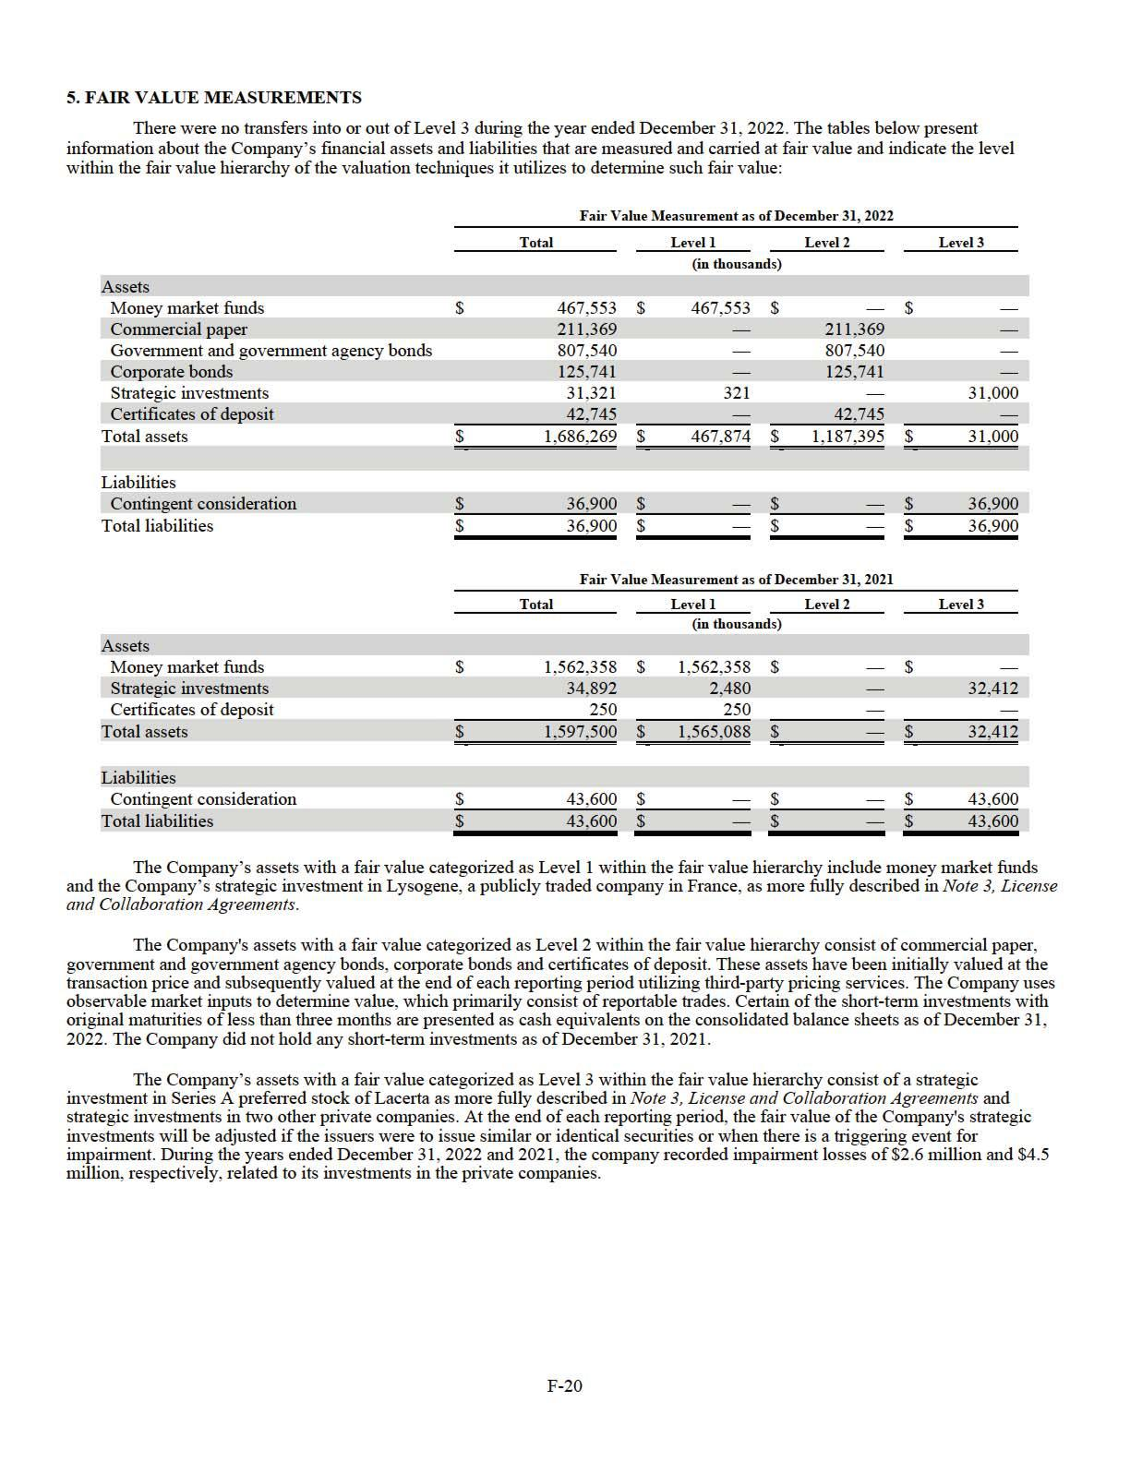

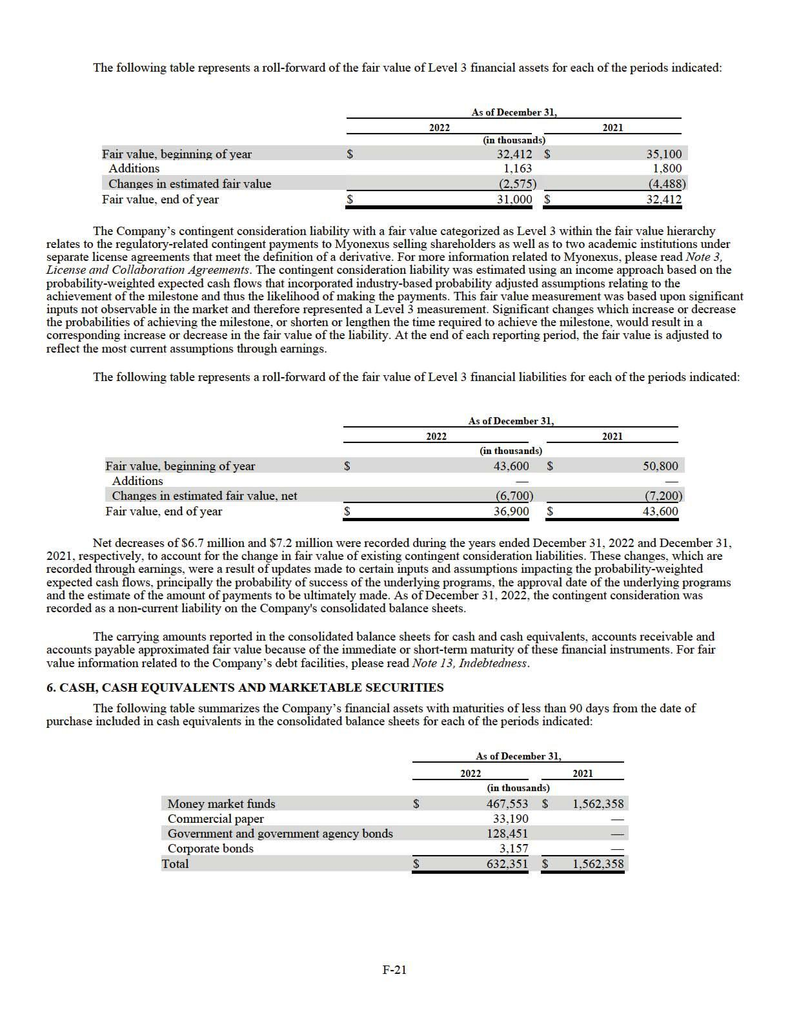

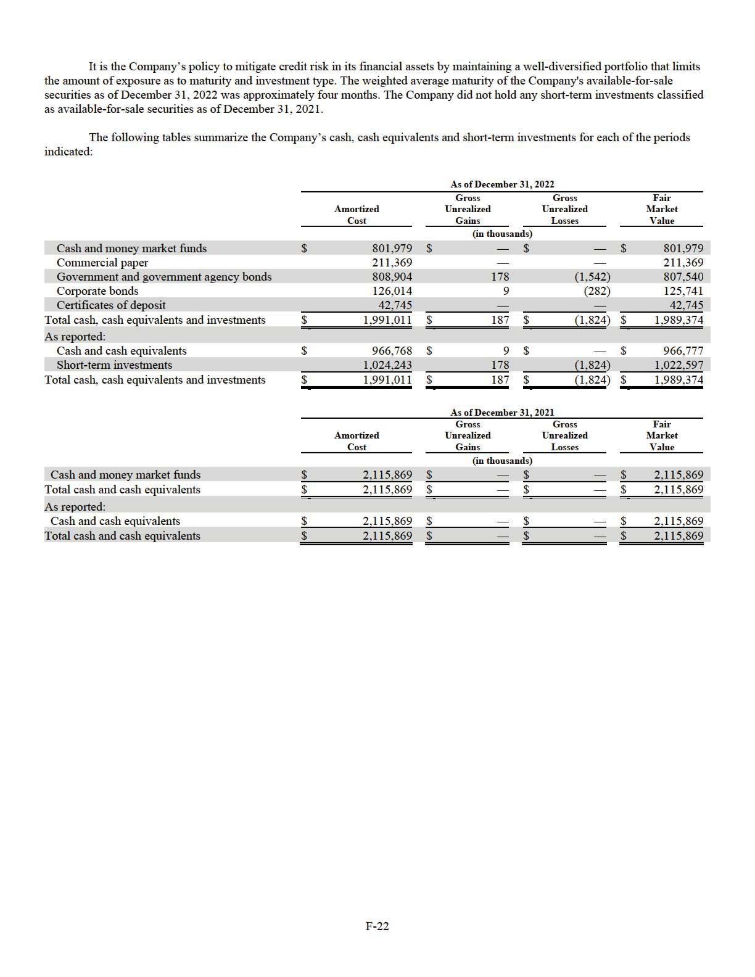

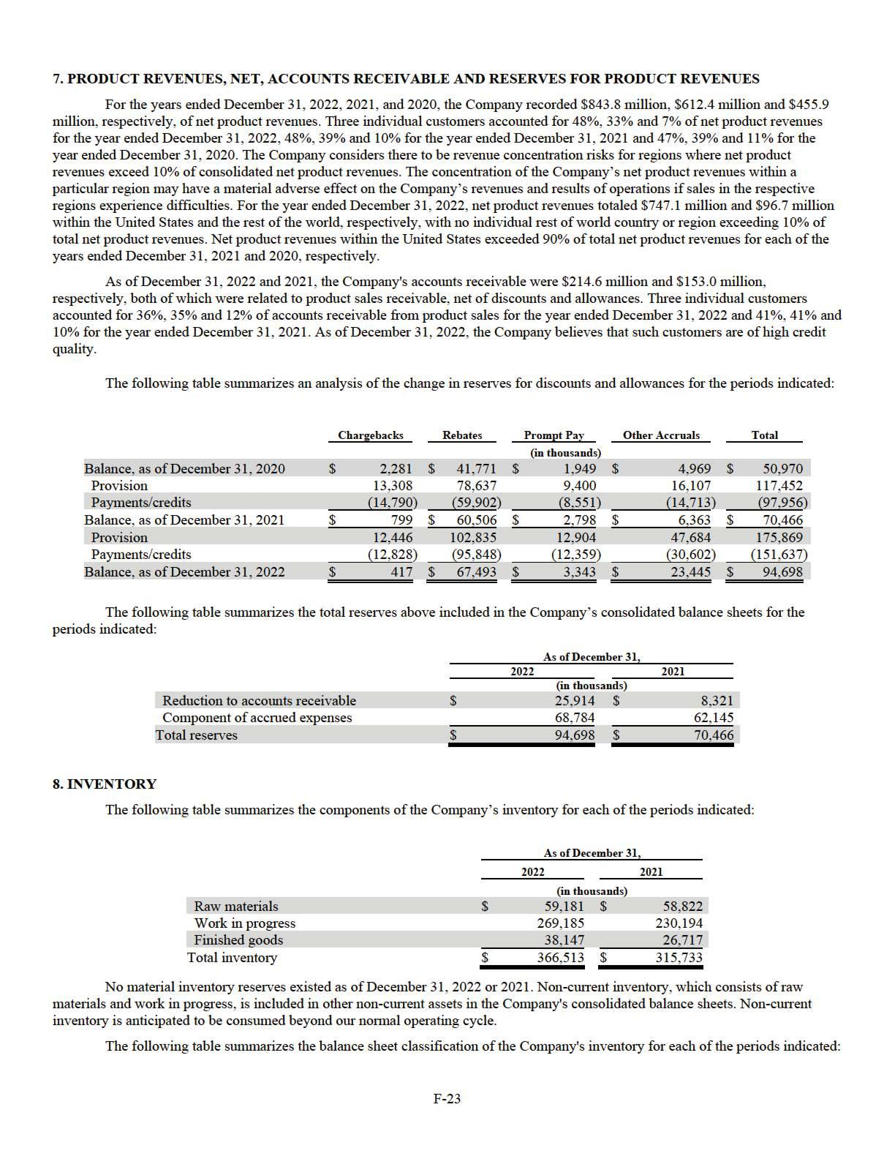

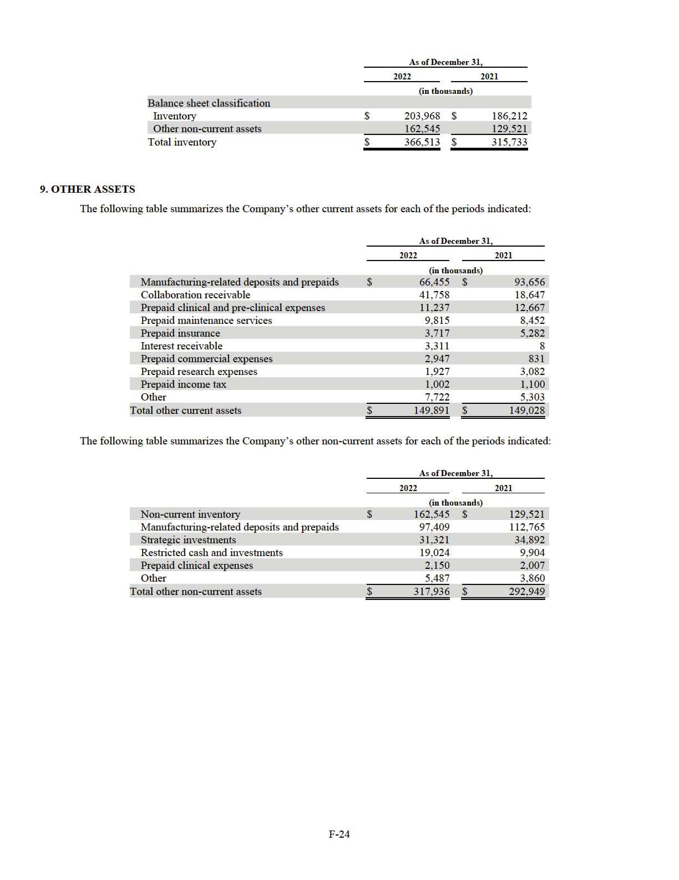

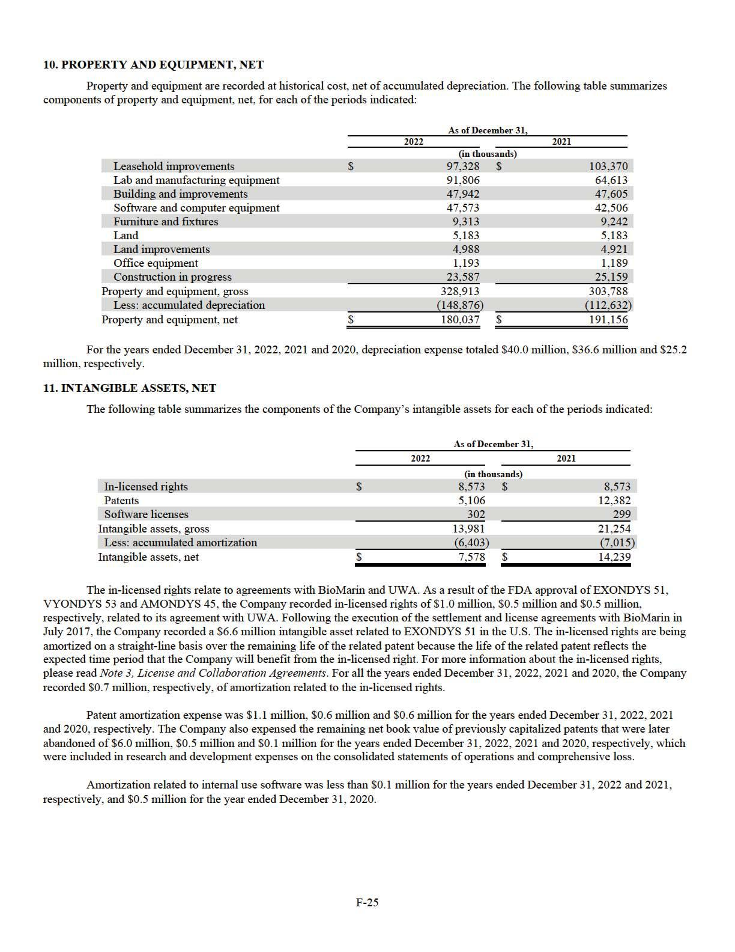

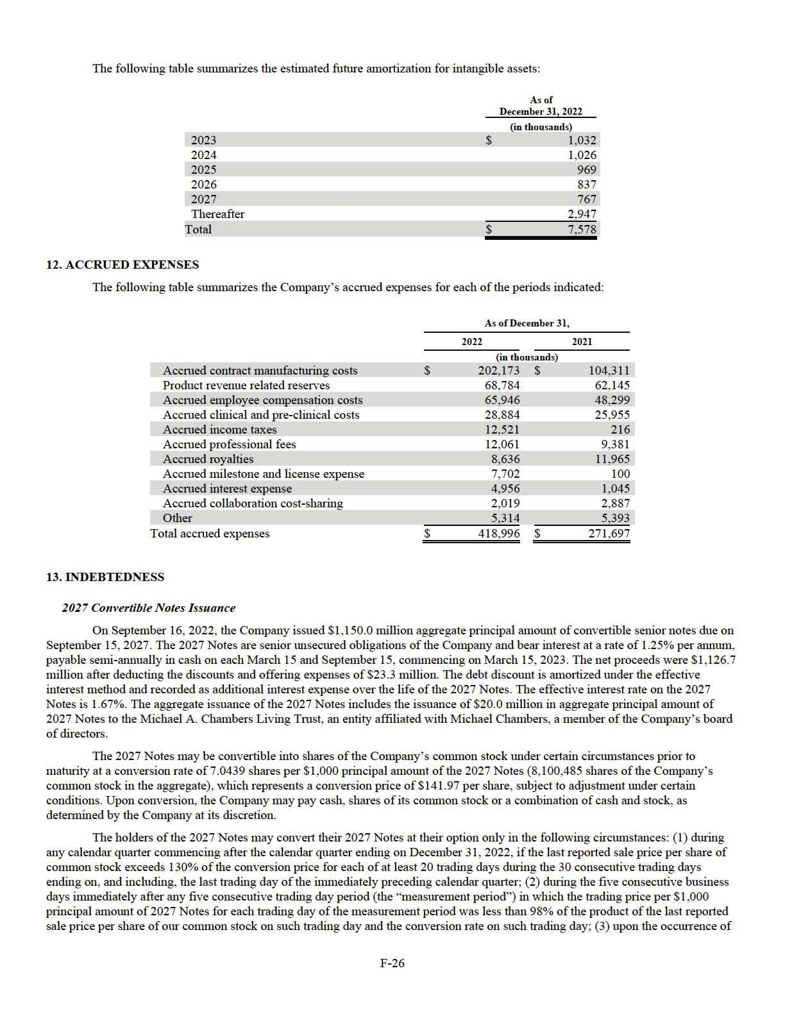

certain corporate events or distributions on the Company's common stock, as described in the indenture agreement; (4) if the Company calls such notes for redemption; and (5) at any time from, and including, March 15, 2027 until the close of business on the second trading day immediately before the maturity date.

The 2027 Notes are not redeemable by the Company prior to September 20, 2025. On or after September 20, 2025, the Company may redeem for cash all or any portion of the 2027 Notes at a redemption price equal to the principal amount of the 2027 Notes to be redeemed, plus accrued and unpaid interest, if the last reported sale price of the Company’s common stock exceeds 130% of the conversion price then in effect for at least 20 trading days (whether or not consecutive) during any 30 consecutive trading day period. Holders of the 2027 Notes have the right to require the Company to repurchase for cash all or a portion of their notes at 100% of its respective principal amount, plus any accrued and unpaid interest, upon the occurrence of a fundamental change as defined in the indenture agreement for the 2027 Notes. The 2027 Notes contain customary covenants and events of default, occurrence of which permits the holders to accelerate all outstanding obligations, including principal and interest.

2022 Capped Call Transactions

In connection with the issuance of the 2027 Notes, the Company entered into privately negotiated capped call transactions with counterparties intended to minimize the impact of potential dilution upon conversion of the 2027 Notes (the “2022 Capped Calls”). The 2022 Capped Calls have an initial strike price of approximately $141.97 per share, which corresponds to the initial conversion price of the 2027 Notes and is subject to anti-dilution adjustments generally similar to those applicable to the 2027 Notes and have a cap price of approximately $210.32 per share. The 2022 Capped Calls cover, subject to anti-dilution adjustments, 8,100,485 shares of the Company’s common stock, which is the same number of shares of the Company’s common stock initially underlying the 2027 Notes. If, upon conversion of the 2027 Notes, the price of the Company’s common stock is between the strike price and the cap price of the capped calls, the counterparties will deliver shares of the Company’s common stock and/or cash with an aggregate value equal to the difference between the price of the Company’s common stock at the conversion date and the strike price, multiplied by the number of shares of the Company’s common stock related to the capped calls being exercised. The Company paid $127.3 million for the 2022 Capped Calls, which was recorded within additional paid-in capital.

2024 Convertible Notes Issuance

On November 14, 2017, the Company issued $570.0 million aggregate principal amount of senior convertible notes due on November 15, 2024. The 2024 Notes are senior unsecured obligations of the Company and bear interest at a rate of 1.50% per annum, payable semi-annually in cash on each May 15 and November 15, commencing on May 15, 2018. The net proceeds were $559.4 million after deducting the discounts and offering expenses of $10.6 million. The debt discount is amortized under the effective interest method and recorded as additional interest expense over the life of the 2024 Notes. The effective interest rate on the 2024 Notes is 1.9%.

The 2024 Notes may be convertible into shares of the Company’s common stock under certain circumstances prior to maturity at a conversion rate of 13.621 shares per $1,000 principal amount of the 2024 Notes (7,763,970 shares of the Company's common stock in the aggregate), which represents a conversion price of $73.42 per share, subject to adjustment under certain conditions. Upon conversion, the Company may pay cash, shares of its common stock or a combination of cash and stock, as determined by the Company at its discretion.

The holders of the 2024 Notes may convert their 2024 Notes at their option only in the following circumstances: (1) during any calendar quarter commencing after the calendar quarter ending on December 31, 2017, if the last reported sale price per share of common stock exceeds 130% of the conversion price for each of at least 20 trading days during the 30 consecutive trading days ending on, and including, the last trading day of the immediately preceding calendar quarter; (2) during the five consecutive business days immediately after any five consecutive trading day period (the “measurement period”) in which the trading price per $1,000 principal amount of notes for each trading day of the measurement period was less than 98% of the product of the last reported sale price per share of our common stock on such trading day and the conversion rate on such trading day; (3) upon the occurrence of certain corporate events or distributions on the Company's common stock, as described in the indenture agreement; and (4) at any time from, and including, May 15, 2024 until the close of business on the scheduled trading day immediately before the maturity date.

The 2024 Notes are not redeemable by the Company prior to the maturity date. Holders of the 2024 Notes have the right to require the Company to repurchase for cash all or a portion of their notes at 100% of its respective principal amount, plus any accrued and unpaid interest, upon the occurrence of a fundamental change as defined in the indenture agreement for the 2024 Notes. The 2024 Notes contain customary covenants and events of default, occurrence of which permits the holders to accelerate all outstanding obligations, including principal and interest.

2017 Capped Call Transactions

In connection with the issuance of the 2024 Notes, the Company entered into privately negotiated capped call transactions with counterparties intended to minimize the impact of potential dilution upon conversion of the 2024 Notes (the “2017 Capped Calls”). The 2017 Capped Calls have an initial strike price of approximately $73.42 per share, which corresponds to the initial conversion price of the 2024 Notes and is subject to anti-dilution adjustments generally similar to those applicable to the 2024 Notes,

F-27

and have a cap price of approximately $104.88 per share. The 2017 Capped Calls initially covered, subject to anti-dilution adjustments, 7,763,970 shares of the Company’s common stock, which is the same number of shares of the Company’s common stock initially underlying the 2024 Notes. If, upon conversion of the 2024 Notes, the price of the Company’s common stock is between the strike price and the cap price of the capped calls, the counterparties will deliver shares of the Company’s common stock and/or cash with an aggregate value equal to the difference between the price of the Company’s common stock at the conversion date and the strike price, multiplied by the number of shares of the Company’s common stock related to the capped calls being exercised. The Company paid $50.9 million for the 2017 Capped Calls, which was recorded within additional paid-in capital.

2024 Notes Repurchase

In connection with the issuance of the 2027 Notes, on September 14, 2022, the Company entered into separate, privately negotiated transactions to repurchase a portion of the outstanding 2024 Notes. The holders exchanged $150.6 million in aggregate principal value of 2024 Notes held by them for an aggregate payment of $248.6 million for full settlement of the principal value and accrued interest on such date. The repurchase was not pursuant to the conversion privileges included in the terms of the debt at issuance and therefore was accounted for as a debt extinguishment. The Company accounted for the debt extinguishment by recognizing the difference between the reacquisition price of the debt and the net carrying amount of the extinguished debt as loss on debt extinguishment. Accordingly, on the repurchase date, the Company: (i) reduced the carrying value of repurchased 2024 Notes by $149.3 million, (ii) eliminated accrued interest of $0.8 million, and (iii) recorded $98.5 million of debt extinguishment expense which is included in the loss on debt extinguishment in consolidated statements of operations and comprehensive loss. The outstanding principal balance of the 2024 Notes as of December 31, 2022, after considering the repurchase discussed above, is $419.4 million, which is convertible into 5,712,253 shares of Company common stock.

2017 Capped Calls Partial Settlement

As a result of the repurchase of a portion of the 2024 Notes discussed above, on September 19, 2022, the Company entered into agreements with the 2017 Capped Calls counterparties to terminate a portion of the 2017 Capped Calls in a notional amount corresponding to the principal amount of the 2024 Notes repurchased. In connection with the termination, the Company received $26.3 million in cash from the counterparties, which was included within additional paid-in capital.

Termination of 2019 Term Loan

On September 16, 2022, using proceeds received from the issuance of the 2027 Notes described above, the Company prepaid in full all of its amounts outstanding with respect to the December 2019 term loan with Biopharma Credit PLC and Biopharma Credit Investments V (Master) LP (the "December 2019 Term Loan") and repaid in full all obligations due. The aggregate payoff amount was approximately $585.5 million, which includes $550.0 million of principal, additional loan consideration and premiums of $25.4 million, and accrued interest of $10.1 million through the repayment date. The loss on debt extinguishment was $26.9 million, and is included in the loss on debt extinguishment in the consolidated statements of operations and comprehensive loss.

Derivatives

Embedded derivatives are required to be separated from the host contract and accounted for as a derivative instrument if the economic characteristics and risk of the embedded derivative are not clearly and closely related to the economic characteristics and risks of the host contract and if a separate instrument with the same terms as the embedded derivative would be a derivative instrument subject to the scope of ASC 815. ASC 815 includes a scope exception for instruments issued by a reporting entity that are both (1) indexed to the reporting entity’s own stock and (2) classified in stockholders’ equity in the reporting entity’s statement of financial position.

All of the features of the 2027 Notes were evaluated to determine if separate accounting as a derivative instrument was required. The conversion feature in the 2027 Notes is indexed solely in the Company's common stock and since the Company retains the option to settle these notes in shares, the conversion feature qualified for a “scope exception” from treatment as a derivative since the conversion feature qualifies as “fixed for fixed”, meaning the settlement is equal to the difference between a fixed monetary amount of convertible notes and the fair value of a fixed number of the Company’s shares, and therefore, the Company did not separately account for it as a derivative. Other features of the notes, such as rights under certain default events, were not considered clearly and closely related to the economic characteristics and risks of the underlying debt host instrument, however, the fair value of these features were determined to be immaterial.

The capped calls are indexed solely to the Company’s common stock and classified in stockholders’ equity since Sarepta retains the right to receive shares if there is an exercise of the capped call options. The premiums paid for the capped call options, equal to their fair value at inception, were recorded as a reduction to additional paid-in capital.

Total Debt Obligations

As of December 31, 2022 and 2021, the Company recorded approximately $1,544.3 million and $1,096.9 million as long-term debt on the consolidated balance sheets. For the years ended December 31, 2022, 2021 and 2020, the Company recorded $ 53.2 million, $63.5 million and $59.9 million of contractual interest expense, respectively. Contractual interest expense for the years ended

F-28

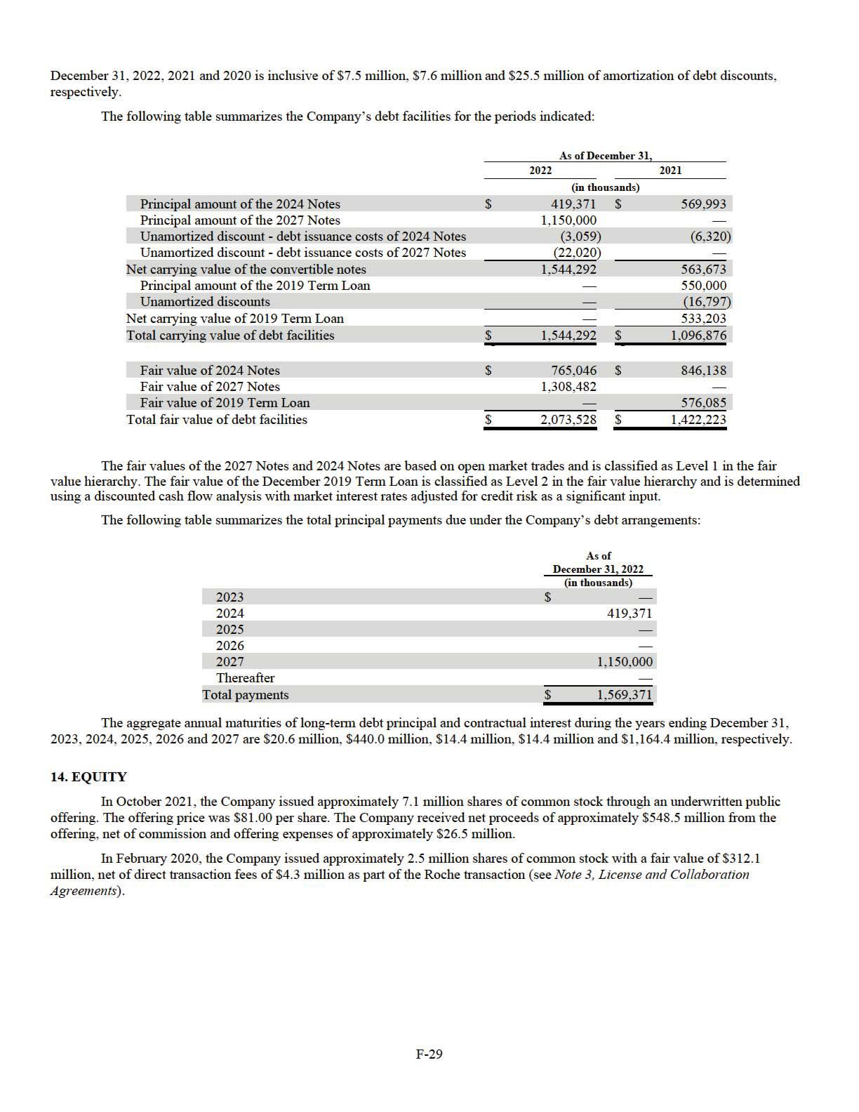

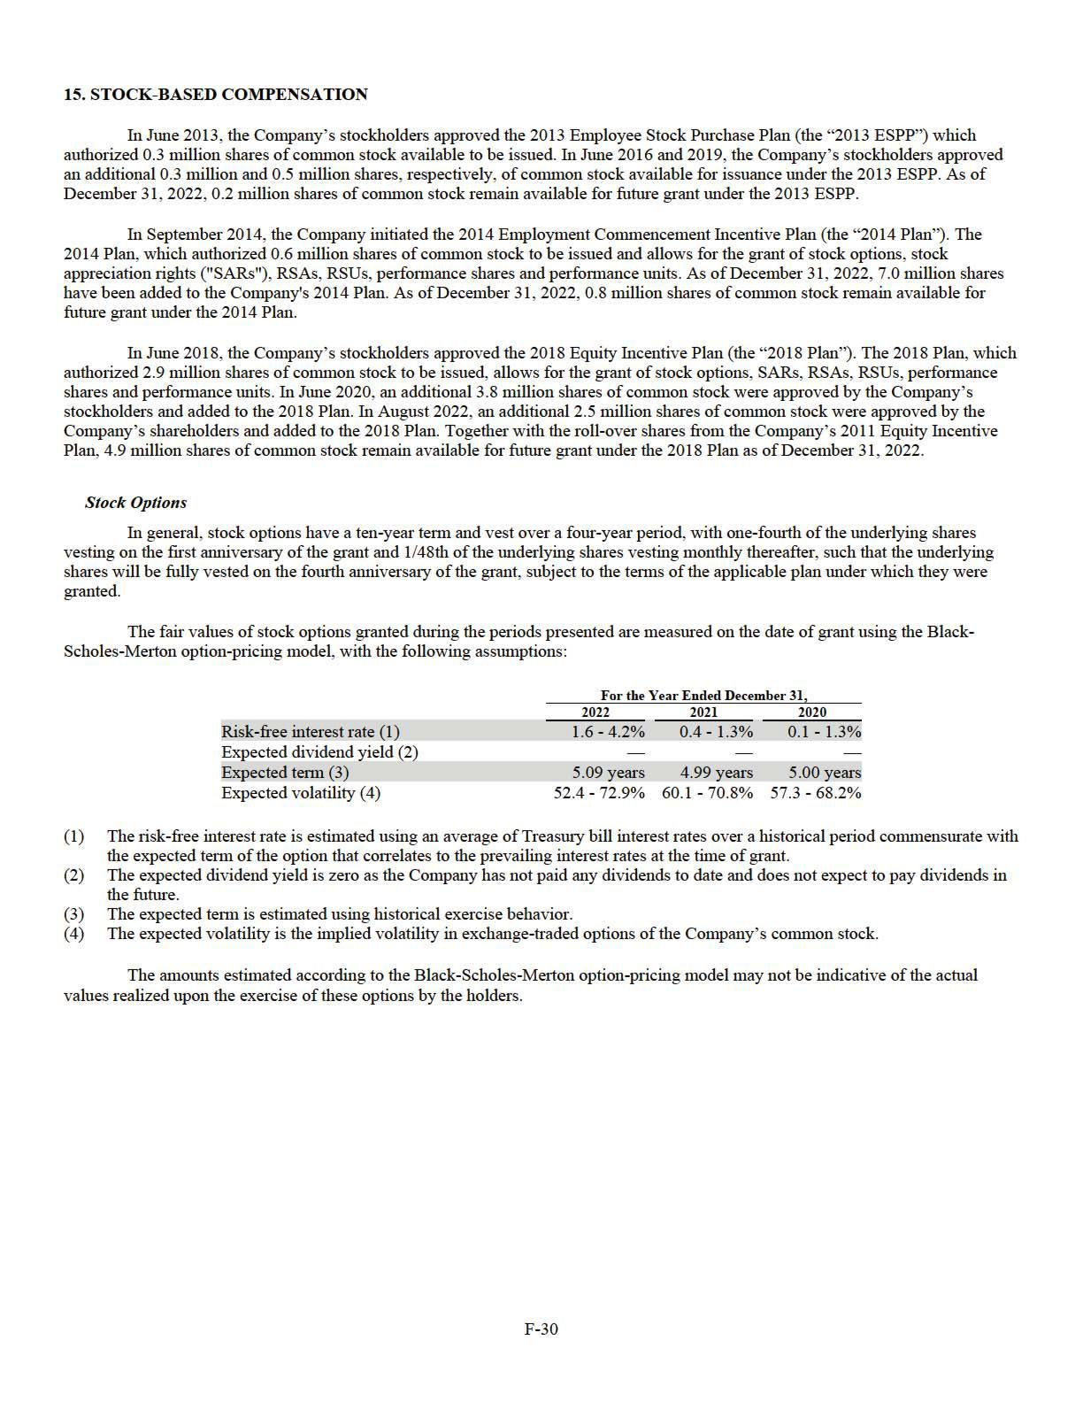

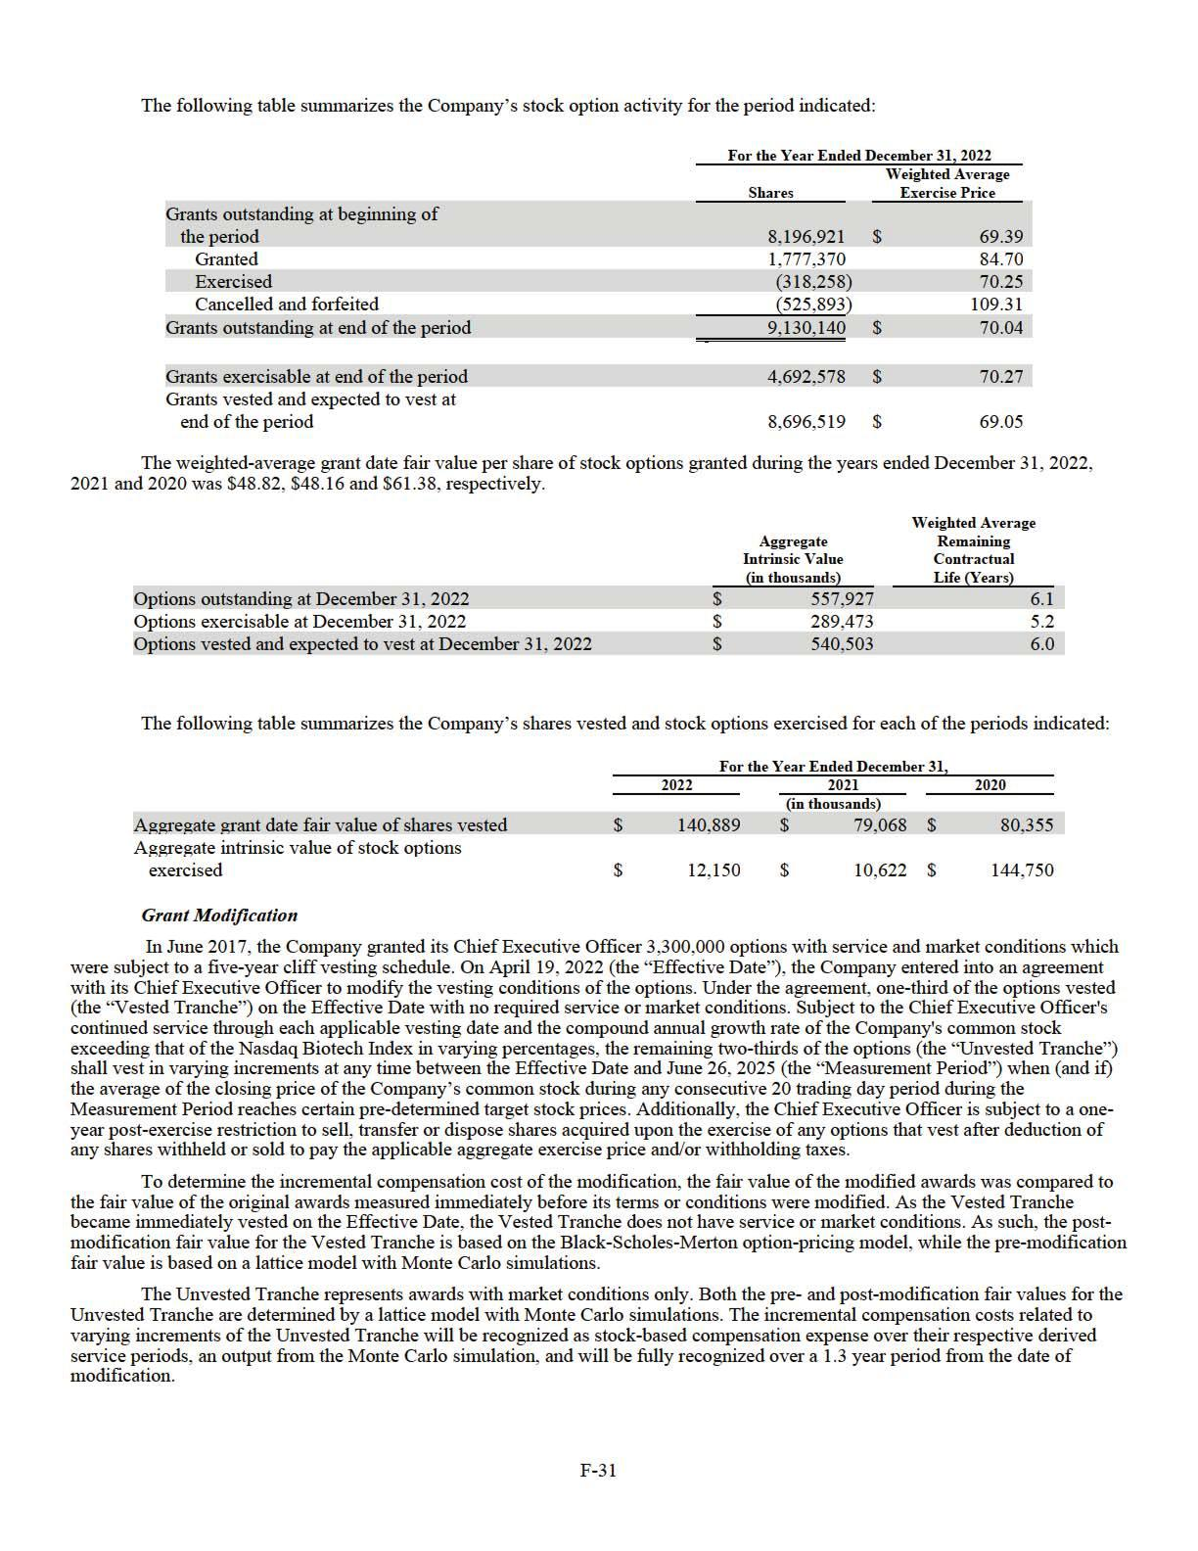

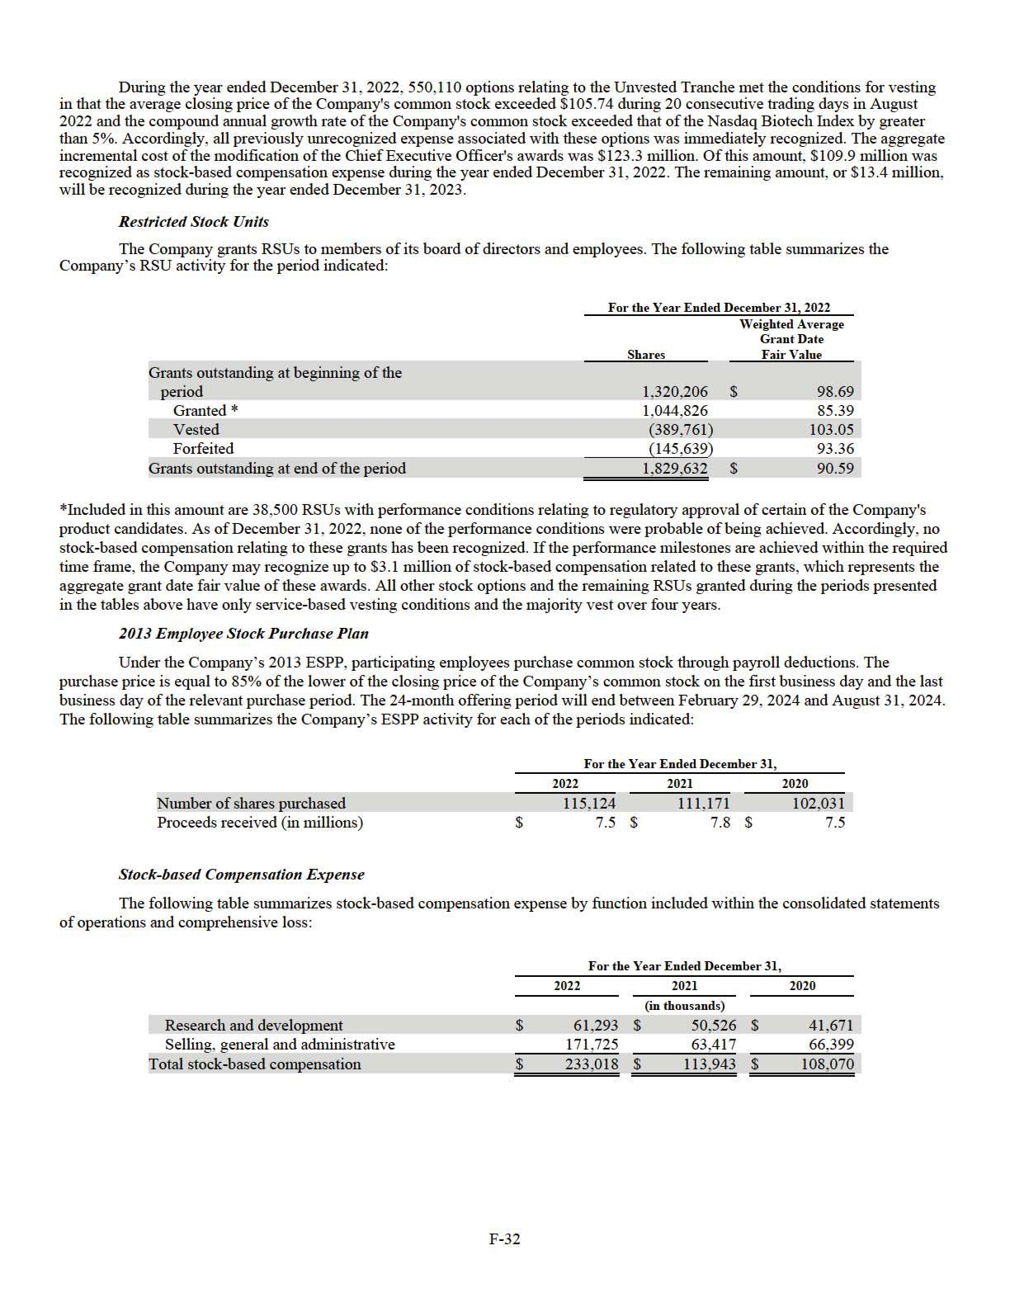

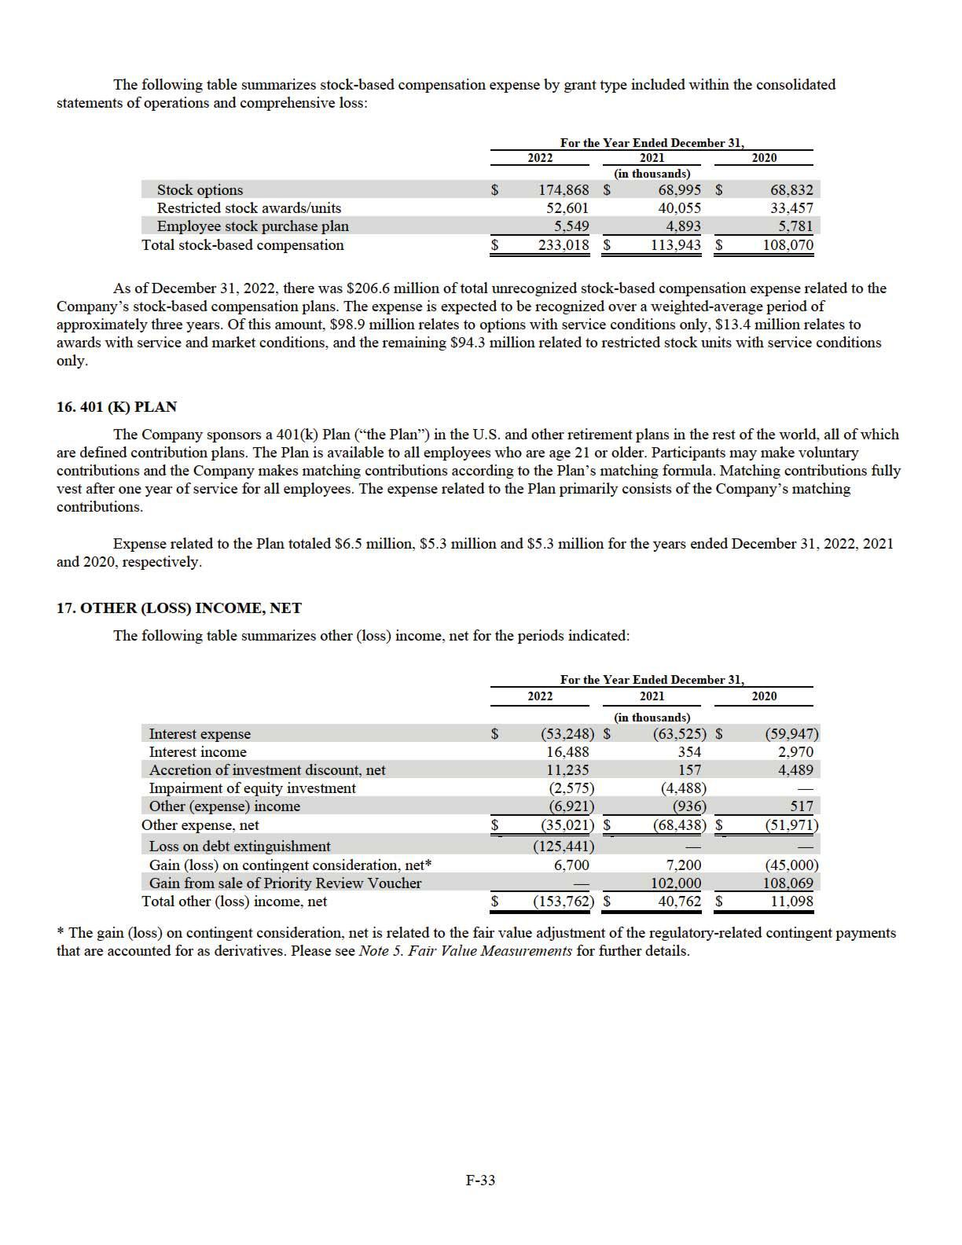

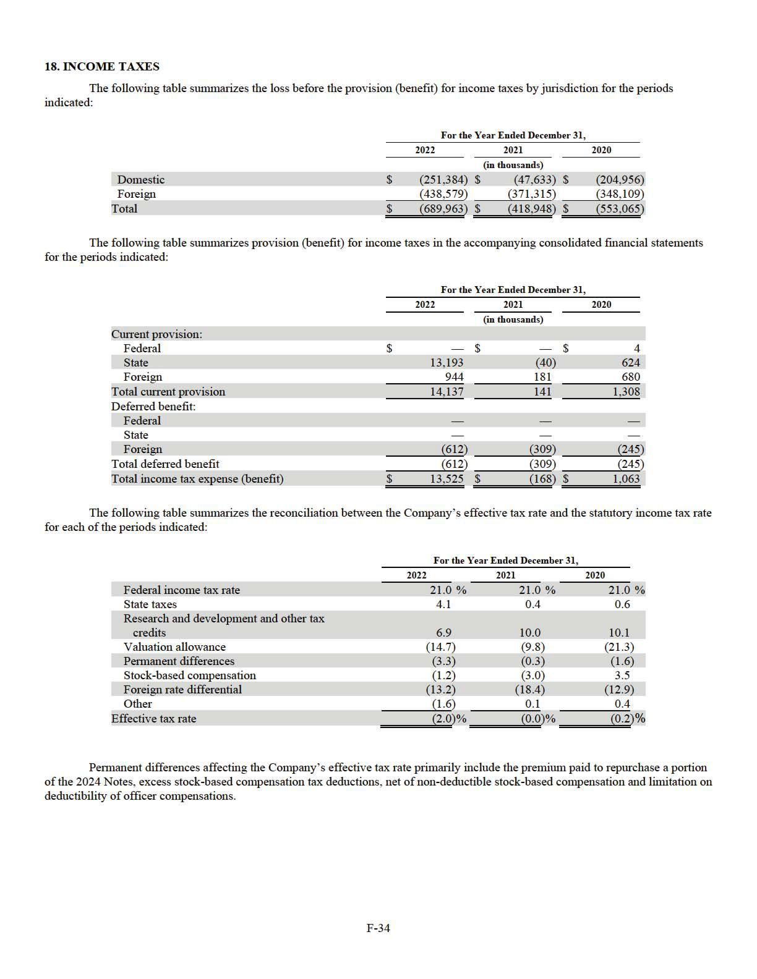

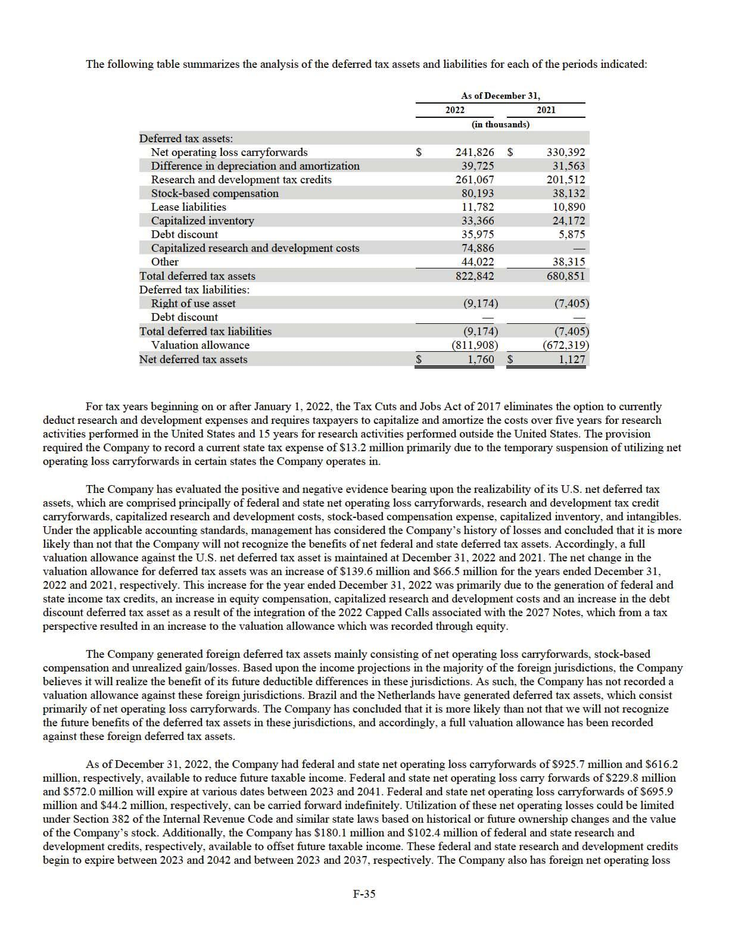

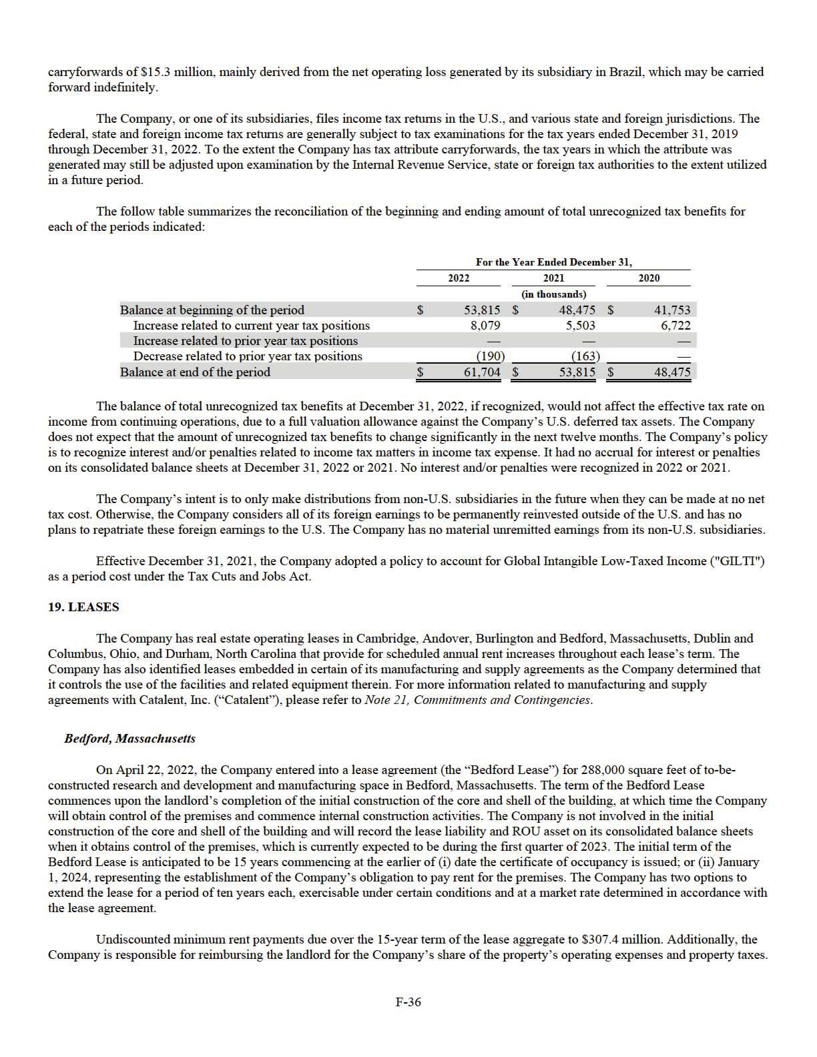

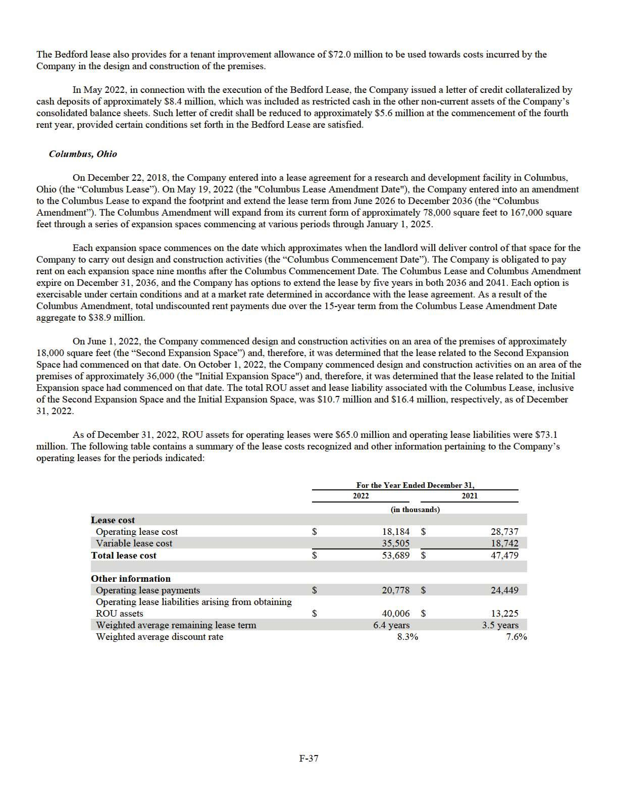

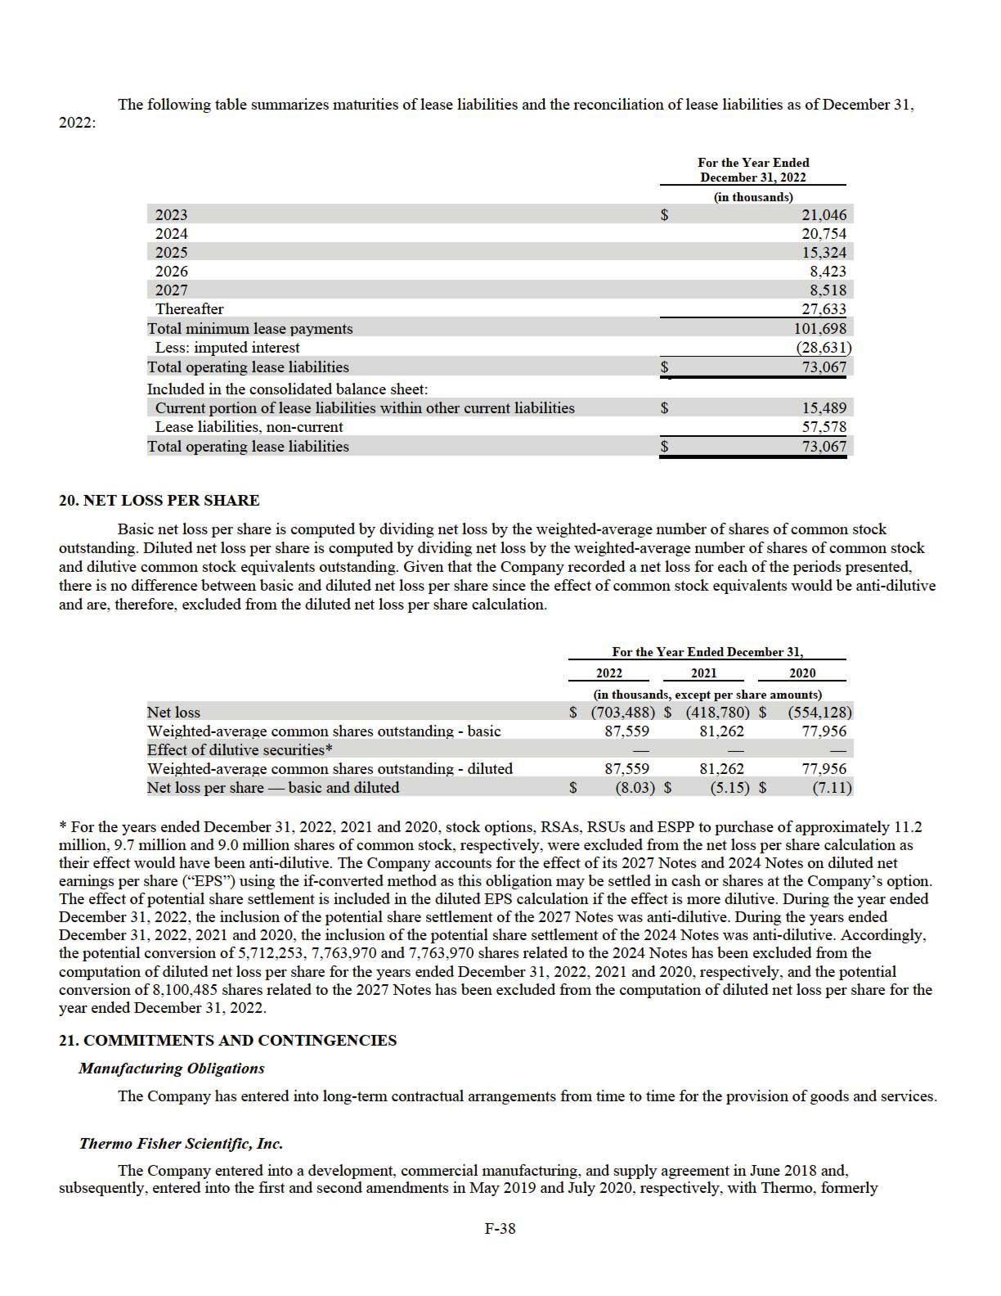

Brammer Bio MA, LLC (collectively, the “Thermo Agreements”). Pursuant to the terms of the Thermo Agreements, the Company had access to substantially all of the facility’s eight clean room suites for the Company’s gene therapy programs, subject to certain minimum and maximum volume limitations. The Company determined that the Thermo Agreements contained a lease because the Company had the right to direct the use of the facility and related equipment therein. The lease on four of the eight dedicated clean room suites at Thermo commenced during 2020 and the remaining four commenced during 2021, which is when the dedicated clean room suites became available for use by the Company.

In October 2021, the Company executed a third amendment (the “Amendment”) that modified the terms of the Thermo Agreements. The modification significantly decreased the Company’s right of use of the facility’s capacity and significantly reduced the fixed and in-substance fixed payments due over the remaining term of the agreement. The modification was accounted for as a lease termination, resulting in: (i) the derecognition of right of use assets of $23.4 million, (ii) the derecognition of lease liabilities of $20.1 million, and (iii) the recognition of a loss of $3.3 million, which is included in research and development expense. In addition, as a result of the capacity changes associated with the Amendment, $21.1 million of accelerated amortization of nonrefundable advance payments made to Thermo that were previously recorded as other assets in the accompanying consolidated balance sheets were charged to research and development expense for the year ended December 31, 2021.

Under the Amendment, the Thermo Agreements will expire on December 31, 2028, or earlier if certain conditions are met. The Company has the ability to extend the term with an 18-months’ notice and an agreement between the two parties. The Company also has the ability to terminate the Thermo Agreements prior to expiration, subject to the payment of additional financial consideration. Further, the Company has committed to guaranteed purchases under the Amendment on a take-or-pay basis regardless of whether services or goods are ordered. During the year ended December 31, 2022, the Company did not satisfy the total guaranteed purchase requirements in the fiscal year 2022. As such, the Company recognized a loss of approximately $54.0 million during the year ended December 31, 2022, reflecting the estimated shortfall related to the annual guaranteed purchase requirement for the manufacturing and supply of gene therapy materials. The loss has been classified as research and development expense in the accompanying consolidated statement of operations and comprehensive loss for the year ended December 31, 2022, with the outstanding liability reflected as accrued contract manufacturing costs within accrued expenses in the consolidated balance sheets as of December 31, 2022. No similar losses were incurred in 2021 or 2020.

Catalent, Inc.

The Company entered into a manufacturing collaboration agreement and, subsequently, entered into a manufacturing and supply agreement with Catalent, formerly Paragon Biosciences, Inc. in October 2018 and February 2019, respectively (collectively, the “Catalent Agreements”). Pursuant to the terms of the Catalent Agreements, Catalent agreed to provide the Company with two dedicated clean room suites and an option to reserve two additional clean room suites for its gene therapy programs, subject to certain minimum and maximum volume limitations. In September 2019, the Company exercised the option to gain access to the two additional clean room suites. The Catalent Agreements will expire on December 31, 2024. The Company has the ability to terminate the Catalent Agreements prior to expiration, subject to the payment of additional financial consideration. The Company determined that the Catalent Agreements contained a lease because the Company had the right to direct the use of the facility and related equipment therein. The lease on all four dedicated clean room suites at Catalent commenced during 2020, which is when the dedicated clean room suites became available for use by the Company.

In March 2021, the Company modified the terms of the Catalent Agreements. The modification decreased the Company’s right of use of certain dedicated clean room suites and reduced the fixed and in-substance fixed payments due over the remaining term of the agreement. The modification was accounted for as a partial lease termination, resulting in: (i) the derecognition of right of use assets of $22.8 million, (ii) the derecognition of lease liabilities of $20.0 million, and (iii) the recognition of a loss of $2.8 million, which is included in research and development expense.

In November 2022, the Company further modified certain terms of the Catalent Agreements which extended the term of the agreement through December 31, 2028. The extension of the term of the agreement resulted in no change to the Company’s right of use of certain dedicated clean room suites other than the length of the term and extended no additional control over other suites at the date of modification. The change in the term of the Catalent Agreements represents a modification of the existing embedded lease over certain clean room suites. The modification resulted in the following: (i) the recognition of additional right of use assets of $19.2 million, (ii) the recognition of additional lease liabilities of $ 19.2 million, and (iii) a $3.9 million increase to long-term deposits manufacturing and a corresponding $3.9 million decrease to short-term deposits manufacturing, which are included in other current assets and other non-current assets, respectively, within the consolidated balance sheets. The modification also removed certain fixed payments due over the remaining term of the agreement. Further, in order to maintain the Company's dedicated clean room suites, it has committed to guaranteed purchases under the Amendment on a take-or-pay basis regardless of whether services or goods are ordered. As of December 31, 2022, the Company believes it is probable that the guaranteed purchase requirements will be met in the normal course of business throughout the term of the Catalent Agreements.

F-39

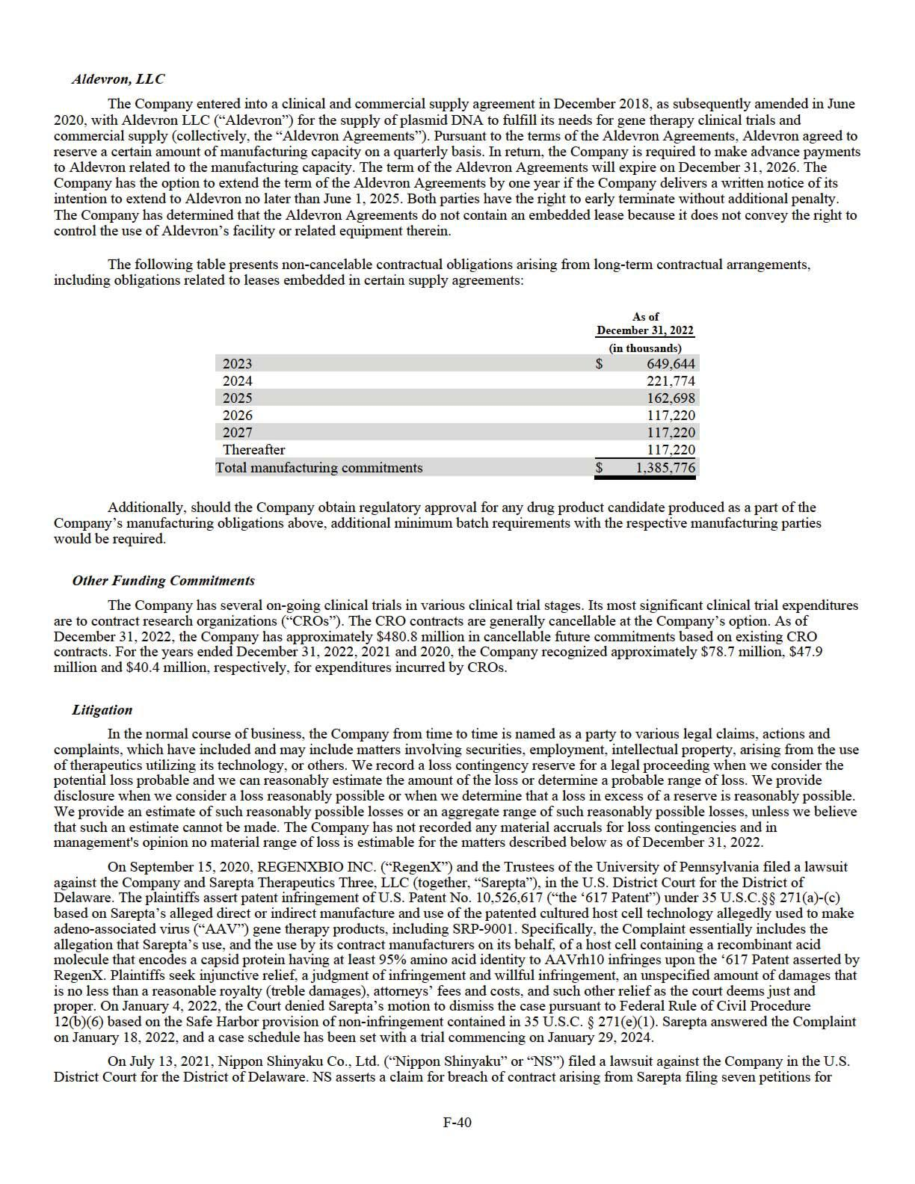

Inter Partes Review (“IPR Petitions”) with the Patent Trial and Appeal Board at the USPTO (PTAB Case Nos. IPR2021-01134, IPR2021-01135, IPR2021-01136, IPR2021-01137, IPR2021-01138, IPR2021-01139, IPR2021-01140) in which Sarepta sought to invalidate certain NS patents concerning exon 53 skipping technology (U.S. Patent Nos. 9,708,361, 10,385,092, 10,407,461, 10,487,106, 10,647,741, 10,662,217, and 10,683,322, respectively, and collectively the “NS Patents”). In addition, NS asserts claims for patent infringement and willful infringement of each of the NS Patents allegedly arising from Sarepta’s activities, including the sale of, its exon 53 skipping product, VYONDYS 53 (golodirsen). NS further seeks a determination of non-infringement by NS alleged to arise from NS’s activities, including the sale of, its exon 53 skipping product, Viltepso (viltolarsen) and invalidity of certain patents licensed to the Company from University of Western Australia (“UWA”) (U.S. Patent Nos. 9,994,851, 10,227,590, and 10,266,827, collectively the “UWA Patents”). NS is seeking legal fees and costs, an unspecified amount of monetary relief (treble damages) attributed to Sarepta’s alleged infringement, and such other relief as the court deems just and proper. In January 2022, the PTAB granted institution of all claims of all NS Patents in response to Sarepta’s IPR Petitions and determined that Sarepta has demonstrated a reasonable likelihood of success in proving that the NS Patents are unpatentable. NS filed a motion for preliminary injunction solely seeking Sarepta’s withdrawal of the IPR Petitions, which was ultimately granted after the U.S. Court of Appeals for the Federal Circuit reversed and remanded to the district court on February 8, 2022. Sarepta subsequently withdrew the IPRs, which were terminated on June 14, 2022. On December 27, 2021, the district court partially granted and denied the motion to dismiss by Sarepta and ordered NS to file a Second Amended Complaint (“SAC”), which it did on January 14, 2022. In the SAC, NS maintains all claims of the original complaint of July 13, 2021, except a determination of non -infringement of the UWA Patents. On January 28, 2022, Sarepta filed its answer to the SAC, with defenses and counterclaims against NS and NS Pharma Inc. that include infringement of the UWA Patents allegedly arising from their activities concerning, including the sale of, its exon 53 skipping product, Viltepso (viltolarsen) and breach of contract. Sarepta is also seeking a determination of invalidity of the NS Patents. Sarepta is seeking an award of relief in its defenses to NS’ allegations, a judgment of breach of contract, a determination of invalidity of the NS Patents, a judgment of infringement and willful infringement of the UWA Patents, legal fees and costs, an unspecified amount of monetary relief (treble damages) attributable to NS’ alleged infringement, and such other relief as the court deems just and proper. The Court entered a scheduling order with a trial scheduled to commence on May 13, 2024.

F-41

EXHIBIT 21.1

 | Sarepta Therapeutics, Inc.
Subsidiaries of the Registrant
Name | Jurisdiction of Incorporation
Sarepta Securities Corp. | Massachusetts, USA
ST International Holdings Two, Inc. | Delaware, USA
Sarepta Therapeutics Three, LLC | Delaware, USA

EXHIBIT 23.1

Consent of Independent Registered Public Accounting Firm

We consent to the incorporation by reference in the registration statements (Nos. 333-234698 and 333-263208) on Form S-3ASR and (Nos. 333-101826, 333-172823, 333-175031, 333-192287, 333-199037, 333-209710, 333-213022, 333-34047, 333-49994, 333-221271, 333-228719, 333-233715, 333-240996 and 333-266461) on Form S-8 of our report dated February 28, 2023, with respect to the consolidated financial statements of Sarepta Therapeutics, Inc. and the effectiveness of internal control over financial reporting.

/s/ KPMG LLP

Boston, Massachusetts

February 28, 2023

EXHIBIT 31.1

CERTIFICATION

I, Douglas S. Ingram, certify that:

- I have reviewed this Annual Report on Form 10-K of Sarepta Therapeutics, Inc., (the “Registrant”);

- Based on my knowledge, this report does not contain any untrue statement of a material fact or omit to state a material fact necessary to make the statements made, in light of the circumstances under which such statements were made, not misleading with respect to the period covered by this report;

- Based on my knowledge, the financial statements, and other financial information included in this report, fairly present in all material respects the financial condition, results of operations and cash flows of the Registrant as of, and for, the periods presented in this report;

- The Registrant’s other certifying officer and I are responsible for establishing and maintaining disclosure controls and procedures (as defined in Exchange Act Rules 13a-15(e) and 15d-15(e)) and internal control over financial reporting (as defined in Exchange Act Rules 13a-15(f) and 15d-15(f)) for the Registrant and have:

- Designed such disclosure controls and procedures, or caused such disclosure controls and procedures to be designed under our supervision, to ensure that material information relating to the Registrant, including its consolidated subsidiaries, is made known to us by others within those entities, particularly during the period in which this report is being prepared;

- Designed such internal control over financial reporting, or caused such internal control over financial reporting to be designed under our supervision, to provide reasonable assurance regarding the reliability of financial reporting and the preparation of financial statements for external purposes in accordance with generally accepted accounting principles;

- Evaluated the effectiveness of the Registrant’s disclosure controls and procedures and presented in this report our conclusions about the effectiveness of the disclosure controls and procedures, as of the end of the period covered by this report based on such evaluation; and

- Disclosed in this report any change in the Registrant’s internal control over financial reporting that occurred during the Registrant’s most recent fiscal quarter (the Registrant’s fourth fiscal quarter in the case of an annual report) that has materially affected, or is reasonably likely to materially affect, the Registrant’s internal control over financial reporting; and

  - The Registrant’s other certifying officer and I have disclosed, based on our most recent evaluation of internal control over financial reporting, to the Registrant’s auditors and the audit committee of the Registrant’s board of directors (or persons performing the equivalent functions):

    - All significant deficiencies and material weaknesses in the design or operation of internal control over financial reporting which are reasonably likely to adversely affect the Registrant’s ability to record, process, summarize and report financial information; and

    - Any fraud, whether or not material, that involves management or other employees who have a significant role in the Registrant’s internal control over financial reporting.

February 28, 2023 | /s/ Douglas S. Ingram
 |  | Douglas S. Ingram
 |  | President and Chief Executive Officer
 |  | (Principal Executive Officer)

EXHIBIT 31.2

CERTIFICATION

I, Ian M. Estepan, certify that:

- I have reviewed this Annual Report on Form 10-K of Sarepta Therapeutics, Inc., (the “Registrant”);

- Based on my knowledge, this report does not contain any untrue statement of a material fact or omit to state a material fact necessary to make the statements made, in light of the circumstances under which such statements were made, not misleading with respect to the period covered by this report;

- Based on my knowledge, the financial statements, and other financial information included in this report, fairly present in all material respects the financial condition, results of operations and cash flows of the Registrant as of, and for, the periods presented in this report;

- The Registrant’s other certifying officer and I are responsible for establishing and maintaining disclosure controls and procedures (as defined in Exchange Act Rules 13a-15(e) and 15d-15(e)) and internal control over financial reporting (as defined in Exchange Act Rules 13a-15(f) and 15d-15(f)) for the Registrant and have:

- Designed such disclosure controls and procedures, or caused such disclosure controls and procedures to be designed under our supervision, to ensure that material information relating to the Registrant, including its consolidated subsidiaries, is made known to us by others within those entities, particularly during the period in which this report is being prepared;

- Designed such internal control over financial reporting, or caused such internal control over financial reporting to be designed under our supervision, to provide reasonable assurance regarding the reliability of financial reporting and the preparation of financial statements for external purposes in accordance with generally accepted accounting principles;

- Evaluated the effectiveness of the Registrant’s disclosure controls and procedures and presented in this report our conclusions about the effectiveness of the disclosure controls and procedures, as of the end of the period covered by this report based on such evaluation; and

- Disclosed in this report any change in the Registrant’s internal control over financial reporting that occurred during the Registrant’s most recent fiscal quarter (the Registrant’s fourth fiscal quarter in the case of an annual report) that has materially affected, or is reasonably likely to materially affect, the Registrant’s internal control over financial reporting; and

  - The Registrant’s other certifying officer and I have disclosed, based on our most recent evaluation of internal control over financial reporting, to the Registrant’s auditors and the audit committee of the Registrant’s board of directors (or persons performing the equivalent functions):

    - All significant deficiencies and material weaknesses in the design or operation of internal control over financial reporting which are reasonably likely to adversely affect the Registrant’s ability to record, process, summarize and report financial information; and

    - Any fraud, whether or not material, that involves management or other employees who have a significant role in the Registrant’s internal control over financial reporting.

February 28, 2023 | /s/ Ian M. Estepan
 | Ian M. Estepan
 | Executive Vice President, Chief Financial Officer
 | (Principal Financial and Accounting Officer)

EXHIBIT 32.1

CERTIFICATION PURSUANT TO

SECTION 906 OF THE SARBANES-OXLEY ACT OF 2002
(18 U.S.C. SECTION 1350)

I, Douglas S. Ingram, certify, pursuant to 18 U.S.C. Section 1350, as adopted pursuant to Section 906 of the Sarbanes-Oxley Act of 2002, that the Annual Report of Sarepta Therapeutics, Inc. on Form 10-K for the fiscal year ended December 31, 2022, fully complies with the requirements of Section 13(a) or 15(d) of the Securities Exchange Act of 1934 and that information contained in such Annual Report on Form 10-K fairly presents, in all material respects, the financial condition and results of operations of Sarepta Therapeutics, Inc.

February 28, 2023 | /s/ Douglas S. Ingram
 |  | Douglas S. Ingram
 |  | President and Chief Executive Officer
 |  | (Principal Executive Officer)

A signed original of this written statement required by Section 906 of the Sarbanes-Oxley Act of 2002 has been provided to Sarepta Therapeutics, Inc. and will be retained by Sarepta Therapeutics, Inc. and furnished to the Securities and Exchange Commission or its staff upon request.

This certification accompanies this Report on Form 10-K pursuant to Section 906 of the Sarbanes-Oxley Act of 2002 and shall not, except to the extent required by such Act, be deemed filed by Sarepta Therapeutics, Inc. for purposes of Section 18 of the Securities Exchange Act of 1934, as amended (the “Exchange Act”). Such certification will not be deemed to be incorporated by reference into any filing under the Securities Act of 1933, as amended, or the Exchange Act, except to the extent that Sarepta Therapeutics, Inc. specifically incorporates it by reference.

EXHIBIT 32.2

CERTIFICATION PURSUANT TO

SECTION 906 OF THE SARBANES-OXLEY ACT OF 2002
(18 U.S.C. SECTION 1350)

I, Ian M. Estepan, certify, pursuant to 18 U.S.C. Section 1350, as adopted pursuant to Section 906 of the Sarbanes-Oxley Act of 2002, that the Annual Report of Sarepta Therapeutics, Inc. on Form 10-K for the fiscal year ended December 31, 2022, fully complies with the requirements of Section 13(a) or 15(d) of the Securities Exchange Act of 1934 and that information contained in such Annual Report on Form 10-K fairly presents, in all material respects, the financial condition and results of operations of Sarepta Therapeutics, Inc.

February 28, 2023 | /s/ Ian M. Estepan
 | Ian M. Estepan
 | Executive Vice President, Chief Financial Officer
 | (Principal Financial and Accounting Officer)

A signed original of this written statement required by Section 906 of the Sarbanes-Oxley Act of 2002 has been provided to Sarepta Therapeutics, Inc. and will be retained by Sarepta Therapeutics, Inc. and furnished to the Securities and Exchange Commission or its staff upon request.

This certification accompanies this Report on Form 10-K pursuant to Section 906 of the Sarbanes-Oxley Act of 2002 and shall not, except to the extent required by such Act, be deemed filed by Sarepta Therapeutics, Inc. for purposes of Section 18 of the Securities Exchange Act of 1934, as amended (the “Exchange Act”). Such certification will not be deemed to be incorporated by reference into any filing under the Securities Act of 1933, as amended, or the Exchange Act, except to the extent that Sarepta Therapeutics, Inc. specifically incorporates it by reference.

