UNITED STATES

SECURITIES AND EXCHANGE COMMISSION

Washington, D.C. 20549

FORM 10-K

(Mark One)

- ANNUAL REPORT PURSUANT TO SECTION 13 OR 15(d) OF THE SECURITIES EXCHANGE ACT OF 1934

For the fiscal year ended December 31, 2025

OR
- TRANSITION REPORT PURSUANT TO SECTION 13 OR 15(d) OF THE SECURITIES EXCHANGE ACT OF 1934

FOR THE TRANSITION PERIOD FROM TO

Commission File Number : 001-14895

Sarepta Therapeutics, Inc.

(Exact name of registrant as specified in its charter)

Delaware | 93-0797222
(State or other jurisdiction of | (I.R.S. Employer
incorporation or organization) | Identification Number)
215 First Street
Suite 415
Cambridge, MA | 02142
(Address of principal executive offices) | (Zip Code)
Registrant’s telephone number, including area code: (617) 274-4000

Securities registered pursuant to Section 12(b) of the Act:

Title of each class | Trading | Name of each exchange on which registered
Title of each class | Symbol(s) | Name of each exchange on which registered

Common Stock, $0.0001 par value |  | SRPT |  | The NASDAQ Stock Market LLC
 |  |  |  | (The NASDAQ Global Select Market)
Securities registered pursuant to Section 12(g) of the Act: None
Indicate by check mark if the Registrant is a well-known seasoned issuer, as defined in Rule 405 of the Securities Act. YES ☒ NO ☐ Indicate by check mark if the Registrant is not required to file reports pursuant to Section 13 or 15(d) of the Act. YES ☐ NO ☒
Indicate by check mark whether the Registrant: (1) has filed all reports required to be filed by Section 13 or 15(d) of the Securities Exchange Act of 1934 during the preceding 12 months (or for such shorter period that the Registrant was required to file such reports), and (2) has been subject to such filing requirements for the past 90
days. YES ☒ NO ☐

Indicate by check mark whether the Registrant has submitted electronically every Interactive Data File required to be submitted pursuant to Rule 405 of Regulation S-T (§232.405 of this chapter) during the preceding 12 months (or for such shorter period that the Registrant was required to submit such files). YES ☒ NO ☐
Indicate by check mark whether the registrant is a large accelerated filer, an accelerated filer, a non-accelerated filer, smaller reporting company, or an emerging growth company. See the definitions of “large accelerated filer,” “accelerated filer,” “smaller reporting company,” and “emerging growth company” in Rule 12b-2 of the Exchange Act.

Large accelerated filer | ☒ | Accelerated filer | ☐
Non-accelerated filer | ☐ | Smaller reporting company | ☐
Emerging growth company | ☐
If an emerging growth company, indicate by check mark if the registrant has elected not to use the extended transition period for complying with any new or revised financial accounting standards provided pursuant to Section 13(a) of the Exchange Act. ☐
Indicate by check mark whether the registrant has filed a report on and attestation to its management’s assessment of the effectiveness of its internal control over financial reporting under Section 404(b) of the Sarbanes-Oxley Act (15 U.S.C. 7262(b)) by the registered public accounting firm that prepared or issued its audit report.

☒

If securities are registered pursuant to Section 12(b) of the Act, indicate by check mark whether the financial statements of the registrant included in the filing reflect the correction of an error to previously issued financial statements. ☐

Indicate by check mark whether any of those error corrections are restatements that required a recovery analysis of incentive-based compensation received by any of the registrant’s executive officers during the relevant recovery period pursuant to §240.10D-1(b). ☐

Indicate by check mark whether the Registrant is a shell company (as defined in Rule 12b-2 of the Exchange Act). YES ☐ NO ☒

The aggregate market value of the voting and non-voting common equity held by non-affiliates of the Registrant, based on the closing price of the shares of common stock on The Nasdaq Global Select Market on June 30, 2025, was approximately $1,670,773,865.

The number of shares of Registrant’s Common Stock outstanding as of February 24, 2026 was 104,989,772.

DOCUMENTS INCORPORATED BY REFERENCE

The registrant has incorporated by reference into Part II and Part III of this Annual Report on Form 10-K portions of its definitive Proxy Statement for the 2026 Annual Meeting of Stockholders to be filed no later than 120 days after the end of the fiscal year covered by this Annual Report on Form 10-K.

Sarepta Therapeutics, Inc.

FORM 10-K INDEX

Page

PART I 6

Item 1. Business 6

Item 1A. Risk Factors 32

Item 1B. Unresolved Staff Comments 73

Item 1C. Cybersecurity 73

Item 2. Properties 74

Item 3. Legal Proceedings 74

Item 4. Mine Safety Disclosures 74

PART II 75

Item 5. Market for Registrant’s Common Equity, Related Stockholder Matters and Issuer Purchases of Equity

Securities 75

Item 6. Reserved 75

Item 7. Management’s Discussion and Analysis of Financial Condition and Results of Operations 76

Item 7A. Quantitative and Qualitative Disclosures About Market Risk 88

Item 8. Financial Statements and Supplementary Data 89

Item 9. Changes in and Disagreements with Accountants on Accounting and Financial Disclosure 89

Item 9A. Controls and Procedures 89

Item 9B. Other Information 90

Item 9C. Disclosure Regarding Foreign Jurisdictions that Prevent Inspections 90

PART III 91

Item 10. Directors, Executive Officers and Corporate Governance 91

Item 11. Executive Compensation 91

Item 12. Security Ownership of Certain Beneficial Owners and Management and Related Stockholder Matters 91

Item 13. Certain Relationships and Related Transactions, and Director Independence 91

Item 14. Principal Accounting Fees and Services 91

PART IV 92

Item 15. Exhibits, Financial Statement Schedules 92

Item 16. Form 10-K Summary 98

-i-

Forward-Looking Information

This Annual Report on Form 10-K, including the “Management’s Discussion and Analysis of Financial Condition and Results of Operations” section in Item 7, and other materials accompanying this Annual Report on Form 10-K contain forward-looking statements or incorporate by reference forward-looking statements. Statements that are not purely historical are forward-looking statements. Forward-looking statements are often identified by words such as “believe,” “anticipate,” “expect,” “intend,” “plan,” “will,” “may,” “estimate,” “could,” “continue,” “ongoing,” “predict,” “potential,” “likely,” “seek” and other similar expressions, as well as variations or negatives of these words. These statements address expectations, projections of future results of operations or financial condition, or other “forward-looking” information. These statements relate to our future plans, objectives, expectations, intentions and financial performance and the assumptions that underlie these statements. These forward-looking statements include, but are not limited to:

- our belief that our proprietary technology, technology platforms and collaborations can be used to develop potential therapeutic candidates to treat a broad range of diseases, including the diseases that we are targeting;

- our expectation that our partnerships with manufacturers will support our clinical and commercial manufacturing capacity for our products and product candidates, including our posphorodiamidate morpholino oligomer (“PMO”), gene therapy and small interfering RNA ("siRNA") programs, while also acting as a manufacturing platform for potential future programs;

- the possible impacts of the clinical hold the U.S. Food and Drug Administration (the “FDA") has placed on our investigational use gene therapy clinical trials for Limb-girdle muscular dystrophy ("LGMD") in July 2025 and the revocation of the platform technology designation for our AAVrh74 platform technology previously granted on June 2, 2025;

- the possible impacts of the results of our ESSENCE confirmatory trial for VYONDYS 53 and AMONDYS 45, including the timing and outcome of any additional results, potential regulatory actions from the FDA, including directives to remove these products from the market or alter labels, patient demand for these products and changes to reimbursement and coverage by payors;

- the estimated impacts of the strategic restructuring plan announced in July 2025, including our ability to meet our 2027 financial obligations;

- our expectation that our partnership with Catalent, Inc. (“Catalent”) will support our clinical and commercial manufacturing demand for certain of our programs, while also acting as a manufacturing platform for potential future gene therapy programs;

- our expectation that Aldevron LLC (“Aldevron”) will provide Good Manufacturing Processes (“GMP”)-grade plasmid for our current and any future gene therapy programs;

- the possible impacts of the ELEVIDYS Suspension (as defined below);

- the possible impact of regulations and regulatory decisions by the FDA and other regulatory agencies on our business, including the addition of a boxed warning for acute liver injury (“ALI”) and acute liver failure (“ALF”) and removal of non-ambulatory population from the Indication and Usage section of the Prescribing Information for ELEVIDYS, as well as the development of our product candidates and our financial and contractual obligations;

- estimated timelines and milestones for 2026 and beyond, including discussions with the FDA regarding ELEVIDYS, VYONDYS 53, AMONDYS 45 and SRP-9003, and sharing data for certain of the Company's siRNA product candidates, including SRP-1001 and SRP-1003;

- our engagement with regulatory authorities outside of the United States (the "U.S.") including the European Medicines Agency (the “EMA”);

- our plan to continue building out our network for commercial distribution in jurisdictions in which our products are approved or in which we are seeking approval for our products;

- our plan to expand our pipeline through internal research and development and through strategic transactions;

- the timely completion and satisfactory outcome of our post-marketing requirements and commitments, including verification of a clinical benefit for our products in confirmatory trials;

- our ability to further secure long-term supply of our commercial products and our product candidates to satisfy our planned commercial, early access programs (“EAP”) and clinical needs;

-2-

- the possible impact of any executive, legislative or regulatory action and competing products on the commercial success of our products and our product candidates and our ability to compete against such products;

- our ability to enter into research, development or commercialization alliances with universities, hospitals, independent research centers, non-profit organizations, pharmaceutical and biotechnology companies and other entities for specific molecular targets or selected disease indications and our ability to selectively pursue opportunities to access certain intellectual property rights that complement our internal portfolio through license agreements or other arrangements;

- our expectation regarding the potential benefits of the partnership, licensing and/or collaboration arrangements and other strategic arrangements and transactions we have entered into or may enter into in the future;

- our plans and ability to file and progress to issue additional patent applications to enhance and protect our new and existing technologies and programs;

- the potential benefits of our technologies and programs, including those with strategic partners;

- our estimates regarding how long our currently available cash and cash equivalents will be sufficient to finance our operations and business plans and statements about our future capital needs;

- our estimates regarding future revenues, research and development expenses, other expenses, capital requirements and payments to third parties;

- our expectation regarding the impact of environmental laws and regulations on our business;

- our expectation regarding our ability to satisfy the conditions to borrow under our Credit Agreement; and

- our beliefs and expectations regarding milestone, royalty or other payments that could be due to third parties under existing agreements.

We undertake no obligation to update any of the forward-looking statements contained in this Annual Report on Form 10-K after the date of this report, except as required by law or the rules and regulations of the U.S. Securities and Exchange Commission (the “SEC”). We caution readers not to place undue reliance on forward-looking statements. Our actual results could differ materially from those discussed in this Annual Report on Form 10-K. The forward-looking statements contained in this Annual Report on Form 10-K, and other written and oral forward-looking statements made by us from time to time, are subject to certain risks and uncertainties that could cause actual results to differ materially from those anticipated in the forward-looking statements, including the risks, uncertainties and assumptions identified under the heading “Risk Factors” in this Annual Report on Form 10-K.

-3-

Risk Factors Summary

Our business is subject to numerous risks and uncertainties, including those described in Item 1A “Risk Factors”. These risks include, but are not limited to the following:

- We are highly dependent on the commercial success of our products in the U.S. We may not be able to meet expectations with respect to sales of our products or maintain profitability and positive cash-flow from operations.

- Even though certain of our products have received accelerated approval from the FDA, they face future post-approval development and regulatory requirements, which present additional challenges for us to successfully navigate.

- Failure to obtain or maintain regulatory exclusivity for our products could result in our inability to protect our products from competition and our business may be adversely impacted,

- If there are significant delays in obtaining, or if we are unable to obtain or maintain required regulatory approvals, we will not be able to commercialize our product candidates in a timely manner or at all.

- We are subject to uncertainty relating to reimbursement policies which, if not favorable, could hinder or prevent the commercial success of our products and/or product candidates.

- Our products may not be widely adopted by patients, payors or healthcare providers, which would adversely impact our potential profitability and future business prospects.

- Historical revenues from eteplirsen, golodirsen and casimersen through our EAP outside the U.S. may not continue and we may not be able to continue to distribute our products through our EAP.

- We face intense competition and rapid technological change, which may result in other companies discovering, developing or commercializing competitive products.

- Our products or product candidates may cause undesirable side effects, result in new safety signals or have other properties that could delay or prevent regulatory approval of product candidates, limit the commercial potential or result in significant negative consequences (including revocation) following any existing or potential marketing approval.

- Our announced strategic restructuring plan may not result in anticipated reductions in our annual combined research and development and selling, general and administrative expenses and may disrupt our business in unexpected ways.

- We have entered into multiple collaborations and strategic transactions, including with F. Hoffman-La Roche Ltd (“Roche”) and Arrowhead Pharmaceuticals, Inc. (“Arrowhead”), and may seek or engage in future collaborations, strategic alliances, acquisitions, licensing agreements or other relationships that complement or expand our business. We may not be able to complete such transactions, and such transactions, if executed, may increase our capital requirements, dilute our stockholders, cause us to incur debt or assume contingent liabilities and subject us to other risks.

- We may find it difficult to enroll patients in our clinical trials, which could delay or prevent clinical trials of our product candidates.

- We are investing significant resources in the development of novel siRNA and gene therapy product candidates. If we are unable to show the safety and efficacy of these product candidates, experience delays in doing so or are unable to successfully commercialize these drugs, our business would be materially harmed.

- Future sales of ELEVIDYS may decrease sales growth, or reduce sales, of EXONDYS 51, AMONDYS 45 and VYONDYS 53 (collectively, the “PMO Products”), which could negatively impact our operating results, including through potential inventory write-offs.

- Failures or delays in the commencement or completion of ongoing and planned clinical trials of our product candidates could negatively impact commercialization efforts; result in increased costs; and delay, prevent or limit our ability to gain regulatory approval of product candidates and to generate revenues and continue our business.

-4-

- Results from pre-clinical and early-stage clinical trials may not be indicative of safety or efficacy in late-stage clinical trials, and pre-clinical and clinical trials may fail to demonstrate acceptable levels of safety, efficacy, and quality of our product candidates, which could prevent or significantly delay their regulatory approval.

- Clinical development is lengthy and uncertain. Clinical trials of our product candidates may be delayed and certain programs may never advance in the clinic or may be more costly to conduct than we anticipate, any of which could have a material adverse impact on our business.

- Because we are developing product candidates for the treatment of certain diseases in which there is little clinical experience and we are using new endpoints or methodologies, there is increased risk that the FDA, the EMA or other regulatory authorities may not consider the endpoints of our clinical trials to provide clinically meaningful results and that these results may be difficult to analyze. Accordingly, the FDA or foreign regulatory authorities could interpret these data in different ways from us or our partners, which could delay, limit or prevent full or accelerated regulatory approval.

- We may not be able to advance all of our programs, and we may use our financial and human resources to pursue particular programs and fail to capitalize on programs that may be more profitable or for which there is a greater likelihood of success.

- If we are unable to maintain our agreements with third parties to distribute our products to patients, our results of operations and business could be adversely affected.

- We rely on third parties (including in some cases our strategic partners) to conduct some aspects of our early-stage research and pre-clinical and clinical development. The inadequate performance by or loss of any of these third parties could affect the development and commercialization of our product candidate development. The third parties we use in the manufacturing process for our products and product candidates may fail to comply with current good manufacturing practices (“cGMP”) regulations.

- Our products and product candidates are novel, complex and difficult to manufacture. We could experience production problems or inaccurately forecast demand, which could result in delays in commercialization or development of our programs, limit the supply of our products, product candidates or future approved products or otherwise harm our business.

- Our success, competitive position and future revenue depend in part on our ability and the abilities of our licensors and other collaborators to obtain, maintain and defend the patent protection for our products, product candidates, and platform technologies, to preserve our trade secrets, and to prevent third parties from infringing on our proprietary rights.

- Our stock price is volatile and may fluctuate, including due to factors beyond our control.

- Our existing and any future indebtedness could adversely affect our ability to operate our business.

- Our revenues and operating results could fluctuate significantly, which may adversely affect our stock price and our ability to maintain profitability.

-5-

PART I

Item 1. Business.

Overview

We are a commercial-stage biopharmaceutical company focused on helping patients through the discovery and development of unique RNA-targeted therapeutics, siRNA knockdown therapies, gene therapy and other genetic therapeutic modalities for the treatment of rare diseases. Applying our proprietary, differentiated and innovative technologies, and through collaborations with our strategic partners, we have developed multiple approved products for the treatment of Duchenne muscular dystrophy ("Duchenne") and are developing potential therapeutic candidates for a broad range of diseases and disorders, including Duchenne and LGMD. We are also developing potential therapeutic candidates through our partnered program with Arrowhead for the treatment of Facioscapulohumeral muscular dystrophy ("FSHD"), myotonic dystrophy type 1 (“DM1”), Spinocerebellar ataxia ("SCA"), Idiopathic Pulmonary Fibrosis ("IPF"), Huntington's disease and other neuromuscular and skeletal diseases.

To date, we have developed and commercialized the following four approved products for the treatment of Duchenne: EXONDYS 51 (eteplirsen) Injection (“EXONDYS 51”), VYONDYS 53 (golodirsen) Injection (“VYONDYS 53”), AMONDYS 45 (casimersen) Injection (“AMONDYS 45”), and ELEVIDYS. Each of these approved products, and the indications for which they have been approved for, is described under the heading “Our Commercial Products” in this Item 1.

Objectives and Business Strategy

We believe that our proprietary technology platforms and collaborations can be used to develop novel pharmaceutical products to treat a broad range of diseases and address key currently-unmet medical needs. We intend to leverage our technology platforms, organizational capabilities, collaborations and resources to lead the field of precision genetic medicines, including the treatment of rare, neuromuscular and other diseases, with a diversified portfolio of product candidates. In pursuit of this objective, we intend to focus on the following activities:

- investing in next-generation precision medicine, including our siRNA programs, through internal research, strategic partnerships, collaborations and other potential opportunities;

- advancing our RNA technologies, launching potential approved products and supporting commercialization of approved products;

- advancing our gene therapy pipeline, including developing gene therapy product candidates, operationalizing our manufacturing strategy and furthering our commercial capabilities in preparation for potential regulatory approvals; and

- continuing to nurture our culture, which is based on strong patient focus, bias to action, a self-starter mentality, smart and appropriate risk-taking and high ethics.

Technology and Platforms

- Exon skipping is intended to promote the production of an internally truncated but functional dystrophin protein. The original PMO structure and variations of this structure that are so-called PMO-based (collectively “PMO-based”) are central to our proprietary chemistry platform. PMO technologies can be used to selectively up-regulate or down-regulate the production of a target protein through pre-mRNA splice alteration. PMO-based compounds have the potential to be designed to create more, less, or none of certain proteins, or produce analogues of endogenous proteins. This technology can be used to correct disease-causing genetic errors by inducing the targeted expression of novel proteins.

- Our siRNA programs make use of Arrowhead’s targeted RNAi molecule platform and are designed to deliver siRNA to multiple tissue and cell types throughout the body with the goal of initiating the RNA interference mechanism and inducing rapid and durable knockdown of target genes. The platform covers a range of rare diseases, with our leading product candidates including SRP-1003 (DM1) and SRP-1001 (FSHD), each as described below.

- As part of our multifaceted approach to Duchenne, we are also developing gene therapy technologies to treat Duchenne. Our gene therapy aims to express a smaller but still functional version of dystrophin. We use a unique adeno-associated virus (“AAV”) vector called AAVrh.74 to transport the transgene – the genetic material that will make the protein of interest – to the target cells. A unique, engineered dystrophin is used because naturally-occurring dystrophin is too large to fit in an AAV. We are also developing a gene therapy product candidate for LGMD, SRP-9003, which is designed to transfer a gene that codes for and restores beta-sarcoglycan protein with the goal of restoring the dystrophin associated protein complex. SRP-9003 utilizes the AAVrh.74 vector, the same vector used in ELEVIDYS.

-6-

Our pipeline includes programs at various stages of discovery, pre-clinical and clinical development. Through our collaborations with our strategic partners, we are expanding into adjacent therapeutic areas. Our pipeline reflects our aspiration to apply our multifaceted approach and expertise in precision genetic medicine to make a profound difference in the lives of patients suffering from rare diseases.

Core Therapeutic Areas

Duchenne: Duchenne is a rare X-linked recessive genetic disorder affecting children (primarily males) that is characterized by progressive muscle deterioration and weakness. It is the most common type of muscular dystrophy. Duchenne is caused by an absence of dystrophin, a protein that protects muscle cells. The absence of dystrophin in muscle cells leads to significant cell damage and ultimately causes muscle cell death and fibrotic replacement. In the absence of dystrophin protein, affected individuals generally experience the following symptoms, although disease severity and life expectancy vary:

- muscle damage characterized by inflammation, fibrosis and loss of myofibers beginning at an early age;

- muscle weakness and progressive loss of muscle function beginning in the first few years of life;

- decline of ambulation and respiratory function after the age of seven;

- total loss of ambulation in the pre-teenage or early teenage years;

- progressive loss of upper extremity function during mid- to late-teens; and

- respiratory and/or cardiac failure, resulting in death before the age of 30.

Other Neuromuscular Disorders: We, and through our strategic collaborations with partners, are exploring therapeutic options for a wide range of other neuromuscular disorders, including FSHD, DM1, SCA and IPF.

LGMDs are autosomal recessive, monogenic, rare neuromuscular diseases caused by missense and deletion mutations. These diseases affect males and females equally. Some types of LGMDs affect skeletal muscle and cardiac muscle. More severe forms of LGMDs mimic Duchenne. LGMDs as a class affect an estimated range of approximately 1 in every 14,500 to 1 in every 123,000 individuals. Currently, there are no approved treatment options for LGMDs. In July 2025, we announced a strategic restructuring plan designed to reduce operating expenses and align our cost structure with strategic priorities, aiming to enhance financial flexibility and meet our 2027 financial obligations (the "Restructuring"). The Restructuring suspended all development of our LGMD programs with the exception of SRP-9003.

Our Commercial Products

EXONDYS 51. We launched our first commercial product, EXONDYS 51, in 2016. EXONDYS 51 is indicated for the treatment of Duchenne in patients who have a confirmed mutation of the dystrophin gene that is amenable to exon 51 skipping. EXONDYS 51 uses our PMO chemistry and exon-skipping technology to skip exon 51 of the dystrophin gene. PMO-based compounds are synthetic compounds that bind to complementary sequences of RNA by standard Watson-Crick nucleobase pairing. The two key structural differences between PMO-based compounds and naturally occurring RNA are that the PMO nucleobases are bound to synthetic morpholino rings instead of ribose rings, and the morpholino rings are linked by phosphorodiamidate groups instead of phosphodiester groups. Replacement of the negatively charged phosphodiester in RNA with the uncharged phosphorodiamidate group in PMO eliminates linkage ionization at physiological pH. Due to these modifications, PMO-based compounds are resistant to degradation by plasma and intracellular enzymes. Unlike the RNA-targeted technologies such as siRNAs and DNA gapmers, PMO-based compounds operate by steric blockade rather than by cellular enzymatic degradation to achieve their biological effects. Thus, PMOs use a fundamentally different mechanism from other RNA-targeted technologies.

EXONDYS 51 targets the most frequent series of mutations that cause Duchenne. Approximately 13% of Duchenne patients are amenable to exon 51 skipping.

VYONDYS 53. We launched VYONDYS 53 in 2019. VYONDYS 53 is indicated for the treatment of Duchenne in patients who have a confirmed mutation of the dystrophin gene that is amenable to exon 53 skipping. VYONDYS 53 uses our PMO chemistry and exon-skipping technology to skip exon 53 of the dystrophin gene. Approximately 8% of Duchenne patients are amenable to exon 53 skipping.

AMONDYS 45. We launched AMONDYS 45 in 2021. AMONDYS 45 is indicated for the treatment of Duchenne in patients who have a confirmed mutation of the dystrophin gene that is amenable to exon 45 skipping. AMONDYS 45 uses our PMO chemistry and exon-skipping technology to skip exon 45 of the dystrophin gene. Approximately 8% of Duchenne patients are amenable to exon 45 skipping.

-7-

We are conducting various clinical trials for EXONDYS 51, VYONDYS 53 and AMONDYS 45, including studies that are required to comply with our post-marketing FDA requirements and commitments to verify and describe the clinical benefit of the three products. On November 3, 2025, we announced top-line results from our ESSENCE trial, a confirmatory trial intended to verify the clinical benefits of AMONDYS 45 and VYONDYS 53. The topline results did not show statistical significance on the study's primary endpoint. We intend to discuss with the FDA the potential pathway forward to traditional approval or continued accelerated approval.

ELEVIDYS. We launched ELEVIDYS, an AAV-based gene therapy, in the second quarter of 2023. ELEVIDYS is contraindicated in patients with any deletion in exon 8 and/or exon 9 in the Duchenne gene. ELEVIDYS was granted accelerated approval from the FDA in June 2023 for the treatment of ambulatory patients aged four through five years with Duchenne with a confirmed mutation in the Duchenne gene. ELEVIDYS received traditional approval by the FDA in June 2024 for the treatment of ambulatory patients at least four years old with Duchenne with a confirmed mutation in the Duchenne gene. ELEVIDYS was also approved for non-ambulatory patients under the accelerated approval pathway in June 2024. In response to safety events announced in March and June 2025, we suspended all shipments of ELEVIDYS to non-ambulatory patients in the U.S in June 2025. In response to a request from the FDA that we voluntarily stop all shipments of ELEVIDYS in the U.S., we temporarily suspended all shipments of ELEVIDYS in the U.S., effective July 22, 2025, to allow us the necessary time to respond to the FDA's requests for information and complete a labeling supplement process(the “ELEVIDYS Suspension”). On July 28, 2025, the FDA informed us that it recommended the removal of the voluntary hold for ambulatory patients. On July 31, 2025, we resumed shipments of ELEVIDYS for ambulatory patients in the U.S. In November 2025, we announced a boxed warning for acute liver injury (“ALI”) and acute liver failure (“ALF”) and removal of non-ambulatory population from the Indication and Usage section of the Prescribing Information.

We are in the process of conducting various clinical trials for ELEVIDYS, including a study to evaluate the use of sirolimus as an enhanced immunosuppressive regimen as part of treatment with ELEVIDYS for non-ambulant individuals living with Duchenne. We intend to discuss with the FDA the results of this study and a potential pathway forward to resume commercial dosing in the non-ambulatory population. Resumption of dosing in the non-ambulatory population will depend on the FDA’s analysis of whether the sirolimus data positively changes ELEVIDYS’ risk/benefit profile and on aligning with the FDA on the process for revising the label, both of which involve risks and uncertainties.

For the years ended December 31, 2025, 2024 and 2023, we recorded net revenues of $1,864.3 million, $1,788.0 million and $1,144.9 million, respectively, related to the sale of our products.

Our Pipeline – Key Programs

Set forth below are our key clinical-stage programs, listed in the order of stage of development:

SRP-9003 (LGMD, gene therapy program). SRP-9003 aims to treat LGMD2E, also known as beta-sarcoglycanopathy, a severe and debilitating form of LGMD characterized by progressive muscle fiber loss, inflammation and muscle fiber replacement with fat and fibrotic tissue. SRP-9003 is designed to transfect a gene that codes for and restores beta-sarcoglycan protein with the goal of restoring the dystrophin associated protein complex. SRP-9003 has generated pre-clinical safety and efficacy data utilizing the AAVrh.74 vector, the same vector used in our SRP-9001 gene therapy program.

A Phase 1/2a trial of SRP-9003 commenced in the fourth quarter of 2018. In June 2020, we announced safety and expression results from three clinical trial participants in the high-dose cohort measured at 60 days, and one-year functional data from three clinical trial participants in the low-dose cohort. In March 2022, we announced 36-month functional data from three clinical trial participants in the low-dose cohort and 24-month functional data from two clinical trial participants in the high-dose cohort. In December 2024, we announced that we had completed enrollment and dosing in EMERGENE (Study SRP-9003-301), a Phase 3 clinical trial of SRP-9003 (bidridistrogene xeboparvovec).

On July 21, 2025, we announced that the FDA placed a clinical hold on our investigational use gene therapy clinical trials for LGMD, including our trials for product candidates SRP-9003 (LGMD2E/R4/bidridistrogene xeboparvovec), SRP-9004 (LGMD2D/patidistrogene bexoparvovec), SRP-6004 (LGMD2B/R2) and SRP-9005 (LGMD2C/R5 g-sarcoglycan), following the death of a patient in our Phase 1/2 LGMD clinical trial for SRP-9004. We previously announced on July 16, 2025 that we had suspended each of the LGMD programs mentioned above as part of the Restructuring, with the exception of SRP-9003. In December 2025, the FDA confirmed that we remain on clinical hold and informed us that it requires data from the study of sirolimus as an immunosuppressant before accepting a biologic license application (“BLA”) for SRP-9003.We anticipate re-engaging with the agency on next steps for the program after we receive data from Cohort 8 of Study 9001-103.

SRP-1001 (FSHD). FSHD is a rare genetic disease in which the body is unable to maintain complete epigenetic suppression of DUX4 expression in differentiated skeletal muscle, leading to overexpression of DUX4, which is myotoxic and can lead to muscle degeneration. SRP-1001 is designed to selectively target and knockdown DUX4 using RNAi, with the goal of preventing or reversing downstream myotoxicity and lead to muscle repair and improvement in muscle function in patients. There are currently no cures or

-8-

approved disease-modifying treatments for FSHD. We are currently investigating SRP-1001 in a Phase 1/2a clinical trial. We expect to share initial data in the first quarter of 2026.

SRP-1003 (DM1). DM1 is an autosomal dominant, debilitating, chronic progressive multisystem disorder characterized by an expansion of a highly unstable CUGexp in the dystrophia myotonica protein kinase ("DMPK") gene. Patients with DM1 have muscle weakness and wasting, myotonia, cataracts, and often have cardiac conduction abnormalities, and may become physically disabled and have a shortened life span. SRP-1003 is designed to reduce expression of the DMPK gene. There is currently no approved disease-modifying therapy for DM1. We are currently investigating SRP-1003 in a Phase 1/2a clinical trial. We expect to share initial data in the first quarter of 2026.

The chart below summarizes the status of our programs, including those with our strategic partners:
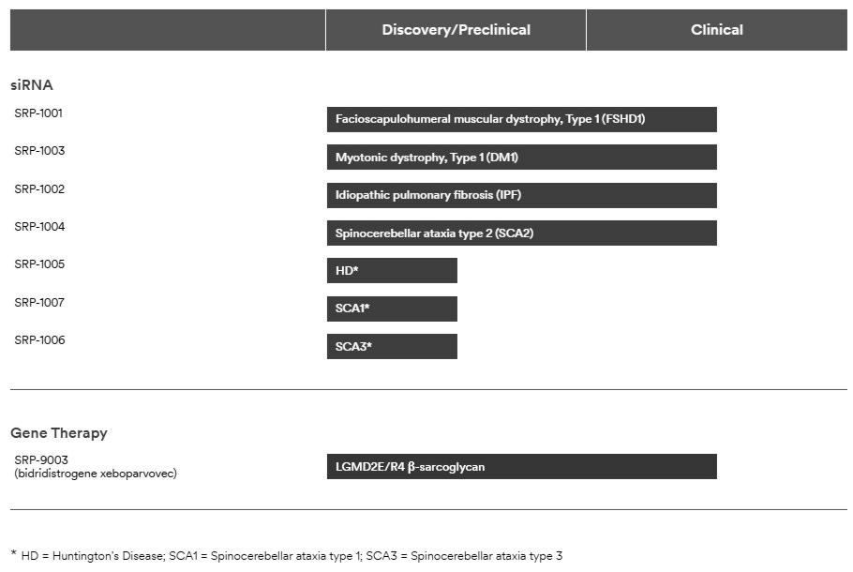

Manufacturing, Supply and Distribution

We have developed proprietary state-of-the-art Chemistry, Manufacturing and Controls (“CMC”) capabilities that allow manufacturing and testing of our products and product candidates to support both clinical development and commercialization. We continue to refine and optimize our manufacturing processes and test methods. We have entered into certain manufacturing and supply arrangements with third-party suppliers (specialized contract manufacturing organizations, or "CMOs"), which will in part utilize these capabilities to support production of certain of our products and product candidates and their components. Specifically, we have entered into agreements with CMOs to produce custom starting materials, active pharmaceutical ingredients (“APIs”), drug product and finished goods for our products and product candidates for both commercial and clinical use. We also have opened facilities over the past several years to further enhance our internal research and development capabilities. However, we currently do not have internal GMP manufacturing capabilities to produce our products and product candidates for commercial and/or clinical use.

All of our CMO partners have extensive technical expertise, GMP experience and experience manufacturing medicinal products and, for commercial products, significant experience utilizing our specific technologies. Manufacturers and suppliers of our commercial products and product candidates are subject to cGMP requirements and other rules and regulations prescribed by the FDA and applicable foreign regulatory authorities. We depend on our third-party partners for continued compliance with cGMP requirements and applicable foreign standards. We believe our current network of CMOs is able to fulfill our requirements for quantity, quality and purity of our commercial products and product candidates, and is capable of expanding capacity as needed. Additionally, we have evaluated and will continue to evaluate further relationships with additional suppliers as appropriate for specific products, considering production volume, logistics, business continuity, and other routine business considerations.

-9-

Our gene therapy manufacturing capabilities continue to benefit from partnerships with Aldevron and Catalent. We utilize a hybrid development and manufacturing strategy in which we rely on experienced contract manufacturing partners to develop, manufacture, and commercialize our gene therapy programs in partnership with our internal expertise relative to AAV-based development and manufacturing. Catalent supports our clinical and commercial manufacturing demand for ELEVIDYS and our SRP-9003 LGMD program, while also acting as a potential manufacturing partner for potential future gene therapy programs. Aldevron provides plasmids for ELEVIDYS and SRP-9003 and is expected to provide plasmid source material for any future gene therapy programs. The collaboration integrates process development, clinical and commercial production and testing.

Our PMO commercial products are distributed in the U.S. through a limited network of home infusion specialty pharmacy providers that deliver the medication to patients and a specialty distributor that distributes our products to hospitals and hospital outpatient clinics. With respect to the precommercial distribution of our products to patients outside of the U.S., we have contracted with third-party distributors and service providers to distribute our products in certain countries through our EAPs. We plan to continue building out our network for commercial distribution in jurisdictions in which our products are approved or in which we are seeking approval for our products.

The U.S. distribution model for ELEVIDYS employs multiple distribution partners that include third-party logistics providers as well as a limited network of specialty pharmacy providers that provide the medication to hospitals for infusion.

With respect to the siRNA programs in our portfolio, we collaborate with our partner Arrowhead to maintain continuity of drug substance manufacturing and testing services for ongoing and future clinical trials. Arrowhead’s cGMP manufacturing facility has the capability to manufacture at multiple scales and can expand capacity as needed to support future clinical and potential commercial needs. We plan to leverage existing contract partners, which have technical expertise and experience working with siRNA therapies, for the manufacture of drug product and finished goods as well as for distribution. As appropriate, we will evaluate additional relationships with supply partners for specific products, taking into account production volume, logistics, business continuity, and other routine business considerations.

Material Agreements

We believe that our technologies could be broadly applicable for the potential development of pharmaceutical products in many therapeutic areas. To enhance and further exploit our core technologies, we have and may continue to enter into research, development or commercialization alliances with universities, hospitals, independent research centers, non-profit organizations, pharmaceutical and biotechnology companies and other entities for new technologies, including for specific molecular targets or selected disease indications. We may also selectively pursue opportunities to access certain intellectual property rights that complement our internal portfolio through license agreements or other arrangements.

The following descriptions of the terms of our material agreements are not complete and are qualified in their entirety by reference to the text of the agreements, copies of which are filed as exhibits to this Annual Report.

Arrowhead Pharmaceuticals, Inc.

On November 25, 2024, we and Arrowhead entered into an Exclusive License and Collaboration Agreement (the “Arrowhead Collaboration Agreement”) pursuant to which Arrowhead granted us an exclusive license under certain of Arrowhead’s intellectual property rights to develop, manufacture, commercialize, and otherwise exploit the lead candidate (and all backup candidates) for four clinical programs (the “Arrowhead Clinical Programs”) and three pre-clinical programs (the “Arrowhead Pre-Clinical Programs”). The Arrowhead Clinical Programs are for targeted siRNA therapies directed to (a) DUX4 for the treatment of facioscapulohumeral muscular dystrophy, (b) DMPK for the treatment of type 1 myotonic dystrophy, (c) ATXN2 for the treatment of ataxias, and (d) MMP7 for the treatment of idiopathic pulmonary fibrosis. The pre-clinical programs are for targeted siRNA therapies directed to (a) ATXN1 for the treatment of ataxias, (b) ATXN3 for the treatment of ataxias, and (c) HTT for the treatment of Huntington’s Disease. We will also collaborate on the discovery and development of compounds that are directed to six targets to be selected by us during the term (each an “Arrowhead Discovery Program,” and together with the Arrowhead Clinical Programs

and Pre-Clinical Programs, the “Arrowhead Programs”). The selection of targets will be subject to certain restrictions set forth in the Arrowhead Collaboration Agreement. Subject to certain restrictions set forth in the Arrowhead Collaboration Agreement, if an Arrowhead Discovery Program target is deemed futile, then we will have the right to substitute any such target up to two times.

Exclusivity

Except for its performance of activities under the Arrowhead Collaboration Agreement, Arrowhead may not perform any development or commercialization activities with respect to any compounds or products (a) directed to any target that is the subject of activities under the Arrowhead Collaboration Agreement until the target for such Arrowhead Program has been terminated, (b) for the treatment of spinocerebellar ataxias until the ATXN1 Program, ATXN2 Program, and ATXN3 Program have all been terminated, or

- directed to a list of reserved skeletal muscle targets for five years, provided that two of the reserved skeletal muscles will be subject to an additional two years of exclusivity.

-10-

Development, Manufacturing, and Commercialization

Arrowhead will conduct development activities with respect to the Arrowhead Programs under the Arrowhead Collaboration Agreement pursuant to agreed-upon development plans. At pre-determined transition points for each Arrowhead Program, Arrowhead will transfer development responsibility to us. We will then perform all development activities in furtherance of obtaining and maintaining regulatory approvals for licensed products throughout the world. We will reimburse Arrowhead for certain pre-determined development activities for the Arrowhead Clinical Programs. Each party is responsible for the costs and expenses of other development activities under the Arrowhead Collaboration Agreement.

Arrowhead will complete all manufacturing activities necessary for Arrowhead’s development activities for each Arrowhead Program. Arrowhead will also provide clinical supply of licensed compounds and licensed products for all Arrowhead Programs under the Arrowhead Collaboration Agreement and commercial supply of licensed compounds and licensed products for the Arrowhead Clinical Programs. The parties will determine at a later date whether Arrowhead will provide commercial supply of licensed compounds and licensed products for the Arrowhead Preclinical Programs and Arrowhead Discovery Programs. Upon the occurrence of certain conditions, Arrowhead will transfer control of manufacturing and supply to us.

We will have the sole right to commercialize licensed products throughout the world.

Governance

The exploitation of licensed compounds and licensed products will be governed by a series of committees established to facilitate transition and collaboration between the parties with respect to development and manufacturing of such products.

Financial Terms

At closing, on February 7, 2025, we paid Arrowhead an up-front payment of $500.0 million in cash. Arrowhead had the potential to receive $300.0 million in near-term payments associated with the continued enrollment of certain cohorts of a Phase 1/2 study, which have been achieved and settled as of the date of this Annual Report as described further below. Additionally, Arrowhead is eligible to receive up to $250.0 million in annual fees and, for each of the Programs, Arrowhead is eligible to receive development milestone payments between $110.0 million and $180.0 million per Arrowhead Program and sales milestone payments between $500.0 million and $700.0 million per Arrowhead Program from us. On August 13, 2025, Arrowhead achieved the first of two Arrowhead DM1 Milestones, triggering a $100.0 million milestone payment. Consequently, the Company entered into an agreement with Arrowhead to transfer approximately 2.7 million shares of Arrowhead common stock, valued at approximately $50.0 million. The Company paid the remaining $50.0 million in cash. On November 24, 2025, Arrowhead achieved the second of two Arrowhead DM1 Milestones, totaling $200.0 million. In January 2026, the Company settled the payment related to the second Arrowhead DM1 Milestone.

In addition, the Arrowhead Collaboration Agreement provides that we will pay Arrowhead tiered royalties on annual net sales of all licensed products for a given Arrowhead Program, up to the low double digits.

Term; Termination

Unless earlier terminated as described below, the Arrowhead Collaboration Agreement will continue on a licensed product-by-licensed product and country-by-country basis, until the expiration of the royalty term for such licensed product in such country. The Arrowhead Collaboration Agreement includes a customary royalty term.

Either party may terminate the Arrowhead Collaboration Agreement for the other party’s material breach if such breach is not cured within a specified cure period.

We may terminate the Arrowhead Collaboration Agreement for convenience, in its entirety, or on an Arrowhead Program-by-Arrowhead Program basis for an entire territory or region. If there is a clinical trial failure of the ongoing clinical trial for ARO-DM1, then, at our election, we may terminate the Arrowhead Collaboration Agreement with respect to either the DM1 Program

or ARO-DM1.

Equity Investment

In connection with the Arrowhead Collaboration Agreement, Sarepta Therapeutics Investments, Inc., a wholly owned subsidiary of Sarepta (“Sarepta Investments”), purchased 11,926,301 shares of common stock, par value $0.001 per share, of Arrowhead, in a private placement transaction, for an aggregate purchase price of $325.0 million on February 7, 2025. On August 13, 2025, the Company sold approximately 9.3 million shares of Arrowhead common stock and as described above, the Company transferred the remaining approximately 2.7 million shares of Arrowhead common stock to Arrowhead as partial satisfaction of the first Arrowhead DM1 Milestone payment.

-11-

F. Hoffman-La Roche Ltd

License, Collaboration, and Option Agreement

On December 21, 2019, we entered into a license, collaboration, and option agreement (the “Roche Collaboration Agreement”) with F. Hoffman-La Roche Ltd (“Roche”) pursuant to which we granted Roche an exclusive license under certain of our intellectual property rights to develop, manufacture, and commercialize ELEVIDYS (SRP-9001) in all countries outside of the U.S. We retained all rights to ELEVIDYS in the U.S. The transaction closed on February 4, 2020. We have subsequently entered into Amendments 1 through 14 to the Roche Collaboration Agreement on: October 23, 2020, October 28, 2020, February 4, 2021, June 23, 2021, August 31, 2021, November 30, 2021, January 5, 2022, January 28, 2022, March 23, 2022, May 31, 2022, June 23, 2022, July 28, 2022, August 31, 2022 and October 31, 2022, respectively.

Also, under the terms of the Roche Collaboration Agreement, Roche granted us a license to use certain of its intellectual property rights to perform development activities worldwide under a joint global development plan, commercialize ELEVIDYS in the U.S., and perform certain manufacturing and medical affairs activities worldwide. Such license is non-exclusive under Roche’s background intellectual property rights, exclusive in the U.S. under intellectual property rights developed by Roche under the Roche Collaboration Agreement, and non-exclusive outside the U.S. under intellectual property rights developed by Roche under the Roche Collaboration Agreement.

We intend to manufacture and supply ELEVIDYS in the relevant markets in which we have approval, or in the future receive approval.

Roche Options and Negotiation Rights

Pursuant to the Roche Collaboration Agreement, we granted Roche an exclusive option to obtain an exclusive license to develop, manufacture and commercialize the following products outside of the U.S.: (i) certain exon-skipping products that target the dystrophin gene to induce exon skipping, including eteplirsen, golodirsen, casimersen (and previously our SRP-5051 program); (ii) certain gene therapy products other than ELEVIDYS that encode and directly express dystrophin or a derivative thereof; and (iii) certain gene-editing products that modify, repair, or activate an endogenous dysfunctional dystrophin gene. All rights have since expired or have been waived.

Pursuant to the Roche Collaboration Agreement, Roche has a right of first negotiation if we seek to grant a third-party license to commercialize ELEVIDYS in the U.S. Roche had a similar right of first negotiation with respect to our LGMDs products, but such right has expired.

Exclusivity

Other than under the Roche Collaboration Agreement, Roche may not perform any clinical trials for, or commercialize, any gene therapy product, gene-editing product, or antisense oligonucleotide for Duchenne for a period of five years following the effective date of the Roche Collaboration Agreement, which obligation has since expired.

Development

The parties will use commercially reasonable efforts to conduct development activities with respect to ELEVIDYS under the Roche Collaboration Agreement pursuant to agreed-upon development plans. Subject to certain exceptions, we will perform all development activities directed to obtaining and maintaining, as applicable, regulatory approvals for ELEVIDYS in the U.S. and the EU, as set forth in a joint global development plan. Subject to certain exceptions, the parties will share the costs of the development activities under such joint global development plan. Roche will have sole responsibility to perform all development activities set forth in a territory-specific development plan for ELEVIDYS, including additional activities not set forth in the joint global development plan that are specifically directed to obtaining and maintaining regulatory approvals for ELEVIDYS outside of the U.S. Roche will be solely responsible for costs arising from the territory-specific development plan for ELEVIDYS.

Governance

Governing committees have been established to facilitate collaboration between the parties with respect to development, manufacturing, medical affairs, intellectual property protection, and commercialization of ELEVIDYS and any other licensed products.

-12-

Financial Terms

In consideration for the rights that we granted and for prepaid funding for development activities, in February 2020, Roche and Roche Finance Ltd, an affiliate of Roche (“Roche Finance”), together paid us an up-front payment of approximately $1.2 billion. Of the $1.2 billion cash received from Roche, (i) $312.1 million, net of issuance costs, was allocated to the approximately 2.5 million shares of our common stock issued to Roche based on the closing price when the shares were issued, (ii) $485.0 million was allocated to the option to purchase the Option Products, and (iii) $348.7 million was allocated to a single, combined performance obligation comprised of: (i) the license of IP relating to ELEVIDYS transferred to Roche, (ii) the related research and development services provided under the joint global development plan, (iii) the services provided to manufacture clinical supplies of ELEVIDYS, and (iv) our participation in a joint steering committee with Roche, because we determined that the license of IP and related activities were not capable of being distinct from one another. Additionally, we are eligible to receive up to $1.7 billion in development, regulatory and sales milestone payments with respect to ELEVIDYS.

In addition, the Roche Collaboration Agreement provides that Roche will pay us royalties on net sales of ELEVIDYS, at a tiered royalty rate based on the average cost to manufacture ELEVIDYS.

Term; Termination

Unless earlier terminated as described below, the Roche Collaboration Agreement will continue with respect to ELEVIDYS on a country-by-country basis, until the end of the royalty term for such product in such country. The royalty term expires on the later of (a) twelve years after first commercial sale in such country, (b) loss of regulatory exclusivity in such country and (c) expiration of all valid claims of specific licensed patents in such country.

Either party may terminate the Roche Collaboration Agreement for the other party’s material breach if such breach is not cured within a specified cure period.

If Roche breaches its development or commercialization diligence obligations with respect to a licensed product or fails to develop or commercialize a particular licensed product in a particular region for a specified period of time, then we may terminate the Roche Collaboration Agreement with respect to such licensed products in such regions.

Roche may terminate the Roche Collaboration Agreement if we fail to supply ELEVIDYS to Roche in accordance with the terms of the Roche Collaboration Agreement and the supply agreements to be entered into between the parties. Roche may also terminate the Roche Collaboration Agreement for convenience with extended advance notice, in its entirety or on a licensed product-by-licensed product and region-by-region basis.

Myonexus Therapeutics Inc.

In April 2019, we acquired Myonexus Therapeutics Inc. (“Myonexus”), a privately-held Delaware corporation, for $173.8 million pursuant to an exclusive warrant to purchase Myonexus that we purchased in May 2018 for an up-front payment of $60.0 million. As part of the consideration for the transaction, we are required to make contingent payments to the former shareholders of Myonexus upon achievement of a threshold amount of net sales of Myonexus products and the receipt and subsequent sale of a Priority Review Voucher (“PRV”) with respect to a Myonexus product.

BioMarin Pharmaceutical Inc. (“BioMarin”)

License and Settlement Agreement

On July 17, 2017, we executed a license agreement (as amended on April 14, 2019 and November 17, 2021, the “License Agreement”) with BioMarin Leiden Holding BV, BioMarin Nederlands BV and BioMarin Technologies BV (collectively, the “BioMarin Parties”), pursuant to which BioMarin Parties granted us a royalty-bearing, worldwide license under patent rights (“Licensed Patents”) and know-how (“Licensed Know -How”) controlled by the BioMarin Parties with respect to BioMarin’s Parties' Duchenne program, which are potentially necessary or useful for the treatment of Duchenne, to practice and exploit the Licensed Patents and Licensed Know-How in all fields of use and for all purposes, including to develop and commercialize antisense oligonucleotide products that target one or more exons of the dystrophin gene to induce exon skipping, including eteplirsen, golodirsen and casimersen (collectively, the “Products”). Under the terms of the License Agreement, we were required to pay the BioMarin Parties an up-front payment of $15.0 million

-13-

Simultaneously in July 2017, Sarepta and The University of Western Australia (“UWA”) on the one hand, and the BioMarin Parties and Academisch Ziekenhuis Leiden (“AZL”) on the other hand (collectively, the “Settlement Parties”), executed a Settlement Agreement (the "Settlement Agreement"). Under the Settlement Agreement, the Settlement Parties agreed to stop or withdraw all legal actions in the U.S. and certain legal actions in Europe (the “Actions”) and release each other and the customers, end-users, agents, suppliers, distributors, resellers, contractors, consultants, services and partners of Sarepta or the BioMarin Parties (as applicable) from claims and damages related to (i) the patent rights controlled by the releasing party that are involved in the Actions, (ii) with respect to Sarepta and UWA, its patent rights related to the patent rights involved in the Actions, and (iii) with respect to the BioMarin Parties and AZL, all of the Licensed Patents and Licensed Know-How.

The license granted to us by the BioMarin Parties is co-exclusive with the BioMarin Parties, with respect to the Licensed Patents, and is non-exclusive with respect to Licensed Know -How. Pursuant to the amendment to the License Agreement dated November 17, 2021 (the “2021 Amendment”), the BioMarin Parties are eligible to receive up to $20.0 million from us per dystrophin gene exon (other than exon 51) targeted by one or more Products in specified regulatory milestones, as well as an additional $10.0 million milestone, payable following the regulatory approval of eteplirsen by the EMA. The BioMarin Parties were also eligible to receive through June 30, 2022 royalties segmented by specified geographic markets, in some jurisdictions dependent on the existence of a patent, ranging from 4% to 8% of net sales on a product-by-product and country-by- country basis. Beginning July 1, 2022, pursuant to the 2021 Amendment, the BioMarin Parties were eligible to receive royalties of 4% in the U.S. and 5% outside the U.S. of net sales of Products covered by a Licensed Patent on a product-by-product and country-by-country basis.

The royalty term applicable to the Products covered by a Licensed Patent expired upon March 31, 2024 in the U.S. and December 31, 2024 outside the U.S. The License Agreement expired upon the expiration of the last-to-expire royalty term. We retain a royalty free, fully paid license to the Licensed Patents.

University of Western Australia

In April 2013, we entered into an agreement with UWA under which an existing exclusive license agreement between the two parties was amended and restated and, in June 2016, we entered into the first amendment to the license agreement (the “UWA License Agreement”). The UWA License Agreement grants us specific rights to compounds for the treatment of Duchenne by inducing exon skipping. EXONDYS 51, VYONDYS 53 and AMONDYS 45 fall under the scope of the license agreement. Under the UWA License Agreement, we are required to make payments of up to $6.0 million in the aggregate to UWA based on the successful achievement of certain development and regulatory milestones relating to EXONDYS 51, VYONDYS 53, AMONDYS 45 and up to three additional product candidates. As of December 31, 2025, $4.2 million of the $6.0 million development and regulatory milestone payments had been made. Additionally, we are required to pay a low-single -digit percentage royalty on net sales of products covered by issued patents licensed from UWA during the term of the UWA License Agreement.

Currently, the latest date on which an issued patent covered by the UWA License Agreement expires in November 2030 (excluding any patent term extension, supplemental protection certificate or pediatric extensions that may be available); however, patents granted from pending patent applications could result in a later expiration date.

Catalent Maryland, Inc.

Catalent Supply Agreement

On November 28, 2022, we entered into an amended and restated product manufacturing and supply agreement with Catalent (the "Catalent Supply Agreement"). Under the Catalent Supply Agreement, Catalent has agreed, to manufacture and supply ELEVIDYS. Catalent is responsible for the operation of dedicated clean room suites for the manufacture of ELEVIDYS subject to Sarepta placing minimum annual orders. Catalent may not develop or manufacture products that compete with ELEVIDYS. In August 2025, we entered into a supplemental letter agreement (the “Letter Agreement”), which addresses certain financial and operational matters related to our suspension of ELEVIDYS shipments for non-ambulatory patients in June 2025 and the temporary suspension of all U.S. ELEVIDYS shipments in July 2025. In addition, the parties agreed to delay delivery of certain ELEVIDYS batches until 2027 and beyond.

Supply Terms and Quality Assurance

The Catalent Supply Agreement contains customary supply terms, including requirements for forecasting, purchase orders, product specifications, batch testing and review procedures, price, payment terms, and delivery mechanics. In addition, it grants to Catalent certain limited license rights of our intellectual property in connection with Catalent’s performance of services under the Catalent Supply Agreement, certain indemnification rights in favor of both parties, and limitations of liability. We and Catalent have also entered into a quality agreement, pursuant to which Catalent will conduct certain quality assurance, testing, characterization, stability and other quality control procedures in connection with the manufacture and supply of our ELEVIDYS product under the Catalent Supply Agreement.

-14-

Financial Terms

Upon receipt of a purchase order from us, Catalent will manufacture ELEVIDYS in accordance with the terms of the Catalent Supply Agreement, the then-current quality agreement and any applicable laws in exchange for the batch price specified in the Catalent Supply Agreement, which may be increased annually for industry standard cost increases.

We are obligated to meet certain minimum annual thresholds with respect to orders of batches of ELEVIDYS to maintain dedicated manufacturing space, and, if we do not release the dedicated manufacturing space, we may be obligated to make certain payments to Catalent to the extent we do not meet such thresholds. In October 2025, we notified Catalent of our intention to release Catalent from its obligation to dedicate clean room suites to us, effective in the fourth quarter of 2026.

Additionally, under the Letter Agreement we agreed to reimburse Catalent for raw materials that had been ordered or received by Catalent and not yet invoiced to us as of the effective date of the Letter Agreement. We remain contractually obligated for the full batch price of certain manufacturing batches, including a portion of batches deferred to calendar year 2027. We are required to pay 50% of the batch price for the deferred batches by July 1, 2026, and the remaining 50% by June 30, 2027, regardless of whether the batches are manufactured.

Term; Termination

Unless earlier terminated as described below, the Catalent Supply Agreement will continue with respect to the manufacture and supply of ELEVIDYS until December 31, 2028.

Either party may terminate the Catalent Supply Agreement for the other party’s material breach, if such breach is not cured within a specified cure period, and in the event that the other party files a petition in bankruptcy, insolvency, or for reorganization or similar arrangement for the benefit of creditors, in the event the other party is served with an involuntary petition against it in any insolvency proceeding and such involuntary petition has not been stayed or dismissed within a specified timeframe, or in the event that the other party makes an assignment of substantially all of its assets for the benefit of creditors.

We may also terminate the Catalent Supply Agreement in the event of certain delivery or supply failures, involuntary market withdrawals, material safety risks, a change of control by Catalent without our prior written consent, or certain patent disputes, among other things.

There can be no assurance that we will be able to continue our present arrangement with Catalent. Our dependence upon our arrangement with Catalent for the supply and manufacture of ELEVIDYS could adversely affect our ability to manufacture and deliver ELEVIDYS on a timely and competitive basis. See “Risk Factors— Risks Related to Manufacturing.”

Nationwide Children’s Hospital

On October 8, 2018, we entered into an exclusive license agreement (as amended on May 19, 2019 and July 11, 2023, the “Nationwide License Agreement”) with Nationwide Children’s Hospital (“Nationwide”) pursuant to which we acquired an exclusive license under certain intellectual property rights to develop, manufacture and commercialize ELEVIDYS in all countries. We entered into Amendment 1 and Amendment 2 to the Nationwide License Agreement on May 29, 2019 and July 11, 2023, respectively.

In consideration for the rights that Nationwide granted to us, we made an up-front payment and are obligated to make payments to Nationwide upon the achievement of certain development and sales milestones with respect to ELEVIDYS. In addition, we are required to pay a low-single-digit percentage royalty on net sales of ELEVIDYS, as well as a tiered percentage of remuneration we receive in connection with any sublicenses we grant. Unless earlier terminated, the Nationwide License Agreement will expire upon the expiration of the last-to-expire royalty period. Either party may terminate the Nationwide License Agreement in the event of the other party’s uncured material breach. Nationwide may also terminate the Nationwide License Agreement under specified circumstances if we pursue litigation against Nationwide.

Patents and Proprietary Rights

Our success depends in part upon our ability to obtain and maintain exclusivity for our products, product candidates and platform technologies. We typically rely on a combination of patent protection and regulatory exclusivity to maintain exclusivity for our products and product candidates, whereas exclusivity for our platform technologies is generally based on patent protection and trade secret protection. In addition to patent protection, regulatory exclusivity, and trade secret protection, we protect our products, product candidates and platform technologies with copyrights, trademarks, and contractual protections.

-15-

We actively seek patent protection for our product candidates and certain of our proprietary technologies by filing patent applications in the U.S. and other countries as appropriate. These patent applications are directed to various inventions, including, but not limited to, active ingredients, pharmaceutical formulations, methods of use, and manufacturing methods. In addition, we actively acquire exclusive rights to third party patents and patent applications to protect our in-licensed product candidates and corresponding platform technologies.

We do not have patents or patent applications in every jurisdiction where there is a potential commercial market for our product candidates. For each of our programs, our decision to seek patent protection in specific foreign markets, in addition to the U.S., is based on many factors, including:

- our available resources;

- the number and types of patents already filed or pending;

- the likelihood of success of the product candidate;

- the size of the commercial market;

- the presence of a potential competitor in the market; and

- whether the legal authorities in the market effectively enforce patent rights.

We continually evaluate our patent portfolio and patent strategy and believe our owned and licensed patents and patent applications provide us with a competitive advantage; however, if markets where we do not have patents or patent applications become commercially important, our business may be adversely affected. A discussion of certain risks and uncertainties that may affect our freedom to operate, patent position, regulatory exclusivities and other proprietary rights is set forth in Item 1A. Risk Factors included in this report, and a discussion of legal proceedings related to the key patents protecting our products and product candidates are set forth below in the footnotes to the tables in this section.

Certain of our product candidates are in therapeutic areas that have been the subject of many years of extensive research and development by academic organizations and third parties who may control patents or other intellectual property that they might assert against us, should one or more of our product candidates in these therapeutic areas succeed in obtaining regulatory approval and thereafter be commercialized. We continually evaluate the intellectual property rights of others in these areas in order to determine whether a claim of infringement may be made by others against us. Should we determine that a third party has intellectual property rights that could impact our ability to freely market a compound, we consider a number of factors in determining how best to prepare for the commercialization of any such product candidate. In making this determination we consider, among other things, the stage of development of our product candidate, the anticipated date of first regulatory approval, whether we believe the intellectual property rights of others are valid, whether we believe we infringe the intellectual property rights of others, whether a license is available upon commercially reasonable terms, whether we will seek to challenge the intellectual property rights of others, the term of the rights, and the likelihood of and liability resulting from an adverse outcome should we be found to infringe the intellectual property rights of others.

Currently, U.S. patents, as well as most foreign patents, are generally effective for 20 years from the date the earliest regular application was filed. Patent term in the U.S. may be shortened if a patent is subject to a terminal disclaimer over another patent. In some countries, the patent term may be extended to recapture a portion of the term lost during regulatory review of the claimed therapeutic. For example, in the U.S., under the Drug Price Competition and Patent Term Restoration Act of 1984, commonly known as the Hatch-Waxman Act, a patent that covers an FDA-approved drug may be eligible for patent term extension (for up to five years, but not beyond a total of 14 years from the date of product approval) as compensation for patent term lost during the FDA regulatory review process. In the U.S., only one patent may be extended for any product based on FDA delay. In addition to patent term extension, patents in the U.S. may be granted additional term due to delays at the United States Patent and Trademark Office ("USPTO") during prosecution of a patent application. We actively strive to maximize the potential for patent protection for our products and product candidates in accordance with the law.

Key Patents & Regulatory Exclusivities

Our products, product candidates and our technologies are primarily protected by composition of matter and methods of use patents and patent applications. Below we provide a summary of certain key granted US and European patents that relate to our marketed products and that we either: (1) solely or with another party own or control, or (2) exclusively license. For our product candidates for which key patents have not yet been granted, we highlight the expiration dates of certain key pending patent applications, if granted. The stated patent expiration dates include any patent term adjustments or extensions already granted.

-16-

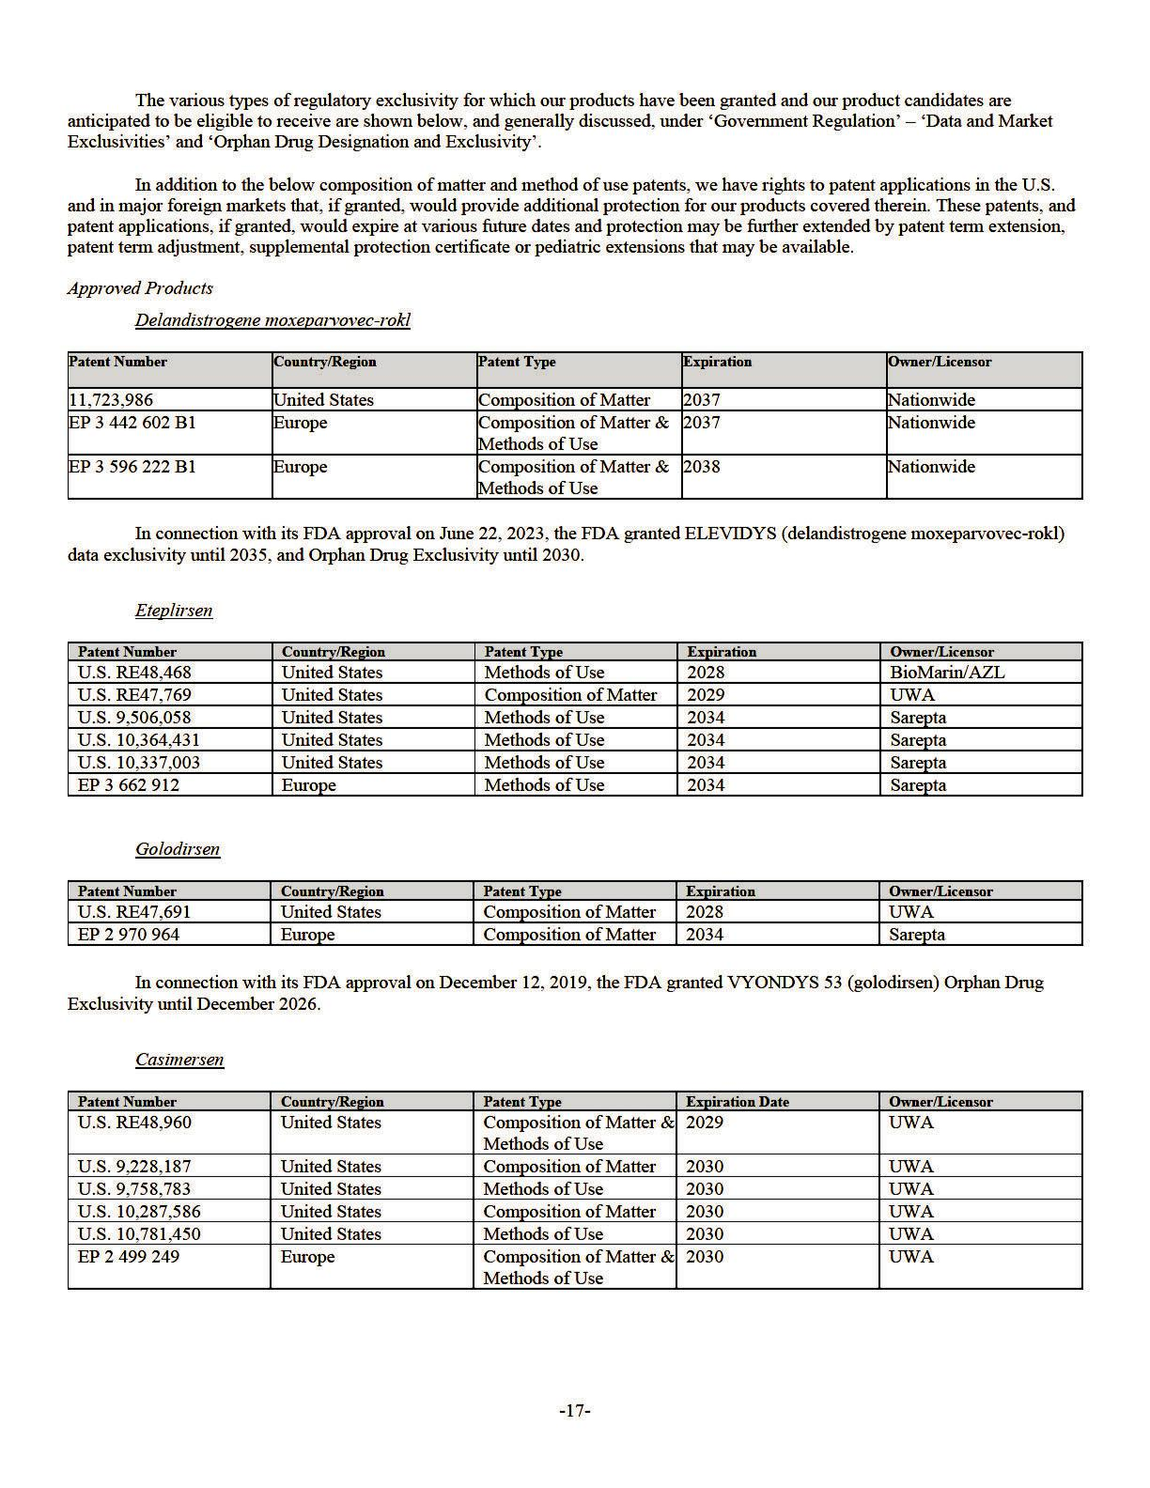

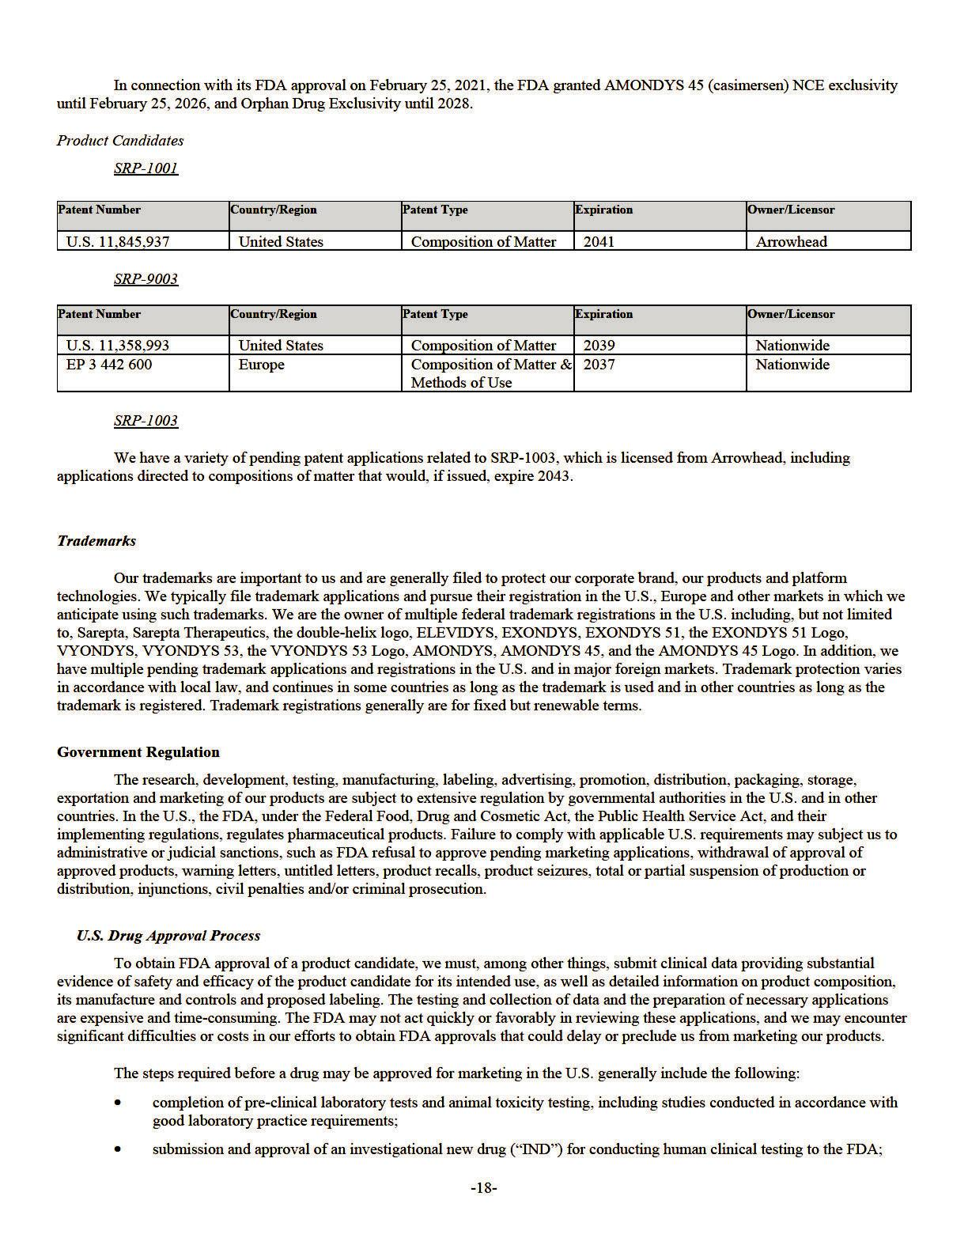

- approval by an Institutional Review Board (“IRB”) or independent ethics committee at each clinical trial site before each trial may be initiated;

- performance of adequate and well-controlled human clinical trials in accordance with good clinical practice (“GCP”) requirements and other clinical trial-related regulations to establish the safety and efficacy of the drug product for each indication;

- submission of a complete and compliant marketing application containing chemistry, manufacturing and control information for the drug substance and drug product, reports of nonclinical and clinical trials, product labeling and administrative information;

- satisfactory completion of an FDA inspection of the commercial manufacturing facilities at which the drug substance and drug product are made to assess compliance with cGMP;

- satisfactory FDA audit of the clinical trial site(s) that generated the pivotal safety and efficacy data included in the marketing application and also potentially the nonclinical trial site(s) in the form of pre-approval inspections; and

- FDA review and approval of the marketing application.

Pre-clinical trials may include laboratory evaluations of the product chemistry, pharmacology, toxicity and formulation, as well as animal studies to assess the pharmacokinetics, metabolism, bio-distribution, elimination and toxicity of the product candidate. The conduct of the pre-clinical tests and formulation of the compounds for testing must comply with federal regulations and requirements. The results of the pre-clinical trials, manufacturing information, analytical data and a proposed first in human clinical trial protocol are submitted to the FDA as part of the IND, which must become effective before clinical trials may be initiated. The IND will become effective 30 days after receipt by the FDA, unless the FDA raises concerns or questions about the supportive data, or the study design, particularly regarding potential safety issues with conducting the clinical trial as described in the protocol. In this situation, the trials are placed on clinical hold and the IND sponsor must resolve any outstanding FDA concerns before clinical trials can proceed.

Clinical trials involve the administration of the product candidate to healthy volunteers or patient participants under the supervision of a qualified principal investigator. Clinical trials are conducted under protocols detailing the objectives of the study, the administration of the investigational product, subject selection and exclusion criteria, study procedures, parameters to be used in monitoring safety and the effectiveness criteria to be evaluated. Each protocol must be submitted to the FDA as a submission to the IND. Clinical trials must be conducted and monitored in accordance with the FDA’s GCP requirements and federal and state laws and regulations protecting study subjects. Further, each clinical trial must be reviewed and approved by the IRB at or servicing each institution in which the clinical trial will be conducted. Both the FDA and IRB can temporarily or permanently halt a clinical trial at any time, or impose other sanctions or conditions, if it believes that the clinical trial is not being conducted in accordance with FDA requirements, GCP or IRB requirements or that it presents an unacceptable risk to the clinical trial subjects.

Clinical trials typically are conducted in three sequential drug development phases (Phases 1, 2 and 3) prior to approval, and a portion of these phases may overlap. A fourth post-approval phase (Phase 4) may include additional clinical trials. A general description of clinical trials conducted in each phase of development is provided below. However, the number of study subjects involved in each phase of drug development for rare diseases can be significantly less than typically expected for more common diseases with larger patient populations:

- Phase 1. Phase 1 clinical trials involve the initial introduction of the drug into human subjects. These studies are usually designed to determine the safety of single and multiple doses of the compound and determine any dose limiting toxicities or intolerance, as well as the metabolism and pharmacokinetics of the drug in humans. Phase 1 studies usually involve fewer than 100 subjects and are conducted in healthy adult volunteers, unless it is unethical to administer the study drug to healthy volunteers, in which case they are tested in patients.

- Phase 2. Phase 2 clinical trials are usually conducted in a limited patient population to evaluate the safety and efficacy of the drug for a specific indication to determine optimal dosage and to identify possible adverse effects and safety risks. Phase 2 studies usually involve patients with the disease under investigation and may vary in size from several dozen to several hundred.

- Phase 3. Larger Phase 3 clinical trials are conducted to confirm clinical efficacy, dosage and safety in the intended patient population, which may involve geographically dispersed clinical trial sites. Generally, two adequate and well-controlled Phase 3 clinical trials which establish the safety and efficacy of the drug for a specific indication are required for approval of a marketing application. Phase 3 studies usually include several hundred to several thousand patients for larger, non-orphan drug indications/diseases. However, clinical trials for rare or orphan diseases generally have fewer patients due to their lower prevalence. For these orphan diseases, a company may also try to demonstrate efficacy and safety by comparing treated patients in clinical trials to untreated patients participating in placebo-controlled clinical trials or to observational natural history studies.

-19-

- Phase 4. Phase 4 trials are clinical trials conducted after the FDA has approved a product for marketing. Typically, there are two forms of Phase 4 trials: those that are conducted to fulfill mandatory conditions of product approval and those that are voluntarily conducted to gain additional experience from the treatment of patients in the intended therapeutic indication.

A company seeking marketing approval for a new drug in the U.S. must submit the results of the pre-clinical and clinical trials to the FDA in the form of a marketing application, together with, among other things, detailed information on the manufacture and composition of the product candidate and proposed labeling, including payment of a user fee for FDA review of the application. The user fee is waived for an application for a product intended to treat an Orphan Indication. To support marketing approval, the data submitted must be sufficient in quality and quantity to establish the safety and efficacy of the investigational drug, or the safety, purity and potency of the investigational biologic, to the satisfaction of the FDA. FDA approval of a marketing application must be obtained before a drug or biologic may be marketed in the U.S.

The FDA assesses all submitted marketing applications for completeness before it accepts them for filing, a decision which must be made within 60 days of receipt. In some cases, the FDA may request additional information in a resubmitted application before accepting a marketing application for filing. Once the submission is accepted for filing, the FDA begins an in -depth review of the marketing application. Applications receive either standard or priority review. Under the current goals mandated under the Prescription Drug User Fee Act (the “PDUFA”), the FDA has ten months in which to complete its initial review of a standard marketing application and respond to the applicant, and six months for a priority marketing application, though the FDA does not always meet its PDUFA goal dates. The review process and the PDUFA goal date may be extended by three months if the FDA requests or the marketing application sponsor otherwise provides additional information or clarification regarding information already provided in the submission within the last three months before the PDUFA goal date. The FDA may refer an application to an advisory committee for review, evaluation and issuance of a non-binding recommendation as to whether the application should be approved. If the FDA’s evaluations of the marketing application and the clinical and manufacturing procedures and facilities are favorable, the FDA may issue an approval letter, authorizing commercial marketing of the drug. If the FDA finds deficiencies in the marketing application, it may issue a complete response letter (“CRL”), which defines the conditions that must be met in order to secure final approval of the marketing application. Sponsors that receive a CRL may submit to the FDA information that represents a complete response to the issues identified by the FDA. Resubmissions by the marketing application sponsor in response to a CRL trigger new review periods of varying length (typically two to six months) based on the content of the resubmission.

Even if the FDA approves a product, depending on the specific risk(s) to be addressed, the FDA may limit the approved indications for use of the product; require that contraindications, warnings or precautions be included in the product labeling, require that post-approval studies, including Phase 4 clinical trials, be conducted to further assess a product’s safety or efficacy after approval, require testing and surveillance programs to monitor the product after commercialization; or impose other conditions, including distribution and use restrictions or other risk management mechanisms under a risk evaluation and mitigation strategy, which can materially affect the potential market and profitability of the product. The FDA may prevent or limit further marketing of a product based on the results of post-marketing studies or surveillance programs. After approval, some types of changes to the approved product, such as adding new indications, manufacturing changes, and additional labeling claims, are subject to further testing requirements and FDA review and approval.

A sponsor may also seek designation of its drug candidates under programs designed to accelerate the FDA’s review and potential approval of marketing applications. For instance, a sponsor may seek FDA designation of a drug candidate as a “fast track product,” a “breakthrough therapy product,” or a “Regenerative Medicine Advanced Therapy (“RMAT”)” designated product, or may seek approval through the accelerated approval pathway or under priority review.

- Fast Track Designation: Fast track products are those products intended for the treatment of a serious or life-threatening disease or condition and which demonstrate the potential to address unmet medical needs for such disease or condition. If fast track designation is obtained, the FDA may initiate early and frequent communication and begin reviewing sections of a marketing application before the application is complete. This “rolling review” is available if the applicant provides, and the FDA approves, a schedule for the remaining information.

- Breakthrough Therapy Designation: Breakthrough therapy designation is focused on expediting the development and review process and by itself does not create an alternate ground for product approval. A sponsor may seek FDA designation of a drug candidate as a breakthrough therapy if the drug is intended, alone or in combination with one or more other drugs, to treat a serious or life-threatening disease or condition and preliminary clinical evidence indicates that the drug may demonstrate substantial improvement over existing therapies on one or more clinically significant endpoints, such as substantial treatment effects observed early in clinical development. The FDA issued guidance entitled “Expedited Programs for Serious Conditions––Drugs and Biologics” in May 2014.

-20-

- RMAT Designation: RMAT designation may be granted to drug products that meet the statutory definition of RMAT; are intended to treat, modify, reverse, or cure a serious condition; and for which preliminary clinical evidence indicates that the RMAT has the potential to address unmet clinical needs for such condition. The statutory definition of an RMAT includes therapies such as our gene therapy product candidates.

- Accelerated Approval: the FDA may also approve products through the accelerated approval pathway, which is aimed at expediting review of drugs that treat serious conditions and provide a meaningful advantage over available therapies. Accelerated approval is based on demonstrated effect on a surrogate endpoint that is reasonably likely to predict clinical benefit or on a clinical endpoint that can be measured earlier than irreversible morbidity or mortality (“IMM”) that is reasonably likely to predict an effect on IMM or other clinical benefit (i.e., an intermediate clinical endpoint). Approvals of this kind typically include requirements for appropriate post-approval Phase 4 clinical trials to confirm clinical benefit. The Food and Drug Omnibus Reform Act of 2022 (“FDORA”) signed by former President Biden on December 29, 2022 as part of the Consolidated Appropriations Act, 2023 (H.R. 2617) included numerous reforms to the accelerated approval process including, among other things, (i) enabling the FDA to require, as appropriate, that a post-approval study be underway prior to granting accelerated approval; and (ii) expanding the expedited withdrawal procedures available to the FDA for revoking accelerated approvals if a sponsor fails to conduct any required post-approval study with due diligence the FDA has issued guidance documents clarifying each of these reforms in January 2025 and December 2024, respectively.

- Priority Review: If a drug candidate demonstrates a significant benefit over existing therapy, it may be eligible for priority review, which means it will be reviewed within a six-month timeframe from the date a complete marketing application is accepted for filing.

We cannot be sure that any of our drug candidates will qualify for any of these expedited development, review and approval programs, or that, if a drug does qualify, that the product candidates will be approved, will be accepted as part of any such program or that the review time will be shorter than a standard review.

Holders of an approved marketing application are required to:

- report serious adverse drug reactions to the FDA;

- submit annual and periodic reports summarizing product information and safety data;

- comply with requirements concerning advertising and promotional labeling;

- continue to have quality control and manufacturing procedures conform to cGMP after approval; and

- conduct any post-marketing study designated as a required condition of the marketing application approval.

The FDA periodically inspects the sponsor’s records related to safety reporting and/or manufacturing; this latter effort includes assessment of compliance with cGMP. Accordingly, manufacturers must continue to expend time, money and effort in the area of production and quality control to maintain cGMP compliance. Discovery of problems with a product after approval may result in restrictions on a product, manufacturer, or holder of an approved marketing application, including withdrawal of the product from the market.

Foreign Regulatory Requirements

In 2018, the Committee for Medicinal Products for Human Use (“CHMP”) within the EMA confirmed its negative opinion for eteplirsen, and the European Commission (“EC”) adopted an implementing decision to ratify the CHMP opinion to refuse marketing authorization.

As of the date of this Annual Report, EXONDYS 51, has been approved for sale and marketing in the U.S., Israel, Libya, Georgia and Kuwait, and AMONDYS 45 and VYONDYS 53 have been approved for sale and marketing in the U.S., Libya and Kuwait. We have received approval for sale and marketing for ELEVIDYS in the U.S., and our strategic partner Roche has received approvals in certain other countries.

Thus, in addition to regulations in the U.S., our business is subject to a variety of foreign regulations governing clinical trials and commercial sales and distribution of our products. Irrespective of whether it concerns an FDA approved or investigational drug, the commencement of clinical trials and the subsequent marketing of a drug product in foreign countries are subject to preliminary approvals from the corresponding regulatory authorities of such countries. For example, the conduct of clinical trials in the EU is governed by the Clinical Trials Regulation (EU) No 536/2014 (the “CTR”) and the principles and guidelines on GCP.

-21-

In April 2014, the EU adopted the CTR, which is now in application. The CTR requires a clinical trial sponsor to obtain a clinical trial authorization (“CTA”) from the national competent authority (“NCA”) of each EU member state in which the clinical trial is to be conducted. Furthermore, the sponsor can only start a clinical trial at a specific study site after the local research ethics committee has issued a favorable opinion.

Subject to the transition arrangement referenced below, a sponsor must submit a single application for a CTA, through a centralized EU clinical trials portal, the Clinical Trials Information System (“CTIS”). One NCA (the reporting EU member state selected by the sponsor) takes the lead in validating and evaluating the application, as well as consulting and coordinating with the other concerned member states in which the clinical trial is to be conducted. If an application is rejected, it may be amended and resubmitted through CTIS. A concerned member state may in limited circumstances declare an “opt-out” from an approval and prevent the clinical trial from being conducted in that member state.

The CTR foresees a three-year transition period. As of January 31, 2023, all new CTAs had to be submitted via CTIS and made pursuant to the CTR. By January 31, 2025, all clinical trials that are still ongoing and that were authorized under the Directive 2001/20/EC (which was replaced by the CTR), must be transitioned to the new regime.

In order to obtain marketing authorization for a medicinal product in the EU, applicants are required to submit a marketing authorization (“MA”) application (“MAA”) to either (a) the NCAs of the EU member states of interest (through the decentralized, mutual recognition, or national procedures) if the medicinal product does not fall within the mandatory scope of the centralized procedure or (b) the EMA (through the centralized authorization procedure). Irrespective of the procedure, applicants are required to demonstrate the quality, safety and efficacy of the medicinal product in the application for MA, which implies the requirement to conduct human clinical trials to generate the necessary clinical data.

Regulation (EC) No 726/2004 of the European Parliament and of the Council lays down the rules applicable to the centralized procedure for the authorization of medicinal products. The centralized procedure allows pharmaceutical companies to submit a single MAA to the EMA, which, if successful, results in a single MA to market the medicinal product throughout the entire EU and Iceland, Liechtenstein and Norway (collectively, the “EEA”). Approval via the centralized procedure is a two-step process whereby the CHMP first evaluates the MAA and issues an opinion on whether the medicinal product may be authorized or not (step

1). The CHMP opinion is subsequently sent to the EC, which takes a legally binding decision to grant a MA (step 2). The MA is valid throughout the EEA and is automatically recognized in Iceland, Lichtenstein and Norway. This allows the MA holder to market the medicine and make it available throughout the entire EEA. The timeframe for the first step of the centralized procedure (evaluation by the CHMP) opinion is 210 days from receipt of a valid application. However, the actual time needed to complete this first step is generally longer than the 210 days, since procedural clock stops are required in order for the applicant to respond to additional requests for information by the CHMP. Following a positive CHMP opinion, the EC has generally 67 days to issue its decision to grant the MA or not.

Accelerated evaluation of the MAA under the centralized procedure is possible in exceptional cases, following a justified request from the applicant, when a medicinal product is of major interest for public health, particularly from the point of view of therapeutic innovation. The CHMP determines what constitutes a major public interest on a case-by-case basis. If the applicant provides sufficient justification for an accelerated assessment, the CHMP can reduce the timeframe for review of a MAA to 150 days, excluding a limited procedural clock-stop. The timeframe for the EC to issue its decision remains unaltered.

In relation to the EEA, Article 3 of Regulation (EC) No 726/2004 defines in which cases the centralized application procedure must (mandatory scope) or may (optional scope) be followed. The centralized procedure is mandatory for certain types of medicinal products, including those developed using a biotechnological process (such as recombinant DNA technology, controlled expression of genes coding for biologically active proteins in prokaryotes and eukaryotes, including transformed mammalian cells, hybridoma and monoclonal antibody methods), orphan medicinal products, advanced therapy medicinal products (gene-therapy, somatic cell-therapy or tissue-engineered medicines) and products containing a new active substance indicated for the treatment of HIV/AIDS, cancer, diabetes, auto-immune and other immune dysfunctions, viral diseases and neurodegenerative diseases biotechnology medicinal products, orphan medicinal products, advanced-therapy medicinal products. For medicinal products that do not fall under any of the aforementioned categories, a submission via the centralized procedure is possible, provided that it concerns

- a new active substance or (ii) product that can demonstrate a significant therapeutic, scientific or technical innovation and for which approval would be in the interest of public health. Given the foregoing, our portfolio of innovative orphan products for neurodegenerative diseases is subject to the mandatory centralized procedure.

Similar to the U.S., MA holders and manufacturers of medicinal products are subject to comprehensive regulatory oversight by the EMA and/or the NCA of the EU member states. This oversight applies both before and after the granting of manufacturing and MAs. It includes compliance with EU GMP and Good Distribution Practice rules in relation to such activities as distribution, importing and exporting of medicinal products, rules governing conduct of pharmacovigilance (including good pharmacovigilance practices) and requirements governing advertising, promotion and sale of medicinal products.

-22-

Failure to comply with the EU member state laws implementing the EU Community Code on medicinal products, and EU rules governing the promotion of medicinal products, interactions with physicians, misleading and comparative advertising and unfair commercial practices, with the EU Member State laws that apply to the promotion of medicinal products, statutory health insurance, bribery and anti-corruption or with other applicable regulatory requirements can result in enforcement action by the relevant EU Member State authorities. This may include any of the following sanctions: fines, imprisonment, orders forfeiting products or prohibiting or suspending their supply to the market, orders to suspend, vary, or withdraw the marketing authorization or requiring the manufacturer to issue public warnings, or to conduct a product recall.

The approval process in other countries outside the U.S. and the EU varies from country to country, and the time may be longer or shorter than that required for the FDA approval. In addition, the requirements governing the conduct of clinical trials, product licensing, pricing and reimbursement for market access vary greatly from country to country. In all cases, clinical trials are conducted in accordance with GCP and the applicable regulatory requirements and the ethical principles that have their origin in the Declaration of Helsinki.

Data and Market Exclusivities

In addition to patent exclusivities, the FDA and certain other foreign health authorities may grant data or market exclusivity for a newly approved chemical entity or biologic, which runs in parallel to any patent protection. Regulatory data protection or exclusivity prevents a potential generic competitor from relying on clinical trial data generated by the sponsor when establishing the safety and efficacy of its competing product. Market exclusivity prohibits any marketing of the same drug for the same indication.

In the U.S., the FDA will generally grant a new chemical entity ("NCE") that is the subject of a new drug application ("NDA") with five years of regulatory data exclusivity, during which time no applications to the FDA for competitor products may be submitted. A competitor, however, may file an application seeking approval of a generic drug four years from the date of approval of the innovative product if it is accompanied by a certification of patent invalidity or noninfringement. The FDA will also grant three years of exclusivity for an NDA for a product that contains an active moiety that has already been approved or supplement to an existing NDA if new clinical investigations, other than bioavailability studies, that were conducted or sponsored by the applicant are deemed by the FDA to be essential to the approval of the application (for example, new indications, dosages or strengths of an existing drug.) This three-year exclusivity covers only the conditions of use associated with the new clinical investigations and does not prohibit the FDA from approving abbreviated new drug applications (“ANDAs”) for drugs containing the original active agent for other conditions of use. For a newly approved biologic that is the subject of a BLA, the FDA will generally grant 12 years of market exclusivity, during which time a competitor may not market the same drug for the same indication.

In addition, the FDA may provide six months of pediatric exclusivity to a sponsor of a marketing application if the sponsor conducted a pediatric study or studies of a product. This process is applied to products developed for adult use and is initiated by the FDA as a written request for pediatric studies that applies to a sponsor’s product. If the sponsor conducts qualifying studies and the studies are accepted by the FDA, then an additional six months of pediatric exclusivity will be added to previously granted exclusivity, such as orphan drug exclusivity and NCE exclusivity, as well as certain patent-based exclusivities.

In relation to the EEA, innovative medicinal products which have been authorized on the basis of a complete independent data package consisting of quality, preclinical testing results and clinical trial data, benefit from an eight-year period of data exclusivity and a ten-year period of marketing protection/exclusivity. During the data exclusivity period, applicants for approval of generics of these innovative products cannot reference or rely upon data contained in the MA dossier submitted for the innovative medicinal product. During the marketing protection period, even if the generic product is approved, it cannot be placed on the market until the full ten-year period of market protection has elapsed from the initial authorization of the reference medicinal product. The marketing protection period can be extended to a maximum of 11 years if, during the first eight years of those ten years, the MA holder for the innovative product obtains an authorization for one or more new therapeutic indications which, during the scientific evaluation prior to their authorization, are held to bring a significant clinical benefit in comparison with existing therapies.

In the EEA, all applications for MA for new medicines must include the results of studies as described in an agreed pediatric investigation plan (“PIP”) aimed at ensuring that the necessary data are obtained through studies in children, unless the medicine is exempt because of a deferral or waiver. PIPs are agreed with the EMA’s Pediatric Committee. The PIP sets out the timing and measures proposed to generate data to support a pediatric indication of the drug for which MA is being sought. Deferrals allow an applicant to delay development of the medicine in children until, for instance, there is enough information to demonstrate its effectiveness and safety in adults. Waivers, on the other hand, may be granted when the development of a medicine in children is not needed or is not appropriate, such as for diseases that only affect the adult population or when the product does not represent a significant therapeutic benefit over existing treatments for pediatric patients. Products that are granted a MA with the results of the pediatric clinical trials conducted in accordance with the PIP (even where such results are negative) are eligible for six months’ supplementary protection certificate extension (if any is in effect at the time of approval). In the case of orphan medicinal products, a two-year extension of the orphan market exclusivity may be available. This pediatric reward is subject to specific conditions and is not automatically available when data in compliance with the PIP are developed and submitted.

-23-

Orphan Drug Designation and Exclusivity

In the U.S., the FDA may grant orphan drug designation to drugs intended to treat a rare disease or condition that affects fewer than 200,000 individuals in the U.S., or more than 200,000 individuals in the U.S. for which there is no reasonable expectation that the cost of developing and making available in the U.S. a drug for this type of disease or condition will be recovered from sales in the U.S. for that drug. An orphan drug designation must be requested before submitting an application for marketing approval, and does not shorten the duration of the regulatory review and approval process. The approval of an orphan designation request does not alter the regulatory requirements and process for obtaining marketing approval. Orphan drug designation generally entitles the product, once approved, to an orphan drug exclusivity period of seven years, which means the FDA may not grant approval to any other application to market the same chemical or biological product for the same indication for a period of seven years, except in limited circumstances, such as where an alternative product demonstrates clinical superiority to the product with orphan exclusivity.

The FDA has historically taken the position that the scope of orphan exclusivity aligns with the approved indication or use of a product, rather than the disease or condition for which the product received orphan designation. However, on September 30, 2021, the U.S. Court of Appeals for the 11th Circuit issued a decision in Catalyst Pharms., Inc. v. Becerra holding that the scope of orphan drug exclusivity must align with the disease or condition for which the product received orphan designation, even if the product’s approval was for a narrower use or indication. The FDA announced on January 24, 2023 that despite the Catalyst decision, it will continue to apply its longstanding regulations, which tie the scope of orphan exclusivity to the uses or indications for which the drug is approved, rather than to the designation. Particularly due to the Supreme Court’s 2024 decision in Loper Bright Enterprises v. Raimondo, which overturned the general judicial practice of deference to Agency’s interpretations of ambiguous statutes, the FDA’s application of its orphan drug regulations post-Catalyst could be the subject of future legislation or to further challenges in court, and it remains to be seen how this decision affects orphan drug exclusivity going forward. In addition, holders of exclusivity for orphan drugs are expected to assure the availability of sufficient quantities of their orphan drugs to meet the needs of patients. Failure to do so could result in the withdrawal of orphan exclusivity for the drug. Competitors may receive approval of different drugs or biologics for the indications for which a prior approved orphan drug has exclusivity.

Pharmaceutical companies can apply for their product to be designated as an orphan medicinal product; such applications must be submitted prior to submitting a MAA. In the EU, applications for orphan designation are evaluated by the EMA’s Committee for Orphan Medicinal Products (“COMP”) in accordance with Regulation (EC) No 141/2000. In order to qualify as an orphan medicinal product, the medicinal product must be intended to diagnose, prevent or treat a condition that is life-threatening or chronically debilitating, with a prevalence of no more than 5 in 10,000 people in the EU or for which it is unlikely that the development of the medicine would generate sufficient returns to justify the investment needed for its development. In addition, the sponsor is required to demonstrate that no satisfactory method of diagnosis, prevention or treatment of the condition has been authorized in the EU or, if such method exists, the medicinal product is of significant benefit to those affected by the condition as compared to approved methods. The COMP is required to re -assess the granted orphan designation at the time of MA grant to ensure that it continues to meet the criteria for the designation to be maintained. Otherwise, the orphan designation can be revoked. The benefits of being granted orphan designation are significant, including up to ten years of market exclusivity. During this ten-year period, the EMA may not accept an MAA for a similar medicinal product for the same authorized therapeutic indication as the approved orphan medicinal product. Pursuant to Regulation (EC) 1901/2006 on medicinal products for pediatric use, and as mentioned above, the ten-year orphan market exclusivity can be extended to a maximum period of 12 years upon the satisfactory completion of all the studies of the agreed PIP with the pediatric study results reflected in the summary of product characteristics. We have been granted orphan drug designation for eteplirsen in the EU.

Expanded / Early Access

In certain countries, drug products approved by key competent regulatory agencies, including the FDA, can be accessed by patients before the drug has obtained marketing approval in such country. There are various forms of this access including, but not limited to, the actual purchase of product by the purchaser, which is often times the government for patients, on a named patient basis, and providing the product free of charge on a named patient basis for compassionate use. Each country has its own laws and regulations that apply to these forms of access and the extent and nature of such laws and regulations vary by country. For example, in 2018, the so-called Right to Try Act became law in the U.S. The law, among other things, allows eligible patients to access certain investigational new drug products that have completed at least a Phase 1 clinical trial and that are undergoing investigation for FDA approval without enrolling in clinical trials and without obtaining FDA permission under the FDA expanded access program. There is no obligation for a pharmaceutical manufacturer to make its drug products available to such eligible patients as a result of the Right to Try Act.

We established a global EAP for eteplirsen, golodirsen and casimersen in some countries where these products currently have not been approved. This EAP provides a mechanism through which physicians can prescribe our products, within their professional responsibility, to patients who meet pre-specified medical and other criteria and can secure funding.

-24-

Other Regulatory Requirements

Environmental Laws

In addition to regulations enforced by the FDA and foreign authorities relating to the clinical development and marketing of products, we are or may become subject to regulation under the Occupational Safety and Health Act, the Toxic Substances Control Act, the Resource Conservation and Recovery Act and other present and potential future foreign, federal, state and local laws and regulations. Our research and development processes involve the controlled use of hazardous materials and chemicals and produce waste products. We are subject to federal, state and local environmental laws and regulations governing the use, manufacture, storage, handling and disposal of hazardous materials and waste products. Although we believe that we are in material compliance with applicable environmental laws that apply to us, we cannot predict whether new regulatory restrictions will be imposed by state or federal regulators and agencies or whether existing laws and regulations will adversely affect us in the future. Compliance with environmental laws is not expected to require significant capital expenditure and has not had, and is not expected to have, a material adverse effect on our operations.

Healthcare Fraud and Abuse Laws

We are subject to various federal, state and local laws targeting fraud and abuse in the healthcare industry, including anti-kickback and false claims laws. Violations of fraud and abuse laws may be punishable by criminal or civil sanctions, including fines and civil monetary penalties, and/or exclusion from federal health care programs (including Medicare and Medicaid). The scope of the federal and the various analogous state anti-kickback, false claims, and similar fraud and abuse laws vary, but is generally broad. Many of the fraud and abuse laws and regulations contain ambiguous requirements or require administrative guidance for implementation. Federal and state authorities are paying increased attention to enforcement of these laws within the pharmaceutical industry, and private individuals have been active in alleging violations of the laws and bringing suits on behalf of the government under the federal False Claims Act (“FCA”) as evidenced by numerous significant settlements. Violations of international fraud and abuse laws could result in similar penalties, including exclusion from participation in health programs outside the U.S. Given the scope, complexity and lack of clarity in laws and their implementation, compliance for any company including ours is challenging, and our activities could be subject to scrutiny and the imposition of penalties under the laws. If we were subject to allegations concerning, or were convicted of violating, these laws, our business could be harmed.

The federal Anti-Kickback Statute generally prohibits, among other things, a pharmaceutical manufacturer from directly or indirectly soliciting, offering, receiving, or paying any remuneration in cash or in kind where one purpose is either to induce the referral of an individual for, or the purchase or prescription of, a particular drug that is payable by a federal health care program, including Medicare or Medicaid. A person or entity does not need to have actual knowledge of the statute or a specific intent to violate the statute. A claim arising from a violation of the federal Anti-Kickback Statute also constitutes a false or fraudulent claim for purposes of the FCA. Another healthcare anti-kickback statute prohibits certain payments related to referrals of patients to certain providers (such as clinical laboratories) and applies to services reimbursed by private health plans as well as government health care programs.

Federal and state false claims laws generally prohibit anyone from knowingly and willfully, among other activities, presenting, or causing to be presented for payment to third party payors (including Medicare and Medicaid) claims for drugs or services that are false or fraudulent. Such laws are not always limited to activities involving government programs or payors. For example, a federal healthcare fraud statute prohibits the knowing and willful execution, or attempt to execute, a scheme to defraud a health care benefit program, including private health plans, or obtain, through false or fraudulent pretenses, money or property owned by, or under the custody or control of, such a health care benefit program.

Laws and regulations have also been enacted by the federal government and various states to regulate the sales and marketing practices of pharmaceutical manufacturers. The laws and regulations generally limit financial interactions between manufacturers and health care providers; require pharmaceutical companies to comply with the pharmaceutical industry’s voluntary compliance guidelines and the relevant compliance guidance promulgated by the U.S. federal government; and/or require disclosure to the government and/or public of financial interactions (so-called “sunshine laws”). State laws may also require disclosure of pharmaceutical pricing information and marketing expenditures. Manufacturers must also submit information to the FDA on the identity and quantity of drug samples requested and distributed by a manufacturer during each year.

Similar to the Anti-Kickback Statue in the U.S., the provision of benefits or advantages to physicians to induce or encourage the prescription, recommendation, endorsement, purchase, supply, order or use of medicinal products is also prohibited in the EU. The provision of benefits or advantages to induce or reward improper performance generally is governed by the national anti-bribery laws of EU member states, and the Bribery Act 2010 in the UK. Infringement of these laws could result in substantial fines and imprisonment. Further, Directive 2001/83/EC, which governs medicinal products for human use, further provides that, where medicinal products are being promoted to persons qualified to prescribe or supply them, no gifts, pecuniary advantages or benefits in

-25-

kind may be supplied, offered or promised to such persons unless they are inexpensive and relevant to the practice of medicine or pharmacy. Given the broad scope of these laws, our activities could be subject to scrutiny under the laws. If we were subject to allegations concerning, or were convicted of violating, these laws, our business could be harmed.

Data Privacy and Security

We may be subject to privacy and security laws in the various jurisdictions in which we operate, obtain or store personally identifiable information. The legislative and regulatory landscape for privacy and data protection continues to evolve, and there has been an increasing focus on privacy and data protection issues with the potential to affect our business. Our ongoing efforts to comply with evolving laws and regulations may be costly and require ongoing modifications to our policies, procedures and systems. Failure to comply with laws regarding data protection would expose us to risk of enforcement actions and penalties under such laws. Even if we are not determined to have violated these laws, government investigations into these issues typically require the expenditure of significant resources and generate negative publicity, which could harm our business, financial condition, results of operations or prospects.

Within the U.S., there are numerous federal and state laws and regulations related to the privacy and security of personal information. For example, at the federal level, the Health Insurance Portability and Accountability Act of 1996 (“HIPAA”), as amended, and its implementing regulations establish privacy and security standards that limit the use and disclosure of individually identifiable health information, or protected health information, and require the implementation of administrative, physical and technological safeguards to protect the privacy of protected health information. While we have determined that we are neither a “covered entity” nor a “business associate” directly subject to HIPAA, many of the U.S. health care providers with which we interact are subject to HIPAA, and we may have assumed obligations related to protecting the privacy of personal information. States are increasingly regulating the privacy and security of personal information. In some states, such as California and Washington, state privacy laws are even more protective than HIPAA. For example, the California Consumer Privacy Act as amended and expanded by the California Privacy Rights Act (together, the “CCPA”), gives California consumers (defined to include all California residents) certain rights, including the right to ask covered companies to disclose copies of personal information collected and delete a consumer’s personal information and requires covered companies to provide notice to California consumers regarding their data processing activities. The CCPA places limitations on a covered company’s ability to sell personal information and share it for purposes of cross-context behavioral advertising. Similar laws are in operation or have been adopted in eleven other states.

In addition, the processing of personal data relating to EEA citizens or in the context of the activities of an establishment in the EEA is subject to the General Data Protection Regulation (the “GDPR”). The GDPR increases obligations with respect to clinical trials conducted in the EEA, such as in relation to the provision of fair processing notices, responding to data subjects who exercise their rights and reporting certain data breaches to regulators and affected individuals. The GDPR also requires us to enter certain contractual arrangements with third parties that process GDPR-covered personal data on our behalf. The GDPR also increases the scrutiny applied to transfers of personal data from the EEA (including from clinical trial sites in the EEA) to countries that are considered by the EC to lack an adequate level of data protection. Similar rules and requirements are applicable in the UK by virtue of section 3 of the European Union (Withdrawal) Act 2018 and as amended by the Data Protection, Privacy and Electronic Communications (Amendments etc.) (EU Exit) Regulations 2019 (together, the “UK GDPR”). If our or our partners’ or service providers’ privacy or data security measures fail to comply with the requirements of the GDPR or UK GDPR, we may be subject to litigation, regulatory investigations, enforcement notices requiring us to change the way we use personal data and/or fines of up to EURO 20 million (£17.5 million in the U.K.) or up to 4% of the total worldwide annual turnover of the preceding financial year, whichever is higher, as well as claims by affected individuals, negative publicity, reputational harm and a potential loss of business and goodwill.

Pharmaceutical Pricing and Reimbursement

Our revenue depends, in part, upon the extent to which payors provide coverage for our products and the amount that payors, including government authorities or programs, private health insurers and other organizations, reimburse patients and healthcare providers for the cost of our products. Reimbursement coverage policies and inadequate reimbursement may reduce the demand for, or the price purchasers are willing to pay for, our or our partners’ products. Patients who are prescribed medications for the treatment of their conditions, and their prescribing physicians, generally rely on third-party payors to reimburse all or part of the costs associated with their prescription drugs. Patients are unlikely to use our products unless coverage is provided, and reimbursement is adequate to cover a significant portion of the cost of such products.

We have an ongoing dialogue with payors globally with the goal of obtaining broad coverage for our products. To date, payors’ policies on coverage for our products have varied widely, including policies that allow broad coverage per the respective product’s prescribing information, policies that provide limited coverage and policies that have denied coverage. The majority of payors have policies that provide for case-by-case coverage or restricted coverage.

-26-

Third Party Reimbursement and Pricing in the U.S.

Within the U.S., coverage and reimbursement for drug products can differ significantly from payor to payor. One third-party payor’s decision to cover a particular drug product does not ensure that other payors will also provide coverage for the drug product. Even if products are covered, third party payors may seek to control utilization of the products through various mechanisms (e.g., requiring a prescriber to obtain prior authorization from a health plan before the product will be covered by the health plan or establishing patient copays and deductibles that encourage use of other products over our products). Coverage of a product by a third-party payor does not mean that reimbursement will be adequate. Third party reimbursement may not be sufficient to enable us to maintain price levels high enough to realize an appropriate return on our investment in product development. Net prices for drugs may be reduced by mandatory discounts or rebates required by government healthcare programs or requested by private payors in exchange for coverage or by any future relaxation of laws that presently restrict imports of drugs from countries where they may be sold. Our ability to commercialize our product candidates successfully may be adversely affected by discounts or rebates that we are required to provide in order to ensure coverage of our products and compete in the marketplace.

Significant uncertainty exists as to the coverage and reimbursement status of new drug products. There may be considerable delays in obtaining reimbursement for newly-approved drugs, and coverage may be more limited than the indications for which the drug is approved by the FDA. Third-party payors may also seek, with respect to an approved product, additional clinical evidence, including comparative effectiveness evidence, that goes beyond the data required to obtain marketing approval in order to demonstrate clinical benefits and value relative to other therapies before covering new products. If so, we may be required to conduct additional pharmacoeconomic studies beyond what is required for marketing approval.

We cannot be sure that adequate coverage and reimbursement will be available, or remain available, for any drug that we commercialize. Following the ELEVIDYS Suspension, certain third-party payors have restricted coverage for ELEVIDYS for certain segments of the ambulatory patient population. Coverage and reimbursement may impact the demand for, or the price of, our products and any product candidate for which we obtain marketing approval and limits on coverage and reimbursement may adversely affect our ability to successfully commercialize any product candidate for which we obtain marketing approval.

Third Party Reimbursement and Pricing outside the U.S.

We currently have three PMO products approved for marketing outside the U.S. EXONDYS 51 has been approved for marketing in the U.S., Georgia, Israel, Libya and Kuwait, VYONDYS 53 in U.S., Georgia, Libya and Kuwait, and AMONDYS 45 in the U.S., Georgia, Libya and Kuwait. We may need to conduct long-term pharmacoeconomic studies in order to demonstrate the cost-effectiveness of our products.

In the EU and certain other territories, price controls and Health Technology Assessments for new, highly priced medicines are expected, and in some cases, mandated. Criteria such as cost-effectiveness, cost per quality-adjusted life year, budget impact, or others, in addition to the clinical benefit, are often required to demonstrate added value or benefit of a drug and vary by country.

EU member states may approve a specific price for a product, by, for example, international reference pricing, or they may instead adopt a system of direct or indirect controls on the profitability of the company placing the product on the market. Other member states allow companies to fix their own prices for products but monitor and control prescription volumes and issue guidance on prescribing criteria to physicians, having an effect on restricting prescriptions or usage. Recently, many countries in the EU have decided to apply significant discounts to prices of pharmaceuticals and these efforts could continue as countries attempt to manage healthcare expenditures. Political, economic and regulatory developments may further complicate pricing negotiations. Third party reimbursement limits may reduce the demand for our products. The pace of the application process in some countries could also delay commercial product launches. Gaining acceptance of our product pipeline and economically viable reimbursement terms in the EU and other markets will require strong education and awareness efforts around Duchenne as well as strong data supporting its effectiveness and cost-effectiveness. In particular, certain countries may require the completion of additional studies that compare the cost-effectiveness of a particular product candidate to currently available therapies in order to obtain reimbursement or pricing approval. Parallel trade, i.e., arbitrage between low-priced and high-priced EU member states, can further reduce prices. There can be no assurance that any country that has price controls or reimbursement limitations for pharmaceutical products will allow favorable reimbursement and pricing arrangements for any products, if approved in those countries.

U.S. Healthcare and Other Reform

In the U.S., federal and state governments continue to propose and pass legislation designed to reform delivery of, or payment for, health care, which include initiatives to reduce the cost of healthcare. For example, in March 2010, the U.S. Congress enacted the Patient Protection and Affordable Care Act and the Health Care and Education Reconciliation Act (the “Healthcare Reform Act”), which expanded health care coverage through Medicaid expansion, implemented the “individual mandate” for health insurance coverage (by imposing a tax penalty on individuals who did not obtain insurance) and changed the coverage and reimbursement of drug products under government healthcare programs.

Beyond the Healthcare Reform Act, there have been ongoing healthcare reform efforts, including efforts focused on drug pricing and payment. For example, the Inflation Reduction Act (“IRA”) of 2022 includes a number of changes intended to address rising prescription drug prices in Medicare Parts B and D, with varying implementation dates. These changes include caps on Medicare Part D out-of-pocket costs, Medicare Part B and Part D drug price inflation rebates, a new Medicare Part D manufacturer

-27-

discount drug program (replacing the ACA Medicare Part D coverage gap discount program) and a drug price negotiation program for certain high spend Medicare Part B and D drugs (with negotiated prices for the first set of drugs taking effect in 2026). The IRA has had and will likely continue to have a significant impact on the pharmaceutical industry. Additionally, changes to Medicaid effective in 2024 eliminated the Medicaid rebate cap. And changes to certain Medicare price reporting requirements for drugs beginning in2026 will likely increase the administrative and compliance burden for manufacturers.

Recently, drug pricing and payment has been subject to a number of reform initiatives. For example, the current administration issued an executive order in April 2025 with multiple directives aimed at lowering drug prices, including refining the Medicare drug price negotiation program established by the IRA; accelerating competition for high-cost prescription drugs by accelerating approval of generics and biosimilars and facilitating the process for re-classifying prescription drugs as over-the-counter drugs; and increasing drug importation. In May 2025, the current presidential administration issued another executive order that directed government agencies and officials to identify most-favored nation pricing targets for prescription drugs (and looked to pharmaceutical manufacturers to make significant progress towards delivering target prices to patients); prevent foreign countries from disproportionately shifting the cost of global pharmaceutical research and development to the U.S.; and facilitate direct-to-consumer purchasing programs for pharmaceutical manufacturers to sell their products to patients at the most-favored-nation price. In the wake of the executive orders and related executive initiatives, a number of pharmaceutical manufacturers have announced direct-to-consumer offerings with discounted prices and/or reached agreement with the federal government regarding pricing for drugs, including prices for Medicaid drugs and newly launched products. A website sponsored by the federal government offering pharmaceutical direct-to-consumer channels has also been launched. Federal agencies are developing new drug pricing pilot programs, such as a voluntary Medicaid initiative which would authorize the federal government to negotiate Medicaid supplemental rebates based on most favored nation price/international reference pricing with participating manufacturers on behalf of state Medicaid programs, in exchange for standardized coverage criteria for participating manufacturer drugs, and proposed Medicare Part B and Part D pilot models that, if finalized as proposed, would replace existing inflation-based Medicare rebates with rebates determined on the basis of international prices, for drugs and patients subject to the model. Many of these reform initiatives would require additional legal and/or administrative action to implement and may be subject to legal challenge.

Other federal healthcare reform efforts or actions could affect access to healthcare coverage or the funding of health care benefits, although the full impact of such efforts or actions cannot be predicted. For example, the Congressional Budget Office has estimated that Medicaid provisions in the 2025 budget reconciliation legislation, including restrictions in eligibility and funding for Medicaid, as well as changes to the healthcare marketplace such as the elimination of certain subsidies, will increase the number of uninsured.

At the state level, individual states are increasingly implementing initiatives designed to control pharmaceutical and biological product pricing, including price or patient reimbursement constraints, setting upper payment limits creating a maximum reimbursement level, discounts, restrictions on certain product access and marketing cost disclosure and transparency measures, and measures to encourage importation from other countries and bulk purchasing. For example, certain states have formed Prescription Drug Affordability Boards that assert authority to set reimbursement rates and/or drug pricing in the state. States are also increasingly expanding or changing Medicaid supplemental rebate programs to secure additional rebates from manufacturers in exchange for drug coverage and to limit coverage of certain drugs for certain Medicaid patients or to all Medicaid patients. These and other future state-level reform activities could negatively affect Medicaid coverage and reimbursement for our products.

Other recent government actions may also affect prices or payments for prescription drugs. For example, the current presidential administration’s recently announced tariff on branded or patented drugs may increase the cost of drug products that are imported from abroad or manufactured using products or materials imported from abroad. The timeline for implementation of this tariff has not yet been finalized. As another example, the Budget Control Act of 2011, as amended, resulted in the imposition of reductions in Medicare (but not Medicaid) payments to providers in 2013 and will remain in effect into 2032 unless additional Congressional action is taken. Any significant spending reductions affecting Medicare, Medicaid or other publicly funded or subsidized health programs that may be implemented and/or any significant taxes or fees that may be imposed on us could have an adverse impact on our results of operations.

Reform efforts have been and may continue to be subject to scrutiny and legal challenge, which increases uncertainty. For example, the IRA drug price negotiation program has been challenged in litigation filed by various pharmaceutical manufacturers and industry groups.

Healthcare or budget reform initiatives at the federal or state level could affect demand for, or pricing of, our products or product candidates if approved for sale and may adversely affect our future business and financial results. We cannot, however, predict the ultimate content, timing or effect of any such reform, or its impact on our business operations.

-28-

Competition

The pharmaceutical and biotechnology industries are intensely competitive, and any product or product candidate developed by us competes or would likely compete with existing drugs and therapies. There are many pharmaceutical companies, biotechnology companies, public and private universities, government agencies and research organizations that compete with us in developing various approaches to the treatment of rare, neuromuscular and other diseases. Many of these organizations have substantially greater financial, technical, manufacturing and sales and marketing resources than we do. Several of them have developed or are developing therapies that could be used for treatment of the same diseases that we are targeting. In addition, some of these competitors have significantly greater commercial infrastructures than we have. Our ability to compete successfully depends largely on:

- the efficacy, safety and reliability of our products and product candidates;

- the dosing, strength, convenience and other product profile attributes of our products and product candidates;

- product acceptance by physicians and other health-care providers;

- protection of our proprietary rights and the level of generic or innovative competition;

- the ability to have freedom to operate to commercialize our products and product candidates;

- our ability to supply commercial quantities of a product meeting FDA specifications to the market and the cost of supplying our products and product candidates;

- our ability to complete clinical development and obtain regulatory approvals for our product candidates;

- obtaining reimbursement for product use in approved indications and the price of our products;

- our ability to recruit and retain skilled employees; and

- the availability of substantial capital resources to fund development and commercialization activities.

EXONDYS 51, VYONDYS 53 and AMONDYS 45 were the first three disease modifying therapeutics approved by the FDA for the treatment of Duchenne for patients with a confirmed mutation that is amenable to exon 51 skipping, exon 53 skipping or exon 45 skipping, respectively. ELEVIDYS was the first gene therapy approved for the treatment of patients aged 4 through 5 years with Duchenne with a confirmed mutation in the Duchenne gene. However, in the field of Duchenne alone, these products and those in our pipeline face competition from companies who have FDA approval for the treatment of Duchenne. For example, Nippon Shinyaku Co. Ltd. (“Nippon”) announced on August 13, 2020 that the FDA approved VILTEPSO (viltolarsen) injection for patients with Duchenne who are amenable to exon 53 skipping therapy. On March 25, 2020, Nippon announced that the Japanese Ministry of Health, Labor, and Welfare approved Viltepso Intravenous Infusion 250 mg (viltolarsen) for the treatment of patients with Duchenne who are amendable to exon 53 skipping therapy making it the first non-steroidal treatment for Duchenne approved in Japan. Nippon has announced plans to pursue global registration for viltolarsen. Beyond Viltolarsen, Nippon is developing NS-089 and NS-050 for the treatment of patients living with Duchenne that have mutations amenable to exons 44 and 50, respectively. In addition, Italfarmaco (approved product Givinostat) received approval from the FDA in March 2024 for the treatment of Duchenne patients aged 6 years or older for all genetic variants.

In addition, there are many companies that are clinically developing or have announced clinical development plans for the treatment of Duchenne, including, but not limited to, the following:

- Wave Life Sciences (“Wave”) announced in December 2023 that it initiated dosing in a Phase 2 potentially registrational, open-label clinical trial evaluating WVE-N531, its exon 53 skipping product candidate, and announced Phase 2 data in March 2025.

- Dyne Therapeutics ("Dyne") is in clinical trials for Dyne-251 for the treatment of patients living with Duchenne that have mutations amenable to exon 51 skipping. Dyne announced that the FDA granted Breakthrough Therapy Designation to Dyne-251 in August 2025 and topline results from its Phase 1/2 trial in December 2025.

- Avidity Biosciences, Inc. ("Avidity") is in clinical trials for AOC 1044 for the treatment of patients living with Duchenne that have mutations amenable to exon 44 skipping.

- Entrada Therapeutics is in clinical trials for ENTR-601-44 for the treatment of patients living with Duchenne that have mutations amenable to exon 44.

- Regenxbio is in clinical trials for RGX-202 for the treatment of patients living with Duchenne and reported functional data from its Phase 1/2 trial in January 2026.

- BioMarin Pharmaceutical announced a Phase 1/2 trial in certain European countries for its oligonucleotide candidate BMN-351 for the treatment of ambulatory patients with Duchenne that have mutations amenable to exon 51 skipping.

- Solid Biosciences announced a Phase 1/2 trial in the USA for its gene therapy candidate SGT-003 and reported initial clinical data in February 2025.

-29-

- Genethon is in clinical trials for GNT0004, an investigational recombinant AAV vector-based gene therapy intended to treat Duchenne. In July 2025, Genethon announced it had received clearance to begin Phase 3 clinical trials in France and the UK.

- Insmed is in clinical trials for INS1201, an intrathecally-delivered gene therapy for patients living with Duchenne.

- Capricor Therapeutics (“Capricor”) is in clinical trials for Deramiocel, an investigational cell therapy for the treatment of Duchenne. In December 2025, Capricor announced top-line data from its HOPE-3 Phase 3 clinical trial evaluating Deramiocel.

We also face intense competition with respect to the siRNA therapies we are developing following the execution of our licensing agreement with Arrowhead. Multiple companies are developing or have announced clinical development plans for product candidates targeting the same disease states as the candidates in our siRNA pipeline, including but not limited to Avidity/Novartis, Dyne, Arthex Biotech, PepGen, Vertex, Entrada, Celularity, Biohaven Pharmaceuticals (“Biohaven”), Vico Therapeutics, Skyhawk Therapeutics, uniQure, Roche Ionis, Wave, and PTC Therapeutics. Several of these companies’ product candidates are further along in development and may obtain regulatory approval in advance of our therapies. For example:

- In December 2024, Biohaven announced the submission of a NDA for troriluzole, a glutamate modulating agent, for the treatment of all SCA genotypes, which the FDA accepted and granted Priority Review in February 2025. In November 2025, Biohaven announced that it received a Complete Response Letter from the FDA for the troriluzole NDA.

- Avidity is in clinical trials for del-desiran, a monoclonal antibody siRNA conjugate designed to address the root cause of DM1. In July 2025, Avidity announced the completion of enrollment in HARBOR, a global Phase 3 trial of del-desiran for treatment of DM1.

- Avidity is also in clinical trials for delpacibart braxlosiran, a monoclonal antibody siRNA conjugate, for treatment of FSHD. In June 2025, Avidity announced that the accelerated approval regulatory pathway is open for delpacibart braxlosiran and the initiation of FORWARD, a global Phase 3 trial.

- Dyne is in clinical trials for zeleciment basivarsen (DYNE-101), an antisense oglionucleotide designed to deliver functional improvement in individuals living with DM1. In October 2025, Dyne announced interim data from its Phase 1/2 clinical trial of DYNE-101 in patients with DM1.

- uniQure is in clinical trials for AMT-130, a one-time administered gene therapy for the treatment of Huntington’s disease, and announced top-line results from its Phase 1/2 trial in September 2025.

- PTC is in clinical trials for PTC518, a small molecule splicing modifier, and announced in May 2025 that its Phase 2 study of PTC518 in Stage 2 and Stage 3 Huntington’s disease had met its primary endpoint.

- Wave is in clinical trials for WVE-003, an antisense oglionucleotide designed to lower mutant huntingtin protein, and announced top-line results from its Phase 1/2 trial in June 2024.

There are several companies in addition to those mentioned above that are pursuing disease modifying programs for Duchenne, DM1, FSHD, SCA, Huntington's disease, and other diseases targeted by our pipeline that are at the pre-clinical stage or clinical stage. These companies are pursuing oligonucleotides, gene transfer therapy, gene editing, antibody-siRNA conjugates, ligand-siRNA conjugates, and therapies with various other mechanisms of action. Other companies continue to pursue development and approval of products for the treatment of these diseases and their products may or may not prove to be safer and/or more efficacious than the products and product candidates in our pipeline. Regarding any of these competitors, it is unknown if clinical development of these or other compounds is planned or would be continued.

Additionally, companies have product candidates with mechanisms of action distinct from ours in different stages of development or approval which we believe could be seen as complementary to our exon skipping, gene therapy and siRNA technologies and not a direct replacement of our products or product candidates at this time. We also believe that other biotechnology and pharmaceutical companies share a focus on RNA-targeted, gene therapy and gene editing drug discovery and development.

Several companies and institutions have also entered into collaborations or other agreements for the development of product candidates, including, but not limited to, gene therapy, gene editing, siRNA, RNA, small molecule, cell therapy or antibody therapeutics that are potential competitors to therapies being developed by us in the muscular dystrophy, neuromuscular, CNS and rare disease space.

-30-

For additional information on the various risks posed by competition, refer to Part I, Item 1A. Risk Factors of this Annual Report on Form 10-K.

Human Capital Resources

As of December 31, 2025, we had 835 employees globally, 49% of whom hold advanced degrees. Of these employees, 71% are engaged directly in research and development activities and 29% are in selling and general and administration. Our voluntary employee turnover rate for 2025 was 9.36%. None of our employees in the U.S. are covered by collective bargaining agreements and we consider relations with our employees to be good.

We face intense competition for qualified and specialized employees from other pharmaceutical and biotechnology companies, universities and government entities, and we are committed to rewarding, supporting, and developing our employees who make it possible to deliver on our strategy. To that end, we offer a comprehensive total rewards package that includes market-competitive pay, broad-based equity grants and bonuses, healthcare benefits, retirement savings plans, paid time off and family leave, caregiving support, fitness subsidies, and an Employee Assistance Program. We also offer robust learning opportunities for employees at every stage in their career and provide annual training to employees on various topics.

General Corporate Information

We were originally incorporated in the State of Oregon on July 22, 1980, and on June 6, 2013, we reincorporated in the State of Delaware. Our principal executive offices are located at 215 First Street, Suite 415, Cambridge, MA 02142 and our telephone number is (617) 274-4000. Our common stock is quoted on the Nasdaq Global Select Market under the symbol “SRPT”.

While we achieve revenue from our products in the U.S. and through distribution of our products through our EAP outside the U.S., we may incur operating losses in the near term associated with our ongoing operations, research and development activities and potential business development activities. For more information about our revenues and operating losses, see Item 7, Management’s Discussion and Analysis of Financial Condition and Results of Operations.

As of December 31, 2025, we had $953.8 million of cash, cash equivalents, restricted cash and investments, consisting of $801.3 million of cash and cash equivalents, $139.4 million of investments and $13.1 million of restricted cash. We believe that our balance of cash, cash equivalents and investments, along with cash inflows from operations and availability under our $600.0 million senior secured revolving credit facility (the "Revolving Credit Facility"), is sufficient to fund our current operational plan for at least the next twelve months. In addition to pursuing additional cash resources through public or private financings, we may also seek to enter into contracts, including collaborations or licensing agreements with respect to our technologies, with third parties, including government entities.

Where You Can Find Additional Information

We make available free of charge through our corporate website, www.sarepta.com, our annual reports, quarterly reports, current reports, proxy statements and all amendments to those reports as soon as reasonably practicable after such material is electronically filed or furnished with the SEC. These reports may also be obtained without charge by submitting a written request via mail to Investor Relations, Sarepta Therapeutics, Inc., 215 First Street, Suite 415, Cambridge, MA 02142 or by e-mail to investorrelations@sarepta.com. Our internet website and the information contained therein or incorporated therein are not intended to be incorporated into this Annual Report on Form 10-K. In addition, the SEC maintains an Internet site that contains reports, proxy and information statements, and other information regarding reports that we file or furnish electronically with the SEC at www.sec.gov.

We have adopted a Code of Business Conduct and Ethics and written charters for our Audit Committee, Compensation Committee and Nominating and Corporate Governance Committee. Each of the foregoing is available on our website at www.sarepta.com under “For Investors—Corporate Governance.” In accordance with SEC rules, we intend to disclose any amendment (other than any technical, administrative, or other non -substantive amendment) to the above code, or any waiver of any provision thereof with respect to any of our executive officers, on our website within four business days following such amendment or waiver. In addition, we may use our website as a means of disclosing material non-public information and for complying with our disclosure obligations under Regulation Fair Disclosure promulgated by the SEC. These disclosures will be included on our website under the “For Investors” section.

-31-

Item 1A. Risk Factors.

Set forth below and elsewhere in this report and in other documents we file with the SEC are descriptions of risks and uncertainties that could cause actual results to differ materially from the results contemplated by the forward-looking statements contained in this report. Because of the following factors, as well as other variables affecting our operating results, past financial performance should not be considered a reliable indicator of future performance and investors should not use historical trends to anticipate results or trends in future periods. The risks and uncertainties described below are not the only ones facing us. Other events that we do not currently anticipate or that we currently deem immaterial also affect our results of operations and financial condition.

Risks Related to Our Business

We are highly dependent on the commercial success of our products. We may not be able to meet expectations with respect to sales of our products or maintain profitability and positive cash-flow from operations.

The commercial success of our products continues to depend on, and the commercial success of any future products would depend on, a number of factors attributable to our products or the products of our competitors, including, but not limited to:

- the effectiveness of our sales, managed markets, marketing efforts and support for our products;

- the generation and dissemination of new data and analyses and the consistency of any new data and analyses with prior results, whether they support a favorable safety, efficacy and effectiveness profile of our products and any potential impact on our FDA approval status and/or FDA package insert for our products;

- the effectiveness of our ongoing commercialization activities, including negotiating and entering into any additional commercial, supply and distribution contracts, ongoing manufacturing efforts and hiring any additional personnel as needed to support commercial efforts;

- our ability to timely comply with FDA post-marketing requirements and commitments, including through successfully conducting additional studies that confirm clinical efficacy, effectiveness and safety of our products, and acceptance of the same by the FDA and medical community, including our ESSENCE trial, a confirmatory trial intended to verify the clinical benefits of VYONDYS 53 and AMONDYS 45, since continued approval of accelerated approval products or transition to traditional approval for such products may be contingent upon verification of a clinical benefit in confirmatory trials, particularly in light of FDA's expanded expedited withdrawal procedures as set forth in FDORA;

- the occurrence of any side effects, adverse reactions or misuse, or any unfavorable publicity in these areas, including recent patient deaths associated with our products and product candidates and the associated public coverage;

- the generation of evidence describing payers, patients and/or societal value of our products;

- whether we can consistently manufacture our products and product candidates at acceptable costs;

- the rate and consistency with which our products are prescribed by physicians, which depends on physicians’ views on the safety, effectiveness and efficacy of our products;

- our ability to secure and maintain adequate reimbursement for our products, including the duration of the prior-authorization as well as the number and duration of re-authorization processes required for patients who initially obtained coverage by third parties, including by government payors, managed care organizations and private health insurers;

- our ability to obtain and maintain patent protection for our products, to preserve our trade secrets, to prevent third parties from infringing on our proprietary rights and to operate without infringing on the proprietary rights of third parties;

- the development, commercialization or pricing of competing products or therapies for the disease areas we aim to treat or their symptoms, and the existence of competing clinical trials;

- our ability to increase awareness of the importance of genetic testing and knowing/understanding Duchenne mutations, and identifying and addressing procedural barriers to obtaining therapy;

- our ability to remain compliant with evolving laws and regulations that apply to us and our commercial activities;

- the actual market-size, ability to identify patients and the demographics of patients eligible for our products, which may be different than expected;

- executive, legislative or regulatory action that restricts pricing, coverage or reimbursement of our current or future products;

-32-

- the sufficiency of our drug supply to meet commercial and clinical demands and standards, which are negatively impacted by various factors, including when our projections on the potential number of amenable patients and their average weight are inaccurate; the potential impacts of future pandemics; if regulatory requirements increase our drug supply needs; if our current drug supply is destroyed or negatively impacted at our manufacturing sites, storage sites or in transit; failure to meet cGMP requirements; or if we encounter delays expanding the number of patients on our products and portions of our products’ supply expire before sale;

- our ability to obtain and maintain regulatory approvals to commercialize our product candidates, and to commercialize our products in markets outside of the U.S., including following the topline results of our ESSENCE trial, a confirmatory trial to verify the clinical benefits of AMONDYS 45 and VYONDYS 53; and

- the process leading to a patient’s first infusion of our products and any future commercial products may be slower for certain patients. For example, the time to first infusion may take longer if a patient chooses to put in an intravenous port, which eases access to the vein. In addition, payor and reimbursement discussions, negotiations and decisions could impact timing and may lead to delays in infusion. Delays in the process prior to infusion could negatively impact the sales of our products, including any future gene therapy products

We experience significant fluctuations in sales of our products from period to period and, ultimately, we may never generate sufficient revenues from our products to maintain profitability or sustain our anticipated levels of operations.

Even though certain of our products have received accelerated approval from the FDA, they face future post-approval development and regulatory requirements, which present additional challenges for us to successfully navigate.

EXONDYS 51, VYONDYS 53, and AMONDYS 45 are currently subject to ongoing FDA requirements governing labeling, packaging, storage, advertising, promotion and recordkeeping, and we are required to submit additional safety, efficacy and other post-marketing information to the FDA. The accelerated approvals for our PMO Products granted by the FDA were based on an increase in the surrogate biomarker of dystrophin in skeletal muscles observed in some patients treated with these products. The accelerated approval for ELEVIDYS in non-ambulatory patients granted by the FDA was based on an effect on the surrogate endpoint of expression of ELEVIDYS micro-dystrophin, the protein produced by ELEVIDYS. In November 2025, we announced that the FDA approved an update to ELEVIDYS' Prescribing Information to include a boxed warning for risk of ALI and ALF and the removal of the non-ambulatory population from the Indication and Usage section.

Under the accelerated approval pathway, continued approval may be contingent upon verification of a clinical benefit in confirmatory trials. These post-marketing requirements and commitments may not be feasible and/or could impose significant burdens and costs on us; could negatively impact our development, manufacturing and supply of our products; and could negatively impact our financial results. Failure to meet post-approval commitments and requirements, including completion of enrollment and in particular, any failure to obtain safety and efficacy data that supports clinical benefits from our ongoing and planned studies of our products, could lead to negative regulatory action from the FDA and/or withdrawal of regulatory approval of one or more of our products that have received accelerated approval. FDORA, enacted in 2022, has expanded FDA's expedited withdrawal procedures for drugs approved via the accelerated approval pathway if a sponsor fails to conduct any required post-approval study with due diligence. For example, on November 3, 2025, we announced topline results from our ESSENCE trial, a confirmatory trial intended to verify the clinical benefits of VYONDYS 53 and AMONDYS 45, which primary endpoint did not meet statistical significance. Our analysis of the ESSENCE trial results is ongoing. However, these topline results could lead to regulatory actions from the FDA, including changes to our drug labels, revocation of accelerated approvals and directives to remove these products from the market altogether. We intend to seek alignment with the FDA regarding the results of our ESSENCE trial and a path to traditional approval or continued accelerated approval of VYONDYS 53 and AMONDYS 45.

Further, the current administration has also undertaken significant efforts to reduce the size and spending of the federal government, including at the FDA. A significant reduction in FDA’s workforce or FDA’s budget, or other disruptions at FDA, including any government shutdown, could materially impact FDA’s ability to engage in a variety of activities that may affect our business, including routine regulatory and oversight activities. For example, any reduction in FDA’s workforce could lead to disruptions and delays in FDA’s review and oversight of our post-approval confirmatory trials.

Manufacturers of drug products and their facilities are subject to continual review and periodic inspections by the FDA and other regulatory authorities for compliance with FDA requirements, including cGMP regulations. Drug product manufacturers are required to continuously monitor and report adverse events from clinical trials and commercial use of the product. If we or a regulatory agency discover previously unknown problems with a product, such as problems with a facility where the API or drug product is manufactured or tested, a regulatory agency may impose restrictions on that product and/or the manufacturer, including removal of specific product lots from the market, withdrawal of the product from the market, suspension of manufacturing or suspension of clinical trials using the same manufacturing materials. Sponsors of drugs approved under FDA accelerated approval provisions also are required to submit to the FDA, at least 30 days before initial use, all promotional materials intended for use after

-33-

the first 120 days following marketing approval. If we or the manufacturing facilities for our products fail to comply with applicable regulatory requirements, a regulatory agency may:

- issue warning letters or untitled letters;

- seek an injunction or impose civil or criminal penalties or monetary fines;

- suspend or withdraw or alter the conditions of our marketing approval;

- mandate modifications to product labeling or to promotional materials or require us to provide corrective information to healthcare practitioners;

- suspend any ongoing clinical trials;

- require us to enter into a consent decree, which can include imposition of various fines, reimbursements for inspection costs, required due dates for specific actions and penalties for noncompliance;

- refuse to approve pending applications or supplements to applications submitted by us;

- suspend or impose restrictions on operations, including costly new manufacturing requirements;

- seize or detain products, refuse to permit the import or export of products or require us to initiate a product recall; or

- refuse to allow us to enter into supply contracts, including government contracts.

If we or a regulatory agency discover previously unknown adverse events or events of unanticipated severity or frequency, a regulatory agency may establish additional regulatory requirements including, among other things, labeling changes, implementation of risk evaluation and mitigation strategy program, or additional post-marketing studies or clinical trials. For example, following two patient deaths due to ALF in non-ambulatory patients associated with the use of ELEVIDYS, the FDA proposed, and we agreed to, a safety label supplement for ELEVIDYS to include a boxed warning for ALI and ALF. Subsequently, on July 18, 2025, we announced a reported case of ALF resulting in death in a patient following dosing in the Company's Phase 1/2 LGMD trial for SRP -9004. The Company recently announced the conclusion of the label supplement for ELEVIDYS, including the addition of a boxed warning for risk of ALI and ALF and the removal of the non-ambulatory population from the Indication and Usage section. We are in the process of conducting various clinical trials for ELEVIDYS, including to evaluate the use of an enhanced immunosuppressive regimen as part of treatment with ELEVIDYS for non-ambulant individuals living with Duchenne. We intend to discuss with the FDA the results of this study and a potential pathway forward to resume commercial dosing in the non-ambulatory population. Regardless of the outcome of the study, however, it is unclear if or when we will be able to resume shipments to non-ambulatory patients.

We are subject to uncertainty relating to reimbursement policies which, if not favorable, could hinder or prevent the commercial success of our products and/or product candidates.

Our ability to successfully maintain and/or increase sales of our products in the U.S. depends in part on the coverage and reimbursement levels set by governmental authorities, private health insurers and other third-party payors. Third party payors are increasingly challenging the effectiveness of, and the prices charged for medical products and services. We may not be able to obtain or maintain adequate third-party coverage or reimbursement for our products, and/or we may be required to provide discounts or rebates on our products in order to obtain or maintain adequate coverage.

We expect that third party payors, including private insurers and government health benefit programs, will continue to consider the efficacy, effectiveness, cost-effectiveness and safety of our products, including any new data and analyses that we are able to collect and make available in a compliant manner, in determining whether to approve reimbursement for our products and at what levels. If there are considerable delays in the generation of new evidence or if any new data and information we collect is not favorable, third party payors may make coverage decisions that negatively impact sales of our products. For example, following the ELEVIDYS Suspension, certain third-party payors have restricted coverage for ELEVIDYS for certain segments of the ambulatory patient population, notwithstanding FDA's recommendation that we resume shipments of ELEVIDYS to ambulatory patients in the U.S. We continue to have discussions with payors, some of which may eventually deny coverage. Additionally, while the New York Drug Utilization Review Board recommended in October 2025 that Medicaid pause coverage of ELEVIDYS, New York Department of Health did not pause coverage, but instead restricted coverage based on age. We may not receive approval for reimbursement of our products from additional insurers on a satisfactory rate or basis, in which case our business would be materially adversely affected. In addition, obtaining these approvals can be a time consuming and expensive process. Our business would be materially adversely affected if we are not able to maintain favorable coverage decisions and/or fail to receive additional favorable coverage decisions from third party insurers, in particular during re-authorization processes for patients that have already initiated therapy. Our business could also be adversely affected if government health programs, private health insurers, including managed care organizations, or other reimbursement bodies or payors limit the indications for which our products will be reimbursed or fail to recognize approval or accelerated approval and surrogate endpoints as clinically meaningful.

-34-

Furthermore, we cannot predict to what extent an economic recession, changes in fiscal policy, restrictions in eligibility for or reductions in funding government health care programs such as Medicaid or a general increase in unemployment rates or shift from commercial payor coverage to government payor coverage may disrupt access to our products or result in an increase in demand for patient assistance and/or free drug programs, any of which would adversely affect access to our products and our net sales.

In some foreign countries, particularly Canada and the countries of Europe, Latin America and Asia Pacific, the pricing and reimbursement of prescription pharmaceuticals is subject to strict governmental control. In these countries, pricing and reimbursement negotiations with governmental authorities can take 12 to 24 months or longer after the receipt of regulatory approval and product launch. In order to obtain favorable reimbursement for the indications sought or pricing approval in some countries, we may be required to collect additional data, including conducting additional studies. Furthermore, several countries around the world have implemented government measures to either freeze or reduce pricing of pharmaceutical products. If reimbursement for our products is unavailable in any country in which reimbursement is sought, limited in scope or amount, or if pricing is set at unsatisfactory levels, our business could be materially harmed. In addition, many foreign countries reference to other countries’ official public list price, hence an unsatisfactory price level in one country could consequently impinge negatively upon overall revenue.

We expect to experience pricing pressures in connection with the sale of our current and future products due to a number of factors, including current and future healthcare reforms and initiatives by government health programs and private insurers (including managed care plans) to reduce healthcare costs, the scrutiny of pharmaceutical pricing, the ongoing debates on reducing government spending and additional legislative, regulatory or executive initiatives. These healthcare reform efforts or any future legislation or regulatory actions aimed at controlling and reducing healthcare costs, including through measures designed to limit reimbursement, restrict access or impose unfavorable pricing modifications on pharmaceutical products, could impact our and our partners’ ability to obtain or maintain reimbursement for our products at satisfactory levels, or at all, which could materially harm our business and financial results.

Additionally, ELEVIDYS and our gene therapy product candidates represent novel approaches to treatment that will call for new levels of innovation in both pricing, reimbursement, payment and drug access strategies. Current reimbursement models may not accommodate the unique factors of our gene therapy product and product candidates, including high up-front costs, lack of long-term efficacy and safety data and fees associated with complex administration, dosing and patient monitoring requirements. Hence, it may be necessary to restructure approaches to payment, pricing strategies and traditional payment models to support these therapies.

The downward pressure on healthcare costs in general has become intense. As a result, increasingly high barriers are being erected to the entry of new products. If we are unable to obtain adequate levels of reimbursement, our ability to successfully market and sell our products and product candidates will be harmed. The manner and level at which reimbursement is provided for services related to our products and product candidates (e.g., for administration of our products to patients) is also important. Inadequate reimbursement for such services may lead to physician resistance and limit our ability to market or sell our products.

Healthcare policy reform and other governmental and private payor initiatives may have an adverse effect upon, and could prevent commercial success of our products and product candidates.

The U.S. government and individual states continue to aggressively pursue healthcare reform, which includes ongoing attempts to manage utilization as well as control and/or lower the cost of prescription drugs and biologics. Recent years have seen a number of reform initiatives focused on drug pricing and payment. For example, the IRA, passed in 2022, IRA has had and will likely continue to have a significant impact on the pharmaceutical industry. In 2025, the current presidential administration issued two executive orders with multiple directives aimed at lowering drug prices. In the wake of these executive orders and related executive initiatives, a number of pharmaceutical manufacturers have announced direct-to-consumer offerings with discounted prices and/or reached agreement with the federal government regarding pricing for drugs, including prices for Medicaid drugs and newly launched products. Many of these reform initiatives would require additional legal and/or administrative action to implement and may be subject to legal challenge. See “Item 1. Business – Government Regulation – U.S. Healthcare and Other Reform” There is no assurance that federal or state health care reform will not adversely affect our future business and financial results, and we cannot predict how future federal or state legislative, judicial or administrative changes relating to healthcare policy will affect our business.

The U.S. government, state legislatures and foreign governments have shown significant interest in implementing cost-containment programs to limit the growth of government-paid and private insurance healthcare costs, including proposed or implemented reforms. Cost containment initiatives might include, among other possible actions, implementation or modification of:

- price controls or other challenges to current pricing;

- controls on government funded reimbursement for drugs;

- mandatory discount requirements under certain government sponsored programs;

-35-

- caps on drug reimbursement under commercial insurance;

- negotiation of direct-to-consumer pricing;

- increases in, or elimination of caps on, rebates paid on products under government healthcare programs;

- waivers from Medicaid drug rebate law requirements;

- reform of drug importation laws;

- delegation of decision making to state Medicaid agencies and waiver of coverage and reimbursement requirements;

- requirements for substitution of generic products for branded prescription drugs;

- mechanisms utilized by managed care organizations to control utilization of drugs and other health care; or

- prohibition on direct-to-consumer advertising or drug marketing practices.

Workforce reductions in and restructuring of the U.S. Department of Health and Human Services, including at the FDA, may also create regulatory uncertainty, potentially impacting drug and biologic development programs and approvals.

Additionally, in its 2024 decision in Loper Bright Enterprises v. Raimondo, the U.S. Supreme Court overruled the “Chevron doctrine,” which gives deference to regulatory agencies’ statutory interpretations in litigation against federal government agencies, such as the FDA, the Centers for Medicare & Medicaid Services (“CMS”) and other federal agencies where the law is ambiguous. The Loper decision could result in additional legal challenges to regulations and guidance issued by federal agencies, including the FDA and the CMS, on which we rely. Any such legal challenges, if successful, could have a material impact on our business. Additionally, the Loper decision may result in increased regulatory uncertainty, inconsistent judicial interpretations, and other impacts to the agency rulemaking process, any of which could adversely impact our business and operations. We cannot predict the likelihood, nature or extent of government regulation that may arise from future legislation or administrative action or as a result of legal challenges, either in the U.S. or abroad. If we are slow or unable to adapt to changes in existing requirements or the adoption of new requirements or policies, or if we are not able to maintain regulatory compliance, our business could be materially harmed.

We are unable to predict what additional legislation, regulations or policies, if any, relating to the healthcare industry or third party coverage and reimbursement may be enacted in the future or what effect such legislation, regulations or policies would have on our business. There is ongoing uncertainty regarding the nature or impact of any drug or broader healthcare reform implemented by the current presidential administration through executive or administrative action or by Congress and the extent to which such action may be subject to litigation or other challenges. Any cost containment measures, including those listed above, or other healthcare system reforms that are adopted, could significantly decrease the available coverage and the price we might establish for our products and product candidates, which would have an adverse effect on our net revenues and operating results.

Our products may not be widely adopted by patients, payors or healthcare providers, which would adversely impact our potential profitability and future business prospects.

The commercial success of our products, particularly in the U.S., depends upon the level of market adoption by patients, payors and healthcare providers. If our products do not achieve an adequate level of market adoption for any reason, or if market adoption does not persist, our potential profitability and our future business prospects will be severely adversely impacted. The degree of market acceptance of our products depends on a number of factors, including:

- our ability to demonstrate to the medical and payor community, including specialists who may purchase or prescribe our products, the clinical efficacy, effectiveness and safety of our products as the prescription products of choice for their respective indications;

- the effectiveness of our sales and marketing organizations and distribution networks;

- the ability of patients or providers to be adequately reimbursed for our products in a timely manner from government and private payors;

- the ability to timely demonstrate to the satisfaction of payors real world effectiveness and the economic, humanistic, societal and clinical benefits of our products;

- the burden or efficiency of payer prior authorization processes and the ability of families and physicians to navigate them;

- the actual and perceived efficacy and safety profile of our products, particularly if new safety signals arise or there are unanticipated adverse events related to our products’ treatment arise and create safety concerns among potential

-36-

patients or prescribers or if new data and analyses we obtain for our products do not support, or are interpreted by some parties to not support, the efficacy of our products; and

- the efficacy and safety of our other product candidates and third parties’ competitive therapies.

For example, in March and June 2025, we announced two reported cases of ALF resulting in death in non-ambulatory patients following treatment with ELEVIDYS. Following these announcements, the FDA proposed, and we agreed to, a safety label supplement for ELEVIDYS to include a boxed warning for ALI and ALF. Subsequently, on July 18, 2025 we announced a reported case of ALF resulting in death in a patient following dosing in our Phase 1/2 LGMD trial for SRP-9004. These announcements have impacted, and may continue to, impact the market adoption of our products and create uncertainty among patients, providers, and payers. Although we have resumed shipments to ambulatory patients in the U.S., we may continue to experience hesitation from patients, payers and healthcare providers, which could adversely impact our business. The degree to which such hesitation continues, and the degree to which it could adversely impact our business, is uncertain and difficult to predict.

Additionally, on November 3, 2025, we announced topline results from our ESSENCE trial, a confirmatory trial intended to verify the clinical benefits of VYONDYS 53 and AMONDYS 45, which primary endpoint did not meet statistical significance. Our analysis of the trial results is ongoing. However, these topline results could lead to regulatory actions from the FDA, including changes to our drug labels or revocation of accelerated approvals and directives to remove these products from the market altogether, negatively impact patient demand for these products or result in changes to reimbursement and coverage of these products by payors. Such outcomes could adversely impact our business, financial condition, results of operations, financial guidance, ability to accurately forecast key financial metrics, and prospects.

Further, the potential commercial success of our product candidates as well as continued commercialization of ELEVIDYS will depend on additional factors, including the capacity of any infusion centers responsible for the administration of our product candidates and ELEVIDYS.

ELEVIDYS and our gene therapy product candidates may be perceived as insufficiently effective, unsafe or may result in unforeseen adverse events. New safety signals, failure of other gene therapy programs, negative public opinion and increased regulatory scrutiny of gene therapy may damage public perception of the safety of ELEVIDYS or our gene therapy product candidates and harm our ability to conduct our business, make accurate financial forecasts, or obtain regulatory approvals for ELEVIDYS or our gene therapy product candidates.

Gene therapy remains a newly applied technology, with only a few gene therapy products approved to date in the U.S., the EU or elsewhere, including ELEVIDYS. Public perception may be influenced by claims that gene therapy is unsafe, and gene therapy may not gain the acceptance of the public or the medical community. In particular, our success will depend upon physicians who specialize in the treatment of genetic diseases targeted by our product candidates, prescribing treatments that involve the use of our product candidates in lieu of, or in addition to, existing treatments with which they are familiar and for which greater clinical data may be available.

In addition, ethical, social and legal concerns about gene therapy, genetic testing and genetic research could result in additional regulations or prohibiting the processes we may use. Federal and state agencies, congressional committees and foreign governments have expressed their intentions to further regulate biotechnology. More restrictive regulations or claims that our products or product candidates are unsafe or pose a hazard could prevent us from commercializing any products. New government requirements may be established that could delay or prevent regulatory approval of our product candidates under development. It is impossible to predict whether legislative changes will be enacted, regulations, policies or guidance changed, or interpretations by agencies or courts changed, or what the impact of such changes, if any, may be.

More restrictive government regulations or negative public opinion would harm our business, financial condition, results of operations, financial guidance, ability to accurately forecast key financial metrics, and prospects and may delay or impair the development and commercialization of our gene therapy product candidates or demand for ELEVIDYS or any other products we may develop. For example, earlier gene therapy trials of other sponsor's products led to several well-publicized adverse events, including death, and other gene therapy trials have failed to demonstrate efficacy. In addition, in March and June 2025 we announced two reported cases of ALF resulting in death of non-ambulatory patients following treatment with ELEVIDYS, as well as one case of ALF resulting in death of a non -ambulatory patient following dosing in our Phase 1/2 LGMD trial for our gene therapy product candidate, SRP-9004. In response to these announcements, the FDA revoked the platform technology designation for the Company’s AAVrh74 Platform Technology previously granted on June 2, 2025. The degree to which these events have impacted or will impact market acceptance of ELEVIDYS in ambulatory patients, or any of our other drug products, is uncertain and difficult to estimate, which may result in unpredictable variability in our financial forecasts.

-37-

Lack of efficacy and/or serious adverse events related to clinical trials or our commercial products we, our strategic partners or other companies conduct, even if such adverse events are not ultimately attributable to the relevant product candidates or products, and/or failed commercialization of gene therapy products may result in increased government regulation, unfavorable public perception, potential regulatory delays in the testing or approval of our product candidates, stricter labeling requirements for those product candidates that are approved and a decrease in demand for any such product candidates, all of which could adversely impact our business.

We may not be able to expand the global footprint of our products outside of the U.S.

In addition to receiving accelerated approval in the U.S., EXONDYS 51 has been approved for marketing in Israel, Libya, Kuwait, and Georgia, AMONDYS 45 in Libya, Kuwait, and Georgia, and VYONDYS 53 in Libya, Kuwait, and Georgia. We may not receive approval to commercialize these products in additional countries. Our partner for ELEVIDYS, Roche, has received certain approvals for ELEVIDYS in territories outside of the U.S. In November 2016, we submitted a MAA for eteplirsen to the EMA and the application was validated in December 2016. As we announced on June 1, 2018, the CHMP of the EMA adopted a negative opinion for eteplirsen. In September 2018, the CHMP of the EMA confirmed its negative opinion for eteplirsen, and the EC adopted the CHMP opinion in December 2018. During 2019, we sought follow-up EMA scientific advice for eteplirsen. Once data from our ongoing studies are available, we plan to evaluate future engagement with the EMA on potential next steps. On September 24, 2025, the EC refused marketing authorization under Regulation (EC) No 726/2004 of the European Parliament and of the Council for “Elevidys – delandistrogene moxeparvovec”) for ambulatory individuals aged three to seven years with Duchenne. We also announced in June 2025 that we paused our ENVISION study and such study remains paused.

In order to market any product in a country outside of the U.S., we must comply with numerous and varying regulatory requirements for approval in those countries regarding demonstration of evidence of the product’s safety and efficacy and governing, among other things, labeling, distribution, advertising, and promotion, as well as pricing and reimbursement of the product. Obtaining marketing approval in a country outside of the U.S. is an extensive, lengthy, expensive and uncertain process, and the regulatory authority may reject an application or delay, limit or deny approval of any of our products for many reasons, including:

- we may not be able to demonstrate to the satisfaction of regulatory authorities outside the U.S. the risk benefit of our products;

- the results of clinical trials may not meet the level of statistical or clinical significance required for approval by regulatory authorities outside the U.S.;

- regulatory authorities outside the U.S. may disagree with the adequacy (number, design, size, controls, conduct or implementation) of our clinical trials prior to granting approval, and we may not be able to generate the required data on a timely basis, or at all;

- regulatory authorities outside the U.S. may conclude that data we submit to them fail to demonstrate an appropriate level of safety or efficacy of our products, or that our products’ respective clinical benefits outweigh their safety risks;

- regulatory authorities outside the U.S. may not accept data generated at our clinical trial sites or require us to generate additional data or information;

- regulatory authorities outside the U.S. may impose limitations or restrictions on the approved labeling of our products, thus limiting intended users or providing an additional hurdle for market acceptance of the product;

- regulatory authorities outside the U.S. may identify deficiencies in the manufacturing processes, or may require us to change our manufacturing process or specifications; and

- regulatory authorities outside the U.S. may adopt new or revised approval policies and regulations.

Approval procedures vary among countries and can involve additional product testing and additional administrative review periods. The time required to obtain approval in other countries might differ significantly from that required to obtain approval in the U.S. In particular, in many foreign countries, it is required that a product receives pricing and reimbursement approval before the product can be distributed commercially. Many foreign countries undertake cost-containment measures that could affect pricing or reimbursement of our products. This can result in substantial delays, and the price that is ultimately approved in some countries may be lower than the price for which we expect to offer our products.

Marketing approval in one country does not ensure marketing approval in another, but a failure or delay in obtaining marketing approval in one country may have a negative effect on the approval process in others. Failure to obtain marketing approval in other countries or any delay or setback in obtaining such approval would impair our ability to develop foreign markets for our products and could adversely affect our business and financial condition. In addition, failure to obtain approval in one country or area

-38-

may affect sales under the EAP in other countries or areas. Even if we are successful in obtaining regulatory approval of our products in additional countries, our revenue earning capacity will depend on commercial and medical infrastructure, pricing and reimbursement negotiations and decisions with third party payors, including government payors.

Historical revenues from eteplirsen, golodirsen and casimersen through our EAP outside the U.S. may not continue and we may not be able to continue to distribute our products through our EAP.

We established a global EAP for our products in some countries where these products currently have not been approved. While we generate revenue from the distribution of these products through our EAP, we cannot predict whether historical revenues from this program will continue, whether we will be able to continue to distribute our products through our EAP, or whether revenues will exceed revenues historically generated from sales through our EAP, especially in light of current geopolitical issues. Reimbursement of aforementioned products through our EAPs may cease to be available if authorization for an EAP expires or is terminated. For example, healthcare providers may prefer to wait until such time as our products are approved by a regulatory authority in their country before prescribing any of our products. Even if a healthcare provider is interested in obtaining access to our products for its patient through our EAP, the patient may not be able to obtain access to our products if funding for the drug is not secured. Also geo-political changes and challenges might negatively impinge upon future revenue generated through our EAP.

To date, our business and financial results have not yet been materially adversely affected by the ongoing conflict between Russia and Ukraine, recent events in Venezuela, or the conflict in the Middle-East. However, access to and reimbursement for patients in those regions through our EAP and consequently, our ability to generate revenue from sales of our products in Russia, Ukraine, Venezuela, the Middle East, or other territories potentially impacted by the current geopolitical issues, may be adversely affected in the future. Even though, the supply of healthcare related products have generally been exempted from global sanctions in the past, the U.S. and other nations have raised the possibility of sanctions on companies that do business with Russia or its allies, including Belarus, including healthcare companies. We also may be adversely impacted by sanctions imposed on third parties with which we do business, such as third -party distributors and service providers of our EAP. In addition, economic sanctions imposed on the U.S. could disrupt operations and have a negative impact on our business.

Any failure to maintain revenues from sales of our products through our EAP and/or to generate revenues from commercial sales of these products exceeding historical sales due to geo-political challenges like those potentially resulting from the ongoing conflict between Russia and Ukraine or the instability in the Middle-East, could have a material adverse effect on our business, financial condition, results of operations and growth prospects.

Failure to obtain or maintain regulatory exclusivity for our products could result in our inability to protect our products from competition and our business may be adversely impacted. If a competitor obtains an authorization to market the same or substantially same product before a product of ours is authorized in a given country and is granted regulatory exclusivity, then our product may not be authorized for sale as a result of the competitor’s regulatory exclusivity and as a result, our investment in the development of that product may not be returned.

In addition to any patent protection, we rely on various forms of regulatory exclusivity to protect our products. During the development of our products, we anticipate any one form of regulatory exclusivities becoming available upon approval of our products. Implementation and enforcement of regulatory exclusivity, which may consist of regulatory data protection and market protection, varies widely from country to country. Failure to qualify for regulatory exclusivity, or failure to obtain or maintain the extent or duration of such protections that we expect in each of the markets for our products due to challenges, changes or interpretations in the law or otherwise, could affect our revenues for our products or our decision on whether to market our products in a particular country or countries or could otherwise have an adverse impact on our results of operations. We are not guaranteed to receive or maintain regulatory exclusivity for our current or future products, and if our products that are granted orphan status were to lose their status as orphan drugs or the data or marketing exclusivity provided for orphan drugs, our business and operations could be adversely affected.

Due to the nature of our products and product candidate pipeline, in addition to NCE exclusivity and new biologic exclusivity, orphan drug exclusivity is especially important for our products that are eligible for orphan drug designation. While orphan drug designation neither shortens the development time or regulatory review time of a drug, nor gives the drug any advantage in the regulatory review or approval process, orphan drug exclusivity qualifies such drug for market exclusivity—meaning that FDA is unable to approve any other marketing application for the same chemical or biological product—for seven years from the time of approval of the applicable marketing authorization. For eligible products, we plan to rely on orphan drug exclusivity to maintain a competitive position. If we do not have adequate patent protection for our products, then the relative importance of obtaining regulatory exclusivity is even greater. While orphan status for any of our products, if granted or maintained, would provide market exclusivity in the U.S. for seven years from the time of approval of the applicable market authorization, we would not be able to exclude other companies from obtaining regulatory approval of products using the same or similar active ingredient for the same

-39-

indication during or beyond the exclusivity period applicable to our product on the basis of orphan drug status. For example, the exclusivity period for EXONDYS 51, which received initial FDA approval in September 2016, ended in September 2023. Recent litigation has raised questions about the appropriate scope of orphan drug exclusivity. A decision in 2021 by the U.S. Court of Appeals for the Eleventh Circuit in Catalyst Pharmaceuticals, Inc. vs. Becerra regarding interpretation of the Orphan Drug Act’s exclusivity provisions as applied to drugs and biologics approved for orphan indications narrower than the product’s orphan designation has the potential to significantly broaden the scope of orphan exclusivity for such products. Specifically, the court held that, under the statute, orphan drug exclusivity blocks approval of another company’s application for the same chemical or biological product for the entire disease or condition for which the drug is granted orphan drug designation, regardless of whether the ultimate marketing approval only covered a narrower use or indication. While the FDA has since taken the position that it will continue to apply orphan drug exclusivity only on the basis of the specific indication, the Supreme Court’s recent decision in 2024 in Loper Bright Enterprises v. Raimondo has the potential to impact how the Agency applies the Catalyst decision. Our ability to obtain or seek to work around orphan exclusivity, as well as our ability to retain orphan exclusivity that the FDA previously has recognized for our products, may be impacted depending on how the Catalyst decision is ultimately implemented. Legislation has been introduced to amend the Orphan Drug Act in a way that may prevent these effects of the Catalyst decision, but it is unclear if or when such legislation could be enacted.

In addition, we may face risks with maintaining regulatory exclusivities for our products, and our protection may be circumvented, even if maintained. For instance, orphan drug exclusivity in the U.S. may be rescinded if (i) an alternative, competing product demonstrates clinical superiority to our product with orphan exclusivity; or (ii) we are unable to assure the availability of sufficient quantities of our orphan products to meet the needs of patients. Moreover, competitors may receive approval of different drugs or biologics for indications for which our prior approved orphan products have exclusivity. In Europe, the granted orphan exclusivity period may be reduced to six years if, at the end of the fifth year, it is established, in respect of the medicinal product concerned, that the criteria for orphan designation are no longer met, among other things, where it is shown on the basis of available evidence that the product is sufficiently profitable not to justify maintenance of market exclusivity. The granted market exclusivity may also be ineffective against a similar medicinal product where the originator is unable to supply sufficient quantities of the medicinal product or a competitor drug, although similar, is safer, more effective or otherwise clinically superior than the initial orphan drug. The scope of the orphan drug exclusivity in Europe may be modified after grant of the market authorization of the orphan product (e.g., the approved therapeutic indication based on the benefit -risk assessment is narrower than or a subset of the designated orphan indication). Where the therapeutic indication being sought for approval does not fall within the scope of the designated orphan condition, a request should be sought for the designation decision to be amended. An amendment is possible only if the new condition differs slightly from that designated previously.

Thus, other companies may have received, or could receive, approval to market a product candidate that is granted orphan drug exclusivity for the same drug or similar drug and same orphan indication as any of our product candidates for which we plan to file an NDA, BLA or MAA. If that were to happen, our prior approved orphan products may face competition and any pending NDA, BLA or MAA for our product candidate for that indication may not be approved until the competing company’s period of exclusivity has expired in the U.S. or the EU, as applicable. For example, in September 2021, the FDA issued guidance concerning its position on interpreting when gene therapy products would be considered the “same” or “different” for purposes of orphan drug exclusivity. The guidance states that if two gene therapy products have or use different vectors, the FDA generally intends to consider them to be “different” drugs. Further, according to the guidance, the FDA generally intends to consider vectors from the same viral group (e.g., AAV2 vs. AAV5) to be different, when the differences between the vectors impact factors such as tropism, immune response avoidance, or potential insertional mutagenesis. However, there is considerable uncertainty as to the interpretation of these guidelines. As illustrated by this guidance, orphan drug exclusivity as applied to gene therapy products is an evolving area subject to change and interpretation by the FDA and therefore, we cannot be certain as to how the FDA will apply those rules to ELEVIDYS, gene therapy product candidates or our siRNA programs. Similarly, pursuant to the 2018 Commission Regulation, two gene therapy medicinal products are not considered similar when there are differences in the therapeutic sequence, viral vector, transfer system, regulatory sequences or manufacturing technology that significantly affect the biological characteristics and/or biological activity relevant for the intended therapeutic effect and/or safety attributes of the product.

If we are unable to successfully maintain and further develop internal commercialization capabilities, sales of our products may be negatively impacted.

We have hired and trained a commercial team and put in the organizational infrastructure we believe we need to support the commercial success of our products in the U.S. Factors that may inhibit our efforts to maintain and further develop commercial capabilities include:

- an inability to retain an adequate number of effective commercial personnel. For example, a number of commercial personnel have departed from the Company in connection with and following our Restructuring, which has resulted in the need for additional hiring and training efforts, which may continue in the future;

-40-

- an inability to train sales personnel, who may have limited experience with our company or our products, to deliver a consistent message regarding our products and be effective in educating physicians on how to prescribe our products;

- an inability to equip sales personnel with compliant and effective materials, including medical and sales literature to help them educate physicians and our healthcare providers regarding our products and their proper administration and educate payors on the safety, efficacy and effectiveness profile of our products to support favorable coverage decisions;

- unforeseen costs and expenses associated with maintaining and further developing an independent sales and marketing organization; and

- an inability to develop effective commercial, sales and marketing infrastructure to support new product launches.

If we are not successful in maintaining an effective commercial, sales and marketing infrastructure, we will encounter difficulty in achieving, maintaining or increasing projected sales of our products in the U.S., which would adversely affect our business and financial condition.

The patient populations living with the diseases we target are small and have not been established with precision. If the actual number of patients is smaller than we estimate, our revenue and ability to achieve profitability may be adversely affected.

Duchenne and LGMD are rare, fatal genetic disorders. Duchenne affects an estimated one in approximately every 3,500 to 5,000 males born worldwide, of which up to 13% are estimated to be amenable to exon 51 skipping, up to 8% are estimated to be amenable to exon 53 skipping and up to 8% are estimated to be amenable to exon 45 skipping. LGMDs as a class affect an estimated range of approximately one in every 14,500 to one in every 123,000 individuals. FSHD is a rare neuromuscular disease with an estimated U.S. prevalent population of approximately 13,000. DM1 is also a rare neuromuscular disease with an estimated U.S. prevalent population of approximately 30,000. Our estimates of the size of these patient populations are based on a limited number of published studies as well as internal analyses. Various factors may decrease the market size of our products and product candidates, including the severity of the disease, patient demographics and the response of patients’ immune systems to our products and product candidates. If the results of these studies or our analysis of them do not accurately reflect the relevant patient population, our assessment of the market may be inaccurate, making it difficult or impossible for us to meet our revenue goals, or to maintain profitability.

We face intense competition and rapid technological change, which may result in other companies discovering, developing or commercializing competitive products.

The biotechnology and pharmaceutical industries are highly competitive and subject to significant and rapid technological change, including the use of artificial intelligence (“AI”). We are aware of many pharmaceutical and biotechnology companies that are actively engaged in research and development in areas in which our products and product candidates are aimed. Some of these competitors have approved products or are developing or testing product candidates that now, or may in the future, compete directly with our products or product candidates. For example, we face competition in the fields of Duchenne, gene therapy and siRNA by third parties who are developing or who had once developed:

- exon skipping product candidates, such as Wave (targeting various exons, including 53 and 51), Nippon (targeting various exons, including 51 and 45, and notably for exon 53 for which it has received accelerated FDA approval for its product Viltepso (viltolarsen)), Dyne pursuing antibody-oligonucleotide conjugates for exons 44, 45, 51, and 53, Avidity pursuing antibody-oligonucleotide conjugates for exons 44, 45 and 51, SQY Therapeutics and BioMarin (for exon 51), Entrada (notably for exon 44, 45, 50, and 51);

- gene therapies, such as Genethon and Solid (also in partnership with Ultragenyx), Regenxbio and Insmed;

- gene editing, including CRISPR/Cas 9 approaches, such as GenAssist, CRISPR Therapeutics, and Precision Biosciences;

- other disease modifying approaches, such as PTC and Satellos, which has a small molecule candidate, ataluren, that targets nonsense mutations; and

- other approaches that may be palliative in nature or potentially complementary with our products and product candidates and that are or were once being developed including but not limited to, Santhera (approved product vamorolone), Capricor Therapeutics (in partnership with Nippon), BioPhytis, Italfarmaco (approved product Givinostat), Dystrogen and Edgewise Therapeutics. Although BioMarin announced on May 31, 2016 its intent to discontinue clinical and regulatory development of drisapersen as well as its other clinical stage candidates, BMN 044, BMN 045 and BMN 053, then currently in Phase 2 studies for distinct forms of Duchenne, it further announced its intent to continue to explore the development of next generation oligonucleotides for the treatment of Duchenne. Indeed, BioMarin is conducting clinical trials for BMN-351, an oligonucleotide therapy. In addition, while Wave announced its intention to discontinue development of suvodirsen and suspend development of WVE-N531, it is conducting clinical trials for its exon 53 oligonucleotide, WVE-N531.

-41-

In the siRNA field, we face competition by third parties who are also developing product candidates targeting the same disease states as our product candidates, including but not limited to Avidity (DM1, FSHD), Dyne (DM1, FSHD), Arthex Biotech (DM1), PepGen (DM1), Vertex Pharmaceuticals (DM1), Entrada (FSHD), Celularity (FSHD), Novartis (FSHD), Biohaven (SCA), Vico Therapeutics (SCA, Huntington’s), Skyhawk Therapeutics (SCA, Huntington’s), uniQure (Huntington’s), Roche Ionis (Huntington’s), Wave (Huntington’s), and PTC (Huntington’s). Some, but not all, of these entities’ product candidates use RNA technologies. Several of these companies’ product candidates are further along in development and may obtain regulatory approval in advance of our product candidates. These and other competitors may have greater financial, scientific, and commercial resources than us, which may impact our ability to secure the technologies we desire or to otherwise effectively compete in these disease states.

In addition, we are aware of many pharmaceutical and biotechnology companies that are actively engaged in research and development using platform technologies that may be viewed as competing with ours beyond and including those companies mentioned immediately above, such as Alnylam Pharmaceuticals, Inc. ("Alnylam"), Arbutus (formerly Tekmira Pharmaceuticals Corp.), Deciphera Pharmaceuticals, Ionis Pharmaceuticals, Inc., Roche Innovation Center Copenhagen (formerly Santaris Pharma A/S), Shire plc (now Takeda), Biogen Inc. ("Biogen"), Moderna Therapeutics ("Moderna"), Stoke Therapeutics, Ultragenyx, Sanofi, Arrakis Therapeutics, Altay Therapeutics, Life Edit, VectorY Therapeutics, Arvinas, and Design Therapeutics. Additionally, several companies and institutions have entered into collaborations or other agreements for the development of product candidates, including mRNA, gene therapy and gene editing (CRISPR and AAV, among others) and small molecule therapies that are potential competitors for therapies being developed in the muscular dystrophy, neuromuscular and rare disease space, including, but not limited to, Astellas Pharma, Biogen, Ionis, Alexion Pharmaceuticals, Inc., Sanofi, Shire (now Takeda), Eli Lilly, Alnylam, Moderna, Akashi, Capricor (in partnership with Nippon), Oxford University, Exonics Therapeutics (acquired by Vertex Pharmaceuticals), and Editas Medicine. Because many of our products are in various stages of preclinical and clinical development, and given the unpredictability inherent in drug development, it is difficult to predict which third parties may provide the most competition.

If any of our competitors are successful in obtaining regulatory approval for any of their product candidates, it may limit our ability to enter into the market, gain market share or maintain market share in the Duchenne, DM1, FSHD, SCA, Huntington's, and IPF spaces or other diseases targeted by our platform technologies, products and product candidate pipeline.

It is possible that our competitors will succeed in developing technologies that, in addition to limiting the market size for our products or product candidates, impact the regulatory approval and post-marketing process for our products and product candidates, are more effective than our products or product candidates or would render our technologies obsolete or noncompetitive. Our competitors may, among other things, relative to our products or product candidates:

- develop safer or more effective products;

- implement more effective approaches to sales and marketing;

- develop less costly products;

- have lower cost of goods;

- receive more favorable reimbursement coverage;

- obtain preferred formulary status;

- obtain regulatory approval more quickly;

- have access to more manufacturing capacity;

- develop products that are more convenient and easier to administer;

- form more advantageous strategic alliances; or

- establish superior intellectual property positions.

Further, development and commercialization of ELEVIDYS and any expansion of its currently approved label, and development of our product candidates, may compete with or supersede our current approved products, which may impact future revenues from sales of our current approved products. Our product candidates are being developed for potential treatment of overlapping patient populations with our current approved products, and we have not determined if our product candidates will be used in patients in combination with our existing approved products or in separate treatment regimens.

Our revenue could face competitive pressures for any of the above reasons. Moreover, if competing products are marketed in a territory in which we also have the authority to market our products, our sales may diminish, or our business could be otherwise materially adversely affected.

-42-

Future sales of ELEVIDYS may decrease sales growth, or reduce sales, of our PMO products, which could negatively impact our operating results, including through potential inventory write-offs.

Substantial overlap may exist between the addressable patient population for ELEVIDYS and the patient populations eligible for treatment with our PMO products. In the future, if approved for such use, ELEVIDYS might be used in combination with our PMO Products or may be adopted as a separate treatment regimen. Accordingly, ELEVIDYS may compete with our PMO products. As a result, successful commercialization of ELEVIDYS may reduce sales of our PMO Products, potentially resulting in significant accounting charges relating to write-off of inventory if such inventory becomes in excess, obsolete or unusable.

We have entered into multiple collaborations and strategic transactions, including with Roche and Arrowhead, and we may seek or engage in future strategic collaborations, alliances, acquisitions or licensing agreements or other relationships that complement or expand our business. We may not be able to complete such transactions, and such transactions, if executed, may increase our capital requirements, dilute our stockholders, cause us to incur debt or assume contingent liabilities and subject us to other risks.

In order to achieve our long-term business objectives, we actively evaluate various strategic opportunities on an ongoing basis, including licensing or acquiring products, technologies or businesses. We may face competition from other companies in pursuing such opportunities. This competition is most intense for approved drugs and late-stage drug candidates, which have the lowest risk in terms of probability of success but would have a higher risk and more immediate effect on our financial performance. Our ability to complete transactions may also be limited by applicable antitrust and trade regulation laws and regulations in the relevant U.S. and foreign jurisdictions in which we or the operations or assets we seek to acquire carry on business.

We have entered into multiple collaborations, including with Roche, Arrowhead, Nationwide, Duke University, and Hansa Biopharma. We may not realize the anticipated benefits of such collaborations, and the anticipated benefits of any future collaborations or strategic relationships, each of which involves numerous risks, including:

- collaborators have significant discretion in determining the efforts and resources that they will apply to a collaboration;

- collaborators may not pursue development and commercialization of our products or product candidates based on clinical trial results, changes in their strategic focus due to the acquisition of competitive products, availability of funding, or other external factors, such as a business combination that diverts resources or creates competing priorities;

- collaborators may delay clinical trials, provide insufficient funding for a clinical trial, stop a clinical trial, abandon a product candidate, repeat or conduct new clinical trials, or require a new formulation of a product candidate for clinical testing;

- collaborators could independently develop, or develop with third parties, products that compete directly or indirectly with our products or product candidates, or otherwise undermine or devalue the efforts of our collaboration;

- collaborators may not properly maintain or defend our intellectual property rights or may use our intellectual property or proprietary information in a way that gives rise to actual or threatened litigation that could jeopardize or invalidate our intellectual property or proprietary information or expose us to potential liability;

- disputes may arise between us and a collaborator that cause the delay or termination of the research, development or commercialization of our products or product candidates, or that result in costly litigation or arbitration that diverts management attention and resources;

- collaborations may be terminated and, if terminated, may eliminate our rights to commercialize certain product candidates or may result in a need for additional capital;

- failure to successfully develop the acquired or licensed drugs or technology or to achieve strategic objectives, including successfully developing and commercializing the drugs, drug candidates or technologies that we acquire or license;

- entry into markets in which we have no or limited direct prior experience or where competitors in such markets have stronger market positions;

- disruption of our ongoing business, distraction of our management and employees from other opportunities and challenges and retention of key employees;

- potential failure of the due diligence processes to identify significant problems, liabilities or other shortcomings or challenges of an acquired company, or acquired or licensed product or technology, including but not limited to, problems, liabilities or other shortcomings or challenges with respect to intellectual property, product quality, safety, accounting practices, employee, customer or third-party relations and other known and unknown liabilities;

-43-

- liability for activities of the acquired company or licensor before the acquisition or license, including intellectual property infringement claims, violations of laws, commercial disputes, tax liabilities, and other known and unknown liabilities;

- exposure to litigation or other claims in connection with, or inheritance of claims or litigation risk as a result of an acquisition or license, including but not limited to, claims from terminated employees, customers, former equity holders or other third-parties;

- difficulty in integrating the products, product candidates, technologies, business operations and personnel of an acquired asset or company; and

- difficulties in the integration of the acquired company’s departments, systems, including accounting, human resource and other administrative systems, technologies, books and records, and procedures, as well as in maintaining uniform standards, controls, including internal control over financial reporting required by the Sarbanes-Oxley Act of 2002 and related procedures and policies.

For example, we will have limited influence and control over the development and commercialization activities of Roche in the territories in which it leads development and commercialization of ELEVIDYS. Roche’s development and commercialization activities in the territories where it is the lead party may adversely impact our own efforts in the U.S. Failure by Roche to meet its obligations under the Roche Collaboration Agreement, to apply sufficient efforts at developing and commercializing collaboration products, or to comply with applicable legal or regulatory requirements, may materially adversely affect our business and our results of operations. In addition, to the extent we rely on Roche to commercialize any products for which we obtain regulatory approval, we will receive less revenues than if we commercialized these products ourselves.

Even if we achieve the long-term benefits associated with strategic transactions, our expenses and short-term costs may increase materially and adversely affect our liquidity and short-term net income (loss). Future licenses or acquisitions could result in potentially dilutive issuances of our equity securities, the incurrence of debt, the creation of contingent liabilities, impairment or expenses related to goodwill, and impairment or amortization expenses related to other intangible assets, which could harm our financial condition.

Risks Related to the Development of our Product Candidates

We may find it difficult to enroll patients in our clinical trials, which could delay or prevent clinical trials of our product candidates.

Identifying and qualifying patients to participate in clinical trials of our product candidates is critical to our success. The timing of our clinical trials depends on the speed at which we can recruit eligible patients to participate in testing our product candidates. We have experienced delays in some of our clinical trials, and we may experience similar delays in the future. These delays could result in increased costs, delays in advancing our product development, delays in testing the effectiveness of our technology, delays in our ability to expand the labels of any of our approved products or termination of the clinical trials altogether.

We, or our strategic partners, may not be able to identify, recruit and enroll a sufficient number of patients, or those with required or desired characteristics to achieve diversity in a study, to complete clinical trials within the expected timeframe. Patient enrollment can be impacted by factors including, but not limited to:

- design and complexity and/or commitment of participation required in the study protocol;

- size of the patient population;

- diagnostic capabilities within patient population;

- eligibility criteria for the study in question;

- clinical supply availability;

- delays in participating site identification, qualification and subsequent activation to enroll;

- perceived risks and benefits of the product candidate under study, including in response to adverse effects observed in our products and product candidates and similar or competing therapies;

- proximity and availability of clinical trial sites for prospective patients;

- availability of competing therapies and clinical trials;

- competition of site efforts to facilitate timely enrollment in clinical trials;

-44-

- participating site motivation;

- patient referral practices of physicians;

- activities of patient advocacy groups;

- ability to monitor patients adequately during and after treatment; and

- severity of the disease under investigation.

In particular, each of the conditions for which we plan to evaluate our product candidates are rare genetic diseases with limited patient pools from which to draw for clinical trials. Further, because newborn screening for these diseases is not widely adopted, and it can be difficult to diagnose these diseases in the absence of a genetic screen, we may have difficulty finding patients who are eligible to participate in our studies. The eligibility criteria of our clinical trials will further limit the pool of available study participants. Additionally, the process of finding and diagnosing patients may prove costly. The treating physicians in our clinical trials may also use their medical discretion in advising patients enrolled in our clinical trials to withdraw from our studies to try alternative therapies. In addition, pandemics and other national or regional health emergencies may impact patient ability and willingness to travel to clinical trial sites as a result of quarantines and other restrictions, which may negatively impact enrollment in our clinical trials.

We may not be able to initiate or continue clinical trials if we cannot enroll the required eligible patients per protocol to participate in the clinical trials required by the FDA or the EMA or other regulatory agencies. Our ability to successfully initiate, enroll and complete a clinical trial in any foreign country is subject to numerous risks unique to conducting business in foreign countries, including:

- difficulty in establishing or managing relationships with contract research organizations (“CROs”) and physicians;

- different standards for the conduct of clinical trials;

- our inability to locate qualified local consultants, physicians and partners;

- the potential burden of complying with a variety of foreign laws, medical standards and regulatory requirements, including the regulation of pharmaceutical and biotechnology products and treatment;

- ability to procure and deliver necessary clinical trial materials needed to perform the study; and

- inability to implement adequate training at participating sites remotely when in person training cannot be completed.

If we have difficulty enrolling a sufficient number of patients to conduct our clinical trials as planned, we may need to delay, limit or terminate ongoing or planned clinical trials, any of which would have an adverse effect on our business and on our ability to maintain our accelerated approval in the U.S.

Failures or delays in the commencement or completion of ongoing and planned clinical trials of our product candidates could negatively impact commercialization efforts; result in increased costs; and delay, prevent or limit our ability to gain regulatory approval of product candidates and to generate revenues and continue our business.

Successful completion of clinical trials at each applicable stage of development is a prerequisite to submitting a marketing application to the regulatory agencies and, consequently, the ultimate approval and commercial marketing of any of our product candidates for the indications in which we develop them. We do not know whether any of our clinical trials, or those with our strategic partners, will begin or be completed, and results announced, as planned or expected, if at all, as the commencement and completion of clinical trials and announcement of results is often delayed or prevented for a number of reasons, including, among others:

- denial by the regulatory agencies of permission to proceed with our planned clinical trials or any other clinical trials we may initiate, or placement of a clinical trial on hold. For example, on July 21, 2025, we announced that the FDA placed our LGMD programs, including SRP-9003, on clinical hold following a case of ALF resulting in the death of a patient in our Phase 1/2 LGMD clinical trial for SRP-9004, which has impacted the timing of a BLA submission for SRP-9003;

- delays in filing or receiving approvals of additional INDs that may be required;

- negative and/or unanticipated results from our ongoing non-clinical trials or clinical trials;

- challenges in identifying, recruiting, enrolling and retaining patients to participate in clinical trials;

- challenges with subject compliance within clinical trials;

-45-

- timely and effectively contract with (under reasonable terms), manage and work with investigators, institutions, hospitals and the CROs/ vendors involved in the clinical trial;

- negotiate contracts and other related documents with clinical trial parties and institutional review boards ("IRBS"), such as informed consents, CRO agreements and site agreements, which can be subject to extensive negotiations that could cause significant delays in the clinical trial process, with terms possibly varying significantly among different trial sites and CROs and possibly subjecting us to various risks;

- inadequate quantity or quality of supplies of a product candidate or other materials necessary to conduct clinical trials, for example as a result of delays in defining and implementing the manufacturing process for materials used in pivotal trials or for the manufacture of larger quantities or other delays or issues arising in the manufacturing of sufficient supply of finished drug product;

- difficulties obtaining IRB approval, and equivalent (Ethics Committees or ECs) approval for sites outside the U.S., to conduct a clinical trial at a prospective site or sites;

- ensure adherence to trial designs and protocols agreed upon and approved by regulatory authorities and applicable legal and regulatory guidelines;

- delays or problems in analyzing data, or the need for additional analysis or data or the need to enroll additional patients;

- the occurrence of serious adverse events or unexpected drug-related side effects experienced by patients in a clinical trial or unexpected results in ongoing non-clinical trials;

- delays in validating endpoints utilized in a clinical trial;

- delays in validating outcome assessments needed in a clinical trial;

- our inability to have formal meetings with the regulatory agencies or to interact with them on a regular basis;

- our inability to satisfy the requirements of the regulatory agencies to commence clinical trials, such as developing potency assays and lot release specifications that correlate with the activity or response of the product candidate or other CMC requirements;

- the regulatory agencies disagreeing with our clinical trial design and our interpretation of data from clinical trials, or changing the requirements for approval even after the regulatory authority has reviewed and commented on the design for our clinical trials;

- reports from non-clinical or clinical testing of competing therapies that raise safety or efficacy concerns; and

- the recruitment and retention of employees, consultants or contractors with the required level of expertise.

Further, any reduction in the FDA’s workforce could delay or materially impact the FDA’s feedback on our development programs, including through meetings and other informal interactions, and affect the FDA’s review and oversight of our product candidates. Additionally, changes in the FDA personnel under the new presidential administration may lead to changes in the regulations, policies and operations of the FDA, which may impact our clinical development plans. Any of these actions could adversely affect the development and approval of our product candidates. In addition, as a result of any government shutdown, the FDA staff may be unable to process and review regulatory submissions in a timely manner or at all.

Any inability to complete successfully pre-clinical and clinical development could result in additional costs to us or impair our ability to generate revenues from product sales, regulatory and commercialization milestones and royalties, as well as our ability to maintain our accelerated approvals. In addition, manufacturing or formulation changes to our product candidates often require additional studies to demonstrate comparability of the modified product candidates to earlier versions. Clinical study delays also shorten any periods during which we may have the exclusive right to commercialize our product candidates or allow our competitors to bring products to market before we do, which impairs our ability to successfully commercialize our product candidates and harms our business and results of operations.

Clinical development is lengthy and uncertain. Clinical trials of our product candidates may be delayed, and certain programs may never advance in the clinic or may be more costly to conduct than we anticipate, any of which could have a material adverse impact on our business.

-46-

Clinical testing is expensive and complex and can take many years to complete, and its outcome is inherently uncertain. We may not be able to initiate, may experience delays in, or may have to discontinue clinical trials for our product candidates as a result of numerous unforeseen events, including:

- the FDA, other regulators, IRBs, or ethics committees may not authorize us or our investigators to commence a clinical trial or conduct a clinical trial at a prospective trial site for any number of reasons, including concerns regarding safety and aspects of the clinical trial design;

- we may experience delays in reaching, or fail to reach, agreement on favorable terms with prospective trial sites and prospective CROs, the terms of which can be subject to extensive negotiation and may vary significantly among different CROs and trial sites;

- the outcome of our pre-clinical studies and our early clinical trials may not be predictive of the success of later clinical trials, and interim results of a clinical trial do not necessarily predict final results;

- we may be unable to establish clinical endpoints that applicable regulatory authorities would consider clinically meaningful;

- clinical trials of any product candidates may fail to show safety or efficacy, or produce negative or inconclusive results, and we may decide, or regulators may require us, to conduct additional nonclinical studies or clinical trials, or we may decide to abandon product development programs;

- differences in trial design between early-stage clinical trials and later-stage clinical trials make it difficult to extrapolate the results of earlier clinical trials to later clinical trials;

- pre-clinical and clinical data are often susceptible to varying interpretations and analyses, and many product candidates believed to have performed satisfactorily in pre-clinical studies and clinical trials have nonetheless failed to obtain marketing approval; and

- regulators may elect to impose a clinical hold, or we or our investigators, IRBs, or ethics committees may elect to suspend or terminate clinical research or trials for various reasons, including noncompliance with regulatory requirements or a finding that the participants are being exposed to unacceptable benefit risk ratio. For example, in the past we have received clinical holds from the FDA, and, on July 21, 2025, we announced that the FDA placed our LGMD programs on clinical hold. There is no assurance that any current hold or future hold would not have a material adverse effect on our development timelines. A clinical hold, or any of the above factors, may be out of our control and could materially impair our development timelines, expenses and results of operations.

Results from pre-clinical and early-stage clinical trials may not be indicative of safety or efficacy in late-stage clinical trials, and pre-clinical and clinical trials may fail to demonstrate acceptable levels of safety, efficacy, and quality of our product candidates, which could prevent or significantly delay their regulatory approval.

To obtain the requisite regulatory approvals to market and sell any of our product candidates, we must demonstrate, through extensive pre-clinical and clinical trials, that the product candidate is safe and effective in humans. Ongoing and future pre-clinical and clinical trials, including those with our strategic partners, of our product candidates may not show sufficient safety, efficacy or adequate quality to obtain or maintain regulatory approvals. For example, although we believe the data for SRP-9003 collected to date are positive, the additional data we collect may not be consistent with the pre-clinical and/or early clinical data or show a safe benefit that warrants further development or pursuit of a regulatory approval.

Furthermore, success in pre-clinical and early clinical trials does not ensure that the subsequent trials will be successful, nor does it predict final results of a confirmatory trial. Some of our clinical trials were conducted with small patient populations and were not blinded or placebo-controlled, making it difficult to predict whether the favorable results that we observed in such trials will be repeated in larger and more advanced clinical trials. For example, announcements for SRP-9003 include: in March 2022, we announced 24-month functional data from two clinical trial participants in the high-dose cohort, and 36-month functional data from three clinical trial participants in the low-dose cohort for SRP-9003. In September 2025 we presented 18 month functional data compared to external control for 6 ambulant patients from the SRP-9003 -101 study and 5 non-ambulant patients from the SRP-9003-102 study, and 5 year safety data from the SRP-9003-101 study. These data are based on small patient samples, and, given the heterogeneity of LGMD patients and potential lot-to-lot variability, the data may not be predictive of future results. In addition, we cannot assure that the results of additional data or data from any future trial will yield results that are consistent with the data presented, that we will be able to demonstrate the safety and efficacy of these product candidates, that later trial results will support further development, or even if such later results are favorable, that we will be able to successfully complete the development of, obtain accelerated, conditional or standard regulatory approval for, or successfully commercialize any of such product candidates. Similarly, we cannot provide assurances that data from our ongoing and planned studies with respect to our commercially approved products and product candidates will be positive and consistent or that the interpretation by regulators, such as the FDA or EMA, of the data we collect for our products or product candidates will be consistent with our interpretations.

-47-

Our products or product candidates may cause undesirable side effects, result in new safety signals or have other properties that could delay or prevent regulatory approval of product candidates, limit the commercial potential or result in significant negative consequences following any potential marketing approval.

We have seen, and may continue to see, new safety signals for our products or product candidates. For example, we reported new safety signals in the non-ambulatory population for ELEVIDYS and for our LGMD product candidate SRP-9004 in 2025. On March 18, 2025, Sarepta announced that a non-ambulatory patient with Duchenne passed away following treatment with ELEVIDYS after having suffered from ALF. On June 15, 2025, Sarepta announced a second reported case of ALF resulting in death in a non-ambulatory patient following treatment with ELEVIDYS. Such adverse events have resulted in the FDA's proposal of, and our agreement to, a label supplement for ELEVIDYS to include a boxed warning for ALI and ALF. On July 18, 2025, Sarepta announced a reported case of ALF resulting in death in a patient following dosing in the our Phase 1/2 LGMD trial for SRP-9004. Occurrences of undesirable side effects and new safety signals could impact the adoption of our products and may harm our business, financial condition, prospects and ability to accurately forecast revenues.

In addition to side effects caused by our product candidates or products, the administration process or related procedures also can cause adverse side effects. If any such adverse events occur in our trials, we may decide, or the FDA, the EMA or other regulatory authorities could order us, to halt, delay or amend pre-clinical development or clinical development of our product candidates or we may be unable to receive regulatory approval of our product candidates for any or all targeted indications. For example, the FDA placed the INDs for SRP-9003, SRP-9004, SRP-6005 and SRP-9005 on clinical hold following the reported death in a patient following dosing in the Company's Phase 1/2 LGMD trial of SRP-9004. Our ENVISION study of ELEVIDYS also remains on clinical hold.

Even if we are able to demonstrate that all future serious adverse events are not product-related, such occurrences could affect patient recruitment or the ability of enrolled patients to complete the trial. Moreover, if we elect, or are required, to delay, suspend or terminate any clinical trial of any of our product candidates, the commercial prospects of such product candidates may be harmed and our ability to generate product revenues from any of these product candidates may be delayed or eliminated. Any of these occurrences may harm our ability to develop other product candidates and may harm our business, financial condition and prospects significantly.

If there are significant delays in obtaining, or if we are unable to obtain or maintain required regulatory approvals, we will not be able to commercialize our product candidates in a timely manner or at all.

The research, testing, manufacturing, labeling, approval, commercialization, marketing, selling and distribution of drug products are subject to extensive regulation by applicable local, regional and national regulatory authorities and regulations may differ from jurisdiction to jurisdiction. In the U.S., approvals and oversight from federal (e.g., the FDA), state and other regulatory authorities are required for these activities. Sale and marketing of our product candidates in the U.S. or other countries is not permitted until we obtain the required approvals from the applicable regulatory authorities. Of the large number of drugs in development in the biopharmaceutical industry, only a small percentage result in the submission of a marketing application to the FDA or an MAA to the EMA (or NCA of an EU member state) and even fewer are approved for commercialization.

Our ability to obtain the government or regulatory approvals required to commercialize any of our product candidates in any jurisdiction, including in the U.S. or the EU, cannot be assured, may be significantly delayed or may never be achieved for various reasons including the following:

- Our non-clinical, clinical, chemistry, manufacturing and controls and other data and analyses from past, current and future studies for any of our product candidates may not be sufficient to meet regulatory requirements for marketing application approvals. The regulatory authorities could disagree with our interpretations and conclusions regarding data we provide in connection with NDA, BLA or MAA submissions for one or more of our product candidates, and may delay, reject or refuse to accept for review, or approve any submission we make or identify additional requirements for product approval to be submitted upon completion, if ever. In addition, in the U.S., an FDA advisory committee could determine that our data are insufficient to provide a positive recommendation for approval of any NDA or BLA we submit to the FDA. Even if we meet FDA requirements and an advisory committee votes to recommend approval of an NDA or BLA submission, the FDA could still disagree with the advisory committee’s recommendation and deny approval of a product candidate based on their review.

- The regulatory approval process for product candidates targeting orphan diseases, such as Duchenne, that use new technologies and processes, such as antisense oligonucleotide therapies, gene therapy and other alternative approaches or endpoints for the determination of efficacy is uncertain due to, among other factors, evolving interpretations of a new therapeutic class, the broad discretion of regulatory authorities, lack of precedent, small safety databases, varying levels of applicable expertise of regulators or their advisory committees, scientific developments, changes in the competitor landscape, shifting political priorities and changes in applicable laws, rules or regulations and

-48-

interpretations of the same. As a result of uncertainty in the approval process for products intended to treat serious rare diseases, we may not be able to anticipate, prepare for or satisfy requests or requirements from regulatory authorities, including completing and submitting planned NDAs, BLAs and MAAs for our product candidates, in a timely manner, or at all. Examples of such requests or requirements could include, but are not limited to, conducting additional or redesigned trials and procedures (e.g., additional safety data, patient muscle biopsies, dystrophin analyses and the use of assays), repeating or completing additional analysis of our data, or providing additional supportive data. In addition, in the U.S., an FDA advisory committee or regulators may disagree with our data analysis, interpretations and conclusions at any point in the approval process, which could negatively impact the approval of our NDA or BLA or result in a decision by the Company not to proceed with an NDA or BLA submission for a product candidate based on feedback from regulators.

- We may not have the resources required to meet regulatory requirements and successfully navigate what is generally a lengthy, expensive and extensive approval process for commercialization of drug product candidates.

Any failure on our part to respond to these requirements in a timely and satisfactory manner could significantly delay or negatively impact confirmatory study timelines and/or the development plans we have for PMO, gene therapy-based product candidates or other product candidates. Responding to requests from regulators and meeting requirements for clinical trials, submissions and approvals may require substantial personnel, financial or other resources, which, as a small biopharmaceutical company, we may not be able to obtain in a timely manner or at all. In addition, our ability to respond to requests from regulatory authorities that involve our agents, third party vendors and associates may be complicated by our own limitations and those of the parties we work with. It may be difficult or impossible for us to conform to regulatory guidance or successfully execute our product development plans in response to regulatory guidance, including guidance related to clinical trial design with respect to any NDA, BLA or MAA submissions.

Even if our product candidates demonstrate safety and efficacy in clinical studies, the regulatory agencies may not complete their review processes in a timely manner, or we may not be able to obtain regulatory approval. Disruptions at regulatory agencies that are unrelated to our products and product candidates could delay the review and approval of our products, which could adversely affect our business. For example, changes in government, the ability to hire and retain key personnel and statutory and regulatory changes could result in delays. In addition, government funding of regulatory, government agencies, and programs on which our operations may rely is subject to the impacts of political events, which are inherently unpredictable and fluid. Further, additional delays may result if an FDA Advisory Committee or other regulatory advisory group or authority recommends non-approval or restrictions on approval. Since the start of the new presidential administration in 2025, U.S. policy changes have been implemented at a rapid pace and additional changes are likely. It is difficult to predict how executive actions that may be taken under the current administration may affect the FDA’s ability to exercise its regulatory authority. If any actions impose constraints on the FDA’s ability to engage in routine oversight and product review activities in the normal course, our business may be negatively impacted. Additionally, the new administration and federal government could adopt legislation, regulations, or policies that adversely affect our business or create a more challenging and costly environment to pursue the development, approval, and commercialization of our products.

In addition, we may experience delays or rejections based upon additional government regulation from future legislation or administrative action, or changes in regulatory agency policy during the period of product development, clinical studies and the review process. Regulatory agencies also may approve a treatment candidate for fewer or more limited indications than requested or may grant approval subject to the performance of post-marketing studies. Furthermore, regulatory agencies may not approve the labeling claims that are necessary or desirable for the successful commercialization of our treatment candidates. Finally, some of our product candidates may require diagnostic tests to ensure we appropriately select patients suitable for treatment. If we are unable to successfully develop diagnostic tests for these product candidates, experience significant delays in doing so, or are unable to obtain required regulatory clearances or approvals for any diagnostic tests, the commercialization of our product candidates may be delayed or prevented. Even if we receive the required regulatory clearance or approvals for certain diagnostic tests, the commercial success of any of our product candidates that require such tests will be dependent upon the continued availability of such tests.

In addition, adverse events or new safety signals have in the past resulted and could result in the future in regulatory agency actions or cause delays in commercialization. For example, in response to two reported cases of ALF resulting in death of non-ambulatory patients, we suspended shipment of ELEVIDYS in the U.S. to non-ambulatory patients in June 2025. Additionally, in July 2025, we disclosed a reported case of ALF in a non-ambulatory patient participating in our Stage 1/2 LGMD trial for SRP-9004, who was not treated with ELEVIDYS. Thereafter, in response to a request from FDA that we voluntary stop all shipments of ELEVIDYS in the U.S., we suspended shipment of ELEVIDYS in the U.S. to ambulatory patients effective July 22, 2025. On July 28, 2025, the FDA informed us that it recommended the removal of the voluntary hold for ambulatory patients. In response, we resumed commercial shipments of ELEVIDYS for ambulatory patients in the U.S. Further, the Company has agreed with FDA to a boxed warning for ALI and ALF and the removal of non-ambulatory population from the Indication and Usage section of the Prescribing

-49-

Information. In November 2025, we announced the FDA's approval of dosing in a clinical trial for ELEVIDYS to evaluate the use of an enhanced immunosuppressive regime as part of treatment with ELEVIDYS for non -ambulatory patients. It is currently unclear whether the FDA will pursue further actions related to ELEVIDYS, such as additional studies, additional product modifications, label supplements or controls, in the future.

We are investing significant resources in the development of novel siRNA and gene therapy product candidates. If we are unable to show the safety and efficacy of these product candidates, experience delays in doing so or are unable to successfully commercialize at least one of these drugs, our business would be materially harmed.

We have invested significant resources in the development of our gene therapy products and product candidates, and are investing significant resources in the development of our siRNA product candidates. Within the FDA, the Center for Drug Evaluation and Research (“CDER”) typically regulates siRNA products. We believe that a significant portion of the long-term value attributed to our company by investors is based on the commercial potential of these product candidates. There can be no assurance that any development problems we experience in the future related to our siRNA programs will not cause significant delays or unanticipated costs, or that such development problems can be solved. Development problems and delays in one program may delay the development of other programs. Early results from ongoing clinical trials may differ materially from final results from such clinical trials. The results from pre-clinical and early clinical studies do not always accurately predict results in later, large-scale clinical trials. We may also experience delays in developing a sustainable, reproducible and commercial-scale manufacturing process or transferring that process to commercial partners, which may prevent us from completing our clinical trials or commercializing our products on a timely or profitable basis, if at all.

In addition, the clinical trial requirements of the FDA, the EMA, and other regulatory agencies and the criteria these regulators use to determine the safety and efficacy of a product candidate vary substantially according to the type, complexity, novelty and intended use and market of the potential products. The regulatory approval process for novel product candidates such as ours can be more expensive and take longer than for other, better known or more extensively studied pharmaceutical or other product candidates. Currently, only a few gene therapy products have been approved in the western world. Given the few precedents of approved gene therapy products, it is difficult to determine how long it will take or how much it will cost to obtain regulatory approvals for our gene therapy product candidates in the U.S., the EU or other jurisdictions. Approvals by the EMA and the EC may not be indicative of what the FDA may require for approval.

Regulatory requirements governing gene therapy products have evolved and may continue to change in the future. Within the FDA, the Center for Biologics Evaluation and Research (“CBER”) regulates gene therapy products. Within the CBER, the review of gene therapy and related products is consolidated in the Office of Cellular, Tissue and Gene Therapies, and the FDA has established the Cellular, Tissue and Gene Therapies Advisory Committee to advise CBER on its reviews. The CBER works closely with the National Institutes of Health (the “NIH”). The FDA and the NIH have published guidance documents with respect to the development and submission of gene therapy protocols. For example, on January 28, 2020, the FDA issued final guidance documents that updated draft guidance documents that were originally released in July 2018 to reflect recent advances in the field, and to set forth the framework for the development, review and approval of gene therapies. These final guidance documents pertain to the development of gene therapies for the treatment of specific disease categories, including rare diseases, and to manufacturing and long-term follow up issues relevant to gene therapy, among other topics. The FDA also issued a new guidance document in September 2021 describing the FDA’s approach for determining whether two gene therapy products were the same or different for the purpose of assessing orphan drug exclusivity, as well as a final guidance document in January 2024 on human gene therapy product incorporating human genome editing. The FDA also issued a draft guidance in December 2023 that provides recommendations for developing a potency assurance strategy for gene therapy products. In addition, the FDA can put an IND on hold if the information in an IND is not sufficient to assess the risks in pediatric patients.

These regulatory review agencies, committees and advisory groups and the new requirements and guidelines they promulgate may lengthen the regulatory review process, require us to perform additional or larger studies, increase our development costs, lead to changes in regulatory positions and interpretations, delay or prevent approval and commercialization of these treatment candidates or lead to significant post-approval studies, limitations or restrictions. As we advance our product candidates, we will be required to consult with these regulatory and advisory groups and comply with applicable requirements and guidelines, failure of which may lead to delayed or discontinued development of our product candidates. For example, the FDA has approved dosing in a clinical trial of ELEVIDYS to evaluate the use of an enhanced immunosuppressive regimen as part of treatment with ELEVIDYS for non-ambulatory patients. FDA may also seek additional clinical trials or studies related to ELEVIDYS, which could adversely impact the Company.

If the anticipated or actual timing of marketing approvals for our product candidates, or the market acceptance of these product candidates, if approved, including treatment reimbursement levels agreed to by third-party payors, do not meet the expectations of investors or public market analysts, the market price of our common stock would likely decline.

-50-

Because we are developing product candidates for the treatment of certain diseases in which there is little clinical experience and we are using new endpoints or methodologies, there is increased risk that the FDA, the EMA or other regulatory authorities may not consider the endpoints of our clinical trials to provide clinically meaningful results and that these results may be difficult to analyze. Accordingly, the FDA or foreign regulatory authorities could interpret these data in different ways from us or our partners, which could delay, limit or prevent full or accelerated regulatory approval.

During the FDA review process, we will need to identify success criteria and endpoints such that the FDA will be able to determine the clinical efficacy and safety profile of our product candidates. As we are developing novel treatments for diseases in which there is little clinical experience with new endpoints and methodologies there is heightened risk that the FDA, the EMA or other regulatory bodies may not consider the clinical trial endpoints to provide clinically meaningful results (reflecting a tangible benefit to patients). In addition, the resulting clinical data and results may be difficult to analyze. Even if the FDA does find our success criteria to be sufficiently validated and clinically meaningful, we may not achieve the pre-specified endpoints to a degree of statistical significance. Achieving appropriate statistical power may be challenging for some of the ultra-rare genetically defined diseases we are targeting in our programs, especially if the acceptance of descriptive data is not yet established. In addition, different methodologies, assumptions and applications we utilize to assess particular safety or efficacy parameters may yield different statistical results. Even if we believe the data collected from clinical trials of our product candidates are promising, these data may not be sufficient to support approval by the FDA or foreign regulatory authorities. Pre-clinical and clinical data can be interpreted in different ways. Accordingly, the FDA or foreign regulatory authorities could interpret these data in different ways from us or our partners, which could delay, limit or prevent full or accelerated regulatory approval.

For example, we are in the process of conducting various clinical trials for ELEVIDYS, including to evaluate the use of an enhanced immunosuppressive regimen as part of treatment with ELEVIDYS for non-ambulant individuals living with Duchenne. Resumption of dosing in the non-ambulatory population will depend on the FDA’s analysis of whether this data positively changes ELEVIDYS’s risk/benefit profile. We intend to discuss with the FDA the results of this study and a potential pathway forward to resume commercial dosing in the non-ambulatory population. The FDA may interpret the data from these trials differently than us and, regardless of the trial results, not permit us to resume shipments to non-ambulatory patients.

If our study data do not consistently or sufficiently demonstrate the safety or efficacy of any of our product candidates, the regulatory approvals for such product candidates could be significantly delayed as we work to meet approval requirements, or, if we are not able to meet these requirements, such approvals could be withheld or withdrawn.

Fast track product, breakthrough therapy, priority review, or RMAT designation by the FDA, or access to the Priority Medicine scheme (“PRIME”) by the EMA, for our product candidates, if granted, may not lead to faster development or regulatory review or approval process, and it does not increase the likelihood that our product candidates will receive marketing approval.

We may seek fast track, breakthrough therapy designation, RMAT designation, PRIME scheme access or priority review designation for our product candidates if supported by the results of clinical trials. A fast track product designation is designed to facilitate the clinical development and expedite the review of drugs intended to treat a serious or life -threatening condition which demonstrate the potential to address an unmet medical need. A breakthrough therapy is defined as a drug that is intended, alone or in combination with one or more other drugs, to treat a serious or life-threatening disease or condition, where preliminary clinical evidence indicates that the drug may demonstrate substantial improvement over existing therapies on one or more clinically significant endpoints, such as substantial treatment effects observed early in clinical development. A RMAT designation is designed to accelerate approval for regenerative advanced therapies such as our gene therapy product candidates. Priority review designation is intended to speed the FDA marketing application review timeframe for drugs that treat a serious condition and, if approved, would provide a significant improvement in safety or effectiveness. PRIME is a scheme built on the existing regulatory framework and tools already available such as scientific advice and accelerated assessment administered by the EMA to enhance support for the development of medicines that are considered of major public health interest, in particular from the viewpoint of therapeutic innovation to address an unmet medical need. By engaging with medicine developers early on, PRIME aims at improving scientific evidence-generation so that the data generated are suitable for evaluating a marketing-authorization application. Once admitted to the PRIME scheme, the sponsor will benefit from scientific and regulatory advice on the overall development plan and at major milestones, with an opportunity to involve stakeholders such as health technology bodies responsible for determining adoption of new treatment methods in the EU national health systems. PRIME-designated medicinal products may be eligible for accelerated assessment where the centralized assessment timeframe for 210 days, not counting procedural clock stops, can be reduced to 150 days.

For drugs and biologics that have been designated as fast track products or breakthrough therapies, or granted access to the PRIME scheme, interaction and communication between the regulatory agency and the sponsor of the trial can help to identify the most efficient path for clinical development. Sponsors of drugs with fast track products or breakthrough therapies may also be able to submit marketing applications on a rolling basis, meaning that the FDA may review portions of a marketing application before the sponsor submits the complete application to the FDA, if the sponsor pays the user fee upon submission of the first portion of the marketing application. For products that receive a priority review designation, the FDA's marketing application review goal is

-51-

shortened to six months, as opposed to ten months under standard review. This review goal is based on the date the FDA accepts the marketing application for review. This application validation period typically adds approximately two months to the timeline for review and decision from the date of submission. RMAT designations will accelerate approval and will include all the benefits of fast track and breakthrough therapy designations, including early interactions with the FDA, but the exact mechanisms have not yet been announced by the FDA.

Designation as a fast track product, breakthrough therapy, RMAT, PRIME, or priority review product is within the discretion of the regulatory agency. Accordingly, even if we believe one of our product candidates meets the criteria for designation as a fast track product, breakthrough therapy, RMAT, PRIME, or priority review product, the FDA or the EMA may disagree and instead determine not to make such designation. In any event, the receipt of such a designation for a product candidate may not result in a faster development process, review or approval compared to drugs considered for approval under conventional regulatory procedures and does not assure ultimate marketing approval by the relevant agency. In addition, regarding fast track products and breakthrough therapies, the FDA may later decide that the products no longer meet the conditions for qualification as either a fast track product, RMAT, or a breakthrough therapy or, for priority review products, decide that period for FDA review or approval will not be shortened.

Even though our products are PRIME designated, the EMA may not accept that our products are eligible for expedited assessment. The EMA may decide to return to the standard assessment timeframe of 210 days if an application initially granted accelerated assessment does not meet the criteria for accelerated assessment.

We may not be able to advance all of our programs, and we may use our financial and human resources to pursue particular programs and fail to capitalize on programs that may be more profitable or for which there is a greater likelihood of success.

Our pipeline includes programs in various stages of development for a broad range of diseases and disorders. Because we have limited resources, we may not be able to advance all of our programs. We may also forego or delay pursuit of opportunities with certain programs or for indications that later prove to have greater commercial potential. For example, in connection with our restructuring in July 2025, we have paused a number of our programs, including those for LGMD (except LGMD2E) and CMT. Our resource allocation decisions may cause us to fail to capitalize on viable commercial products or profitable market opportunities. Our spending on current and future research and development programs for product candidates may not yield any commercially viable products. If we do not accurately evaluate the commercial potential or target market for a particular product candidate, we may relinquish valuable rights to that product candidate through strategic collaboration, licensing or other royalty arrangements in cases in which it would have been more advantageous for us to retain sole development and commercialization rights to such product candidate, or we may allocate internal resources to a product candidate in a therapeutic area in which it would have been more advantageous to enter into a partnering arrangement.

Interim, initial, “topline” and preliminary data from our clinical trials that we announce or publish from time to time are subject to audit and verification procedures and may differ materially from final data as more patient data become available.

Preliminary or topline data from our preclinical studies and clinical trials that we announce or publish from time to time are based on preliminary analyses of then-available data, and the results, related findings and conclusions are subject to change following a more comprehensive review of the data related to the particular preclinical study or clinical trial. We also make assumptions, estimations, calculations and conclusions as part of our analyses of data, and we may not have received or had the opportunity to fully and carefully evaluate all data. As a result, the topline or preliminary results may differ from future results of the same studies or trials, or different conclusions or considerations may qualify such results once additional data have been received and fully evaluated. Topline data also remain subject to audit and verification procedures that may result in the final data being materially different from the preliminary data. As a result, topline data should be viewed with caution until the final data are available. For example, we announced topline results from our ESSENCE trial, a confirmatory trial intended to verify the clinical benefits of VYONDYS 53 and AMONDYS 45. Our analysis of the trial results is ongoing.

From time to time, we also may disclose interim data from our preclinical studies and clinical trials. Interim data from clinical trials are subject to the risk that one or more of the clinical outcomes may materially change as participant enrollment continues and more participant data become available or as participants from our clinical trials continue other treatments for their disease.

Furthermore, third parties, including regulatory authorities, may not accept or agree with our assumptions, estimates, calculations, conclusions or analyses or may interpret or weigh the importance of data differently, which could delay or prevent regulatory approval of, or limit commercial prospects for, the particular product candidate. In addition, the information we choose to

-52-

publicly disclose regarding a particular study or clinical trial is based on what is typically extensive information, and investors or others may not agree with what we determine to disclose.

If the interim, top-line or preliminary data that we report differ from final results, or if others, including regulatory authorities, disagree with the conclusions reached, our ability to obtain approval for, and commercialize, our product candidates may be harmed, which could harm our business, financial condition, results of operations and prospects. Further, disclosure of interim, top-line or preliminary data by us or by our competitors could result in volatility in the price of our common stock.

Risks Related to Third Parties

If we are unable to maintain our agreements with third parties to distribute our products to patients, our results of operations and business could be adversely affected.

We rely on third parties to commercially distribute our products to patients in the U.S. We have contracted with third-party logistics companies to warehouse our products and with distributors and specialty pharmacies to sell and distribute our products to patients. A specialty pharmacy is a pharmacy that specializes in the dispensing of medications for complex or chronic conditions that require a high level of patient education and ongoing management.

This distribution network requires significant coordination with our sales and marketing and finance organizations. In addition, failure to coordinate financial systems could negatively impact our ability to accurately report product revenue from our products. If we are unable to effectively manage the distribution process, the sales of our products, as well as any future products we may commercialize, could be delayed or severely compromised and our results of operations may be harmed.

In addition, the use of third parties involves certain risks, including, but not limited to, risks that these organizations will:

- not provide us with accurate or timely information regarding their inventories, the number of patients who are using our products or serious adverse events and/or product complaints regarding our products;

- not effectively sell or support our products;

- reduce or discontinue their efforts to sell or support our products;

- not devote the resources necessary to sell our products in the volumes and within the time frame we expect;

- be unable to satisfy financial obligations to us or others; or

- cease operations.

Any such events may result in decreased product sales, lower product revenue, loss of revenue, and/or reputational damage, which would harm our results of operations and business.

With respect to the pre-commercial distribution of our products to patients outside of the U.S., we have contracted with third party distributors and service providers to distribute our products in certain countries through our EAP. We will need to continue building out our network for commercial distribution in jurisdictions in which our products are approved, which will also require third party contracts. The use of distributors and service providers involves certain risks, including, but not limited to, risks that these organizations will not comply with applicable laws and regulations, or not provide us with accurate or timely information regarding serious adverse events and/or product complaints regarding our products. Any such events may result in regulatory actions that may include suspension or termination of the distribution and sale of our products in a certain country, loss of revenue, and/or reputational damage, which could harm our results of operations and business.

We rely on third parties, including in some cases our strategic partners, to conduct some aspects of our early-stage research and pre-clinical and clinical development. The inadequate performance by or loss of any of these third parties could affect the development and commercialization of our product candidate development.

We have relied upon, and plan to continue to rely upon, third parties to conduct some aspects of our early-stage research and pre-clinical and clinical development with respect to certain of our product candidates, including our follow-on exon-skipping product candidates, gene therapy, gene editing product candidates and siRNA product candidates. Our third-party collaborators may not commit sufficient resources or adequately develop our programs for these candidates. If our third-party collaborators fail to commit sufficient resources to any of our product candidates or to carry out their contractual duties or obligations, our programs related to any particular product candidate could be delayed, terminated, or unsuccessful. Furthermore, if we fail to make required payments to these third-party collaborators, including up-front, milestone, reimbursement or royalty payments, or to observe other obligations in our agreements with them, these third parties may not be required to perform their obligations under our respective agreements with them

-53-

and may have the right to terminate such agreements. In addition, if our strategic partners experience regulatory delays for the development of their clinical product candidates, including clinical holds, our opportunities to commercialize products may be delayed.

We also have relied upon and plan to continue to rely upon third-party CROs to monitor and manage data completeness for our ongoing pre-clinical and clinical programs. We rely on these parties for execution of our pre -clinical and clinical trials, and we control only certain aspects of their activities. Nevertheless, we are responsible for ensuring that each of our studies is conducted in accordance with the applicable protocol and legal, regulatory and scientific standards, and our reliance on collaborators and CROs does not relieve us of our regulatory responsibilities.

The individuals at our third-party collaborators and CROs who conduct work on our behalf, including their sub-contractors, are not always our employees, and although we participate in the planning of our early stage research and pre -clinical and clinical programs, we cannot control whether or not they devote sufficient time and resources or exercise appropriate oversight of these programs, except for remedies available to us under our agreements with such third parties. If our collaborators and CROs do not successfully carry out their contractual duties or obligations or if the quality or accuracy of the data they obtain is compromised due to the failure to adhere to our pre-clinical and clinical protocols, regulatory requirements or for other reasons, our clinical trials may be extended, delayed or terminated, and we may not be able to obtain regulatory approval for or successfully commercialize our product candidates. As a result, our results of operations and the commercial prospects for our product candidates would be harmed, our costs could increase and our ability to generate revenues could be delayed.

Our reliance on third parties requires us to share our proprietary information, which increases the possibility that a competitor will discover them or that our proprietary information will be misappropriated or inadvertently disclosed.

Our reliance on third-party collaborators requires us to disclose our proprietary information to these parties, which could increase the risk that a competitor will discover this information or that this information will be misappropriated or disclosed without our intent to do so. If any of these events were to occur, then our ability to obtain patent protection or other intellectual property rights could be irrevocably jeopardized, and costly, distracting litigation could ensue. Furthermore, if these third parties cease to continue operations and we are not able to quickly find a replacement provider or we lose information or items associated with our products or product candidates, our development programs may be delayed. Although we carefully manage our relationships with our third-party collaborators and CROs, there can be no assurance that we will not encounter challenges or delays in the future or that these delays or challenges will not have a material adverse impact on our business, financial condition and prospects.

Some of the third parties we rely for early-stage research and pre-clinical development are located in China. There has been increased governmental focus in the U.S. on the role of Chinese companies in the life sciences industry. This focus has included U.S. legislative proposals, such as the proposed BIOSECURE Act, which is pending before the U.S. Senate. If enacted, the BIOSECURE Act would, among other things, prohibit U.S. federal agencies from entering into or renewing any contract with any entity that uses biotechnology equipment or services produced or provided by a “biotechnology company of concern” to perform that contract with the government. If adopted, the BIOSECURE Act could cause us to seek to exit some or all of our arrangements with China-based service providers determined to be “biotechnology companies of concern” and transition these services to alternative companies.

Risks Related to Manufacturing and CMC

We currently rely on third parties to manufacture our products and to produce our product candidates. Our dependence on these parties, including failure on our part to accurately anticipate product demand and timely secure manufacturing capacity to meet commercial, EAP, clinical and pre-clinical product demand, may impair the availability of product for commercial supply or to successfully support various programs, including research and development and the potential commercialization of additional product candidates in our pipeline.

We rely on, and expect to continue relying on for the foreseeable future, a limited number of third parties to manufacture and supply materials (including raw materials, starting materials and subunits), API and drug product and to provide labeling and packaging of vials and storage of our products and product candidates. The limited number of third parties with facilities, expertise and the capability suited to manufacture our products and product candidates creates a risk that we may not be able to obtain materials and APIs in the quantity and purity that we require. As of the date of this Annual Report, we have dual sourcing for the APIs and drug product for all three of our PMO commercial products and one source for ELEVIDYS drug substance and drug product manufacturing.

In light of the limited number of third parties with the expertise to produce our products and product candidates, the lead time needed to manufacture them, and the availability of underlying materials, we may not be able to, in a timely manner or at all, establish or maintain sufficient commercial and other manufacturing arrangements on the commercially reasonable terms necessary to provide adequate supply of our products and product candidates. Furthermore, we may not be able to obtain the significant financial capital

-54-

that may be required in connection with such arrangements. Even after successfully engaging third parties to execute the manufacturing process for our products and product candidates, such parties may not comply with the terms and timelines they have agreed to for various reasons, some of which may be out of their or our control, which impacts our ability to execute our business plans on expected or required timelines in connection with the commercialization of our products and the continued development of our product candidates.

We may also be impacted by production disruptions involving these third parties and our partners, the reasons for which also may be outside of their or our control. Several factors could cause production interruptions, disturbances or supply chain issues at our third party manufacturing sites, including but not limited to talent acquisition/retention, equipment malfunctions, quality control and quality assurance issues, facility contamination, raw material shortages or contamination, man-made or natural disasters, public-health pandemics or epidemics, disruption in utility services, regulatory decisions and delays and possible negative effects of such delays on supply chains and expected timelines for product availability, production yield issues, shortages of qualified personnel, discontinuation of facility or business, government shutdowns, economic sanctions, human error, or disruptions in the operations of suppliers, including those caused by geopolitical conflicts or tariffs. In addition, the need to prioritize rated orders issued by the Federal Emergency Management Agency pursuant to the U.S. Defense Production Act could impact the manufacturing, supply chain and distribution of our products and product candidates. Any interruption in the operation of our third-party manufacturing partners or any of their suppliers or partners could result in the cancellation of shipments, loss of product in the manufacturing process or a shortfall in supply of our products, product candidates or materials. In turn, any delay or interruption in the supply of finished commercial or clinical products could hinder our ability to distribute our products to meet commercial or clinical demand or execute our commercialization or clinical trial plans on the timing that we expect, which could result in the loss of potential revenues, adversely affect our ability to gain regulatory or market acceptance, or otherwise adversely affect our business, financial condition and prospects.

In addition, several of the components used in our testing are currently from single-source suppliers. If these single-source suppliers fail to satisfy the Company's requirements on a timely basis, or if the Company is forced to change suppliers, the Company could suffer delays, a possible loss of revenue, or incur higher costs, any of which could adversely affect its operating results.

From time to time, we may need to add new manufacturing capacity to meet increased product demand. The process for adding new manufacturing capacity is lengthy and often causes delays in development efforts. Further, there may be circumstances in which we cease or temporarily suspend manufacturing for our products or product candidates altogether, which could impair the development of our product candidates and ability to meet commercial demand. For example, in June 2025, we suspended shipments of ELEVIDYS to non-ambulatory patients, and in July 2025 we temporarily suspended the shipments of ELEVIDYS to ambulatory patients. While the Company has resumed shipments of ELEVIDYS to ambulatory patients, the non-ambulatory population has since been removed from the Indications and Usages section of the ELEVIDYS Prescribing Information. Generally, any interruption or delay of the development of manufacturing facilities, or any suspension of manufacturing at our existing third-party manufacturing facilities, could result in our inability to meet commercial or clinical product demand, which could result in the loss of potential revenues, adversely affect our ability to meet product development or regulatory milestones on anticipated timelines, or otherwise adversely affect our business, financial conditions and prospects. Moreover, should shipments of ELEVIDYS to the non-ambulatory population resume in the future, our CMOs may experience delays associated with increasing manufacturing output for unpredictable reasons that may be outside their or our control, which could adversely impact our ability to predict production timelines and meet commercial demand.

If any of these third parties on which we rely cease providing quality manufacturing and related services to us, and we are not able to engage appropriate replacements in a timely manner, our ability to manufacture our products or product candidates in sufficient quality and quantity required for our planned commercial, pre-clinical and clinical or EAPs, our various product research, development and commercialization efforts would be adversely affected. For example, with respect to ELEVIDYS, we rely on a third party to develop, manufacture, obtain and maintain regulatory approval for necessary diagnostic tests for ELEVIDYS. Any delay or failure by us or our collaborators to develop, obtain or maintain regulatory approval of the necessary diagnostic tests could harm our business, possibly materially. In addition, in connection with our siRNA programs, we currently collaborate with and rely on Arrowhead to supply drug substance manufacturing and testing services for ongoing and future clinical trials. If in the future we seek to directly manage manufacturing of any clinical and commercial products and product candidates in our siRNA pipeline, such change may divert attention from management and could shift resources from our commercial manufacturing for our other drug products and product candidates.

Lastly, we may enter into long-term manufacturing agreements that contain exclusivity provisions and /or substantial termination penalties; in doing so, we constrain our operational flexibility. Furthermore, any problems in our manufacturing process or the facilities with which we contract make us a less attractive collaborator for potential partners, including larger pharmaceutical companies and academic research institutions, which could limit our access to additional attractive development programs.

-55-

Our products are novel, complex and difficult to manufacture. We could experience production problems or inaccurately forecast demand, which could result in delays in commercialization or development of our programs, limit the supply of our products, product candidates or future approved products or otherwise harm our business.

Our commercial products and product candidates in development—including our PMOs, gene therapies, and siRNA therapies—are novel and complex technologies that are or may be difficult to manufacture. The novelty of these therapies, in addition to the regulatory oversight and review they face, may lead to production issues or volatility in both supply and demand.

We may not be able to accurately estimate commercial demand for our products given their novelty and complexity. If commercial demand for our products or product candidates is greater than we estimate, we and our manufacturers may be unable to fulfill all orders in a timely manner, which may adversely affect our business, financial condition and prospects. Conversely, if commercial demand is less than we estimate, we may be required to reduce, suspend, or cease production, which has, and could in the future, result in significant accounting charges relating to write-off of inventory if such inventory becomes in excess, obsolete or unusable.

Our ability to accurately predict commercial demand may also be impacted by regulatory decisions. For instance, following a safety label update process, the non-ambulatory population has been removed from the Indications and Usages section of the ELEVIDYS Prescribing Information. This removal has impacted our previously forecasted demand for ELEVIDYS, which increases the risk of products and portions of our products’ supply expiring before sale or having excess materials on hand, which could have a material impact on our financial operations. To date, this has resulted in recorded reserves related to excess inventory. These types of events may continue to cause volatility in demand for ELEVIDYS, which could result in our inability to accurately forecast commercial demand for ELEVIDYS.

In addition, if our third-party manufacturers are unable to satisfy requirements related to the manufacturing of ELEVIDYS, our ability to meet commercial demand may be adversely impacted, which could result in the loss of potential revenues, adversely affect our ability to gain market acceptance of ELEVIDYS, or otherwise adversely affect our business, financial condition and prospects

Further, the physical and chemical properties of biologics such as ours generally cannot be fully characterized. As a result, assays of the finished product may not be sufficient to ensure that the product will perform in the intended manner. Accordingly, we employ multiple steps to control our manufacturing process to assure that the process works and the product candidate is made strictly and consistently in compliance with the process. We may encounter problems hiring and retaining the experienced scientific, quality control and manufacturing personnel needed to operate our manufacturing process, which could result in delays in our production or difficulties in maintaining compliance with applicable regulatory requirements. Problems with the manufacturing process, even minor deviations from the normal process, could result in delays in product release, product defects or manufacturing failures that result in lot failures, product recalls, product liability claims or insufficient inventory. We may encounter problems achieving adequate quantities and quality of clinical and/or commercial-grade materials that meet FDA, EMA or other applicable foreign standards or specifications with consistent and acceptable production yields and costs. We also face risk of damage during shipping and storage of the APIs or finished drug product. Lot failures or product recalls could cause us to delay clinical trials or product launches, or may result in an inability to fulfill demand for commercial supply of our products, which could be costly to us and otherwise harm our business, financial condition, results of operations and prospects. In addition, the FDA, the EMA and other foreign regulatory authorities may require us to submit samples of any approved product together with the protocols showing the results of applicable tests at any time. Under some circumstances, the FDA, the EMA or other foreign regulatory authorities may require that we not distribute a lot until the competent authority authorizes its release.

As our product candidates advance to later stage clinical trials, it is customary that various CMC aspects of the development program, such as manufacturing, formulation and other processes, and route of administration, may be altered to optimize the candidates and processes for scale-up necessary for later stage clinical trials and potential approval and commercialization. These changes may not produce the intended optimization, including production of drug substance and drug product of a quality and in a quantity sufficient for clinical stage development or for commercialization, which may cause delays in the initiation or completion of clinical trials and greater costs. We may also need to conduct additional studies to demonstrate comparability between newly manufactured drug substance and/or drug product for commercialization relative to previously manufactured drug substance and/or drug product for clinical trials. Demonstrating comparability may require us to incur additional costs or delay initiation or completion of clinical trials and, if unsuccessful, could require us to complete additional pre-clinical studies or clinical trials.

Finally, with respect to ELEVIDYS and our gene therapy programs, the current capacity to produce our viral vectors or gene therapy product candidates at commercial levels is limited, and the availability of sufficient GMP compliant capacity may result in delays in our development plans or increased capital expenditures, and the development and sales of any gene therapy products, if approved, may be materially harmed.

-56-

The third parties we use in the manufacturing process for our products and product candidates may fail to comply with cGMP regulations.

Our contract manufacturers are required to produce our materials, APIs and drug products under cGMP. We and our contract manufacturers are subject to periodic inspections by the FDA, EMA and corresponding state and foreign authorities to ensure strict compliance with cGMP and other applicable government regulations. In addition, before we can begin to commercially manufacture our product candidates in third-party or our own facilities, we must obtain regulatory approval from the FDA, which includes a review of the manufacturing process and facility. A manufacturing authorization also must be obtained from the appropriate EU regulatory authorities and may be required by other foreign regulatory authorities. The timeframe required to obtain such approval or authorization is uncertain. In order to obtain approval, we need to demonstrate that all of our processes, methods and equipment are compliant with cGMP, and perform extensive audits of vendors, contract laboratories and suppliers. In complying with cGMP, we are obligated to expend time, money and effort in production, record keeping and quality control to seek to assure that the product meets applicable specifications and other requirements.

We do not have direct operational control over a third-party manufacturer’s compliance with regulations and requirements. In addition, changes in cGMP could negatively impact the ability of our contract manufacturers to complete the manufacturing process of our products and product candidates in a compliant manner on the schedule we require for commercial and clinical trial use, respectively. Failure to achieve and maintain compliance with cGMP and other applicable government regulations, including failure to detect or control anticipated or unanticipated manufacturing errors, results in product recalls, clinical holds, delayed or withheld approvals, patient injury or death.

Failure by our contract manufacturers to adhere to applicable cGMP and other applicable government regulations, or our contract manufacturers experiencing manufacturing problems, may result in significant negative consequences, including product seizures or recalls, postponement or cancellation of clinical trials, loss or delay of product approval, fines and sanctions, loss of revenue, termination of the development of a product candidate, reputational damage, shipment delays, inventory shortages, inventory write-offs and other product-related charges and increased manufacturing costs. If we experience any of these consequences, the success of our commercialization of our products and/or our development efforts for our product candidates could be significantly delayed, fail or otherwise be negatively impacted.

We may not be able to successfully optimize manufacturing of our product candidates in sufficient quality and quantity or within targeted timelines, or be able to secure ownership of intellectual property rights developed in this process, which could negatively impact the commercial success of our products and/or the development of our product candidates.

We have historically focused on optimizing manufacturing, including for our product candidates, gene therapy and other programs. We may not be able to successfully increase manufacturing capacity for the production of materials, APIs and drug products, whether in collaboration with third party manufacturers or on our own, in a manner that is safe, compliant with cGMP conditions or other applicable legal or regulatory requirements, in a cost-effective manner, in a time frame required to meet our timeline for commercialization, clinical trials and other business plans, or at all.

Challenges complying with cGMP requirements and other quality issues arise during efforts to increase manufacturing capacity and scale up production. We experience such issues in connection with manufacturing, packaging and storage of our products and product candidates, and during shipping and storage of the APIs or finished drug product. In addition, in order to release our products for commercial use and demonstrate stability of product candidates for use in clinical trials (and any subsequent drug products for commercial use), our manufacturing processes and analytical methods must be validated in accordance with regulatory guidelines. Failure to successfully validate, or maintain validation of, our manufacturing processes and analytical methods or demonstrate adequate purity, stability or comparability of our products or product candidates in a timely or cost -effective manner, or at all, may undermine our commercial efforts. Failure to successfully validate our manufacturing processes and analytical methods or to demonstrate adequate purity, stability or comparability, will negatively impact the commercial availability of our products and the continued development and/or regulatory approval of our product candidates, which could significantly harm our business.

During our work with our third-party manufacturers to increase and optimize manufacturing capacity, they may make proprietary improvements in the manufacturing processes for our products or product candidates. We may not own or be able to secure ownership of such improvements or may have to share the intellectual property rights to those improvements. Additionally, we may need additional processes, technologies and validation studies, which could be costly and which we may not be able to develop or acquire from third parties. Failure to secure the intellectual property rights required for the manufacturing process needed for large-scale clinical trials or the continued development of our product candidates could cause significant delays in our business plans or otherwise negatively impact the continued development of our product candidates.

-57-

Risks Related to our Intellectual Property

Our success, competitive position and future revenue depend in part on our ability and the abilities of our licensors and other collaborators to obtain, maintain and defend the patent protection for our products, product candidates, and platform technologies, to preserve our trade secrets, and to prevent third parties from infringing on our proprietary rights.

We currently directly hold various issued patents and patent applications, or have exclusive license or option rights to issued patents and patent applications, in each case in the U.S. as well as other countries that protect our products, product candidates and platform technologies. We anticipate filing additional patent applications both in the U.S. and in other countries. Our success will depend, in significant part, on our ability to obtain, maintain and defend our U.S. and foreign patents covering our products, product candidates and platform technologies as well as preserving our trade secrets for these assets. The patent process is subject to numerous risks and uncertainties, and we can provide no assurance that we will be successful in obtaining, maintaining, or defending our patents. Even when our patent claims are allowed, the claims may not issue, or in the event of issuance, may not be sufficient to protect our products, product candidates or platform technologies or may be challenged in post-grant proceedings by third parties.

The patent positions of pharmaceutical, biotechnology and other life sciences companies can be highly uncertain and involve complex legal and factual questions for which important legal principles remain unresolved. This uncertainty is heightened for our PMO-based products and product candidates, our gene therapy-based products and product candidates, and our siRNA product candidates for which there has not been a significant number of patent litigations involving such technologies. Congress periodically considers changes to patent law, and that such changes could have adverse effects. No consistent policy regarding the breadth of claims allowed in biotechnology patents has emerged to date in the U.S. and tests used for determining the patentability of patent claims in all technologies are in flux. The USPTO and patent offices in other jurisdictions have often required that patent applications directed to pharmaceutical and/or biotechnology-related inventions be limited or narrowed substantially to cover only the specific innovations exemplified in the patent application, thereby limiting the scope of protection against competitive challenges. Accordingly, even if we or our licensors are able to obtain patents, the patents might be substantially narrower than anticipated. Thus, there is no assurance as to the degree and range of protections any of our patents, if issued, may afford us or whether patents will be issued. Patents which may be issued to us may be subjected to further governmental review that may ultimately result in the reduction of their scope of protection or term of patent, and pending patent applications may have their requested breadth of protection significantly limited before being issued, if issued at all. The pharmaceutical, biotechnology and other life sciences patent situation outside the U.S. can be even more uncertain.

As a matter of public policy, there might be significant pressure on governmental bodies to limit the scope of patent protection or impose compulsory licenses for disease treatments that prove successful, particularly as a tactic to impose a price control. Additionally, competitors may leverage such pressure to enhance their ability to exploit these laws to create, develop and market competing products.

We may be able to assert that certain activities engaged in by our competitors infringe on our current or future patent rights. To the extent that we enforce our patents, an alleged infringer may deny infringement and/or counter-claim that our patents are not valid or enforceable, and if successful, could negatively impact our patent estate. We may not be able to successfully defend patents necessary to prevent competitors from developing, manufacturing, or commercializing competing product candidates or products. To the extent we assert infringement of a patent that covers a competing product candidate or product as well as our own product candidate(s) or product(s), or such a patent is otherwise challenged without our initiation, the patent protection for our own product candidate(s) or product(s) could be materially adversely affected should an infringing competitor be successful in challenging the validity, enforceability, or scope of our patent(s). Our patent rights might be challenged, invalidated, circumvented or otherwise not provide any competitive advantage. Defending our patent positions may require significant financial resources and could negatively impact other Company objectives. Even if we successfully enforce our patent rights against a competitor, we may not be able to recover adequate damages or obtain other desired relief.

Under the Hatch-Waxman Act, one or more motivated third parties may file an ANDA, seeking approval of a generic copy of an innovator product approved under the NDA pathway such as our PMO Products, or an NDA under Section 505(b)(2), for a new or improved version of the original innovator products. In certain circumstances, motivated third parties may file such an ANDA or NDA under Section 505(b)(2) as early as the so-called “NCE-1” date that is one year before the expiry of the five-year period of NCE exclusivity or more generally four years after NDA approval. The third parties are allowed to rely on the safety and efficacy data of the innovator’s product, may not need to conduct clinical trials and can market a competing version of a product after the expiration or loss of patent exclusivity or the expiration or loss of regulatory exclusivity and often charge significantly lower prices. Upon the expiration or loss of patent protection or the expiration or loss of regulatory exclusivity for a product, the major portion of revenues for that product may be dramatically reduced in a very short period of time. If we are not successful in defending our patents and regulatory exclusivities, we will not derive the expected benefit from them. As such, a third party could be positioned to market an ANDA or Section 505(b)(2) product that competes with one of our products prior to the expiry of our patents if the third party successfully challenges the validity, enforceability, or scope of our patents protecting the product.

-58-

The patent landscape is continually evolving, and we may be able to assert that certain activities engaged in by third parties infringe our current or future patent rights. There has been, and we believe that there will continue to be, significant litigation in the biopharmaceutical and pharmaceutical industries regarding patent and other intellectual property rights. As such, the patents and patent applications that we own, license, have optioned, and rely on for exclusivity for our product candidates may be challenged.

Uncertainty over intellectual property in the pharmaceutical and biotechnology industry has been the source of litigation and other disputes, which is inherently costly and unpredictable.

Litigation, interferences, oppositions, inter partes reviews, administrative challenges or other similar types of proceedings are, have been and may in the future be necessary in some instances to determine the validity and scope of certain of our proprietary rights, and in other instances to determine the validity, enforceability, scope or non-infringement of certain patent rights claimed by third parties to be pertinent to the manufacture, use or sale of our product candidates or products. We may also face challenges to our patent and regulatory exclusivities covering our products by third parties, including manufacturers of generics and/or biosimilars who may choose to launch or attempt to launch their products before the expiration of our patents or regulatory exclusivity. Litigation, interferences, oppositions, inter partes reviews, administrative challenges or other similar types of proceedings are unpredictable and may be protracted, expensive and distracting to management. The outcomes of such proceedings could adversely affect the validity, enforceability, and scope of our patents or other proprietary rights, hinder our ability to manufacture and market our products, require us to seek a license for the infringed products or technology or result in the assessment of significant monetary damages against us that may exceed amounts, if any, accrued in our financial statements. An adverse determination in a judicial or administrative proceeding or a failure to obtain necessary licenses could prevent us from developing, manufacturing or selling our products. Furthermore, payments under any licenses that we are able to obtain would reduce our profits derived from our products. Any of these circumstances could result in financial, business or reputational harm to us or could cause a decline or volatility in our stock price.

Our business prospects will be impaired if third parties successfully assert that our products, product candidates, or platform technologies infringe proprietary rights of such third parties.

Similar to us, competitors continually seek intellectual property protection for their technology. Several of our development programs, particularly gene therapy programs, focus on therapeutic areas that have been the subject of extensive research and development by third parties for many years and have been protected with third party patent rights. Due to the amount of intellectual property in our various fields of technology, we cannot be certain that we do not infringe intellectual property rights of competitors or other third parties or that we will not infringe intellectual property rights of competitors or other third parties granted or created in the future. Moreover, activities we conduct or those conducted on our behalf in connection with the development of our product candidates may not be protected from infringement under the so-called Safe Harbor provision of 35 U.S.C. § 271(e)(1) and thus may be found to infringe the patent rights of third parties. Our competitors or other third parties might have obtained, or could obtain in the future, patents that threaten, limit, interfere with or eliminate our ability to make, use and sell our products, product candidates or platform technologies in important commercial markets.

Due to the nature of our various partnerships, collaborators, licensors, CROs, CMOs and the like, we may be subjected to claims of infringement arising from activities conducted by these third parties in connection with our product candidates, whether or not such activities are authorized by us. In addition, we may have contractual obligations to indemnify these partners from claims of infringement or declaratory relief. As a result, we may be subject to substantial unforeseen costs, distraction, and financial liability if a third party making such a claim was successful in obtaining a final judgment of infringement and validity.

In order to maintain or obtain freedom to operate for our products and product candidates, we may incur significant expenses, including those associated with entering into agreements with third parties that require milestone and royalty payments. Additionally, if we were to challenge the patent rights of our competitors or otherwise defend against allegations of infringement, misappropriation, breach of contract or related claims, we could incur substantial costs and ultimately might not be successful.

If our products, product candidates, or platform technologies are alleged to infringe or are determined to infringe enforceable proprietary rights of others, we could incur substantial costs and may have to:

- obtain rights or licenses from others, which might not be available on commercially reasonable terms or at all;

- abandon development of an infringing product candidate, or cease commercialization of an infringing product;

- redesign our products, product candidates or processes to avoid infringement;

- pay damages; and/or

- defend litigation or administrative proceedings which might be costly whether we win or lose, and which could result in a substantial diversion of financial and management resources.

-59-

Any of these events could result in product and product candidate development delays or cessation, and as such substantially harm our potential earnings, financial condition and operations. The patent landscape of our products and product candidates is continually evolving and multiple parties, including both commercial entities and academic institutions, may have rights to claims or may be pursuing additional claims that could provide these parties a basis to assert that our products, product candidates or platform technologies infringe on the intellectual property rights of such parties. There has been, and we believe that there will continue to be, significant litigation in the biopharmaceutical and pharmaceutical industries regarding patent and other intellectual property rights.

Risks Related to our Business Operations

Failure to comply with healthcare and other regulations may subject us to substantial penalties and our business, operations and financial condition could be adversely affected.

As a manufacturer of pharmaceuticals, within the U.S., certain federal and state healthcare laws and regulations apply to or affect our business. These laws may constrain the business or financial arrangements and relationships through which we conduct business, including how we conduct research regarding, market, sell, and distribute our products. The laws and regulations include:

- federal healthcare anti-kickback law, which prohibit, among other things, persons from soliciting, receiving or providing remuneration, directly or indirectly, to induce either the referral of an individual, for an item or service or the purchasing or ordering of a good or service, for which payment may be made under federal healthcare programs such as Medicare and Medicaid;

- federal false claims laws which prohibit, among other things, individuals or entities from knowingly presenting, or causing to be presented, information or claims for payment from Medicare, Medicaid or other third-party payors that are false or fraudulent;

- the Federal Food, Drug and Cosmetic Act, which among other things, strictly regulates drug product and medical device marketing, prohibits manufacturers from marketing such products for off-label use and regulates the distribution of samples;

- federal consumer protection and unfair competition laws, which broadly regulate marketplace activities and activities that potentially harm consumers;

- federal laws that require pharmaceutical manufacturers to calculate, certify and report certain complex calculated product prices to the government or provide certain discounts or rebates to government authorities or private entities, often as a condition of reimbursement under government healthcare programs;

- the so-called “federal sunshine” law, which requires pharmaceutical and medical device companies to monitor and report certain financial interactions with teaching hospitals, physicians and certain non-physician practitioners as well as physician ownership interests to the federal government for re-disclosure to the public; and

- state law equivalents of the above federal laws, such as anti-kickback and false claims laws which may apply to items or services reimbursed by any third party payor, including commercial insurers, state laws regulating interactions between pharmaceutical manufactures and healthcare providers (e.g., requiring pharmaceutical companies to comply with specific compliance standards that restrict financial interactions between pharmaceutical companies and healthcare companies providers), state laws requiring the registration of pharmaceutical sales representatives, and state laws governing the privacy and security of health information in certain circumstances, many of which differ from each other in significant ways and often are not preempted by federal laws, thus complicating compliance efforts.

The number and complexity of both federal and state laws continues to increase, and additional governmental resources are being used to enforce these laws and to prosecute companies and individuals who are believed to be violating them. We anticipate that government scrutiny of pharmaceutical sales and marketing practices and other activities will continue for the foreseeable future and subject us to the risk of government investigations and enforcement actions. Given the breadth of the laws and regulations, limited guidance for certain laws and regulations, and evolving government interpretations of the laws and regulations, governmental authorities may possibly conclude that our business practices are non-compliant. For example, in September 2025, the FDA stated that it intends to more aggressively enforce requirements for direct-to-consumer ("DTC") drug advertising and sent more than 100 warning or untitled letters to companies for allegedly deceptive prescription drug advertising, which represents a dramatic increase in FDA actions as compared to prior years. The FDA also announced plans to expand its oversight of digital and social media advertising and to initiate a rulemaking that would call for drug companies to disclose additional safety information in DTC broadcast advertisements. The nature and extent of changes to FDA regulations and enforcement approach is unclear but may impact pharmaceutical marketing efforts industry-wide, including for us, which could in turn impact our sales and operations. As another example, recent government communications indicate that the longstanding focus of federal enforcement agencies on pharmaceutical company activities will continue. In 2025, the U.S. Department of Justice (“DOJ”) issued a white collar enforcement plan identifying enforcement priorities

-60-

for prosecuting corporate and white collar crime which includes health care fraud. Similarly, the DOJ-HHS False Claims Act Working Group enforcement priorities include drug pricing and kickbacks related to drugs paid for by federal healthcare programs.

We have implemented a compliance program, which is based on industry best practices and is designed to ensure that our activities comply with all applicable laws, regulations and industry standards. While our compliance program is intended to detect and prevent potential non-compliance, we cannot be certain that compliance will be assured. If our operations are found to be in violation of any of the laws described above or any other laws, rules or regulations that apply to us, we will be subject to penalties, including civil and criminal penalties, damages, fines and the curtailment or restructuring of our operations. Any penalties, damages, fines, curtailment or restructuring of our operations could adversely affect our ability to operate our business and our financial results. Responding to government investigations, defending any claims raised, and any resulting fines, restitution, damages and penalties, settlement payments or administrative actions, as well as any related actions brought by stockholders or other third parties, could have a material impact on our reputation, business and financial condition and divert the attention of our management from operating our business. Even if we successfully defend against an action against us for violation of a law, the action and our defense could nonetheless cause us to incur significant legal expenses and divert our management’s attention from the operation of our business. Moreover, achieving and sustaining compliance with applicable federal and state privacy, security, fraud and reporting laws may prove costly.

Our announced strategic restructuring plan may not result in anticipated reductions in our annual combined research and development and selling, general and administrative expenses and may disrupt our business in unexpected ways.

In July 2025, we announced a strategic restructuring plan, which included a revised cost structure and program portfolio and a reduction in force. The workforce reduction represented approximately 36% of our workforce at the time it was implemented. We may not realize, in full or in part, the anticipated benefits, savings and improvements in our cost structure from these efforts due to unforeseen difficulties, delays or unexpected costs. If we are unable to realize the potential cost savings from the strategic restructuring plan, our business strategy, operating results and financial condition would be adversely affected. Our workforce reductions could yield unanticipated consequences, such as disruptions in our day-to-day operations. The restructuring and reduction in force has resulted, and may continue to result, in an increase in the turnover of our employees. Our strategic restructuring plan, including our revised cost structure and reduction in force, could also harm our ability to attract and retain qualified management and development personnel who are critical to our business. If we are unable to realize the expected benefits from the strategic restructuring plan, we may decide to undertake additional workforce reductions.

Failure to comply with data privacy and security laws and regulations could adversely affect our operating results and business.

We may collect, use, transfer, or otherwise process proprietary, confidential, and sensitive information, including personal information and health-related data, which subjects us to numerous evolving and complex data privacy and security obligations, including various laws, regulations, guidance, and industry standards. Within the U.S., there are numerous federal and state laws and regulations related to the privacy and security of personal information. For example, at the federal level, HIPAA, as amended, and its implementing regulations establish privacy and security standards that limit the use and disclosure of individually identifiable health information, or protected health information, and require the implementation of administrative, physical and technological safeguards to protect the privacy of protected health information. While we have determined that we are neither a “covered entity” nor a “business associate” directly subject to HIPAA, many of the U.S. health care providers with which we interact are subject to HIPAA, and we may have assumed obligations related to protecting the privacy of personal information. States are increasingly regulating the privacy and security of personal information. In some states, such as California and Washington, state privacy laws are even more protective than HIPAA. For example, the CCPA, regulates companies’ use and disclosure of the personal information of California residents and grants California residents several rights with respect to their personal information. The CCPA also provides for civil penalties for violations, including statutory fines for noncompliance, as well as a limited private right of action in connection with certain data breaches, and establishes a new regulatory agency to implement and enforce the law. In addition, almost 20 other states have now passed comprehensive privacy laws that have taken effect or will come into effect at various times over the next few years. All of these evolving compliance and operational requirements impose significant costs that are likely to increase over time, may require us to modify our data processing practices and policies, divert resources from other initiatives and projects and could restrict the way services involving data are offered, all of which may adversely affect our results of operations. Certain state laws may be more stringent or broader in scope, or offer greater individual rights, than federal or other state laws, and such laws may differ from each other, which may complicate compliance efforts. State laws are changing rapidly and there is ongoing discussion in Congress of a new federal data protection and privacy law to which we may be subject. We will continue to monitor and assess the impact of these state laws, which may impose substantial penalties for violations, impose significant costs for investigations and compliance, and carry significant potential liability for our business.

-61-

Outside of the U.S., data protection laws, including the GDPR, which also forms part of the law of England and Wales, Scotland and Northern Ireland by virtue of section 3 of the European Union (Withdrawal) Act 2018 and as amended by the UK GDPR, also apply to some of our operations. The GDPR and UK GDPR increase our obligations with respect to clinical trials conducted in the member states of the EEA and the UK by expanding the definition of personal data to include coded data and requiring changes to informed consent practices and more detailed notices for clinical trial subjects and investigators. In addition, the GDPR and the UK GDPR increase the scrutiny that clinical trial sites located in the EEA and the UK should apply to transfers of personal data from such sites to countries that are considered to lack an adequate level of data protection, such as the U.S. The GDPR and the UK GDPR impose substantial fines for breaches of data protection requirements, which can be up to four percent of global revenue or 20 million Euros (£17.5 million in the UK), whichever is greater, and they also confer a private right of action on data subjects for breaches of data protection requirements. Compliance with these directives is a rigorous and time-intensive process that requires review and updates that may increase our cost of doing business, and despite those efforts, there is a risk that we may be subject to fines and penalties, litigation and reputational harm in connection with our European and UK activities. Other governmental authorities around the world are considering and, in some cases, have enacted, similar privacy and data security laws. Failure to comply with federal, state and international data protection laws and regulations could result in government investigations and/or enforcement actions (which could include substantial civil and/or criminal penalties), private litigation and adverse publicity and could negatively affect our business, financial condition and results of operations.

Government pricing requirements, such as those under the Medicaid Drug Rebate Program, other federal government programs, and state price transparency laws, and their related reporting and payment obligations require strict adherence; our failure to adhere to such requirements could subject us to penalties, sanctions, and fines that could have a material adverse effect on our business, financial condition, results of operations, and growth prospects.

We participate in the Medicaid Drug Rebate Program, the Public Health Services (“PHS”) 340B drug pricing program, the U.S. Department of Veterans Affairs, Federal Supply Schedule pricing program, and the Tricare Retail Pharmacy program, and have obligations to report the average sales price for certain drug products to the Medicare program. Compliance is challenging. Pricing and rebate calculations vary across products and programs, are complex, and are often subject to interpretation by us, governmental or regulatory agencies, and the courts, which can change and evolve over time.

Requirements are subject to challenge and change. For instance, the PHS 340B drug pricing program continues to be subject to legal and regulatory activity, including litigation, at the federal and state levels, and any related developments could alter the scope of the program and our obligation to offer discounts. Continued expansion of the PHS 340B drug pricing program and growth of entities claiming entitlement to 340B pricing, including in ways that may be inconsistent with the statutory scheme, could impact our revenue. Changes to the calculation of rebates under the Medicaid program could increase our Medicaid rebate obligations and decrease the prices charged to 340B covered entities. Any such changes in Medicare average sales price reporting could implicate those pricing calculations and the Medicare reimbursement rates for drugs. For example, beginning in 2026, enhanced documentation and certification requirements must be met for manufacturers to exclude certain service fees from pricing calculations under the Medicare program.

If we become aware that our reporting for a prior quarter or other time period was incorrect or has changed as a result of recalculation of pricing data, we generally are obligated to resubmit the corrected data and provide refunds or other reconciliations. Price recalculations may affect the ceiling price at which we are required to offer our products to certain customers under the PHS 340B drug pricing program and increase our general costs.

Civil monetary penalties can be applied if we are found to have knowingly submitted any false price or product information to the government, if we are found to have made a misrepresentation in the reporting of our average sales price, if we fail to submit the required price data on a timely basis, or if we are found to have charged certain customers more than the statutorily mandated ceiling price. CMS also could decide to terminate our Medicaid Drug Rebate agreement. Our failure to comply with our reporting and payment obligations under the Medicaid Drug Rebate Program and other governmental programs could negatively impact our financial results.

Recent drug pricing and payment reforms initiatives under the current presidential administration such as the call for “most favored nation pricing” for products covered under government programs, if implemented, could affect our obligations under government pricing and price reporting programs. See “Risks Related to Our Business—Healthcare policy reform and other governmental and private payor initiatives may have an adverse effect upon, and could prevent commercial success of our products and product candidates.” Several states have also passed or are considering legislation that requires or purports to require companies to report pricing information, including proprietary pricing information. Such reporting requirements are not always clearly defined and failure to appropriately disclose in accordance with these requirements may lead to the imposition of penalties.

-62-

If we, our collaborators, or any third-party manufacturers engaged by us or our collaborators fail to comply with environmental, health and safety laws and regulations, we could become subject to fines or penalties or incur costs that could harm our business.

We, our collaborators, and any third-party manufacturers we engage are subject to numerous environmental, health and safety laws and regulations, including those governing laboratory procedures and the generation, handling, use, storage, treatment, manufacture, transportation and disposal of, and exposure to, hazardous materials and wastes, as well as laws and regulations relating to occupational health and safety, including those governing laboratory procedures, exposure to blood -borne pathogens and the handling of bio-hazardous materials. Our operations involve the use of hazardous materials, including organic and inorganic solvents and reagents. Although we believe that our activities conform in all material respects with such environmental laws, there can be no assurance that violations of these laws will not occur in the future as a result of human error, accident, equipment failure or other causes. Liability under environmental, health and safety laws can be joint and several and without regard to fault or negligence. The failure to comply with past, present or future laws could result in the imposition of substantial fines and penalties, remediation costs, property damage and personal injury claims, loss of permits or a cessation of operations, and any of these events could harm our business and financial condition. We expect that our operations will be affected by other new environmental, health and workplace safety laws on an ongoing basis, and although we cannot predict the ultimate impact of any such new laws, they may impose greater compliance costs or result in increased risks or penalties, which could harm our business.

Further, with respect to the operations of any current or future collaborators or third party contract manufacturers, it is possible that if they fail to operate in compliance with applicable environmental, health and safety laws and regulations or properly dispose of wastes associated with our product or product candidates, we could be held liable for any resulting damages, suffer reputational harm or experience a disruption in the manufacture and supply of our product or product candidates.

Comprehensive tax reform in the U.S. and other jurisdictions in which we operate and future guidance could adversely affect our business and financial condition.

We are unable to predict what tax reform may be proposed or enacted in the future by the U.S. and other countries in which we currently or may in the future operate in or what effect such changes would have on our business and results of operations. Changes in tax rates, laws, practices, treaties, policies or regulations, or the change in interpretation thereof, could increase our effective tax rate or otherwise affect our financial position, results of operations and financial condition and/or increase the complexity, burden and cost of tax compliance.

In addition, the Inflation Reduction Act of 2022, among other things, implemented a corporate book minimum tax (“BMT”) rate of 15% that could apply to consolidated groups of companies with adjusted financial statement income in excess of $1.0 billion over a three-year period. The BMT has various limitations, including a more restrictive limit on availability of net operating loss carryforwards, which, if applied to us, could impact our cash tax liability and ability to utilize tax attributes. The current proposal of the BMT may also result in increases in taxes imposed by non-U.S. jurisdictions. In addition, many of the jurisdictions in which we operate have or are expected to adopt changes to tax laws as a result of the Base Erosion and Profit Shifting final proposals from the Organization for Economic Co-operation and Development and specific country anti-avoidance initiatives, which may adversely affect our tax provision, cash tax liability and effective tax rate.

Further, on July 4, 2025, the One Big Beautiful Bill Act (“OBBBA”) was enacted in the U.S. The OBBBA contains, among other provisions, changes to the U.S. corporate income tax system, including allowing immediate expensing of U.S. qualifying research and development expenses and allowing taxpayers an election to accelerate the deduction for previously capitalized U.S. research and development costs. The favorable U.S. research and development expenditure provisions will reduce taxable income but will not have a material impact on the Company’s net deferred tax assets.

These and other tax law changes and anti-avoidance initiative increase uncertainty and may adversely affect our tax provision, cash tax liability and effective tax rate.

Our ability to use net operating loss carryforwards and other tax attributes to offset future taxable income may be limited by provisions of the Internal Revenue Code, and it is possible that certain transactions or a combination of certain transactions may result in material additional limitations on our ability to use our net operating losses.

We have generated net operating loss and tax credit carryforwards in certain historical periods as we pursued our business strategy. To the extent that we continue to generate taxable losses, unused losses will carry forward to offset a portion of future taxable income, if any, subject to expiration of such carryforwards in the case of carryforwards generated prior to January 1, 2018. In general, under Section 382 of the Internal Revenue Code, a corporation that undergoes an “ownership change” is subject to limitations on its ability to utilize its pre-change net operating losses and certain other tax assets (including R&D tax credits) to offset future taxable

-63-

income. In general, an ownership change occurs if the aggregate stock ownership of certain stockholders increases by more than 50 percentage points over such stockholders’ lowest percentage ownership during the testing period, which is generally three years. An ownership change could limit our ability to utilize our net operating loss and tax credit carryforwards for taxable years including or following such “ownership change.” Such limitations may result in expiration of a portion of the net operating loss carryforwards incurred prior to 2018 before utilization and may be substantial. If such change has occurred or does occur, the tax benefits related to the net operating loss carryforwards and certain other tax assets may be limited or lost. Limitations imposed on the ability to use net operating losses and tax credits to offset future taxable income could require us to pay U.S. federal income taxes earlier than we estimated or than would have otherwise been required if such limitations were not in effect and could cause such net operating losses and tax credits to expire unused, in each case reducing or eliminating the benefit of such net operating losses and tax credits and potentially adversely affecting our financial position. Similar rules and limitations may apply for state income tax purposes. At the state level, there may also be periods during which the use of net operating loss carryforwards or other attributes is suspended or otherwise limited, which could accelerate or permanently increase state taxes owed. These net operating losses have been fully offset by a valuation allowance due to uncertainties surrounding our ability to realize these tax benefits.

Our employees, principal investigators, consultants and strategic partners may engage in misconduct or other improper activities, including non-compliance with regulatory standards and requirements and insider trading.

We are exposed to the risk of fraud or other misconduct by our employees, principal investigators, consultants and strategic partners. Misconduct by these parties could include intentional failures to comply with the regulations of the FDA and non-U.S. regulators, provide accurate information to the FDA and non-U.S. regulators, comply with healthcare fraud and abuse laws and regulations in the U.S. and abroad, report financial information or data accurately or disclose unauthorized activities to us. We adopted a code of conduct applicable to all of our employees, but it is not always possible to identify and deter employee misconduct, and the precautions we take to detect and prevent this activity may not be effective in controlling unknown or unmanaged risks or losses or in protecting us from governmental investigations or other actions or lawsuits stemming from a failure to comply with these laws or regulations. If any such actions are instituted against us, and we are not successful in defending ourselves or asserting our rights, those actions could have a significant impact on our business, including the imposition of significant fines or other sanctions. In addition, these actions may divert our management’s attention away from our day-to-day operations and may be disruptive to our business.

Failure to retain our key personnel or an inability to attract and retain additional qualified personnel would cause our future growth and our ability to compete to suffer.

We are highly dependent on the efforts and abilities of the principal members of our senior management. Additionally, we have scientific personnel with significant and unique expertise in the disease areas we aim to treat. The loss of the services of any one of the principal members of our managerial team or staff may prevent us from achieving our business objectives.

The competition for qualified personnel in the biotechnology field is intense, and our future success depends upon our ability to attract, retain, motivate and support such personnel. In order to develop and commercialize our products successfully, we will be required to retain key management and talent. In certain instances, we may also need to expand or replace our workforce and our management ranks. In addition, we rely on certain consultants and advisors, including scientific and clinical advisors, to assist us in the formulation and advancement of our research and development programs. Our consultants and advisors may be employed by other entities or have commitments under consulting or advisory contracts with third parties that limit their availability to us, or both. If we are unable to attract, assimilate or retain such key personnel, our ability to advance our programs would be adversely affected.

Turnover rates of key employees have varied substantially in recent years. Over the last few years, we have had several executive management changes, including the departure of Dallan Murray, Chief Customer Officer in July 2025 and Bilal Arif, Chief Technical Operations Officer in August 2025. Leadership transitions can be inherently difficult to manage and may cause uncertainty or a disruption to our business or may increase the likelihood of turnover in other key officers and employees. Further, our recent restructuring and reduction in force has resulted in an increase in the turnover of employees. The restructuring and reduction in force could lead to unforeseen disruptions to our business and may continue to impact the likelihood of turnover of additional employees, key employees or officers. If we lose the services of one or more of our senior management or key employees, or if one or more of them decides to join a competitor or otherwise to compete with us, our business could be harmed.

-64-

Risks Related to our Financial Condition and Capital Requirements

We have previously incurred operating losses and we may not maintain profitability.

We incurred an operating loss of $699.8 million for the year ended December 31, 2025. Our accumulated deficit was $4.9 billion as of December 31, 2025. Although we currently have four commercially approved products in the U.S., we believe that it will take us some time to attain positive cash flow from operations. Since our products and product candidates target small patient populations, the per-patient drug pricing must be high in order to recover our development and manufacturing costs, fund adequate patient support programs, fund additional research and achieve profitability. We may be unable to maintain or obtain sufficient sales volumes at a price high enough to justify our product development efforts and our sales, marketing and manufacturing expenses.

We have generally incurred expenses related to research and development of our technologies and product candidates and from general and administrative expenses that we have incurred while building our business infrastructure. We anticipate that our expenses will increase substantially if and/or as we:

- continue the commercialization of our products in the U.S.;

- expand the global footprint of our products outside of the U.S.;

- establish our sales, marketing and distribution capabilities;

- continue our research, pre-clinical and clinical development of our product candidates;

- respond to and satisfy requests and requirements from regulatory authorities in connection with development and potential approval of our product candidates;

- initiate additional clinical trials for our product candidates;

- seek marketing approvals for our product candidates that successfully complete clinical trials;

- acquire or in-license other product candidates;

- maintain, expand and protect our intellectual property portfolio;

- increase manufacturing capabilities, including capital expenditures related to our real estate facilities and entering into manufacturing agreements;

- hire additional clinical, quality control and scientific personnel; and

- add operational, financial and management information systems and personnel, including personnel to support our product development and planned future commercialization efforts.

Because of the numerous risks and uncertainties associated with developing biopharmaceutical products, we are unable to predict our ability to continue to generate profitability or the extent of it.

Our existing and any future indebtedness could adversely affect our ability to operate our business.

On February 13, 2025, we entered into a $600.0 million revolving credit agreement with JPMorgan Chase Bank, N.A., as administrative agent and as collateral agent, the lenders party thereto, and Sarepta Therapeutics Investments, Inc., a Delaware corporation and wholly owned subsidiary (the “Credit Agreement”). To the extent we draw amounts under the Credit Agreement in the future, our payment obligations under the Credit Agreement may reduce cash available to fund working capital, capital expenditures, research and development and general corporate needs. In addition, indebtedness incurred under the Credit Agreement bears interest at a variable rate, which would make us vulnerable to increases in interest rates. If interest rates increase, we would be required to pay additional interest on any indebtedness incurred under the Credit Agreement, which would further reduce cash available for our other business needs. We may not have sufficient funds, and may be unable to arrange for additional financing, to pay the amounts due under or refinance any indebtedness outstanding under the Credit Agreement, which is repayable on the maturity date, February 13, 2030.

Our obligations under the Credit Agreement are secured by substantially all of our assets and the assets of certain wholly owned material subsidiaries, subject to certain customary exceptions and exclusions. The security interest granted over our assets could limit our ability to obtain additional debt financing. In addition, the Credit Agreement contains financial covenants that are tested on the last day of each of the Company’s fiscal quarters. These financial covenants include a (x) maximum secured net leverage ratio of 3.5:1.0, subject to a 4.0:1.0 covenant holiday following certain permitted acquisitions or permitted collaborations, and (y) minimum consolidated interest coverage ratio of 2.5:1.0. Failure to comply with the covenants in the Credit Agreement, including the financial covenants, could result in the acceleration of our obligations under the Credit Agreement and prevent us from borrowing

-65-

under the Credit Agreement. If an event of default (other than certain events of bankruptcy or insolvency) occurs and is continuing, JPMorgan Chase Bank, N.A. may terminate the commitments under the Credit Agreement, prevent additional borrowing and declare all or any portion of the outstanding principal amount of the loans plus accrued and unpaid interest to be due and payable. Upon the occurrence of certain events of bankruptcy or insolvency, all of the outstanding principal amount of the loans plus accrued and unpaid interest will automatically become due and payable. If such acceleration were to occur, it would materially and adversely affect our business, financial condition, operating results, cash flows and prospects.

Any outstanding indebtedness, combined with our other financial obligations, could increase our vulnerability to adverse changes in general economic, industry and market conditions, limit our flexibility in planning for, or reacting to, changes in our business and the industry and impose a competitive disadvantage compared to our competitors that have less debt, fewer operational restrictions or better debt servicing options.

If we fail to maintain effective internal controls, we may not be able to accurately report our financial condition or results of operations, which may adversely affect investor confidence in us and, as a result, the value of our common stock.

We are required, pursuant to Section 404 of the Sarbanes-Oxley Act of 2002 to furnish a report by management on, among other things, the effectiveness of our internal control over financial reporting for the fiscal year ended December 31, 2025. In addition, our independent registered public accounting firm is required to attest to the effectiveness of our internal control over financial reporting for the fiscal year ended December 31, 2025.

We cannot assure you that the measures we have taken to date, and actions we may take in the future, will prevent or avoid potential material weaknesses in our internal control over financial reporting in the future. Any failure to maintain internal control over financial reporting, including as a result of impacts to our financial reporting team in light of our July 2025 restructuring, could severely inhibit our ability to accurately report our financial condition or results of operations and may result in a restatement of our financial statements for prior periods. If we are unable to conclude that our internal control over financial reporting are effective, or if management or our independent registered public accounting firm determines we have a material weakness or significant deficiency in our internal control over financial reporting, we could lose investor confidence in the accuracy and completeness of our financial reports, the market price of our common stock could decline, and we could be subject to sanctions or investigations by the SEC or other regulatory authorities. Failure to remedy any material weakness in our internal control over financial reporting, or to implement or maintain other effective control systems required of public companies, could also restrict our future access to the capital markets.

Raising additional capital may cause dilution to our existing stockholders, restrict our operations or require us to relinquish rights.

We may seek additional capital through a combination of private and public equity offerings, debt financings, collaborations and strategic and licensing arrangements. To the extent that we raise additional capital through the sale of common stock or securities convertible or exchangeable into common stock, the ownership interest of our stockholders in our company may be diluted. In addition, the terms of any such securities may include liquidation or other preferences that materially adversely affect the rights of our stockholders. Debt financing, if available, may increase our fixed payment obligations and may involve agreements that include covenants limiting or restricting our ability to take specific actions, such as incurring additional debt, making capital expenditures or declaring dividends. If we raise additional funds through collaboration, strategic partnerships and licensing arrangements with third parties, we may have to relinquish valuable rights to our product candidates, our intellectual property, future revenue streams or grant licenses on terms that are not favorable to us.

The estimates and judgments we make, or the assumptions on which we rely, in preparing our consolidated financial statements and condensed consolidated financial statements could prove inaccurate.

Our consolidated financial statements and condensed consolidated financial statements are prepared in accordance with accounting principles generally accepted in the U.S. (the “U.S. GAAP”). The preparation of these consolidated financial statements requires us to make estimates and judgments that affect the reported amounts of our assets, liabilities, revenues and expenses, the amounts of charges accrued by us and related disclosure of contingent assets and liabilities. Such estimates and judgments include revenue recognition, inventory, valuation of stock-based awards, research and development expenses and income tax. We base our estimates on historical experience, facts and circumstances known to us and on various other assumptions that we believe to be reasonable under the circumstances. We cannot provide assurances, however, that our estimates, or the assumptions underlying them, will not change over time or otherwise prove inaccurate. If this is the case, we may be required to restate our consolidated financial statements or condensed consolidated financial statements, which could, in turn, subject us to securities class action litigation. Defending against such potential litigation relating to a restatement of our consolidated financial statements or condensed consolidated financial statements would be expensive and would require significant attention and resources of our management. Moreover, our insurance to cover our obligations with respect to the ultimate resolution of any such litigation may be inadequate. As a result of these

-66-

factors, any such potential litigation could have a material adverse effect on our financial results and cause our stock price to decline, which could in turn subject us to securities class action litigation.

Risks Related to Our Common Stock

Our stock price is volatile and may fluctuate due to factors beyond our control.

The market prices for and trading volumes of securities of biotechnology companies, including our securities, have historically been volatile. Our stock has had significant swings in trading prices, in particular in connection with our public communications regarding feedback received from regulatory authorities, the adverse events observed in non-ambulatory patients receiving ELEVIDYS and in our Phase 1/2 LGMD trial for SRP-9004, and our ESSENCE readout. For example, over the last twelve months, as of the date of this report, our stock has increased as much as 20% in a single day or decreased as much as 42% in a single day. The market has from time to time experienced significant price and volume fluctuations unrelated to the operating performance of particular companies. The market price of our common stock may fluctuate significantly due to a variety of factors, including but not limited to:

- the commercial performance of our products;

- the timing of our submissions to regulatory authorities and regulatory decisions, as well as regulatory interactions and decision-making, which could be impacted by changes in FDA priorities, practices or leadership;

- positive or negative clinical trial results or regulatory interpretations of data collected in clinical trials conducted by us, our strategic partners, our competitors or other companies with investigational drugs targeting the same, similar or related diseases to those targeted by us;

- delays in beginning and completing pre-clinical and clinical trials for potential product candidates and our products;

- delays in entering or failing to enter into strategic relationships with respect to development and/or commercialization of our products or product candidates or entry into strategic relationships on terms that are not deemed to be favorable to us;

- technological innovations, product development or additional commercial product introductions by ourselves or competitors;

- changes in applicable government regulations or regulatory requirements in the approval process;

- developments concerning proprietary rights, including patents and patent litigation matters, such as developments in the interferences declared by the USPTO, including in the near term any outcomes of ongoing interference proceedings and over the longer term the outcomes from any related appeals;

- public concern relating to the commercial value, efficacy or safety of any of our products;

- our ability to obtain funds, through the issuance of equity or equity linked securities or incurrence of debt, or other corporate transactions;

- comments by securities analysts;

- developments in existing litigation in which we are a party and new lawsuits filed against us;

- changes in senior management; or

- general market conditions in our industry or in the economy as a whole.

Broad market and industry factors may seriously affect the market price of a company’s stock, including ours, regardless of actual operating performance. For example, the trading prices of biopharmaceutical companies have been highly volatile as a result of inflation, announced tariffs and increased interest rates and overall market volatility. In addition, our operations and performance may be affected by political or civil unrest or military action, including the ongoing conflict between Russia and Ukraine. Additionally, in the past, following periods of volatility in the overall market and the market price of a particular company’s securities, securities class action litigation has often been instituted against these companies. The Company is currently facing a securities class action litigation filed on June 26, 2025. In addition, related derivative lawsuits have been filed in 2025. Such litigation could result in substantial costs and a diversion of our management’s attention and resources.

-67-

Our revenues and operating results could fluctuate significantly, which may adversely affect our stock price and our ability to maintain profitability.

Our revenues and operating results may vary significantly from year-to-year and quarter-to-quarter as well as in comparison to the corresponding quarter of the preceding year. Variations may result from one or more factors, including, without limitation:

- timing of purchase orders, enrollment forms and delays in patient infusions;

- changes in coverage and reimbursement policies of health plans and other health insurers, especially in relation to those products that are currently manufactured, under development or identified for future development by us;

- re-authorizations processes that may be required for patients who initially obtained coverage by third parties, including government payors, managed care organizations and private health insurers;

- transition from temporary billing codes established by the CMS to permanent medical codes;

- timing of approval of applications filed with the FDA;

- timing of product launches and market acceptance of products launched;

- changes in the amounts spent to research, develop, acquire, license or promote new and existing products;

- results of clinical trial programs;

- serious or unexpected health or safety concerns with our product or product candidates and any resulting clinical holds;

- introduction of new products by others that render one or more of our products obsolete or noncompetitive;

- the ability to maintain selling prices and gross margins on our products;

- increases in the cost of raw materials contained within our products and product candidates;

- manufacturing and supply interruptions, including product rejections or recalls due to failure to comply with manufacturing specifications;

- timing of revenue recognition relating to our distribution agreements;

- changes in estimates or potential asset impairments;

- the ability to protect our intellectual property from being acquired by other entities;

- the ability to avoid infringing the intellectual property of others;

- the impact of global pandemics; and

- the addition or loss of customers.

In addition, in one or more future periods, our results of operations may fall below the expectations of securities analysts and investors. In that event, the market price of our common stock could decline.

Provisions of our certificate of incorporation, bylaws and Delaware law might deter acquisition bids for us that might be considered favorable and prevent or frustrate any attempt to replace or remove the then-current management and board of directors.

Certain provisions of our certificate of incorporation and bylaws may make it more difficult for a third party to acquire control of us or effect a change in our board of directors and management. These provisions include:

- when the board is comprised of six or more directors, classification of our board of directors into two classes, with only one class elected each year;

- directors may only be removed for cause by the affirmative vote of a majority of the voting power of all the then-outstanding shares of voting stock;

- prohibition of cumulative voting of shares in the election of directors;

- right of the board of directors to elect directors to fill a vacancy created by the expansion of the board of directors or the resignation, death, disqualification or removal of a director;

- express authorization of the board of directors to make, alter or repeal our bylaws;

-68-

- prohibition on stockholder action by written consent;

- advance notice requirements for nominations for election to our board or for proposing matters that can be acted upon by stockholders at stockholder meetings;

- the ability of our board of directors to authorize the issuance of undesignated preferred stock, the terms and rights of which may be established and shares of which may be issued without stockholder approval, including rights superior to the rights of the holders of common stock; and

- a super-majority (66 2/3%) of the voting power of all of the then-outstanding shares of capital stock are required to amend, rescind, alter or repeal our bylaws and certain provisions of our certificate of incorporation.

In addition, we are governed by the provisions of Section 203 of the Delaware General Corporation Law, which may prohibit certain business combinations with stockholders owning 15% or more of our outstanding voting stock. These and other provisions in our certificate of incorporation and our bylaws and in the Delaware General Corporation Law could make it more difficult for stockholders or potential acquirers to obtain control of our board of directors or initiate actions that are opposed by the then-current board of directors.

A significant number of shares of our common stock are issuable pursuant to outstanding stock awards, and we expect to issue additional stock awards and shares of common stock to attract and retain employees, directors and consultants. We may also issue shares of common stock to finance our operations and in connection with our strategic goals. The vesting and exercise of these awards and sales of shares will dilute the interests of existing security holders and may depress the price of our common stock.

Currently, our Amended and Restated Certificate of Incorporation authorizes the issuance of up to 198.0 million shares of common stock. As of December 31, 2025, there were approximately 105.0 million shares of common stock outstanding and outstanding awards to purchase 12.8 million shares of common stock under various incentive stock plans. Additionally, as of December 31, 2025, there were approximately 1.8 million shares of common stock available for future issuance under our 2018 Equity Incentive Plan, and approximately 2.3 million shares of common stock available for issuance under our 2024 Employment Commencement Incentive Plan.

We may issue additional shares to grant equity awards to our employees, officers, directors and consultants under our 2018 Equity Incentive Plan or our 2024 Employment Commencement Incentive Plan. We may also issue additional common stock and warrants from time to time to finance our operations and in connection with strategic transactions, such as acquisitions and licensing. For example, in February 2020, we issued and sold 2,522,227 shares of common stock to Roche Finance Ltd in connection with the entry into the collaboration agreement with Roche.

The issuance of additional shares of common stock or warrants to purchase common stock and the perception that such issuances may occur or exercise of outstanding warrants or stock options may have a dilutive impact on other stockholders and could have a material negative effect on the market price of our common stock.

Future sales of our common stock in the public market could cause our share price to fall.

Sales of a substantial number of our common stock in the public market, including sales by members of our management or board of directors, or the perception that these sales might occur, could depress the market price of our common stock and could impair our ability to raise capital through the sale of additional equity or equity-related securities.

Risks Related to Our Convertible Senior Notes

Servicing our 2027 Notes and 2030 Notes requires a significant amount of cash, and we may not have sufficient cash flow to pay our debt.

In September 2022, we issued $1,150.0 million aggregate principal amount of 2027 Notes, pursuant to that certain indenture dated as of September 16, 2022, between us, as issuer, and U.S. Bank National Association, as trustee, including $20.0 million of 2027 Notes issued to the Michael A. Chambers Living Trust in a private placement. Additionally, on August 28, 2025, the Company completed privately negotiated exchanges of $700.0 million in aggregate principal amount of 2027 Notes for consideration consisting of (i) $602.0 million in aggregate principal amount of 2030 Notes, (ii) an aggregate of 5,851,693 shares of the Company’s Common Stock, and (iii) an aggregate of approximately $127.3 million in cash. On December 18, 2025, the Company completed privately negotiated exchanges of approximately $291.4 million in aggregate principal amount of 2027 Notes for consideration consisting of (i) approximately $291.4 million in aggregate principal amount of 2030 Notes and (ii) an aggregate of approximately $31.6 million in

-69-

cash. As of December 31, 2025, the aggregate principal amount of 2027 Notes totaled approximately $158.6 million and the aggregate principal amount of 2030 Notes totaled approximately $893.4 million.

Our ability to make scheduled payments of the principal of, to pay interest on, or to refinance our indebtedness, including the 2027 Notes and 2030 Notes, depends on our future performance, which is subject to many factors, including, economic, financial, competitive and other, beyond our control. We do not expect our business to be able to generate cash flow from operations in the foreseeable future, sufficient to service our debt and make necessary capital expenditures and we may therefore be required to adopt one or more alternatives, such as selling assets, restructuring debt or obtaining additional equity capital on terms that may be onerous or highly dilutive. Our ability to refinance the remaining outstanding 2027 Notes, which mature in 2027, or our 2030 Notes which mature in 2030, will depend on the capital markets and our financial condition at such times. We may not be able to engage in any of these activities or engage in these activities on desirable terms, which could result in a default on our debt obligations, and limit our flexibility in planning for and reacting to changes in our business.

We may not have the ability to raise the funds necessary to repurchase the 2027 Notes or the 2030 Notes as required upon a fundamental change, and our future debt may contain limitations on our ability to repurchase the 2027 Notes or the 2030 Notes.

Holders of the 2027 Notes and 2030 Notes will have the right to require us to repurchase their 2027 Notes and 2030 Notes, respectively, for cash upon the occurrence of a fundamental change at a fundamental change repurchase price equal to 100% of the principal amount of the 2027 Notes or the 2030 Notes to be repurchased, plus accrued and unpaid interest, if any. A fundamental change may also constitute an event of default or prepayment under, and result in the acceleration of the maturity of, our then-existing indebtedness. We cannot assure you that we will have sufficient financial resources, or will be able to arrange financing, to pay the fundamental change repurchase price in cash with respect to any 2027 Notes or 2030 Notes surrendered by holders for repurchase upon a fundamental change. In addition, restrictions under our then existing credit facilities or other indebtedness, if any, may not allow us to repurchase the 2027 Notes or 2030 Notes upon a fundamental change. Our failure to repurchase the 2027 Notes or 2030 Notes upon a fundamental change when required would result in an event of default with respect to the 2027 Notes or 2030 Notes which could, in turn, constitute a default under the terms of our other indebtedness, if any. If the repayment of the related indebtedness were to be accelerated after any applicable notice or grace periods, we may not have sufficient funds to repay the indebtedness and repurchase the 2027 Notes or 2030 Notes.

Capped call transactions entered into in connection with the 2027 Notes may impact the value of our common stock.

In connection with the 2027 Notes, we entered into capped call transactions (the “Capped Call Transactions”) with certain financial institutions. The Capped Call Transactions are expected to generally reduce the potential dilution upon conversion of the 2027 Notes into shares of our common stock.

In connection with establishing their initial hedges of the Capped Call Transactions, these financial institutions or their respective affiliates may have entered into various derivative transactions with respect to our common stock and/or purchased our common stock. The financial institutions, or their respective affiliates, may modify their hedge positions by entering into or unwinding various derivatives with respect to our common stock and/or purchasing or selling our common stock or other securities of ours in secondary market transactions prior to the maturity of the 2027 Notes. This activity may have an impact on the value of our common stock.

General Risks

Unfavorable and uncertain global economic conditions could harm our business, financial condition or results of operations.

Our results of operations could be harmed by general conditions in the global economy and in the global financial markets. A severe or prolonged economic downturn, including the impact of increased interest rates, tariffs and inflation (such as the recent rise in inflation in the U.S.), could result in a variety of risks to our business, including weakened demand for our products, product candidates and our ability to raise additional capital when needed on acceptable terms, if at all. Significant uncertainty regarding general political and geopolitical conditions, including economic sanctions imposed by the U.S. or on the U.S., as well as the stability of financial markets related to any future changes in policies, could adversely impact our business. In addition, a weak or declining economy could strain the third-parties we rely upon, including manufacturers, possibly resulting in manufacturing disruption, or cause delays in payments for our services by third-party payors or our future collaborators. Any of the foregoing could harm our business and we cannot anticipate all of the ways in which the current economic climate and financial market conditions could harm our business.

-70-

We may be subject to product liability claims and our insurance may not be adequate to cover damages.

The current and future use of our product candidates by us and our collaborators in clinical trials, EAPs, the sale of our products, or the use of our products under emergency use vehicles may expose us to liability claims inherent to the manufacture, clinical testing, marketing and sale of medical products. These claims might be made directly by consumers or healthcare providers or indirectly by pharmaceutical companies, our collaborators or others selling such products. Regardless of merit or eventual outcome, we may experience financial losses in the future due to such product liability claims. We have obtained commercial general liability insurance coverage for our clinical trials and the sale of commercial products. However, we may not be able to maintain insurance coverage at a reasonable cost or in sufficient amounts to protect us against all losses. If a successful product liability claim or series of claims is brought against us for uninsured liabilities or in excess of insured liabilities, our assets may not be sufficient to cover such claims and our business operations could be impaired.

Despite our recent workforce reduction, we may in the future seek to expand, our organization and may experience difficulties in managing this growth, which could disrupt our operations.

Despite our workforce reduction in July 2025, we may in the future expand our full-time employee base, as well as our consultant and contractor base to support our business operations. Our management may need to divert a disproportionate amount of its attention away from our day-to-day activities and devote a substantial amount of time to managing these growth activities. Our ability to manage our growth properly and maintain compliance with all applicable rules and regulations will require us to continue to improve our operational, legal, financial and management controls, as well as our reporting systems and procedures. We may not be able to effectively manage the expansion of our operations, which may result in weaknesses in our infrastructure, operational mistakes, loss of business opportunities, loss of employees and reduced productivity among remaining employees. Our growth could require significant capital expenditures and may divert financial resources from other projects, such as the development of additional product candidates. If our management is unable to effectively manage our growth, our expenses may increase more than expected, our ability to generate and/or grow revenues could be reduced, and we may not be able to implement our business strategy.

Our sales and operations are subject to the risks of doing business internationally.

We are increasing our presence in international markets, including emerging markets, subjecting us to many risks that could adversely affect our business and revenues, such as:

- the inability to obtain necessary foreign regulatory or pricing approvals of products in a timely manner;

- uncertainties regarding the collectability of accounts receivable;

- fluctuations in foreign currency exchange rates that may adversely impact our revenues, net income and value of certain of our investments;

- difficulties in staffing and managing international operations;

- the imposition of governmental controls;

- less favorable intellectual property or other applicable laws;

- increasingly complex standards for complying with foreign laws and regulations that may differ substantially from country to country and may conflict with corresponding U.S. laws and regulations;

- the far-reaching anti-bribery and anti-corruption legislation in the UK, including the UK Bribery Act 2010, and elsewhere and escalation of investigations and prosecutions pursuant to such laws;

- compliance with complex import and export control laws;

- restrictions on direct investments by foreign entities and trade restrictions; and

- changes in tax laws and tariffs.

In addition, our international operations are subject to regulation under U.S. law. For example, the Foreign Corrupt Practices Act (“FCPA”) prohibits U.S. companies and their representatives from paying, offering to pay, promising to pay or authorizing the payment of anything of value to any foreign government official, government staff member, political party or political candidate for the purpose of obtaining or retaining business or to otherwise obtain favorable treatment or influence a person working in an official capacity. In many countries, the healthcare professionals we regularly interact with may meet the FCPA's definition of a foreign government official. Failure to comply with domestic or foreign laws could result in various adverse consequences, including: possible delay in approval or refusal to approve a product, recalls, seizures or withdrawal of an approved product from the market, disruption in the supply or availability of our products or suspension of export or import privileges, the imposition of civil or criminal

-71-

sanctions, the prosecution of executives overseeing our international operations and damage to our reputation. Any significant impairment of our ability to sell products outside of the U.S. could adversely impact our business and financial results.

We rely significantly on information technology and any failure, inadequacy, interruption or security lapse of that technology, including any cybersecurity incidents, could harm our ability to operate our business effectively.

In the ordinary course of our business, we collect and store sensitive data, including intellectual property, our proprietary business information and that of our suppliers, as well as personally identifiable information of the patients using our commercially approved products, clinical trial participants and employees. Similarly, our third-party providers possess certain of our sensitive data. The secure maintenance of this information is critical to our operations and business strategy. Our ongoing operating activities also depend on functioning computer systems. Cyberattacks have increased in frequency and potential harm over time, and the methods used to gain unauthorized access constantly evolve, making it increasingly difficult to anticipate, prevent, and/or detect incidents successfully in every instance. We are required to expend significant resources in an effort to protect against security incidents and may be required or choose to spend additional resources or modify our business activities, particularly where required by applicable data privacy and security laws or regulations or industry standards. Our security measures may be insufficient, and our information technology and infrastructure, as well as that of our vendors, contractors, and other third-party partners who process information on our behalf or have access to our systems, may be susceptible to security incidents, disruptions, cyberattacks, ransomware, breaches, viruses, phishing attacks and other forms of social engineering, denial-of-service attacks, third-party or employee theft or misuse and other negligent actions. Any such breach could result in a material compromise of our networks, and the information stored there could be accessed, publicly disclosed, lost, stolen, or rendered, permanently or temporarily, inaccessible. Any perceived or actual unauthorized or inadvertent disclosure of personal or other confidential information, cyberattack, or other breach or theft of information could have a material impact on our business, operations or financial results. Any such access, disclosure or other loss of information, including our data being breached at third party providers, could result in legal claims or proceedings, liability under laws that protect the privacy of personal information, disrupt our operations and damage our reputation, which could adversely affect our business.

We may incur substantial costs in connection with litigation and other disputes.

In the ordinary course of business we may become involved in lawsuits and other disputes such as securities claims, intellectual property challenges, including interferences declared by the USPTO, contractual disputes, and employee matters. For example, we currently are involved in various intellectual property and securities litigations. Consequently, we expect to expend significant amounts of money and company resources in connection with these and other disputes and it is possible that we may not prevail in claims made against us in such disputes. The outcome of such lawsuits and disputes is inherently uncertain and may have a negative impact on our business, financial condition and results of operations. In addition, defending these lawsuits, including any appeals, and other disputes may divert our management’s attention away from our day-to-day operations and may be disruptive to our business.

The increasing use of social media platforms and artificial intelligence tools presents new risks and challenges.

Social media is increasingly being used to communicate about our products, technologies and programs, and the diseases our product and product candidates are designed to treat. Social media practices in the biopharmaceutical industry continue to evolve and regulations relating to such use are not always clear. This evolution creates uncertainty and risk of noncompliance with regulations applicable to our business. For example, patients may use social media channels to comment on the effectiveness of a product or to report an alleged adverse event. When such disclosures occur, there is a risk that we fail to monitor and comply with applicable adverse event reporting obligations or we may not be able to defend ourselves or the public's legitimate interests in the face of the political and market pressures generated by social media due to restrictions on what we may say about our product and/or product candidates.

Additionally, AI tools are increasingly being used in our industry, and after evaluation, we have begun using certain AI tools across our organization. We are evaluating, and will continue to evaluate, the use of AI tools throughout our organization. There are risks involved in developing and using AI in our operations, including related to enhanced governmental or regulatory scrutiny and our development and use of AI may not be beneficial to our business, including the development of our product candidates or our profitability or efficiency.

In addition, any misuse of social media or AI may result in inappropriate disclosure of sensitive information or cause reputational harm, give rise to liability, lead to the loss of trade secrets and other IP, or lead to other consequences. If any of these events described above were to occur or we otherwise fail to comply with applicable regulations, we could incur liability, face overly restrictive regulatory actions or incur other harm to our business.

-72-

We or the third parties upon whom we depend may be adversely affected by natural disasters and/or terrorism attacks, and our business continuity and disaster recovery plans may not adequately protect us from a serious disaster.

Natural disasters could severely disrupt our operations, and have a material adverse effect on our business, results of operations, financial condition and prospects. If a natural disaster, power outage, terrorism attack or other event occurred that prevented us from using all or a significant portion of our office, manufacturing and/or lab spaces, that damaged critical infrastructure, such as the manufacturing facilities of our third-party contract manufacturers, or that otherwise disrupted operations, it may be difficult or, in certain cases, impossible for us to continue our business for a substantial period of time.

The disaster recovery and business continuity plans we have in place may prove inadequate in the event of a serious disaster or similar event. We may incur substantial expenses as a result of the limited nature of our disaster recovery and business continuity plans, which could have a material adverse effect on our business.

Item 1B. Unresolved Staff Comments.

None.

Item 1C. Cybersecurity

Program Details

Our information security program is developed using industry standards and best practices as a guide, including the National Institute of Standards and Technology (“NIST”) Cybersecurity Framework. The program includes regular internal evaluations, including annual penetration tests and monthly vulnerability scans, as well as evaluations by external vendor partners in support of our operations model. The results of these evaluations are regularly shared with senior management and the Audit Committee of the Board of Directors (the “Audit Committee”), where appropriate.

We have developed and implemented a cybersecurity risk management program intended to protect the Confidentiality, Integrity, and Availability (“CIA”) of our critical systems and information.

Our cybersecurity risk management program is integrated into our overall enterprise risk management processes and shares common methodologies, reporting channels and governance processes that apply across the enterprise risk management program to other legal, compliance, strategic, operational, and financial risk areas.

Our cybersecurity risk management program includes:

- A layered defense approach with controls deployed that seek to meet the requirements of the NIST Cybersecurity Framework.
- Risk assessments designed to help identify material cybersecurity risks to our critical systems, information, products, services, and our broader enterprise IT environment.

- A security team principally responsible for managing (a) our cybersecurity risk assessment processes, (b) our security controls, and (c) our response to cybersecurity incidents.
- The use of external service providers, where appropriate, to assess, test or otherwise assist with aspects of our security controls as part of our operational security model.

- A threat intelligence function that informs our cybersecurity and IT personnel about new vulnerabilities and risks that require timely intervention or remediation.

- Cybersecurity awareness training of our employees, incident response personnel, and senior management.

- A cybersecurity incident response plan that includes procedures for responding to cybersecurity incidents.

- A third-party risk management process for service providers, suppliers, and vendors.

As of the date of this Annual Report, we have not experienced any material cybersecurity incidents, but we cannot provide assurance that we will not be materially affected in the future by such risks or any future material incidents.

Oversight

The Audit Committee oversees our information technology systems and related cybersecurity program. Our cybersecurity program is managed by our dedicated Chief Information Security Officer (the “CISO”), reporting directly to the Company’s Chief Information Officer (the “CIO”), whose team is responsible for leading the Company’s cybersecurity policies and procedures.

-73-

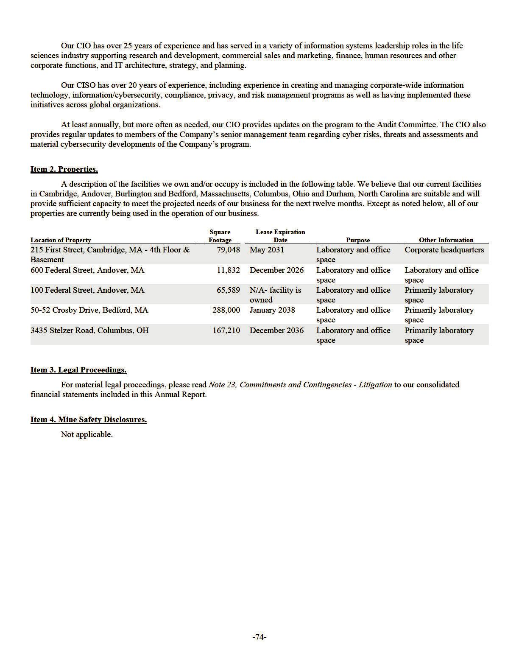

PART II

Item 5. Market for Registrant’s Common Equity, Related Stockholder Matters and Issuer Purchases of Equity Securities. Market Information
Our common stock is quoted on the Nasdaq Global Select Market under the same symbol “SRPT”.

Holders

As of February 24, 2026, we had 140 stockholders of record of our common stock.

Dividends

We did not declare or pay cash dividends on our common stock in 2025, 2024 or 2023. We currently expect to retain future earnings, if any, to finance the operation and expansion of our business, and we do not anticipate paying any cash dividends in the foreseeable future. Any future determination related to our dividend policy will be made at the discretion of our board of directors.

Performance Graph

The following graph compares the performance of our Common Stock for the periods indicated with the performance of the NASDAQ Biotechnology Index, NASDAQ Composite Index and the NYSE ARCA Biotechnology Index. This graph assumes an investment of $100 after the market closed December 31, 2020 in each of our common stock, NASDAQ Biotechnology Index, the NASDAQ Composite Index and the NYSE ARCA Biotechnology Index, and assumes reinvestment of dividends, if any. The stock price performance shown on the graph below is not necessarily indicative of future stock price performance. This graph is not “soliciting material,” is not deemed “filed” with the SEC and is not to be incorporated by reference into any of our filings under the Securities Act of 1933, as amended, or the Securities Exchange Act of 1934, as amended, whether made before or after the date hereof and irrespective of any general incorporation language in any such filing.
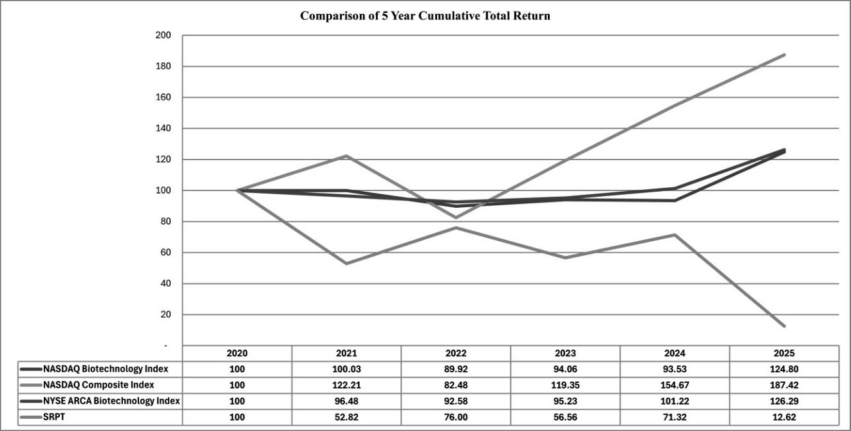

Recent Sales of Unregistered Securities.

None.

Purchases of Equity Securities by the Issuer and Affiliated Purchasers.

None.

Item 6. Reserved

-75-

Item 7. Management’s Discussion and Analysis of Financial Condition and Results of Operations.

The purpose of Management's Discussion and Analysis of Financial Condition and Results of Operations is to provide an understanding of the financial condition, changes in financial condition and results of operations of Sarepta Therapeutics, Inc. The following discussion and analysis of our financial condition and results of operations should be read in conjunction with our consolidated financial statements and related notes included elsewhere in this Annual Report on Form 10-K. This discussion contains forward-looking statements that involve risks and uncertainties. Please review our legend titled “Forward-Looking Information” at the beginning of this Annual Report on Form 10-K which is incorporated herein by reference. Our actual results could differ materially from those discussed below. Factors that could cause or contribute to such differences include, but are not limited to, those identified below, and those discussed in the section titled “Risk Factors” included elsewhere in this Annual Report on Form 10-K. Throughout this discussion, unless the context specifies or implies otherwise, the terms “Sarepta”, “we”, “us” and “our” refer to Sarepta Therapeutics, Inc. and its subsidiaries.

This section discusses 2025 and 2024 items and year-to-year comparisons between 2025 and 2024. Discussions of 2023 items and year-to-year comparisons between 2024 and 2023 have been excluded from this Form 10-K and can be found in “Management’s Discussion and Analysis of Financial Condition and Results of Operations” in Part II, Item 7 of our Annual Report on Form 10-K for the fiscal year ended December 31, 2024.

Overview

We are a commercial-stage biopharmaceutical company focused on helping patients through the discovery and development of unique RNA-targeted therapeutics, siRNA knockdown therapies, gene therapy and other genetic therapeutic modalities for the treatment of rare diseases. Applying our proprietary, differentiated and innovative technologies, and through collaborations with our strategic partners, we have developed multiple approved products for the treatment of Duchenne and are developing potential therapeutic candidates for a broad range of diseases and disorders, including Duchenne and LGMD, as well as those through our partnered programs with Arrowhead, including FSHD, DM1, SCA2, IPF, Huntington's disease and other neuromuscular and skeletal diseases.

We commercialized four products that have been approved by the FDA, including EXONDYS 51, VYONDYS 53, AMONDYS 45, and ELEVIDYS. We are in the process of conducting various clinical trials for our approved products, including studies that are required to comply with our post-marketing FDA requirements/commitments to verify and describe the clinical benefit of these products. On November 3, 2025, we announced top-line results from our ESSENCE trial, a confirmatory trial intended to verify the clinical benefits of AMONDYS 45 and VYONDYS 53. The topline results did not show statistical significance on the study's primary endpoint. We intend to discuss with FDA the potential pathway forward.

Our pipeline includes programs at various stages of discovery, pre-clinical and clinical development. Through our collaborations with our strategic partners, we are expanding into adjacent therapeutic areas. Our pipeline reflects our aspiration to apply our multifaceted approach and expertise in precision genetic medicine to make a profound difference in the lives of patients suffering from rare diseases.

We have developed proprietary state-of-the-art CMC and manufacturing capabilities that allow synthesis and purification of our products and product candidates to support both clinical development as well as commercialization. Our current main focus in manufacturing is to sustain large-scale production of our PMO-based therapies and optimizing manufacturing for gene therapy-based product candidates. We have entered into certain manufacturing and supply arrangements with third-party suppliers and will utilize these capabilities to support production of certain of our products and product candidates and their components.

The likelihood of our long-term success must be considered in light of the expenses, difficulties and delays frequently encountered in the development and commercialization of new pharmaceutical products, competitive factors in the marketplace, the risks associated with government sponsored reimbursement programs and the complex regulatory environment in which we operate.

Critical Accounting Policies and Estimates

The discussion and analysis of our financial condition and results of operations is based upon our consolidated financial statements included elsewhere in this Annual Report on Form 10-K. The preparation of our consolidated financial statements in accordance with U.S. GAAP requires us to make estimates and judgments that affect the reported amounts of assets, liabilities, revenues and expenses and related disclosures of contingent assets and liabilities for the periods presented. Some of these judgments can be subjective and complex, and, consequently, actual results may differ from these estimates. We believe that the estimates and judgments upon which we rely are reasonable based upon historical experience and information available to us at the time that we make these estimates and judgments. To the extent there are material differences between these estimates and actual results, our consolidated financial statements will be affected. Although we believe that our judgments and estimates are appropriate, actual results may differ from these estimates. We believe the following accounting policies to be most critical to the judgments and estimates used in the preparation of our consolidated financial statements:

- inventory; and

- income tax.

-76-

Inventory Valuation

Inventories are stated at the lower of cost and net realizable value with cost determined on a first-in, first-out basis. We capitalize inventory costs associated with products following regulatory approval when future commercialization is considered probable and the future economic benefit is expected to be realized. EXONDYS 51, VYONDYS 53, AMONDYS 45 and ELEVIDYS inventory that may be used in clinical development programs is charged to research and development expense when the product enters the research and development process and no longer can be used for commercial purposes.

We periodically analyze our inventories for excess or obsolescence and write down excess or obsolete or otherwise unmarketable inventory to its estimated net realizable value. Reserves are recorded to reduce the cost basis of inventory when it is determined that inventory on hand is excess or obsolete. Our determination of excess or obsolete inventory is based on assumptions about forecasted demand for our products, market conditions and regulatory approvals. In 2025, we recorded $165.3 million of charges as a component of cost of sales in the consolidated statements of comprehensive (loss) income relating to excess or obsolete inventory. It is reasonably possible that actual results may differ from management’s estimates regarding forecasted demand, market conditions and regulatory approval and such differences could be material to our consolidated balance sheets, consolidated statements of comprehensive (loss) income and consolidated statements of cash flows. Additionally, though our products are subject to strict quality control and monitoring, which we perform throughout the manufacturing processes, certain batches or units of product may not meet quality specifications. Expense incurred related to excess inventory, obsolete inventory, or inventories that do not meet our quality specifications is recorded as a component of cost of sales in the consolidated statements of comprehensive (loss) income.

Income Tax

We follow the asset and liability method of accounting for income taxes, which requires the recognition of deferred tax assets and liabilities for expected future tax consequences attributable to differences between the consolidated financial statement carrying amounts of existing assets and liabilities and their respective tax bases. Deferred tax assets and liabilities are measured using enacted tax rates in effect for the year in which the differences are expected to reverse. A valuation allowance is recorded to reduce the net deferred tax asset to zero when it is more likely than not that the net deferred tax asset will not be realized. As of December 31, 2025, we continued to maintain a full valuation allowance against all of our deferred tax assets, with the exception of deferred tax assets in certain foreign jurisdictions, based on management's evaluation of all available evidence, including our earnings history.

We will continue to monitor the realizability of our deferred tax assets in future periods. We may release all or a portion of the valuation allowance in the near-term; however, the release of the valuation allowance, as well as the exact timing and the amount of such release, continue to be subject to, among other things, our level of profitability, revenue growth and expectations regarding future profitability. If and when we determine the valuation allowance should be released or reduced, the adjustment would result in a benefit to income tax expense for the period the release is recorded, which could have a material impact on net earnings.

We recognize the effect of income tax positions only if those positions are more likely than not of being sustained upon an examination. The calculation of our tax liabilities (or amount of reduction in our deferred tax assets from net operating loss carryover and research credit carryover) resulting from uncertain tax positions can involve significant judgment. Further, the calculation may involve the application of complex tax regulations in a foreign jurisdiction. Any significant impact as a result of changes in underlying facts, law, tax rates, tax audit, or review could lead to adjustments to our deferred tax asset, income tax expense, our effective tax rate, and/or our cash flow. Although we believe that we have adequately provided for tax liabilities resulting from uncertain tax positions, the actual amounts paid, if any, could have a material impact on our results of operations. Interest and penalties associated with uncertain tax positions are classified as a component of income tax expense.

Please read Note 2, Summary of Significant Accounting Policies and Recent Accounting Pronouncements to the consolidated financial statements, included elsewhere in this Annual Report on Form 10-K, for a further discussion of our critical accounting policies and estimates.

-77-

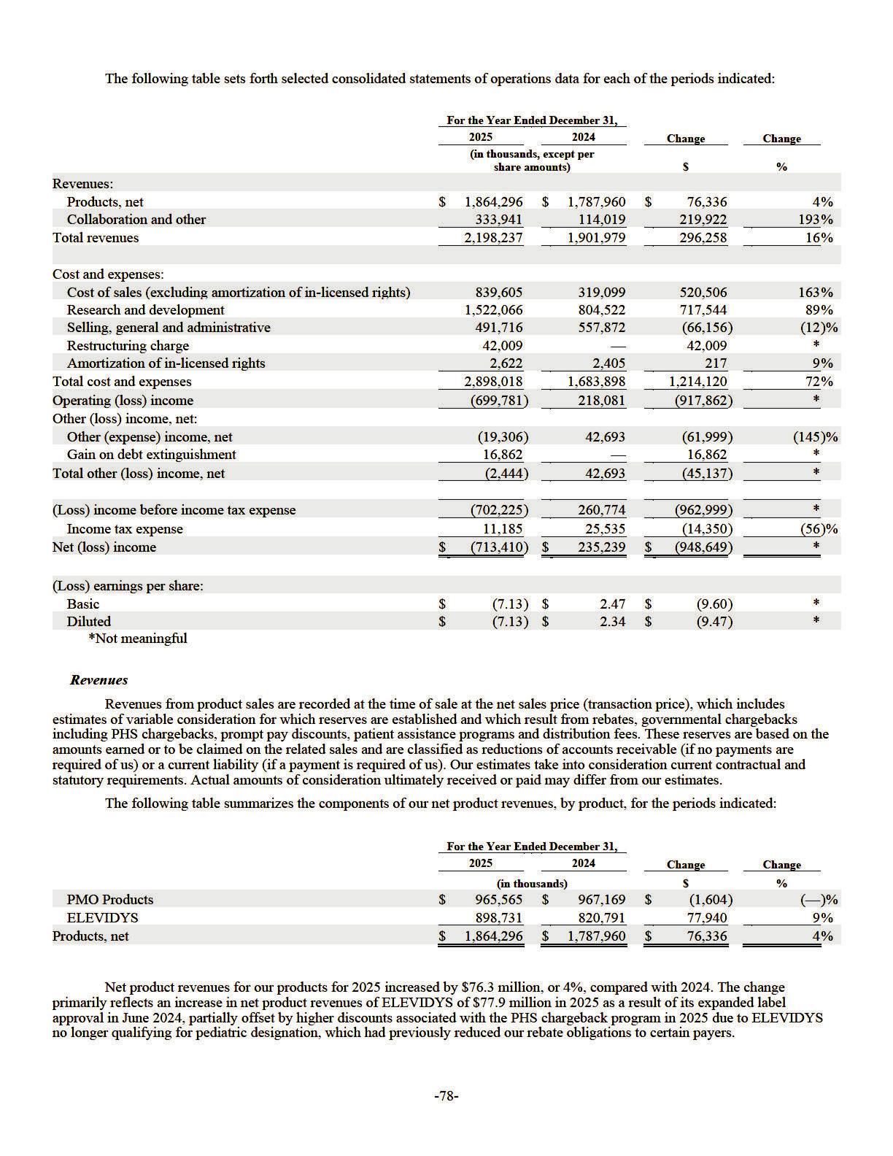

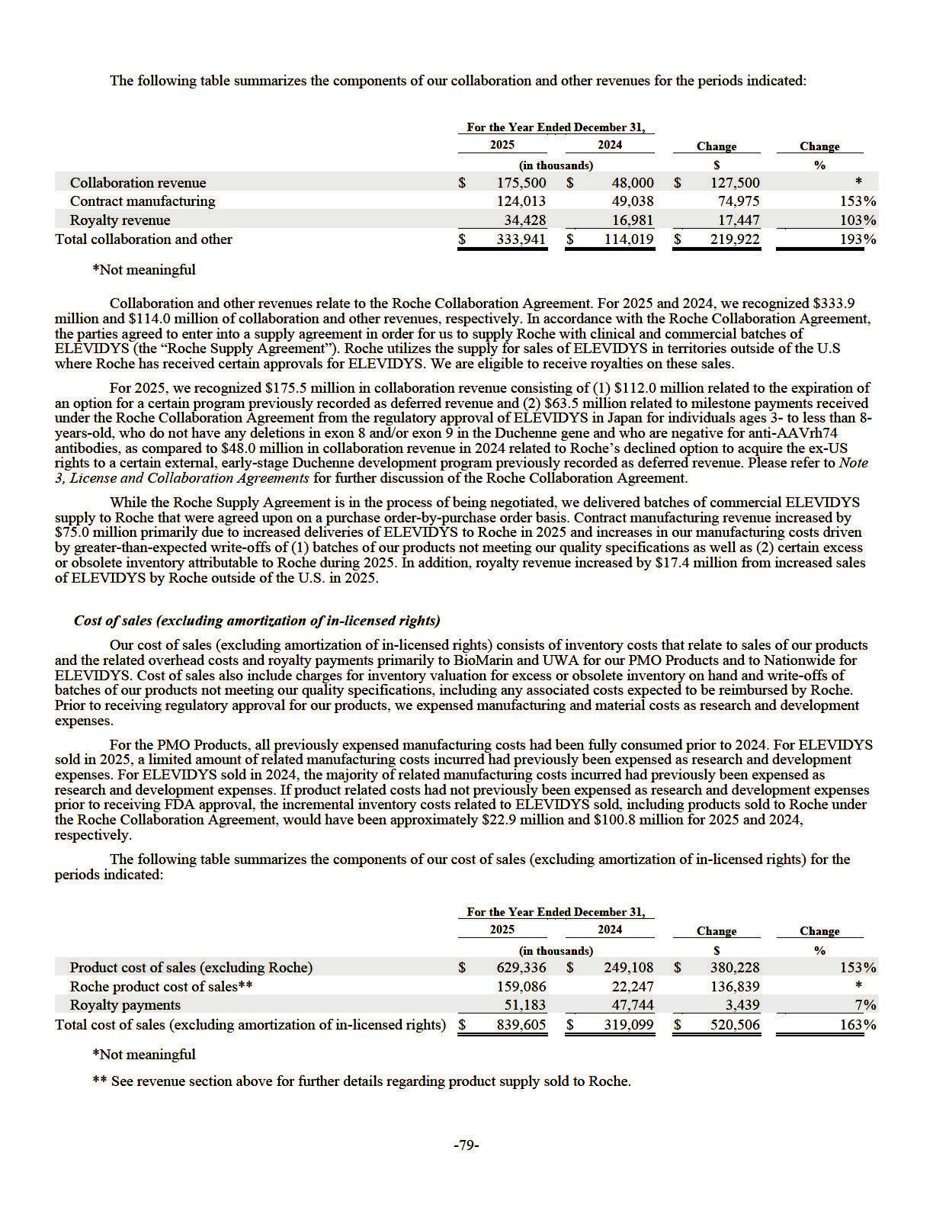

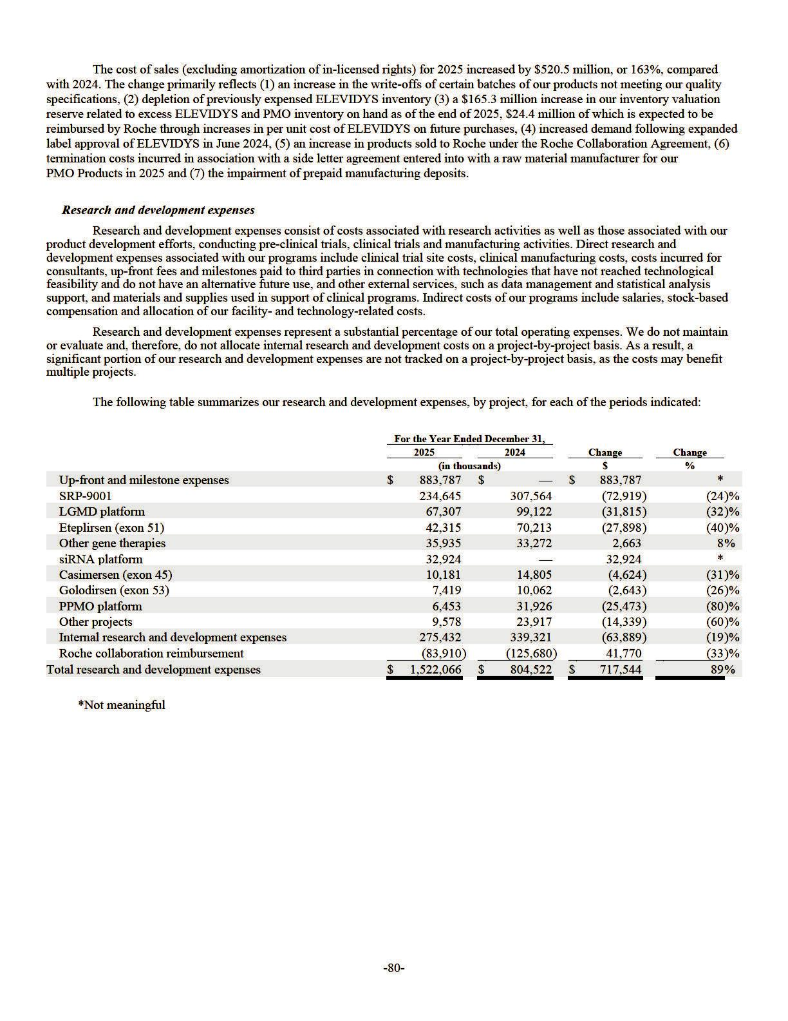

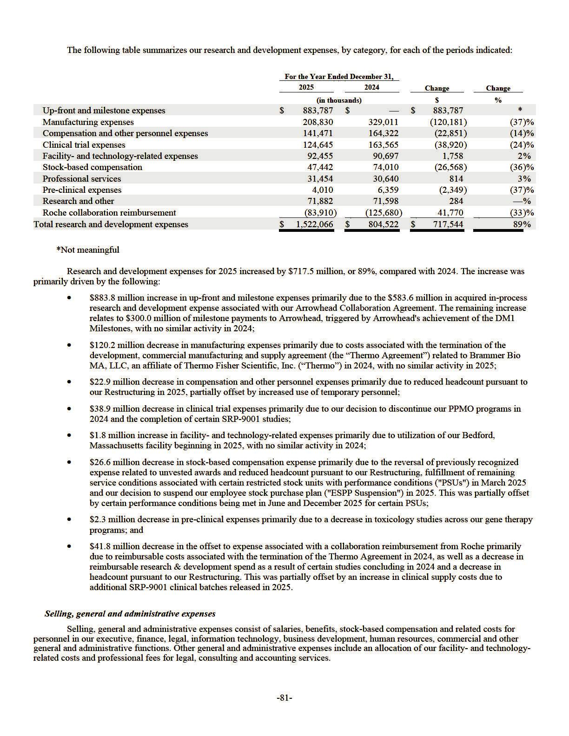

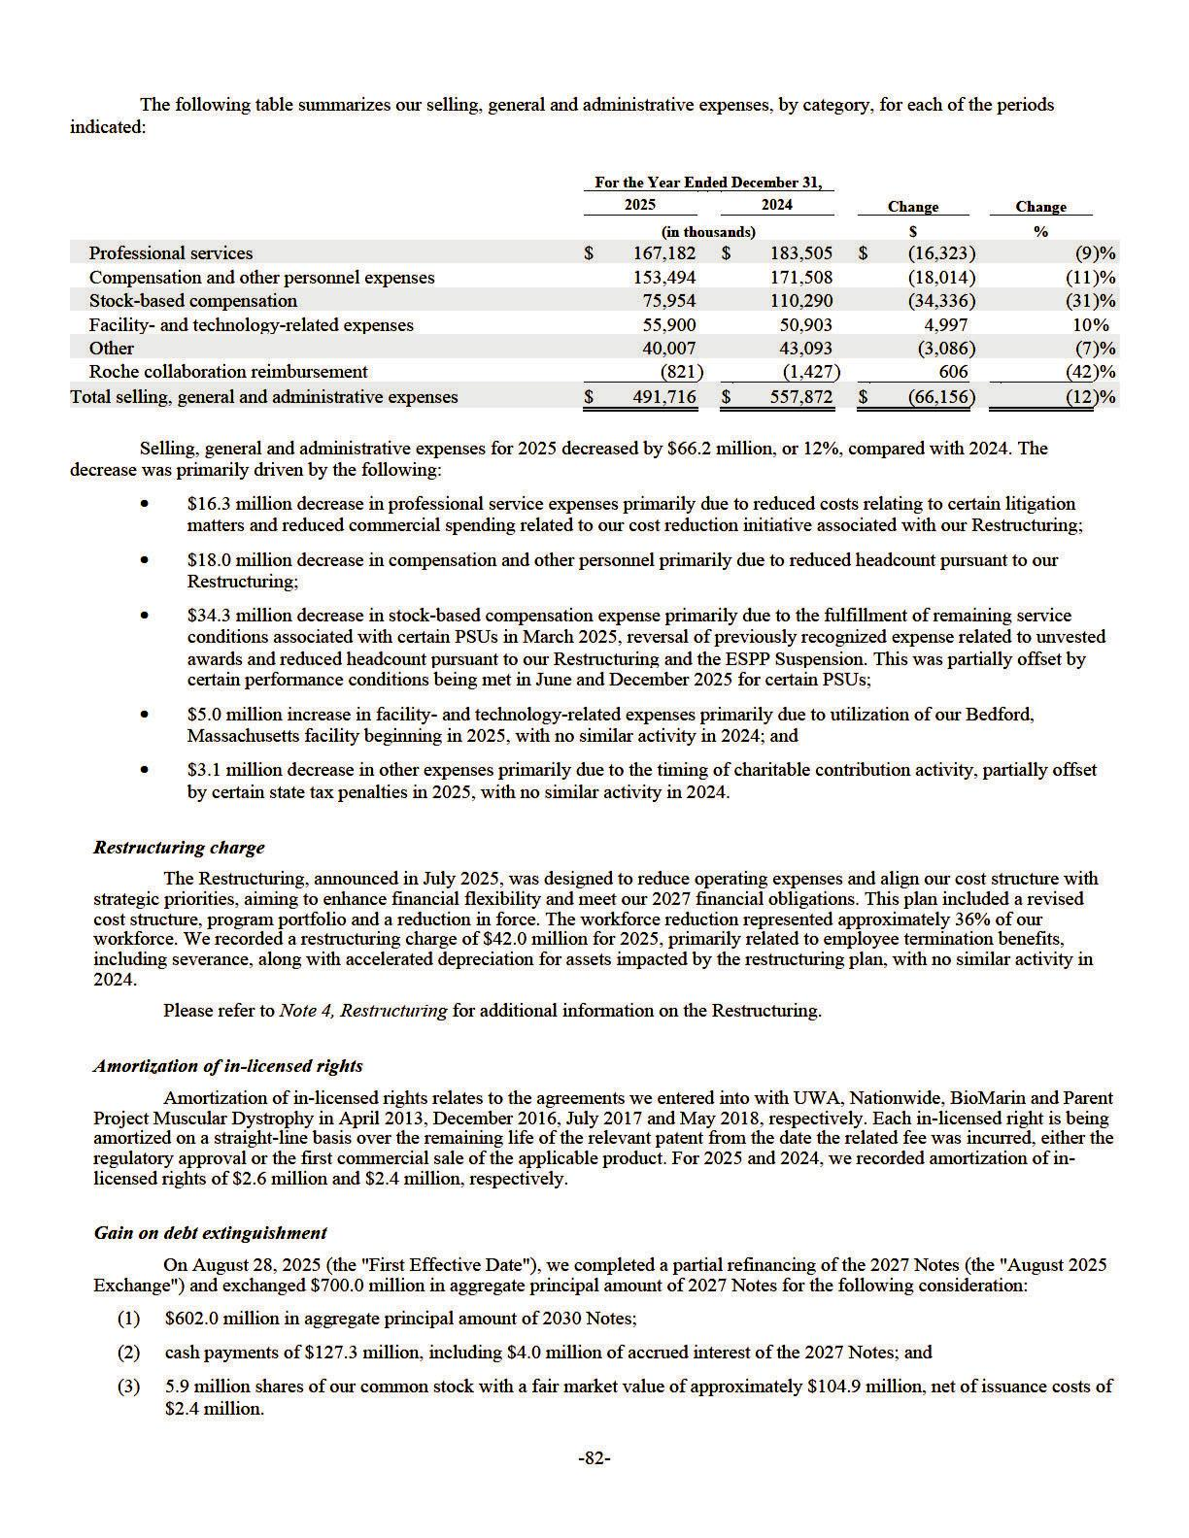

On December 18, 2025 (the "Second Effective Date"), we completed the second partial refinancing of the 2027 Notes (the “December 2025 Exchange”) and exchanged $291.4 million in aggregate principal amount of the 2027 Notes for the following consideration:

- $291.4 million in aggregate principal amount of the 2030 Notes; and

- cash payments of $31.6 million, including $1.0 million of accrued interest of the 2027 Notes.

The Company concluded that neither the August 2025 Exchange nor December 2025 Exchange (collectively, the “Exchange Transactions”) met the criteria for induced conversion. Further, we concluded that the refinanced debt in the August 2025 Exchange as well as approximately $182.8 million of that in the December 2025 Exchange were substantially different from the original debt and, thus, accounted for as debt extinguishments. The gain recognized on the extinguishments for the year ended December 31, 2025 was $16.9 million. The Company also determined that the remaining $108.6 million of the refinanced debt in the December 2025 Exchange was not substantially different from the original debt and, therefore, accounted for as debt modification. Please refer to Note 13, Indebtedness for additional information on the August 2025 Exchange and December 2025 Exchange.

There was no similar activity in 2024.

Other (expense) income, net

Other (expense) income, net primarily consists of the unrealized gain or loss from our investments in our strategic equity investments, interest expense on our 2027 Notes and 2030 Notes, interest income on our cash, cash equivalents and investments and accretion of investment discount. Our cash equivalents and investments consist of money market funds, government and government agency bonds, corporate bonds, commercial paper and certificates of deposit.

Other (expense) income, net for 2025 increased by $62.0 million compared to 2024. The change is primarily due to a $35.2 million decrease in interest income as a result of lower interest rates and the investment mix of our investment portfolio, a $19.7 million increase in interest expense primarily due to the 2030 Notes carrying a higher interest rate than our 2027 Notes and a $13.1 million increase in the loss on our strategic investments in publicly traded companies, including Arrowhead. These changes were partially offset by a $7.8 million loss associated with the change in fair value derivative liabilities in 2024, which primarily relates to our contingent consideration, with no similar activity in 2025 due to the adoption of Accounting Standards Update 2025-07 ("ASU 2025-07"). As a result, two existing contracts that include a settlement feature based on our operations or activities are now excluded from ASC 815, Derivatives and Hedging and any liabilities will be recognized as such obligations become probable and estimable under ASC 450, Contingencies. Refer to Note 2, Summary of Significant Accounting Policies and Recent Accounting Pronouncements for additional information related to the adoption of ASU 2025-07.

Income tax expense

Income tax expense for 2025 and 2024 was $11.2 million and $25.5 million, respectively. Income tax expense for 2025 primarily relates to state taxes. Income tax expense for 2024 relates to state, foreign and federal taxes for which available tax losses or credits were not available to offset. As of December 31, 2025, we continued to maintain a full valuation allowance against our deferred tax assets, with the exception of deferred tax assets in certain foreign jurisdictions. We continue to monitor the available evidence relative to recovery of our deferred tax assets and whether such evidence would be sufficient to conclude that it is more likely than not that such deferred tax assets may be partially or fully recoverable. If we were to remove our valuation allowance in part or full, any such adjustment could have a material impact on our effective tax rate in the applicable period and beyond. Refer to Note 18, Income Taxes for discussion of the key drivers impacting our effective tax rate.

Liquidity and Capital Resources

In the August 2025 Exchange, we exchanged 2027 Notes for a combination of 2030 Notes, common stock and cash. Concurrently with the issuance of the 2030 Notes during the August 2025 Exchange, we completed the private placement of approximately 1.1 million shares of Common Stock to J. Wood Capital Advisors LLC ("JWCA") at a purchase price per share of $18.07. In the December 2025 Exchange, we exchanged 2027 Notes for 2030 Notes and cash. While the 2030 Notes carry a higher interest rate than the 2027 Notes, the August 2025 Exchange and December 2025 Exchange reduced our total outstanding principal amount of long-term debt by $98.0 million and delayed $893.4 million of the principal payment to 2030. Additionally, our Revolving Credit Facility remains undrawn as of December 31, 2025. Refer to Note 13, Indebtedness for additional discussion of our outstanding indebtedness. We periodically engage in discussions with the lenders under our Revolving Credit Facility regarding business developments and our continued ability to borrow under our Revolving Credit Facility. See Risk Factors—Risks Related to our Financial Condition and Capital Requirements—Our existing and any future indebtedness could adversely affect our ability to operate our business.

-83-

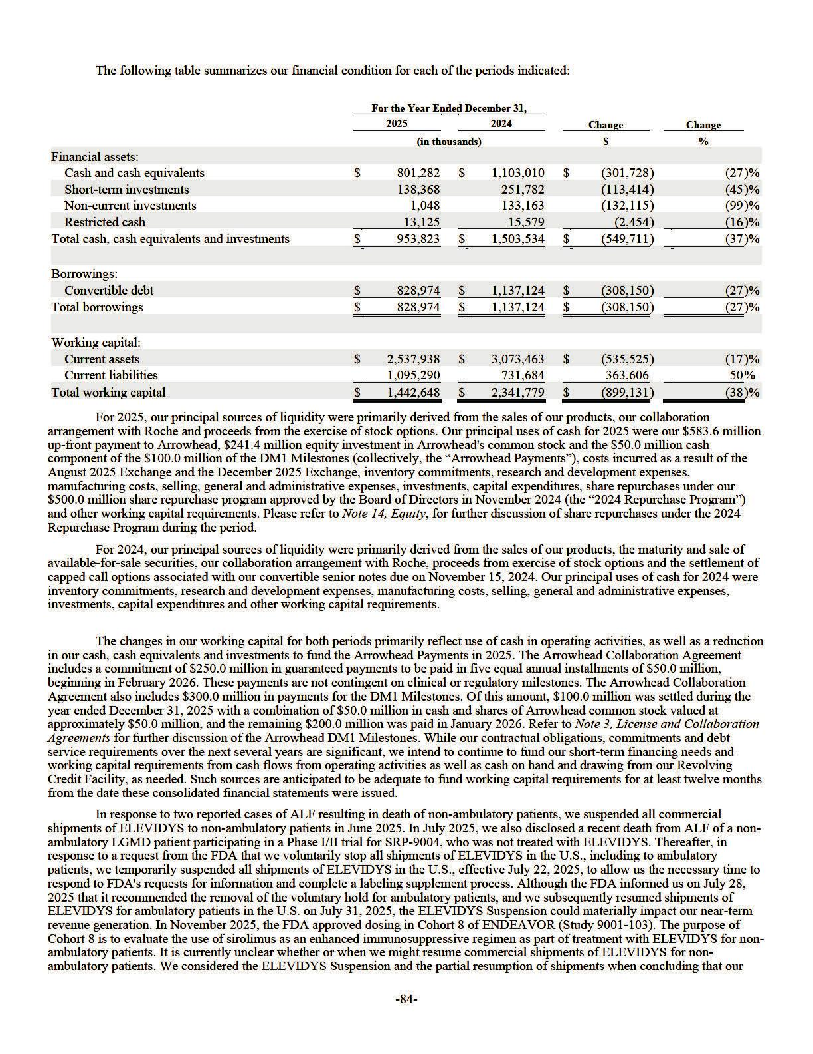

cash, cash equivalents and investments as of the date of issuance of this report, along with future cash inflows from operations and availability under our Revolving Credit Facility, are sufficient to fund our current operational plan for at least the next twelve months. Additionally, any regulatory action in response to the topline results of our ESSENCE trial that were announced on November 3, 2025 and failed to meet statistical significance on its primary endpoint, could adversely impact our cash flows from operations.

Beyond 2026, our cash requirements will depend extensively on our ability to advance our research, development and commercialization of product candidates. The likelihood of our long-term success must be considered in light of the expenses, difficulties and delays frequently encountered in the development and commercialization of new pharmaceutical products, competitive factors in the marketplace, the risks associated with government sponsored reimbursement programs and the complex regulatory environment in which we operate. We may seek additional financing primarily from, but not limited to, the sale and issuance of equity and debt securities, the licensing or sale of our technologies and entering into additional government contracts and/or funded research and development agreements. Further, while we anticipate that the Restructuring announced in July 2025 will result in a reduction in our future expenditures, actual savings realized may vary and there can be no assurance that the Restructuring will achieve our anticipated cost savings or operational efficiencies. Our future expenditures and long-term capital requirements may be substantial and will depend on many factors, including but not limited to the following:

- our ability to continue to generate revenues from sales of commercial products and potential future products;

- our ability to resume commercial shipments of ELEVIDYS for non-ambulatory patients in the U.S.;

- our ability to realize the benefits of the Restructuring;

- the risk that our Restructuring and pipeline reprioritization efforts may not generate their intended benefits to the extent or as quickly as anticipated;

- the impact of potential regulatory actions from the FDA including changes to our drug labels or revocation of accelerated approvals and directives to remove products from the market relating to the topline results of our ESSENCE trial that failed to meet statistical significance on its primary endpoint;

- the timing and costs associated with repurchases of our common stock under our 2024 Repurchase Program;

- the timing of payments related to our future inventory commitments and manufacturing obligations;

- the timing and costs associated with our existing lease obligations and new obligations expected to be entered into in future years;

- the timing and costs associated with our pre-clinical and clinical trials;

- the attainment of milestones and our obligations to make milestone payments to Arrowhead, Myonexus Therapeutics, Inc.'s selling shareholders, BioMarin, Nationwide, UWA and other institutions;

- the timing and repayment of future borrowings on our Revolving Credit Facility;

- obligations to holders of our 2027 Notes and 2030 Notes; and

- the costs of filing, prosecuting, defending and enforcing patent claims and our other intellectual property rights.

We cannot provide assurances that financing will be available when and as needed or that, if available, the financings will be on favorable or acceptable terms. If we are unable to obtain additional financing when and if we require, this would have a material adverse effect on our business and results of operations. To the extent we issue additional equity securities, our existing stockholders could experience substantial dilution. Additional information regarding our Revolving Credit Facility is provided in Note 13, Indebtedness to the consolidated financial statements included elsewhere in this Annual Report on Form 10-K. We believe that our existing cash, cash equivalents and investments along with future cash generated from operations and availability under our Revolving Credit Facility will be sufficient to meet the capital requirements of our operations for the next twelve months and foreseeable future.

-85-

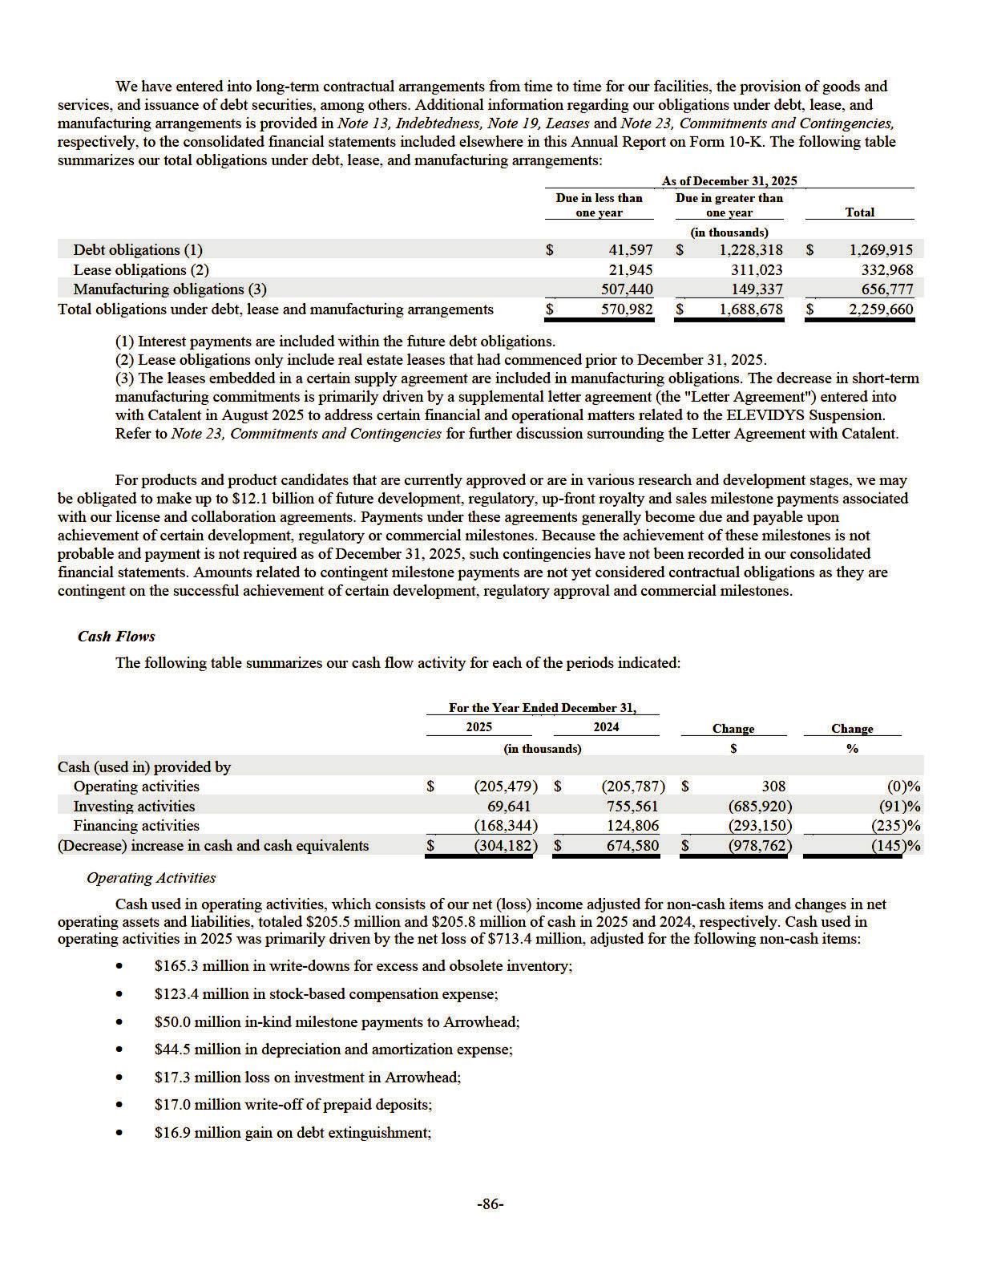

- $14.0 million reduction in the carrying amount of the right of use assets; and

- $20.6 million in other non-cash items.

These amounts were partially offset by $5.3 million in accretion of investment discount, net.

The net cash outflow from changes in our operating assets and liabilities was primarily driven by the following:

- $301.1 million increase in inventory primarily due to capitalized inventory related to ELEVIDYS;

- $203.8 million decrease in accounts receivable primarily due to reduced shipments of ELEVIDYS in the second half of 2025 compared to 2024 due to the ELEVIDYS Suspension;

- $79.8 million increase in other assets primarily due to the timing of billings to Roche for orders of ELEVIDYS for use outside of the U.S., as well as increased royalty receivables from Roche related to increased ELEVIDYS sales outside of the U.S.;

- $104.3 million increase in accounts payable, accrued expenses, lease liabilities and other liabilities primarily due to the remaining $200.0 million associated with the Arrowhead DM1 Milestones being included in accounts payable as of December 31, 2025, partially offset by a reduction in accrued employee compensation costs pursuant to our Restructuring and payments on accrued employee compensation costs, a reduction in accrued income taxes and the timing and invoicing of payments with our contract research organizations and contract manufacturing organizations;

- $72.1 million increase in deferred revenue primarily related to the timing of billings to Roche for orders of ELEVIDYS not yet shipped, partially offset by the recognition of collaboration revenue related to the expiration of an option for a certain program previously recorded as deferred revenue; and

- $78.8 million decrease in manufacturing-related deposits and prepaids primarily due to the use of raw materials and services previously prepaid with Catalent and Aldevron.

Cash used in operating activities in 2024 was primarily driven by the net income of $235.2 million, adjusted for the following non-cash items:

- $184.3 million in stock-based compensation expense;

- $62.7 million in non-cash termination charges as a result of the Thermo Agreement termination;

- $37.7 million in depreciation and amortization expense;

- $16.2 million reduction in the carrying amount of the right of use assets;

- $7.8 million charge related to the change in the fair value of derivatives; and

- $7.1 million in other non-cash items.

These amounts were partially offset by $40.3 million in accretion of investment discount, net.

The net cash outflow from changes in our operating assets and liabilities was primarily driven by the following:

- $395.2 million increase in inventory primarily due to capitalized inventory related to ELEVIDYS;

- $201.7 million increase in accounts receivable due to an increase in demand for ELEVIDYS following its initial FDA approval in June 2023 and subsequent expanded label approval in June 2024 and an increase in payment terms for product sales related to the PMO Products;

- $188.6 million increase in manufacturing-related deposits and prepaids primarily due to an increase in prepaids for raw materials and batch fees with Catalent, partially offset by decreases in manufacturing-related deposits and prepaids at Thermo as a result of the termination of the Thermo Agreement during 2024; and

- $32.2 million decrease in deferred revenue primarily related to the collaboration with Roche.

These amounts were partially offset by a $110.6 million increase in accounts payable, accrued expenses, lease liabilities and other liabilities primarily due to the timing and invoicing of payments with our CROs and CMOs.

Investing Activities

Cash provided by investing activities for 2025 was $69.6 million, compared to $755.6 million in 2024. Cash provided by investing activities in 2025 consisted of $295.9 million from the maturity and sales of available- for-sale securities and $174.1 million in proceeds from the sale of the Arrowhead investment, partially offset by $245.8 million in the acquisition of strategic investments primarily related to Arrowhead as well as purchases of property and equipment, available-for-sale securities and intangible assets of $102.0 million, $44.7 million and $7.9 million, respectively.

-87-

Cash provided by investing activities in 2024 consisted of $2,002.1 million from the maturity and sales of available-for-sale securities, partially offset by purchases of available-for-sale securities, property and equipment and intangible assets of $1,099.6 million, $137.0 million and $10.0 million, respectively.

Financing Activities

Cash used in financing activities was $168.3 million in 2025, compared to $124.8 million of cash provided by financing activities in 2024. Cash used in financing activities in 2025 primarily consisted of the following:

- $158.4 million for the repurchase of a portion of our 2027 Notes;

- $25.0 million of purchases of our common stock under our 2024 Repurchase Program;

- $17.1 million of debt issuance costs associated with our 2030 Notes;

- $4.2 million of payments related to our Revolving Credit Facility; and

- $2.4 million of issuance costs associated with issuance of our common stock.

These amounts were partially offset by the following items:

- $20.0 million in proceeds from the private placement of approximately 1.1 million shares of our common stock pursuant to a privately negotiated subscription agreement with JWCA; and

- $18.7 million in proceeds from exercise of options and purchase of stock under our Employee Stock Purchase Program.

Cash provided by financing activities in 2024 primarily consisted of $79.5 million in proceeds from exercise of options and purchase of stock under our Employee Stock Purchase Program and $45.3 million in proceeds from the settlement of the 2017 Capped Calls.

Other Funding Commitments

We have several on-going clinical trials in various development stages. Our most significant clinical trial expenditures are to CROs. The CRO contracts are generally cancellable at our option. As of December 31, 2025, we had $404.3 million in cancellable future commitments based on existing CRO contracts.

Recent Accounting Pronouncements

Please read Note 2, Summary of Significant Accounting Policies and Recent Accounting Pronouncements to the consolidated

financial statements included elsewhere in this Annual Report on Form 10-K.

Item 7A. Quantitative and Qualitative Disclosures About Market Risk.

Interest-Rate-Sensitive Financial Instruments

Our current investment policy is to maintain a diversified investment portfolio consisting of money market investments, commercial paper, certificates of deposit, government and government agency bonds and high-grade corporate bonds with maturities of 24 months or less. Our cash is primarily deposited in and invested through highly rated financial institutions in the U.S. As of December 31, 2025, we had $953.8 million of cash, cash equivalents, restricted cash and investments, comprised of $801.3 million of cash and cash equivalents, $139.4 million of investments and $13.1 million non-current restricted cash. The Company only holds debt securities classified as available-for-sale. The fair value of cash equivalents and investments is subject to change as a result of potential changes in market interest rates. Our future investment income may fluctuate due to changes in interest rates or we may suffer losses in principal if we sell securities that decline in market value due to changes in interest rates. The potential change in fair value for interest rate sensitive instruments has been assessed on a hypothetical 10 basis point adverse movement across all maturities. As of December 31, 2025, we estimate that such hypothetical adverse 10 basis point movement would result in a hypothetical loss in fair value of less than $0.1 million to our interest rate sensitive instruments.

The $158.6 million aggregate principal amount outstanding of our 2027 Notes has a fixed interest rate of 1.25% per annum, payable semiannually in cash on each March 15 and September 15. The $893.4 million aggregate principal amount outstanding of our 2030 Notes has a fixed interest rate of 4.875% per annum, payable semi -annually in cash on each March 1 and September 1. Therefore, no outstanding debt is subject to fluctuations in market interest rates. However, to the extent that we borrow funds pursuant to our $600.0 million revolving credit agreement among JPMorgan Chase Bank, N.A., as administrative agent and as collateral agent, the lenders party thereto, and Sarepta Therapeutics Investments, Inc., a Delaware corporation (the “Credit Agreement”), in the future, indebtedness incurred under the Credit Agreement would bear interest at a variable rate, which would make us vulnerable to increases in interest rates.

-88-

Market-Price-Sensitive Financial Instruments

Our strategic investment portfolio includes an investment in equity securities of a publicly traded biotechnology company as a result of a certain business development transaction. While we are holding such securities, we are subject to equity price risk and this may increase the volatility of our income in future periods due to changes in the fair value of our strategic equity investment. Changes in the fair value of this strategic equity investment are impacted by the volatility of the stock market and changes in general economic conditions, among other factors. The potential change in fair value for market-price-sensitive instruments has been assessed on a hypothetical 10.0% adverse movement. As of December 31, 2025, we estimate that such hypothetical 10.0% adverse movement would result in a hypothetical loss in fair value of approximately $0.4 million to our market-price-sensitive financial instruments.

Item 8. Financial Statements and Supplementary Data.

The information required by this Item 8 begins on page F-1 in Item 15 of Part IV of this Annual Report on Form 10-K and is incorporated into this item by reference.

Item 9. Changes in and Disagreements with Accountants on Accounting and Financial Disclosure.

None.

Item 9A. Controls and Procedures.

Disclosure Controls and Procedures

We carried out an evaluation as of the end of the period covered by this Annual Report on Form 10-K, under the supervision and with the participation of our management, including our principal executive officer and principal financial officer, of the effectiveness of our disclosure controls and procedures pursuant to paragraph (b) of Rule 13a-15 and 15d-15 under the Exchange Act. Based on that review, the principal executive officer and principal financial officer have concluded that our disclosure controls and procedures are effective to ensure that information required to be disclosed by us in the reports we file or submit under the Exchange Act (1) is recorded, processed, summarized, and reported within the time periods specified in the SEC rules and forms, and (2) is accumulated and communicated to our management, including our principal executive officer and principal financial officer, as appropriate to allow timely decisions regarding required disclosure.

We do not expect that our disclosure controls and procedures will prevent all errors and all fraud. A control procedure, no matter how well conceived and operated, can provide only reasonable, not absolute, assurance that the objectives of the control procedure are met. Because of the inherent limitations in all control procedures, no evaluation of controls can provide absolute assurance that all control issues and instances of fraud, if any, within our Company have been detected. These inherent limitations include the realities that judgments in decision making can be faulty, and that breakdowns can occur because of simple error or mistake. Additionally, controls can be circumvented by the individual acts of some persons, by collusion of two or more people, or by management override of the control. We considered these limitations during the development of our disclosure controls and procedures, and will continually reevaluate them to ensure they provide reasonable assurance that such controls and procedures are effective.

Internal Control over Financial Reporting

Management’s Annual Report on Internal Control over Financial Reporting

Management is responsible for establishing and maintaining adequate internal control over financial reporting for our Company, as such term is defined in Rules 13a-15(f) and 15d-15(f) under the Exchange Act.

Our internal control over financial reporting is a process designed to provide reasonable assurance regarding the reliability of financial reporting and the preparation of financial statements for external purposes in accordance with generally accepted accounting principles, and includes those policies and procedures that:

- pertain to the maintenance of records that, in reasonable detail, accurately and fairly reflect the transactions and dispositions of our assets;

- provide reasonable assurance that transactions are recorded as necessary to permit preparation of financial statements in accordance with generally accepted accounting principles, and that our receipts and expenditures are being made only in accordance with authorizations of our management and directors; and

- provide reasonable assurance regarding prevention or timely detection of unauthorized acquisition, use or disposition of our assets that could have a material effect on our financial statements.

-89-

Because of its inherent limitations, internal control over financial reporting may not prevent or detect misstatements. Also, projections of any evaluation of effectiveness to future periods are subject to the risk that controls may become inadequate because of changes in conditions, or that the degree of compliance with the policies or procedures may deteriorate. Management assessed the effectiveness of our internal control over financial reporting as of December 31, 2025. In making this assessment, management used the criteria set forth by the Committee of Sponsoring Organizations of the Treadway Commission in its 2013 Internal Control Integrated Framework.

Based on this assessment, management has concluded that, as of December 31, 2025, our internal control over financial reporting was effective based on those criteria.

The effectiveness of our internal control over financial reporting as of December 31, 2025, has been audited by KPMG LLP, an independent registered public accounting firm, as stated in their report which appears in this Annual Report on Form 10-K.

Changes in Internal Control over Financial Reporting

There have not been material changes in our internal control over financial reporting as defined in Rules 13a–15(f) and 15d– 15(f) under the Exchange Act for the quarter ended December 31, 2025 that our certifying officers concluded materially affected, or are reasonably likely to materially affect, our internal control over financial reporting.

Item 9B. Other Information.

During the three months ended December 31, 2025, Cristin L. Rothfuss, Executive Vice President, General Counsel, entered into and adopted a written plan for the sale of our securities that is intended to satisfy the conditions specified in Rule 10b5-1(c) under the Exchange Act for an affirmative defense against liability for trading in securities on the basis of material nonpublic information (a “Rule 10b5-1 trading plan”). Ms. Rothfuss' 10b5-1 trading plan has an adoption date of December 16, 2025 and an end date of January 8, 2027, covering a total of 2,152 shares of common stock underlying vested restricted stock units as well as the net shares issued to Ms. Rothfuss upon the future vesting of restricted stock units.

Item 9C. Disclosure Regarding Foreign Jurisdictions that Prevent Inspections.

Not applicable.

-90-

PART III

Item 10. Directors, Executive Officers and Corporate Governance.

The information regarding our directors and executive officers required by this item will be included in either an amendment to this Annual Report on Form 10-K or in our definitive proxy statement for our 2026 annual meeting of stockholders to be filed with the Commission not later than 120 days after the end of the fiscal year covered by this Annual Report on Form 10-K and is incorporated herein by reference.

Item 11. Executive Compensation.

The information required by this item will be included in either an amendment to this Annual Report on Form 10-K or in our definitive proxy statement for our 2026 annual meeting of stockholders to be filed with the Commission not later than 120 days after the end of the fiscal year covered by this Annual Report on Form 10-K and is incorporated herein by reference.

Item 12. Security Ownership of Certain Beneficial Owners and Management and Related Stockholder Matters.

The information required by this item will be included in either an amendment to this Annual Report on Form 10-K or in our definitive proxy statement for our 2026 annual meeting of stockholders to be filed with the Commission not later than 120 days after the end of the fiscal year covered by this Annual Report on Form 10-K and is incorporated herein by reference.

Item 13. Certain Relationships and Related Transactions, and Director Independence.

The information required by this item will be included in either an amendment to this Annual Report on Form 10-K or in our definitive proxy statement for our 2026 annual meeting of stockholders to be filed with the Commission not later than 120 days after the end of the fiscal year covered by this Annual Report on Form 10-K and is incorporated herein by reference.

Item 14. Principal Accounting Fees and Services.

The information required by this item will be included in either an amendment to this Annual Report on Form 10-K or in our definitive proxy statement for our 2026 annual meeting of stockholders to be filed with the Commission not later than 120 days after the end of the fiscal year covered by this Annual Report on Form 10-K and is incorporated herein by reference.

-91-

PART IV

Item 15. Exhibits, Financial Statement Schedules.

(a) The following documents are filed as part of this Annual Report on Form 10-K:

(1) Financial Statements

The following consolidated financial statements of the Company and the Report of KPMG LLP, Independent Registered Public Accounting Firm, are included in Part IV of this Annual Report on Form 10-K on the pages indicated:

Report of Independent Registered Public Accounting Firm (KPMG LLP, Boston, MA, Auditor Firm ID: 185) | F-2
Consolidated Balance Sheets | F-4
Consolidated Statements of Comprehensive (Loss) Income | F-5
Consolidated Statements of Stockholders’ Equity | F-6
Consolidated Statements of Cash Flows | F-7
Notes to Consolidated Financial Statements | F-8

(2) Financial Statement Schedules

All schedules are omitted because they are not applicable or the required information is shown in the consolidated financial statements or the notes thereto.

(3) Exhibits

The exhibits required by Item 601 of Regulation S-K are listed in paragraph (b) below.

(b) Exhibits.

The following exhibits are filed herewith or are incorporated by reference to exhibits filed with the SEC:

Exhibit |  |  |  |  |  |  |  |  |  |  |  |  |  |  |  |  |  |  |  |  |  | Incorporated by Reference to Filings Indicated
Exhibit |  |  |  | Description |  |  |  |  |  |  |  |  |  |  |  |  |  |  |  |  | Form |  | File No. |  | Exhibit |  | Filing |  | Provided
Number |  |  |  |  |  |  |  |  |  |  |  |  |  |  |  |  |  |  |  |  | Form |  | File No. |  | Exhibit |  | Date |  | Herewith
2.1 |  | Agreement and Plan of Merger dated June 6, 2013 |  |  |  |  |  |  |  |  |  |  |  |  |  |  |  |  |  |  | 8-K12B | 001-14895 |  | 2.1 |  | 6/6/13
 |  | between Sarepta Therapeutics, Inc., a Delaware
 |  | corporation, and Sarepta Therapeutics, Inc., an
 |  | Oregon corporation.
2.2* |  | Warrant to Purchase Common Stock of Myonexus |  |  |  |  |  |  |  |  |  |  |  |  |  |  |  |  |  |  | 10-Q | 001-14895 |  | 2.1 |  | 8/8/18
 |  | Therapeutics, Inc., issued by Myonexus
 |  | Therapeutics, Inc. to Sarepta Therapeutics, |  |  |  |  |  |  | Inc.,
 |  | dated as of May 3, 2018.
3.1 |  | Amended and Restated Certificate of Incorporation. |  |  |  |  |  |  |  |  |  |  |  |  |  |  |  |  |  |  | 8-K12B | 001-14895 |  | 3.1 |  | 6/6/13
3.2 |  | Amendment to the Amended and Restated |  |  |  |  |  |  |  |  |  |  |  |  |  |  |  |  |  |  | 8-K | 001-14895 |  | 3.1 |  | 6/30/15
3.2 |  | Certificate of Incorporation.
3.3 |  | Second Amended and Restated ByLaws of Sarepta |  |  |  |  |  |  |  |  |  |  |  |  |  |  |  |  |  |  | 8-K | 001-14895 |  | 3.1 |  | 12/13/22
 |  | Therapeutics, Inc.
3.4 |  | Amendment No. 1 to Second Amended and Restated |  |  |  |  |  |  |  |  |  |  |  |  |  |  |  |  |  |  | 8-K | 001-14895 |  | 3.1 |  | 9/16/24
 |  | Bylaws of Sarepta Therapeutics, Inc.
4.1 |  | Form of Specimen Certificate for Common Stock. |  |  |  |  |  |  |  |  |  |  |  |  |  |  |  |  |  |  | 10-Q | 001-14895 |  | 4.1 |  | 8/8/13
4.2 |  |  |  |  |  |  |  |  |  |  |  |  |  |  |  |  |  |  |  |  | 8-K | 001-14895 |  | 4.1 |  | 9/19/22
4.2 |  | Indenture, dated as of September 16, 2022, by and
 |  | between Sarepta Therapeutics, Inc. and U. S. Bank
Trust Company, National Association (including the

form of the 1.250% Convertible Senior Note due
2027).

-92-

4.3 | Form of 2027 Note (included in Exhibit 4.2) |  |  |  |  |  |  |  |  |  |  |  |  |  |  |  |  |  |  |  |  |  |  |  |  |  |  |  |  |  |  |  |  |  |  |  |  |  |  |  | 8-K | 001-14895 | 4.2 | 9/19/22
4.4 | Indenture, dated as of August 28, 2025, by and |  |  |  |  |  |  |  |  |  |  |  |  |  |  |  |  |  |  |  |  |  |  |  |  |  |  |  |  |  |  |  |  |  |  |  |  |  |  |  | 8-K | 001-14895 | 4.1 | 8/29/25
 | between Sarepta Therapeutics, Inc. and U.S. Bank
 | Trust Company, National Association (including the
 | form of the 4.875% Convertible Senior Note
 | due2030).
4.5 | First Supplemental Indenture, dated as of December |  |  |  |  |  |  |  |  |  |  |  |  |  |  |  |  |  |  |  |  |  |  |  |  |  |  |  |  |  |  |  |  |  |  |  |  |  |  |  | 8-K | 001-14895 | 4.1 | 12/19/25
 | 18, 2025, by and between Sarepta Therapeutics, Inc.
 | and U.S. Bank Trust Company, National
 | Association.
4.6 | Form of 2030 Note (included in Exhibit 4.4) |  |  |  |  |  |  |  |  |  |  |  |  |  |  |  |  |  |  |  |  |  |  |  |  |  |  |  |  |  |  |  |  |  |  |  |  |  |  |  | 8-K | 001-14895 | 4.1 | 8/29/25
4.7 | Description of Registered Securities |  |  |  |  |  |  |  |  |  |  |  |  |  |  |  |  |  |  |  |  |  |  |  |  |  |  |  |  |  |  |  |  |  |  |  |  |  |  |  | 10-K | 001-14895 | 4.4 | 2/26/20
10.1† | Sarepta Therapeutics, Inc. Amended and Restated |  |  |  |  |  |  |  |  |  |  |  |  |  |  |  |  |  |  |  |  |  |  |  |  |  |  |  |  |  |  |  |  |  |  |  |  |  |  |  | 8-K | 001-14895 | 10.1 | 7/1/16
 | 2011 Equity Incentive Plan.
10.2† | Form of Stock Option Award Agreement under the |  |  |  |  |  |  |  |  |  |  |  |  |  |  |  |  |  |  |  |  |  |  |  |  |  |  |  |  |  |  |  |  |  |  |  |  |  |  |  | 10-K | 001-14895 | 10.13 | 2/28/17
 | Amended and Restated 2011 Equity Incentive Plan.
10.3† | Form of Restricted Stock Agreement under the |  |  |  |  |  |  |  |  |  |  |  |  |  |  |  |  |  |  |  |  |  |  |  |  |  |  |  |  |  |  |  |  |  |  |  |  |  |  |  | 10-K | 001-14895 | 10.14 | 2/28/17
 | Amended and Restated 2011 Equity Incentive |  |  |  |  |  |  |  |  |  |  |  |  |  |  |  |  |  |  |  |  |  | Plan.
10.4† | Form of Restricted Stock Unit Award Agreement |  |  |  |  |  |  |  |  |  |  |  |  |  |  |  |  |  |  |  |  |  |  |  |  |  |  |  |  |  |  |  |  |  |  |  |  |  |  |  | 10-K | 001-14895 | 10.17 | 2/28/17
 | under 2011 Equity Incentive Plan.
10.5† | Form of Stock Appreciation Right Award |  |  |  |  |  |  |  |  |  |  |  |  |  |  |  |  |  |  |  |  |  |  |  |  |  |  |  |  |  |  |  |  |  |  |  |  |  |  |  | 10-K | 001-14895 | 10.18 | 2/28/17
 | Agreement under the 2011 Equity Incentive |  |  |  |  |  |  |  |  |  |  |  |  |  |  |  | Plan.
10.6† | Sarepta Therapeutics, Inc. Amended and Restated |  |  |  |  |  |  |  |  |  |  |  |  |  |  |  |  |  |  |  |  |  |  |  |  |  |  |  |  |  |  |  |  |  |  |  |  |  |  |  | 8-K | 001-14895 | 10.2 | 7/1/16
10.7† | 2013 Employee Stock Purchase Plan. |  |  |  |  |  |  |  |  |  |  |  |  |  |  |  |  |  |  |  |  |  |  |  |  |  |  |  |  |  |  |  |  |  |  |  |  |  |  |  | S-8 | 001-14895 | 4.4 | 2/25/16
10.7† | Sarepta Therapeutics, Inc. 2014 Employment
 | Commencement Incentive Plan, as amended.
10.8† | Form of Stock Option Award Agreement under |  |  |  |  |  |  |  |  |  |  |  |  |  |  |  |  |  |  |  |  |  |  |  |  |  |  |  |  |  |  |  |  |  |  |  |  |  |  |  | 10-K | 001-14895 | 10.28 | 3/3/14
 | 2014 Employment Commencement Incentive Plan
10.9* | Amended and Restated Exclusive License |  |  |  |  |  |  |  |  |  |  |  |  |  |  |  |  |  |  |  |  |  |  |  |  |  |  |  |  |  |  |  |  |  |  |  |  |  |  |  | 10-Q | 001-14895 | 10.1 | 5/9/13
 | Agreement by and among The University |  |  |  |  |  |  |  |  |  |  |  |  | of
 | Western Australia, Sarepta Therapeutics, Inc., and
 | Sarepta International CV dated April 10, 2013.
10.10* | First Amendment to License Agreement by and |  |  |  |  |  |  |  |  |  |  |  |  |  |  |  |  |  |  |  |  |  |  |  |  |  |  |  |  |  |  |  |  |  |  |  |  |  |  |  | 10-Q | 001-14895 | 10.1 | 8/9/16
 | among The University of Western Australia, Sarepta
 | Therapeutics, Inc., and Sarepta International CV
 | dated June 19, 2016.
10.11† | Amendment No. 1 to the Sarepta Therapeutics, Inc. |  |  |  |  |  |  |  |  |  |  |  |  |  |  |  |  |  |  |  |  |  |  |  |  |  |  |  |  |  |  |  |  |  |  |  |  |  |  |  | 8-K | 001-14895 | 10.1 | 6/30/15
 | Amended and Restated 2011 Equity Incentive Plan
10.12 | Asset Purchase Agreement dated February 20, 2017 |  |  |  |  |  |  |  |  |  |  |  |  |  |  |  |  |  |  |  |  |  |  |  |  |  |  |  |  |  |  |  |  |  |  |  |  |  |  |  | 10-Q | 001-14895 | 10.1 | 5/4/17
 | by and between Sarepta Therapeutics Inc. and
 | Gilead Sciences, Inc.
10.13† | Employment Agreement, dated as of June 26, 2017, |  |  |  |  |  |  |  |  |  |  |  |  |  |  |  |  |  |  |  |  |  |  |  |  |  |  |  |  |  |  |  |  |  |  |  |  |  |  |  | 8-K | 001-14895 | 10.1 | 6/28/17
 | between Sarepta Therapeutics, Inc. and Douglas S.
 | Ingram
10.14† | Change in Control and Severance Agreement by and |  |  |  |  |  |  |  |  |  |  |  |  |  |  |  |  |  |  |  |  |  |  |  |  |  |  |  |  |  |  |  |  |  |  |  |  |  |  |  | 8-K | 001-14895 | 10.2 | 6/28/17
 | between Douglas S. Ingram and Sarepta
 | Therapeutics, Inc., effective June 26, 2017
10.15† | Amendment No. 1 to the Sarepta Therapeutics, Inc. |  |  |  |  |  |  |  |  |  |  |  |  |  |  |  |  |  |  |  |  |  |  |  |  |  |  |  |  |  |  |  |  |  |  |  |  |  |  |  | 8-K | 001-14895 | 10.3 | 6/28/17
 | 2014 Employment Commencement Incentive Plan
10.16† | Restricted Stock Agreement under the 2014 |  |  |  |  |  |  |  |  |  |  |  |  |  |  |  |  |  |  |  |  |  |  |  |  |  |  |  |  |  |  |  |  |  |  |  |  |  |  |  | 8-K | 001-14895 | 10.4 | 6/28/17
 | Employment Commencement Incentive Plan
 |  |  |  |  |  |  |  |  |  |  |  |  |  |  |  |  |  |  |  |  |  |  |  |  |  |  |  |  |  |  |  |  |  |  |  |  |  |  |  |  | -93-

10.17† | Performance Stock Option Award Agreement under |  |  |  |  |  |  |  |  |  |  |  |  |  |  |  |  |  |  |  |  |  |  |  |  |  |  | 8-K | 001-14895 | 10.5 | 6/28/17
 | the 2014 Employment Commencement Incentive
 | Plan
10.18* | Settlement Agreement between Sarepta |  |  |  |  |  |  |  |  |  |  |  |  |  |  |  |  |  |  |  |  |  |  |  |  |  |  | 10-Q | 001-14895 | 10.7 | 8/3/17
 | Therapeutics, Inc., Sarepta International |  |  |  |  | C.V. and
 | The University of Western Australia on the one
 | hand, and BioMarin Leiden Holding BV, BioMarin
 | Nederlands BV and BioMarin Technologies BV on
 | the other hand dated July 17, 2017
10.19* | License Agreement between Sarepta Therapeutics, |  |  |  |  |  |  |  |  |  |  |  |  |  |  |  |  |  |  |  |  |  |  |  |  |  |  | 10-Q | 001-14895 | 10.8 | 8/3/17
 | Inc. and Sarepta International C.V. on the one hand
 | and BioMarin Leiden Holding BV, BioMarin
 | Nederlands BV and BioMarin Technologies |  |  |  |  |  |  |  | BV on
 | the other hand dated July 17, 2017
10.20 |  |  |  |  |  |  |  |  |  |  |  |  |  |  |  |  |  |  |  |  |  |  |  |  |  |  |  | 8-K | 001-14895 | 10.3 | 9/19/22
10.20 | Base Call Option Transaction Confirmation, dated
 | as of September 13, 2022, between Sarepta
 | Therapeutics, Inc. and Barclays Bank PLC.
10.21 | Base Call Option Transaction Confirmation, dated |  |  |  |  |  |  |  |  |  |  |  |  |  |  |  |  |  |  |  |  |  |  |  |  |  |  | 8-K | 001-14895 | 10.4 | 9/19/22
 | as of September 13, 2022, between Sarepta
 | Therapeutics, Inc. and Goldman Sachs & Co. LLC.
10.22 | Base Call Option Transaction Confirmation, dated |  |  |  |  |  |  |  |  |  |  |  |  |  |  |  |  |  |  |  |  |  |  |  |  |  |  | 8-K | 001-14895 | 10.5 | 9/19/22
 | as of September 13, 2022, between Sarepta
 | Therapeutics, Inc. and Mizuho Markets Americas
 | LLC.
10.23 | Base Call Option Transaction Confirmation, dated |  |  |  |  |  |  |  |  |  |  |  |  |  |  |  |  |  |  |  |  |  |  |  |  |  |  | 8-K | 001-14895 | 10.6 | 9/19/22
 | as of September 13, 2022, between Sarepta
 | Therapeutics, Inc. and Morgan Stanley & Co. LLC.
10.24 | Base Call Option Transaction Confirmation, dated |  |  |  |  |  |  |  |  |  |  |  |  |  |  |  |  |  |  |  |  |  |  |  |  |  |  | 8-K | 001-14895 | 10.7 | 9/19/22
 | as of September 13, 2022, between Sarepta
 | Therapeutics, Inc. and RBC Capital Markets, |  |  |  |  |  | LLC.
10.25 | Additional Call Option Transaction Confirmation, |  |  |  |  |  |  |  |  |  |  |  |  |  |  |  |  |  |  |  |  |  |  |  |  |  |  | 8-K | 001-14895 | 10.8 | 9/19/22
 | dated as of September 14, 2022 between Sarepta
 | Therapeutics, Inc. and Barclays Bank PLC.
10.26 | Additional Call Option Transaction Confirmation, |  |  |  |  |  |  |  |  |  |  |  |  |  |  |  |  |  |  |  |  |  |  |  |  |  |  | 8-K | 001-14895 | 10.9 | 9/19/22
 | dated as of September 14, 2022 between Sarepta
 | Therapeutics, Inc. and Goldman Sachs & Co. LLC.
10.27 | Additional Call Option Transaction Confirmation, |  |  |  |  |  |  |  |  |  |  |  |  |  |  |  |  |  |  |  |  |  |  |  |  |  |  | 8-K | 001-14895 | 10.10 | 9/19/22
 | dated as of September 14, 2022 between Sarepta
 | Therapeutics, Inc. and Mizuho Markets Americas
 | LLC.
10.28 | Additional Call Option Transaction Confirmation, |  |  |  |  |  |  |  |  |  |  |  |  |  |  |  |  |  |  |  |  |  |  |  |  |  |  | 8-K | 001-14895 | 10.11 | 9/19/22
 | dated as of September 14, 2022 between Sarepta
 | Therapeutics, Inc. and Morgan Stanley & Co. LLC.
10.29 | Additional Call Option Transaction Confirmation, |  |  |  |  |  |  |  |  |  |  |  |  |  |  |  |  |  |  |  |  |  |  |  |  |  |  | 8-K | 001-14895 | 10.12 | 9/19/22
 | dated as of September 14, 2022 between Sarepta
 | Therapeutics, Inc. and RBC Capital markets, LLC.
10.30† | Sarepta Therapeutics, Inc. 2018 Equity Incentive |  |  |  |  |  |  |  |  |  |  |  |  |  |  |  |  |  |  |  |  |  |  |  |  |  |  | 10-Q | 001-14895 | 10.1 | 8/8/18
 | Plan
10.31† | Letter Agreement between Douglas S. Ingram and |  |  |  |  |  |  |  |  |  |  |  |  |  |  |  |  |  |  |  |  |  |  |  |  |  |  | 10-Q | 001-14895 | 10.4 | 8/8/18
 | Sarepta Therapeutics, Inc. dated June 26, 2018

-94-

10.32† | Form of Restricted Stock Unit Award Agreement |  |  |  |  |  |  |  |  |  |  |  |  |  |  |  |  |  |  |  |  |  |  |  |  |  |  |  |  |  |  |  |  |  |  |  |  | 10-Q | 001-14895 | 10.5 | 8/8/18
 | under Sarepta Therapeutics, Inc. 2014 Employment
 | Commencement Incentive Plan
10.33† | Amendment No. 2 to the Sarepta Therapeutics, Inc. |  |  |  |  |  |  |  |  |  |  |  |  |  |  |  |  |  |  |  |  |  |  |  |  |  |  |  |  |  |  |  |  |  |  |  |  | 10-Q | 001-14895 | 10.6 | 8/8/18
 | 2014 Employment Commencement Incentive Plan
10.34† | Form of Stock Option Award Agreement under |  |  |  |  |  |  |  |  |  |  |  |  |  |  |  |  |  |  |  |  |  |  |  |  |  |  |  |  |  |  |  |  |  |  |  |  | 10-Q | 001-14895 | 10.1 | 10/31/18
 | Sarepta Therapeutics, Inc. 2018 Equity Incentive
 | Plan
10.35† | Form of Restricted Stock Award Agreement under |  |  |  |  |  |  |  |  |  |  |  |  |  |  |  |  |  |  |  |  |  |  |  |  |  |  |  |  |  |  |  |  |  |  |  |  | 10-Q | 001-14895 | 10.2 | 10/31/18
 | Sarepta Therapeutics, Inc. 2018 Equity Incentive
 | Plan
10.36† | Form of Restricted Stock Unit Award Agreement |  |  |  |  |  |  |  |  |  |  |  |  |  |  |  |  |  |  |  |  |  |  |  |  |  |  |  |  |  |  |  |  |  |  |  |  | 10-Q | 001-14895 | 10.3 | 10/31/18
 | under Sarepta Therapeutics, Inc. 2018 Equity
 | Incentive Plan
10.37† | Form of Stock Appreciation Right Award |  |  |  |  |  |  |  |  |  |  |  |  |  |  |  |  |  |  |  |  |  |  |  |  |  |  |  |  |  |  |  |  |  |  |  |  | 10-Q | 001-14895 | 10.4 | 10/31/18
 | Agreement under Sarepta Therapeutics, Inc. 2018
 | Equity Incentive Plan
10.38† | Form of Performance-Based Restricted Stock Unit |  |  |  |  |  |  |  |  |  |  |  |  |  |  |  |  |  |  |  |  |  |  |  |  |  |  |  |  |  |  |  |  |  |  |  |  | 10-Q | 001-14895 | 10.1 | 05/4/22
 | Award Agreement under Sarepta Therapeutics, Inc.
 | 2018 Equity Incentive Plan
10.39† | Amendment to Restricted Stock Award Agreement |  |  |  |  |  |  |  |  |  |  |  |  |  |  |  |  |  |  |  |  |  |  |  |  |  |  |  |  |  |  |  |  |  |  |  |  | 10-K | 001-14895 | 10.75 | 2/28/19
 | between Douglas S. Ingram and Sarepta
 | Therapeutics, Inc. dated December 17, |  |  |  |  |  |  |  |  |  |  |  | 2018
10.40^ | Amendment No. 1 to License Agreement between |  |  |  |  |  |  |  |  |  |  |  |  |  |  |  |  |  |  |  |  |  |  |  |  |  |  |  |  |  |  |  |  |  |  |  |  | 10-Q | 001-14895 | 10.1 | 8/7/19
 | Sarepta Therapeutics, Inc. and ST International
 | Holdings Two, Inc. on the one hand and BioMarin
 | Leiden Holding BV, BioMarin Nederlands BV and
 | BioMarin Technologies BV on the other hand
10.41† | Amendment No. 1 to the Sarepta Therapeutics, Inc. |  |  |  |  |  |  |  |  |  |  |  |  |  |  |  |  |  |  |  |  |  |  |  |  |  |  |  |  |  |  |  |  |  |  |  |  | 10-Q | 001-14895 | 10.4 | 8/7/19
 | Amended and Restated 2013 Employment Stock
 | Purchase Plan (as Amended and Restated on June
 | 27, 2016)
10.42 | Letter Agreement between Sarepta Therapeutics, |  |  |  |  |  |  |  |  |  |  |  |  |  |  |  |  |  |  |  |  |  |  |  |  |  |  |  |  |  |  |  |  |  |  |  |  | 10-Q | 001-14895 | 10.1 | 5/8/19
 | Inc. and Myonexus Therapeutics, Inc. dated
 | February 26, 2019
10.43† | Form of Executive Vice President Severance Letter |  |  |  |  |  |  |  |  |  |  |  |  |  |  |  |  |  |  |  |  |  |  |  |  |  |  |  |  |  |  |  |  |  |  |  |  | 10-Q | 001-14895 | 10.2 | 5/8/19
 | Agreement
10.44† | Form of Executive Vice President Change in |  |  |  |  |  |  |  |  |  |  |  |  |  |  |  |  |  |  |  |  |  |  |  |  |  |  |  |  |  |  |  |  |  |  |  |  | 10-Q | 001-14895 | 10.3 | 5/8/19
 | Control and Severance Agreement
10.45^ | License, Collaboration, and Option Agreement |  |  |  |  |  |  |  |  |  |  |  |  |  |  |  |  |  |  |  |  |  |  |  |  |  |  |  |  |  |  |  |  |  |  |  |  | 10-K | 001-14895 | 10.51 | 2/26/20
 | between Sarepta Therapeutics Three, LLC and |  |  |  |  |  |  |  |  |  |  |  |  |  |  |  |  |  |  |  | F.
 | Hoffman-La Roche Ltd dated December 21, 2019
10.46† | Director Compensation Policy |  |  |  |  |  |  |  |  |  |  |  |  |  |  |  |  |  |  |  |  |  |  |  |  |  |  |  |  |  |  |  |  |  |  |  |  | 10-K | 001-14895 | 10.55 | 2/26/20
10.47† | Amendment No. 2 to the Sarepta Therapeutics, Inc. |  |  |  |  |  |  |  |  |  |  |  |  |  |  |  |  |  |  |  |  |  |  |  |  |  |  |  |  |  |  |  |  |  |  |  |  | 8-K | 001-14895 | 10.1 | 2/21/20
 | 2014 Employment Commencement Incentive Plan
10.48† | Amendment No. 1 to the Sarepta Therapeutics, Inc. |  |  |  |  |  |  |  |  |  |  |  |  |  |  |  |  |  |  |  |  |  |  |  |  |  |  |  |  |  |  |  |  |  |  |  |  | 8-K | 001-14895 | 10.1 | 6/8/2020
 | 2018 Equity Incentive Plan
10.49† | Amendment No. 2 to the Sarepta Therapeutics, Inc. |  |  |  |  |  |  |  |  |  |  |  |  |  |  |  |  |  |  |  |  |  |  |  |  |  |  |  |  |  |  |  |  |  |  |  |  | 10-Q | 001-14895 | 10.1 | 8/2/2022
 | 2018 Equity Incentive Plan
10.50† | Promotion Letter dated December 14, 2020 by and |  |  |  |  |  |  |  |  |  |  |  |  |  |  |  |  |  |  |  |  |  |  |  |  |  |  |  |  |  |  |  |  |  |  |  |  | 10-K | 001-14895 | 10.59 | 3/1/21
 | between Sarepta Therapeutics, Inc. and Louise
 | Rodino-Klapac
 |  |  |  |  |  |  |  |  |  |  |  |  |  |  |  |  |  |  |  |  |  |  |  |  |  |  |  |  |  |  |  |  |  |  |  |  |  | -95-

10.51† | Offer Letter dated April 19, 2018 by and between |  |  |  |  |  |  |  |  |  |  |  |  |  |  |  |  |  |  |  |  |  |  |  |  |  |  |  |  |  |  |  |  |  |  |  |  | 10-K |  |  | 001-14895 | 10.60 |  |  | 3/1/21
 | Sarepta Therapeutics, Inc. and Louise Rodino-
 | Klapac
10.52† | Promotion Letter dated December 14, 2020 by and |  |  |  |  |  |  |  |  |  |  |  |  |  |  |  |  |  |  |  |  |  |  |  |  |  |  |  |  |  |  |  |  |  |  |  |  | 10-K |  |  | 001-14895 | 10.61 |  |  | 3/1/21
 | between Sarepta Therapeutics, Inc. and Ian M.
 | Estepan
10.53† | Offer Letter dated by December 18, 2014 and |  |  |  |  |  |  |  |  |  |  |  |  |  |  |  |  |  |  |  |  |  |  |  |  |  |  |  |  |  |  |  |  |  |  |  |  | 10-K |  |  | 001-14895 | 10.62 |  |  | 3/1/21
 | between Sarepta Therapeutics, Inc. and Ian M.
 | Estepan
10.54 |  |  |  |  |  |  |  |  |  |  |  |  |  |  |  |  |  |  |  |  |  |  |  |  |  |  |  |  |  |  |  |  |  |  |  |  |  | 10-Q |  |  | 001-14895 | 10.1 |  |  | 8/4/21
10.54 | Amendment no. 1 dated October 23, 2020 to the |  |  |  |  |  |  |  |  |  |  |  |  |  |  |  |  |  |  |  |  |  |  |  |  |  |  |  |  |  |  |  |  |  |  |  |  |  |  |  | 001-14895
 | License, Collaboration, and Option Agreement
 | between Sarepta Therapeutics Three, LLC and |  |  |  |  |  |  |  |  |  |  |  |  |  |  |  |  |  |  |  | F.
 | Hoffman-La Roche Ltd dated December 21, 2019
10.55 | Amendment no. 14 dated October 31, 2022 to the |  |  |  |  |  |  |  |  |  |  |  |  |  |  |  |  |  |  |  |  |  |  |  |  |  |  |  |  |  |  |  |  |  |  |  |  | 10-K |  |  | 001-14895 | 10.74 |  |  | 2/28/24
 | License, Collaboration, and Option Agreement
 | between Sarepta Therapeutics Three, LLC and |  |  |  |  |  |  |  |  |  |  |  |  |  |  |  |  |  |  |  | F.
 | Hoffman-La Roche Ltd, dated December 21, 2019
10.56^ | Amendment No. 2, dated November 17, 2021 to |  |  |  |  |  |  |  |  |  |  |  |  |  |  |  |  |  |  |  |  |  |  |  |  |  |  |  |  |  |  |  |  |  |  |  |  | 10-K |  |  | 001-14895 | 10.66 |  |  | 3/1/22
 | License Agreement between Sarepta Therapeutics,
 | Inc. and ST International Holdings Two, Inc. on the
 | one hand and BioMarin Leiden Holding BV,
 | BioMarin Nederlands BV and BioMarin
 | Technologies BV on the other hand
10.57† | Letter Agreement, dated November 18, 2022, |  |  |  |  |  |  |  |  |  |  |  |  |  |  |  |  |  |  |  |  |  |  |  |  |  |  |  |  |  |  |  |  |  |  |  |  | 10-K |  |  | 001-14895 | 10.72 |  |  | 2/28/23
 | between Sarepta Therapeutics, Inc. and Douglas S.
 | Ingram
10.58†^ | Omnibus Equity Award Agreement, dated as of |  |  |  |  |  |  |  |  |  |  |  |  |  |  |  |  |  |  |  |  |  |  |  |  |  |  |  |  |  |  |  |  |  |  |  |  |  | 8-K |  | 001-14895 | 10.1 |  |  | 12/8/25
 | December 7, 2025, between the Company and
 | Douglas S. Ingram
10.59† | General Release and Separation and Consulting |  |  |  |  |  |  |  |  |  |  |  |  |  |  |  |  |  |  |  |  |  |  |  |  |  |  |  |  |  |  |  |  |  |  |  |  | 10-Q |  |  | 001-14895 | 10.1 |  |  | 11/6/25
 | Agreement with Dallan Murray
10.60† | General Release and Separation and Consulting |  |  |  |  |  |  |  |  |  |  |  |  |  |  |  |  |  |  |  |  |  |  |  |  |  |  |  |  |  |  |  |  |  |  |  |  | 10-Q |  |  | 001-14895 | 10.2 |  |  | 11/6/25
 | Agreement with Bilal Arif
10.61^ | Amended and Restated Lead DMD Product |  |  |  |  |  |  |  |  |  |  |  |  |  |  |  |  |  |  |  |  |  |  |  |  |  |  |  |  |  |  |  |  |  |  |  |  | 10-Q |  |  | 001-14895 | 10.1 |  |  | 8/2/23
 | Manufacturing and Supply Agreement between
 | Catalent Maryland, Inc. and Sarepta Therapeutics
 | Three, LLC
10.62^ | Exclusive License Agreement between the Research |  |  |  |  |  |  |  |  |  |  |  |  |  |  |  |  |  |  |  |  |  |  |  |  |  |  |  |  |  |  |  |  |  |  |  |  | 10-Q |  |  | 001-14895 | 10.2 |  |  | 8/2/23
 | Institute at Nationwide Children's Hospital and
 | Sarepta Therapeutics, Inc., dated October 8, 2018
10.63^ | First Amendment to the Amended and Restated |  |  |  |  |  |  |  |  |  |  |  |  |  |  |  |  |  |  |  |  |  |  |  |  |  |  |  |  |  |  |  |  |  |  |  |  | 10-Q |  |  | 001-14895 | 10.5 |  |  | 8/2/23
 | Lead DMD Product Manufacturing & Supply
 | Agreement between Catalent Maryland, Inc. |  |  |  |  |  |  |  |  |  |  |  |  |  | and
 | Sarepta Therapeutics Three, LLC
10.64† | Amendment No. 2 to the Sarepta Therapeutics, Inc. |  |  |  |  |  |  |  |  |  |  |  |  |  |  |  |  |  |  |  |  |  |  |  |  |  |  |  |  |  |  |  |  |  |  |  |  |  | 8-K |  | 001-14895 | 10.2 |  |  | 6/9/23
 | Amended and Restated 2013 Employee Stock
 | Purchase Plan
10.65† | Amendment No. 3 to the Sarepta Therapeutics, Inc. |  |  |  |  |  |  |  |  |  |  |  |  |  |  |  |  |  |  |  |  |  |  |  |  |  |  |  |  |  |  |  |  |  |  |  |  |  | 8-K |  | 001-14895 | 10.2 |  |  | 6/6/25
 | Amended and Restated 2013 Employee Stock
 | Purchase Plan
10.66† | Amendment No. 3 to the Sarepta Therapeutics, Inc. |  |  |  |  |  |  |  |  |  |  |  |  |  |  |  |  |  |  |  |  |  |  |  |  |  |  |  |  |  |  |  |  |  |  |  |  |  | 8-K |  | 001-14895 | 10.1 |  |  | 6/9/23
 | 2018 Equity Incentive Plan
 |  |  |  |  |  |  |  |  |  |  |  |  |  |  |  |  |  |  |  |  |  |  |  |  |  |  |  |  |  |  |  |  |  |  |  |  |  | -96-

10.67†

10.66^

Amendment No. 4 to the Sarepta Therapeutics, Inc. |  |  |  | 8-K | 001-14895 | 10.1 | 6/6/25
2018 Equity Incentive Plan
First Amendment, dated May 29, |  |  |  | 10-Q | 001-14895 | 10.3 | 8/2/23
2019, to the Exclusive License |  | Agreement between
Research Institute at Nationwide Children's Hospital
and Sarepta Therapeutics, Inc.

10.67^ | Second Amendment, dated July 11, 2023, |  |  |  |  |  |  |  |  |  |  |  |  |  |  |  |  |  |  |  |  |  |  |  |  |  |  |  | 10-Q | 001-14895 | 10.4 | 8/2/23
10.67^ | to the Exclusive License Agreement between
 | Research Institute at Nationwide Children's |  |  |  |  |  |  |  |  |  | Hospital
 | and Sarepta Therapeutics, Inc.
10.68 | Credit Agreement, dated February 13, 2025, among |  |  |  |  |  |  |  |  |  |  |  |  |  |  |  |  |  |  |  |  |  |  |  |  |  |  |  | 8-K | 001-14895 | 10.1 | 2/14/25
 | Sarepta Therapeutics, Inc., Sarepta Therapeutics
 | Investments, Inc., JPMorgan Chase Bank, N.A., |  |  |  |  |  |  |  |  |  |  |  |  |  |  | as
 | administrative agent, and the lenders party thereto
10.69 | First Amendment to Credit Agreement, dated |  |  |  |  |  |  |  |  |  |  |  |  |  |  |  |  |  |  |  |  |  |  |  |  |  |  |  |  |  |  | X
 | December 18, 2025, among Sarepta Therapeutics,
 | Inc., JPMorgan Chase Bank, N.A., as administrative
 | agent, and the lenders party thereto
10.70^ | Exclusive License and Collaboration Agreement, |  |  |  |  |  |  |  |  |  |  |  |  |  |  |  |  |  |  |  |  |  |  |  |  |  |  |  | 10-K | 001-14895 | 10.67 | 2/28/25
 | dated November 25, 2024, between Sarepta
 | Therapeutics, Inc. and Arrowhead Pharmaceuticals,
 | Inc.
19.1 | Sarepta Therapeutics, Inc. Insider Trading Policy |  |  |  |  |  |  |  |  |  |  |  |  |  |  |  |  |  |  |  |  |  |  |  |  |  |  |  | 10-K | 001-14895 | 19.1 | 2/28/25
21.1 | Subsidiaries of the Registrant. |  |  |  |  |  |  |  |  |  |  |  |  |  |  |  |  |  |  |  |  |  |  |  |  |  |  |  |  |  |  | X
23.1 | Consent of Independent Registered Public |  |  |  |  |  |  |  |  |  |  |  |  |  |  |  |  |  |  |  |  |  |  |  |  |  |  |  |  |  |  | X
 | Accounting Firm.
24.1 | Power of Attorney (contained on signature page). |  |  |  |  |  |  |  |  |  |  |  |  |  |  |  |  |  |  |  |  |  |  |  |  |  |  |  |  |  |  | X
31.1 | Certification of the Company’s President and Chief |  |  |  |  |  |  |  |  |  |  |  |  |  |  |  |  |  |  |  |  |  |  |  |  |  |  |  |  |  |  | X
 | Executive Officer, Douglas S. Ingram, pursuant to
 | Section 302 of the Sarbanes-Oxley Act of 2002.
31.2 | Certification of the Company’s Executive Vice |  |  |  |  |  |  |  |  |  |  |  |  |  |  |  |  |  |  |  |  |  |  |  |  |  |  |  |  |  |  | X
 | President, Chief Financial Officer, Ryan Wong, |  |  |  |  |  |  |  |  |  |  |  |  | Act
 | pursuant to Section 302 of the Sarbanes-Oxley
 | of 2002.
32.1** | Certification of the Company’s President and Chief |  |  |  |  |  |  |  |  |  |  |  |  |  |  |  |  |  |  |  |  |  |  |  |  |  |  |  |  |  |  | X
 | Executive Officer, Douglas S. Ingram, pursuant to
 | Section 906 of the Sarbanes-Oxley Act of 2002.
32.2** | Certification of the Company’s Executive Vice |  |  |  |  |  |  |  |  |  |  |  |  |  |  |  |  |  |  |  |  |  |  |  |  |  |  |  |  |  |  | X
 | President, Chief Financial Officer, Ryan Wong,
 | pursuant to Section 906 of the Sarbanes-Oxley |  |  |  |  |  |  |  |  |  |  |  |  | Act
 | of 2002.
97.1 | Sarepta Therapeutics Inc.'s Policy for Recoupment |  |  |  |  |  |  |  |  |  |  |  |  |  |  |  |  |  |  |  |  |  |  |  |  |  |  |  | 10-K | 001-14895 | 10.77 | 2/28/24
97.1 | of Incentive Compensation
 | Inline XBRL Instance Document - the instance |  |  |  |  |  |  |  |  |  |  |  |  |  |  |  |  |  |  |  |  |  |  |  |  |  |  |  |  |  |  | X
 | document does not appear in the Interactive Data

101.INS | File as its XBRL tags are embedded within the
 | Inline XBRL document.

-97-

101.SCH | Inline XBRL Taxonomy Extension Schema With | X
 | Embedded Linkbase Documents
104 | Cover Page Interactive Data File (embedded within | X
 | the Inline XBRL document)

† Indicates management contract or compensatory plan, contract or arrangement.

- Certain identified information has been excluded from the exhibit because it is both (i) not material and (ii) would be competitively harmful if publicly disclosed.

* Confidential treatment has been granted for portions of this exhibit.
** Furnished herewith. This exhibit shall not be deemed “filed” for purposes of Section 18 of the Securities Exchange Act of 1934, or otherwise subject to the liability of that Section. Such exhibit shall not be deemed incorporated into any filing under the Securities Act of 1933 or the Securities Exchange Act of 1934.

Item 16. Form 10-K Summary.

Not applicable.

-98-

SIGNATURES

Pursuant to the requirements of Section 13 or 15(d) of the Securities Exchange Act of 1934, the registrant has duly caused this report to be signed on its behalf by the undersigned, thereunto duly authorized.

Dated: March 2, 2026 SAREPTA THERAPEUTICS, INC.

By: /s/ Douglas S. Ingram

Douglas S. Ingram

Chief Executive Officer

POWER OF ATTORNEY

KNOW ALL PERSONS BY THESE PRESENTS, that each person whose signature appears below constitutes and appoints Douglas S. Ingram and Ryan H. Wong, and each of them, with full power of substitution and resubstitution and full power to act without the other, as his or her true and lawful attorney-in-fact and agent to act in his or her name, place and stead and to execute in the name and on behalf of each person, individually and in each capacity stated below, and to file, any and all documents in connection therewith, with the Securities and Exchange Commission, granting unto said attorneys-in-fact and agents, and each of them, full power and authority to do and perform each and every act and thing, ratifying and confirming all that said attorneys-in-fact and agents or any of them or their and his or her substitute or substitutes, may lawfully do or cause to be done by virtue thereof.

Pursuant to the requirements of the Securities Exchange Act of 1934, this report has been signed below by the following persons on behalf of the registrant and in the capacities indicated on March 2, 2026:

Signature |  | Title
/s/ Douglas S. Ingram |  | Chief Executive Officer and Director (Principal Executive Officer)
Douglas S. Ingram
/s/ Ryan H. Wong |  | Executive Vice President, Chief Financial Officer (Principal Financial and
Ryan H. Wong |  | Accounting Officer)
/s/ M. Kathleen Behrens |  | Chairwoman of the Board
M. Kathleen Behrens, Ph.D.
/s/ Richard Barry |  | Director
Richard Barry
/s/ Deirdre Connelly |  | Director
Deirdre Connelly
/s/ Kathryn Boor |  | Director
Kathryn J. Boor, Ph.D.
/s/ Michael A. Chambers |  | Director
Michael A. Chambers
/s/ Stephen L. Mayo |  | Director
Stephen L. Mayo, Ph.D.
/s/ Claude Nicaise |  | Director
Claude Nicaise, MD
/s/ Hans Wigzell |  | Director
Hans Wigzell, M.D., Ph.D.

-99-

SAREPTA THERAPEUTICS, INC.

CONSOLIDATED FINANCIAL STATEMENTS

 | Page
Report of Independent Registered Public Accounting Firm (KPMG LLP, Boston, MA, Auditor Firm ID: 185) | Number
 | F-2
Consolidated Balance Sheets ...................................................................................................................................................... | F-4
Consolidated Statements of Comprehensive (Loss) Income....................................................................................................... | F-5
Consolidated Statements of Stockholders’ Equity ...................................................................................................................... | F-6
Consolidated Statements of Cash Flows ..................................................................................................................................... | F-7
Notes to Consolidated Financial Statements............................................................................................................................... | F-8

F-1

Report of Independent Registered Public Accounting Firm

To the Stockholders and Board of Directors

Sarepta Therapeutics, Inc.:

Opinions on the Consolidated Financial Statements and Internal Control Over Financial Reporting

We have audited the accompanying consolidated balance sheets of Sarepta Therapeutics, Inc. and subsidiaries (the Company) as of December 31, 2025 and 2024, the related consolidated statements of comprehensive (loss) income, stockholders’ equity, and cash flows for each of the years in the three-year period ended December 31, 2025, and the related notes (collectively, the consolidated financial statements). We also have audited the Company’s internal control over financial reporting as of December 31, 2025, based on criteria established in Internal Control – Integrated Framework (2013) issued by the Committee of Sponsoring Organizations of the Treadway Commission.

In our opinion, the consolidated financial statements referred to above present fairly, in all material respects, the financial position of the Company as of December 31, 2025 and 2024, and the results of its operations and its cash flows for each of the years in the three-year period ended December 31, 2025, in conformity with U.S. generally accepted accounting principles. Also in our opinion, the Company maintained, in all material respects, effective internal control over financial reporting as of December 31, 2025 based on criteria established in Internal Control – Integrated Framework (2013) issued by the Committee of Sponsoring Organizations of the Treadway Commission.

Basis for Opinions

The Company’s management is responsible for these consolidated financial statements, for maintaining effective internal control over financial reporting, and for its assessment of the effectiveness of internal control over financial reporting, included in the accompanying Management’s Annual Report on Internal Control over Financial Reporting. Our responsibility is to express an opinion on the Company’s consolidated financial statements and an opinion on the Company’s internal control over financial reporting based on our audits. We are a public accounting firm registered with the Public Company Accounting Oversight Board (United States) (PCAOB) and are required to be independent with respect to the Company in accordance with the U.S. federal securities laws and the applicable rules and regulations of the Securities and Exchange Commission and the PCAOB.

We conducted our audits in accordance with the standards of the PCAOB. Those standards require that we plan and perform the audits to obtain reasonable assurance about whether the consolidated financial statements are free of material misstatement, whether due to error or fraud, and whether effective internal control over financial reporting was maintained in all material respects.

Our audits of the consolidated financial statements included performing procedures to assess the risks of material misstatement of the consolidated financial statements, whether due to error or fraud, and performing procedures that respond to those risks. Such procedures included examining, on a test basis, evidence regarding the amounts and disclosures in the consolidated financial statements. Our audits also included evaluating the accounting principles used and significant estimates made by management, as well as evaluating the overall presentation of the consolidated financial statements. Our audit of internal control over financial reporting included obtaining an understanding of internal control over financial reporting, assessing the risk that a material weakness exists, and testing and evaluating the design and operating effectiveness of internal control based on the assessed risk. Our audits also included performing such other procedures as we considered necessary in the circumstances. We believe that our audits provide a reasonable basis for our opinions.

Definition and Limitations of Internal Control Over Financial Reporting

A company’s internal control over financial reporting is a process designed to provide reasonable assurance regarding the reliability of financial reporting and the preparation of financial statements for external purposes in accordance with generally accepted accounting principles. A company’s internal control over financial reporting includes those policies and procedures that (1) pertain to the maintenance of records that, in reasonable detail, accurately and fairly reflect the transactions and dispositions of the assets of the company; (2) provide reasonable assurance that transactions are recorded as necessary to permit preparation of financial statements in accordance with generally accepted accounting principles, and that receipts and expenditures of the company are being made only in accordance with authorizations of management and directors of the company; and (3) provide reasonable assurance regarding prevention or timely detection of unauthorized acquisition, use, or disposition of the company’s assets that could have a material effect on the financial statements.

F-2

Because of its inherent limitations, internal control over financial reporting may not prevent or detect misstatements. Also, projections of any evaluation of effectiveness to future periods are subject to the risk that controls may become inadequate because of changes in conditions, or that the degree of compliance with the policies or procedures may deteriorate.

Critical Audit Matter

The critical audit matter communicated below is a matter arising from the current period audit of the consolidated financial statements that was communicated or required to be communicated to the audit committee and that: (1) relates to accounts or disclosures that are material to the consolidated financial statements and (2) involved our especially challenging, subjective, or complex judgments. The communication of a critical audit matter does not alter in any way our opinion on the consolidated financial statements, taken as a whole, and we are not, by communicating the critical audit matter below, providing a separate opinion on the critical audit matter or on the accounts or disclosures to which it relates.

Evaluation of lower of cost or net realizable value of raw materials inventory

As discussed in Note 8 to the consolidated financial statements, raw materials inventory represented approximately 13%, or $141.3 million, of the Company’s total inventory balance as of year-end. As discussed in Note 2, the Company periodically analyzes its inventories for excess amounts or obsolescence and writes down obsolete or otherwise unmarketable inventory to its estimated net realizable value (NRV). The Company’s determination of NRV requires estimates of forecasted demand for the Company’s products, consideration of market conditions, and regulatory approvals.

We identified the evaluation of NRV of raw materials inventory as a critical audit matter. Subjective auditor judgment was required to evaluate the forecasted demand assumptions used to estimate NRV for raw materials inventory. Specifically, there was a high degree of subjectivity in evaluating the impact of the outcome of uncertain future events such as clinical progress, competitive developments, and patient adoption rate on the forecasted demand and the forecasted demand assumptions were sensitive to variation such that minor changes in these assumptions could cause significant changes in the estimates.

The following are the primary procedures we performed to address this critical audit matter. We evaluated the design and tested the operating effectiveness of certain internal controls related to the Company’s inventory process, including controls over the forecasted demand assumptions used in the estimation of NRV for raw materials inventory. For certain raw materials inventory, we assessed management’s ability to forecast future product demand by comparing prior period estimates to actual usage. We evaluated the reasonableness of management’s forecasted demand assumptions used in estimating NRV for raw materials inventory by:

- comparing management’s assumptions of forecasted demand to independent forecasted demand assumptions developed using certain independent inputs

- assessing clinical progress of the Company’s products and the potential impact on expected future product demand by inspecting clinical data and internal meeting minutes, and inquiring with research and development personnel

- reading publicly available information related to competitor products that may influence expected future demand to assess the impact of competitor’s products on demand for certain raw materials inventory

- assessing patient adoption rate by inspecting historical enrollment information

- performing sensitivity analyses over the forecasted demand assumptions and assessing the results of the analyses against the recorded amounts.

/s/ KPMG LLP

We have served as the Company’s auditor since 2002.

Boston, Massachusetts

March 2, 2026

F-3

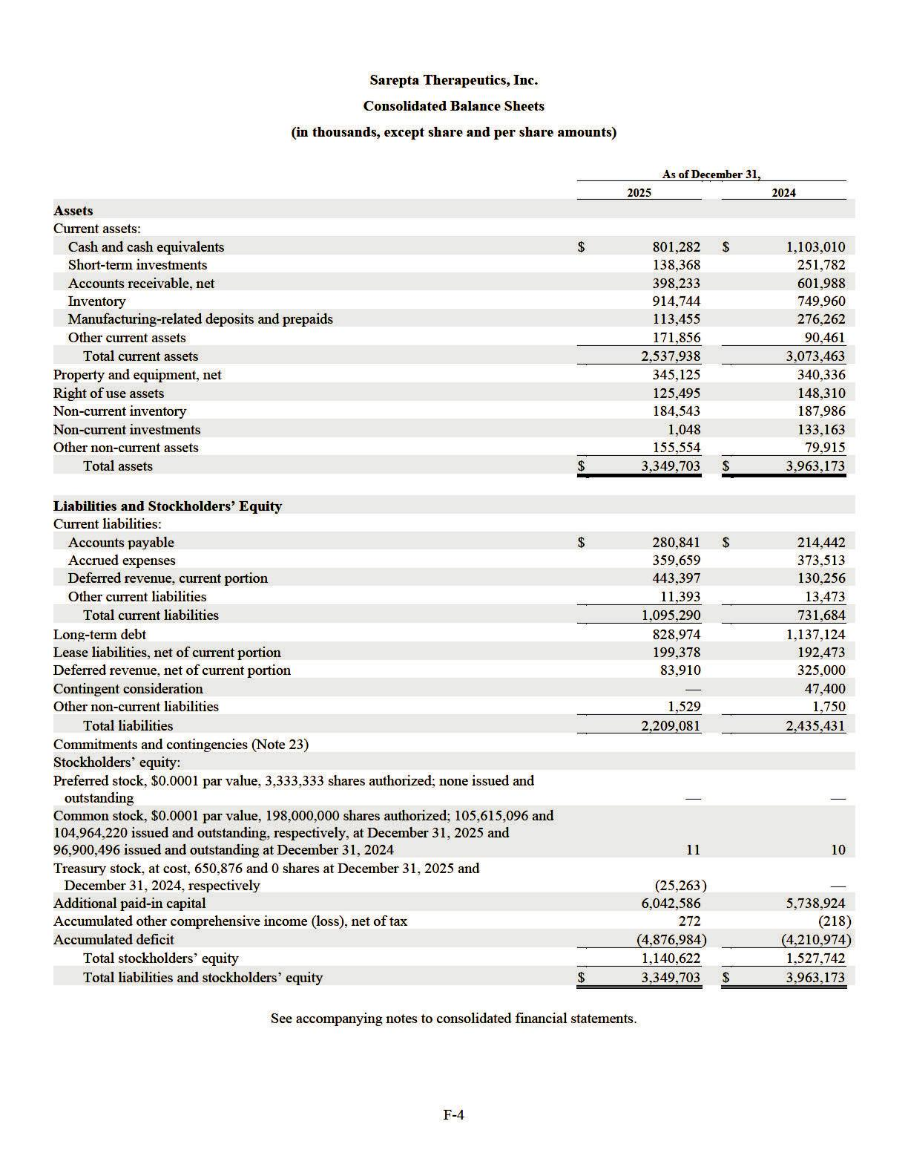

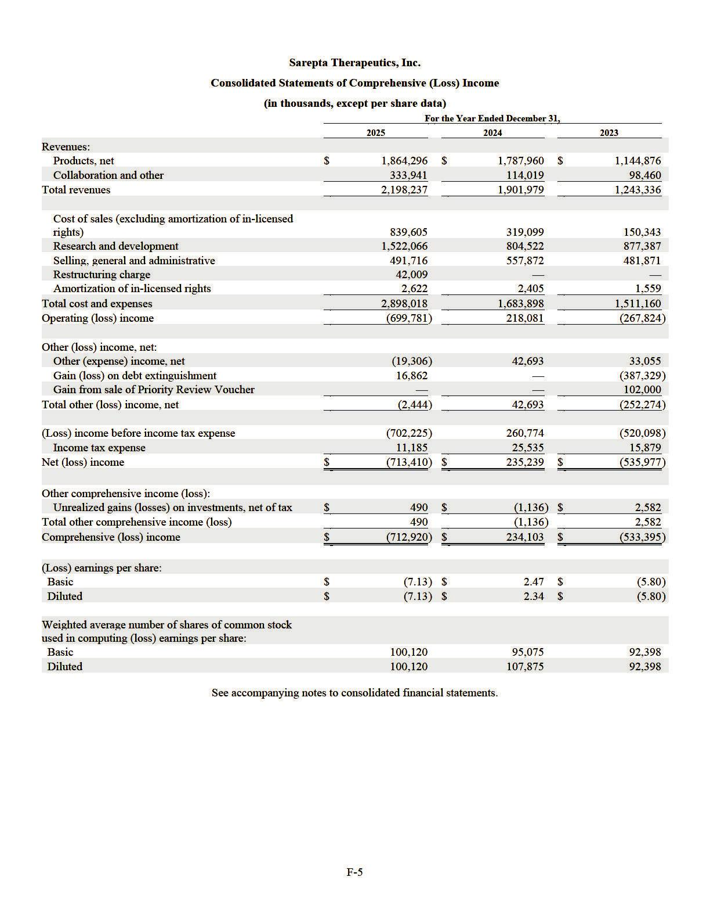

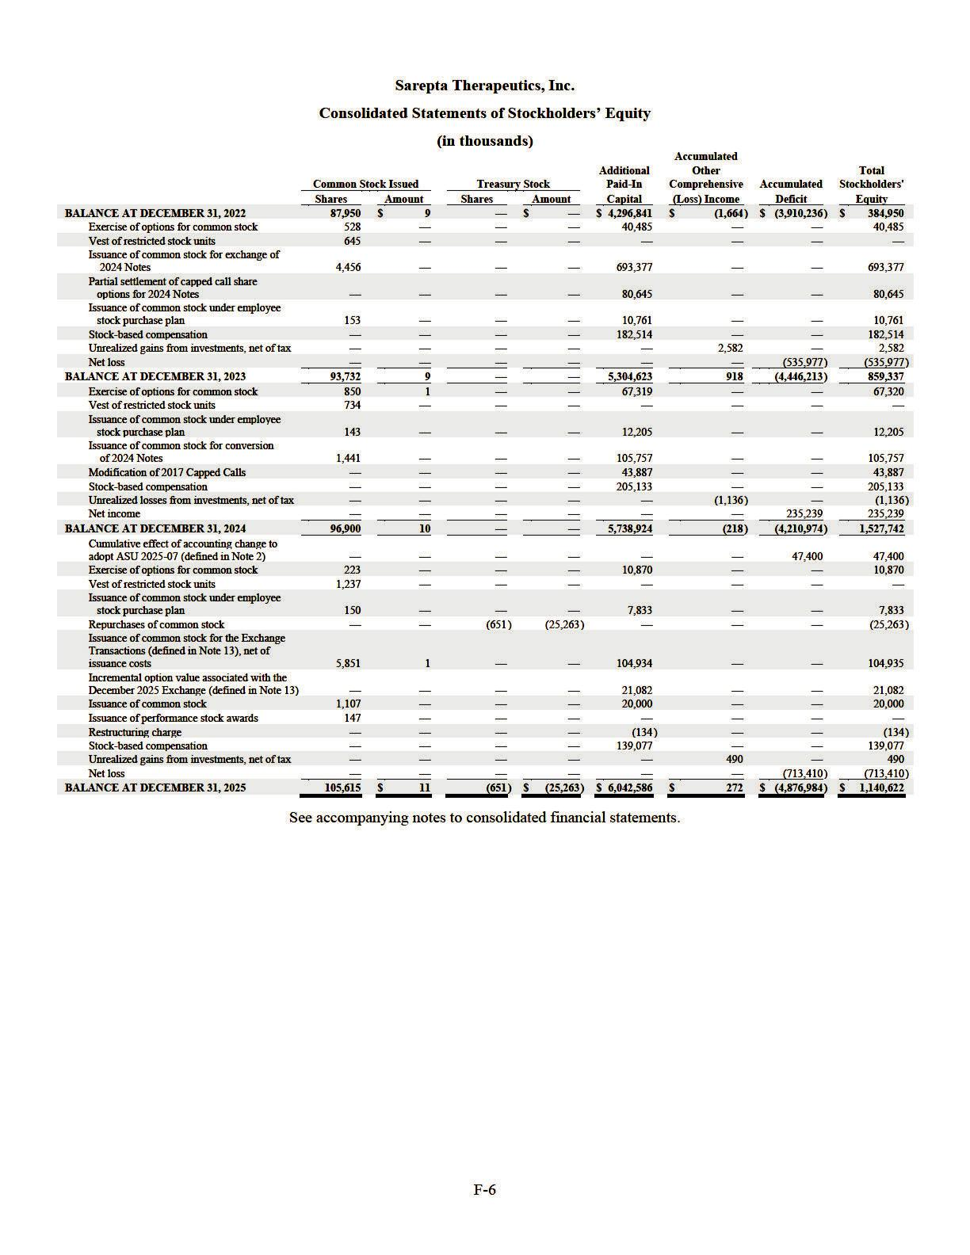

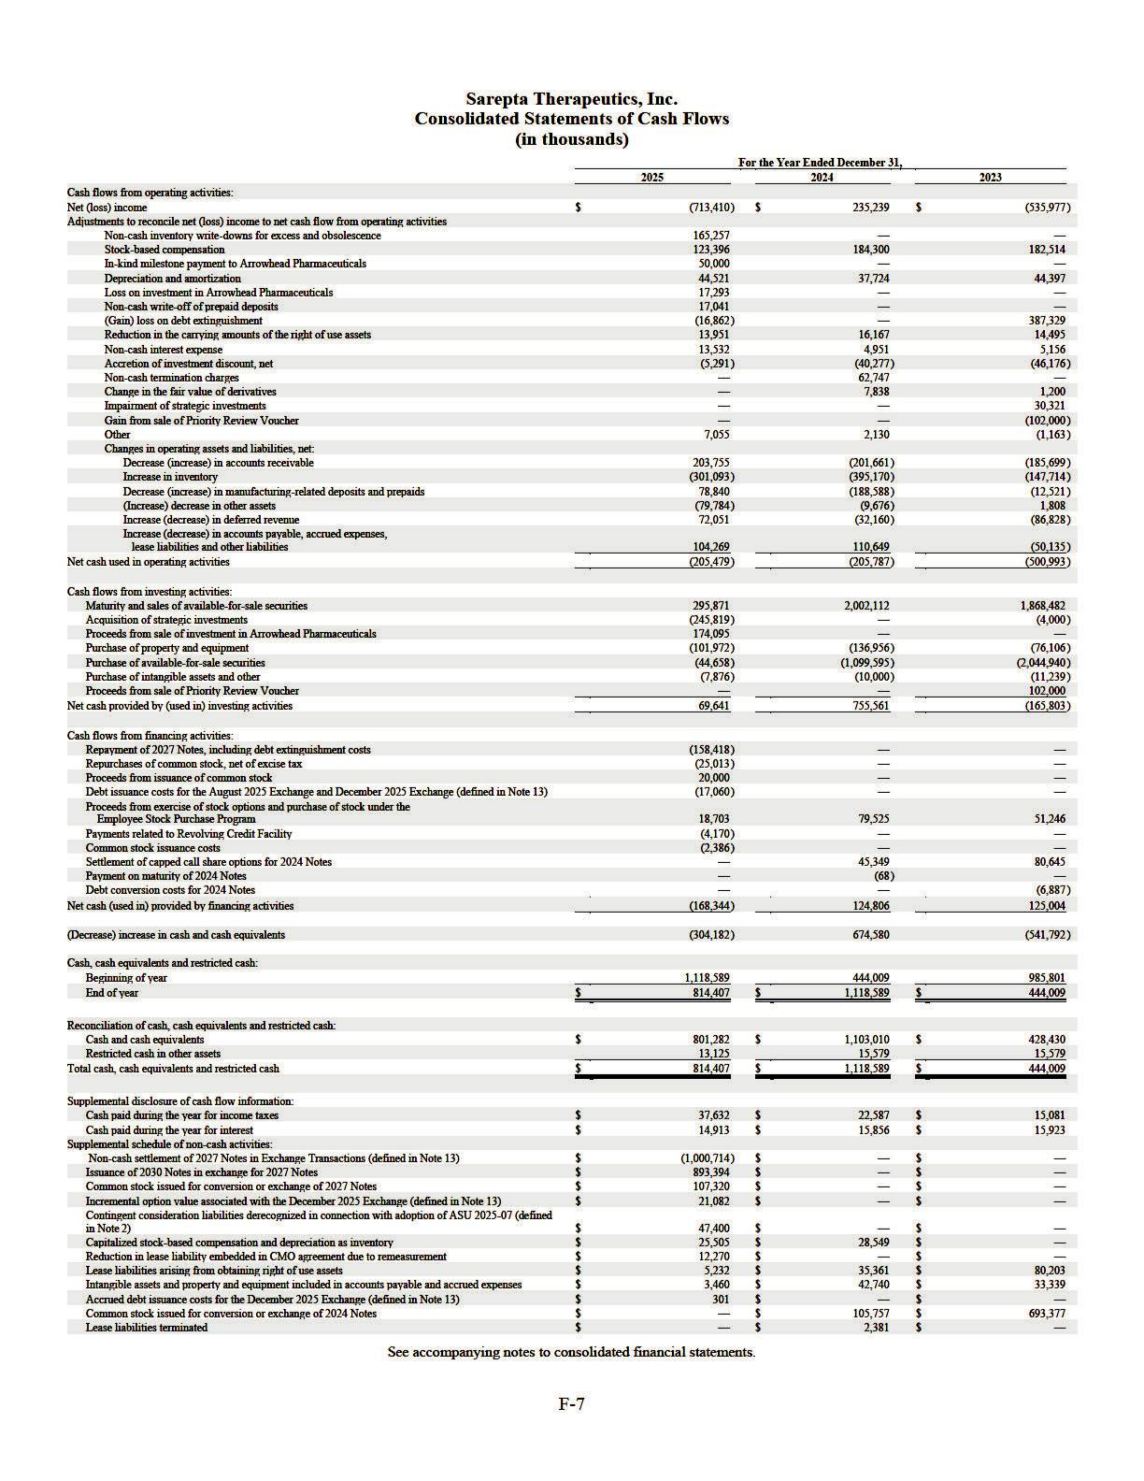

Sarepta Therapeutics, Inc.

NOTES TO CONSOLIDATED FINANCIAL STATEMENTS

1. ORGANIZATION AND NATURE OF BUSINESS

Sarepta Therapeutics, Inc. (together with its wholly-owned subsidiaries, “Sarepta” or the “Company”) is a commercial-stage biopharmaceutical company focused on helping patients through the discovery and development of unique RNA-targeted therapeutics, small interfering RNA ("siRNA") platform, gene therapy and other genetic therapeutic modalities for the treatment of rare diseases.
Applying its proprietary, differentiated and innovative technologies, and through collaborations with its strategic partners, the Company has developed multiple approved products for the treatment of Duchenne muscular dystrophy (“Duchenne”) and is developing potential therapeutic candidates for a broad range of diseases and disorders, including Duchenne, Myotonic Dystrophy type 1 (“DM1"), facioscapulohumeral muscular dystrophy (“FSHD”) and other neuromuscular and central nervous system (“CNS”) disorders.

The Company's products in the U.S., EXONDYS 51 (eteplirsen) Injection (“EXONDYS 51”), VYONDYS 53 (golodirsen) Injection (“VYONDYS 53”) and AMONDYS 45 (casimersen) Injection (“AMONDYS 45”), were granted accelerated approval by the U.S. Food and Drug Administration (the “FDA”) in 2016, 2019 and 2021, respectively. Indicated for the treatment of Duchenne in patients who have a confirmed mutation of the dystrophin gene that is amenable to exon 51, exon 53 and exon 45 skipping, respectively, EXONDYS 51, VYONDYS 53 and AMONDYS 45 (collectively, the “PMO Products”) use the Company’s phosphorodiamidate morpholino oligomer (“PMO”) chemistry and exon-skipping technology to skip exon 51, exon 53 and exon 45 of the dystrophin gene. Exon skipping is intended to promote the production of an internally truncated but functional dystrophin protein.

ELEVIDYS (delandistrogene moxeparvovec-rokl), an adeno-associated virus-(“AAV”) based gene therapy, was approved by the FDA in June 2024 for the treatment of ambulatory patients at least four years old with Duchenne with a confirmed mutation in the Duchenne gene, as well as for non-ambulatory patients under the accelerated approval pathway. ELEVIDYS was previously granted accelerated approval by the FDA in June 2023 for the treatment of ambulatory patients aged four through five years with Duchenne with a confirmed mutation in the Duchenne gene. In response to safety events announced in March and June 2025, the Company suspended all shipments of ELEVIDYS to non-ambulatory patients in the U.S. In response to a request from the FDA that the Company voluntarily stop all shipments of ELEVIDYS in the U.S., it temporarily suspended all shipments of ELEVIDYS in the U.S., effective July 22, 2025. On July 28, 2025, the FDA informed the Company that the FDA recommended the removal of the voluntary hold for ambulatory patients. On July 31, 2025, the Company resumed shipments of ELEVIDYS for ambulatory patients in the U.S. In November 2025, the Company announced a boxed warning for acute liver injury (“ALI”) and acute liver failure (“ALF”) and removal of non-ambulatory population from the Indication and Usage section of the Prescribing Information.

As of December 31, 2025, the Company had $953.8 million of cash, cash equivalents, restricted cash and investments, consisting of $801.3 million of cash and cash equivalents, $139.4 million of investments and $13.1 million of non-current restricted cash. The Company believes that its balance of cash, cash equivalents and investments as of the date of the issuance of this report, along with future cash inflows from operations and availability under the Company's Revolving Credit Facility (defined in Note 13), is sufficient to fund its current operational plan for at least the next twelve months, though it may pursue additional cash resources through public or private debt and equity financings, seek funded research and development arrangements and additional government contracts and establish collaborations with or license its technology to other companies.

- SUMMARY OF SIGNIFICANT ACCOUNTING POLICIES AND RECENT ACCOUNTING PRONOUNCEMENTS Basis of Presentation
The accompanying consolidated financial statements, which have been prepared in accordance with accounting principles generally accepted in the United States (“U.S. GAAP”), reflect the accounts of Sarepta and its wholly-owned subsidiaries. All intercompany transactions between and among its consolidated subsidiaries have been eliminated. All adjustments of a normal recurring nature necessary for a fair presentation have been reflected.

Estimates and Uncertainties

The preparation of the consolidated financial statements in conformity with U.S. GAAP requires management to make estimates and assumptions that affect the reported amounts of assets, liabilities, equity, revenue, expenses and the disclosure of contingent assets and liabilities. Actual results could differ from those estimates.

Correction of Immaterial Errors

During the fourth quarter ended December 31, 2025, the Company recorded an immaterial error correction associated with the accounting for its partial refinancing of its convertible senior notes due on September 15, 2027 (the “2027 Notes”) that was

F-8

completed on August 28, 2025 (the "August 2025 Exchange"). During the three and nine months ended September 30, 2025, the Company recognized a loss on debt extinguishment of $138.6 million associated with the August 2025 Exchange. Upon further analysis during the fourth quarter of 2025, the Company determined that a gain on debt extinguishment of $3.8 million should have been recognized based on the fair value of the 2030 Notes at issuance. Correspondingly, the related interest expense recognized during the three and nine months ended September 30, 2025 should have been $1.9 million higher and the long-term debt balance should have been $140.5 million lower as of September 30, 2025. The correction of the errors resulted in a net decrease of $140.5 million to the previously reported net loss for both the three and nine months ended September 30, 2025. Accordingly, the previously reported basic and diluted net loss per share decreased by $1.40 and $1.43, respectively, for the three and nine months ended September 30, 2025.

The quarterly financial data required by Item 302(a) of Regulation S-K, including the three months ended September 30, 2025, has been updated to reflect this correction in Note 24, Quarterly Financial Data.

Fair Value Measurements

The Company has certain financial assets and liabilities that are recorded at fair value which have been classified as Level 1,

2 or 3 within the fair value hierarchy as described in the accounting standards for fair value measurements:

- Level 1—quoted prices for identical instruments in active markets;

- Level 2—quoted prices for similar instruments in active markets, quoted prices for identical or similar instruments in markets that are not active, and model-derived valuations in which all significant inputs and significant value drivers are observable in active markets; and

- Level 3—valuations derived from valuation techniques in which one or more significant value drivers are unobservable.

The fair value of the majority of the Company’s financial assets is categorized as Level 1 within the fair value hierarchy. These assets include money market funds, the Company's strategic investment in a biotechnology company listed on Nasdaq and assets associated with the Company's deferred compensation plan that are held in a trust. For additional information related to fair value measurements, please read Note 5, Fair Value Measurements to the consolidated financial statements.

Cash Equivalents

Only investments that are highly liquid and readily convertible to cash and have original maturities of three months or less at the time of acquisition are considered cash equivalents.

Investments

Available-For-Sale Debt Securities

Available-for-sale debt securities are recorded at fair value and unrealized gains and losses are included in accumulated other comprehensive (loss) income in the consolidated statements of stockholders’ equity. Interest income and realized gains and losses are reported in other (expense) income, net, on a specific identification basis. The amortized cost of debt securities is adjusted for amortization of premiums and accretion of discounts to maturity, the net amount of which, along with interest and realized gains and losses, is included in other (expense) income, net in the consolidated statements of comprehensive (loss) income.

Equity Investments

The Company’s equity investments include its strategic investments in both publicly traded and private biotechnology companies and are included in other non-current assets in the Company’s consolidated balance sheets. The strategic investment in the publicly traded biotechnology company has a readily determinable fair value and is carried at fair value. The strategic investments in the privately held biotechnology companies do not have a readily determinable fair value and are measured at cost less any impairment, plus or minus changes resulting from observable price changes for the identical or a similar investment of the same issuer. Any change in the valuation of equity investments is recorded as a gain or loss on the Company’s consolidated statements of comprehensive (loss) income.

Accounts Receivable, Net

The Company’s accounts receivable, net arise from product sales. They are generally stated at the invoiced amount and do not bear interest.

F-9

The accounts receivable, net from product sales represents receivables due from the Company’s specialty distributor and specialty pharmacies and sites of care in the U.S., as well as certain distributors in South America, Europe, and the Middle East. Historically, the Company has had no material write-offs of its accounts receivable, net. Payment terms range from 65 to 90 days for sales within the U.S. and 90 and 150 days for the majority of product sales outside the U.S. The Company monitors the financial performance and creditworthiness of its customers so that it can properly assess and respond to changes in the customers’ credit profiles or any specific issues. The Company provides reserves against trade receivables for expected credit losses that may result from a customer’s inability to pay. Amounts determined to be uncollectible are written-off against the established reserve. As of December 31, 2025 and 2024, the credit profiles for the Company’s customers are deemed to be in good standing and an allowance for expected credit losses is not considered necessary.

Concentration of Credit Risk

Financial instruments that potentially subject the Company to concentrations of credit risk consist of cash held at financial institutions, cash equivalents, investments and accounts receivable, net from customers. As of December 31, 2025, the Company’s cash was concentrated at five financial institutions, which potentially exposes the Company to credit risks. However, the Company does not believe that there is significant risk of non-performance by the financial institutions. The Company also purchases commercial paper, government and government agency bonds, corporate bonds and certificates of deposit issued by highly rated corporations, financial institutions and governments and limits the amount of credit exposure to any one issuer. These amounts may at times exceed federally insured limits. The Company has not experienced any credit losses related to these financial instruments and does not believe to be exposed to any significant credit risk related to these instruments. As of December 31, 2025, four entities accounted for 33%, 26%, 20% and 10% of accounts receivable, net, respectively. As of December 31, 2024, three entities accounted for 54%, 21%, and 13%, of accounts receivable, net, respectively.

Inventories

Inventories are stated at the lower of cost and net realizable value with cost determined on a first -in, first-out basis. The Company capitalizes inventory costs associated with products following regulatory approval when future commercialization is considered probable and the future economic benefit is expected to be realized. EXONDYS 51, VYONDYS 53, AMONDYS 45 and ELEVIDYS inventory used in clinical development programs is charged to research and development expense when the product enters the research and development process and can no longer be used for commercial purposes.

The Company periodically analyzes its inventories for excess or obsolescence and writes down excess or obsolete or otherwise unmarketable inventory to its estimated net realizable value. Reserves are recorded to reduce the cost basis of inventory when it is determined that inventory on hand is excess or obsolete. The Company determines excess or obsolete inventory based on assumptions about forecasted demand for our products, market conditions and regulatory approval. Additionally, though the Company’s products are subject to strict quality control and monitoring, which the Company performs throughout the manufacturing processes, certain batches or units of product may not meet quality specifications. Expense incurred related to excess inventory, obsolete inventory, or inventories that do not meet the Company's quality specifications is recorded as a component of cost of sales in the Company's consolidated statements of comprehensive (loss) income.

For products which are under development and have not yet been approved by regulatory authorities, purchased drug product is charged to research and development expense upon delivery. Delivery occurs when the inventory passes quality inspection and title and risk of loss transfers to the Company. Nonrefundable advance payments for research and development activities, including production of purchased drug product, are deferred and capitalized until the goods are delivered. If the Company does not expect the goods to be delivered or services to be rendered, the capitalized advanced payment will be charged to expense.

Property and Equipment

Property and equipment are initially recorded at cost, including the acquisition cost and all costs necessarily incurred to bring the asset to the location and working condition necessary for their intended use. The cost of normal, recurring or periodic repairs and maintenance activities related to property and equipment are expensed as incurred. The cost for planned major maintenance activities, including the related acquisition or construction of assets, is capitalized if the repair will result in future economic benefits. Interest costs incurred during the construction period of major capital projects are periodically reviewed, and if determined to be material, capitalized until the asset is ready for its intended use, at which point the interest costs are amortized as depreciation expense over the life of the underlying asset.

F-10

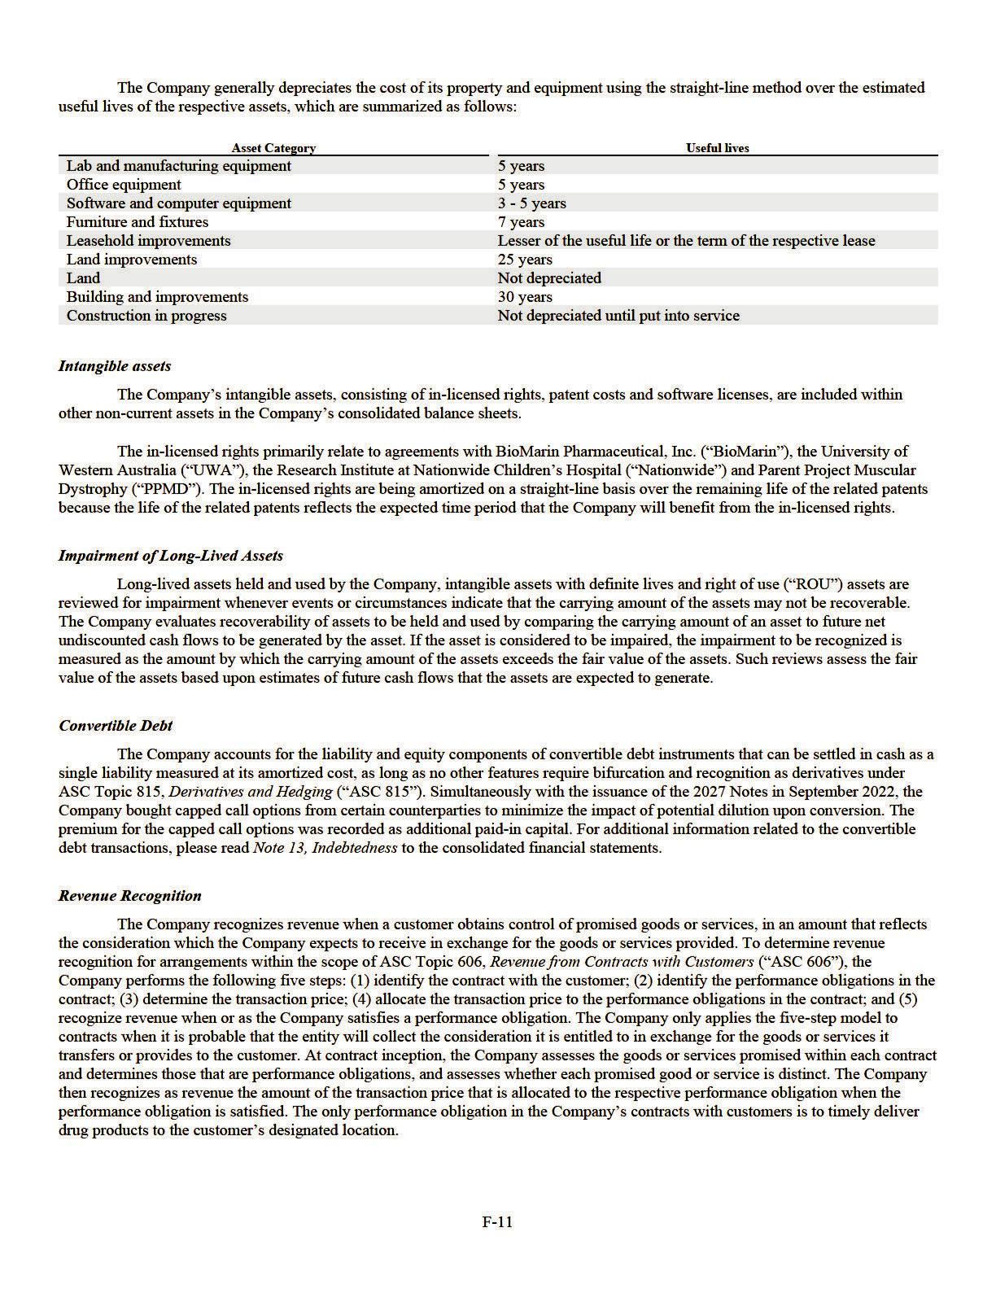

Product revenues

The Company distributes its products principally through its customers or sells directly to sites of care. When the product is distributed through customers, the customers subsequently resell the products to patients and health care providers. The Company provides right of return to the customers only in cases of shipping error or product defect and other limited rights. Product revenues are recognized when the customers take control of the products, which typically occurs upon delivery. For information related to revenues by product type and region, please read Note 7, Product Revenues, Net, Accounts Receivable, Net and Reserves for Product Revenues to the consolidated financial statements.

Variable Consideration

Product revenues are recorded at the net sales price (transaction price) which includes reserves for variable consideration

such as: rebates and chargebacks, distribution fees, prompt pay discounts, patient assistance and return reserves. These reserves,
representing the Company’s best estimates of the amount of consideration to which it is entitled based on the terms of the contracts,
are based on the amounts earned or to be claimed on the related sales and are classified as reductions of accounts receivable if no
payments are required of the Company or a current liability if a payment is required of the Company. Where appropriate, the estimates

reflect the Company’s historical experience, contractual and statutory requirements, industry data and forecasted customer buying and
payment patterns. Actual amounts may differ from the Company’s estimates. If actual results vary, these estimates are adjusted, which
could have an effect on revenue in the period of adjustment.

Additional details relating to variable consideration are as follows:

- Rebates and chargebacks: relating to governmental and commercial rebates and chargebacks.

- Governmental rebates, including Medicaid rebates, relate to the Company’s estimated obligations to federal or state governments under established reimbursement arrangements. The commercial rebates relate to arrangements the Company enters into with payors that provide for privately-negotiated rebates. Rebate reserves are recorded in the same period the related revenue is recognized, resulting in a reduction of product revenue and the establishment of a liability which is included in accrued expenses.

  - Chargebacks, including Public Health Services (“PHS”) chargebacks, relate to the Company’s estimated obligations resulting from contractual commitments to sell products to qualified healthcare providers at prices lower than the list prices that the Company charges to wholesalers. The wholesaler charges the Company for the difference between what the wholesaler pays for the products and the ultimate selling price to the qualified healthcare providers. Chargeback reserves are recorded in the same period the related revenue is recognized, resulting in a reduction of product revenue and accounts receivable. Chargeback amounts are generally determined at the time of resale to the qualified healthcare provider from the wholesaler, and the Company generally issues credits for such amounts within a few weeks of receiving notification of resale from the wholesaler.

xDistribution fees: relating to fees paid to customers in the distribution channel that provide the Company with inventory management and data and distribution services are generally accounted for as a reduction of revenue. To the extent that the services received are distinct from the Company’s sale of products to the customers, these payments are accounted for as selling, general and administrative expenses. Reserves for distribution fees result in an increase in a liability if payments are required of the Company or a reduction of accounts receivable if no payments are required of the Company.

- Prompt payment discounts: relating to the Company’s estimated obligations for credits to be granted to specialty pharmacies for remitting payment on their purchases within established incentive periods. Reserves for prompt payment discounts are recorded in the same period the related revenue is recognized, resulting in a reduction of product revenue and accounts receivable.

- Patient assistance: relating to financial assistance programs provided to qualified patients. Reserves for costs related to patient assistance programs are recorded in the same period the related revenue is recognized, resulting in a reduction of product revenue and the establishment of a liability which is included in accrued expenses.

- Return reserves: relating to the limited return rights the Company provides to customers. The Company records product return reserve, if appropriate, as a reduction of revenue at the time product sales are recorded. Several factors are considered in determining whether return reserves are required, including the patient population and the customers’ limited return rights. Because of the pricing, the limited number of patients, and the customers’ limited return rights, most customers only carry a limited inventory. Based on these factors and the fact that the Company has not experienced significant product returns to date, return reserves have been immaterial to date.

F-12

Collaboration revenue

The Company’s collaboration revenue is primarily generated from its collaboration arrangement with F. Hoffman-La Roche Ltd. (“Roche”). For more information, please read Note 3, License and Collaboration Agreements. At the inception of a collaboration arrangement, the Company first assesses whether the contractual arrangement is within the scope of ASC Topic 808, Collaborative Arrangements to determine whether the arrangement involves a joint operating activity and involves two (or more) parties that are both active participants in the activity and exposed to significant risks and rewards dependent on the commercial success of such activity. Then the Company determines whether the collaboration arrangement in its entirety represents a contract with a customer as defined by ASC 606. If only a portion of the collaboration arrangement is potentially with a customer, the Company applies the distinct good or service unit-of-account guidance in ASC 606 to determine whether there is a unit of account that should be accounted for under ASC 606. For the units of account in the collaboration arrangement that do not represent a vendor-customer relationship, the Company will (i) consider applying other GAAP, including by analogy, or (ii) if there is no appropriate analogy, consistently apply a reasonable and rational accounting policy election.

In general, by analogy to ASC 606, the Company identifies the performance obligations within the collaboration arrangement and identifies and allocates the transaction price the Company expects to receive on a relative standalone selling price basis to each performance obligation. Variable consideration, consisting of development and regulatory milestones, will be included in the transaction price only if the Company expects to receive such consideration and if it is probable that the inclusion of the variable consideration will not result in a significant reversal in the cumulative amount of revenue recognized under the arrangement. Sales-based royalty and milestone payments are excluded from the transaction price the Company expects to receive until the underlying sales occur because the license to the Company’s intellectual property is deemed to be the predominant item to which the royalties or milestones relate as it is the primary driver of value in its collaboration arrangement.

For the recognition of revenue associated with each performance obligation, if the Company determines ASC 606 is not appropriate to apply by analogy, the Company will apply a reasonable, rational and consistently applied accounting policy election to faithfully depict the transfer of services to the collaboration partner over the estimated performance period. Up-front payments from a collaboration partner are recognized as deferred revenue when received and recognized as revenue over the estimated performance period. Reimbursement payments from a collaboration partner associated with cost-sharing provisions in a collaboration arrangement are recognized as the related expense is incurred and classified as an offset to operating expenses. Revenue from sales-based royalty payments is included as collaboration and other revenues on the consolidated statements of comprehensive (loss) income. Revenue from product sold to collaboration partners under a collaboration arrangement via contract manufacturing is included as collaboration and other revenues on the consolidated statements of comprehensive (loss) income.

Valuation of Product Options

The Company's collaboration arrangements may contain options which provide the collaboration partner with the right to obtain additional licenses. If an arrangement contains product options, by analogy to ASC 606, the Company evaluates the product options to determine whether they represent material rights, which may include options to acquire additional goods or services for free or at a discount. If the customer options are determined to represent material rights, they are recognized as a separate performance obligation at inception of the arrangement. The Company allocates a portion of the transaction price of the collaboration arrangement to material rights based on the relative standalone selling price. Amounts allocated to material rights are not recognized as revenue until related options are exercised or expire. Key assumptions to determine the standalone selling price of product options in a collaboration arrangement include, but are not limited to, forecasted revenues, development timelines, incremental costs related to the arrangement, discount rates and likelihood of technical and regulatory success.

Research and Development Expenses

Research and development expenses consist of costs associated with research activities as well as those with the Company’s product development efforts, conducting pre-clinical trials, clinical trials and manufacturing activities. Research and development expenses are expensed as incurred. Up-front fees and milestones paid to third parties in connection with technologies which have not reached technological feasibility and do not have an alternative future use are expensed when incurred.

Direct research and development expenses associated with the Company’s programs include payments made to contract research organizations, clinical trial site costs, clinical manufacturing costs, costs incurred for consultants and other external services, such as data management and statistical analysis support and materials and supplies used in support of clinical programs. Indirect costs of the Company’s research and development programs include salaries, stock-based compensation and an allocation of its facility and technology costs.

F-13

When third-party service providers’ billing terms do not coincide with the Company’s period-end, the Company is required to make estimates of its obligations to those third parties, including clinical trial and pharmaceutical development costs, contractual services costs and costs for supply of its drug candidates incurred in a given accounting period, and record accruals at the end of the period. The Company bases its estimates on its knowledge of the research and development programs, services performed for the period, past history for related activities and the expected duration of the third-party service contract, where applicable.

Selling, General and Administrative Expenses

Selling, general and administrative expenses consist of salaries, benefits, stock -based compensation and related costs for personnel in the Company's executive, finance, legal, information technology, business development, human resources, commercial and other general and administrative functions. Other general and administrative expenses include an allocation of the Company's facility- and technology-related costs and professional fees for legal, consulting and accounting services.

Advertising costs are included in selling, general and administrative expenses and are expensed as incurred. The Company considers advertising costs as expenses related to the promotion of the Company's commercial products. For the years ended December 31, 2025, 2024 and 2023, advertising costs totaled $29.5 million, $32.0 million and $28.6 million, respectively.

Stock-Based Compensation

The Company’s stock-based compensation programs include stock options, restricted stock units (“RSUs”), RSU shares with performance conditions (“PSUs”), performance stock awards ("PSAs") and an employee stock purchase program (“ESPP”). Stock-based compensation is recognized based on grant date fair value of stock awards.

The fair value of stock options are estimated on the date of grant using the Black-Scholes-Merton option-pricing model. The fair values of RSUs, PSUs and PSAs are based on the fair market value of the Company’s common stock on the date of the grant. The fair value of stock awards, with consideration given to estimated forfeitures, is recognized as stock-based compensation expense on a straight-line basis over the requisite service period, which is, in most cases, the vesting period of the grants. The Company estimates forfeitures over the requisite service period using historical forfeiture activity. For stock awards with performance-vesting conditions, including PSUs and PSAs, the Company does not recognize stock-based compensation expense until it is probable that the performance condition will be achieved.

Additionally, the Company granted its Chief Executive Officer ("CEO") options with service and market conditions. A market condition relates to the achievement of a specified price of the Company’s common stock, a specified amount of intrinsic value indexed to the Company’s common stock or a specified price of the Company’s common stock in terms of other similar equity shares. The grant date fair value for the options with service and market conditions is determined by a lattice model with Monte Carlo simulations and is recognized as stock-based compensation expense on a straight-line basis over the respective derived service period.

Under the Company’s ESPP, participating employees purchase common stock through payroll deductions. The purchase price is equal to 85% of the lower of the closing price of the Company’s common stock on the first business day and the last business day of the relevant purchase period. The fair value of stock purchase rights is estimated using the Black-Scholes-Merton option-pricing model. The fair value of the look-back provision with the 15% discount is recognized on a graded-vesting basis as stock-based compensation expense over the offering period.

Income Taxes

The Company follows the asset and liability method of accounting for income taxes, which requires the recognition of deferred tax assets and liabilities for expected future tax consequences attributable to differences between the consolidated financial statement carrying amounts of existing assets and liabilities and their respective tax bases. Deferred tax assets and liabilities are measured using enacted tax rates in effect for the year in which the differences are expected to reverse. A valuation allowance is recorded to reduce the net deferred tax asset to zero when it is more likely than not that the net deferred tax asset will not be realized.

The Company recognizes the effect of income tax positions only if those positions are more likely than not of being sustained upon an examination. The amount of the benefit that may be recognized in the financial statements is the largest amount that has a greater than 50% likelihood of being realized. The Company recognizes interest and penalties related to uncertain tax positions within income tax expense.

It is the intention of the Company to reinvest the earnings of its non-U.S. subsidiaries in those operations and not to repatriate the earnings to the U.S. Accordingly, the Company does not provide for deferred taxes on the excess of the financial reporting over the tax basis in its investments in foreign subsidiaries as they are considered permanent in duration.

The Company accounts for Global Intangible Low-Taxed Income (“GILTI”) as a period cost.

F-14

Leases

At the inception of an arrangement, the Company determines whether the arrangement is or contains a lease based on the unique facts and circumstances present in the arrangement. Leases with a term greater than twelve months are recognized on the consolidated balance sheets as ROU assets and short-term and long-term lease liabilities, as applicable. The Company has elected not to recognize leases with terms of twelve months or less on the consolidated balance sheets. The Company typically only includes an initial lease term in its assessment of a lease arrangement. Options to renew a lease are not included in the Company’s assessment unless there is reasonable certainty that the Company will renew. The Company monitors its plans to renew its leases quarterly or on an as-needed basis. In addition, the Company’s lease agreements generally do not contain any residual value guarantees or restrictive covenants.

Operating lease liabilities and their corresponding ROU assets are recorded based on the present value of future lease payments over the expected remaining lease term at lease commencement. The initial measurement of the lease liability is determined based on the future lease payments, which may include lease payments that depend on an index or a rate (such as the consumer price index or other market index). The Company initially measures payments based on an index or rate by using the applicable rate at lease commencement and subsequent changes in such rates are recognized as variable lease costs. Variable payments that do not depend on a rate or index are not included in the lease liability and are recognized as they are incurred. Lease costs for operating leases are recognized on a straight-line basis over the lease term as an operating expense with unrecognized variable lease payments recognized as incurred. Certain adjustments to the ROU asset may be required for items such as lease prepayments or incentives received. The interest rate implicit in lease contracts is typically not readily determinable. As a result, the Company utilizes its incremental borrowing rate, which reflects the fixed rate at which the Company could borrow on a collateralized basis the amount of the lease payments in the same currency, for a similar term, in a similar economic environment. Components of a lease are bifurcated between lease components and non-lease components. The fixed and in-substance fixed contract consideration identified is then allocated based on the relative standalone price to the lease and non-lease components. The Company adopted a practical expedient provided by ASC Topic 842, Leases , and elected to account for the lease and non-lease components together for existing classes of underlying assets and allocates the contract consideration to the lease component only. In contrast, the Company elected not to apply the practical expedient provided by ASC Topic 842, Leases, for leases embedded in manufacturing and supply agreements with certain of its contract manufacturing organizations and has allocated contract consideration between the lease and non-lease components based on their relative standalone price.

(Loss) Earnings per Share

Basic (loss) earnings per share is computed by dividing net (loss) income by the weighted-average number of shares of common stock outstanding. Diluted earnings per share is computed based on the treasury stock method for stock awards and if-converted method for convertible notes by dividing net income by the weighted-average number of shares of common stock and potentially dilutive common stock equivalents outstanding. Potential common equivalent shares are excluded if their effect is anti-dilutive.

Embedded Derivatives

Effective January 1, 2025, the Company adopted Accounting Standard Update ("ASU") 2025-07, Derivatives and Hedging (Topic 815) and Revenue from Contracts with Customers (Topic 606): Scope Refinements ("ASU 2025-07"), which introduced a scope exception for non- exchange-traded contracts with underlyings based on operations or activities specific to one party. As a result, certain contingent consideration obligations previously accounted for as embedded derivatives no longer meet the definition of a derivative under ASC 815, Derivatives and Hedging (“ASC 815”). See Recent Accounting Pronouncements below related to the cumulative effect of adopting this new accounting guidance.

Contingent Consideration Arising from Asset Acquisitions

Following the adoption of ASU 2025-07, cash contingent consideration obligations arising from asset acquisitions, which are not accounted for as derivatives, are accounted for under ASC 450, Contingencies ("ASC 450"). The Company will recognize a liability when it becomes probable that payment will be required and the amount can be reasonably estimated.

Acquired In-Process Research and Development

Acquired in-process research and development (“IPR&D”) is recognized at fair value and initially characterized as an indefinite-lived intangible asset, irrespective of whether the acquired IPR&D has an alternative future use. If the acquired net assets do not constitute a business under the acquisition method of accounting, the transaction is accounted for as an asset acquisition and no goodwill is recognized. In an asset acquisition, the amount allocated to acquired IPR&D with no alternative future use is recorded as an expense at the acquisition date.

F-15

Treasury Stock

Treasury stock purchases are accounted for under the cost method whereby the entire cost of the acquired stock is recorded as treasury stock. Repurchased shares are held as treasury stock until they are retired or re-issued. The Company uses the weighted average purchase cost to determine the cost of treasury stock that is reissued, if any. Excise taxes incurred on share repurchases and broker fees paid represent direct costs of share repurchases. Excise taxes are recorded as a part of the cost basis of repurchased shares within treasury stock and are paid when due.

Commitments and Contingencies

The Company records liabilities for legal and other contingencies when information available to the Company indicates that it is probable that a liability has been incurred and the amount of loss can be reasonably estimated. Legal costs in connection with legal and other contingencies are expensed as costs are incurred as selling, general and administrative expenses.

Recent Accounting Pronouncements

Recently adopted

In September 2025, the Financial Accounting Standards Board (the "FASB") issued ASU 2025-07. ASU 2025-07 clarifies the application of derivative accounting to certain contracts and refines the guidance for share-based noncash consideration received from customers. Specifically, ASU 2025-07 introduces a scope exception for contracts that are not exchange-traded and whose underlying is tied to operations or activities specific to one party. It also clarifies that share-based noncash consideration from a customer should initially be accounted for under ASC 606 until the right to receive or retain such consideration becomes unconditional, at which point financial instruments guidance may apply. ASU 2025-07 is effective for fiscal years beginning after December 15, 2026 and interim periods within those fiscal years. Early adoption is permitted.

Effective in the fourth quarter of 2025, the Company early adopted ASU 2025-07 using the modified retrospective transition method. As a result, two existing contracts that include a settlement feature based on the Company’s operations or activities are now excluded from the scope of ASC 815 and any liabilities will be recognized as such obligations become probable and estimable under ASC 450. The Company recorded the cumulative effect of this accounting change to remove the previously recognized derivative liabilities as of January 1, 2025, reducing the contingent consideration liability by $47.4 million, with an offsetting adjustment to accumulated deficit. The elimination of this derivative liability would result in an increase of $11.1 million to the previously reported net loss for both the three and nine months ended September 30, 2025. Accordingly, the previously reported basic and diluted net loss per share would increase by $0.11 for both the three and nine months ended September 30, 2025. There is no impact to the previously reported net loss for the quarters ended March 31, 2025 and June 30, 2025, respectively.

In November 2024, the FASB issued ASU 2024-04, Induced Conversions of Convertible Debt Instruments ("ASU 2024-04"), which clarifies the requirements for determining whether certain settlements of convertible debt instruments should be accounted for as an induced conversion. The amendments clarify that, to account for a settlement as an induced conversion, an inducement offer must provide at least the consideration (in form and amount) issuable under the original conversion terms, even for instruments with cash conversion features. The amendments also clarify that the guidance applies to instruments not currently convertible, provided they had a substantive conversion feature at issuance and at the time of the inducement offer. The Company early adopted ASU 2024-04, effective January 1, 2025 as permitted for entities that have previously adopted ASU 2020-06, Accounting for Convertible Instruments and Contracts in an Entity's Own Equity. The Company elected to apply the guidance prospectively to settlements occurring after the adoption date. The Company considered the application of this guidance in the accounting for the debt exchange transaction described in Note 13, Indebtedness.

In December 2023, the FASB issued ASU 2023-09, Improvements to Income Tax Disclosures. ASU 2023-09 is effective for fiscal years beginning after December 15, 2024. ASU 2023-09 enhances the transparency and decision usefulness of income tax disclosures, primarily related to the rate reconciliation and income taxes paid information. The Company adopted ASU 2023-09 on a retrospective basis for all periods presented. The adoption of ASU 2023-09 had no impact to the Company’s consolidated balance sheets, consolidated statements of comprehensive (loss) income, or consolidated statements of cash flows, as ASU 2023-09 affects disclosures only. Refer to Note 18, Income Taxes for the related disclosures required by ASU 2023-09.

Recently issued but not yet adopted

In September 2025, the FASB issued ASU 2025-06, Intangibles - Goodwill and Other - Internal-Use Software (Subtopic 350-40): Targeted Improvements to the Accounting for Internal Use Software ("ASU 2025-06"). ASU 2025-06 eliminates accounting considerations of software project development stages and clarifies the threshold applied to begin capitalizing costs. ASU 2025-06 is effective for fiscal years beginning after December 15, 2027 and interim periods within those fiscal years. Early adoption is permitted. The Company is evaluating the impact of this guidance on its consolidated financial statements and related disclosures.

F-16

In November 2024, the FASB issued ASU 2024-03, Income Statement - Reporting Comprehensive Income - Expense Disaggregation Disclosures (Subtopic 220-40): Disaggregation of Income Statement Expenses ("ASU 2024-03"), which requires public entities to provide disaggregated disclosure of income statement expenses. Public entities are required to disaggregate, in a tabular presentation, each relevant expense caption on the face of the consolidated statements of comprehensive (loss) income such as the following expenses: purchases of inventory, employee compensation, intangible asset amortization, and depreciation. ASU 2024-03 is effective for annual reporting periods beginning after December 15, 2026 and interim periods beginning after December 15, 2027, with early adoption permitted. The Company is evaluating the impact of this guidance on its consolidated financial statements and related disclosures.

- LICENSE AND COLLABORATION AGREEMENTS Arrowhead Pharmaceuticals, Inc.
On November 25, 2024, the Company and Arrowhead Pharmaceuticals, Inc. (“Arrowhead”) entered into an exclusive global license and collaboration agreement and a stock purchase agreement (collectively, the “Arrowhead Collaboration Agreement”), which became effective as of February 7, 2025 (the “Effective Date”), upon the expiration or termination of the waiting period under the Hart-Scott-Rodino Antitrust Improvements Act of 1976.

The Arrowhead Collaboration Agreement granted the Company an exclusive license under certain of Arrowhead’s intellectual property rights to develop, manufacture and commercialize the lead candidate (and all backup candidates) for the following programs:

Development Stage | Indication
Arrowhead Clinical Programs | (a) DUX4 for the treatment of FSHD;
 | (b) DM1 for the treatment of myotonic dystrophy type 1;
 | (c) ATXN2 for the treatment of ataxias; and
 | (d) MMP7 for the treatment of idiopathic pulmonary fibrosis.
Arrowhead Pre-clinical Programs | (a) ATXN1 for the treatment of ataxias;
 | (b) ATXN3 for the treatment of ataxias; and
 | (c) HTT for the treatment of Huntington’s Disease.

In addition, the parties will collaborate on the discovery and development of compounds that are directed to six targets to be selected by the Company during the term (each an “Arrowhead Discovery Program,” and together with the Arrowhead Clinical Programs and Pre-clinical Programs, the “Arrowhead Programs”).

The development and manufacturing activities under the Arrowhead Collaboration Agreement are governed by a series of committees established to facilitate transition and collaboration between the two parties.

Under the terms of the Arrowhead Collaboration Agreement, Arrowhead will conduct development activities with respect to the Arrowhead Programs pursuant to agreed-upon development plans. At pre-determined transition points for each Arrowhead Program, Arrowhead will transfer development responsibility to the Company, who will then perform all development activities necessary to obtain and maintain regulatory approvals throughout the world. The Company will have the sole worldwide right to commercialize licensed products.

The Company will reimburse Arrowhead for certain pre-determined development activities for the Arrowhead Clinical Programs. Each party is responsible for the costs and expenses of other development activities under the Arrowhead Collaboration Agreement. Arrowhead will complete all manufacturing activities necessary for their development activities and provide clinical supply for all Arrowhead Programs and commercial supply for the Arrowhead Clinical Programs. The parties will determine at a later date whether Arrowhead will provide commercial supply for the Arrowhead Pre-clinical Programs and Arrowhead Discovery Programs. Upon the occurrence of certain conditions, Arrowhead will transfer control of manufacturing and supply to the Company.

In connection with the Arrowhead Collaboration Agreement, Arrowhead appointed the Company’s CEO, Douglas Ingram, as a director, effective February 2025. The Company’s CEO’s is not standing for re-election to Arrowhead’s board of directors and their term will conclude at Arrowhead’s 2026 annual meeting.

When the Arrowhead Collaboration Agreement became effective, the Company paid Arrowhead an up-front payment of $500.0 million and invested $325.0 million in approximately 11.9 million shares of Arrowhead's common stock at a premium to the valuation on the closing date. Based on the closing price of Arrowhead’s common stock traded on the Nasdaq Global Select Market (“Nasdaq”) on the Effective Date, $241.4 million was allocated to the equity investment in Arrowhead and recorded within strategic

F-17

investments on the Company’s consolidated balance sheets on the Effective Date. For the year ended December 31, 2025, the Company recorded $583.6 million as acquired IPR&D expense, as the remainder of the up-front payments was allocated to the up-front license fee representing rights to potential future benefits associated with research and development activities that have no alternative future use. The Company concluded that it did not have a controlling financial interest in Arrowhead, as the Company did not have the power to direct the activities that would most significantly impact the economic performance of Arrowhead. Additionally, the Company concluded that, as it did not have significant influence over Arrowhead, the Company’s investment in Arrowhead was not subject to the equity method of accounting. Accordingly, the investment in Arrowhead’s common stock was recorded at fair value and remeasured each reporting period through the date of sale in August 2025, with changes recorded to other (expense) income, net in the Company’s consolidated statements of comprehensive (loss) income. The Arrowhead Collaboration Agreement also provided the Company with the option to exchange its holding of Arrowhead’s common stock into pre-funded warrants (“Warrants”) with an exercise price of $0.001 per Warrant share.

Additionally, the Company will pay Arrowhead an aggregate total of $250.0 million in annual installments of $50.0 million over five years (“Annual Fees”), with the first payment due on the first anniversary of the Effective Date. The Annual Fees are contingent upon the Company not terminating the Arrowhead Collaboration Agreement. Over the term of the Arrowhead Collaboration Agreement, the Company may be obligated to make payments to Arrowhead totaling up to $10.3 billion upon the achievement of certain development, regulatory and sales milestones, inclusive of two payments associated with the continued enrollment of certain cohorts of a Phase 1/2 study for the DM1 program (the "Arrowhead DM1 Milestones"), totaling $300.0 million, both of which were achieved during the year ended December 31, 2025, as described below. Furthermore, upon commercialization, the Company will be required to make tiered royalty payments based on net sales.

On August 13, 2025, Arrowhead achieved the first of two Arrowhead DM1 Milestones, totaling $100.0 million. Consequently, the Company entered into an agreement with Arrowhead to transfer approximately 2.7 million shares of Arrowhead common stock, valued at approximately $50.0 million. The remaining $50.0 million was paid by the Company in cash. On November 24, 2025, Arrowhead achieved the second of two Arrowhead DM1 Milestones, totaling $200.0 million (the "November 2025 Milestone"). In accordance with the Arrowhead Collaboration Agreement, the Company is required to remit the payment within 60 days of achievement of the associated milestone. As of December 31, 2025, the November 2025 Milestone was not settled and the obligation is included in accounts payable in the accompanying consolidated balance sheets. In January 2026, the Company settled the November 2025 Milestone. The Company recognized milestone expenses of $300.0 million associated with the achievement of the Arrowhead DM1 Milestones as research and development expense in the accompanying consolidated statements of comprehensive (loss) income for the year ended December 31, 2025. For the year ended December 31, 2025, the Company recorded $31.5 million of research and development expense related to reimbursable development costs incurred by Arrowhead.

In August 2025, the Company's contractual sale restriction associated with its Arrowhead common stock expired and the Company sold the remainder of its Arrowhead common stock, representing approximately 9.3 million shares, resulting in gross proceeds of $174.1 million. For the year ended December 31, 2025, the Company recognized a loss of $17.3 million, reflecting the realized loss on the sale of this strategic investment.

In December 2025, the Company entered into a clinical supply agreement with Arrowhead (the “Arrowhead CSA”) in connection with the Arrowhead Collaboration Agreement. Under the Arrowhead CSA, Arrowhead is responsible for the manufacturing and supply of certain drug substance required to support the Company's ongoing and future clinical development activities for programs under the Arrowhead Collaboration Agreement. The Arrowhead CSA provides for a jointly prepared clinical supply plan to forecast and update anticipated supply needs and employs statements of work to define required batch quantities, delivery timing and pricing for each batch. The Arrowhead CSA will remain in effect on a program-by-program basis until the earlier of (i) the conclusion of the applicable program's clinical supply term, or (ii) the termination of the Arrowhead Collaboration Agreement.

F. Hoffman-La Roche Ltd.

In December 2019, the Company entered into a license, collaboration and option agreement with Roche and a stock purchase agreement (collectively, the “Roche Collaboration Agreement”) with Roche, providing Roche with exclusive commercial rights to ELEVIDYS outside the U.S. The Company retains all rights to ELEVIDYS in the U.S. and will perform all development activities within the joint global development plan necessary to obtain and maintain regulatory approvals for ELEVIDYS in the U.S. and the EU, unless otherwise agreed to by the parties. Further: (i) research and development expenses incurred under the joint global development plan will be equally shared between the Company and Roche, (ii) Roche is solely responsible for all costs incurred in connection with any development activities (other than those within the joint global development plan) that are necessary to obtain or maintain regulatory approvals outside the U.S, and (iii) the Company will continue to be responsible for the manufacturing of clinical and commercial supplies of ELEVIDYS. The Company has also granted Roche options to acquire ex-U.S. rights to certain future Duchenne-specific programs (the “Options”) in exchange for separate option exercise payments, milestone and royalty considerations, and cost-sharing provisions. The agreement became effective in February 2020. The Roche Collaboration Agreement is governed by a joint steering committee (“JSC”) formed by representatives from Roche and the Company. The JSC, among other activities, manages the overall strategic alignment between the parties, approves any material update to the joint global development plan and budget and oversees the operations of the subcommittees.

F-18

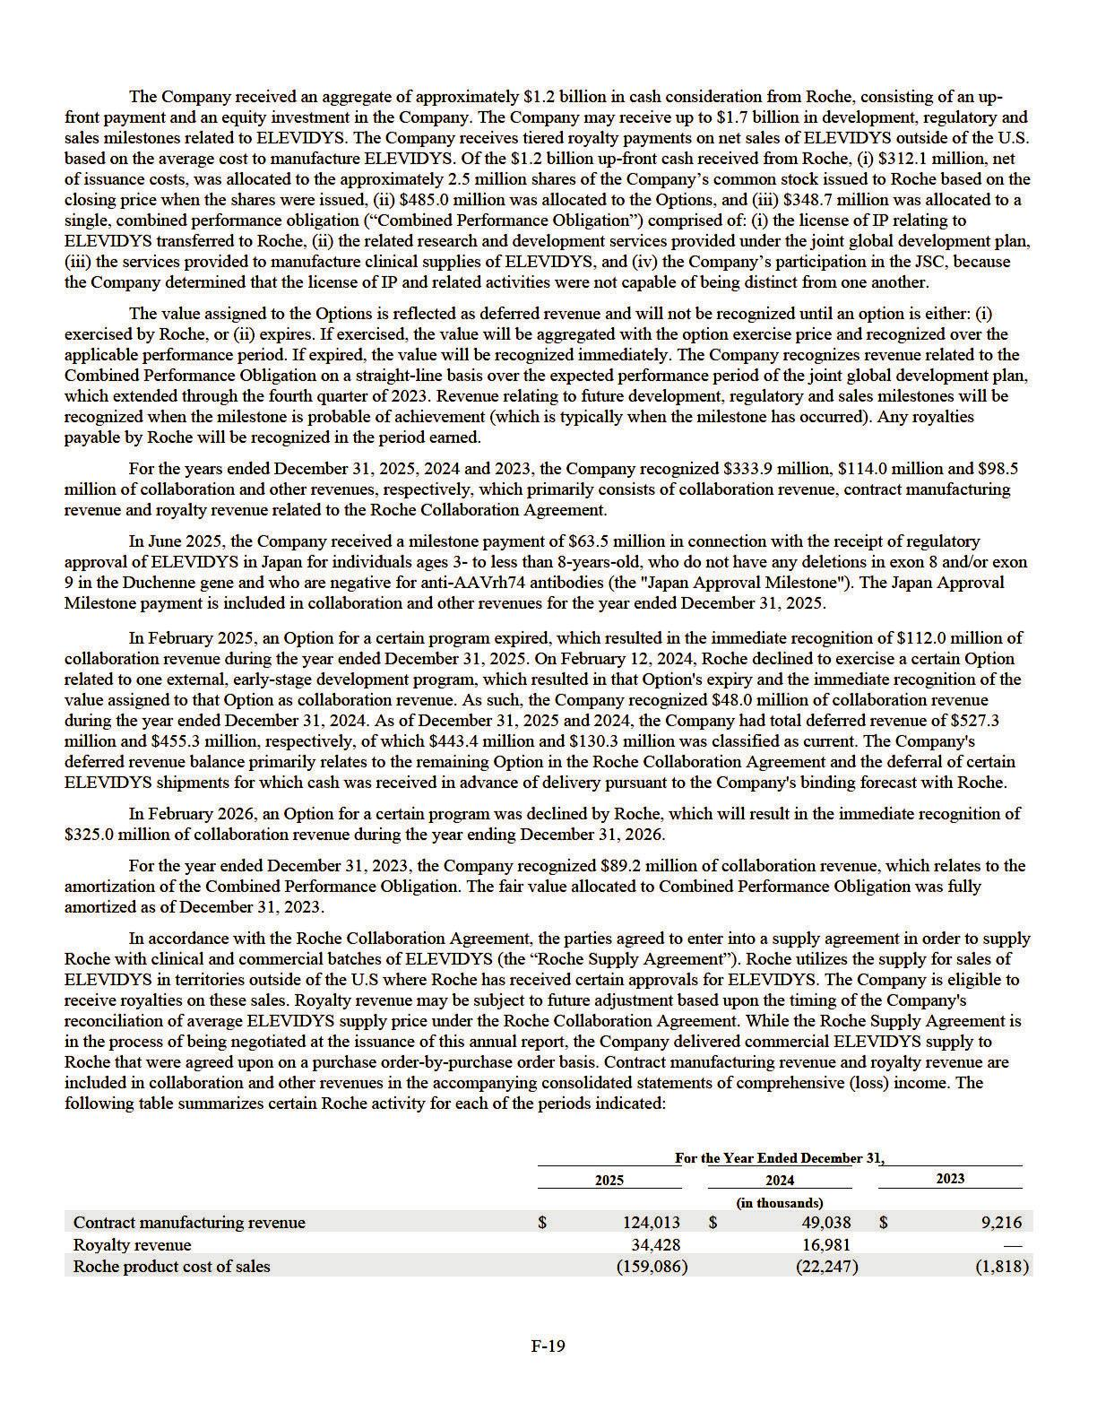

The costs associated with co-development activities performed under the Roche Collaboration Agreement are included in operating expenses, with any reimbursement of costs by Roche reflected as a reduction of such expenses when the related expense is incurred. For the years ended December 31, 2025, 2024 and 2023, costs reimbursable by Roche and reflected as a reduction to operating expenses were $84.7 million, $127.1 million and $106.9 million, respectively. As of December 31, 2025 and 2024, there were $104.1 million and $34.6 million of collaboration and other receivables included in other current assets on the consolidated balance sheets, respectively.

Myonexus Therapeutics Inc.

In April 2019, the Company completed its acquisition of Myonexus Therapeutics, Inc. (“Myonexus”), a clinical-stage gene therapy biotechnology company that was developing gene therapies for Limb-girdle muscular dystrophy ("LGMD") for $178.3 million. The Company may also be required to make up to $200.0 million in additional payments to selling shareholders of Myonexus based on the achievement of certain sales-and regulatory- related milestones. The acquisition was accounted for as an asset acquisition as substantially all of the fair value of the gross assets acquired is concentrated in a group of similar identifiable assets (the five LGMD gene therapy programs). As part of the consideration for the transaction, the Company is required to make contingent payments to the selling shareholders of Myonexus upon the receipt and subsequent sale of a PRV with respect to a Myonexus product. As of December 31, 2024, the contingent consideration liability associated with Myonexus was $47.1 million. Effective January 1, 2025, upon adoption of ASU 2025-07, the Company derecognized its contingent consideration liability associated with Myonexus. Future liabilities will be recognized as such obligations become probable and estimable under ASC 450. Refer to Note 2, Summary of

Significant Accounting Policies and Recent Accounting Pronouncements for additional information related to the adoption of ASU 2025-07.

Nationwide Children’s Hospital

In December 2016, the Company entered into an exclusive option agreement with Nationwide from which the Company obtained an exclusive right to acquire a worldwide license of the micro-dystrophin gene therapy technology for Duchenne and Becker muscular dystrophy. In October 2018, the Company exercised the option and entered into a license agreement with Nationwide, which granted the Company exclusive worldwide rights to develop, manufacture and commercialize a micro -dystrophin gene therapy product candidate. Under this agreement, the Company is liable for future regulatory milestone, sales milestone and sublicense payments as well as lower single-digit royalties upon commercialization.

During the year ended December 31, 2025, the Company recorded and paid $5.1 million due to Nationwide as a result of the Japan Approval Milestone received from Roche as an in-licensed right intangible asset in its consolidated balance sheets in accordance with the Company's license agreement with Nationwide. As of December 31, 2025, the in -licensed right asset with a net carrying value of $4.8 million is being amortized on a straight-line basis over the remaining life of the relevant patent as it reflects the expected time period that the Company will benefit from this in-licensed right.

During the year ended December 31, 2023, the Company recorded $23.0 million as an in-licensed right intangible asset in its consolidated balance sheets, $10.0 million of which related to the regulatory approval of ELEVIDYS, and the remaining related to sales-based milestones as the Company determined that all sales-based milestones were achieved or were probable of being achieved. As of December 31, 2025, the in-licensed right asset with a net carrying value of $19.0 million is being amortized on a straight-line basis over the remaining life of the relevant patent. Royalty payments due to Nationwide associated with commercial sales of ELEVIDYS totaled $38.5 million, $30.6 million, and $6.0 million for the years ended December 31, 2025, 2024 and 2023, respectively, and were recorded as cost of sales in the accompanying consolidated statements of comprehensive (loss) income.

BioMarin Pharmaceutical, Inc.

In July 2017, the Company and UWA entered into a settlement agreement with BioMarin, and simultaneously entered into a license agreement, which was subsequently amended in April 2019 (the “BioMarin Agreement”), with BioMarin and Academisch Ziekenhuis Leiden (collectively with the Company, UWA and BioMarin, the “Settlement Parties”). The BioMarin Agreement provides the Company with an exclusive license to certain intellectual property with an option to convert the exclusive license into a co-exclusive license and the Settlement Parties agreed to stop most existing efforts to continue with ongoing litigation and opposition and other administrative proceedings concerning BioMarin’s intellectual property. BioMarin is also eligible to receive tiered royalty payments, ranging from 4% to 8%, based on the net sales for the three products and product candidates.

In November 2021, the Company entered into a second settlement agreement and second amendment to the license agreement, which waived certain future milestone payments and altered royalty payment terms of the agreement. The royalty terms under the license agreement expired in March 2024 in the U.S. and expired as of December 31, 2024 in the EU and other countries.

F-20

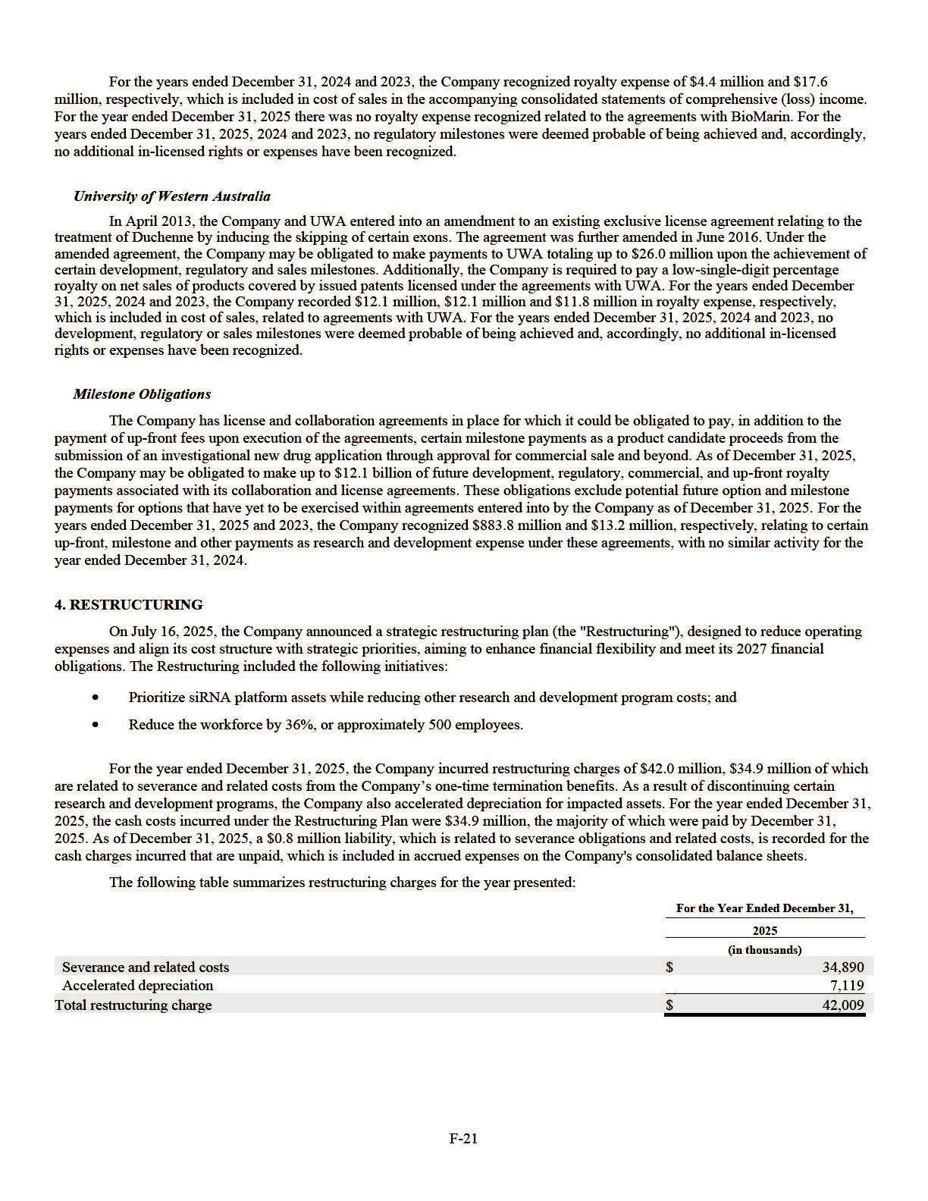

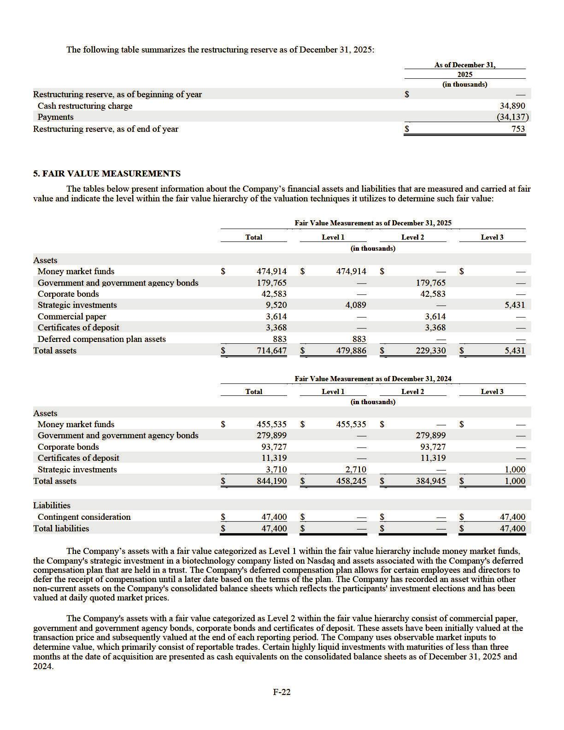

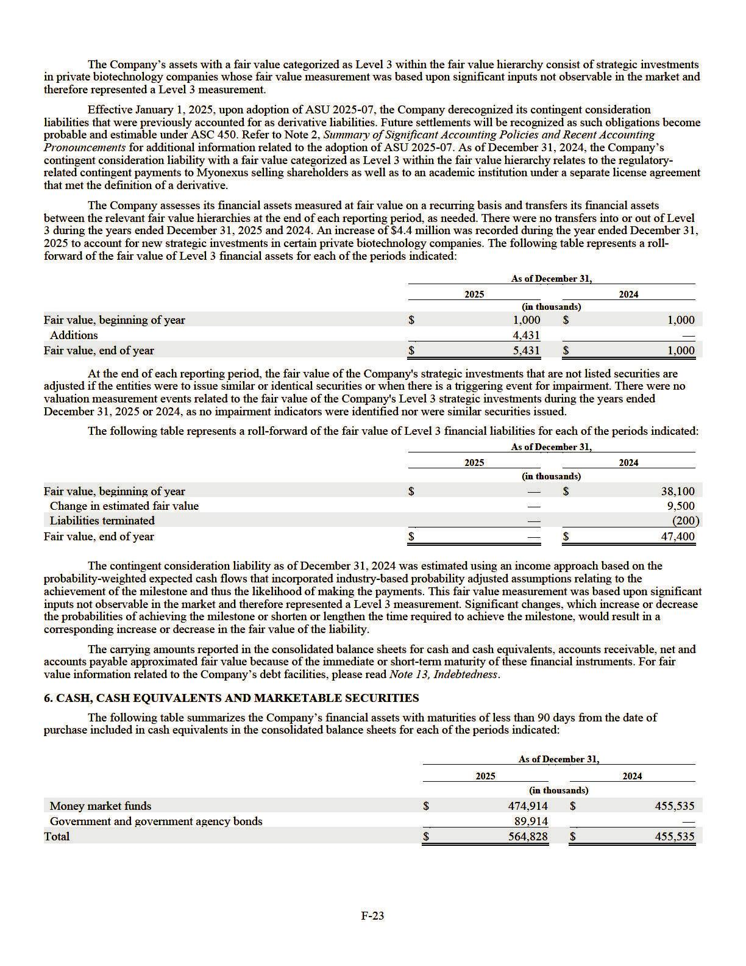

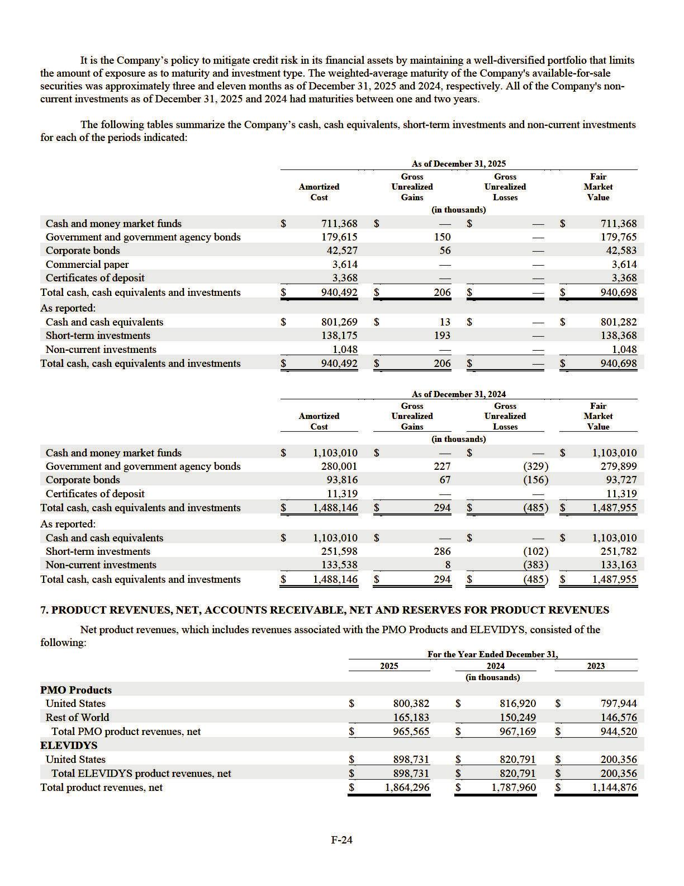

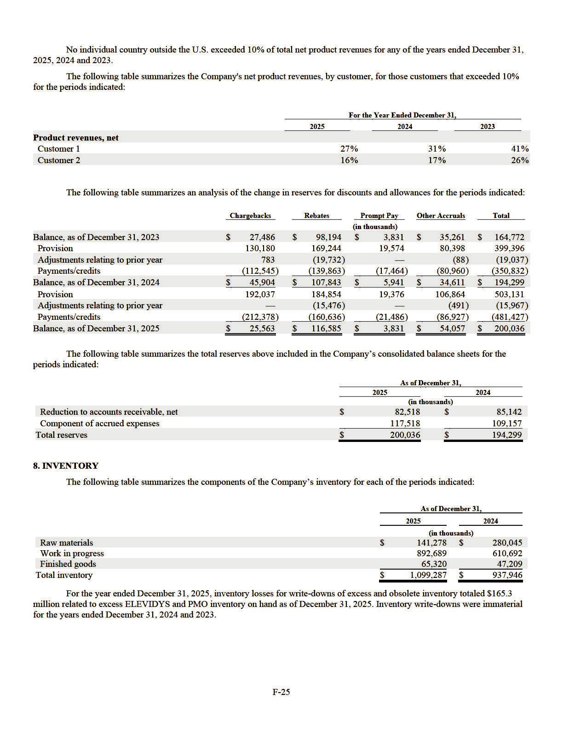

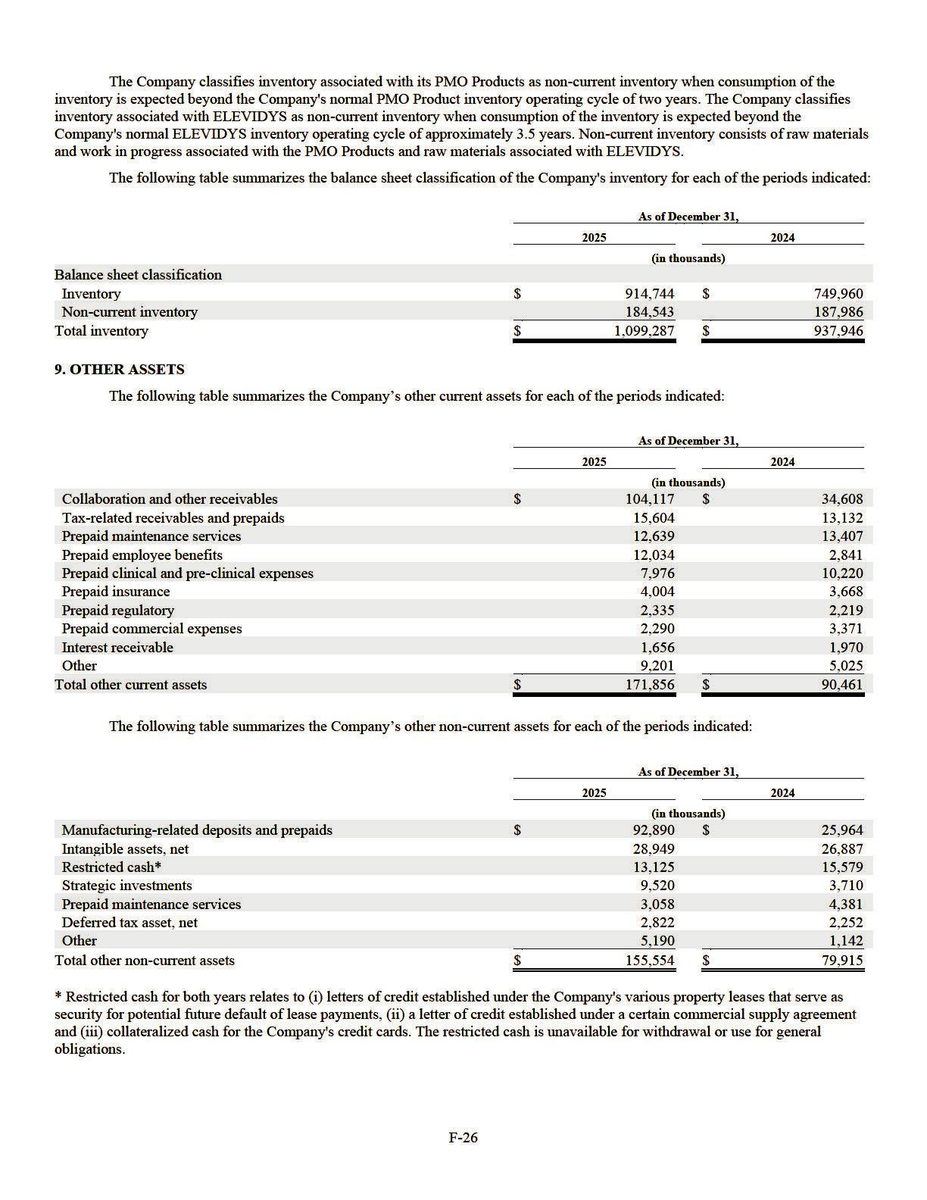

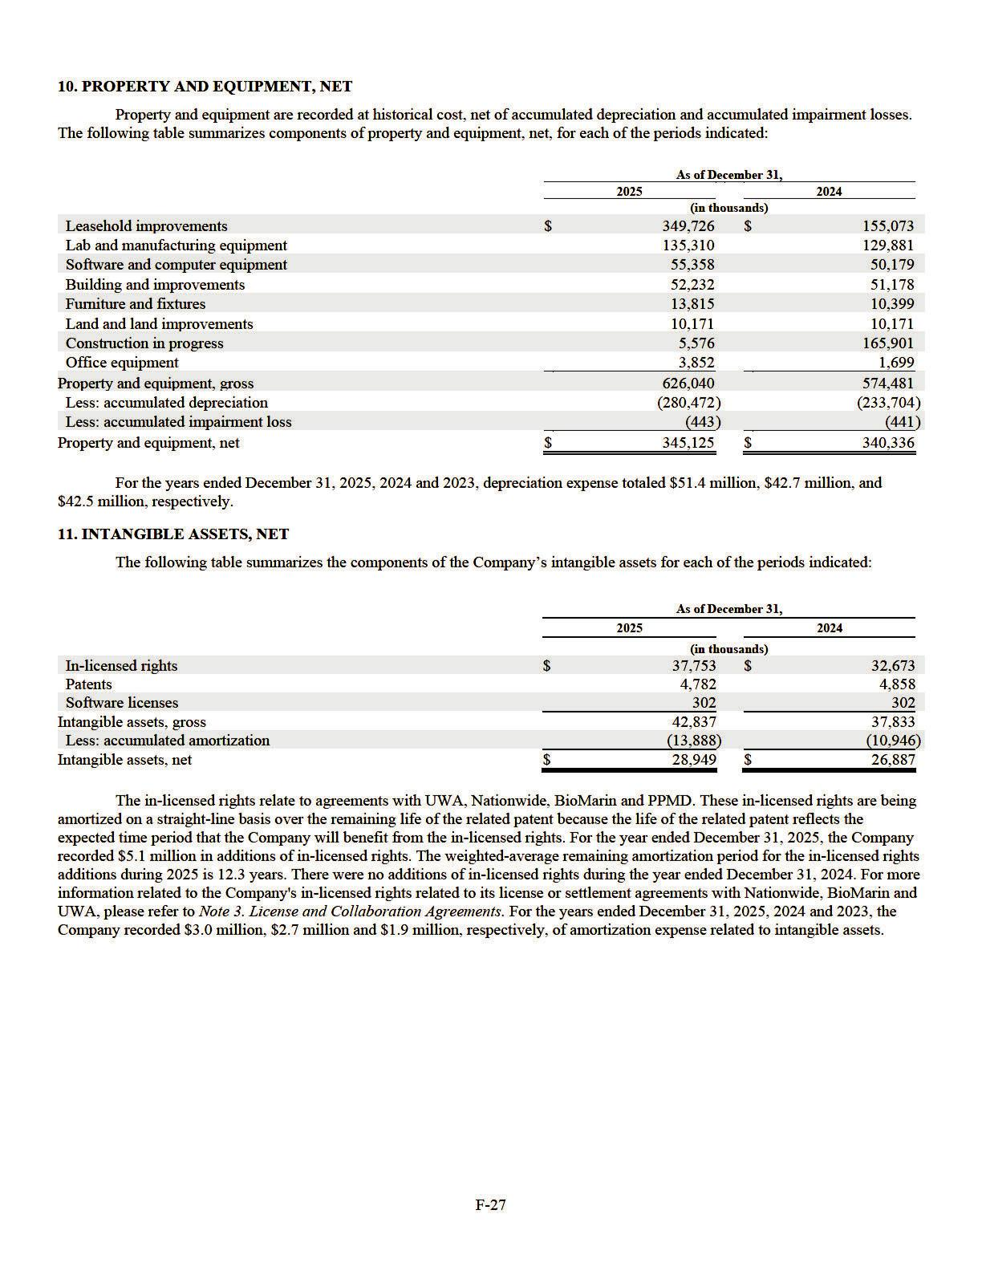

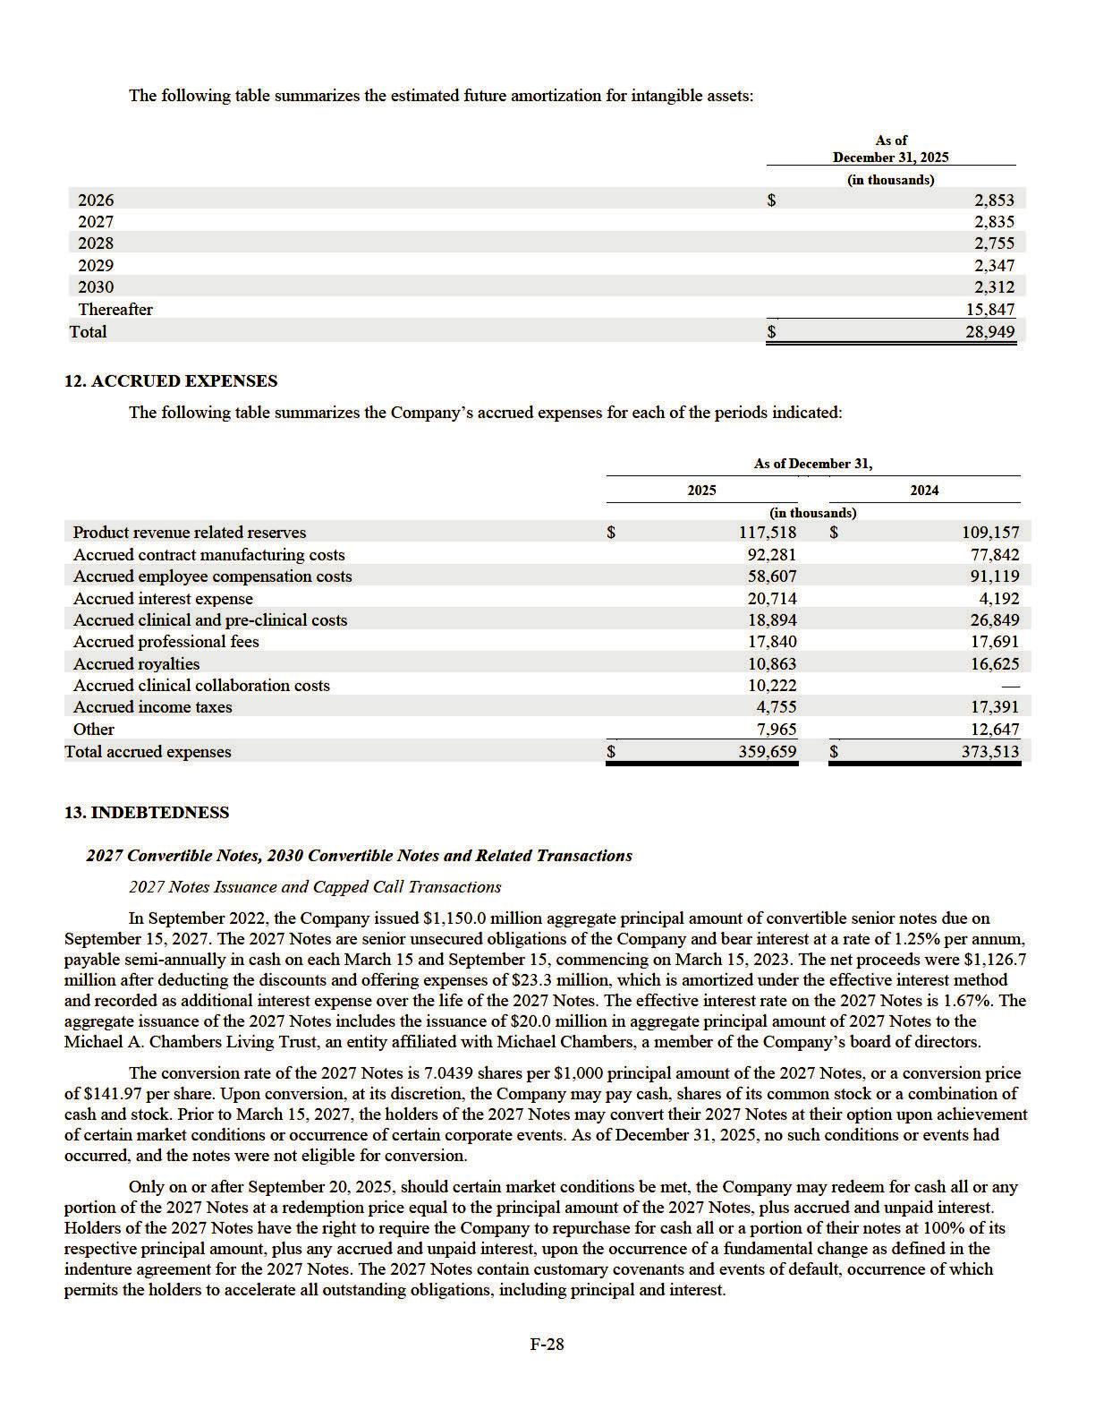

In connection with the issuance of the 2027 Notes, the Company entered into privately negotiated capped call transactions with counterparties intended to minimize the impact of potential dilution upon conversion of the 2027 Notes (the “2022 Capped Calls”), which covers approximately 8.1 million shares of the Company’s common stock. The 2022 Capped Calls have an initial strike price of approximately $141.97 per share and a cap price of approximately $210.32 per share. If, upon conversion of the 2027 Notes, the price of the Company’s common stock is between the strike price and the cap price of the capped calls, the counterparties will deliver shares of the Company’s common stock and/or cash with an aggregate value equal to the difference between the price of the Company’s common stock at the conversion date and the strike price, multiplied by the number of shares of the Company’s common stock related to the capped calls being exercised. The Company paid $127.3 million for the 2022 Capped Calls.

Exchange of 2027 Notes

On August 28, 2025 (the “First Closing Date”), the Company completed the August 2025 Exchange. The Company exchanged $700.0 million in aggregate principal amount of the 2027 Notes for the following consideration:

- $602.0 million in aggregate principal amount of 2030 Notes;

- cash payments of $127.3 million, including $4.0 million of accrued interest of the 2027 Notes; and

- 5.9 million shares of the Company’s common stock with a fair market value of approximately $104.9 million, net of issuance costs of $2.4 million.

The 2030 Notes issued in association with the August 2025 Exchange were issued at a discount of $142.4 million, based on the fair market value of the 2030 Notes on the First Closing Date. The Company incurred debt issuance costs of $13.4 million associated with the August 2025 Exchange.

On December 18, 2025 (the "Second Closing Date"), the Company completed a second partial refinancing of its 2027 Notes (the “December 2025 Exchange”). The Company exchanged $291.4 million in aggregate principal amount of the 2027 Notes for the following consideration:

- $291.4 million in aggregate principal amount of the 2030 Notes; and

- cash payments of $31.6 million, including $1.0 million of accrued interest of the 2027 Notes.

The 2030 Notes issued in association with the December 2025 Exchange were issued at a discount of $36.4 million, based on the fair market value of the 2030 Notes on the Second Closing Date. The Company incurred debt issuance costs of $4.0 million associated with the December 2025 Exchange.

The December 2025 Exchange included $20.0 million of 2027 Notes held by the Michael A. Chambers Living Trust. The terms of Mr. Chambers' exchange were on the same basis as all other participating holders. The remaining aggregate principal amount of $158.6 million of the 2027 Notes, which are currently convertible into approximately 1.1 million shares of the Company’s common stock, remains outstanding with the respective terms unchanged. Additionally, all capped calls related to the 2027 Notes remain outstanding. The December 2025 Exchange did not result in any material changes to the related party debt arrangements.

2030 Notes Issuance

The 2030 Notes are senior unsecured obligations of the Company and bear interest at a rate of 4.875% per annum, payable semi-annually in cash on each March 1 and September 1, commencing on March 1, 2026.

The 2030 Notes have an initial conversion rate of 16.6667 shares per $1,000 principal amount (approximately 14.9 million shares of the Company’s common stock in the aggregate), which represents a conversion price of $60.00 per share, subject to adjustment under certain conditions. Upon conversion, the Company may pay cash, shares of its common stock or a combination of cash and stock, as determined by the Company at its discretion.

The holders of the 2030 Notes may convert their 2030 Notes at their option only in the following circumstances:

- during any calendar quarter commencing after the calendar quarter ending on December 31, 2025, if the last reported sale price per share of common stock exceeds 130% of the conversion price for each of at least 20 trading days during the 30 consecutive trading days ending on, and including, the last trading day of the immediately preceding calendar quarter;

- during the five consecutive business days immediately after any five consecutive trading day period (the “Measurement Period”) in which the trading price per $1,000 principal amount of 2030 Notes for each trading day of the Measurement Period was less than 98% of the product of the last reported sale price per share of our common stock on such trading day and the conversion rate on such trading day;

F-29

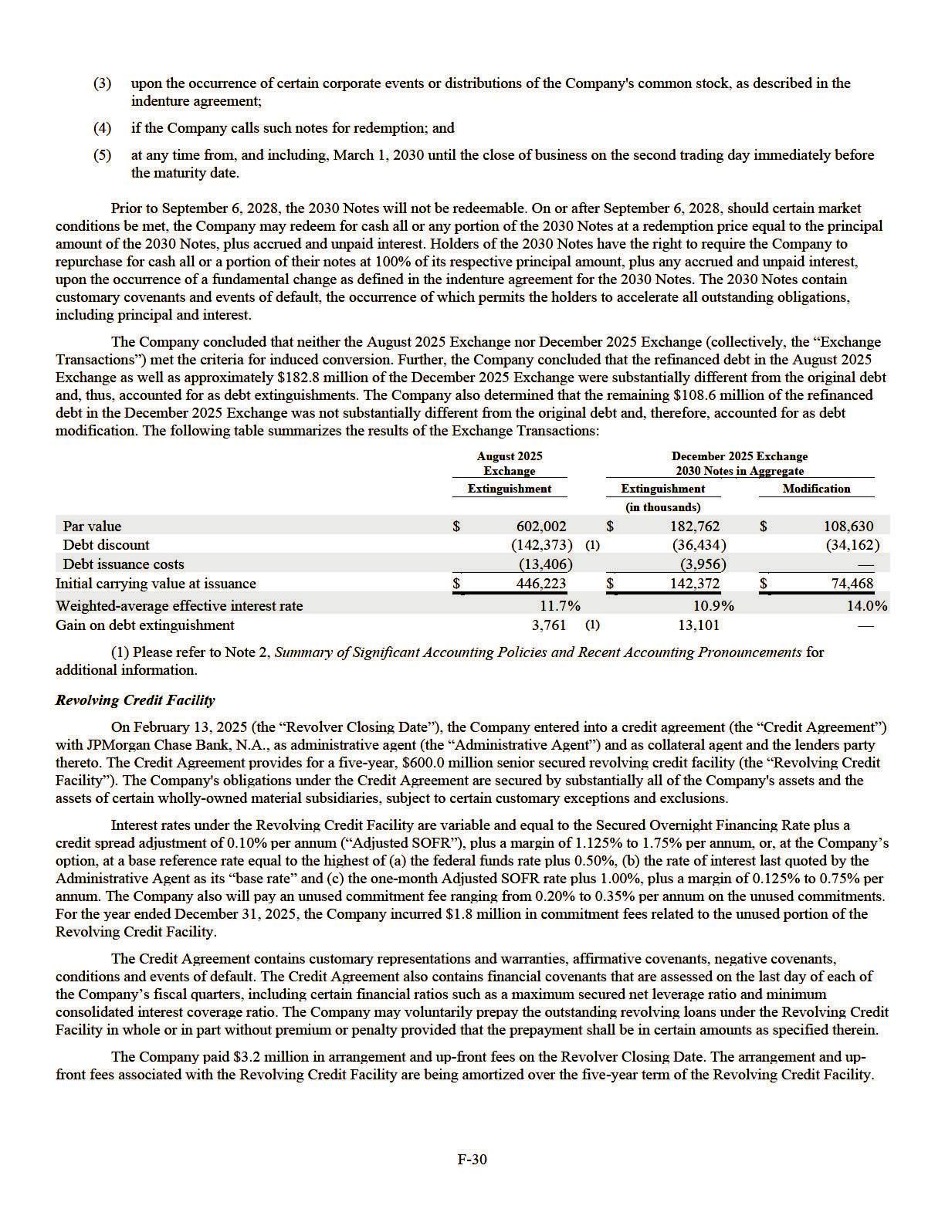

On December 18, 2025, the Company executed the first amendment to its Credit Agreement (the "First Amendment"). The First Amendment primarily updated regulatory representations and reaffirmed the Company’s compliance with existing covenants. No financial terms were amended as a result of the First Amendment. As of December 31, 2025, there were no amounts outstanding under the Revolving Credit Facility and the Company was in compliance with the covenants described above.

2024 Convertible Notes and Related Transactions

Issuance and Capped Call Transactions

In November 2017, the Company issued $570.0 million aggregate principal amount of senior convertible notes due on November 15, 2024 (the "2024 Notes"). The 2024 Notes were senior unsecured obligations of the Company and bore interest at a rate of 1.50% per annum, payable semi-annually in cash on each May 15 and November 15, commencing on May 15, 2018. The net proceeds were $559.4 million after deducting the discounts and offering expenses of $10.6 million. The effective interest rate on the 2024 Notes was 1.9%. The conversion rate of the 2024 Notes was 13.621 shares per $1,000 principal amount, or a conversion price of $73.42 per share, subject to adjustment under certain conditions. In connection with the issuance of the 2024 Notes, the Company entered into privately negotiated capped call transactions with counterparties intended to minimize the impact of potential dilution upon conversion of the 2024 Notes (the “2017 Capped Calls”) which covers approximately 7.8 million shares of the Company’s common stock. The Company paid $50.9 million for the 2017 Capped Calls.

Exchange and Capped Call Settlement

In March 2023, the Company entered into separate, privately negotiated exchange agreements with certain holders of the outstanding 2024 Notes (the “2024 Notes Exchange”), which resulted in an exchange of $313.5 million in aggregate principal value of the 2024 Notes for shares of the Company’s common stock. In connection with the 2024 Notes Exchange, the Company issued approximately 4.5 million shares of the Company's common stock with a fair value of approximately $693.4 million. The Company also incurred approximately $6.9 million in third-party debt conversion costs. The 2024 Notes Exchange was not pursuant to the conversion privileges included in the terms of the debt at issuance and therefore was accounted for as a debt extinguishment and resulted in a loss on debt extinguishment of $387.3 million, inclusive of the $6.9 million in third-party debt conversion costs, which was included in the consolidated statements of comprehensive (loss) income for the year ended December 31, 2023. Corresponding to the 2024 Notes Exchange, the related 2017 Capped Calls were terminated. As a result, the Company received $80.6 million in cash.

Conversion and Capped Call Settlement in 2024

Upon maturity as of November 15, 2024 (“the Maturity Date”), the Company converted the remaining outstanding bonds into approximately 1.2 million shares of its common stock equivalent to an aggregate principal amount of $91.6 million. A de minimis number of bonds were not converted and, as a result, the Company paid less than $0.1 million in cash to those bondholders. As the conversions were completed under the original terms of the 2024 Notes, there is no gain or loss impact on the accompanying consolidated statements of comprehensive (loss) income.

In May 2024, the Company informed remaining holders of the 2024 Notes of its election to settle the 2024 Notes in shares, which, pursuant to the terms of the 2017 Capped Call agreements, would require the Company to settle the 2017 Capped Calls in shares. On September 16, 2024, the Company entered into supplements with each of the counterparties to modify the terms of each of the 2017 Capped Calls to require settlement in cash rather than in shares. As a result of the modification, the Company reclassified the fair value of the 2017 Capped Calls of $43.9 million from stockholders’ equity to derivative assets. As a result of the conversion, the Company ultimately received $45.3 million in cash to settle the remaining 2017 Capped Calls on November 15, 2024. The change in the fair value of the derivative assets from September 16, 2024 to Maturity Date was a gain of $1.5 million and recorded to other (expense) income, net in the consolidated statements of comprehensive (loss) income. There were no derivative assets remaining as of December 31, 2025 or 2024.

Total Debt Obligations

As of December 31, 2025 and 2024, the Company recorded $829.0 million and $1,137.1 million as debt on the consolidated balance sheets, respectively. As of December 31, 2025, all debt was long-term in nature.

F-31

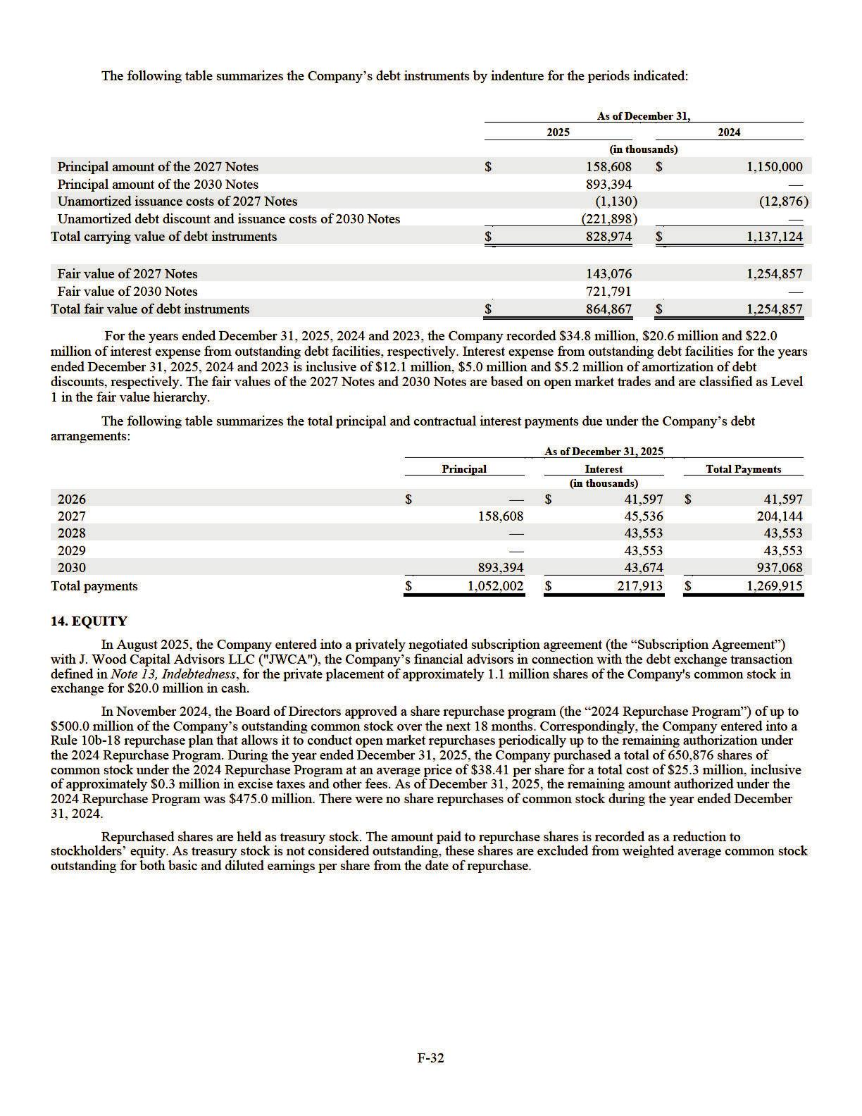

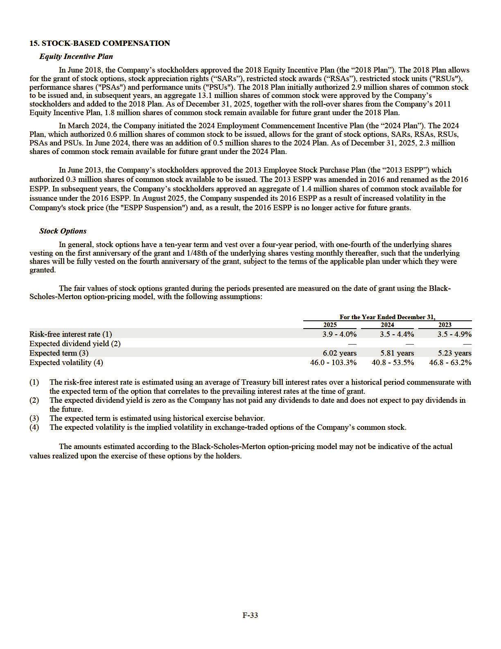

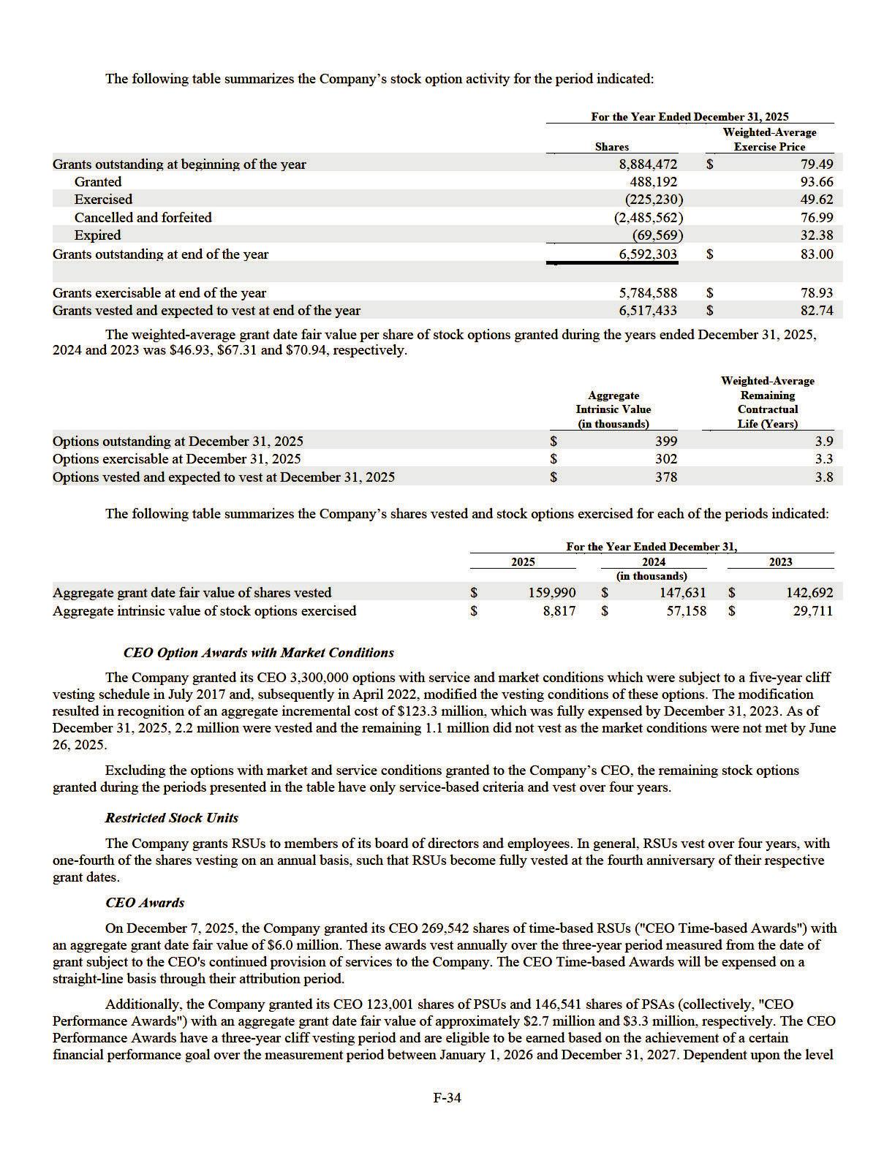

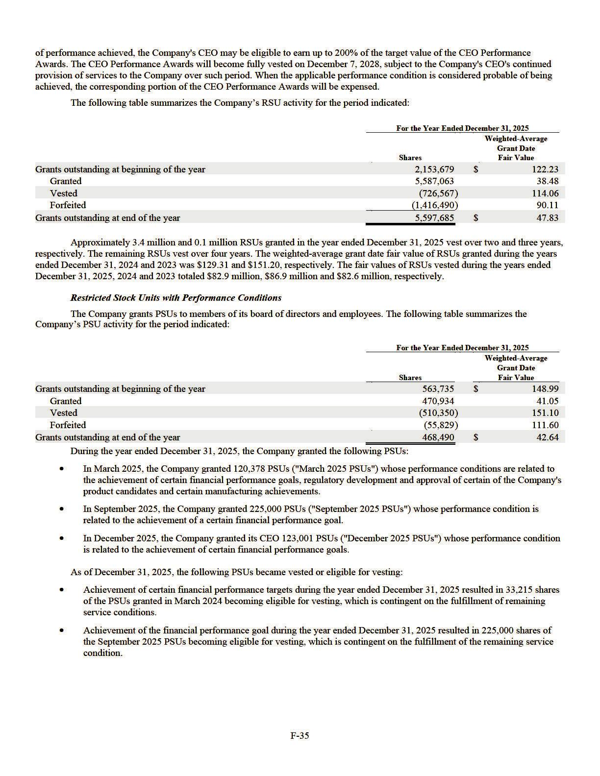

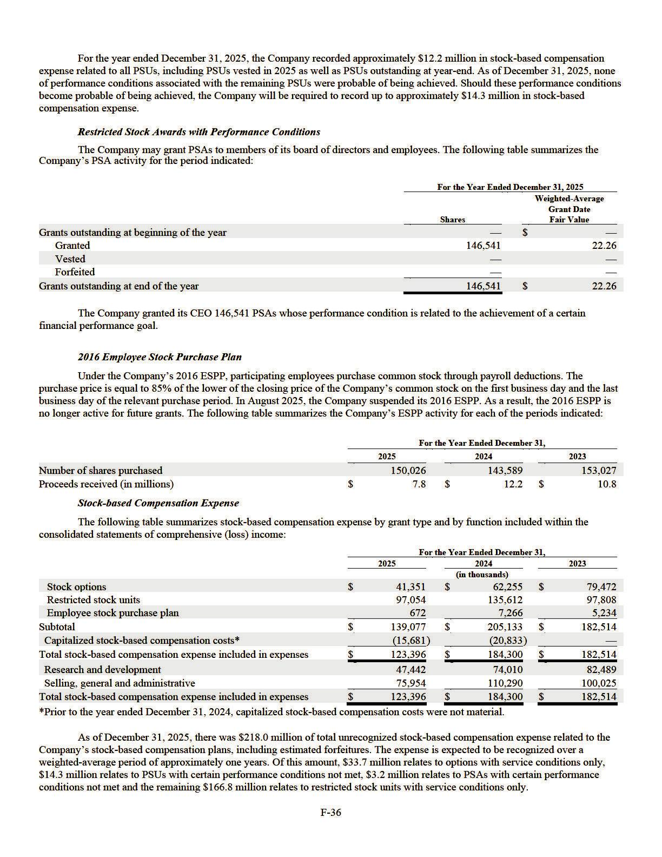

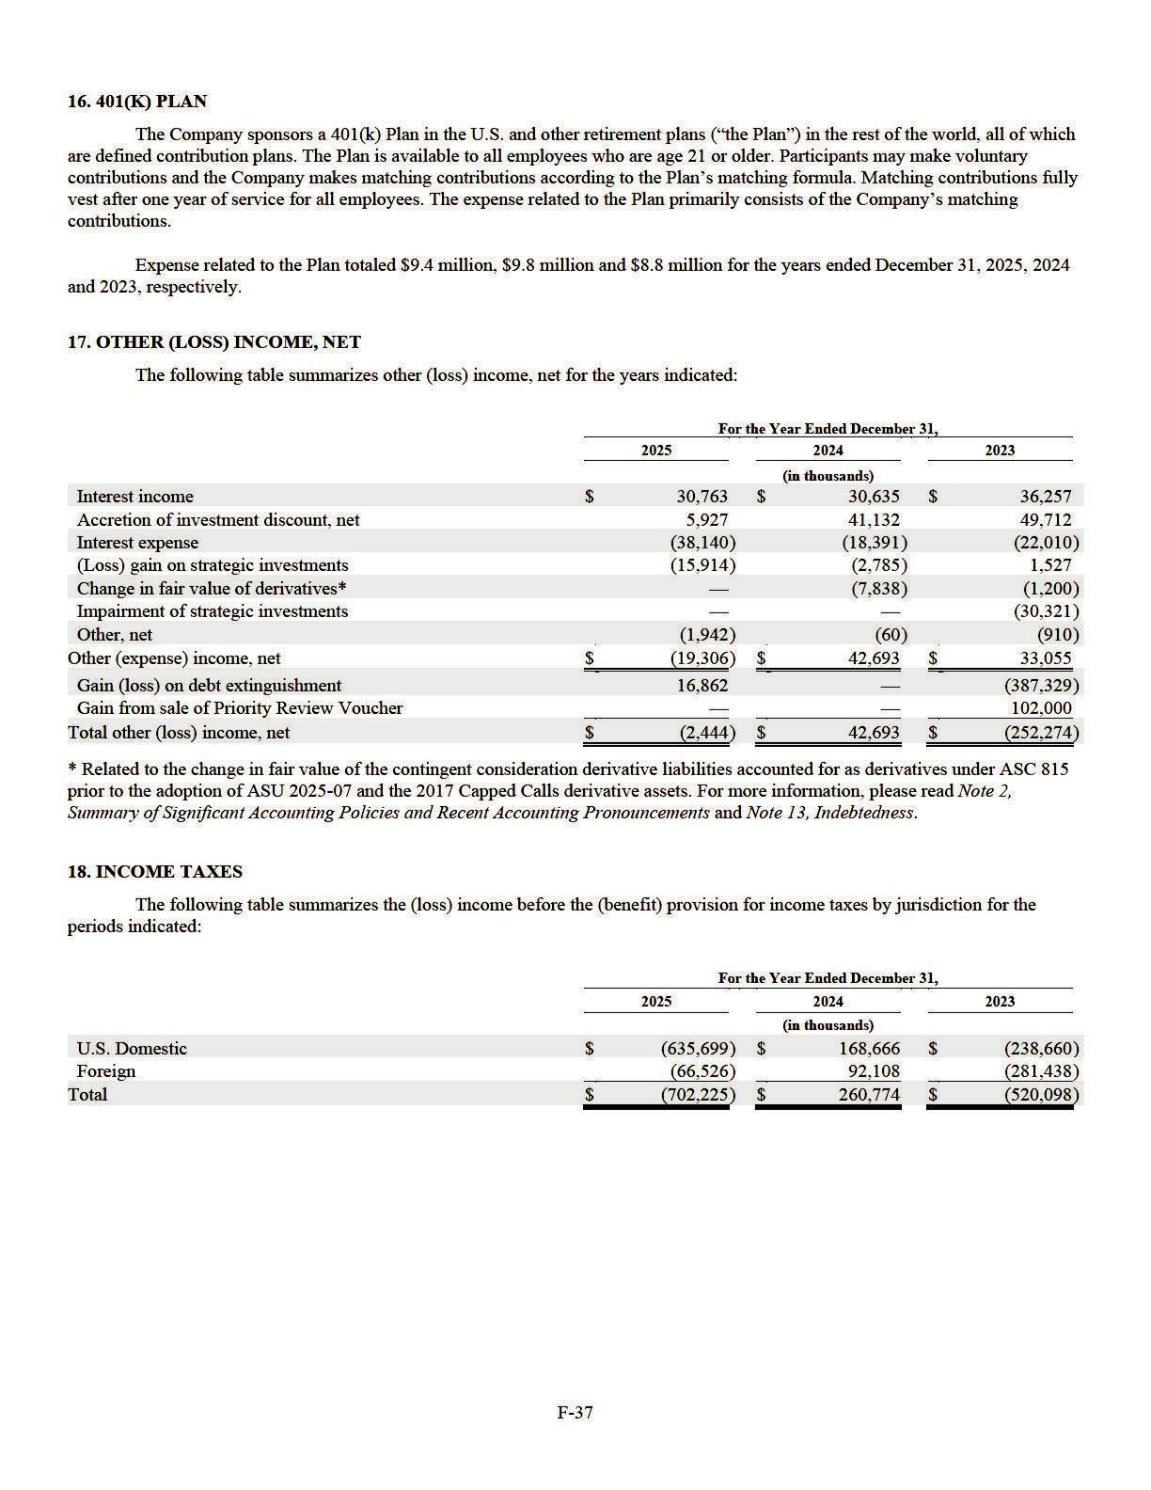

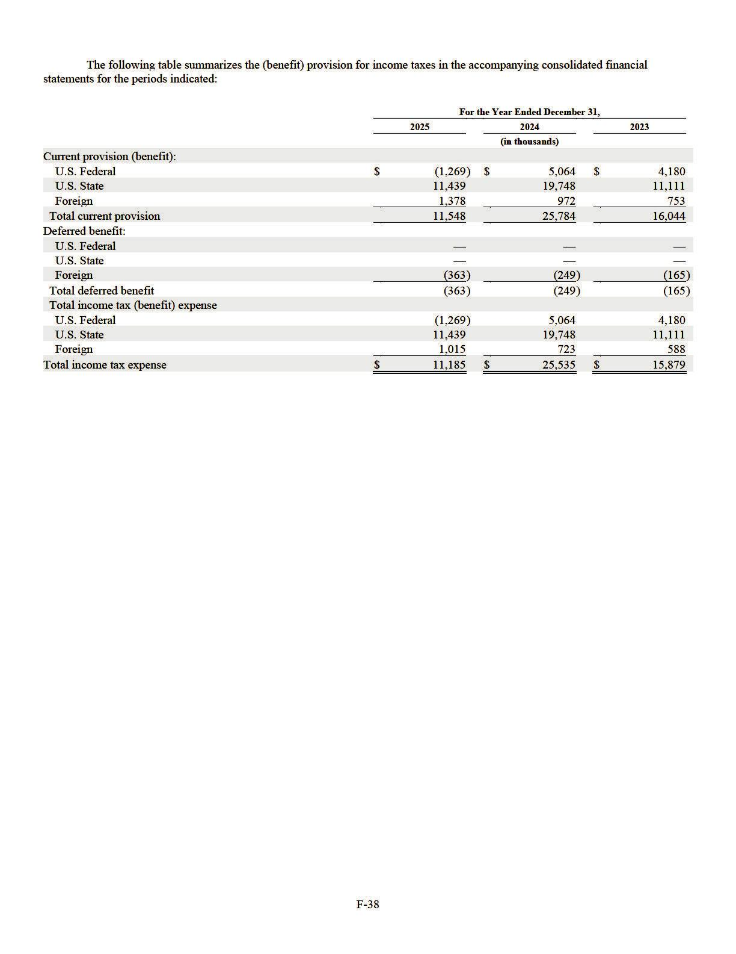

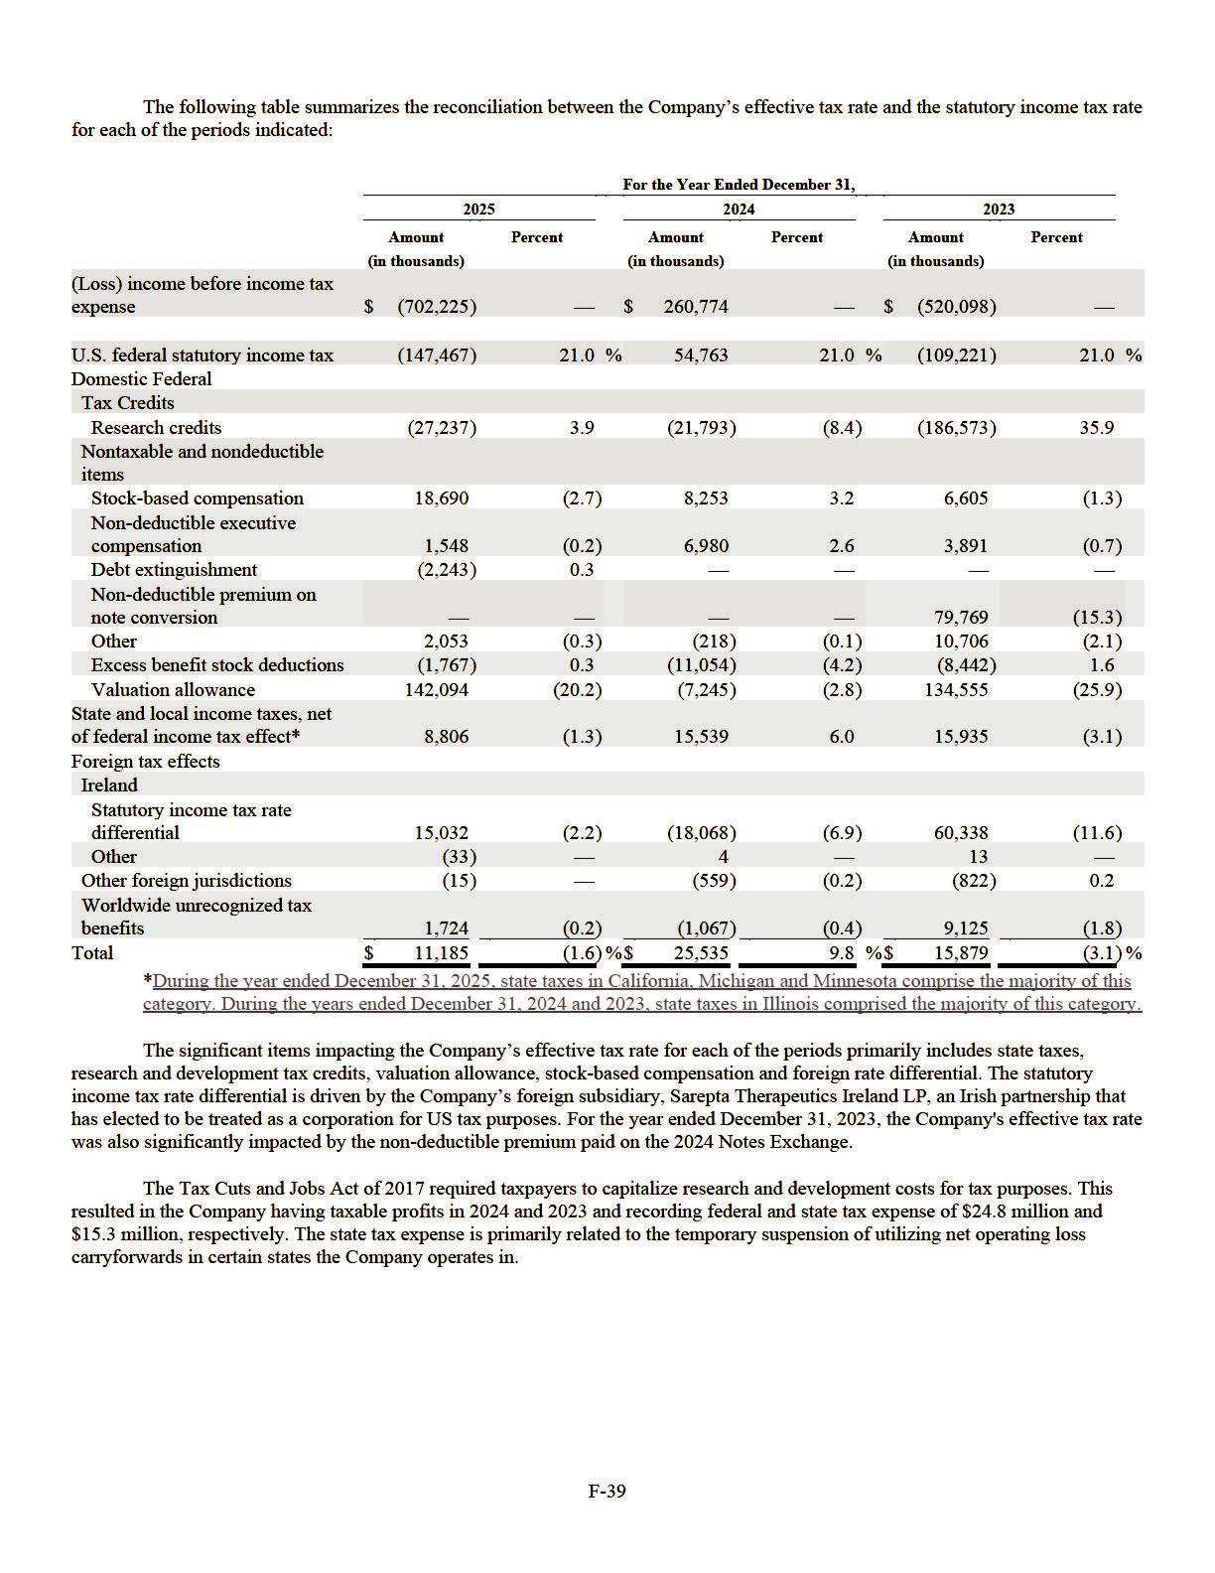

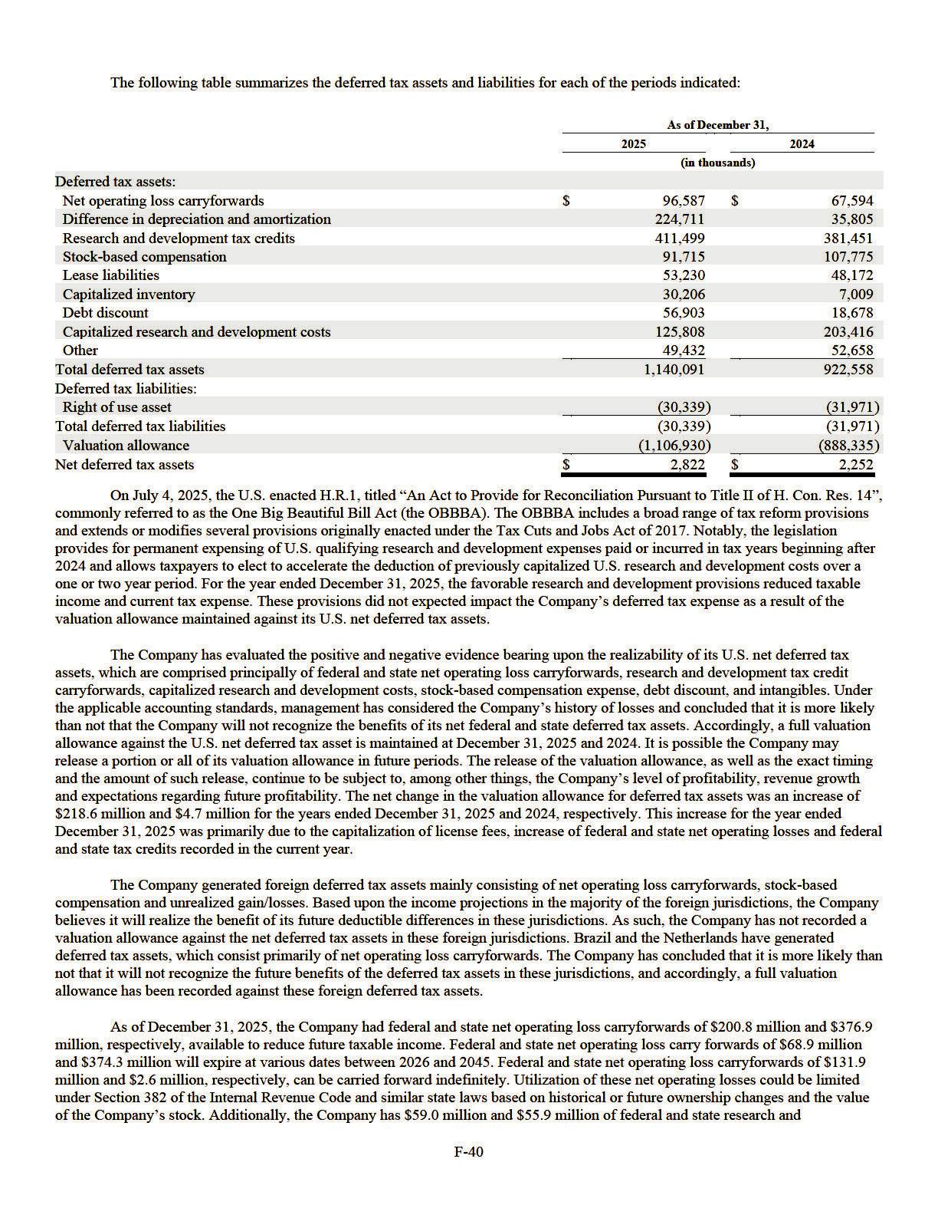

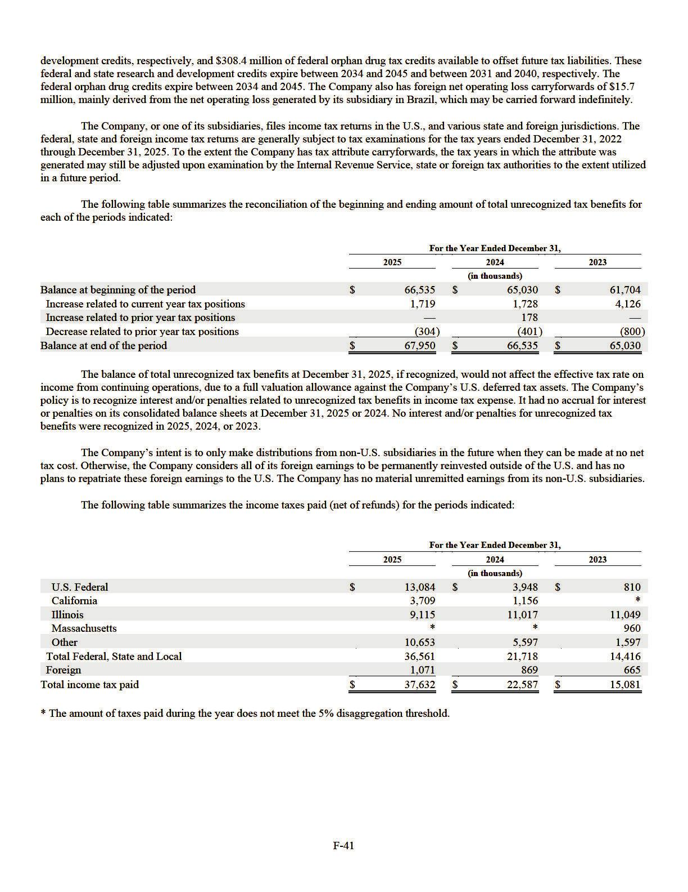

19. LEASES

The Company has real estate operating leases in Cambridge, Andover and Bedford, Massachusetts and Columbus, Ohio that provide for scheduled annual rent increases throughout each lease’s term. The Company has also identified leases embedded in certain of its manufacturing and supply agreements as the Company determined that it controls the use of the facilities and related equipment therein. For more information related to the leases embedded in manufacturing and supply agreements with Catalent, Inc. (“Catalent”), please refer to Note 23, Commitments and Contingencies.

Bedford, Massachusetts

On April 22, 2022, the Company entered into a lease agreement (the “Bedford Lease”) for 288,000 square feet of to-be-constructed research and development and manufacturing space in Bedford, Massachusetts. The term of the Bedford Lease commences upon the landlord’s completion of the initial construction of the core and shell of the building, at which time the Company will obtain control of the premises and commence internal construction activities. The initial term of the Bedford Lease is anticipated to terminate on December 31, 2038. The Company has two options to extend the lease for a period of ten years each, exercisable under certain conditions and at a market rate determined in accordance with the lease agreement. The lease commenced in May 2023 as the Company obtained control of the premises.

The Bedford Lease provides for a tenant improvement allowance from the landlord of $72.0 million to be used towards costs incurred by the Company in the design and construction of the premises, which was recorded as a reduction to ROU assets and lease liabilities. In August 2024, the Company entered into an amendment to the Bedford Lease to extend the term in which the tenant improvement allowance could be reimbursed from the landlord (the “Bedford Amendment”) through December 2, 2025. The Company also agreed to reimburse the landlord for certain costs incurred in order to fund the extension of the reimbursement period associated with the tenant improvement allowance, totaling $2.9 million. The Bedford Amendment was accounted for as a modification to the Bedford Lease.

In May 2022, in connection with the execution of the Bedford Lease, the Company issued a letter of credit collateralized by cash deposits of $8.4 million, which was included in other non-current assets of the Company’s consolidated balance sheets. Such letter of credit shall be reduced to $5.6 million at the commencement of the fourth rent year, provided certain conditions set forth in the Bedford Lease are satisfied. Additionally, the Company is responsible for reimbursing the landlord for the Company’s share of the property’s operating expenses and property taxes.

The Company had a lease liability and ROU asset of $168.9 million and $89.7 million, respectively, on the consolidated balance sheets as of December 31, 2025 related to the Bedford Lease. Tenant improvement costs incurred by the Company that have been reimbursed by the landlord total $69.8 million as of December 31, 2025 and are recorded as an increase to the lease liability within the Company's consolidated balance sheets.

Columbus, Ohio

In December 2018, the Company entered into a lease agreement for a research and development facility in Columbus, Ohio, which was subsequently amended in May 2022 (the “Columbus Amendment,” together with the Columbus Amendment, the lease agreement is referred to as the “Columbus Lease”). The Columbus Lease expands from its current form of approximately 78,000 square feet to 167,000 square feet through a series of expansion spaces commencing at various periods through January 1, 2025.

Each expansion space commences on the date when the landlord will deliver control of that space for the Company to carry out design and construction activities (the “Columbus Commencement Date”). The Company is obligated to pay rent on each expansion space nine months after the Columbus Commencement Date. The Columbus Lease expires on December 31, 2036, and the Company has options to extend the lease by five years in both 2036 and 2041. Each option is exercisable under certain conditions and at a market rate determined in accordance with the lease agreement.

The Company commenced design and construction activities on areas of the premises of approximately 18,000 square feet (the “Second Expansion Space”), 36,000 square feet (the “Initial Expansion Space”), 19,000 square feet (the “Third Expansion Space”) and 16,000 square feet (the “Fourth Expansion Space”) on June 1, 2022, October 1, 2022, September 1, 2023 and January 1, 2025, respectively. As a result, it was determined that the lease related to the Second Expansion Space, the Initial Expansion Space, the Third Expansion Space and the Fourth Expansion Space had commenced on those four dates, respectively. The total ROU asset and lease liability associated with the Columbus Lease, inclusive of the Fourth Expansion Space, Third Expansion Space, the Second Expansion Space and the Initial Expansion Space, was $12.9 million and $21.2 million, respectively, as of December 31, 2025.

F-42

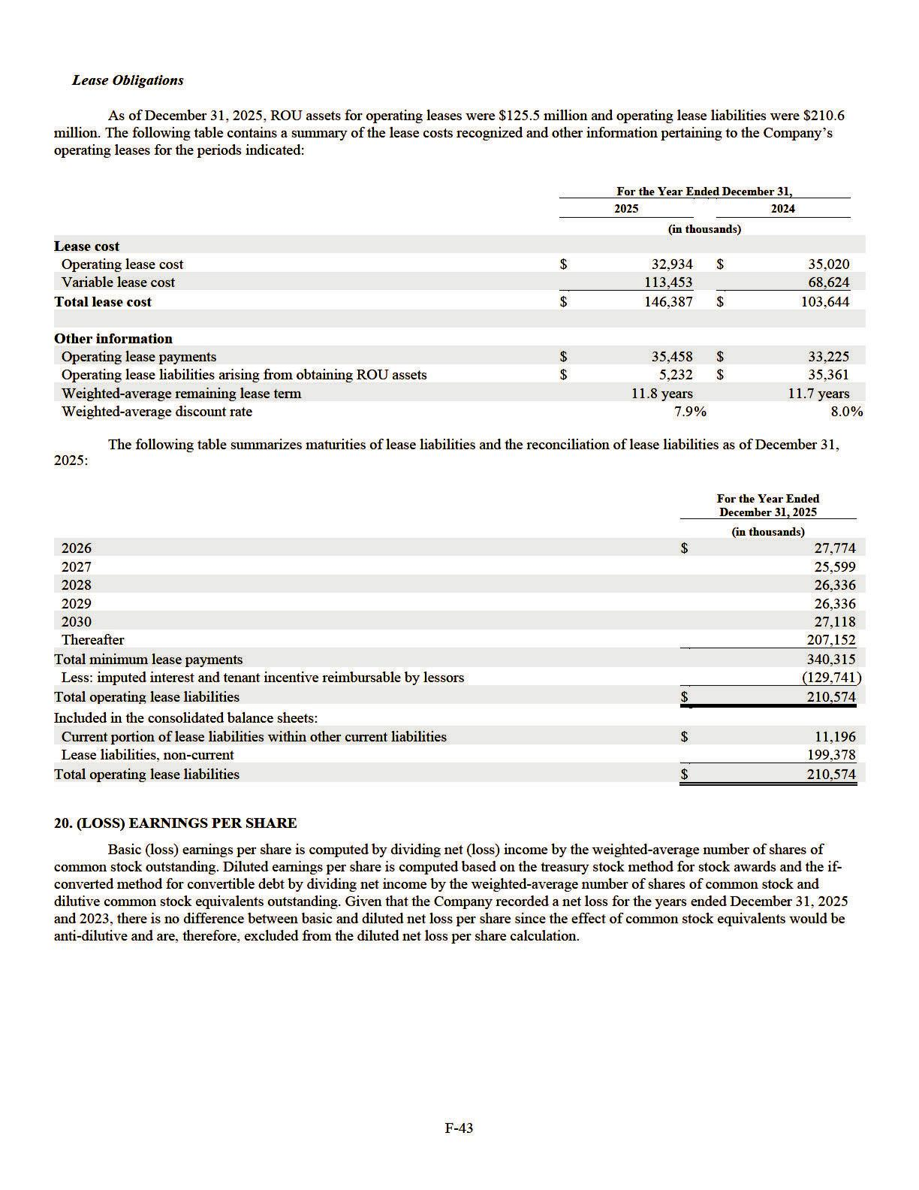

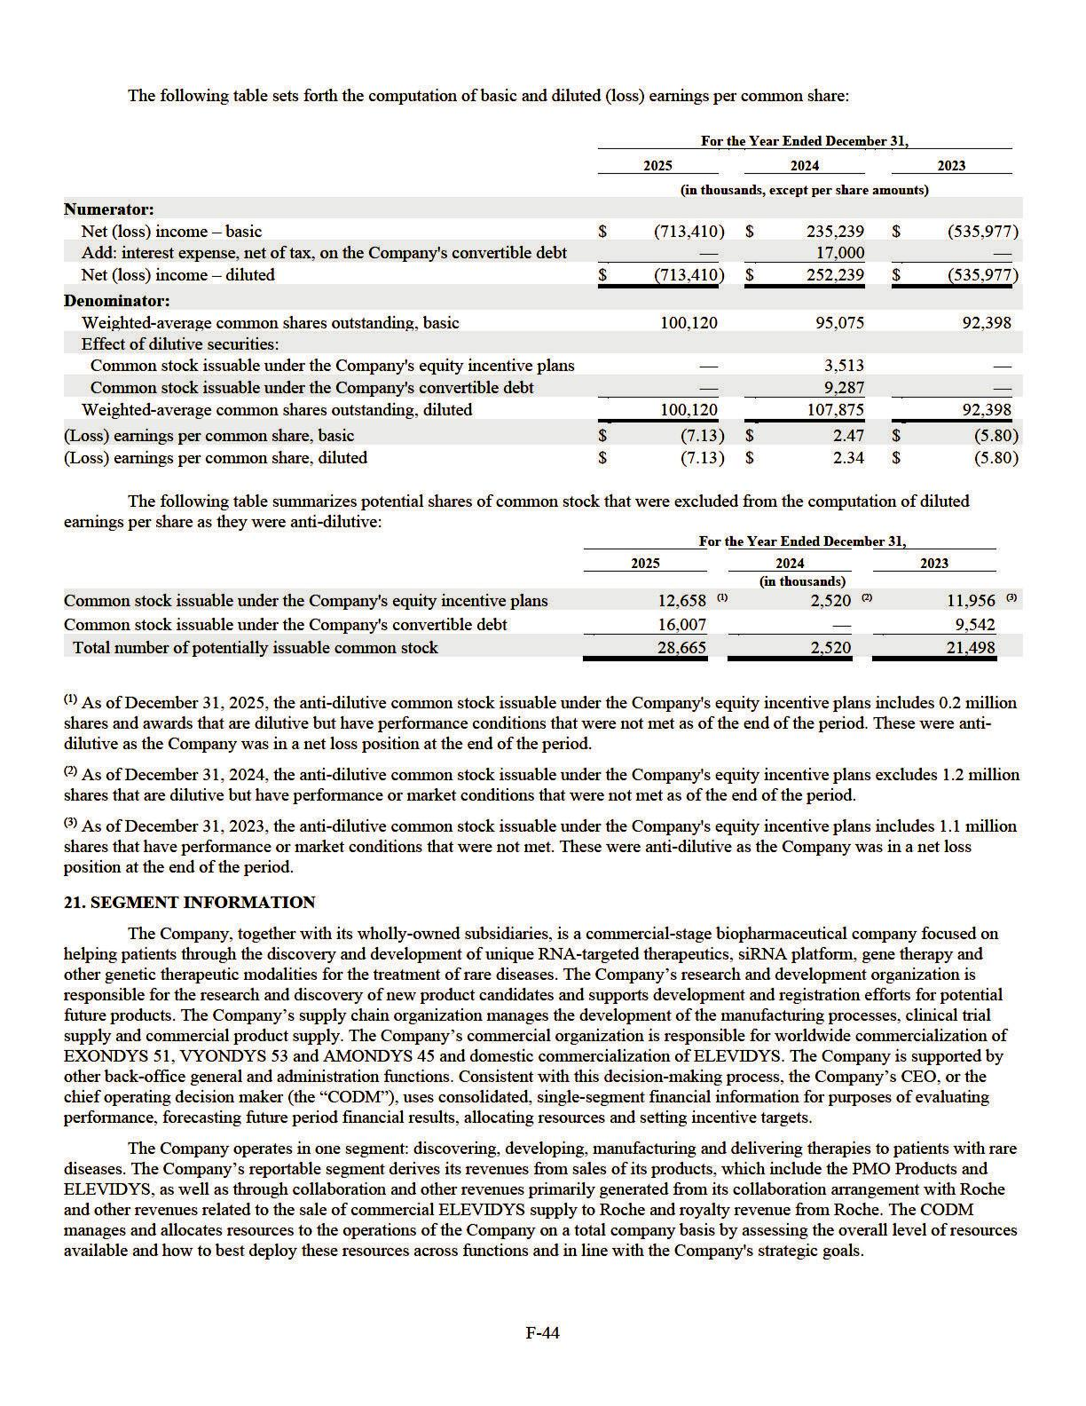

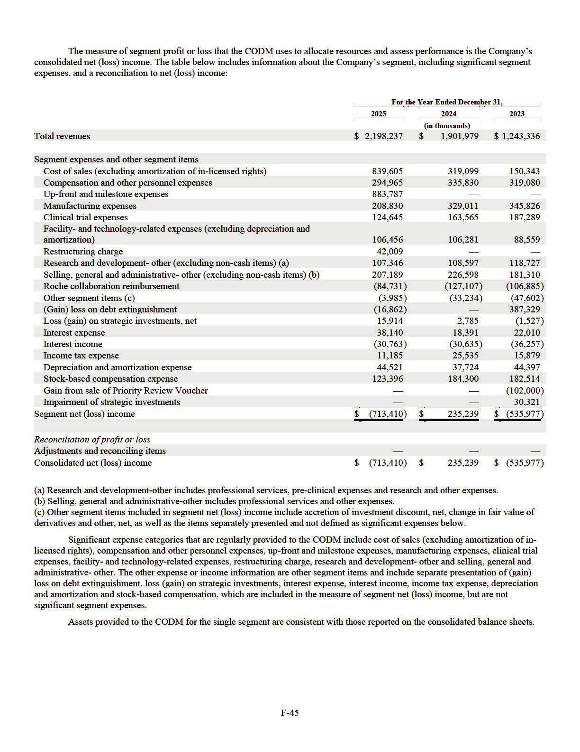

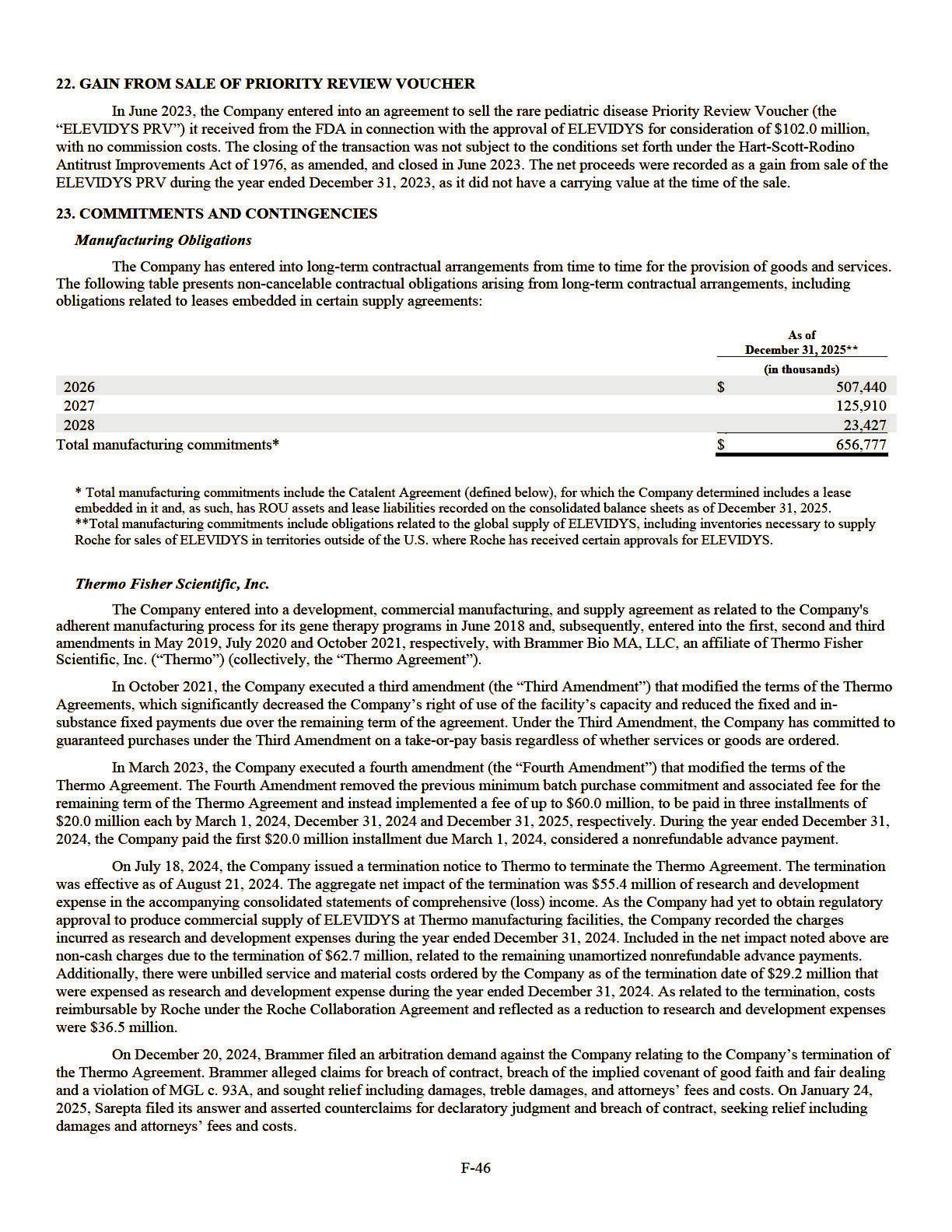

On July 12, 2025, the Company entered into a settlement agreement with Brammer to resolve the outstanding claims related to the termination of the Thermo Agreement (the “Brammer Settlement”). Under the Brammer Settlement, the Company agreed to pay Brammer an aggregate amount of $13.0 million. The arbitration was subsequently dismissed. The Brammer Settlement is recorded in the Company's consolidated statements of comprehensive (loss) income within research and development expense for the year ended December 31, 2025.

Catalent, Inc.

The Company entered into a manufacturing collaboration agreement and, subsequently, a manufacturing and supply agreement with Catalent, formerly Paragon Biosciences, Inc. in October 2018 and February 2019, respectively (collectively, the “Catalent Agreements”). Pursuant to the terms of the Catalent Agreements, Catalent agreed to provide the Company with two dedicated clean room suites and an option to reserve two additional clean room suites for its gene therapy programs, subject to certain minimum and maximum volume limitations. In September 2019, the Company exercised the option to gain access to the two additional clean room suites. The Company determined that the Catalent Agreements contained a lease because the Company had the right to direct the use of the facility and related equipment therein. The lease on all four dedicated clean room suites at Catalent commenced during 2020, which is when the dedicated clean room suites became available for use by the Company. In March 2021, the Company modified the terms of the Catalent Agreements, which decreased the Company’s right of use of certain dedicated clean room suites. As of December 31, 2025, the Company controls two clean room suites.

In November 2022, the Company modified certain terms of the Catalent Agreements which extended the term of the agreement through December 31, 2028, which represented a modification of the existing embedded lease over certain clean room suites. The modification resulted in the recognition of additional ROU assets and lease liabilities of $19.2 million, as well as reclassification of $3.9 million between long-term and short-term manufacturing deposits. The modification also removed certain fixed payments due over the remaining term of the agreement. Further, in order to maintain the Company's dedicated clean room suites, it has committed to guaranteed purchases under the amendment on a take-or-pay basis regardless of whether services or goods are ordered.

In October 2025, the Company notified Catalent of its intention to release Catalent from its obligation to dedicate certain clean room suites to the Company, effective October 2026 (the "Dedicated Suites Release"). The Dedicated Suites Release shortened the embedded lease term for those suites and resulted in the derecognition of ROU assets and lease liabilities of $12.3 million, as the related balances were remeasured over the remaining embedded lease term. The Dedicated Suites Release did not change any other terms of the Catalent Agreements.

The Company has the ability to terminate the Catalent Agreements prior to expiration, subject to the payment of additional financial consideration. As of December 31, 2025, the Company believes it is probable that the guaranteed purchase requirements will be met in the normal course of business throughout the term of the Catalent Agreements.

On August 18, 2025 (the “Effective Date”), the Company entered into a supplemental letter agreement (the “Letter Agreement”) with Catalent in connection with the Catalent Agreements. The Letter Agreement addresses certain financial and operational matters related to the Company’s suspension of ELEVIDYS shipments for non-ambulatory patients in June 2025 and the temporary suspension of all U.S. ELEVIDYS shipments in July 2025. In addition, the parties agreed to delay delivery of certain ELEVIDYS batches until 2027 and beyond.

Under the terms of the Letter Agreement, the Company:

- agreed to reimburse Catalent for raw materials that had been ordered or received by Catalent and not yet invoiced to the Company as of the Effective Date of the Letter Agreement. As such, the Company paid $61.8 million and $62.6 million for raw materials associated with the Company's binding payment for the first and second quarter of 2026, respectively. As of December 31, 2025, $40.7 million was classified as manufacturing related deposits and prepaids and $83.7 million was classified as other non-current assets in the consolidated balance sheets, reflecting the expected consumption of these raw materials. The Company and Catalent finalized the outstanding balance related to certain unbilled raw materials associated with the Letter Agreement as of December 31, 2025, resulting in $33.1 million of previously unbilled raw materials being recorded as accrued expenses in the consolidated balances sheets.

- will remain contractually obligated for the full batch price of certain manufacturing batches, including a portion of batches deferred to calendar year 2027. The Company is required to pay 50% of the batch price for the deferred batches by July 1, 2026, and the remaining 50% by June 30, 2027, regardless of whether the batches are manufactured. These commitments are considered purchase obligations and are reflected in the Company’s total manufacturing commitments disclosure above.

- agreed to reimburse Catalent an amount representing estimated failed batches through June 30, 2025 based on the batch success rate stipulated in the Catalent Agreements. As a result, the Company recorded $23.0 million within cost of sales in its consolidated statements of comprehensive (loss) income for the year ended December 31, 2025.

F-47

Additionally, in connection with changes to the Company's forward-looking production for ELEVIDYS, the Company recognized an impairment charge of $17.0 million related to prepaid deposits, which was recorded within cost of sales in the Company's consolidated statements of comprehensive (loss) income for the year ended December 31, 2025.

Aldevron, LLC

The Company entered into a clinical and commercial supply agreement in December 2018, as subsequently amended in June 2020, with Aldevron LLC (“Aldevron”) for the supply of plasmid DNA to fulfill its needs for gene therapy clinical trials and commercial supply (collectively, the “Aldevron Agreements”). Pursuant to the terms of the Aldevron Agreements, Aldevron agreed to reserve a certain amount of manufacturing capacity on a quarterly basis. In return, the Company is required to make advance payments to Aldevron related to the manufacturing capacity.

In January 2025, the Company modified certain terms of the Aldevron Agreements which extended the term of the agreement through December 31, 2028 (the “Aldevron Amendment”). As a result of the Aldevron Amendment, the Company has the option to extend the term of the Aldevron Agreements by one year if the Company delivers a written notice of its intention to extend to Aldevron no later than June 1, 2028. Both parties have the right to early terminate without additional penalty. The Company has determined that the Aldevron Amendment does not contain an embedded lease because it does not convey the right to control the use of Aldevron’s facility or related equipment therein.

Euroapi Germany GmbH

On October 24, 2025, the Company entered into a side letter agreement (the “Euroapi Side Letter”) with Euroapi Germany GmbH (“Euroapi”) in connection with the Company’s manufacturing and supply agreement entered into in October 2020 and as amended in December 2023 and November 2024, respectively (collectively, the “Euroapi Agreement”). The Euroapi Side Letter suspends certain contractual obligations under the Euroapi Agreement. Specifically, manufacturing of certain raw materials associated with the PMO Products will be paused during the term of the side letter.

The Company agreed to pay approximately $10.4 million to satisfy the remainder of the Company’s 2025 purchase obligations under the Euroapi Agreement. The Company and Euroapi may mutually agree to reinstate commercial supply for 2026, which would otherwise require minimum purchase commitments of approximately $15.1 million. Based on its assessment as of December 31, 2025, the Company determined it was not probable that commercial supply will resume in 2026. Accordingly, the Company recorded $15.1 million related to 2026 minimum purchase commitments as cost of sales in the accompanying consolidated statements of comprehensive (loss) income for the year ended December 31, 2025, with the outstanding liability reflected as accrued contract manufacturing costs within accrued expenses in the consolidated balance sheets as of December 31, 2025.

As a result of the Euroapi Side Letter, the total impact to cost of sales for the year ended December 31, 2025 was approximately $25.5 million, representing $10.4 million and $15.1 million for 2025 purchase obligations and 2026 minimum purchase commitments, respectively.

Other Funding Commitments

The Company has several on-going clinical trials in various clinical trial stages. Its most significant clinical trial expenditures are to contract research organizations (“CROs”). The CRO contracts are generally cancellable at the Company’s option. As of December 31, 2025, the Company had approximately $404.3 million in cancellable future commitments based on existing CRO contracts. For the years ended December 31, 2025, 2024 and 2023, the Company recognized $89.8 million, $110.1 million and $112.2 million, respectively, for expenditures incurred by CROs.

Litigation

In the normal course of business, the Company from time to time is named as a party to various legal claims, actions and complaints, which have included and may include matters involving securities, employment, intellectual property, arising from the use of therapeutics utilizing its technology, or others. The Company records a loss contingency reserve for a legal proceeding when it considers the potential loss probable and it can reasonably estimate the amount of the loss or determine a probable range of loss. The Company provides disclosure when it considers a loss reasonably possible or when it determines that a loss in excess of a reserve is reasonably possible. The Company provides an estimate of such reasonably possible losses or an aggregate range of such reasonably possible losses, unless the Company believes that such an estimate cannot be made. The Company has not recorded any material accruals for loss contingencies, and in management's opinion, no material range of loss is estimable for the matters described below as of December 31, 2025.

On September 15, 2020, REGENXBIO INC. (“Regenx”) and the Trustees of the University of Pennsylvania (“U-Penn”) filed a lawsuit against the Company and Sarepta Therapeutics Three, LLC, in the U.S. District Court for the District of Delaware. The plaintiffs assert patent infringement of U.S. Patent No. 10,526,617 (“the ’617 Patent”) under 35 U.S.C.§§ 271(a)-(c) based on Sarepta’s alleged direct or indirect manufacture and use of the patented cultured host cell technology allegedly used to make AAV gene therapy products, including SRP-9001 (approved June 22, 2023 in the U.S. as ELEVIDYS®). Specifically, the Complaint

F-48

essentially includes the allegation that Sarepta’s use, and the use by its contract manufacturers on its behalf, of a host cell containing a recombinant acid molecule that encodes a capsid protein having at least 95% amino acid identity to AAVrh10 infringes the ’617 Patent asserted by Regenx. Plaintiffs seek injunctive relief, a judgment of infringement and willful infringement, damages that are no less than a reasonable royalty (including treble damages), attorneys’ fees and costs, and such other relief as the court deems just and proper. On January 5, 2024, the Court granted Sarepta’s motion for summary judgment on the grounds that the asserted claims of Regenx’s ’617 Patent are invalid because they cover patent ineligible subject matter under 35 U.S.C. § 101. On January 12, 2024, the Court entered judgment and closed the case. Plaintiffs appealed to the U.S. Court of Appeals for the Federal Circuit (the “Federal Circuit”), which reversed the district court's decision on February 20, 2026, and remanded the case for further proceedings.

On June 20, 2023, Regenx and U-Penn commenced a second patent infringement lawsuit against Sarepta and its contract manufacturer, Catalent, asserting alleged patent infringement of U. S. Patent No. 11,680,274 (“the ’274 Patent”). In the second lawsuit, Regenx and U-Penn allege that Sarepta and Catalent’s manufacture, use and commercial launch of ELEVIDYS® (formerly/also known as SRP-9001) infringe the ’274 Patent. Sarepta answered the complaint on August 10, 2023. On February 21, 2024, Sarepta submitted a petition for inter partes review ("IPR") for filing with the Patent Trial and Appeal Board (“PTAB”) at the U.S. Patent and Trademark Office (“USPTO”). The petition sought to invalidate the ’274 Patent. On March 20, 2024, the court in the patent infringement litigation ordered that the case be stayed pending final resolution of the IPR proceedings. On August 22, 2024, the PTAB instituted review of all challenged claims of the ’274 Patent on all asserted grounds. U-Penn subsequently disclaimed five of the six challenged claims, and on August 20, 2025, the PTAB entered a final written decision in the IPR proceedings finding that the sole remaining claim was not unpatentable. On October 3, 2025, the parties submitted a joint status report to the court in the patent infringement litigation, in which they agreed that the stay of the patent litigation should remain in place until Sarepta has exhausted its right to review by the Federal Circuit. On October 20, 2025, Sarepta filed a notice of appeal of the PTAB's decision to the Federal Circuit, and the appeal is pending.

On July 13, 2021, Nippon Shinyaku Co., Ltd. (“Nippon Shinyaku” or “NS”) filed a lawsuit against the Company in the U.S. District Court for the District of Delaware. NS asserted a claim for breach of contract arising from Sarepta filing seven IPR petitions with the PTAB at the USPTO, in which Sarepta sought to invalidate certain NS patents concerning exon 53 skipping technology (U.S. Patent Nos. 9,708,361, 10,385,092, 10,407,461, 10,487,106, 10,647,741, 10,662,217, and 10,683,322, respectively, and collectively the “NS Patents”). In addition, NS asserted claims for patent infringement and willful infringement of each of the NS Patents allegedly arising from Sarepta’s activities, including the sale of, its exon 53 skipping product, VYONDYS 53 (golodirsen). NS further sought a determination of non-infringement by NS alleged to arise from NS’s activities, including the sale of, its exon 53 skipping product, Viltepso (viltolarsen) and invalidity of certain patents licensed to the Company from UWA (U.S. Patent Nos. 9,994,851, 10,227,590, and 10,266,827, collectively the “UWA Patents”). In its complaint, NS sought legal fees and costs, an unspecified amount of monetary relief (treble damages) attributed to Sarepta’s alleged infringement, and such other relief as the court deems just and proper. In January 2022, the PTAB granted institution of all claims of all NS Patents in response to Sarepta’s IPR petitions and determined that Sarepta demonstrated a reasonable likelihood of success in proving that the NS Patents are unpatentable. NS filed a motion for preliminary injunction solely seeking Sarepta’s withdrawal of the IPR petitions, which was ultimately granted after the U.S. Court of Appeals for the Federal Circuit reversed and remanded to the district court on February 8, 2022. Sarepta subsequently withdrew the IPRs, which were terminated on June 14, 2022. On December 27, 2021, the district court partially granted and denied the motion to dismiss by Sarepta and ordered NS to file a Second Amended Complaint (“SAC”), which it did on January 14, 2022. In the SAC, NS maintained all claims of the original complaint of July 13, 2021, except a determination of non -infringement of the UWA Patents. On January 28, 2022, Sarepta filed its answer to the SAC, with defenses and counterclaims against NS and NS Pharma Inc. that include infringement of the UWA Patents allegedly arising from their activities concerning, including the sale of, its exon 53 skipping product, Viltepso (viltolarsen) and breach of contract. Sarepta also sought a determination of invalidity of the NS Patents. In its counterclaim complaint, Sarepta sought an award of relief in its defenses to NS’ allegations, a judgment of breach of contract, a determination of invalidity of the NS Patents, a judgment of infringement and willful infringement of the UWA Patents, legal fees and costs, an unspecified amount of monetary relief (treble damages) attributable to NS’ alleged infringement, and such other relief as the court deems just and proper. UWA has since been joined as a Plaintiff in Sarepta’s counterclaims against NS. On August 14, 2023, the Court granted cross motions to amend the pleadings, allowing Sarepta to add a counterclaim against NS for inequitable conduct, and NS to add counterclaims against Sarepta for inequitable conduct and Walker Process fraud. The parties have since stipulated to the dismissal of NS’s claim of infringement of its ’361 Patent and certain claims of the ’322 Patent, and NS’s breach of contract claim. The Court bifurcated the Walker Process fraud claim on April 18, 2024, and granted Sarepta's motion for summary judgment of infringement of the ’851 Patent and NS’s motion for partial summary judgment of infringement of certain NS patents on May 1, 2024. After a jury trial in December 2024, the jury found that NS’s ’092 Patent is invalid as obvious and Sarepta’s and UWA’s ’851 Patent is not invalid. The jury did not find that NS’s infringement was willful. The jury awarded Sarepta approximately $115.2 million in damages for NS’s infringement relating to its sales of Viltepso in the United States, and the parties stipulated to approximately $0.8 million in reasonable royalty damages for NS's sales of Viltepso outside of the United States, both through December 15, 2024. Judgment was entered on January 7, 2025. On February 14, 2025, Sarepta filed a motion seeking supplemental damages and NS filed post-trial motions challenging the jury's verdict, as well as briefing relating to its inequitable conduct claim, which was tried to the court in December 2024. Those motions remain pending.

On July 26, 2024, Genzyme Corporation ("Genzyme") filed a lawsuit against Sarepta Therapeutics, Inc. and Sarepta Therapeutics Three, LLC, in the U.S. District Court for the District of Delaware. The complaint asserts infringement of United States Patent Nos. 9,051,542 (the “’542 Patent”) and 7,704,721 (the “’721 Patent”) arising from Sarepta’s alleged manufacture and sale of ELEVIDYS® (delandistrogene moxeparvovec-rokl). In its complaint, Genzyme seeks, inter alia, damages for the alleged infringement, including treble damages, together with prejudgment and post-judgment interest and costs. Following a partial motion to dismiss by Sarepta, Genzyme filed its First Amended Complaint on November 21, 2024. In its First Amended Complaint, Genzyme

F-49

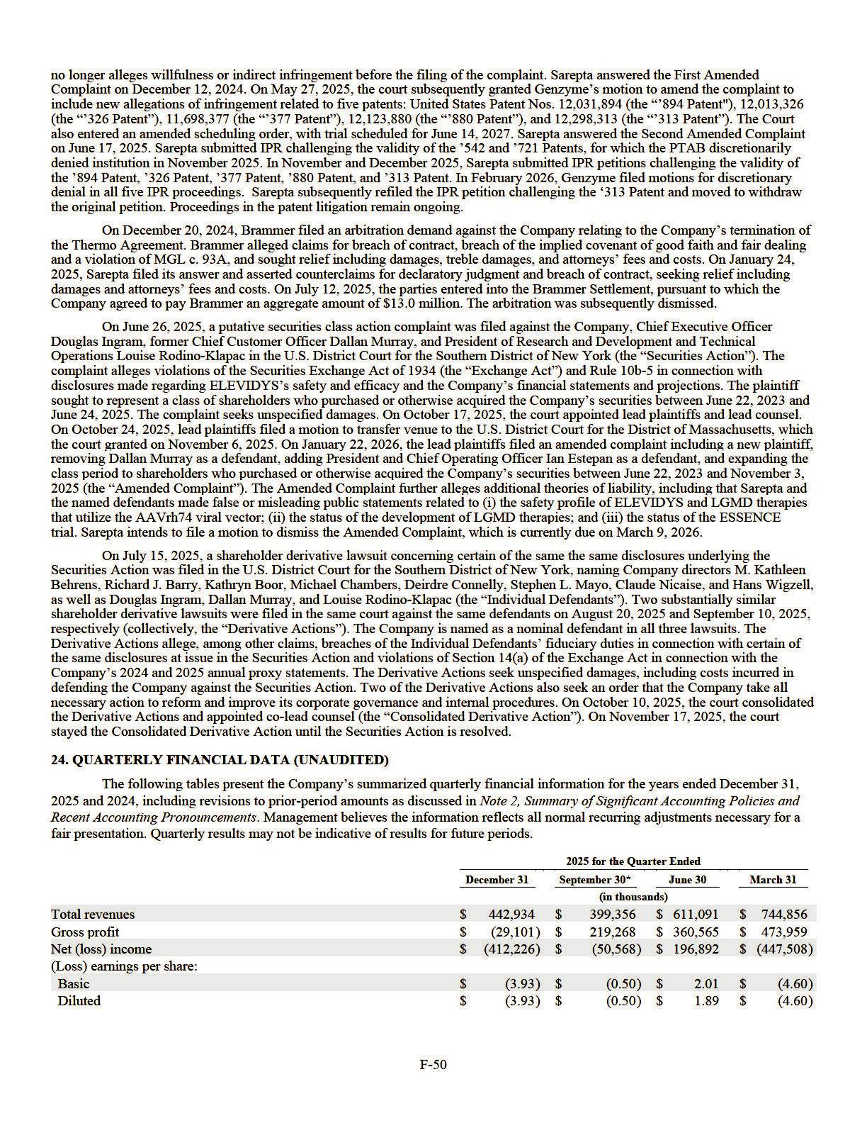

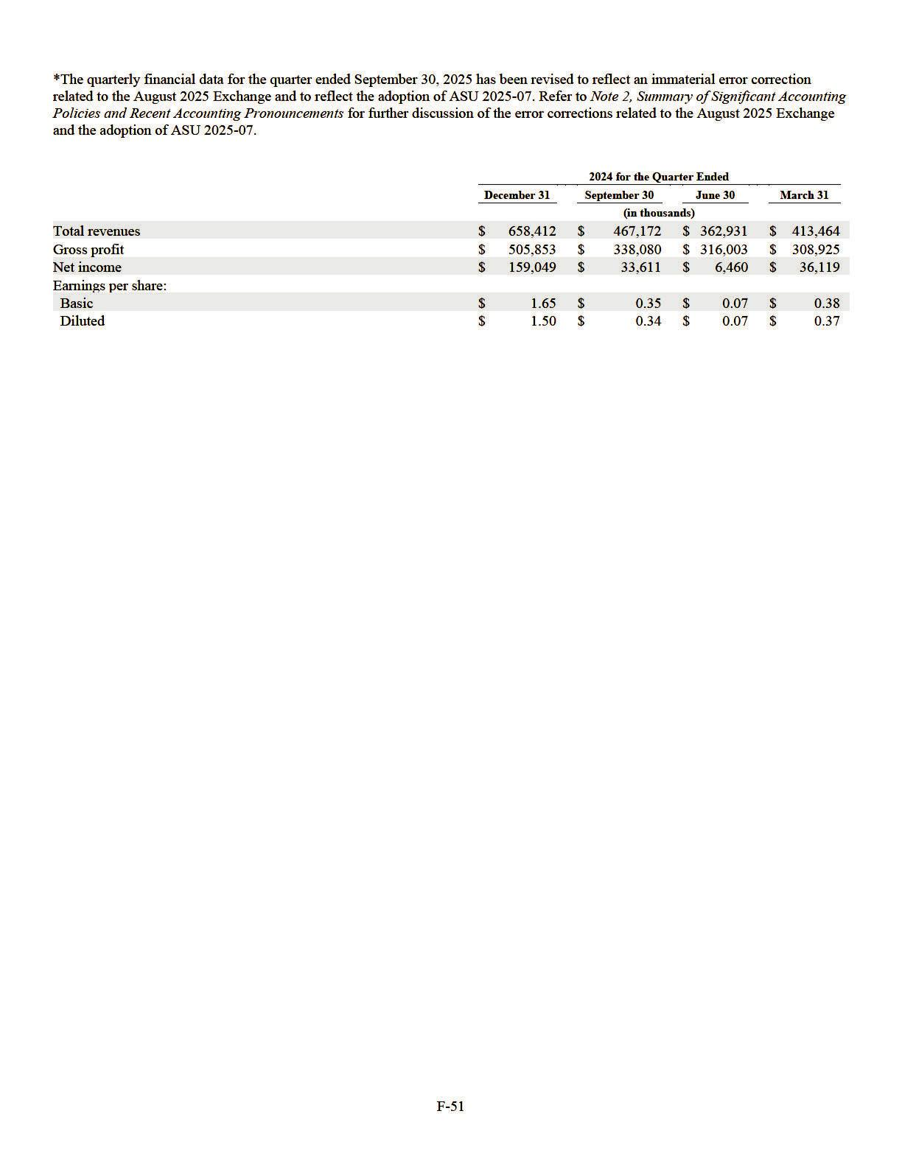

Exhibit 10.69

FIRST AMENDMENT

This FIRST AMENDMENT, dated as of December 18, 2025 (this “Amendment”), to the Credit Agreement, dated as of February 13, 2025 (as amended, restated, supplemented or otherwise modified from time to time prior to the date hereof, the “Credit Agreement”; the Credit Agreement, as amended by this Amendment is herein referred to as the “Amended Credit Agreement”), among SAREPTA THERAPEUTICS, INC., a Delaware limited liability company (the “Borrower”), the lenders from time to time party thereto(the “Existing Lenders”) and JPMORGAN CHASE BANK, N.A., as administrative agent (in such capacity, the “Administrative Agent ”) and as an Issuing Bank, is entered into by and among the Borrower and each of the Existing Lenders party hereto (such Existing Lenders constituting Required Lenders under the Credit Agreement). Terms defined in the Credit Agreement or the Amended Credit Agreement, as applicable, shall be used in this Amendment with their defined meanings therein unless otherwise defined herein.

W I T N E S S E T H:

WHEREAS, the Borrower, the Existing Lenders party hereto and the Administrative Agent are parties to the Credit Agreement;

WHEREAS, in accordance with the provisions of Section 9.02(b) of the Credit Agreement, the Borrower has requested, and the Existing Lenders party hereto (such Existing Lenders constituting the Required Lenders under the Credit Agreement) have agreed, to amend the Credit Agreement as set forth in Section 1 of this Amendment;

WHEREAS, subject to the terms and conditions of this Amendment, the parties hereto wish to amend the Credit Agreement as herein provided;

NOW, THEREFORE, the parties hereto agree as follows:

SECTION 1. Amendments to the Credit Agreement. As of the First Amendment Effective Date (as defined below), the Credit Agreement is amended as follows:

- Section 1.01 of the Credit Agreement is further amended by inserting the following new definitions in their proper alphabetical order:

“Existing Regulatory Actions ” means the Regulatory Actions taken prior to the First Amendment Effective Date in connection with (a) the limit for the ELEVIDYS indication to the treatment of patients four years of age and older with Duchenne muscular dystrophy (“DMD”) who are ambulatory and have a confirmed mutation in the DMD gene and (b) ELEVIDYS labeling changes solely related to the removal of non-ambulatory patients from the FDA-approved indication for use for ELEVIDYS; provided that any other Regulatory Actions as a result of the findings, reports or results of the Observational Study are not Existing Regulatory Actions.

“First Amendment” means that certain First Amendment, dated as of the First Amendment Effective Date, among the Borrower and the Lenders party thereto.

“First Amendment Effective Date” has the meaning specified in the First Amendment.

“Observational Study” means the post-marketing observational study of ELEVIDYS required by the FDA and titled “A Long-term Multicenter Prospective Observational Study

2

Evaluating the Comparative Effectiveness and Safety of Sarepta Gene Transfer Therapy vs. Standard of Care in Participants with Duchenne Muscular Dystrophy under Conditions of Routine Clinical Practice – Safety PMR Cohort”.

- Section 3.07(b)(i)(2) of the Credit Agreement is amended and restated in its entirety as follows:

“(2) neither the Borrower nor any of its Subsidiaries has received written notice of any pending or, to the knowledge of the Borrower or any Subsidiary, threatened claim, suit, proceeding, hearing, enforcement, audit, formal inquiry, qui tam action, appeal, professional disciplinary or regulatory proceedings, inspection, investigation, seizure, shutdown, field action, recall, untitled letter or warning letter, notice of suspension or cancellation of a drug establishment license, medical device establishment registration or other license or clinical trial, U.S. Food and Drug Administration and any successor agency thereto (“FDA”) Form 483, clinical hold, arbitration or other similar correspondence or action (each, a “ Regulatory Action”) from the DEA, the U.S. Department of Health and Human Services and any successor agency thereto, the U.S. Department of Health and Human Services Office of Inspector General, the U.S. Customs and Border Protection, and any successor agency to any of the above or any applicable Governmental Authority with jurisdiction over the safety, efficacy, research, design, development, manufacture, ownership, testing, storage, transportation, distribution, supply, packaging, processing, use, marketing, labeling, promotion, advertising, holding, import or export, disposal or sale or offer for sale of any product, service, operation or activity of the Loan Parties, including equivalent foreign and state Governmental Authorities (each a “Regulatory Authority”),

- that is reasonably likely to result in a determination or finding by such Regulatory Authority that any such service, operation or activity of the Borrower or any of its Subsidiaries, or any of such products, is in violation of any applicable Health Care Law in any material respect or (b) that is reasonably likely to (i) result in the imposition of any material penalties under a Health Care Law or (ii) materially restrict the ability of the Borrower or its Subsidiaries to conduct their business, taken as a whole, as currently conducted under Health Care Laws (it being understood that the Existing Regulatory Actions do not constitute a restriction on the ability of the Borrower or its Subsidiaries to conduct their business, taken as a whole, as currently conducted under Health Care Laws);”

SECTION 2. Conditions to Effectiveness. The effectiveness of this Amendment is subject solely to the satisfaction (or waiver) of each of the following conditions (the date of the satisfaction (or waiver) of all such conditions, the “First Amendment Effective Date”):

- the Administrative Agent shall have received from each Existing Lender party hereto (such Existing Lenders constituting the Required Lenders under the Credit Agreement) and the Borrower, a counterpart of this Amendment signed on behalf of such party; and

- The Administrative Agent shall have received all reasonable and documented out-of-pocket expenses (including the reasonable and documented out-of-pocket fees and expenses of legal counsel) to the extent due and payable under Section 9.03 of the Credit Agreement and for which invoices have been presented at least three Business Days (or such later date as agreed to by the Borrower) prior to the First Amendment Effective Date.

SECTION 3. Representations and Warranties. On and as of the date hereof, the Borrower hereby represents and warrants that, after giving effect to this Amendment (i) each of the representations and warranties made by any Loan Party in or pursuant to the Loan Documents is true and

3

correct in all material respects (provided that any representation or warranty that is qualified by materiality or Material Adverse Effect shall be true and correct in all respects), except to the extent that such representations and warranties specifically refer to an earlier date, in which case they are true and correct in all material respects (provided that any representation or warranty that is qualified by materiality or Material Adverse Effect shall be true and correct in all respects) as of such earlier date and (ii) no Default or Event of Default has occurred and is continuing.

SECTION 4. Continuing Effect; No Other Amendments or Consents.

- Except as expressly provided herein, all of the terms and provisions of the Credit Agreement and the other Loan Documents are and shall remain in full force and effect. The amendments provided for herein are limited to the specific provisions of the Credit Agreement specified herein and shall not constitute a consent, waiver or amendment of, or an indication of the Administrative Agent’s or the Lenders’ willingness to consent to any action requiring consent under any other provisions of the Credit Agreement or any other Loan Document or the same provision for any other date or time period. Upon the effectiveness of the amendments set forth herein, on and after the First Amendment Effective Date, each reference in the Amended Credit Agreement to “this Agreement,” “the Agreement,” “hereunder,” “hereof” or words of like import referring to the Amended Credit Agreement, and each reference in the other Loan Documents to “Credit Agreement,” “thereunder,” “thereof” or words of like import referring to the Amended Credit Agreement, shall mean and be a reference to the Amended Credit Agreement.

- The Borrower, the Existing Lenders party hereto and the Administrative Agent acknowledge and agree that this Amendment shall constitute a Loan Document.

- Nothing contained herein shall be construed as a substitution or novation of the obligations outstanding under the Credit Agreement or the other Loan Documents, which shall remain in full force and effect, except to any extent expressly modified hereby or by instruments executed concurrently herewith.

SECTION 5. Expenses. The Borrower agrees to pay and reimburse the Administrative Agent for all its reasonable and documented out-of-pocket costs and expenses incurred in connection with the preparation and delivery of this Amendment, and any other documents prepared in connection herewith and the transactions contemplated hereby, including, without limitation, the reasonable and documented out-of-pocket fees and disbursements of legal counsel to the Administrative Agent, in accordance with and to the extent required by the terms in the Credit Agreement.

SECTION 6. GOVERNING LAW; WAIVER OF JURY TRIAL; MISCELLANEOUS:

- GOVERNING LAW. THIS AMENDMENT SHALL BE CONSTRUED IN ACCORDANCE WITH AND GOVERNED BY THE LAW OF THE STATE OF NEW YORK.

- WAIVER OF JURY TRIAL. EACH PARTY HERETO HEREBY IRREVOCABLY WAIVES, TO THE FULLEST EXTENT PERMITTED BY APPLICABLE LAW, ANY RIGHT IT MAY HAVE TO A TRIAL BY JURY IN ANY LEGAL PROCEEDING DIRECTLY OR INDIRECTLY ARISING OUT OF OR RELATING TO THIS AMENDMENT OR THE TRANSACTIONS CONTEMPLATED HEREBY (WHETHER BASED ON CONTRACT, TORT OR ANY OTHER THEORY). EACH PARTY HERETO (A) CERTIFIES THAT NO REPRESENTATIVE, AGENT OR ATTORNEY OF ANY OTHER PARTY HAS REPRESENTED, EXPRESSLY OR OTHERWISE, THAT SUCH OTHER PARTY WOULD NOT, IN THE EVENT OF LITIGATION, SEEK TO ENFORCE THE FOREGOING WAIVER AND (B)

4

ACKNOWLEDGES THAT IT AND THE OTHER PARTIES HERETO HAVE BEEN INDUCED TO ENTER INTO THIS AMENDMENT BY, AMONG OTHER THINGS, THE MUTUAL WAIVERS AND CERTIFICATIONS IN THIS SECTION.

- Submission to Jurisdiction. The submission to jurisdiction provision of Section 9.09(c) of the Credit Agreement is hereby incorporated by reference, mutatis mutandis.

- Waiver of Venue. The waiver of venue provision of Section 9.09(d) of the Credit Agreement is hereby incorporated by reference, mutatis mutandis.

- Successors and Assigns. The provisions of this Amendment shall be binding upon and inure to the benefit of the parties hereto and their respective successors and assigns. Each party hereto acknowledges and agrees that its submission of a signature page to this Amendment is irrevocable and binding on such party and its respective successors and assigns even if such signature page is submitted prior to the effectiveness of any amendment contained herein.

- Severability. Any provision of any Amendment held to be invalid, illegal or unenforceable in any jurisdiction shall, as to such jurisdiction, be ineffective to the extent of such invalidity, illegality or unenforceability without affecting the validity, legality and enforceability of the remaining provisions thereof; and the invalidity of a particular provision in a particular jurisdiction shall not invalidate such provision in any other jurisdiction.

- Miscellaneous. Section 9.06 of the Credit Agreement is hereby incorporated by reference, mutatis mutandis.

[Signature Pages Follow]

5

Each of the parties hereto has caused a counterpart of this Amendment to be duly executed and delivered as of the date first above written.

SAREPTA THERAPEUTICS, INC.,

as the Borrower

By: /s/ Ryan Wong

Name: Ryan Wong
Title: Chief Financial Officer

6

JPMORGAN CHASE BANK, N.A.,

as a Lender

By: /s/ Helen D. Davis

Name: Helen D. Davis
Title: Executive Director

7

UBS AG, STAMFORD BRANCH,

as a Lender

By: /s/ Blake Caruso

Name: Blake Caruso
Title: Director

By: /s/ Andrea Moore

Name: Andrea Moore
Title: Associate Director

8

Royal Bank of Canada,

as a Lender

By: /s/ Scott Mac Vicar

Name: Scott Mac Vicar
Title: Authorized Signatory

9

FIFTH THIRD BANK, NATIONAL ASSOCIATION as a Lender

By: /s/ Peter Spruill

Name: Peter Spruill
Title: Officer

10

CITIZENS BANK, N.A.,

as a Lender

By: /s/ Benjamin Sileo

Name: Benjamin Sileo
Title: SVP

11

Goldman Sachs Bank, USA,

as a Lender

By: /s/ Roopa Chandra

Name: Roopa Chandra
Title: Authorized Signatory

EXHIBIT 21.1

Sarepta Therapeutics, Inc.
Subsidiaries of the Registrant
Name | Jurisdiction of Incorporation
Sarepta Securities Corp. | Massachusetts, USA
ST International Holdings, Inc. | Delaware, USA
ST International Holdings Two, Inc. | Delaware, USA
Sarepta Therapeutics Two, LLC | Delaware, USA
Sarepta Therapeutics Three, LLC | Delaware, USA
Sarepta Therapeutics Ireland LLP | Ireland
Sarepta Therapeutics Ireland Two LLP | Ireland

EXHIBIT 23.1

Consent of Independent Registered Public Accounting Firm

We consent to the incorporation by reference in the registration statements (No. 333-285491) on Form S-3ASR and (Nos. 333-289296, 333-281334, 333-273608, 333-266461, 333-240996, 333-233715, 333-228719, 333-221271, 333-213022, 333-209710, 333-199037, 333-192287, 333-175031, 333-172823, 333-101826, 333-49996, 333-49994 and 333-34047) on Form S-8 of our report dated March 2, 2026, with respect to the consolidated financial statements of Sarepta Therapeutics, Inc. and subsidiaries and the effectiveness of internal control over financial reporting.

/s/ KPMG LLP

Boston, Massachusetts

March 2, 2026

EXHIBIT 31.1

CERTIFICATION

I, Douglas S. Ingram, certify that:

- I have reviewed this Annual Report on Form 10-K of Sarepta Therapeutics, Inc., (the “Registrant”);

- Based on my knowledge, this report does not contain any untrue statement of a material fact or omit to state a material fact necessary to make the statements made, in light of the circumstances under which such statements were made, not misleading with respect to the period covered by this report;

- Based on my knowledge, the financial statements, and other financial information included in this report, fairly present in all material respects the financial condition, results of operations and cash flows of the Registrant as of, and for, the periods presented in this report;

- The Registrant’s other certifying officer and I are responsible for establishing and maintaining disclosure controls and procedures (as defined in Exchange Act Rules 13a-15(e) and 15d-15(e)) and internal control over financial reporting (as defined in Exchange Act Rules 13a-15(f) and 15d-15(f)) for the Registrant and have:

- Designed such disclosure controls and procedures, or caused such disclosure controls and procedures to be designed under our supervision, to ensure that material information relating to the Registrant, including its consolidated subsidiaries, is made known to us by others within those entities, particularly during the period in which this report is being prepared;

- Designed such internal control over financial reporting, or caused such internal control over financial reporting to be designed under our supervision, to provide reasonable assurance regarding the reliability of financial reporting and the preparation of financial statements for external purposes in accordance with generally accepted accounting principles;

- Evaluated the effectiveness of the Registrant’s disclosure controls and procedures and presented in this report our conclusions about the effectiveness of the disclosure controls and procedures, as of the end of the period covered by this report based on such evaluation; and

- Disclosed in this report any change in the Registrant’s internal control over financial reporting that occurred during the Registrant’s most recent fiscal quarter (the Registrant’s fourth fiscal quarter in the case of an annual report) that has materially affected, or is reasonably likely to materially affect, the Registrant’s internal control over financial reporting; and

- The Registrant’s other certifying officer and I have disclosed, based on our most recent evaluation of internal control over financial reporting, to the Registrant’s auditors and the audit committee of the Registrant’s board of directors (or persons performing the equivalent functions):

- All significant deficiencies and material weaknesses in the design or operation of internal control over financial reporting which are reasonably likely to adversely affect the Registrant’s ability to record, process, summarize and report financial information; and

- Any fraud, whether or not material, that involves management or other employees who have a significant role in the Registrant’s internal control over financial reporting.

March 2, 2026 | /s/ Douglas S. Ingram
 | Douglas S. Ingram
 | Chief Executive Officer
 | (Principal Executive Officer)

EXHIBIT 31.2

CERTIFICATION

I, Ryan H. Wong, certify that:

- I have reviewed this Annual Report on Form 10-K of Sarepta Therapeutics, Inc., (the “Registrant”);

- Based on my knowledge, this report does not contain any untrue statement of a material fact or omit to state a material fact necessary to make the statements made, in light of the circumstances under which such statements were made, not misleading with respect to the period covered by this report;

- Based on my knowledge, the financial statements, and other financial information included in this report, fairly present in all material respects the financial condition, results of operations and cash flows of the Registrant as of, and for, the periods presented in this report;

- The Registrant’s other certifying officer and I are responsible for establishing and maintaining disclosure controls and procedures (as defined in Exchange Act Rules 13a-15(e) and 15d-15(e)) and internal control over financial reporting (as defined in Exchange Act Rules 13a-15(f) and 15d-15(f)) for the Registrant and have:

- Designed such disclosure controls and procedures, or caused such disclosure controls and procedures to be designed under our supervision, to ensure that material information relating to the Registrant, including its consolidated subsidiaries, is made known to us by others within those entities, particularly during the period in which this report is being prepared;

- Designed such internal control over financial reporting, or caused such internal control over financial reporting to be designed under our supervision, to provide reasonable assurance regarding the reliability of financial reporting and the preparation of financial statements for external purposes in accordance with generally accepted accounting principles;

- Evaluated the effectiveness of the Registrant’s disclosure controls and procedures and presented in this report our conclusions about the effectiveness of the disclosure controls and procedures, as of the end of the period covered by this report based on such evaluation; and

- Disclosed in this report any change in the Registrant’s internal control over financial reporting that occurred during the Registrant’s most recent fiscal quarter (the Registrant’s fourth fiscal quarter in the case of an annual report) that has materially affected, or is reasonably likely to materially affect, the Registrant’s internal control over financial reporting; and

- The Registrant’s other certifying officer and I have disclosed, based on our most recent evaluation of internal control over financial reporting, to the Registrant’s auditors and the audit committee of the Registrant’s board of directors (or persons performing the equivalent functions):

- All significant deficiencies and material weaknesses in the design or operation of internal control over financial reporting which are reasonably likely to adversely affect the Registrant’s ability to record, process, summarize and report financial information; and

- Any fraud, whether or not material, that involves management or other employees who have a significant role in the Registrant’s internal control over financial reporting.

March 2, 2026 | /s/ Ryan H. Wong
 | Ryan H. Wong
 | Executive Vice President, Chief Financial Officer
 | (Principal Financial and Accounting Officer)

EXHIBIT 32.1

CERTIFICATION PURSUANT TO

SECTION 906 OF THE SARBANES-OXLEY ACT OF 2002
(18 U.S.C. SECTION 1350)

I, Douglas S. Ingram, certify, pursuant to 18 U.S.C. Section 1350, as adopted pursuant to Section 906 of the Sarbanes-Oxley Act of 2002, that the Annual Report of Sarepta Therapeutics, Inc. on Form 10-K for the fiscal year ended December 31, 2025, fully complies with the requirements of Section 13(a) or 15(d) of the Securities Exchange Act of 1934 and that information contained in such Annual Report on Form 10-K fairly presents, in all material respects, the financial condition and results of operations of Sarepta Therapeutics, Inc.

March 2, 2026 | /s/ Douglas S. Ingram
 | Douglas S. Ingram
 | Chief Executive Officer
 | (Principal Executive Officer)

A signed original of this written statement required by Section 906 of the Sarbanes-Oxley Act of 2002 has been provided to Sarepta Therapeutics, Inc. and will be retained by Sarepta Therapeutics, Inc. and furnished to the Securities and Exchange Commission or its staff upon request.

This certification accompanies this Report on Form 10-K pursuant to Section 906 of the Sarbanes-Oxley Act of 2002 and shall not, except to the extent required by such Act, be deemed filed by Sarepta Therapeutics, Inc. for purposes of Section 18 of the Securities Exchange Act of 1934, as amended (the “Exchange Act”). Such certification will not be deemed to be incorporated by reference into any filing under the Securities Act of 1933, as amended, or the Exchange Act, except to the extent that Sarepta Therapeutics, Inc. specifically incorporates it by reference.

EXHIBIT 32.2

CERTIFICATION PURSUANT TO

SECTION 906 OF THE SARBANES-OXLEY ACT OF 2002
(18 U.S.C. SECTION 1350)

I, Ryan H. Wong, certify, pursuant to 18 U.S.C. Section 1350, as adopted pursuant to Section 906 of the Sarbanes-Oxley Act of 2002, that the Annual Report of Sarepta Therapeutics, Inc. on Form 10-K for the fiscal year ended December 31, 2025, fully complies with the requirements of Section 13(a) or 15(d) of the Securities Exchange Act of 1934 and that information contained in such Annual Report on Form 10-K fairly presents, in all material respects, the financial condition and results of operations of Sarepta Therapeutics, Inc.

March 2, 2026 | /s/ Ryan H. Wong
 | Ryan H. Wong
 | Executive Vice President, Chief Financial Officer
 | (Principal Financial and Accounting Officer)

A signed original of this written statement required by Section 906 of the Sarbanes-Oxley Act of 2002 has been provided to Sarepta Therapeutics, Inc. and will be retained by Sarepta Therapeutics, Inc. and furnished to the Securities and Exchange Commission or its staff upon request.

This certification accompanies this Report on Form 10-K pursuant to Section 906 of the Sarbanes-Oxley Act of 2002 and shall not, except to the extent required by such Act, be deemed filed by Sarepta Therapeutics, Inc. for purposes of Section 18 of the Securities Exchange Act of 1934, as amended (the “Exchange Act”). Such certification will not be deemed to be incorporated by reference into any filing under the Securities Act of 1933, as amended, or the Exchange Act, except to the extent that Sarepta Therapeutics, Inc. specifically incorporates it by reference.

